This is only guide for the first time.
1. Current Password
Pin Number : Z4
Password :Z5
If you want to change the PIN number or password, go to Z4 and Z5.
If you want to change the invoice number, please update the value in Z3.
2. Client (Compony) Settings
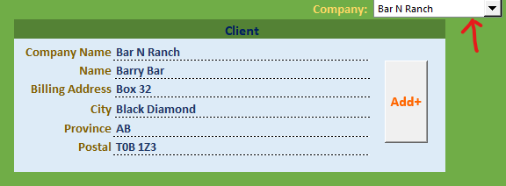
When the combo box selection changes, the client information is automatically updated with the selected company’s details.
To add a new client, enter the required information in each field and click “Add”.
Important: The information displayed here is the same as the invoice information. Any changes made will also update the corresponding invoice details.
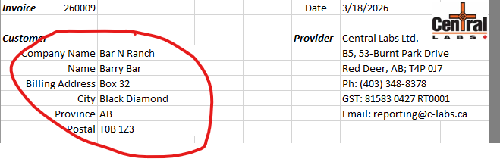
3. Register Services and pack services for invoice.
1) Register
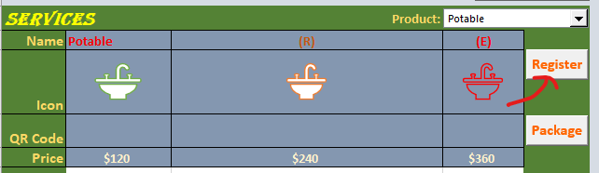
Register work can be done in two ways: one is to register prices for a new product( service ), and the other is to modify existing prices.
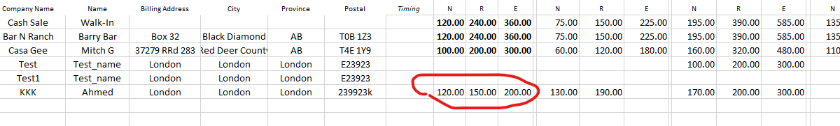
If this product value already exists, it will be replaced with the new value.
2)Package
This is to add services to invoice.
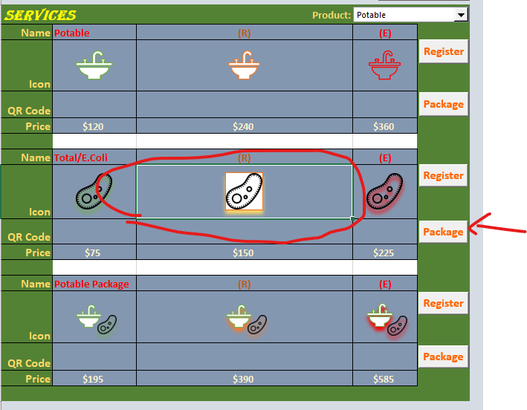
Only selected product is added to invoice.
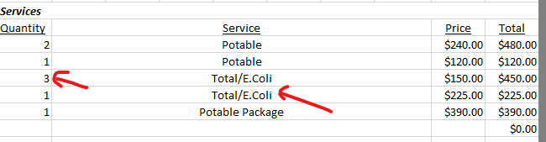
If you click on a package multiple times, the quantity value increases.
Even if it is the same service, different levels are listed as separate items.
Once 8 items have been added, no additional products can be added.
After the invoice has been paid, no more items can be added.

