Hello Arturo!
Let me know two settings status.
First: Did you set the video folder on the configure.py manually?
Check your python file folder. I think that you created the “pi” folder on “/home” and add all folders on there.
It's right.
If the folder location is not same with “/home/pi”, All errors are from this file location.
But after checking your video, the folder path may be “/home/smartabsystems/interactive_display.
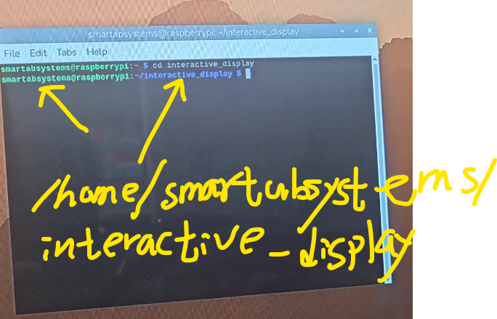
So the python file folder is different with the code.

Solution:
You need to change the code and reboot file location like this:
VIDEO_FOLDER = "/home/smartabsystems/videos/"

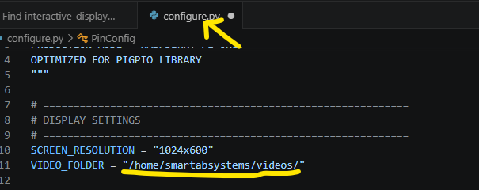
And you need to copy video files on this Videos folder.
And the name must like
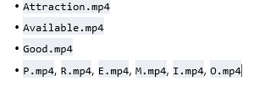
2. You need to this reboot location too.
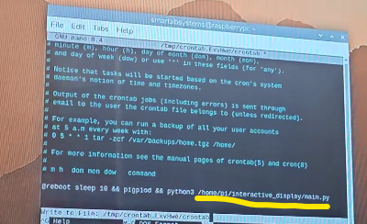
@reboot sleep 10 && pigpiod && python3 /home/smartabsystems/interactive_display/main.py
Thank you for your effort.
Try again and tell me.
I hope you release the milestone.
Your friends.

