**King Abdulaziz University**

**Faculty of Engineering**

**EE462-Computer Communications Networks**

**Evaloution_1**

|  |  |
| --- | --- |
| **Name** | **ID** |
| **Ahmed Khaled Al-Hebshi** | **2035091** |

1.Config of SW3

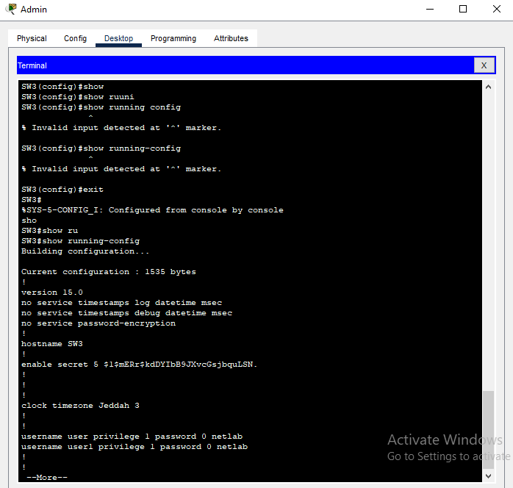

2.Configrution of the router

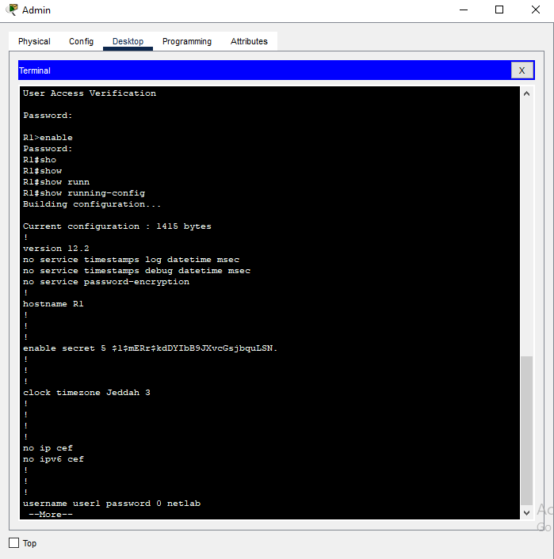

4 &&5 . pinging from pc1 to dns server && Web server

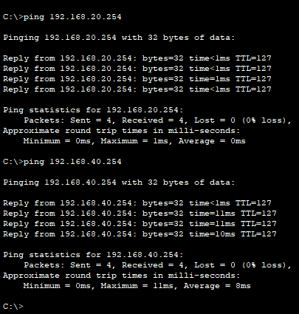

6. Web page from PC’S

PC2 :

PC3 :

Locked

