#1
Title : when user logged out session didn’t deleted
Description : after user logged out he can back to website without re-login
Related test case: 3 in Sheet Functional_standard_user
Steps :
1-open Chrome Browser
2-enter "https://www.saucedemo.com/v1/index.html" in url field
3- enter "standard_user" in userName field &"secret_sauce" in password field
4- click on "login"
5-click on menu icon that in upperLeft side
6- click on "Logout" which in side bar that appeared
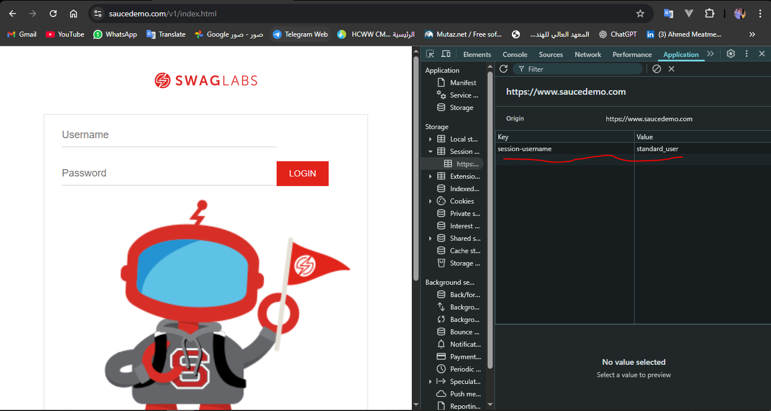
ScreenShot/Video:
Result:
1-expectedResult : deleting session
2-ActualResult : session not deleted

Sevirity : High
Priority : High

Environment: Windows 10 pro "Chrome v.117.0.5938.149"
#2
Title : products shown as selected after deleting it from cart
Description : when user click on reset app state it empty cart but products still shown as selected
Related test case: 4 in Sheet Functional_standard_user
Steps :
1-open Chrome Browser
2-enter "https://www.saucedemo.com/v1/index.html" in url field
3- enter "standard_user" in userName field &"secret_sauce" in password field
4- click On "login"
5-click on menu icon that in upperLeft side
6- click on "Reset App State" which in side bar that appeared
ScreenShot/Video:
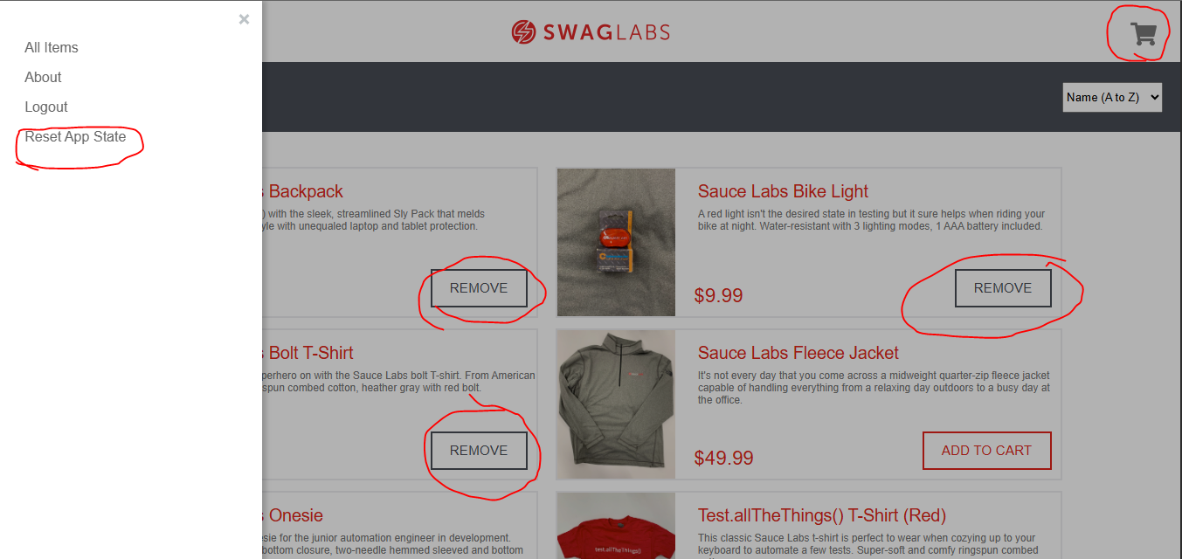
Result:
1-expectedResult : products back to default state “ADD TO CART”
2-ActualResult : products shown as selected
Sevirity : High
Priority : High
Environment: Windows 10 pro "Chrome v.117.0.5938.149"
#3
Title : sorting filter doesn’t get back to default state “A-Z”
Description : when user click on reset app state sorting filter doesn’t get back to default state
Related test case: 4 in Sheet Functional_standard_user
Steps :
1-open Chrome Browser
2-enter "https://www.saucedemo.com/v1/index.html" in url field
3- enter "standard_user" in userName field &"secret_sauce" in password field
4- click On "login"
5-click on menu icon that in upperLeft side
6- click on "Reset App State" which in side bar that appeared
ScreenShot/Video:
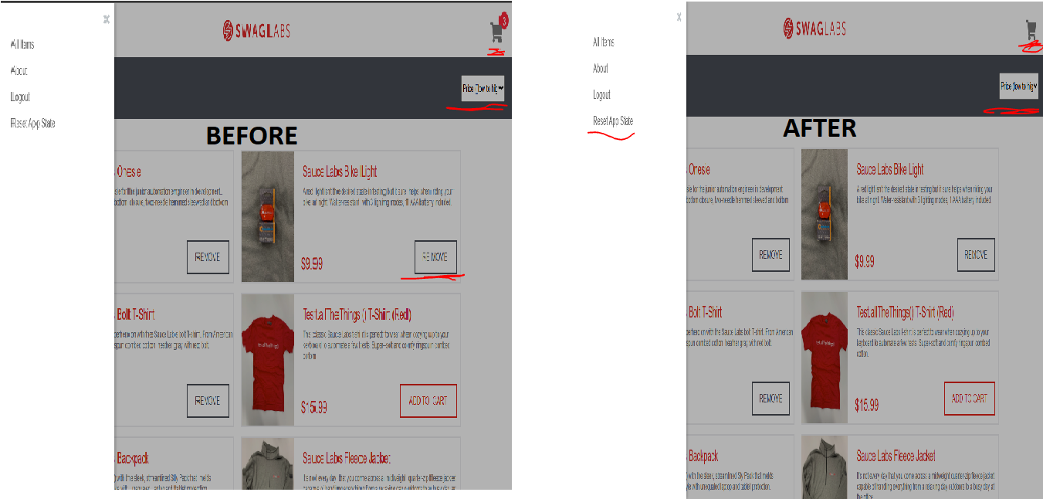
Result:
1-expectedResult : sorting filter getting back to default state
2-ActualResult : sorting filter didn’t get back to default state
Sevirity : low
Priority : low
Environment: Windows 10 pro "Chrome v.117.0.5938.149"
#4
Title : when user logged out session didn’t deleted
Description : after user logged out he can back to website without re-login
Related test case: 3 in Sheet Functional_ problem_user
Steps :
1-open Chrome Browser
2-enter "https://www.saucedemo.com/v1/index.html" in url field
3- enter "problem_user" in userName field &"secret_sauce" in password field
4- click on "login"
5-click on menu icon that in upperLeft side
6- click on "Logout" which in side bar that appeared
ScreenShot/Video:
Result:
1-expectedResult : deleting session
2-ActualResult : session not deleted

Sevirity : High
Priority : High

Environment: Windows 10 pro "Chrome v.117.0.5938.149"
#5
Title : products shown as selected after deleting it from cart
Description : when user click on reset app state it empty cart but products still shown as selected
Related test case: 4 in Sheet Functional_ problem_user
Steps :
1-open Chrome Browser
2-enter "https://www.saucedemo.com/v1/index.html" in url field
3- enter "problem_user" in userName field &"secret_sauce" in password field
4- click On "login"
5-click on menu icon that in upperLeft side
6- click on "Reset App State" which in side bar that appeared
ScreenShot/Video:
Result:
1-expectedResult : products back to default state “ADD TO CART”
2-ActualResult : products shown as selected
Sevirity : High
Priority : High
Environment: Windows 10 pro "Chrome v.117.0.5938.149"
#6
Title : sorting filter doesn’t get back to default state “A-Z”
Description : when user click on reset app state sorting filter doesn’t get back to default state
Related test case: 4 in Sheet Functional_ problem_user
Steps :
1-open Chrome Browser
2-enter "https://www.saucedemo.com/v1/index.html" in url field
3- enter "problem_user" in userName field &"secret_sauce" in password field
4- click On "login"
5-click on menu icon that in upperLeft side
6- click on "Reset App State" which in side bar that appeared
ScreenShot/Video:
Result:
1-expectedResult : sorting filter getting back to default state
2-ActualResult : sorting filter didn’t get back to default state
Sevirity : low
Priority : low
Environment: Windows 10 pro "Chrome v.117.0.5938.149"
#7
Title : sidebar displayed in checkout Page
Description : in checkout Page it’s available to show side bar
Related test case: 5 in Sheet Non_Functional_standard_user
Steps :
1-open Firefox Browser
2-enter "https://www.saucedemo.com/v1/index.html" in url field
3- enter "standard_user" in userName field &"secret_sauce" in password field
4- click On "login"
5-click on cart icon that in upper_Right side
6- click on "check out"
7- verify that sidebar icon isn't thereScreenShot/Video:
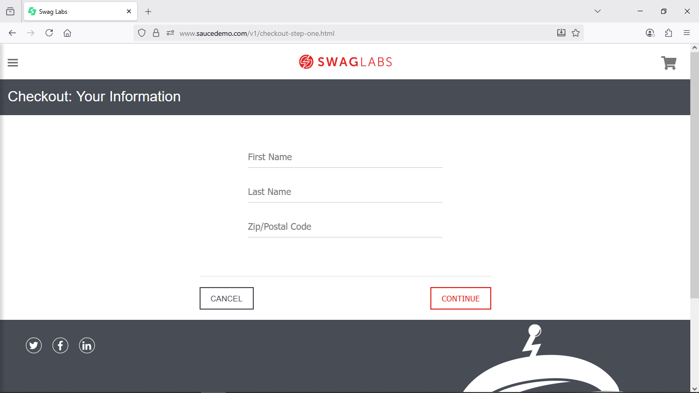
Result:
1-expectedResult : sidebar shouldn’t displayed in checkout page
2-ActualResult : sidebar displayed in checkout page
Sevirity : low
Priority : low
Environment: Windows 10 pro " Firefox v. 143.0.1 (64-bit)"
#8
Title : sidebar displayed in checkout Page
Description : in checkout Page it’s available to show side bar
Related test case: 5 in Sheet Non_Functional_problem_user
Steps :
1-open Firefox Browser
2-enter "https://www.saucedemo.com/v1/index.html" in url field
3- enter "problem_user" in userName field &"secret_sauce" in password field
4- click On "login"
5-click on cart icon that in upper_Right side
6- click on "check out"
7- verify that sidebar icon isn't thereScreenShot/Video:
Result:
1-expectedResult : sidebar shouldn’t displayed in checkout page
2-ActualResult : sidebar displayed in checkout page
Sevirity : low
Priority : low
Environment: Windows 10 pro " Firefox v. 143.0.1 (64-bit)"

