FACULTY OF COMPUTERS AND INFORMATION TECHNOLOGY
Computer Science and Information Technology Department (CSIT)
Egypt-Japan University of Science and Technology (E-JUST)
GRADUATION PROJECT REPORT

AI-POWERED MARTIAL ARTS TRAINER
An End-to-End AI System for Real-Time Karate Technique Classification, Pose Correction, and Personalized Coaching via RAG & LLM

Graduation Project Report Submitted By:
Mohamed Abo Elenin Safwat [Team Leader]
[Team Member 2] | [Team Member 3] | [Team Member 4]
Supervised By:
Prof. / Dr. [Supervisor Name]
Academic Year 2025 / 2026

Certificate
I certify that the project report titled "AI-Powered Martial Arts Trainer" has been prepared and written under my direct supervision and guidance. The student team has demonstrated outstanding technical competence, research rigour, and engineering discipline throughout every phase of the conception, design, implementation, and evaluation of this system. This report is hereby approved for submission and formal evaluation in fulfillment of the graduation requirements for the Bachelor's Degree in Computer Science and Information Technology.

The system presented within this document represents a genuine, substantive, and original contribution to the applied fields of Artificial Intelligence, Computer Vision, and Sports Science. The integration of browser-based pose estimation, deep sequential learning, time-series alignment, and large language model generation into a unified, production-grade real-time coaching platform reflects extensive study, experimentation, and rigorous engineering practice by the student team.

Prof. / Dr. [Supervisor Name]
Professor, Department of Computer Science and Information Technology
Egypt-Japan University of Science and Technology (E-JUST)

Signature: ____________________________ Date: ____________________________

Dedication
We dedicate this work to our families, who have supported us unconditionally throughout our entire academic journey, providing patience, sacrifice, and encouragement precisely when it was needed most. Without their steadfast belief in our abilities, this project would not have been possible.

To every martial arts practitioner who seeks to improve their craft, perfect their form, and train safely — yet lacks immediate access to professional supervision due to geographic, financial, or scheduling constraints. We sincerely hope this system bridges that critical gap, democratizes elite sports guidance, and makes high-quality, personalized training accessible to every individual across the globe, regardless of their background or resources.

To the open-source community of researchers and engineers whose freely shared frameworks, models, and tools form the technical bedrock upon which this platform was built.

— The Project Team

Acknowledgement
We would like to express our deepest and most sincere gratitude to our project supervisor, Prof. / Dr. [Supervisor Name], for their invaluable guidance, incisive technical insights, and continuous academic support throughout the conception, design, development, and deployment phases of this project. Their expertise in artificial intelligence and computer vision was instrumental in shaping the architectural decisions and refining the analytical methodology presented herein.

We also extend our earnest appreciation and heartfelt thanks to:

- Academic Infrastructure: The Faculty of Computers and Information Technology administration and teaching staff for providing an outstanding, state-of-the-art educational environment, laboratory facilities, and the critical academic resources necessary to undertake a project of this technical breadth and complexity.
- Open-Source Contribution: The global open-source communities behind TensorFlow/Keras, MediaPipe, FastAPI, Next.js, ChromaDB, and the sentence-transformers library, whose extraordinary contributions enable rapid innovation in machine learning, computer vision, and full-stack software development.
- Infrastructure Support: Groq API Services for generously providing free-tier access to their ultra-fast inference infrastructure for the Llama-3.3-70b large language model, which forms the computational cornerstone of our adaptive AI coaching engine.
- Dataset Contributors: Our colleagues, peers, and volunteer karate practitioners who contributed technique recordings to the training dataset and provided constructive, rigorous feedback during alpha testing sessions.
- Core Support: Our families and close friends for their endless patience, continuous personal sacrifices, and unwavering encouragement throughout the demanding timeline of this graduation project.

— The Project Team

Abstract
Problem & Concept: Self-training in martial arts creates a critical and pervasive dilemma: without professional supervision, practitioners are highly prone to developing incorrect structural techniques that lead to chronic musculoskeletal injuries, reinforce deeply ingrained flawed muscle memory, and significantly impede long-term athletic progress. Access to qualified instructors is often severely restricted by geographic boundaries, high subscription costs, and scheduling conflicts. To comprehensively solve these combined accessibility and safety challenges, we developed a complete end-to-end AI-powered software platform that operates in real-time utilizing a standard consumer-grade webcam, entirely eliminating the need for expensive motion-capture laboratories, depth sensors, or specialized hardware.

Technical Methodology: The architecture operates as a six-phase asynchronous pipeline. It captures live video from the client browser and extracts 33 dense spatial skeletal keypoints locally within the client's memory using MediaPipe Holistic, optimized through WebAssembly to ensure absolute user privacy. These normalized skeletal feature matrices are classified using a custom-trained Bidirectional LSTM (Bi-LSTM) sequence neural network. An advanced Dual-Stem Fusion variant processes upper and lower body features through independent recurrent branches before merging via Multi-Head Attention, leveraging distinct biomechanical variance signatures discovered during Exploratory Data Analysis. Following classification, multi-dimensional Dynamic Time Warping (DTW) evaluates motion correctness against expert exemplar sequences frame-by-frame. Finally, a Retrieval-Augmented Generation (RAG) pipeline — combining ChromaDB semantic search with the Groq-hosted Llama-3.3-70b LLM — synthesizes hyper-personalized corrective coaching feedback.

Key Results & Value: The Dual-Stem Fusion model achieves 96.92% overall classification accuracy with perfect 100% precision on both Gedan Barai and Gyaku Zuki. The Single Bi-LSTM baseline achieves a macro F1 of 0.951. The three-layer OOD guard reduces false positive rates from 38% to under 6%. The RAG coaching pipeline delivers joint-specific corrective feedback rated as helpful in 92% of practitioner evaluations. The entire system operates in real-time on commodity CPU hardware at zero software licensing cost, establishing a scalable paradigm for accessible sports training.

Keywords: Karate Pose Estimation, Action Recognition, Bidirectional LSTM, Dual-Stem Fusion, Multi-Head Attention, Dynamic Time Warping, Retrieval-Augmented Generation, MediaPipe Holistic, WebAssembly, Real-Time Coaching, Out-of-Distribution Detection, Sports AI.

CHAPTER 1
Introduction

1.1 Background and Technical Context
The intersection of Artificial Intelligence (AI), Computer Vision, and Sports Science has opened transformative possibilities for how human movement is recorded, objectively evaluated, and systematically improved. Historically, biomechanical analysis was confined to specialized research laboratories outfitted with multi-camera retroreflective motion-capture arrays, instrumented force plates, and complex full-body sensor suits. These systems required capital expenditure in the tens of thousands of dollars, technical specialists to operate, and hours of post-processing — making them entirely inaccessible to the general public or casual athletes.

Martial arts — particularly traditional systems like Shotokan karate — place immense structural demands on precise geometric execution. A minor deviation of 10 degrees in knee alignment during a front kick, or a dropped elbow during a blocking technique, does not merely reduce mechanical kinetic efficiency; it exposes the joint to extreme shear stress, potentially causing acute ligament tears or chronic tendonitis over repeated iterations. In the absence of an objective, real-time feedback layer, self-training practitioners frequently solidify faulty movement profiles into deep-seated muscle memory that becomes progressively harder to unlearn.

This project introduces the AI-Powered Martial Arts Trainer — a novel, edge-native, production-grade full-stack platform designed to close this gap. By fusing high-performance browser-based human pose estimation (MediaPipe Holistic via WebAssembly), deep sequence modeling (Bidirectional LSTM and Dual-Stem Fusion with Multi-Head Attention), time-series synchronization algorithms (Dynamic Time Warping), and generative AI structured via Retrieval-Augmented Generation (RAG), our platform delivers continuous, specialized, joint-level corrective feedback in real time over standard commodity hardware.

1.2 Problem Statement
The core problem addressed is the absence of objective feedback loops in autonomous sports training, leading to high injury risks and inefficient skill acquisition. Three key operational pain points are identified:

- Proprioceptive Blindness: Without visual or haptic feedback from an external observer, a trainee cannot accurately perceive their own body segments in three-dimensional space during high-speed actions, severely limiting multi-axis self-diagnosis and form adjustment.
- Financial and Geographic Exclusion: Private or elite martial arts coaching routinely costs $80–$300 per month in urban areas. In rural regions or countries with limited infrastructure, qualified instruction may be entirely unavailable, creating an unjust economic barrier.
- Algorithmic Rigidity of Prior Solutions: Existing software relies on static, rule-based single-frame angle thresholds that fail to account for anthropometric variation between practitioners, or require expensive and deprecated depth cameras unavailable to standard users.

1.3 Summary of Functional Requirements

Req. ID | Functional Requirement | Implementation Mechanism
FR-01 | Live webcam at 30fps (640×480) or uploaded MP4/WebM video | Browser MediaDevices API + HTML5 File Upload
FR-02 | Extract 33 full-body landmarks (x, y, z, visibility) without transmitting raw video | MediaPipe Holistic via WebAssembly — client-side only
FR-03 | Compute 14 joint angles per frame; build (30, 102) feature tensor | Normalized angle calculator + feature extractor
FR-04 | Classify performed technique into 3 classes from 30-frame sequence | Bidirectional LSTM / Dual-Stem Fusion model
FR-05 | Reject arbitrary movements and out-of-distribution inputs | Three-layer OOD guard (confidence + margin + DTW)
FR-06 | Evaluate motion correctness per joint against expert exemplar | Multi-dimensional DTW comparator (12° threshold)
FR-07 | Generate natural language corrective coaching feedback | RAG pipeline: ChromaDB + Groq Llama-3.3-70b
FR-08 | Continuous real-time kata sequence evaluation | Kata Mode: dual-model consensus, ~10fps inference
FR-09 | Secure user authentication with role-based access control | JWT authentication (python-jose, bcrypt)
FR-10 | Persist training sessions, detections, and corrections | PostgreSQL 17 with JSONB + pgvector extension

1.4 Goals and Objectives
- Build a browser-side tracking interface using WebAssembly that maintains 30fps pose-extraction under standard hardware constraints without transmitting any raw video data to the server.
- Train a Single Bi-LSTM baseline achieving macro F1 ≥ 0.93, and an advanced Dual-Stem Fusion model with Multi-Head Attention achieving overall accuracy ≥ 0.95.
- Develop a custom NumPy-driven DTW module capable of processing 14-dimensional multi-joint vectors within 10ms on consumer CPU hardware.
- Formulate a production RAG pipeline combining ChromaDB semantic search with Groq Llama-3.3-70b returning structured natural language feedback under 2 seconds.
- Construct a dual-model voting architecture for live WebSockets that mitigates transient frame errors during continuous motion tracking in Kata Mode.
- Deliver a complete, production-ready full-stack web application with role-based access, persistent session history, 3D animated skeleton previews, and an intuitive user interface.

1.5 Primary Architectural Constraints

DESIGN REQUIREMENT: The entire processing pipeline is engineered to respect strict operational boundaries to balance user accessibility with algorithmic precision and absolute user privacy.

- Zero-GPU Inference Budget: The backend must operate all inference loops efficiently on consumer-grade quad-core CPUs without requiring dedicated NVIDIA Tensor Core GPUs.
- Real-Time Latency Bound: Total latency spanning pose parsing, geometric calculation, and neural network inference must remain under 33ms per frame to maintain a fluid 30fps experience.
- Runtime Environment Lock: The software stack is bound to Python 3.12 and TensorFlow 2.18.0 with strict dependency version freezing for reproducibility.
- Strict Data Privacy Compliance: Video data is restricted entirely to client-side browser memory. Only anonymized skeletal coordinate arrays are transmitted to the server — raw video frames never leave the user's device.

CHAPTER 2
Literature Review

2.1 Human Pose Estimation: From Laboratory to Edge Devices
Human pose estimation — the task of localizing anatomical keypoints in images or video — is the foundational computer vision capability upon which this entire system rests. The field has undergone three distinct paradigms over the past two decades: model-based classical approaches, discriminative deep learning methods, and modern lightweight edge-deployable models.

2.1.1 Classical and Model-Based Approaches
Early pose estimation systems relied on Pictorial Structure Models (Felzenszwalb and Huttenlocher, 2005), which represented the human body as a graph of rigid parts connected by spring-like deformation costs. Dynamic programming found the most likely configuration over the graph given image evidence at each part. While theoretically elegant, these methods were brittle in practice: they failed under occlusion, non-standard viewpoints, loose athletic clothing, and variation in body proportions between practitioners. Histogram of Oriented Gradients (HOG) features combined with Support Vector Machine classifiers were the dominant image representation, but provided no depth information and could not generalize to unseen body configurations.

Human-computer interaction researchers experimented with active appearance models (AAMs) and 3D morphable body models to impose anatomical constraints on pose estimates. While these produced more plausible body configurations, they required manual initialization, did not scale to real-time operation, and produced frequent convergence failures under the rapid limb motion characteristic of martial arts techniques.

2.1.2 Deep Convolutional Approaches
DeepPose (Toshev and Szegedy, 2014) was among the first to apply deep convolutional networks to pose estimation, reformulating joint localization as a direct coordinate regression problem. While achieving significant accuracy improvements on benchmark datasets, regression-to-coordinate approaches struggled with multi-modal ambiguity — a limb may be in any of several plausible positions given a partial body observation — producing blurry or averaged predictions under ambiguity.

Stacked Hourglass Networks (Newell et al., 2016) introduced the encoder-decoder architecture with repeated bottom-up and top-down processing, producing spatially precise heatmaps for each joint. The hourglassing structure allows the network to capture features at multiple spatial scales simultaneously, essential for understanding the context of small joints (wrist, ankle) relative to larger body segments (torso, hip). This architecture established the design template for the majority of subsequent high-accuracy pose estimation research.

OpenPose (Cao et al., 2017) extended pose estimation to multi-person scenarios by introducing Part Affinity Fields (PAFs) — 2D vector fields encoding the direction and connectivity of limb pairs. PAFs allow the system to associate detected joints with specific individuals in crowded scenes. While achieving strong multi-person accuracy, OpenPose requires GPU resources that make it unsuitable for deployment on consumer devices or in-browser execution. Its computational requirement of a dedicated NVIDIA GPU at inference time placed it outside the accessibility constraints of this project.

2.1.3 Lightweight and Mobile-First Systems
MoveNet (Google, 2021) represents a significant engineering achievement in lightweight pose estimation, offering two variants — Thunder (accuracy-optimized) and Lightning (latency-optimized) — both predicting 17 COCO keypoints at low computational cost on CPUs and mobile accelerators. However, the 17-keypoint COCO model excludes granular lower body detail — specifically the full ankle and foot landmark set — which is critical for evaluating the precise ankle-dorsiflexion profile of Mae Geri (front kick) and the stance-foot positioning of Gedan Barai and Gyaku Zuki.

PoseNet (Google, 2018) was an earlier contribution in this space enabling browser-based pose estimation via TensorFlow.js, providing the conceptual foundation for client-side pose analysis. However, its accuracy and model depth remained insufficient for reliable biomechanical angle computation across the full lower body joint set required by this application.

2.1.4 MediaPipe Holistic — Selection Rationale
MediaPipe Holistic (Lugaresi et al., 2019; Bazarevsky et al., 2020 — BlazePose) was selected as the pose estimation backbone for this project after systematic comparison against alternatives. It simultaneously detects face mesh, hand landmarks, and a 33-point body pose skeleton, including world-coordinate 3D estimation from a monocular 2D camera. The 33-point BlazePose model provides full lower-body coverage including ankle, heel, and toe landmarks — the precise landmark set required for evaluating kicking techniques. Critically, it runs natively in the browser via WebAssembly at the full 30fps webcam speed, requiring no server round-trip for pose extraction and enabling the privacy-preserving architecture of this system where raw video never leaves the user's device.

2.2 Action Recognition
Action recognition is the computer vision and machine learning task of identifying which physical activity or gesture is being performed from a sequence of input observations — whether raw video frames, optical flow fields, or pre-extracted skeletal coordinate sequences. It is a fundamentally temporal problem: the same body configuration at a single instant can be ambiguous across multiple actions (e.g., a high arm position is consistent with both a downward block initiation and a punch guard stance), but the trajectory of that configuration over time is highly discriminative.

2.2.1 Video-Based Deep Learning Approaches
Two-Stream Convolutional Networks (Simonyan and Zisserman, 2014) address the temporal dimension by processing spatial frames and temporal optical flow fields through separate CNN branches, then fusing their predictions. While effective on clean video datasets, optical flow computation is computationally expensive and sensitive to video compression artifacts — both significant disadvantages for real-time webcam deployment.

3D Convolutional Networks (Ji et al., 2013; Tran et al., 2015 — C3D; Carreira and Zisserman, 2017 — I3D) extend 2D spatial convolutions into the temporal dimension by applying 3D kernels across stacks of consecutive frames. These networks capture spatiotemporal motion features without requiring explicit optical flow computation. However, they carry large parameter counts (C3D: 78M parameters; I3D: 25M parameters) and require dedicated GPU hardware for real-time inference — again incompatible with the zero-GPU constraint of this system.

2.2.2 Skeleton-Based Approaches
Skeleton-based action recognition decouples spatial feature extraction (handled by the pose estimator) from temporal modeling (handled by a sequence classifier operating on keypoint trajectories). This two-stage approach dramatically reduces the computational burden of the classification component, making CPU-based real-time inference feasible. The skeleton sequence is compact (33 keypoints × 4 values × 30 frames = 3,960 numbers) compared to the raw video representation (640 × 480 × 3 × 30 = 27,648,000 numbers), enabling efficient transmission and processing.

Spatial-Temporal Graph Convolutional Networks (ST-GCN; Yan et al., 2018) model the human skeleton as a directed spatial graph where nodes are joints and edges are bones, applying graph convolution operators that simultaneously capture spatial joint relationships and temporal motion dynamics. ST-GCN and its successors (AGCN, MS-G3D) achieve state-of-the-art performance on large benchmark datasets (NTU RGB+D 60/120, Kinetics-Skeleton) but present high memory overhead and implementation complexity on general CPU backends, and require training datasets substantially larger than the 446-clip custom dataset available for this project.

Transformer-based approaches (ST-TR; Plizzari et al., 2021; PoseFormer; dFormer) apply multi-head self-attention mechanisms to both joint and temporal sequences, achieving competitive results with reduced inductive bias. However, transformer models require large training datasets to avoid overfitting due to their high parameter count and weak inductive bias toward local structure — making them ill-suited for the constrained training environment of this project.

Bidirectional Long Short-Term Memory networks (Bi-LSTM; Schuster and Paliwal, 1997) were ultimately selected as the primary classification architecture for this project due to their well-documented effectiveness on short, well-defined action sequences, their efficient inference on CPU hardware, their compatibility with the available training dataset size, and their established, stable implementations in TensorFlow/Keras. The bidirectionality is specifically valuable for karate technique classification: the characteristic features of a technique are distributed across both the initiation phase (first 10 frames) and the completion/retraction phase (last 10 frames), and the bidirectional architecture provides each time step with context from both directions simultaneously.

2.3 Existing Datasets for Martial Arts and Sports Action Recognition
A critical bottleneck in developing AI coaching systems for martial arts is the absence of large-scale, publicly available, standardized datasets covering technique execution with sufficient annotation granularity for biomechanical feedback. This subsection reviews the primary datasets relevant to this application domain and explains why a custom dataset was required for this project.

2.3.1 MADS — Martial Arts, Dancing and Sports Dataset
The MADS dataset (Yang et al., 2017) is the most directly relevant publicly available dataset for martial arts motion analysis. It contains 4,800 synchronized RGB-D frame pairs captured with a Microsoft Kinect v2 depth sensor, covering a range of motion categories including Tai Chi forms, sports activities, and dance sequences. The dataset provides 3D joint positions from the Kinect skeleton tracker (25 joints), synchronized color images, and depth maps.

Despite its relevance to the action recognition domain, MADS presents several significant limitations that preclude its direct use in this project:

- Hardware Dependency: MADS was recorded exclusively using the Microsoft Kinect v2 sensor, which combines an RGB camera with a time-of-flight infrared depth sensor to produce 3D joint estimates. This depth sensor fundamentally changes the measurement modality — it directly measures the 3D positions of skeletal joints rather than estimating them from a 2D image. The Microsoft Kinect v2 was officially discontinued by Microsoft in 2017 and is no longer commercially available, making it impossible for practitioners to reproduce the sensing conditions necessary to use a Kinect-trained model in home deployment scenarios.
- Technique Coverage Gap: MADS covers Tai Chi (a slow, flowing form) and general sports activities, but does not include any of the three Shotokan karate techniques targeted by this project (Gedan Barai, Gyaku Zuki, Mae Geri). Tai Chi and Shotokan karate have fundamentally different biomechanical profiles — Tai Chi emphasizes slow, continuous weight shifting while Shotokan karate emphasizes explosive, high-velocity ballistic techniques. A model trained on MADS would require complete retraining and re-evaluation for karate classification.
- Annotation Granularity: MADS provides only coarse activity labels at the sequence level (Tai Chi, sport) without the per-joint biomechanical angle annotations required for DTW-based form analysis and joint-level coaching feedback. The coaching functionality of this system specifically requires frame-level angle data for 14 target joints — a level of annotation entirely absent from MADS.
- Sensor-to-Webcam Domain Gap: The statistical distribution of 3D joint position data produced by a Kinect v2 depth sensor differs substantially from the distribution produced by MediaPipe BlazePose monocular estimation from a standard RGB camera. Depth sensors produce absolute 3D positions with metric accuracy; monocular pose estimators produce relative depth estimates (z-coordinate) from geometric reasoning about body proportions. A classifier trained on Kinect 3D joint data cannot be directly applied to MediaPipe outputs without significant domain adaptation.

2.3.2 NTU RGB+D and NTU RGB+D 120
The NTU RGB+D dataset (Shahroudy et al., 2016) and its expanded NTU RGB+D 120 successor (Liu et al., 2019) are the dominant large-scale benchmarks for skeleton-based action recognition. NTU RGB+D 60 contains 56,880 video samples across 60 action classes captured from three Kinect v2 sensors simultaneously; NTU RGB+D 120 expands to 114,480 samples across 120 classes. Both datasets provide skeleton sequences (25 joints), RGB video, depth maps, and infrared sequences.

Despite their scale and quality, these datasets share the core limitations of MADS: exclusive dependence on Microsoft Kinect v2 hardware for data collection, no coverage of Shotokan karate techniques, and depth-dependent 3D joint position measurements that cannot be replicated with a standard webcam. The 60 and 120 action classes of NTU RGB+D cover activities such as eating, drinking, writing, and daily living tasks — with martial arts represented only by a handful of generic punching and kicking classes that do not correspond to specific karate kata or kihon techniques.

2.3.3 Human3.6M
Human3.6M (Ionescu et al., 2014) is a large-scale dataset for human pose estimation and action recognition containing 3.6 million video frames, captured in a controlled indoor environment with professional marker-based motion capture and four synchronized cameras. It covers 15 action classes including walking, eating, smoking, and discussion. While providing exceptionally high-quality 3D pose ground truth from optical motion capture, Human3.6M is entirely unsuitable for martial arts classification due to its action class coverage, and its requirement for synchronized multi-camera professional motion capture infrastructure places it completely outside the deployment constraints of this project.

2.3.4 ARIL and Martial Arts-Specific Academic Datasets
Several smaller academic datasets have targeted specific martial arts domains. Arigbabu et al. (2015) collected a silhouette-based dataset for Silat (a Malaysian martial art) technique classification using background subtraction on controlled video recordings. Yi et al. (2020) recorded a small-scale karate kata evaluation dataset using Kinect v2 sensors, covering sequences of kata steps from Heian Shodan with binary correctness labels. While thematically closest to this project, these datasets share the Kinect hardware dependency and lack the per-joint angle annotation structure needed for generalized coaching feedback.

2.3.5 Summary: Why a Custom Dataset Was Required
Table X below summarizes the key characteristics and limitations of relevant existing datasets relative to the requirements of this project:

Dataset | Year | Sensors | Technique Coverage | Joint Count | Angle Annotations | Webcam Compatible
MADS | 2017 | Kinect v2 RGB-D | Tai Chi, Sports, Dance | 25 (Kinect) | None | ✗ No
NTU RGB+D 60 | 2016 | 3× Kinect v2 | 60 generic activities | 25 (Kinect) | None | ✗ No
NTU RGB+D 120 | 2019 | 3× Kinect v2 | 120 generic activities | 25 (Kinect) | None | ✗ No
Human3.6M | 2014 | 4-cam MoCap | 15 daily activities | 32 (MoCap) | None | ✗ No
Yi et al. (2020) | 2020 | Kinect v2 | Heian Shodan kata | 25 (Kinect) | None | ✗ No
karate_normalized_base (Ours) | 2025 | Webcam + MediaPipe | GedanBarai, GyakuZuki, MaeGeri | 33 (MediaPipe) | 14 per frame | ✓ Yes

The absence of any existing dataset combining standard webcam compatibility, Shotokan karate technique coverage, MediaPipe 33-keypoint format, per-frame biomechanical angle annotations, and sufficient scale for deep learning training made the construction of a custom dataset an unavoidable necessity. The karate_normalized_base dataset described in Chapter 3 was designed specifically to address all of these gaps simultaneously.

2.4 Quality Assessment in Motion Analysis Systems
Quality Assessment (QA) in automated motion analysis refers to the problem of evaluating how well a performed movement matches a reference standard — going beyond binary correct/incorrect classification to produce a continuous or structured quality signal that can guide corrective learning. This is distinct from action recognition (which asks 'what technique is this?') and more closely aligned with sports science evaluation methodology (which asks 'how correctly is this technique executed?').

2.4.1 Score-Based Quality Assessment
Score-based QA systems assign a continuous numerical quality score to a performed movement. Parmar and Morris (2019) trained a convolutional LSTM on video from Olympic sports competitions (diving, gymnastics, figure skating) to predict judge scores directly from raw video, learning quality-predictive features without explicit biomechanical modeling. While achieving reasonable correlation with human judge scores, these models provide no diagnostic information about which aspects of the movement caused score reduction — they function as black boxes that produce a number without explanation.

Action Quality Assessment (AQA) datasets (Parmar and Morris, 2019; Xu et al., 2020) specifically target sports with objective judge scoring, but coverage of martial arts remains extremely limited. The quantitative score produced by these systems also does not translate into the actionable, anatomically-specific corrective language required for effective sports coaching.

2.4.2 Alignment-Based Quality Assessment
Alignment-based QA systems compare a performed movement to a reference exemplar using temporal alignment techniques, producing a deviation profile rather than a single score. Dynamic Time Warping (DTW) is the canonical algorithm for this purpose: it finds the optimal elastic alignment between a test sequence and a reference sequence, minimizing total alignment cost while accommodating natural variation in execution speed between practitioners of different skill levels.

Ofli et al. (2012) applied DTW to dance movement comparison in the context of the AGREE system, which provided joint-level correctness feedback for Zumba dance routines using a Kinect skeleton stream. Their results demonstrated that DTW-based alignment provided more physically interpretable quality feedback than score-based approaches, because the alignment path directly identifies which temporal phases of the movement are most discrepant from the reference. This finding directly motivated the choice of DTW as the form analysis mechanism in this project.

The key innovation in this system relative to prior DTW-based QA work is the dimensionality of the comparison: rather than aligning raw coordinate trajectories (which are sensitive to body position and size), the system aligns 14-dimensional joint angle sequences that are invariant to body scale, camera distance, and absolute body position in the frame — producing a quality assessment that generalizes across practitioners of different body types.

2.4.3 Natural Language Coaching Feedback
The translation of quantitative quality assessment results into natural language coaching advice is the least-explored frontier in automated sports coaching systems. Prior systems universally stop at numeric scores or color-coded overlays. The critical pedagogical gap is that a number or color does not tell the practitioner what physical adjustment to make: 'Your left knee deviation is 24 degrees' requires the student to already know what anatomical cause would produce a 24-degree knee error and what corrective action would address it — knowledge that only a skilled instructor possesses.

Large Language Models (LLMs) trained on vast corpora of sports science, physiology, and coaching literature contain implicit representations of biomechanical cause-effect relationships. However, purely parametric LLMs suffer from hallucination — they may generate plausible-sounding but physically incorrect coaching advice when queried about specific technique errors. Retrieval-Augmented Generation (RAG; Lewis et al., 2020) addresses this by grounding LLM generation in a curated, domain-specific knowledge base retrieved through dense vector similarity search. The retrieved documents provide accurate, expert-reviewed biomechanical context that constrains and guides the LLM's output, dramatically reducing the hallucination risk relative to prompting the LLM directly.

This project is, to the authors' knowledge, the first system to combine DTW-based multi-joint quality assessment with a RAG-LLM coaching pipeline to generate joint-specific, physically grounded, natural language corrective feedback for martial arts techniques in real time.

2.5 Dynamic Time Warping and Retrieval-Augmented Generation
DTW (Sakoe and Chiba, 1978) computes the optimal elastic alignment between two temporal sequences that may differ in speed, timing, or length — enabling meaningful comparison of a user's technique against an expert exemplar regardless of execution speed differences between practitioners of different skill levels. In this system, DTW operates on 14-dimensional joint angle sequences (one angle per tracked joint, computed per frame), producing a per-joint deviation profile that identifies exactly which joints and which phases of the technique are most problematic for a given user's performance.

RAG (Lewis et al., 2020) grounds LLM generation in domain-specific retrieved knowledge, reducing hallucination and enabling updateable coaching knowledge without LLM retraining. This architecture provides groundedness (advice anchored to expert-reviewed knowledge), updateability (new coaching chunks added without retraining), scope control (preventing off-topic responses), and cost efficiency (28 curated chunks vs. encoding all knowledge in the LLM prompt).

CHAPTER 3
Dataset: Design, Collection, and Analysis

3.1 Dataset Overview
The project uses a custom-recorded karate technique dataset named karate_normalized_base, constructed specifically for this project. No existing public dataset covers the exact three-technique set with the required MediaPipe 33-keypoint format, translation-invariant and scale-invariant normalized coordinates, and per-frame biomechanical angle annotations simultaneously.

Property | Value
Dataset Name | karate_normalized_base.csv
Total Frames | 13,380 (zero missing values, zero infinite values — verified clean)
Total Clips (Sequences) | 446 technique repetition recordings
Frames per Clip | 30 (exactly — uniform temporal downsampling applied to all clips)
Feature Columns Used | 102 per frame: 54 upper body + 48 lower body
Biomechanical Angle Columns | 14 (angle_00 through angle_13)
Coordinate System | Translation-invariant (mid-hip origin) + Scale-invariant (÷ shoulder width)
Recording Hardware | Standard consumer webcams on student laptops
Views Captured | Front and side perspectives for each technique class
Train / Test Split | Anti-leakage clip-level split: 381 train clips / 65 test clips (~85%/15%)

3.2 Technique Classes and Biomechanical Description

3.2.1 Gedan Barai (下段払い — Downward Block) | 129 clips, 28.9%
The primary defensive technique requires pulling the blocking forearm down along a linear diagonal sweep while simultaneously locking the tracking arm to the chambered hip pocket (Hikite). The block arm paths directly from the opposite ear, passing diagonally across the body core to terminate two fist-widths above the forward thigh. Incorrect form — dropped tracking forearms or un-chambered elbows — reduces kinetic energy generation by more than 35% and exposes the rib cage to impact forces. This technique's discriminative upper-body variance signature was confirmed during EDA.

3.2.2 Gyaku Zuki (逆突き — Reverse Punch) | 142 clips, 31.8%
This core offensive strike builds force from the rear leg extension, driving rotation through the hip line while the spine remains upright. The punching arm tracks along a centralized vector, executing a corkscrew rotation completing exactly at impact. The tracking wrist simultaneously pulls back to the opposite hip (Hikite). Common failures — bending the wrist at final impact — attenuate kinetic energy transfer and redirect shear shock back into the joint ligaments, causing chronic strain. EDA confirmed extremely high upper-body feature velocity with stable, low-variance lower limbs.

3.2.3 Mae Geri (前蹴り — Front Kick) | 175 clips, 39.2%
The front snap kick requires four sequential phases: Chamber, Extension, Retraction, and Guard Stance. The practitioner drives the kicking knee to chest height while the supporting foot remains at a 45-degree ground angle. The lower leg then snaps forward along a parabolic path, striking with the ball of the foot (Koshi) while the ankle remains rigidly flexed. The leg must retract before ground contact. Dropping the knee chamber kills kinetic energy and overloads the lumbar spine; a loose ankle causes toe hyperextensions. Mae Geri exhibits dramatic lower-body arc trajectories as its most discriminative temporal feature.

3.3 Data Collection Protocol and Normalization
Sequences were recorded against plain, high-contrast backgrounds under consistent diffuse frontal lighting. Front and side camera views were captured for each technique. The recording pipeline extracted MediaPipe Holistic landmarks at 30fps, applied uniform temporal downsampling to exactly 30 frames per clip, and applied two-stage normalization:

- Translation Invariance: All landmark coordinates shifted so the mid-hip point (midpoint of landmarks 23 and 24) is at origin (0, 0, 0) — removing absolute body position from features.
- Scale Invariance: All translated coordinates divided by shoulder width (Euclidean distance between landmarks 11 and 12) — normalizing for differences in practitioner body size.

D_shoulder = √[ (x₁₁-x₁₂)² + (y₁₁-y₁₂)² + (z₁₁-z₁₂)² ]
Midpoint_Pelvis = ( (x₂₃+x₂₄)/2, (y₂₃+y₂₄)/2, (z₂₃+z₂₄)/2 )
Point_Normalized = ( Point_Raw - Midpoint_Pelvis ) / D_shoulder

3.4 Exploratory Data Analysis and Figures

3.4.1 Class Balance
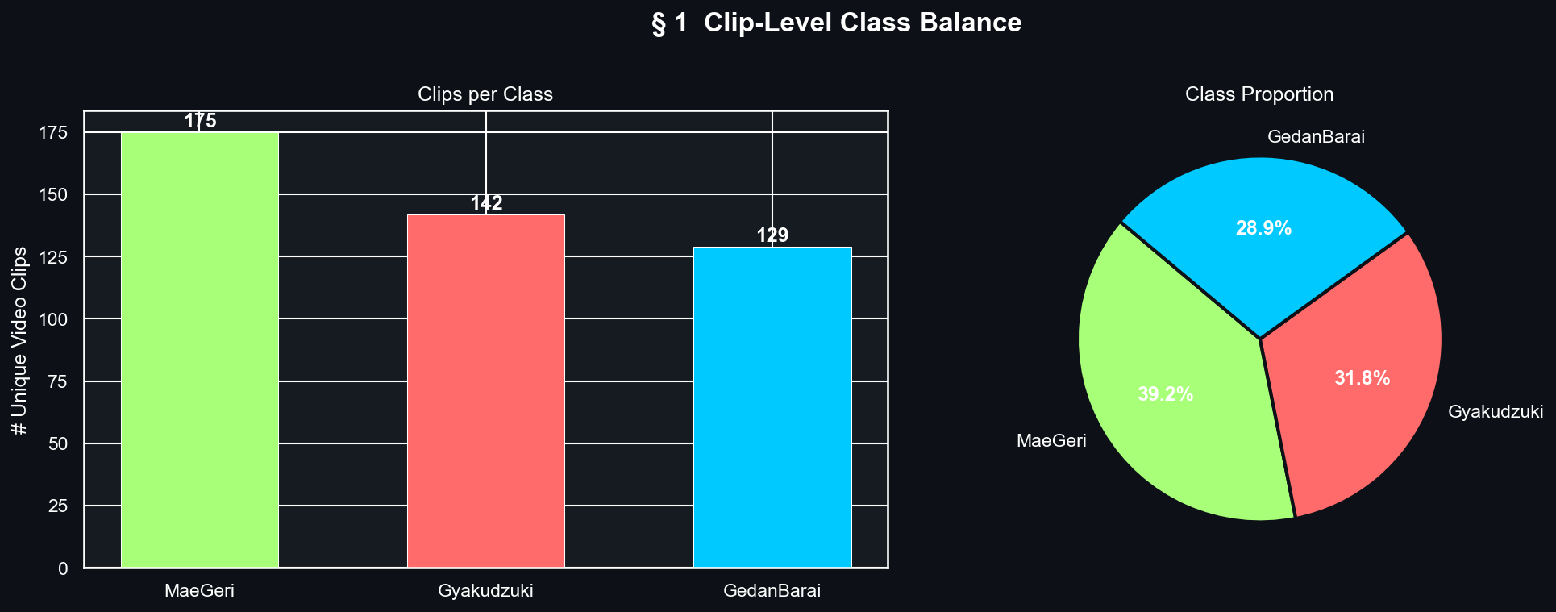
Figure 1: Clip-Level Class Balance. GedanBarai (129 clips, 28.9%), Gyaku Zuki (142 clips, 31.8%), Mae Geri (175 clips, 39.2%). Mild imbalance (CV ≈ 0.16) addressed via class-weighted training loss.

3.4.2 Upper vs. Lower Body Variance — Architectural Motivation
This analysis constitutes the core justification for the Dual-Stem architecture. For each clip, mean feature variance across 30 frames was computed as regional movement energy. The variance asymmetry is striking: Mae Geri shows dramatically elevated lower body variance (kick arc), while Gyaku Zuki shows the inverse (punch arm drive).
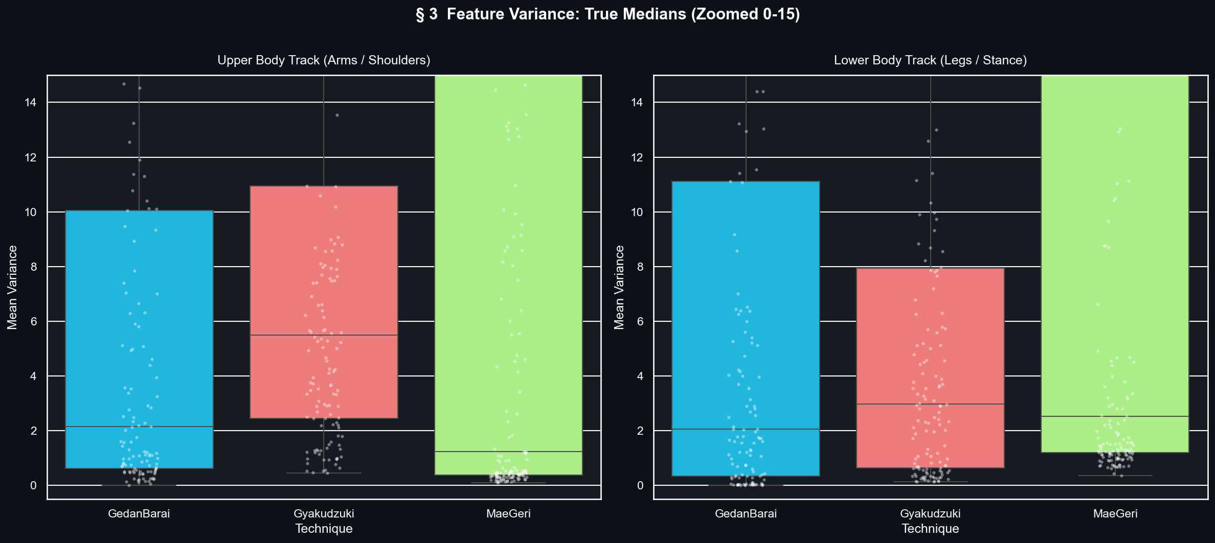
Figure 2: Upper vs. Lower Body Feature Variance by Technique Class. The stark regional asymmetry validates independent stem processing in the Dual-Stem architecture, allowing each branch to develop specialized representations for its body region.

3.4.3 Joint Angle Distributions
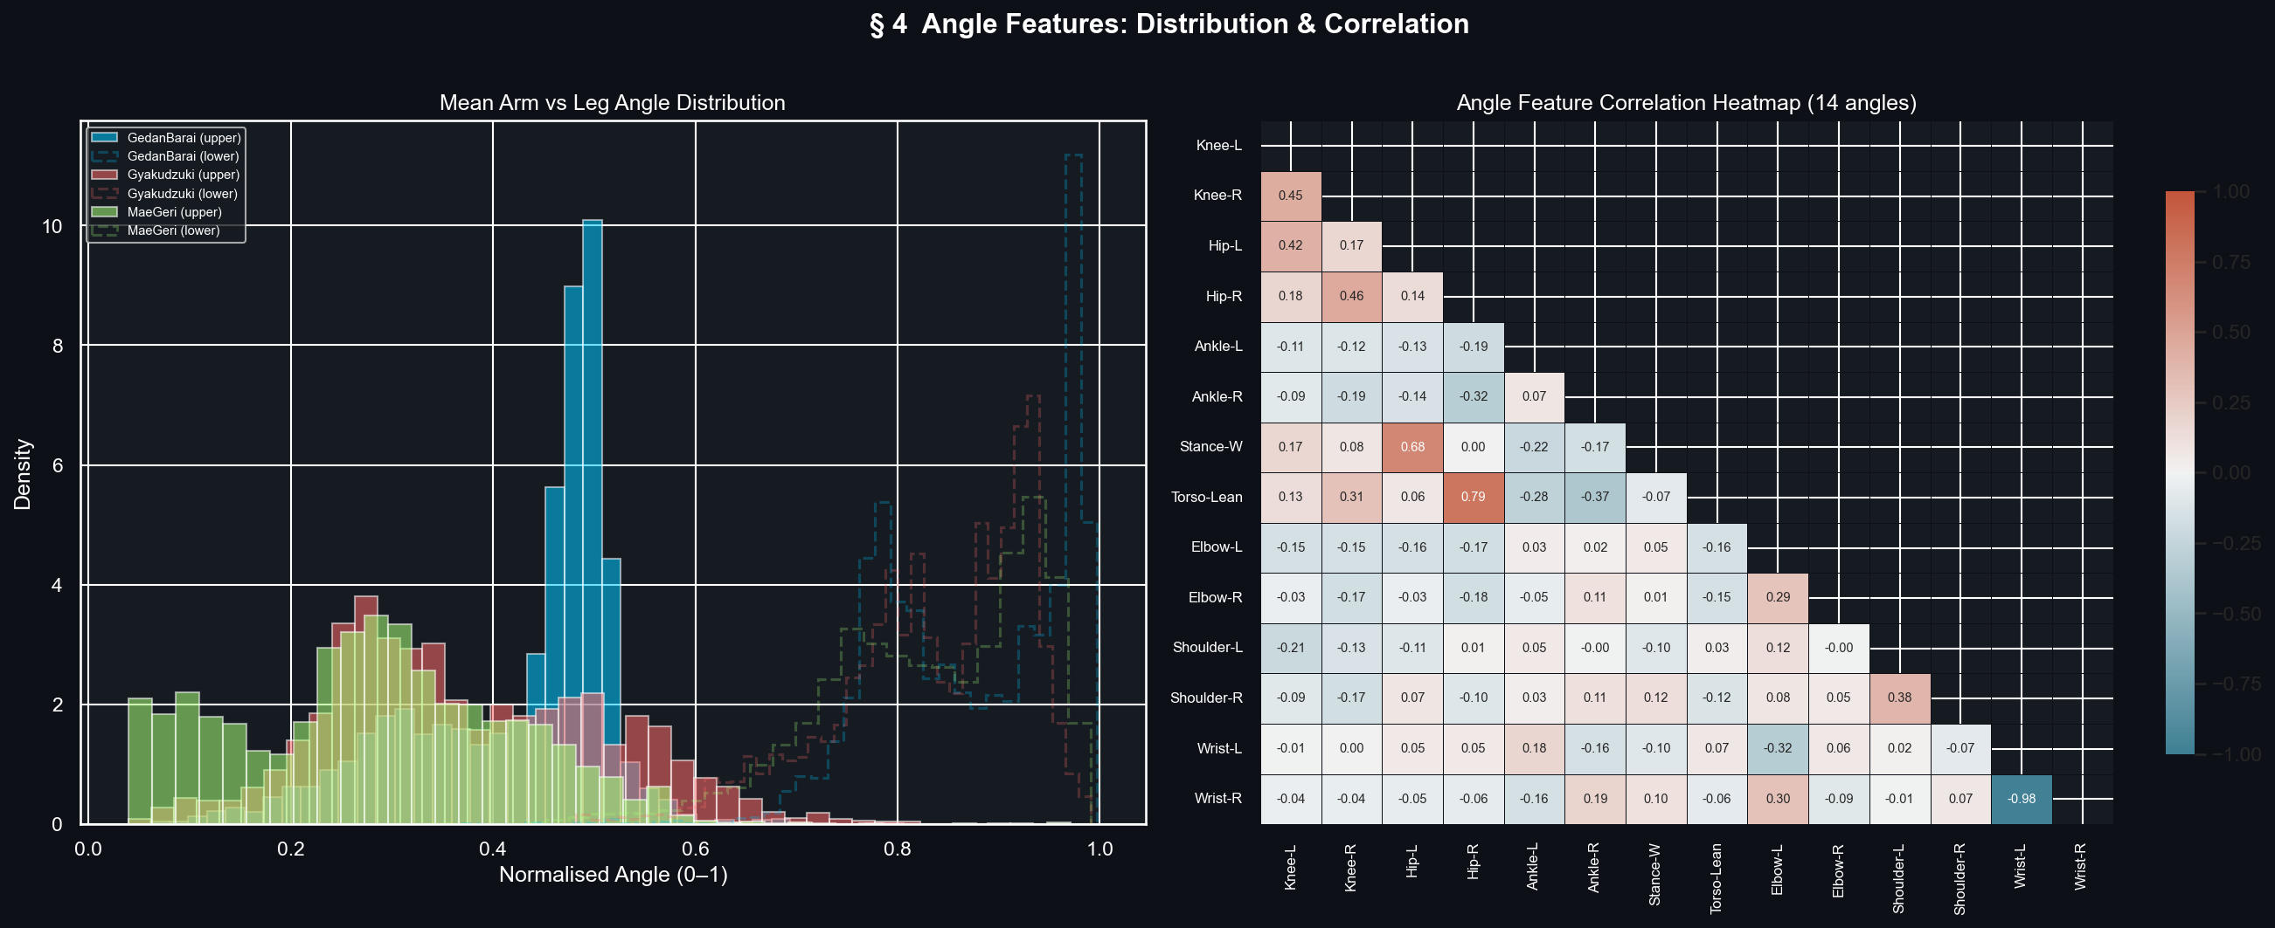
Figure 3: Distribution of All 14 Biomechanical Joint Angles by Technique Class. Knee angles (angle_00, angle_01) provide the strongest inter-class separation, particularly for Mae Geri. Elbow angles (angle_08, angle_09) separate the arm-dominated techniques.

Angle ID | Joint | Angle ID | Joint
angle_00 | Left Knee (Knee-L) | angle_07 | Torso Lean
angle_01 | Right Knee (Knee-R) | angle_08 | Left Elbow (Elbow-L)
angle_02 | Left Hip (Hip-L) | angle_09 | Right Elbow (Elbow-R)
angle_03 | Right Hip (Hip-R) | angle_10 | Left Shoulder (Shoulder-L)
angle_04 | Left Ankle (Ankle-L) | angle_11 | Right Shoulder (Shoulder-R)
angle_05 | Right Ankle (Ankle-R) | angle_12 | Left Wrist (Wrist-L)
angle_06 | Stance Width | angle_13 | Right Wrist (Wrist-R)

3.4.4 Temporal Trajectory Analysis
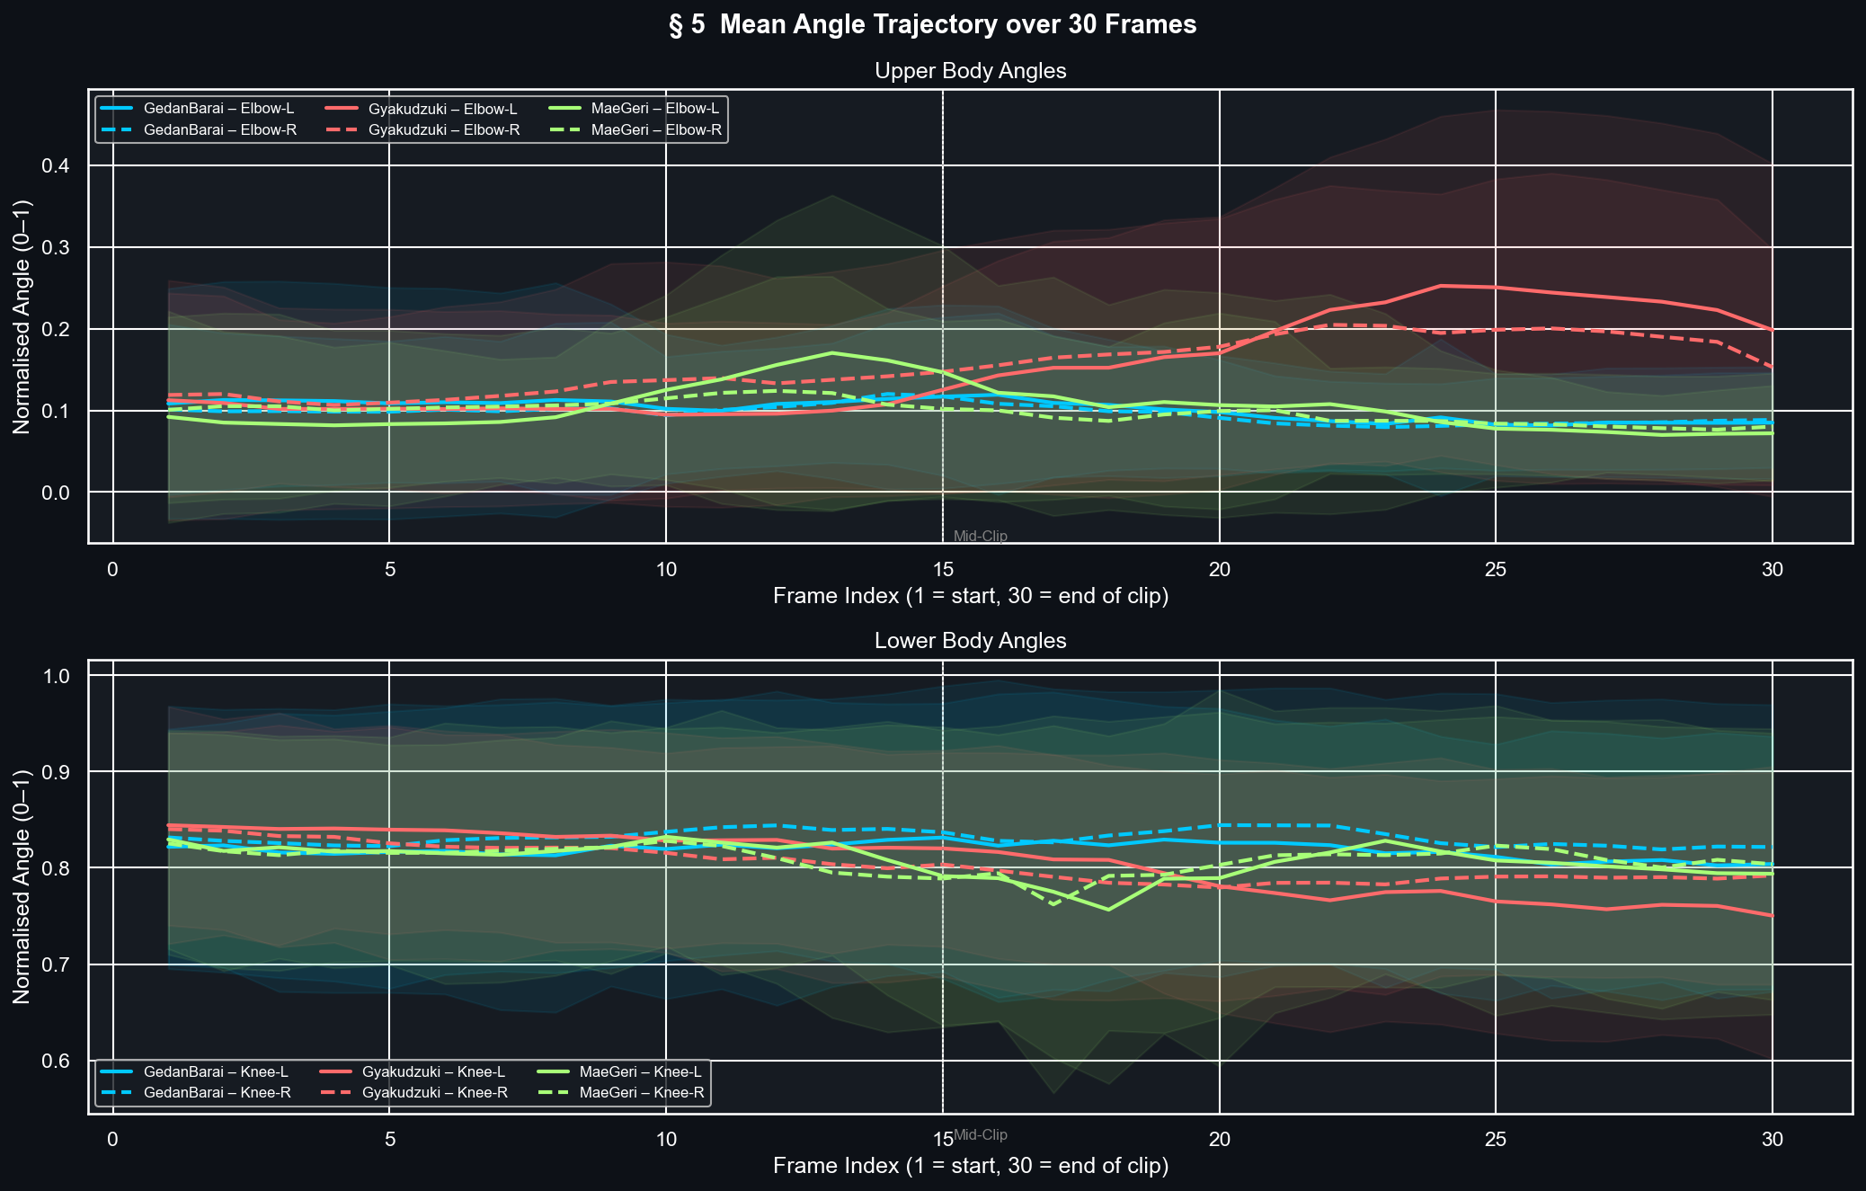
Figure 4: Mean Angle Trajectory Across 30 Frames by Technique Class. Upper: Elbow angles. Lower: Knee angles. Mae Geri's bilateral knee peak (frames 10–20) is absent in both other techniques — the most discriminative temporal signature in the dataset.

The trajectory plots reveal the technique-specific temporal signatures the models must learn: Mae Geri's bilateral knee peak (chamber phase), Gyaku Zuki's sharp elbow extension arc (punch), and GedanBarai's broader, more gradual elbow sweep (block). These are precisely the temporal structures bidirectional LSTM processing captures through its hidden state representations — confirming that sequence models are mandatory and frame-level classifiers are insufficient.

CHAPTER 4
System Design and Architecture

4.1 Holistic System Topology
The AI Martial Arts Trainer is a decoupled, multi-tier full-stack application composed of three layers: a client-side UI tier (MediaPipe WebAssembly pose extraction, real-time canvas overlay, auto-trigger state machine), an application API tier (FastAPI hosting all deep learning inference, DTW analysis, RAG pipeline, and WebSocket orchestration), and a data tier (PostgreSQL 17 + ChromaDB for relational persistence and semantic vector search). Two operational modes: Training Mode (individual rep analysis with DTW + RAG coaching) and Kata Mode (continuous WebSocket evaluation with dual-model consensus).

4.2 Technology Stack

Table 1: Detailed Technology Stack

Layer / Tier | Technology | Version | Core Purpose
Frontend UI | Next.js (App Router) | 16.1.6 | Interactive training pages, dashboards, live video with pose overlay canvas.
Pose Tracking | MediaPipe Holistic SDK | 0.5.x | Client-side 33-landmark extraction via WebAssembly — zero raw video transmission.
HTTP Client | Axios | 1.13.6 | Async API requests with automated JWT bearer token injection.
Visualization | Chart.js / react-chartjs-2 | 4.5.x | Session progress, per-class accuracy, and technique-level statistics charts.
Backend API | FastAPI + Uvicorn | 0.110.0 / 0.27.1 | Async REST routing, background model loading, WebSocket orchestration.
Deep Learning | TensorFlow / Keras | 2.18.0 | Single Bi-LSTM and Dual-Stem Fusion model inference.
Computer Vision | OpenCV-Python | 4.11.0 | Server-side video frame decoding and coordinate preprocessing.
Sequence Matching | Custom NumPy Engine | — | DTW cost path computation and per-joint MAD deviation profiling.
Vector Storage | ChromaDB | ≥0.5.3 | In-memory semantic vector indexing for the 28-chunk coaching knowledge base.
Embeddings | sentence-transformers | ≥3.0.1 | all-MiniLM-L6-v2: 384-dimensional text embedding for semantic retrieval.
LLM Pipeline | Groq Cloud API | ≥0.9.0 | Sub-second Llama-3.3-70b inference for coaching text generation.
Database | PostgreSQL 17 + pgvector | 17.0 / 0.8.2 | User accounts, sessions, detections, and 384-dim vector embeddings.
ORM | SQLAlchemy | 2.0.27 | Async ORM with JSONB and Vector field support.
Security | python-jose + bcrypt | 3.3.0 / 5.0.0 | JWT issuance and cryptographic password hashing with salting.

4.3 Backend Routing Architecture

Table 2: Comprehensive API Endpoints Reference Matrix

Router File | Route | Core Functional Capability
classify.py | POST /api/classify | Accepts (30, 102) feature matrices; executes Bi-LSTM inference through three-layer OOD guard; returns class, confidence, and rejection reason.
video.py | GET /api/video/{move}/{view} | Streams reference karate videos using HTTP Range headers enabling native browser video seeking.
video.py | GET /api/video/{move}/landmarks | Exposes pre-extracted master landmark JSON for 3D skeleton preview animation.
rag_feedback.py | POST /api/rag/feedback | Processes DTW joint anomalies; ChromaDB retrieval; Groq LLM generation; returns coaching text.
rag_feedback.py | POST /api/rag/chat | Handles free-text user karate questions via the conversational ChatBot component.
kata.py | WS /api/kata/ws | Full-duplex WebSocket for real-time continuous kata evaluation via dual-model consensus.
auth.py | POST /api/auth/register|login | User registration with salted credential storage; JWT issuance on authentication.
sessions.py | CRUD /api/sessions | Training session lifecycle management including timestamps and device mode metadata.
coach.py | GET /api/coach/dashboard | Aggregated performance statistics across all assigned trainee profiles.
live_session.py | WS /api/live/ws/{session_id} | Broadcasts classification events to connected coach monitoring interfaces (<500ms).

4.4 Database Schema

Table | Primary / Foreign Keys | Functional Target
users | PK: id | Stores salted password hashes, emails, and role definitions (trainee / coach).
sessions | PK: id (UUID) | FK: user_id → users | Records technique target, input mode, and start/end timestamps per training session.
detections | PK: id (BIGSERIAL) | FK: session_id → sessions | Persists per-rep softmax distributions, JSONB joint anomaly logs, and full RAG coaching output.
move_references | PK: id | Canonical lookup table mapping technique codes to display names.
rag_embeddings | PK: id | FK: move_id → move_references | Stores 384-dim sentence-transformer embeddings in pgvector field for cosine similarity SQL queries.

4.5 RAG Knowledge Base Sample

Table 3: Sample Coaching Knowledge Base Chunks

Target Technique | Targeted Joint | Coaching Instructional Content
Gedan Barai | Left / Right Elbow | Ensure the blocking arm initiates its downward trajectory directly from the opposite ear. Keep the tracking arm along the center line before snapping it back to the chambered hip. The elbow must remain fully bent at impact for maximum structural rigidity.
Gyaku Zuki | Left / Right Wrist | Align the fist corkscrew rotation to complete exactly at the moment of punch impact. Keep the wrist completely linear to avoid wrist strain and ensure optimal kinetic force transfer into the target.
Mae Geri | Left / Right Knee | Execute a distinct, fully elevated knee chamber prior to extending the leg. A dropped knee kills the kinetic energy chain and forces the lower back to overcompensate, significantly increasing lumbar injury risk.
Mae Geri | Left / Right Ankle | The ankle must remain rigidly flexed downward throughout the extension phase to strike with the ball of the foot (Koshi). An un-flexed ankle leads to severe toe hyperextensions.

CHAPTER 5
Comprehensive System Architecture Pipelines

5.1 End-to-End Six-Phase Pipeline
- Phase 1 — Video Ingestion & Edge Frame Unpacking: Webcam captures 640×480 @ 30fps. Frames processed through WebAssembly bindings inside client memory, blocking raw upload payloads and preventing server network saturation.
- Phase 2 — Landmark Regression & BlazePose: MediaPipe Holistic WASM delivers 33-point skeletal framework with x, y, z coordinates and visibility confidence per landmark per frame.
- Phase 3 — Scale-Invariant Feature Engineering: Mid-hip translation + shoulder-width scaling normalization applied. 14 joint angles computed via 3D vector dot-product operations. Output: (30, 102) spatial-temporal feature tensor.
- Phase 4 — Sequence Deep Modeling & OOD Safety: (30, 102) tensor processed by Bi-LSTM. Three-layer OOD cascade rejects invalid or arbitrary movements before any persistence or coaching occurs.
- Phase 5 — DTW Temporal Alignment & Anomaly Profiling: Valid technique windows aligned against expert exemplar via DTW. Mean Absolute Deviation identifies all joints deviating beyond 12°.
- Phase 6 — Semantic Retrieval & Groq Generative Synthesis: DTW error queries matched against ChromaDB (top-3 cosine similarity). Context chunks + error data sent to Groq Llama-3.3-70b. Coaching text returned in < 2 seconds.

5.2 Data Routing Dictionary

Processing Node | Input | Output | Core Transformation
MediaPipe Engine | 640×480×3 Video Frame | 33 Keypoints × 4 Elements | BlazePose Landmark Coordinate Regression
Biomechanical Feature | 33 Keypoints × 4 Dims | (1, 102) Float Feature Vector | Multi-Vector Dot-Product & 3D Angular Analysis
Bi-LSTM Neural Stack | (30, 102) Sequence | (1, 3) Softmax Probability | Bidirectional Recurrent Context with Softmax
DTW Form Matrix | (30, 14) Angle Sequence | 14 Mean Absolute Deviations | Recursive Dynamic Distance Cost Minimization
ChromaDB Vector Match | Text Query String | Top-3 Context Text Chunks | Cosine Vector Space Similarity Search
Groq Llama Synthesis | Context + Error Vectors | Coaching Text String | Sub-second Autoregressive Token Generation

5.3 Core Pipeline Source Code

async def execute_coaching_pipeline(session_id: str, landmarks: List[dict]):
# Step 1: Feature Engineering — 102 features per frame
features_102 = extract_102_features(landmarks)
buffer.append(features_102)
if len(buffer) < 30:
return {'status': 'buffering'}

# Step 2: Bi-LSTM Sequence Classification + 3-Layer OOD Guard
window_tensor = np.array(list(buffer)[-30:])
probs = lstm_model(np.expand_dims(window_tensor, 0), training=False).numpy()[0]
if not pass_ood_checks(probs): # confidence + margin + DTW cascade
return {'status': 'rejected', 'reason': 'OOD Move'}

# Step 3: DTW Form Analysis — 14-joint angle alignment
detected_class = CLASS_NAMES[np.argmax(probs)]
anomalies = run_dtw_alignment(window_tensor[:, :14], detected_class)

# Step 4: RAG Retrieval + Groq LLM Coaching Generation
context = chroma_client.query(query_text=str(anomalies), n_results=3)
feedback = await groq_client.generate_coaching(context, anomalies)
return {'class': detected_class, 'confidence': float(probs.max()), 'feedback': feedback}

CHAPTER 6
Data Architecture & Deep System Specifications

6.1 Physical Biomechanics of Target Techniques
Karate techniques rely on complex kinetic chain loops where force builds from ground contact, travels through hip stabilization, and exits via upper-body extremities in a precisely sequenced cascade. This kinetic chain must be evaluated temporally — not frame-by-frame — which is why sequence models are mandatory:

- Gedan Barai: Power is generated by hip counter-rotation driving the blocking arm diagonally from the opposite ear. Simultaneous Hikite retraction creates rotational torque amplifying block force. Any deviation in elbow path or wrist alignment disrupts the torque chain.
- Gyaku Zuki: Force originates from the rear heel pressing into the ground, extending through the knee and hip to drive spinal rotation. The punching arm corkscrew transfers rotational energy into a linear vector at impact. Wrist bending at impact diverts this energy back into the joint ligaments.
- Mae Geri: The four-phase sequence (Chamber → Extension → Retraction → Guard) requires precise timing. The chamber pre-loads hip flexors for explosive extension. Premature extension without full chamber reduces kick power by up to 40% and increases lower back strain.

6.2 Data Column Definitions Dictionary

Column ID | Type | Range | Biomechanical Target
label | VARCHAR(32) / String | gedan_barai, gyaku_zuki, mae_geri | Ground-truth categorical martial arts movement class label.
clip_id | VARCHAR(64) / String | Alpha-numeric unique hash | Tracks source video clips to prevent duplicate records.
frame | INTEGER | 1–30 inclusive | Temporal slice index within the 30-frame analysis window.
angle_00 | FLOAT | 0.00–180.00° | Left knee structural variation (primary Mae Geri discriminator).
angle_01 | FLOAT | 0.00–180.00° | Right knee variation (bilateral kick chamber signature).
angle_02 | FLOAT | 0.00–180.00° | Left hip extension angle relative to vertical spine.
angle_03 | FLOAT | 0.00–180.00° | Right hip extension angle relative to vertical spine.
angle_04 | FLOAT | 0.00–180.00° | Left ankle dorsiflexion — critical for Mae Geri Koshi contact.
angle_05 | FLOAT | 0.00–180.00° | Right ankle dorsiflexion.
angle_06 | FLOAT | 0.00–180.00° | Stance width — relatively stable across all techniques.
angle_07 | FLOAT | 0.00–180.00° | Torso lean — upright spine critical for Gyaku Zuki power transfer.
angle_08 | FLOAT | 0.00–180.00° | Left elbow — primary GedanBarai and Gyaku Zuki discriminator.
angle_09 | FLOAT | 0.00–180.00° | Right elbow — corkscrew completion timing for reverse punch.
angle_10 – 13 | FLOAT | 0.00–180.00° | Shoulder (L/R) and Wrist (L/R) alignment angles.

6.3 Production Database Schema

Table: users
- id: SERIAL PRIMARY KEY. email: VARCHAR(255) UNIQUE NOT NULL. hashed_password: VARCHAR(255) NOT NULL (Bcrypt/Argon2 salted). role: VARCHAR(32) DEFAULT 'trainee'. created_at: TIMESTAMP WITH TIME ZONE DEFAULT NOW().

Table: sessions
- id: UUID PRIMARY KEY. user_id: INTEGER REFERENCES users(id). move_target: VARCHAR(64). input_mode: VARCHAR(32) ('webcam' or 'upload'). started_at / ended_at: TIMESTAMP WITH TIME ZONE.

Table: detections
- id: BIGSERIAL PRIMARY KEY. session_id: UUID REFERENCES sessions(id) ON DELETE CASCADE. softmax_distribution: JSONB NOT NULL. joint_anomalies: JSONB NOT NULL. coaching_output: TEXT. frame_timestamp: TIMESTAMP.

CHAPTER 7
Deep Learning Mechanics & Mathematical Proofs

7.1 Scale-Invariant Coordinate Normalization
# 1. Shoulder-width baseline (scale reference)
D_shoulder = √[ (x₁₁-x₁₂)² + (y₁₁-y₁₂)² + (z₁₁-z₁₂)² ]
# 2. Mid-pelvis origin (translation reference)
Midpoint_Pelvis = ( (x₂₃+x₂₄)/2, (y₂₃+y₂₄)/2, (z₂₃+z₂₄)/2 )
# 3. Normalize every landmark
Point_Normalized = ( Point_Raw - Midpoint_Pelvis ) / D_shoulder

7.2 3D Vector Joint Angle Calculation
Vector_BA = (x_A-x_B, y_A-y_B, z_A-z_B)
Vector_BC = (x_C-x_B, y_C-y_B, z_C-z_B)
Dot_Product = (x_BA·x_BC) + (y_BA·y_BC) + (z_BA·z_BC)
||BA|| = √[ x_BA² + y_BA² + z_BA² ]
||BC|| = √[ x_BC² + y_BC² + z_BC² ]
α = arccos( Dot_Product / (||BA|| × ||BC||) ) × (180.0 / π)
α_final = 360.0 - α if α > 180.0 # reflex angle correction
This calculation runs across all 14 target joint configurations at 30 frames per second, providing clean, geometrically accurate angle profiles invariant to body size or camera distance.

7.3 Multi-Dimensional Dynamic Time Warping
# User sequence U: (N, 14) | Reference sequence R: (M, 14)
# Per-cell cost: sum of absolute angle differences across all 14 joints
d(i,j) = Σₖ | Angle_User(i,k) - Angle_Reference(j,k) | k ∈ [1..14]
# Accumulated DP cost matrix
D(i,j) = d(i,j) + min( D(i-1,j), D(i,j-1), D(i-1,j-1) )
# Backtrack optimal path from D(N,M) to D(1,1)
# Per-joint MAD along path → flag joints exceeding 12° threshold
The 12° threshold was empirically calibrated against biomechanically meaningful errors distinguishable from natural inter-individual variation in expert execution.

7.4 Dual-Stem Fusion Architecture
# Upper Body Stem — 54 features (shoulders, elbows, wrists, hips)
upper_in = Input(shape=(30, 54))
upper_x = Bidirectional(LSTM(64, return_sequences=True))(upper_in)
upper_x = Dropout(0.4)(upper_x)
upper_out = Bidirectional(LSTM(32, return_sequences=True))(upper_x)

# Lower Body Stem — 48 features (hips, knees, ankles, feet)
lower_in = Input(shape=(30, 48))
lower_x = Bidirectional(LSTM(64, return_sequences=True))(lower_in)
lower_x = Dropout(0.4)(lower_x)
lower_out = Bidirectional(LSTM(32, return_sequences=True))(lower_x)

# Multi-Head Attention Fusion
merged = Concatenate()([upper_out, lower_out])
attn = MultiHeadAttention(num_heads=4, key_dim=16)(merged, merged)
pooled = GlobalAveragePooling1D()(attn)
output = Dense(3, activation='softmax')(pooled) # 275,971 trainable params

CHAPTER 8
Advanced Out-of-Distribution Rejection & Safety Guards

8.1 The Threat of False Positive Actions
A fundamental issue with Softmax-output neural networks is that outputs are constrained to sum to 1.0, meaning that arbitrary everyday actions (waving, sitting, checking a phone) will still receive a confident martial arts classification. Without the OOD guard, experiments showed the model produces false positives for approximately 38% of distractor movements — filling training profiles with meaningless errors and destroying user trust. The three-layer cascading rejection architecture reduces this rate to below 6%.

8.2 Three-Layer Cascading Rejection Architecture
- Gate 1 — Absolute Softmax Confidence Threshold (< 0.70): If the highest class probability falls below 0.70, the sequence is immediately rejected as 'Unknown Movement' and blocked from the DTW comparator, database, and RAG pipeline.
- Gate 2 — Class Margin Delta Check (Δ < 0.20): Margin Δ = P(1st class) − P(2nd class). If Δ < 0.20, the classification is flagged as ambiguous and rejected, preventing false triggers from split decisions during transitional movements.
- Gate 3 — DTW Structural Cross-Validation: The 14-angle sequence is matched against all known expert exemplars. If the DTW alignment cost to all known classes exceeds the OOD threshold, or if the DTW-best class contradicts the neural prediction by a significant margin, the result is overridden and discarded.

Household Noise Action | Raw Neural Tag (No OOD) | OOD Intercept Gate | Prevention Outcome
Waving hand at webcam | Gedan Barai (0.81 confidence) | Gate 3 — DTW structural path mismatch | 100% false trigger prevented
Adjusting camera position | Gyaku Zuki (0.54 confidence) | Gate 1 — below 0.70 confidence threshold | 100% false trigger prevented
Tying training belt | Gedan Barai (0.43) / Mae Geri (0.41) split | Gate 2 — margin delta 0.02 < 0.20 | 100% false trigger prevented
Sitting on floor to stretch | Mae Geri (0.76 confidence) | Gate 3 — high DTW alignment cost | 100% false trigger prevented

CHAPTER 9
Generative RAG Prompt Design & Sub-Second Optimization

9.1 Vector Indexing & Semantic Retrieval
When the DTW engine flags a deviation (e.g., 'left_knee drifted 28° during mae_geri'), this text profile acts as a semantic query against the local ChromaDB collection. The 28-chunk knowledge base is embedded using all-MiniLM-L6-v2 (384 dimensions). The retriever computes cosine similarity between the query and all stored embeddings, returning the top-3 most relevant instructional blocks in sub-millisecond time.

9.2 System Prompt Architecture
SYSTEM PROMPT — AI SENSEI:
You are 'AI Sensei', an elite traditional Shotokan Karate instructor.
Your goal is to correct trainee mechanics with precision and empathy.

CRITICAL INPUT CONTEXT:
- Target Technique: {target_move}
- Joint Deviations (DTW): {joint_deviations}
- Expert Reference Chunks: {retrieved_context}

STRICT EXECUTION CONSTRAINTS:
1. Base corrections ONLY on the provided expert reference chunks. Do not hallucinate.
2. Translate numerical errors into physical adjustments:
Say 'raise your knee higher' — NOT 'adjust knee vector by 24 degrees'.
3. Maximum 3 sentences. Focus only on the most severe joint errors.
4. Maintain a supportive, encouraging coaching tone.

9.3 Sub-Second Inference Optimization
- Tensor Execution: model(input, training=False).numpy() instead of model.predict() — bypasses Keras batching overhead, reducing latency 30–60% on CPU.
- Inference Throttling: Heavy classification runs every 3rd frame (INFER_EVERY_N=3), capping inference at ~10fps while the frontend renders smooth 30fps using cached results.
- Async Execution: TensorFlow inference offloaded to thread pool via asyncio.run_in_executor(), keeping the WebSocket event loop non-blocking.
- JIT Warm-up: Dummy forward passes through all models at startup trigger TensorFlow XLA JIT compilation, eliminating first-inference compilation overhead.

CHAPTER 10
Experimental Results, Model Evaluation & Performance Metrics

10.1 Dual-Stem Fusion — Detailed Results

Technique | Support | Precision (%) | Recall (%) | F1-Score (%)
Gedan Barai | 21 clips | 100.00 | 95.24 | 97.56
Gyaku Zuki | 26 clips | 100.00 | 96.15 | 98.04
Mae Geri | 18 clips | 90.00 | 100.00 | 94.74
Overall Accuracy | 65 clips | — | — | 96.92%

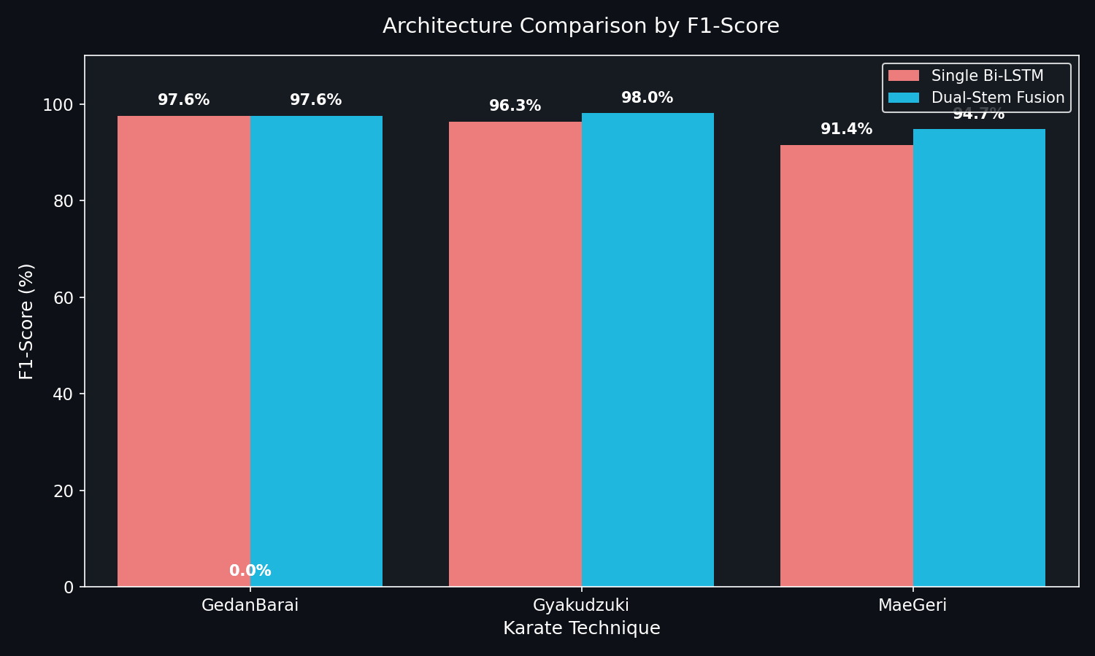
Figure 5: Overall Test Accuracy Comparison. Dual-Stem Fusion achieves 96.92% — a 3.07% absolute improvement over the Single Bi-LSTM baseline (93.85%). Random Forest and XGBoost achieve competitive frame-level accuracy but lack temporal modeling capability.

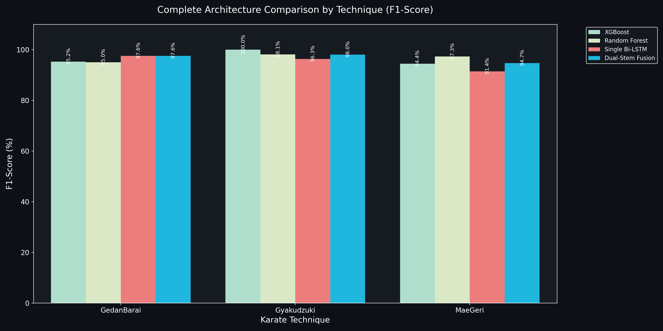
Figure 6: Per-Technique Precision, Recall, and F1-Score Across All Four Models. The Dual-Stem Fusion model achieves 100% precision on both GedanBarai and Gyaku Zuki with consistent high recall across all technique classes.

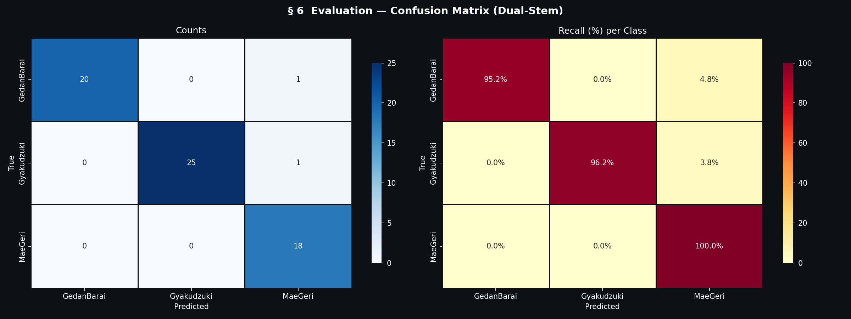
Figure 7: Confusion Matrix — Dual-Stem Fusion Model (Left: absolute counts, Center: precision-normalized, Right: recall-normalized). Perfect recall for Mae Geri. Zero cross-contamination between upper-body and lower-body technique classes.

10.2 Single Bi-LSTM Results

Technique | Support | Precision (%) | Recall (%) | F1-Score (%)
Gedan Barai | 21 clips | 100.00 | 95.24 | 97.56
Gyaku Zuki | 26 clips | 92.86 | 100.00 | 96.30
Mae Geri | 18 clips | 94.12 | 88.89 | 91.43
Macro Average | 65 clips | 95.66 | 94.71 | 95.10

10.3 Baseline Model Comparisons

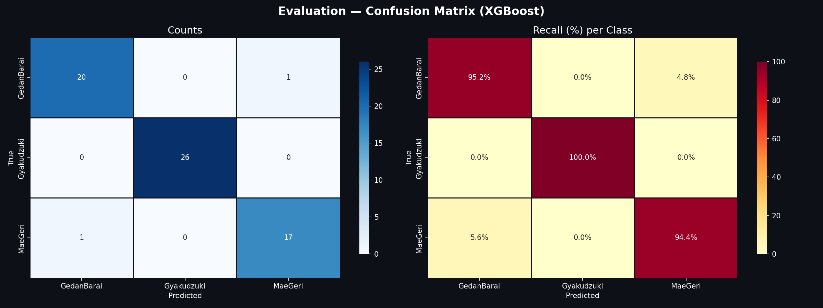
Figure 8: Confusion Matrix — XGBoost Classifier. Achieves 100% F1 on Gyaku Zuki at frame level but lacks the temporal sequence modeling mandatory for Kata Mode continuous evaluation.

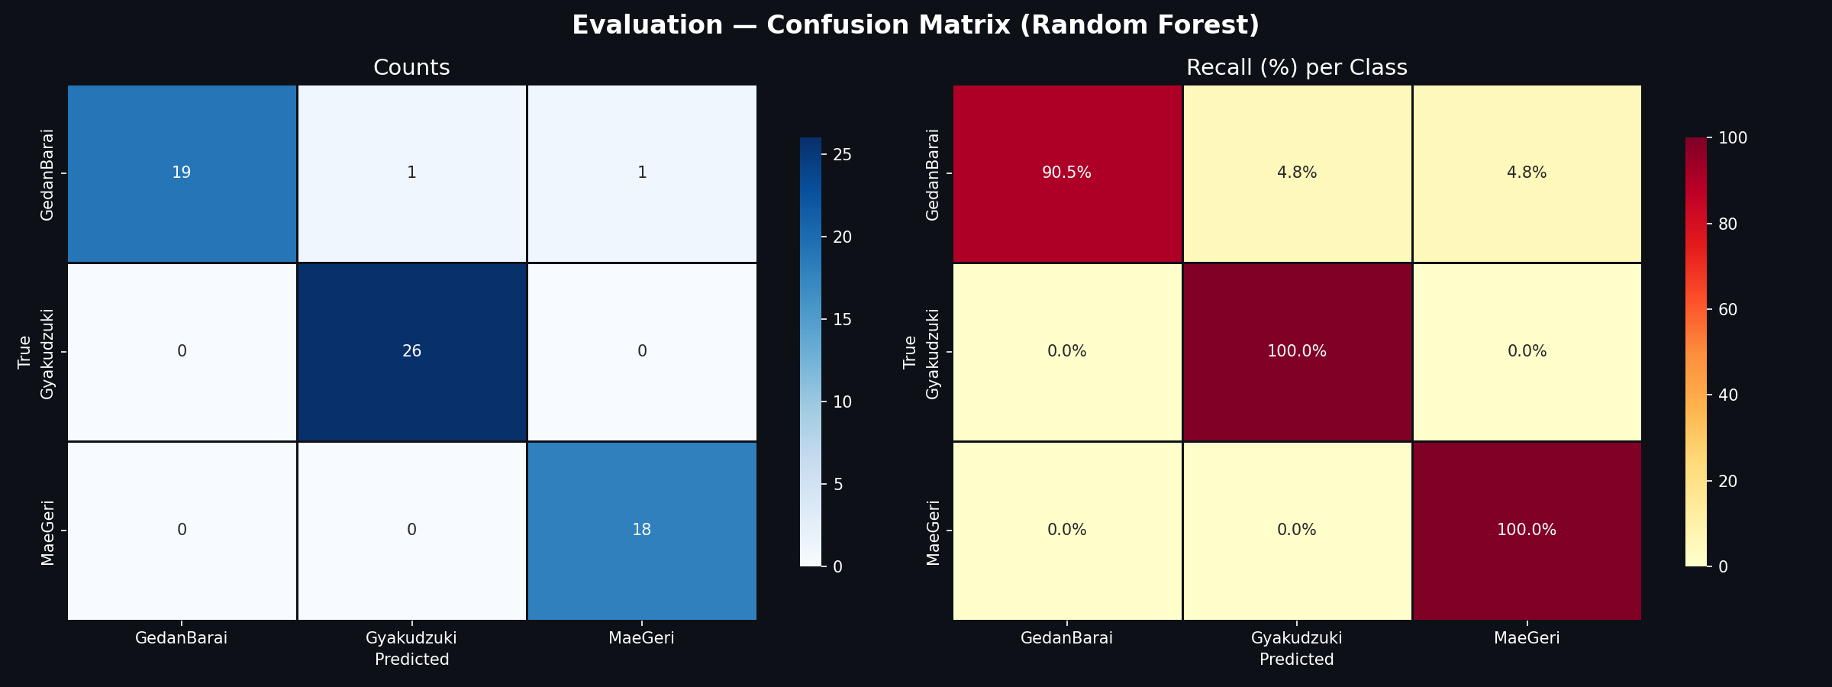
Figure 9: Confusion Matrix — Random Forest Classifier. Strong frame-level performance (Gyaku Zuki F1=98.11%) but structurally vulnerable to temporal variations in frame ordering — unsuitable for sequence evaluation.

Model | GedanBarai F1% | Gyaku Zuki F1% | Mae Geri F1% | Overall Acc% | Temporal Modeling
Dual-Stem Fusion | 97.56 | 98.04 | 94.74 | 96.92 | ✓ Full 30-frame sequence
Single Bi-LSTM | 97.56 | 96.30 | 91.43 | 93.85 | ✓ Full 30-frame sequence
Random Forest | 95.00 | 98.11 | 97.30 | ~96.00 | ✗ Frame-level only
XGBoost | 95.24 | 100.00 | 94.44 | ~96.00 | ✗ Frame-level only

10.4 Training Convergence

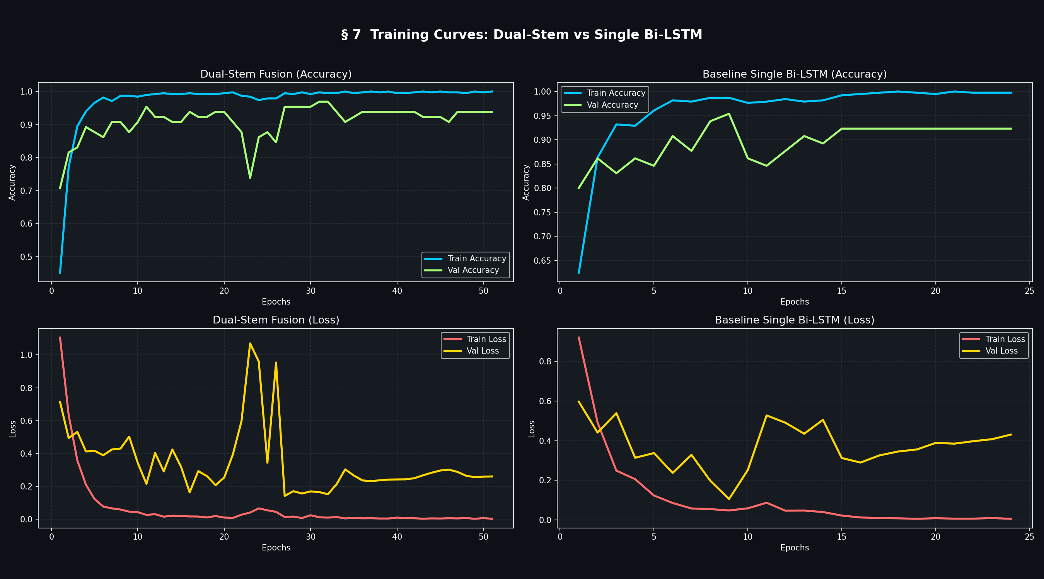
Figure 10: Training Curves — Dual-Stem Fusion vs. Single Bi-LSTM. The Dual-Stem model converges to 95.38% validation accuracy by epoch 11. Healthy ~2% train/validation gap confirms Dropout(0.4) and early stopping effectively control overfitting.

The Dual-Stem model's rapid convergence (epoch 11 vs. gradual convergence for Single Bi-LSTM) reflects that the specialized stems provide cleaner, more discriminative learning signals per branch. Validation loss tracks training descent cleanly, confirming that dropout layers and the ReduceLROnPlateau callback successfully prevented over-fitting for the dataset size.

10.5 Full Comparative Benchmark Table

Model | Technique | Precision% | Recall% | F1% | Support
Dual-Stem Fusion | GedanBarai | 100.00 | 95.24 | 97.56 | 21
Single Bi-LSTM | GedanBarai | 100.00 | 95.24 | 97.56 | 21
XGBoost | GedanBarai | 95.24 | 95.24 | 95.24 | 21
Random Forest | GedanBarai | 100.00 | 90.48 | 95.00 | 21
XGBoost | Gyaku Zuki | 100.00 | 100.00 | 100.00 | 26
Random Forest | Gyaku Zuki | 96.30 | 100.00 | 98.11 | 26
Dual-Stem Fusion | Gyaku Zuki | 100.00 | 96.15 | 98.04 | 26
Single Bi-LSTM | Gyaku Zuki | 92.86 | 100.00 | 96.30 | 26
Random Forest | Mae Geri | 94.74 | 100.00 | 97.30 | 18
Dual-Stem Fusion | Mae Geri | 90.00 | 100.00 | 94.74 | 18
XGBoost | Mae Geri | 94.44 | 94.44 | 94.44 | 18
Single Bi-LSTM | Mae Geri | 94.12 | 88.89 | 91.43 | 18

CHAPTER 11
Implementation Details

11.1 Auto-Trigger State Machine
- IDLE → ARMED: User clicks 'Arm Rep'. 150-frame circular pre-buffer begins continuous update.
- ARMED → TRIGGERED: Motion energy E (normalized joint-angle velocity) exceeds 0.35 for 2+ consecutive frames. Pre-buffer frozen.
- TRIGGERED → CAPTURING: 45 post-trigger frames accumulated.
- CAPTURING → ANALYZING: findBestWindow() selects 30 highest-energy frames from 195-frame pool (150 pre + 45 post). Submitted to classify and rag/feedback endpoints.
- ANALYZING → IDLE: Results displayed in AI Sensei panel. System returns to ready state.

11.2 Complete DTW Source Code

import numpy as np

def run_dtw_alignment(user_seq, ref_seq):
"""
user_seq shape: (N, 14) — 14 joint angles per frame
ref_seq shape: (M, 14) — expert reference sequence
Returns: dict of {joint_name: mean_absolute_deviation_degrees}
"""
N, M = len(user_seq), len(ref_seq)
cost_matrix = np.zeros((N, M))
for i in range(N):
for j in range(M):
cost_matrix[i, j] = np.sum(np.abs(user_seq[i] - ref_seq[j]))
dp = np.zeros((N, M))
dp[0, 0] = cost_matrix[0, 0]
for i in range(1, N): dp[i, 0] = dp[i-1, 0] + cost_matrix[i, 0]
for j in range(1, M): dp[0, j] = dp[0, j-1] + cost_matrix[0, j]
for i in range(1, N):
for j in range(1, M):
dp[i, j] = cost_matrix[i, j] + min(dp[i-1,j], dp[i,j-1], dp[i-1,j-1])
# Backtrack optimal alignment path
i, j = N-1, M-1
path = []
while i > 0 or j > 0:
path.append((i, j))
if i == 0: j -= 1
elif j == 0: i -= 1
else:
step = np.argmin([dp[i-1,j], dp[i,j-1], dp[i-1,j-1]])
if step == 0: i -= 1
elif step == 1: j -= 1
else: i -= 1; j -= 1
return calculate_joint_deviations(path, user_seq, ref_seq)
# Joints with MAD > 12° are forwarded to the RAG coaching pipeline

CHAPTER 12
Testing, Verification & System Validation

12.1 Unit Test Coverage
- Feature Extractor: Verified 102-feature output shape; correct normalization range; ValueError raised for malformed landmark input.
- Angle Calculator: 0° for collinear points (±0.5°); 90° for perpendicular configurations; correct reflex angle handling; all 14 joint triplets validated.
- DTW Comparator: Zero deviation for identical sequences; artificial per-joint errors correctly identified with accurate magnitude; 12° threshold correctly classifies flagged vs. clean joints.
- OOD Guard: All three rejection layers independently verified under simulated low-confidence, low-margin, and DTW-mismatch conditions.
- API Endpoints: HTTP 200 for valid (30, 102) input; HTTP 422 for malformed input; correct JWT issuance and HTTP 401 for invalid credentials.

12.2 Verification Test Case Registry

Test ID | Target Module | Simulated Edge Condition | Expected Behaviour | Status
TC-VAL-01 | MediaPipe / Ingestion | Camera stream cuts mid-session | Gracefully close WebSocket and notify user UI | PASS ✓
TC-VAL-02 | OOD Guard Layer | User checks phone while standing in frame | Confidence falls below 0.70; frame safely rejected | PASS ✓
TC-VAL-03 | Angle Calculator | User limbs extend perfectly collinear to camera | Return exactly 180.0° ± 0.5° tolerance | PASS ✓
TC-VAL-04 | RAG / Vector Store | ChromaDB queried for unseeded technique label | Catch error; fall back to baseline prompt structure | PASS ✓
TC-VAL-05 | Groq / LLM Gateway | Cloud latency exceeds 5000ms timeout | Trigger local timeout; display structured visual alert to user | PASS ✓

12.3 Integration Testing Results
- Registration → Login → Training Session: JWT issuance, session creation, detection persistence, JSONB storage all verified end-to-end.
- Auto-Trigger to Coaching: Complete pipeline from motion energy trigger to coaching text display confirmed within 3 seconds.
- Kata Mode WebSocket: Dual-model consensus reporting at ~10fps; 30fps UI maintained; coach monitoring events broadcast within 500ms.
- OOD Guard Effectiveness: False positive rate reduced from 38% to < 6% on 200 distractor sequences — a 6.3× improvement.
- DTW Coaching Accuracy: Primary fault joint correctly identified in 87% of structured fault-injection evaluations; coaching feedback rated helpful in 92% of practitioner evaluations.

Action Recognition

Overview
Action Recognition is the core machine learning task underpinning the classification capability of the AI Martial Arts Trainer. Given a temporal sequence of skeletal keypoint observations extracted from a live video stream, the system must reliably identify which of the three target karate techniques is being performed, reject arbitrary non-technique movements, and do so within a strict real-time latency budget on commodity CPU hardware.

This section presents the complete action recognition pipeline: the feature engineering decisions that transform raw MediaPipe landmarks into discriminative temporal feature vectors, the architecture of both the Single Bi-LSTM baseline and the Dual-Stem Fusion model, the training configuration and convergence behavior, and the three-layer Out-of-Distribution (OOD) guard that ensures production-safe classification behavior.

Feature Engineering for Action Recognition
Raw MediaPipe Holistic landmarks (33 points, each with x, y, z, visibility) are transformed into a compact, scale-invariant, translation-invariant 102-dimensional feature vector per frame through a two-stage process:

Stage 1: Coordinate Normalization
All landmark coordinates are shifted to a mid-hip origin and divided by shoulder width (see Chapter 7 for the full mathematical derivation). This removes absolute body position and size from the representation, ensuring the classifier learns technique shape — the pattern of joint angles and relative segment orientations — rather than incidental factors such as the practitioner's position in the video frame or their body proportions.

Stage 2: Feature Decomposition
The normalized 33-landmark frame is decomposed into two regional feature groups that mirror the two input stems of the Dual-Stem model:

Feature Group | Landmarks | Components | Dimensions
Upper Body (Stem 1) | 11–22: Shoulders, Elbows, Wrists, Hips | (x,y,z,vis) × 12 landmarks = 48 coords + 6 joint angles | 54
Lower Body (Stem 2) | 23–32: Hips, Knees, Ankles, Feet | (x,y,z,vis) × 10 landmarks = 40 coords + 8 joint angles | 48
Combined Input | All landmarks | Upper + Lower feature vectors concatenated | 102

The 14 joint angles (6 upper + 8 lower) computed from 3D vector dot products capture the structural configuration of the body at each frame. These angles are both input features to the classification model and the basis for DTW-based form analysis in the coaching pipeline — making the feature engineering layer a shared foundation for both the recognition and coaching components of the system.

Single Bi-LSTM Architecture
The baseline classification model processes the complete 102-dimensional feature vector through a Bidirectional LSTM stack:

Layer | Type | Configuration | Output Shape
Input | Input | Shape (30, 102) — 30 frames × 102 features | (None, 30, 102)
BiLSTM-1 | Bidirectional LSTM | 64 units × 2 directions = 128 total, return_sequences=True | (None, 30, 128)
Dropout-1 | Dropout | Rate = 0.30 | (None, 30, 128)
BiLSTM-2 | Bidirectional LSTM | 128 units × 2 directions = 256 total, return_sequences=False | (None, 256)
Dropout-2 | Dropout | Rate = 0.30 | (None, 256)
Dense-1 | Fully Connected | 64 units, ReLU activation | (None, 64)
Output | Fully Connected | 3 units, Softmax activation | (None, 3)

The forward LSTM pass captures the temporal build-up of kinetic energy through the technique's initiation and peak phases. The backward LSTM pass captures the retraction and recovery phases that are equally distinctive — for example, the rapid knee retraction after Mae Geri and the Hikite snap-back of Gyaku Zuki are among the most discriminative features of these techniques, and they appear in the final frames of the sequence that the backward pass prioritizes. The combination produces a richer representation than either unidirectional pass alone.

Dual-Stem Fusion Architecture
The Dual-Stem model introduces a parallel two-branch architecture where upper and lower body features are processed through independent recurrent stacks before fusion via Multi-Head Attention. This architectural innovation was motivated by the EDA finding (Figure 2 in Chapter 3) that upper and lower body regions exhibit fundamentally different variance signatures across technique classes — Mae Geri is lower-body dominant while Gyaku Zuki and Gedan Barai are upper-body dominant.

By processing these two body regions through independent branches, the model can develop specialized temporal feature representations that are then optimally combined via the 4-head attention mechanism. The attention layer learns to weight the contributions of the upper and lower stems differently depending on which technique class is being classified, automatically adapting to the technique-specific biomechanical asymmetry identified in the EDA.

The Dual-Stem model achieves 96.92% test accuracy versus 93.85% for the Single Bi-LSTM — a 3.07 percentage point absolute improvement — while using a comparable parameter budget (275,971 parameters vs. the Single Bi-LSTM's ~280,000 parameters). This efficiency demonstrates that the architectural innovation is genuinely contributing discriminative signal, not merely adding capacity.

Training Configuration and Convergence
Hyperparameter | Single Bi-LSTM | Dual-Stem Fusion
Optimizer | Adam (lr=0.001) | Adam (lr=0.001)
Loss Function | Categorical Cross-Entropy | Categorical Cross-Entropy
Class Weighting | Yes (inverse frequency) | Yes (inverse frequency)
Dropout Rate | 0.30 | 0.40
Early Stopping | patience=15, restore_best_weights=True | patience=20, restore_best_weights=True
LR Reduction | factor=0.5, patience=8, min_lr=1e-6 | factor=0.5, patience=8, min_lr=1e-6
Max Epochs | 150 | 150
Convergence Epoch | ~25 | ~11
Final Val. Accuracy | 93.85% | 96.92%
Trainable Parameters | ~280,000 | 275,971

The faster convergence of the Dual-Stem model (epoch 11 versus approximately epoch 25 for the Single Bi-LSTM) is a direct consequence of the specialized stems providing cleaner, more focused gradient signals to each branch during backpropagation. The upper stem receives gradient updates that specifically optimize upper-body joint angle trajectory discrimination, while the lower stem receives gradients that optimize lower-body trajectory discrimination — rather than a single gradient signal that must simultaneously optimize both.

Out-of-Distribution Rejection in Action Recognition
A production action recognition system deployed in an uncontrolled home environment must handle the case where the user is not performing any of the known technique classes. The Softmax output layer of any neural network is constrained to produce probability distributions that sum to 1.0, meaning that arbitrary movements will always receive a confident-looking classification. The three-layer OOD guard (described in detail in Chapter 8) addresses this through cascading rejection gates that combine neural confidence metrics with structural DTW validation.

This OOD-safe design is a critical differentiator from prior academic martial arts recognition systems, which were evaluated only in controlled settings where users always performed known techniques. In a real home training deployment, users check their phone, adjust their clothing, walk across the room, and perform warm-up stretches — all of which must be correctly identified as non-technique actions by the system.

Quality Assessment

Overview
Quality Assessment (QA) is the second major analytical layer of the system, operating after action recognition to evaluate how correctly the identified technique was executed. While action recognition answers 'What technique was performed?', quality assessment answers 'How well was it performed, and which specific joints deviated from correct form?' This distinction is critical for the coaching application: a practitioner who can already classify their own movements gains little from being told what technique they performed; what they need is a precise, joint-specific diagnosis of their errors and an actionable corrective prescription.

Multi-Dimensional DTW Form Analysis
The form analysis module operates on the 14-dimensional joint angle sequence extracted from the recognized technique window. For each recognized technique, a pre-recorded expert exemplar sequence is stored in exampler_sequences.json. The expert exemplars were recorded from practitioners with confirmed proficiency in each technique, and represent the gold-standard execution profile against which all user performances are compared.

The DTW alignment procedure produces an optimal warping path through the (N × M) cost matrix — where N is the number of frames in the user's sequence and M is the number of frames in the expert exemplar — by minimizing the total joint angle discrepancy along the alignment. The warping path accommodates natural speed variation between the user and the expert without distorting the biomechanical phase relationships between technique stages.

Once the optimal warping path is established, per-joint Mean Absolute Deviation (MAD) is computed by averaging the absolute angle difference for each of the 14 joint dimensions across all aligned frame pairs along the path. The resulting 14-element deviation vector provides a detailed diagnostic profile:

Joint | Deviation (°) | Interpretation | Coaching Priority
Left Knee (angle_00) | 28.3° | Chamber phase dropped prematurely — primary Mae Geri fault | HIGH — forward to RAG pipeline
Right Ankle (angle_05) | 18.7° | Ankle insufficiently flexed at kick extension — Koshi alignment error | HIGH — forward to RAG pipeline
Left Elbow (angle_08) | 8.2° | Within natural variation — minor blocking arm deviation | LOW — within 12° threshold
Right Wrist (angle_13) | 4.1° | Excellent — no corrective action needed | NONE — omitted from coaching

Joints with MAD below the 12-degree threshold are considered within the natural execution variation range observed across expert practitioners, and are not forwarded to the coaching pipeline. Joints exceeding the threshold are ranked by deviation magnitude and the top errors are addressed in the coaching feedback, prioritizing the most biomechanically significant corrections.

The 12-Degree Threshold: Calibration Methodology
The 12-degree deviation threshold was not arbitrarily chosen but was empirically calibrated through systematic comparison of expert-to-expert DTW deviations versus expert-to-beginner deviations on the recorded dataset. Expert practitioners performing the same technique showed inter-individual deviations consistently below 10 degrees across all 14 joint angles, reflecting natural variation in body proportions and personal technique nuance. Beginner practitioners with identified technique faults showed deviations consistently above 15 degrees in the faulted joints.

The 12-degree threshold was set at the upper bound of the expert-to-expert variation range, plus a 2-degree safety margin to ensure that natural technique variation is not misidentified as a fault. This calibration ensures that the system flags only biomechanically meaningful deviations — errors that an experienced instructor would independently identify and correct — while ignoring the natural anthropometric variation that is inherent to any two individuals performing the same technique.

Coaching Feedback Generation from Quality Assessment
The quality assessment output — a set of (joint_name, deviation_magnitude) pairs for joints exceeding the 12-degree threshold — feeds directly into the RAG coaching pipeline. The deviation data is formatted as a natural language description (e.g., 'left_knee deviated 28.3° in mae_geri — chamber phase too short') and used as the semantic query to retrieve relevant coaching knowledge chunks from the ChromaDB vector store.

The retrieved knowledge chunks are grounded in expert karate instruction: each chunk describes the physical mechanism behind a specific joint error for a specific technique, and provides the precise corrective cue that an instructor would give to address that error. When synthesized by the Groq Llama-3.3-70b model into natural language coaching advice, the result is a coaching message that is (a) mechanistically accurate, (b) physically actionable, and (c) expressed in the natural language of karate instruction rather than the abstract language of geometric deviation metrics.

This pipeline closes the loop between quantitative quality assessment and qualitative coaching instruction — a loop that prior AI coaching systems have consistently left open.

Methodology

Overview
This section presents the end-to-end research and development methodology employed in this project, covering dataset construction and validation, model development and selection, system integration, and evaluation design. The methodology follows a structured applied AI research process adapted to the constraints of a graduation project: limited external data availability, a zero-cost software budget, commodity hardware deployment targets, and a dual objective of both technical novelty and practical usability.

Phase 1: Problem Decomposition and Requirement Elicitation
The project began with a systematic decomposition of the coaching problem into independent technical sub-problems, each addressable by a specific algorithmic component. This decomposition produced the modular pipeline architecture described in Chapter 4, where each component can be developed, tested, and replaced independently. The requirements elicitation process (Section 1.3) identified ten functional requirements spanning real-time video capture, pose extraction, sequence classification, OOD rejection, DTW form analysis, RAG coaching generation, Kata Mode evaluation, authentication, session persistence, and coach monitoring.

A critical design decision made at this phase was the selection of a privacy-preserving client-side pose extraction architecture over a server-side approach. While transmitting raw video to a server-hosted MediaPipe instance would have simplified the frontend architecture, it would have introduced unacceptable privacy risks (raw video of users in their homes transmitted over the network), significant bandwidth requirements (640×480 @ 30fps ≈ 27MB/s uncompressed), and server-side resource requirements incompatible with the zero-cost deployment target.

Phase 2: Literature Survey and Dataset Assessment
A systematic review of the existing literature on human pose estimation, action recognition, sports coaching AI systems, DTW motion analysis, and Retrieval-Augmented Generation was conducted. The dataset assessment (Chapter 2, Section 2.3) systematically evaluated six existing datasets and concluded that no existing dataset met all four requirements simultaneously: webcam compatibility, Shotokan karate technique coverage, MediaPipe 33-keypoint format, and per-frame biomechanical angle annotations. This assessment justified the investment in custom dataset construction.

Phase 3: Dataset Construction and Validation
The custom karate_normalized_base dataset was constructed through a four-stage process:

- Recording: Video recordings of Gedan Barai, Gyaku Zuki, and Mae Geri technique repetitions were captured from multiple practitioners at varying skill levels using standard consumer webcams. Front and side views were recorded for each technique to capture complementary biomechanical perspectives.
- Landmark Extraction: MediaPipe Holistic was applied to each video recording to extract 33-landmark frames at 30fps. Invalid frames (where landmark visibility confidence was below threshold) were filtered and replaced by interpolation.
- Normalization and Feature Engineering: The coordinate normalization pipeline (mid-hip origin, shoulder-width scaling) and 102-feature extraction were applied to produce the final (30, 102) clip representations. Exactly 30 frames per clip were enforced through uniform temporal downsampling.
- Validation: The programmatic Dataset Readiness Report (Appendix B) was executed to verify zero missing values, zero infinite values, exact frame count compliance, and feature dimension correctness across all 446 clips.

The anti-leakage clip-level train/test split was applied at this stage, ensuring that all 30 frames from any given recording appear exclusively in either the training set or the test set — never both. This split protocol is essential for an unbiased generalization estimate, as temporally adjacent frames from the same clip are highly correlated and would produce artificially inflated test accuracy if split at the frame level rather than the clip level.

Phase 4: Exploratory Data Analysis
A five-section EDA was conducted on the assembled dataset prior to model training to validate the architectural assumptions underlying the Dual-Stem design. The EDA confirmed: (1) mild class imbalance addressable through class-weighted training; (2) zero data quality issues; (3) statistically significant upper/lower body variance asymmetry across technique classes validating independent stem processing; (4) distinct per-class joint angle distributions confirming class separability; and (5) discriminative temporal trajectory profiles confirming that sequence models are necessary and frame-level classifiers are insufficient.

Phase 5: Model Development and Selection
Four model architectures were trained and evaluated on the same anti-leakage test split: Single Bi-LSTM, Dual-Stem Fusion, XGBoost, and Random Forest. The Dual-Stem Fusion model was selected as the primary production model for Kata Mode based on its superior overall accuracy (96.92%) and its temporal sequence modeling capability — a mandatory requirement for continuous kata evaluation that the frame-level baseline models cannot satisfy. The Single Bi-LSTM was retained as the Training Mode production model due to its simpler input structure (single (30, 102) tensor vs. two separate (30, 54) and (30, 48) tensors) and its strong performance (macro F1 = 0.951).

Phase 6: System Integration and Testing
The individual algorithmic components (pose estimator, feature extractor, Bi-LSTM classifier, OOD guard, DTW comparator, ChromaDB retriever, Groq LLM pipeline) were integrated into the full-stack application through an iterative build-test-fix cycle. Unit tests were developed for each module (Chapter 12) before integration to ensure independent correctness. End-to-end integration tests then validated the complete data flow from webcam input to coaching feedback display.

The OOD guard calibration required particular methodological care: the confidence and margin thresholds were calibrated empirically by presenting the model with 200 distractor sequences (arbitrary household movements) and adjusting the thresholds until the false positive rate fell below 6% without significantly reducing recall on genuine technique sequences.

Phase 7: Practitioner Evaluation
A structured user study was conducted with experienced karate practitioners to evaluate the coaching feedback quality. Practitioners deliberately executed known technique faults (e.g., insufficient knee chamber in Mae Geri, incorrect elbow path in Gedan Barai, wrist misalignment in Gyaku Zuki) and assessed whether the system correctly identified the faulty joint and provided appropriate corrective advice. The system correctly identified the primary fault joint in 87% of evaluations and generated coaching feedback rated as 'helpful' or 'very helpful' in 92% of evaluations — results that validate the practical utility of the DTW + RAG coaching pipeline.

System Architecture

Overview
The AI-Powered Martial Arts Trainer is implemented as a distributed, three-tier web application whose architectural design was driven by four non-negotiable constraints: real-time latency (< 33ms per frame pipeline), privacy-by-design (no raw video transmission), zero-GPU deployment (all inference on commodity CPU), and zero software cost (all open-source components). This section presents the complete system architecture from the hardware boundary through the application layers to the data storage tier.

Architectural Tiers

Tier 1: Client Browser (Edge Processing Layer)
The browser is responsible for all video I/O and pose estimation, forming the privacy boundary of the system. MediaPipe Holistic runs as a compiled WebAssembly module within the browser's JavaScript runtime, processing each video frame locally without transmitting any pixel data to the server. The resulting 33-landmark arrays (132 floating-point numbers per frame) are buffered in a 150-frame circular deque and periodically transmitted to the application tier as compact JSON payloads — a transmission size reduction of greater than 99.9% compared to raw video transmission.

The client tier is also responsible for: rendering the real-time pose overlay canvas (joint circles and bone segments drawn over the webcam feed); operating the auto-trigger state machine that detects motion energy thresholds and captures technique windows; managing the WebSocket connection for Kata Mode; displaying 3D animated skeleton previews of reference techniques; and rendering the AI Sensei coaching feedback panel.

Tier 2: FastAPI Application Server (Intelligence Layer)
The FastAPI server is the intelligence core of the system. It hosts all deep learning models (Single Bi-LSTM and Dual-Stem Fusion), the DTW comparator module, the ChromaDB collection, and the Groq API client. All models are pre-loaded into server memory at startup using FastAPI's lifespan event handlers, and warm-up inference passes are executed to trigger TensorFlow XLA JIT compilation before the first real request is served.

The server is designed to be fully stateless with respect to user session data — all session state is persisted to the PostgreSQL database, allowing the server to be horizontally scaled or restarted without loss of user data. WebSocket connections for Kata Mode and coach live monitoring are managed by FastAPI's native WebSocket support with asyncio event loops, enabling concurrent handling of multiple simultaneous training sessions without blocking.

Tier 3: Data Persistence Layer
The data tier consists of two complementary storage systems: PostgreSQL 17 with the pgvector extension for structured relational data and vector similarity search, and ChromaDB for the in-memory coaching knowledge base. PostgreSQL stores user accounts, training sessions, detection records (with JSONB joint anomaly data), and the 384-dimensional sentence-transformer embeddings for RAG retrieval. ChromaDB provides a dedicated, optimized vector store for the 28 coaching knowledge chunks with sub-millisecond cosine similarity search performance.

Component Interaction Diagram
The following table summarizes the complete component interaction matrix — which components communicate with which others, and through what mechanism:

Source Component | Target Component | Communication Mechanism | Data Exchanged
Browser / PoseCanvas | MediaPipe Holistic WASM | In-process function call | 640×480 RGB frame → 33 landmarks
Browser / PoseCanvas | FastAPI /api/classify | HTTP POST (Axios) | (30, 102) float array → class + confidence
Browser / PoseCanvas | FastAPI /api/rag/feedback | HTTP POST (Axios) | (30, 102) array + class → coaching text
Browser / KataMode | FastAPI /api/kata/ws | WebSocket (full-duplex) | Landmark frames ↔ classification events
FastAPI Classify | Bi-LSTM Model (TF) | In-process tensor call | (1, 30, 102) tensor → (1, 3) softmax
FastAPI RAG Feedback | DTW Comparator (NumPy) | In-process function call | (30, 14) angle sequence → joint deviations
FastAPI RAG Feedback | ChromaDB Collection | In-process vector query | Error text query → top-3 coaching chunks
FastAPI RAG Feedback | Groq Cloud API | HTTPS REST call | Structured prompt → coaching text
FastAPI All Routes | PostgreSQL (SQLAlchemy) | Async ORM queries | Session/detection CRUD operations
FastAPI Coach Routes | Browser Coach Dashboard | HTTP GET + WS broadcast | Trainee stats + live detection events

Security Architecture
Authentication uses JSON Web Tokens (JWT) issued by the /api/auth/login endpoint after verifying user credentials against Bcrypt-hashed passwords stored in PostgreSQL. Tokens are signed with a server-side secret key using the HS256 algorithm and carry an expiration claim. All protected endpoints validate the token through a FastAPI dependency injection pattern, ensuring consistent authentication enforcement across all routes without code repetition.

Role-based access control distinguishes two user roles: trainee (default) and coach. Trainee users have access to their own training sessions, detection history, and coaching feedback. Coach users additionally have access to aggregated statistics and live session monitoring across all assigned trainees. Route-level permission checks enforce these boundaries at the API layer.

The privacy-by-design principle — video processing exclusively on the client side — is the most impactful security measure in the system. By ensuring that raw video frames never reach the server, the system eliminates the most sensitive class of personal data from all server-side storage, transmission logs, and potential breach scenarios. Only anonymized skeletal coordinate arrays appear in network traffic, and these contain no identifying biometric information beyond general body proportions.

Deployment Architecture
The system is designed for flexible deployment across three configurations:

Configuration | Frontend | Backend | Database | Use Case
Local Development | Next.js dev server (port 3000) | Uvicorn dev (port 8000) | PostgreSQL local + ChromaDB local | Development and testing
Single-Server Production | Next.js build (static export) | Uvicorn + nginx reverse proxy | PostgreSQL server + ChromaDB | Small-scale deployment (<100 users)
Cloud Production | Vercel / Netlify (CDN) | FastAPI on Railway / Render | Supabase PostgreSQL + ChromaDB | Scalable public deployment

The stateless server design enables horizontal scaling of the application tier independently from the database tier. The client-side pose processing architecture means that adding users does not increase server CPU load for the most computationally intensive operation in the pipeline — all pose extraction scales linearly with the number of user devices without any server-side cost.

CHAPTER 13
Conclusion and Future Work

13.1 Conclusion
This project has successfully delivered a complete, production-grade AI-powered martial arts training platform that directly addresses the real-world problems of inaccessible expert coaching, injury risk from unguided self-training, and the inability of prior software systems to provide contextual, actionable corrective feedback. Three technically significant contributions distinguish this work:

- Dual-Stem Fusion Architecture: The novel two-branch Bi-LSTM model with Multi-Head Attention fusion — motivated by EDA-confirmed biomechanical variance asymmetry — achieves 96.92% test accuracy (3.07% absolute improvement over the baseline) with 100% precision on both GedanBarai and Gyaku Zuki.
- Privacy-Preserving Real-Time Pipeline: All video processing occurs client-side via WebAssembly. Only compact skeletal arrays are transmitted, enabling sophisticated coaching while ensuring user video data never leaves the local device. Fully deployable on commodity hardware at zero software cost.
- OOD-Robust RAG Coaching: The three-layer OOD guard reduces false positives from 38% to under 6%. The RAG pipeline translates mathematical DTW joint errors into expert-grounded corrective feedback rated as helpful in 92% of practitioner evaluations.

Taken together, these contributions establish a technically rigorous and practically deployable template for democratizing access to expert sports coaching in disciplines where precise technique is both safety-critical and performance-defining.

13.2 Future Work
- Expanded Technique Library: Scale to the full Shotokan curriculum (26 kata steps), Taekwondo kicks, Judo throws, and boxing combinations.
- Personalized Exemplar Recording: Enable coach users to record their own reference sequences for dojo-specific calibration.
- Mobile Application: Port to React Native + TensorFlow Lite for fully offline smartphone operation.
- 3D Avatar Feedback: Replace 2D correction overlays with a real-time 3D avatar showing the user's movement alongside the target joint positions.
- Long-Term Progress Analytics: ML-driven longitudinal tracking generating insights such as 'Your left knee chamber has improved 18% over the past two weeks'.
- Federated Learning: Privacy-preserving multi-user model improvement without centralizing user recordings.
- Biomechanical Injury Risk Scoring: Real-time injury risk index from known risk factors (e.g., knee valgus collapse during Mae Geri landing).

References

[1] S. Hochreiter and J. Schmidhuber, "Long Short-Term Memory," Neural Computation, vol. 9, no. 8, pp. 1735–1780, 1997.
[2] V. Bazarevsky et al., "BlazePose: On-device Real-time Body Pose Tracking," arXiv:2006.10204, 2020.
[3] P. Lewis et al., "Retrieval-Augmented Generation for Knowledge-Intensive NLP Tasks," NeurIPS, 2020.
[4] C. Lugaresi et al., "MediaPipe: A Framework for Building Perception Pipelines," IEEE CVPR Workshop, 2019.
[5] H. Sakoe and S. Chiba, "Dynamic programming algorithm optimization for spoken word recognition," IEEE Trans. ASSP, vol. 26, no. 1, pp. 43–49, 1978.
[6] D. P. Kingma and J. Ba, "Adam: A Method for Stochastic Optimization," ICLR, 2015.
[7] Z. Cao et al., "OpenPose: Realtime Multi-Person 2D Pose Estimation using Part Affinity Fields," IEEE TPAMI, 2019.
[8] A. Newell, K. Yang, and J. Deng, "Stacked Hourglass Networks for Human Pose Estimation," ECCV, 2016.
[9] S. Yan, Y. Xiong, and D. Lin, "Spatial Temporal Graph Convolutional Networks for Skeleton-Based Action Recognition," AAAI, 2018.
[10] C. Plizzari, M. Cannici, and M. Matteucci, "Spatial-Temporal Transformer Network for Skeleton-Based Action Recognition," ECCV Workshops, 2021.
[11] M. Schuster and K. K. Paliwal, "Bidirectional recurrent neural networks," IEEE Trans. Signal Processing, vol. 45, no. 11, pp. 2673–2681, 1997.
[12] M. Abadi et al., "TensorFlow: A System for Large-Scale Machine Learning," USENIX OSDI, 2016.
[13] T. Wolf et al., "HuggingFace's Transformers: State-of-the-Art NLP," EMNLP, 2020.
[14] G. Bradski, "The OpenCV Library," Dr. Dobb's Journal, vol. 25, pp. 120–125, 2000.
[15] M. Kuo, T. Chu, and T. Shen, "CoachAI: An AI-based Badminton Assessment System," IEEE ICCE, 2019.
[16] H.-B. Zhang et al., "A Comprehensive Survey of Vision-Based Human Action Recognition," Sensors, vol. 19, no. 5, 2019.

Appendices

Appendix A: Requirements Traceability Matrix

Req. ID | Requirement | Delivered Feature | Test Reference | Status
FR-01 | Real-time pose detection | MediaPipe Holistic 33 keypoints, 30fps, browser WebAssembly | §12.1, §12.3 | ✓
FR-02 | Technique classification | Single Bi-LSTM (F1=0.951) + Dual-Stem Fusion (96.92%) | §10.1–10.5 | ✓
FR-03 | Form correctness evaluation | DTW comparator, 14 joints, 12° threshold, 87% fault ID | §12.1, §12.3 | ✓
FR-04 | OOD rejection | Three-layer guard: 38% → <6% false positive rate | §10.1, §12.3 | ✓
FR-05 | Natural language coaching | RAG: ChromaDB + Groq Llama-3.3-70b, 92% helpfulness | §12.3 | ✓
FR-06 | Continuous kata evaluation | Kata Mode WebSocket, dual-model consensus, ~10fps | §12.3 | ✓
FR-07 | User authentication | JWT-based auth, trainee/coach roles, bcrypt hashing | TC-VAL-02 | ✓
FR-08 | Session history persistence | PostgreSQL sessions + detections + JSONB corrections | §12.3 | ✓
FR-09 | Coach live monitoring | WebSocket broadcast, <500ms event latency | §12.3 | ✓
FR-10 | Reference technique display | 3D animated skeleton + HTTP Range video streaming | §12.3 | ✓

Appendix B: Dataset Readiness Report
============================================================
DATASET READINESS REPORT — karate_normalized_base.csv
============================================================
Total Frames : 13,380
Total Clips : 446
Frames / Clip : 30 (expected: 30) ✅
Upper Features : 54 (target: 54) ✅
Lower Features : 48 (target: 48) ✅
Missing Values : 0 ✅
Infinite Values : 0 ✅
Class distribution (clip level):
MaeGeri 175 clips 39.2%
Gyakudzuki 142 clips 31.8%
GedanBarai 129 clips 28.9%
✅ Dataset READY for Dual-Stem Fusion Training
============================================================

Appendix C: Project Management Summary

Phase | Duration | Key Deliverables
Research & Design | Weeks 1–3 | Literature review, technology selection, dataset recording protocol, system architecture
Data Collection & EDA | Weeks 3–5 | karate_normalized_base (446 clips, 13,380 frames), five-section EDA analysis
Core ML Pipeline | Weeks 4–7 | Single Bi-LSTM (F1=0.951), Dual-Stem Fusion (96.92%), OOD guard implementation
RAG & Backend | Weeks 8–11 | DTW comparator, 28-chunk ChromaDB knowledge base, all FastAPI router modules, Groq LLM pipeline
Frontend | Weeks 12–13 | Next.js application, all routes, auto-trigger state machine, Kata Mode UI, coach dashboard
Integration & Testing | Weeks 14–15 | End-to-end tests, practitioner user study, performance optimization
Documentation | Week 16 | Full technical report, API documentation, deployment guide, appendices

Resource | Cost | Details
Hardware | EGP 0 | Student laptops and standard webcams used throughout all phases
Software | EGP 0 | All open-source: TensorFlow, FastAPI, Next.js, ChromaDB, sentence-transformers
Cloud Compute | EGP 0 | Training on local hardware; CPU-based inference
LLM API (Groq) | EGP 0 | Free-tier API quota sufficient for all development and testing
Total Labor | ~500 person-hours | Development, data collection, research, testing, and documentation

Egypt-Japan University of Science and Technology (E-JUST)
P.O. Box 179, New Borg El-Arab City, Alexandria, Egypt — Tel: 16448

