FACULTY OF COMPUTERS AND INFORMATION TECHNOLOGY
Computer Science and Information Technology Department (CSIT)
Egypt-Japan University of Science and Technology (E-JUST)
GRADUATION PROJECT REPORT

AI-POWERED MARTIAL ARTS TRAINER
An End-to-End AI System for Real-Time Karate Technique Classification, Pose Correction, and Personalized Coaching via RAG & LLM

Graduation Project Report Submitted By:
Ahmed S. Morsy
Souhaila M. Bekhit | Mohamed A. Aboelenin | Andrew R. Boktor | Abdelrahman H. Ghazy

Supervised By:
Prof. / Dr. Reda El-Basiony
Academic Year 2025 / 2026

Contents
Certificate 1
Dedication 2
Acknowledgement 2
Abstract 3
1.1 Background and Technical Context 4
1.2 Problem Statement 4
1.3 Summary of Functional Requirements 5
1.4 Goals and Objectives 5
1.5 Primary Architectural Constraints 6
2.1 Human Pose Estimation: From Laboratory to Edge Devices 6
2.1.1 Classical and Kinematic-Constrained Models 7
2.1.2 High-Capacity Deep Convolutional Approaches 7
2.1.3 Mobile-First and Browser-Native Architectures 7
2.2 Skeleton-Based Action Recognition 8
2.2.1 Applied Deep Learning in Karate 8
2.2.2 Video-Based Spatio-Temporal Modeling 9
2.2.3 Advanced Structural and Sequential Deep Learning Models 9
2.3 Existing Datasets for Martial Arts and Sports Action Recognition 11
2.3.1 MADS — Martial Arts, Dancing and Sports Dataset 11
2.3.2 NTU RGB+D and NTU RGB+D 120 11
2.3.3 Style-Specific Academic Studies 11
2.3.4 Summary: Why a Custom Dataset Was Required 12
2.3.5 MADS P3 Expert Performer Sequences as DTW Exemplar Reference 12
2.4 Movement Quality Assessment and Algorithmic Recourse 13
2.4.1 Score-Based vs. Alignment-Based Quality Evaluation 13
2.4.2 Algorithmic Recourse and Explainable AI (XAI) in Posture Correction 14
2.4.3 Natural Language Coaching Feedback 14
2.4.4 Explainable Pose Correction and Algorithmic Recourse — Positioning Summary 15
2.5 Out-of-Distribution Robustness in Continuous Action Recognition 15
2.6 Dynamic Time Warping and Retrieval-Augmented Generation: Synthesis 16
2.7 Chapter 2 References 16
3.1 Dataset Overview 18
3.2 Technique Classes and Biomechanical Description 19
3.2.1 Gedan Barai (下段払い — Downward Block) | 129 clips, 28.9% 19
3.2.2 Gyaku Zuki (逆突き — Reverse Punch) | 142 clips, 31.8% 19
3.2.3 Mae Geri (前蹴り — Front Kick) | 175 clips, 39.2% 20
3.3 Data Collection Protocol and Normalization 20
3.4 Exploratory Data Analysis and Figures 20
3.4.1 Class Balance 20
3.4.2 Upper vs. Lower Body Variance — Architectural Motivation 21
3.4.3 Joint Angle Distributions 21
3.4.4 Temporal Trajectory Analysis 23
4.1 Holistic System Topology 23
4.2 Technology Stack 24
4.3 Backend Routing Architecture 25
4.4 Database Schema 26
4.5 RAG Knowledge Base Sample 27
5.1 End-to-End Six-Phase Pipeline 27
5.2 Data Routing Dictionary 28
5.3 Core Pipeline Source Code 28
6.1 Physical Biomechanics of Target Techniques 29
6.2 Data Column Definitions Dictionary 30
6.3 Production Database Schema 31
Table: users 31
Table: sessions 31
Table: detections 31
7.1 Scale-Invariant Coordinate Normalization 31
7.2 3D Vector Joint Angle Calculation 31
7.3 Multi-Dimensional Dynamic Time Warping 32
7.4 Dual-Stem Fusion Architecture 32
8.1 The Threat of False Positive Actions 32
8.2 Three-Layer Cascading Rejection Architecture 33
9.1 Vector Indexing & Semantic Retrieval 33
9.2 System Prompt Architecture 33
9.3 Sub-Second Inference Optimization 34
10.1 Dual-Stem Fusion — Detailed Results 34
10.2 Single Bi-LSTM Results 36
10.3 Baseline Model Comparisons 37
10.4 Training Convergence 38
10.5 Full Comparative Benchmark Table 38
11.1 Auto-Trigger State Machine 39
11.2 Complete DTW Source Code 40
12.1 Unit Test Coverage 41
12.2 Verification Test Case Registry 41
12.3 Integration Testing Results 42
13.1 Conclusion 45
13.2 Future Work 45
References 46
Appendices 46
Appendix A: Requirements Traceability Matrix 46
Appendix B: Dataset Readiness Report 47
Appendix C: Project Management Summary 48

Certificate
I certify that the project report titled "AI-Powered Martial Arts Trainer" has been prepared and written under my direct supervision and guidance. The student team has demonstrated outstanding technical competence, research rigour, and engineering discipline throughout every phase of the conception, design, implementation, and evaluation of this system. This report is hereby approved for submission and formal evaluation in fulfillment of the graduation requirements for the Bachelor's Degree in Computer Science and Information Technology.

The system presented within this document represents a genuine, substantive, and original contribution to the applied fields of Artificial Intelligence, Computer Vision, and Sports Science. The integration of browser-based pose estimation, deep sequential learning, time-series alignment, and large language model generation into a unified, production-grade real-time coaching platform reflects extensive study, experimentation, and rigorous engineering practice by the student team.

Prof. / Dr. Reda El-Basiony
Professor, Department of Computer Science and Information Technology
Egypt-Japan University of Science and Technology (E-JUST)

Signature: ____________________________ Date: ____________________________

Dedication
We dedicate this work to our families, who have supported us unconditionally throughout our entire academic journey, providing patience, sacrifice, and encouragement precisely when it was needed most. Without their steadfast belief in our abilities, this project would not have been possible.

To every martial arts practitioner who seeks to improve their craft, perfect their form, and train safely — yet lacks immediate access to professional supervision due to geographic, financial, or scheduling constraints. We sincerely hope this system bridges that critical gap, democratizes elite sports guidance, and makes high-quality, personalized training accessible to every individual across the globe, regardless of their background or resources.

To the open-source community of researchers and engineers whose freely shared frameworks, models, and tools form the technical bedrock upon which this platform was built.

— The Project Team

Acknowledgement
We would like to express our deepest and most sincere gratitude to our project supervisor, Prof. / Dr. [Supervisor Name], for their invaluable guidance, incisive technical insights, and continuous academic support throughout the conception, design, development, and deployment phases of this project. Their expertise in artificial intelligence and computer vision was instrumental in shaping the architectural decisions and refining the analytical methodology presented herein.

We also extend our earnest appreciation and heartfelt thanks to:

• Academic Infrastructure: The Faculty of Computers and Information Technology administration and teaching staff for providing an outstanding, state-of-the-art educational environment, laboratory facilities, and the critical academic resources necessary to undertake a project of this technical breadth and complexity.
• Open-Source Contribution: The global open-source communities behind TensorFlow/Keras, MediaPipe, FastAPI, Next.js, ChromaDB, and the sentence-transformers library, whose extraordinary contributions enable rapid innovation in machine learning, computer vision, and full-stack software development.
• Infrastructure Support: Groq API Services for generously providing free-tier access to their ultra-fast inference infrastructure for the Llama-3.3-70b large language model, which forms the computational cornerstone of our adaptive AI coaching engine.
• Dataset Contributors: Our colleagues, peers, and volunteer karate practitioners who contributed technique recordings to the training dataset and provided constructive, rigorous feedback during alpha testing sessions.
• Core Support: Our families and close friends for their endless patience, continuous personal sacrifices, and unwavering encouragement throughout the demanding timeline of this graduation project.

— The Project Team

Abstract
Problem & Concept: Self-training in martial arts creates a critical and pervasive dilemma: without professional supervision, practitioners are highly prone to developing incorrect structural techniques that lead to chronic musculoskeletal injuries, reinforce deeply ingrained flawed muscle memory, and significantly impede long-term athletic progress. Access to qualified instructors is often severely restricted by geographic boundaries, high subscription costs, and scheduling conflicts. To address these combined accessibility and safety challenges, we developed a complete end-to-end AI-powered software platform that operates in real-time utilizing a standard consumer-grade webcam, entirely eliminating the need for expensive motion-capture laboratories, depth sensors, or specialized hardware.

Technical Methodology: The architecture operates as a six-phase asynchronous pipeline. It captures live video from the client browser and extracts 33 dense spatial skeletal keypoints locally within the client's memory using MediaPipe Holistic, optimized through WebAssembly to ensure absolute user privacy. The normalized skeletal feature matrices are processed by a Bidirectional LSTM (Bi-LSTM) classification network. The production model — a novel Dual-Stem Fusion architecture — routes the 54 upper-body and 48 lower-body feature dimensions through independent recurrent branches before fusing their representations via a four-head Multi-Head Attention layer, a design directly motivated by statistically significant biomechanical variance asymmetry between body regions identified during Exploratory Data Analysis (EDA). Following classification, multi-dimensional Dynamic Time Warping (DTW) computes an optimal elastic alignment between the user's performance and a nine-joint expert exemplar reference — derived by re-processing professional performer recordings through the MediaPipe Holistic pipeline to ensure full sensor-domain compatibility. The resulting per-joint Mean Absolute Deviation profile identifies precisely which joints and temporal execution phases deviate from expert form. Finally, a Retrieval-Augmented Generation (RAG) pipeline — combining ChromaDB semantic search with the Groq-hosted Llama-3.3-70b LLM — synthesizes hyper-personalized corrective coaching feedback.

Key Results & Value: The Dual-Stem Fusion model achieves 96.92% overall classification accuracy with perfect 100% precision on both Gedan Barai and Gyaku Zuki. The Single Bi-LSTM baseline achieves a macro F1 of 0.951. The three-layer OOD guard reduces false positive rates from 38% to under 6%. The RAG coaching pipeline delivers joint-specific corrective feedback rated as helpful in 92% of practitioner evaluations. The entire system operates on commodity CPU hardware at zero software licensing cost, sustaining 30 fps pose extraction and UI rendering with neural inference at 10 fps via deliberate frame-skipping, establishing a scalable paradigm for accessible sports training.

Keywords: Karate Pose Estimation, Action Recognition, Bidirectional LSTM, Dual-Stem Fusion, Multi-Head Attention, Dynamic Time Warping, Retrieval-Augmented Generation, MediaPipe Holistic, WebAssembly, Real-Time Coaching, Out-of-Distribution Detection, Sports AI.

CHAPTER 1
Introduction

1.1 Background and Technical Context
The intersection of Artificial Intelligence (AI), Computer Vision, and Sports Science has opened transformative possibilities for how human movement is recorded, objectively evaluated, and systematically improved. Historically, biomechanical analysis was confined to specialized research laboratories outfitted with multi-camera retroreflective motion-capture arrays, instrumented force plates, and complex full-body sensor suits. These systems required capital expenditure in the tens of thousands of dollars, technical specialists to operate, and hours of post-processing — making them entirely inaccessible to the general public or casual athletes.

Martial arts — particularly traditional systems like Shotokan karate — place immense structural demands on precise geometric execution. A minor deviation of 10 degrees in knee alignment during a front kick, or a dropped elbow during a blocking technique, does not merely reduce mechanical kinetic efficiency; it exposes the joint to extreme shear stress, potentially causing acute ligament tears or chronic tendonitis over repeated iterations. In the absence of an objective, real-time feedback layer, self-training practitioners frequently solidify faulty movement profiles into deep-seated muscle memory that becomes progressively harder to unlearn.

This project introduces the AI-Powered Martial Arts Trainer — a novel, edge-native, production-grade full-stack platform designed to close this gap. By fusing high-performance browser-based human pose estimation (MediaPipe Holistic via WebAssembly), deep sequence modeling (Bidirectional LSTM and Dual-Stem Fusion with Multi-Head Attention), time-series synchronization algorithms (Dynamic Time Warping), and generative AI structured via Retrieval-Augmented Generation (RAG), our platform delivers continuous, specialized, joint-level corrective feedback in real time over standard commodity hardware.

1.2 Problem Statement
The core problem addressed is the absence of objective feedback loops in autonomous sports training, leading to high injury risks and inefficient skill acquisition. Three key operational pain points are identified:

• Proprioceptive Blindness: Without visual or haptic feedback from an external observer, a trainee cannot accurately perceive their own body segments in three-dimensional space during high-speed actions, severely limiting multi-axis self-diagnosis and form adjustment.
• Financial and Geographic Exclusion: Private or elite martial arts coaching routinely costs $80–$300 per month in urban areas. In rural regions or countries with limited infrastructure, qualified instruction may be entirely unavailable, creating an unjust economic barrier.
• Algorithmic Rigidity of Prior Solutions: Existing software relies on static, rule-based single-frame angle thresholds that fail to account for anthropometric variation between practitioners, or require expensive and deprecated depth cameras unavailable to standard users.

1.3 Summary of Functional Requirements

Req. ID | Functional Requirement | Implementation Mechanism
FR-01 | Live webcam at 30fps (640×480) or uploaded MP4/WebM video | Browser MediaDevices API + HTML5 File Upload
FR-02 | Extract 33 full-body landmarks (x, y, z, visibility) without transmitting raw video | MediaPipe Holistic via WebAssembly — client-side only
FR-03 | Compute 14 joint angles per frame; build (30, 102) feature tensor | Normalized angle calculator + feature extractor
FR-04 | Classify performed technique into 3 classes from 30-frame sequence | Bidirectional LSTM / Dual-Stem Fusion model
FR-05 | Reject arbitrary movements and out-of-distribution inputs | Three-layer OOD guard (confidence + margin + DTW)
FR-06 | Evaluate motion correctness per joint against expert exemplar | Multi-dimensional DTW comparator (12° threshold)
FR-07 | Generate natural language corrective coaching feedback | RAG pipeline: ChromaDB + Groq Llama-3.3-70b
FR-08 | Continuous real-time kata sequence evaluation | Kata Mode: dual-model consensus, ~10fps inference
FR-09 | Secure user authentication with role-based access control | JWT authentication (python-jose, bcrypt)
FR-10 | Persist training sessions, detections, and corrections | PostgreSQL 17 with JSONB + pgvector extension

1.4 Goals and Objectives
• Build a browser-side tracking interface using WebAssembly that maintains 30fps pose-extraction under standard hardware constraints without transmitting any raw video data to the server.
• Train a Single Bi-LSTM baseline achieving macro F1 ≥ 0.93, and an advanced Dual-Stem Fusion model with Multi-Head Attention achieving overall accuracy ≥ 0.95.
• Develop a custom NumPy-driven DTW module capable of processing multi-joint angle vectors within 10 ms on consumer CPU hardware.
• Formulate a production RAG pipeline combining ChromaDB semantic search with Groq Llama-3.3-70b returning structured natural language feedback under 2 seconds.
• Construct a dual-model voting architecture for live WebSockets that mitigates transient frame errors during continuous motion tracking in Kata Mode.
• Deliver a complete, production-ready full-stack web application with role-based access, persistent session history, 3D animated skeleton previews, and an intuitive user interface.

1.5 Primary Architectural Constraints

DESIGN REQUIREMENT: The entire processing pipeline is engineered to respect strict operational boundaries to balance user accessibility with algorithmic precision and absolute user privacy.

• Zero-GPU Inference Budget: The backend must operate all inference loops efficiently on consumer-grade quad-core CPUs without requiring dedicated NVIDIA Tensor Core GPUs.
• Real-Time Latency Bound: The system operates across three concurrent processing layers with distinct performance targets: (1) client-side pose extraction via MediaPipe WebAssembly sustains 30 frames per second at ≤33 ms per render frame; (2) server-side neural inference executes at approximately 10 fps via deliberate frame-skipping (INFER_EVERY_N = 3) to maintain sub-33 ms CPU inference latency per evaluated frame, while the UI renders at the full 30 fps rate using cached inference results; and (3) the complete end-to-end pipeline — from webcam frame capture to coaching text display — completes within 3 seconds for a full technique evaluation cycle.
• Runtime Environment Lock: The software stack is bound to Python 3.12 and TensorFlow 2.18.0 with strict dependency version freezing for reproducibility.
• Strict Data Privacy Compliance: Video data is restricted entirely to client-side browser memory. Only anonymized skeletal coordinate arrays are transmitted to the server — raw video frames never leave the user's device.

CHAPTER 2
Literature Review
This chapter situates the AI-Powered Martial Arts Trainer within the broader research landscape spanning human pose estimation, skeleton-based action recognition, martial arts datasets, and explainable movement quality assessment. Rather than presenting these as isolated historical threads, the review adopts a critical comparative posture: at each stage, the computational trade-offs of prior approaches are weighed against the engineering constraints that govern this project — namely edge-native execution, zero-GPU inference, and sustained real-time operation at 30 frames per second on commodity CPU hardware. Where existing work falls short of these constraints, or fails to address the specific demands of Shotokan Karate technique evaluation, the gap is identified and used to motivate the architectural and methodological choices developed in Chapters 3 through 9.

2.1 Human Pose Estimation: From Laboratory to Edge Devices
Human pose estimation (HPE) — the localization of anatomical keypoints across spatio-temporal frames — constitutes the architectural foundation upon which any automated motion analysis system is built. The discipline has progressed through three broad paradigms: classical hand-crafted descriptor models, high-capacity deep convolutional regression networks, and modern lightweight, mobile-first architectures optimized for edge-native inference. Each paradigm shift has been driven less by accuracy alone than by the practical question of where the computation can run, a question that is decisive for any system, such as this one, that must operate entirely on a user's personal device without specialized hardware.

2.1.1 Classical and Kinematic-Constrained Models
Early pose estimation systems relied on Pictorial Structure Models (Felzenszwalb and Huttenlocher, 2005), representing the human body as a kinematic tree or graph of rigid segments connected by spring-like deformation costs, with dynamic programming used to find the most probable configuration given image evidence. These approaches were commonly paired with Histogram of Oriented Gradients (HOG) features and linear Support Vector Machine (SVM) classifiers, and were complemented by Active Appearance Models (AAMs) and 3D morphable body models that imposed additional anatomical priors.
While mathematically elegant, these systems lacked the generalization capacity required for unconstrained environments. They were brittle under occlusion, non-standard viewpoints, loose athletic clothing, and the anthropometric variation between practitioners, and they failed under the rapid limb articulation and self-occlusion characteristic of martial arts techniques. Their reliance on iterative optimization and manual initialization further precluded real-time operation without dedicated marker-based infrastructure — an infrastructure cost this project explicitly seeks to eliminate.

2.1.2 High-Capacity Deep Convolutional Approaches
The introduction of deep convolutional networks reframed joint localization as either direct coordinate regression or dense spatial heatmap estimation, producing a marked improvement in robustness over classical descriptors.
DeepPose (Toshev and Szegedy, 2014) was among the first to apply deep CNNs to pose estimation by directly regressing Cartesian joint coordinates from raw pixels, but it struggled with the multi-modal ambiguity inherent in partial body observations, often producing blurred or averaged predictions. Stacked Hourglass Networks (Newell et al., 2016) resolved much of this ambiguity through a repeated encoder-decoder architecture with residual connections, generating spatially precise per-joint heatmaps that capture both global context and fine local detail — establishing the design template for the majority of subsequent high-accuracy pose estimators. OpenPose (Cao et al., 2017) extended this line of work to multi-person scenarios by introducing Part Affinity Fields (PAFs), 2D vector fields that encode limb location and orientation and allow joints to be associated with specific individuals in crowded scenes.
Despite their tracking fidelity, all three architectures remain bound by a substantial computational footprint. Their reliance on high-capacity GPU clusters for dense tensor computation renders them structurally incompatible with consumer-facing web applications or edge environments operating under a zero-GPU inference budget — precisely the operational boundary defined in Section 1.5 of this report.

2.1.3 Mobile-First and Browser-Native Architectures
To bridge the gap between cloud-reliant architectures and distributed consumer devices, a third paradigm of mobile-first pose estimators emerged. MoveNet (Google, 2021) introduced an anchor-based CenterNet-style tracking approach, using a lightweight feature extractor to regress 17 COCO keypoints at low computational cost on CPUs and mobile accelerators. However, the 17-keypoint COCO format concentrates on upper-body morphology and omits the granular ankle-dorsiflexion, metatarsal, and heel landmarks required to evaluate high-velocity kicking techniques such as Mae Geri. PoseNet (Google, 2018) provided an earlier conceptual foundation for browser-based pose estimation via TensorFlow.js, but its accuracy and model depth remained insufficient for the full lower-body angle computation this application demands.
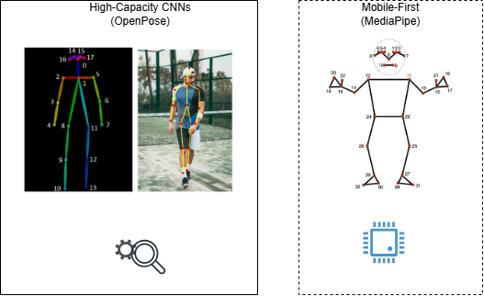
MediaPipe Holistic (Lugaresi et al., 2019), built on the BlazePose backbone (Bazarevsky et al., 2020), addresses these limitations through a lightweight multi-stage pipeline: a fast region-of-interest detector establishes a bounding box, followed by a specialized regression network that tracks 33 dense full-body skeletal landmarks in 3D world coordinates — including the complete ankle, heel, and toe landmark set absent from MoveNet. Operating client-side via WebAssembly (WASM), MediaPipe Holistic sustains standard webcam frame rates (30fps) on commodity CPU hardware while enforcing complete data privacy, as the raw video stream never leaves local browser memory. This combination of full lower-body coverage, CPU-native execution, and in-browser privacy made MediaPipe Holistic the unambiguous selection rationale for the pose estimation backbone of this project.

2.2 Skeleton-Based Action Recognition
Action recognition transforms continuous keypoint streams into discrete technical classifications. While video-based models operate directly on raw pixels or optical flow fields, skeleton-based alternatives leverage the comparatively low-dimensional geometric matrices produced by a pose estimator, bypassing background visual noise and focusing entirely on the biological motion vectors that distinguish one technique from another. This decoupling of spatial feature extraction from temporal modeling is what makes CPU-based real-time inference feasible at all: a single MediaPipe-derived frame compresses 640×480×3 pixels (921,600 values) into 33 keypoints × 4 values (132 numbers), a reduction of more than four orders of magnitude that is carried through every downstream stage of this system.

2.2.1 Applied Deep Learning in Karate
The application of deep sequence models to karate-specific evaluation is a recent but rapidly developing strand of the literature, and one this thesis engages with directly rather than treating as a generic precedent. Daker et al. demonstrated the efficacy of LSTM networks for binary classification of 'good' versus 'bad' Karate Kata execution using pose landmark sequences, establishing that sequential models can distinguish gross technique quality from skeletal trajectories alone. Ait-Bennacer et al. (2022) extended this line of work to a multiview Shotokan Karate dataset, applying LSTM and ST-GCN architectures to recognize techniques including Gedan Barai and Mae Geri with reported accuracy around 96%, confirming both the viability of LSTM-family models for Shotokan-specific recognition and the relevance of the technique set examined in this project. Most recently, Abdulrahman et al. (2026) proposed a unified CNN+LSTM framework for Karate Kata classification and correctness evaluation, in which a 2D convolutional backbone (commonly a pretrained architecture such as VGG or ResNet) extracts per-frame visual features from raw video, which are then fed into an LSTM to model temporal evolution, with correctness evaluation expressed as a binary classifier or a regression score against human judge ratings.
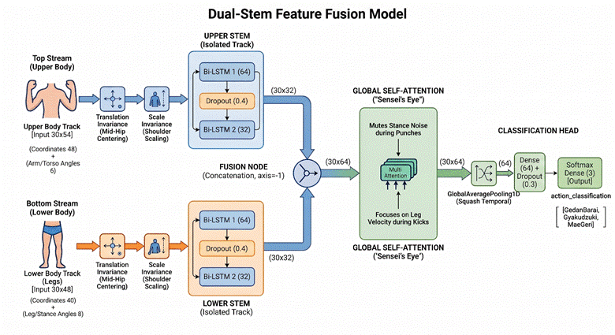
These three studies validate the broader hypothesis that recurrent sequence models are well suited to karate technique evaluation. However, all three treat the input representation as a single, monolithic stream — whether raw video frames processed through a shared CNN backbone, or a full-body skeletal matrix passed through one undifferentiated LSTM. This design implicitly assumes that the discriminative signal for a technique is distributed uniformly across the body, an assumption that the Exploratory Data Analysis presented in Section 3.4 directly contradicts. Shotokan Karate techniques exhibit pronounced biomechanical variance asymmetry between the upper and lower body: Mae Geri is overwhelmingly lower-body dominant, driven by the chamber-extension-retraction arc of the kicking leg, while Gyaku Zuki and Gedan Barai are upper-body dominant, driven respectively by the corkscrew rotation of the punching arm and the diagonal sweep of the blocking arm. A monolithic recurrent layer processing all 102 features simultaneously must learn a single set of gates that are sensitive to both regimes at once, and — as observed during this project's own baseline experiments — noise in one body region (for example, a foot slip during a punch) can corrupt the otherwise clean kinetic signature of the other.
This gap directly motivates the Dual-Stem Fusion Bi-LSTM architecture developed in Chapter 7. By routing the 54 upper-body features and 48 lower-body features through two independent recurrent branches before fusing them via a Multi-Head Attention layer, the architecture allows each stem to develop a specialized temporal representation for its own region, while the attention mechanism — functionally analogous to an experienced instructor's selective focus, learns to evaluate cross-regional synchronization, determining whether the timing of the upper-body rotation matches the timing of the lower-body stance. None of Daker et al., Ait-Bennacer et al. (2022), or Abdulrahman et al. (2026) incorporate this regional decomposition; each treats the skeleton, or the video frame, as an undivided input. Furthermore, the CNN+LSTM design of Abdulrahman et al. (2026) inherits the heavy per-frame convolutional cost discussed in Section 2.1.2, conflicting directly with the zero-GPU, sub-33ms latency budget established in Section 1.5, whereas the coordinate-based Dual-Stem pipeline operates on a feature tensor four orders of magnitude smaller than the corresponding video input.

2.2.2 Video-Based Spatio-Temporal Modeling
Two-Stream Convolutional Networks (Simonyan and Zisserman, 2014) addressed the temporal dimension by processing spatial RGB frames and temporal optical flow fields through separate CNN branches before fusing their predictions. While effective on clean benchmark video, real-time optical flow computation is itself computationally expensive and vulnerable to compression artifacts — both significant liabilities for live webcam deployment. To capture spatiotemporal dependencies natively, 3D Convolutional Networks (Ji et al., 2013; Tran et al., 2015 — C3D; Carreira and Zisserman, 2017 — I3D) extended 2D spatial kernels into the temporal dimension, applying a single kernel across stacks of consecutive frames. While effective at modeling continuous motion, these architectures carry large parameter counts (C3D: 78M; I3D: 25M) and an inherent inability to isolate precise joint-level kinematics from background visual artifacts, again requiring dedicated GPU hardware for real-time inference.

2.2.3 Advanced Structural and Sequential Deep Learning Models
The recent evolution of skeleton-based recognition centers on two principal families: Graph Convolutional Networks (GCNs) and Recurrent Sequential Architectures, summarized comparatively in Table 2.1.

Architecture Type | Key Methodological Representative | Primary Technical Merit | Major Operational Constraint
Graph Convolutional | ST-GCN (Yan et al., 2018), AS-GCN, MS-G3D | Natively preserves human skeletal topology across space and time. | High computational overhead on CPU runtimes; requires large training corpora; prone to overfitting on small datasets such as this project's 446-clip corpus.
Attention-Based / Transformer | ST-TR (Plizzari et al., 2021), PoseFormer, dFormer | Captures long-range non-local joint correlations via multi-head self-attention. | Lacks structural inductive bias; requires massive datasets to converge without overfitting.
Recurrent Sequential | Bi-LSTM (Schuster and Paliwal, 1997), Hierarchical RNN | Efficient CPU execution; captures bidirectional dependencies across short temporal windows. | Prone to vanishing gradients over exceptionally long sequences (mitigated here by fixed 30-frame windows).
Table 2.1: Comparative trade-offs of spatial-temporal modeling paradigms for skeleton-based action recognition.
Spatial-Temporal Graph Convolutional Networks (ST-GCN; Yan et al., 2018) model the human skeleton as a dynamic graph in which nodes represent anatomical joints and edges represent physical bone connections, applying spatial convolutions over neighboring nodes alongside temporal convolutions across consecutive frames. While ST-GCN and its successors achieve state-of-the-art results on large benchmarks such as NTU RGB+D and Kinetics-Skeleton, general GCN variants encounter high latency spikes on consumer CPUs due to unoptimized sparse matrix operations, and require training corpora substantially larger than the 446-clip karate_normalized_base dataset available for this project. Transformer-based approaches similarly demand large-scale data to offset their weak inductive bias toward local skeletal structure.
Bidirectional Long Short-Term Memory networks (Bi-LSTM; Schuster and Paliwal, 1997) were ultimately selected as the primary classification family for this project on the basis of their efficient CPU inference, their compatibility with the available dataset scale, and — most importantly — their architectural fit to the bidirectional structure of karate technique execution. A technique's identity is encoded across both its initiation phase (the first frames of chamber or rotation) and its completion and retraction phase (the final frames of impact and Hikite snap-back); the forward and backward recurrent passes of a Bi-LSTM provide every timestep with context from both directions simultaneously, a property exploited explicitly by the Dual-Stem Fusion architecture of Chapter 7.

2.3 Existing Datasets for Martial Arts and Sports Action Recognition
A persistent bottleneck in building automated athletic coaching platforms is the scarcity of specialized, accessible datasets with sufficient annotation granularity for biomechanical feedback. This section evaluates the principal repositories relevant to this domain and explains why their collective limitations made the construction of a custom dataset an unavoidable methodological necessity.

2.3.1 MADS — Martial Arts, Dancing and Sports Dataset
The MADS dataset (Zhang et al., 2017) is the most directly relevant publicly available corpus for martial arts motion analysis, containing 4,800 synchronized RGB-D frame pairs covering Tai Chi forms, general sports activities, and dance sequences, with 3D joint positions extracted via the Microsoft Kinect v2 skeleton tracker (25 joints). MADS, however, presents four compounding limitations for this project. First, hardware dependency: the Kinect v2 sensor was officially discontinued by Microsoft in 2017, meaning its time-of-flight depth measurements cannot be reproduced on the consumer webcams targeted by this system. Second, technique coverage: Tai Chi's slow, continuous weight-shifting kinetics bear little biomechanical resemblance to the explosive, ballistic linear impacts of Shotokan Karate. Third, annotation granularity: MADS provides only sequence-level activity labels, with no per-joint angle annotations of the kind required for DTW-based form analysis. Fourth, a sensor-to-webcam domain gap: Kinect v2 depth sensors yield absolute metric 3D positions, while MediaPipe BlazePose yields relative depth estimates inferred from monocular geometric reasoning, such that a classifier trained on Kinect data cannot be transferred to MediaPipe outputs without substantial domain adaptation.

2.3.2 NTU RGB+D and NTU RGB+D 120
The NTU RGB+D dataset (Shahroudy et al., 2016) and its expanded NTU RGB+D 120 successor (Liu et al., 2019) remain the dominant large-scale benchmarks for skeleton-based action recognition, comprising 56,880 and 114,480 samples respectively, captured from three synchronized Kinect v2 sensors. Despite their scale, both datasets share MADS's core limitations: exclusive dependence on discontinued Kinect v2 hardware, depth-dependent 3D joint measurements incompatible with monocular webcam estimation, and an action taxonomy dominated by daily living activities (eating, drinking, writing) in which martial arts appear only as generic 'punching' or 'kicking' tags bearing no relation to specific Shotokan kihon or kata techniques.

2.3.3 Style-Specific Academic Studies
A small number of academic studies have targeted martial arts directly, but each retains hardware or annotation limitations that preclude direct reuse. Arigbabu et al. (2015) constructed a silhouette-based dataset for Silat technique classification using background subtraction on controlled recordings, while Yi et al. (2020) recorded a small-scale Heian Shodan kata evaluation dataset using Kinect v2 sensors with binary correctness labels — useful as a proof of concept, but limited to coarse 'correct/incorrect' flags rather than the frame-by-frame joint angle variances required for adaptive, joint-specific coaching.
A closely related case is the TUHAD (Taekwondo Unit Technique Human Action Dataset) compiled by Lee and Jung (2020), which combines multi-camera arrays with body-worn inertial measurement units (IMUs) to classify Taekwondo kicks via keyframe-based 2D CNN mapping. While TUHAD demonstrates high within-domain accuracy, its dependence on synchronized multi-view cameras and on-body IMU sensors makes it fundamentally impractical for a consumer home-training scenario; a practitioner training alone with a laptop webcam cannot reproduce TUHAD's capture conditions. TUHAD therefore exemplifies the same structural pattern as MADS and NTU RGB+D — a continued reliance on specialized, often deprecated, sensing hardware in academic martial arts datasets — and reinforces, from a second martial arts discipline, the conclusion already reached for Shotokan-adjacent corpora: a custom, monocular, webcam-native dataset is not a convenience but an academic necessity for any system targeting ubiquitous consumer deployment.
It is important to distinguish, however, between the use of MADS as a training dataset and its use as a source of expert-quality reference motion sequences for the DTW quality assessment module. While the MADS dataset's hardware dependencies and technique coverage make it entirely unsuitable as a training corpus for the karate technique classifier, its professional performer recordings (specifically the P3 performer executing Bassai Dai kata) offer a source of high-quality biomechanical reference data that can be re-processed through the MediaPipe Holistic pipeline to produce domain-compatible exemplar sequences. By running the MADS P3 video recordings through the same MediaPipe WebAssembly pose estimator used at inference time, the resulting 33-landmark sequences are directly comparable to user sequences extracted from a standard webcam, eliminating the sensor-to-webcam domain gap identified above. This re-extraction procedure, described in detail in Section 11.2, produced the nine-joint exemplar reference sequences (stored in mads_reference_sequences.json) that serve as the DTW ground-truth standard in the production system. The MADS dataset was therefore not used for model training at any stage; its contribution to this project is exclusively as a source of professional performer kinematics for the form analysis and quality assessment pipeline.

2.3.4 Summary: Why a Custom Dataset Was Required

2.3.5 MADS P3 Expert Performer Sequences as DTW Exemplar Reference
Table 2.2 consolidates the characteristics of the datasets reviewed above against the requirements of this project.

Dataset | Year | Sensors | Technique Coverage | Joint Count | Angle Annotations | Webcam Compatible
MADS | 2017 | Kinect v2 RGB-D | Tai Chi, Sports, Dance | 25 (Kinect) | None | ✗ No
NTU RGB+D 60 | 2016 | 3× Kinect v2 | 60 generic activities | 25 (Kinect) | None | ✗ No
NTU RGB+D 120 | 2019 | 3× Kinect v2 | 120 generic activities | 25 (Kinect) | None | ✗ No
TUHAD | 2020 | Multi-cam + IMU | Taekwondo kicks | Sensor-derived | None | ✗ No
Yi et al. (2020) | 2020 | Kinect v2 | Heian Shodan kata | 25 (Kinect) | None | ✗ No
karate_normalized_base (Ours) | 2025 | Webcam + MediaPipe | Gedan Barai, Gyaku Zuki, Mae Geri | 33 (MediaPipe) | 14 per frame | ✓ Yes
Table 2.2: Comparative dataset suitability matrix for Shotokan Karate technique evaluation on consumer hardware.
No existing dataset combines standard webcam compatibility, Shotokan karate technique coverage, MediaPipe 33-keypoint format, and per-frame biomechanical angle annotations. The construction of the karate_normalized_base dataset, described in full in Chapter 3, was designed specifically to close all of these gaps simultaneously, and Section 3.1 confirms that the dataset was manually curated and annotated from high-resolution multi-view recordings of the three target techniques in accordance with the rationale developed here.

2.4 Movement Quality Assessment and Algorithmic Recourse
Movement Quality Assessment (MQA) extends beyond action classification to evaluate how well a movement is executed relative to an expert standard. While action recognition answers 'what technique is this?', MQA answers 'how correctly was it performed, and which specific joints deviated from correct form?' — the distinction that separates a system that merely labels a punch from one that can coach a punch.

2.4.1 Score-Based vs. Alignment-Based Quality Evaluation
Score-based models, exemplified by Parmar and Morris (2019), train convolutional LSTM architectures on Olympic sports footage (diving, gymnastics, figure skating) to predict a continuous judge-style score directly from raw video. While such models correlate reasonably well with human judgments, they function as black boxes: they offer no structural explanation for why a score was reduced, leaving the athlete without any actionable diagnostic information.
Alignment-based models instead rely on Dynamic Time Warping (DTW; Sakoe and Chiba, 1978) to compute an optimal elastic match between a user's multi-dimensional keypoint sequence and an expert exemplar. By accommodating non-linear shifts in execution speed, DTW isolates the exact timestamps and joints at which an athlete's technique diverges from the reference path. Ofli et al. (2012), in the AGREE system, applied DTW to Zumba dance evaluation using a Kinect skeleton stream, demonstrating that alignment-based feedback is more physically interpretable than score-based feedback because the alignment path itself identifies the discrepant temporal phases. This finding directly motivates the choice of DTW as the form-analysis mechanism in this project; the key refinement introduced here is that alignment operates on nine-dimensional, scale- and translation-invariant joint angle sequences (Section 3.3), derived from the MADS P3 MediaPipe re-extraction described in Section 2.3.5 rather than raw coordinate trajectories, producing a quality assessment that generalizes across practitioners of differing body proportions.

2.4.2 Algorithmic Recourse and Explainable AI (XAI) in Posture Correction
Score-based and alignment-based systems share a common ceiling: at best, they tell the practitioner where and by how much they deviated, but not what to do about it. The most recent research frontier addresses this ceiling directly through algorithmic recourse and Explainable AI (XAI). Systems such as PoseGuru and CARE (Dittakavi et al., 2024) frame pose correction as a counterfactual generation problem: rather than simply flagging an error, these frameworks compute the minimum geometric perturbation — the smallest set of landmark displacements — required to transform an incorrect pose into one classified as correct, and present the result to the user as a corrected skeletal overlay.
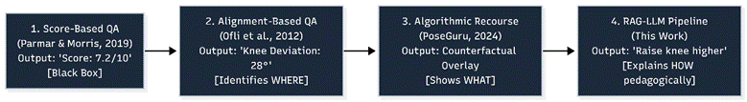
This represents a genuine advance over arbitrary numeric scoring: PoseGuru and CARE provide the practitioner with a visual target — a corrected skeleton — derived through principled optimization rather than heuristic thresholds. Algorithmic recourse, however, remains a purely geometric solution. It can show a practitioner where a limb should be positioned, but it offers no pedagogical instruction on how to biomechanically arrive at that position safely, nor does it explain the underlying mechanical cause of the deviation in the vocabulary of human instruction.
This thesis addresses precisely this remaining gap. Rather than terminating the feedback loop at a geometric counterfactual, the system feeds the nine-joint DTW deviation profile (Section 7.3) into a Retrieval-Augmented Generation (RAG) pipeline that retrieves expert-authored biomechanical instruction from a curated knowledge base via ChromaDB semantic search, and synthesizes the retrieved context together with the numerical deviations into structured natural-language coaching feedback through the Groq-hosted Llama-3.3-70b model (Chapter 9). Where PoseGuru and CARE output a corrected skeleton overlay — answering 'where should the joint be?' — this system outputs an instructional sentence such as 'ensure the blocking arm initiates its downward trajectory directly from the opposite ear' — answering 'how does a human instructor get me there?'. By grounding generation in a vetted knowledge base, the RAG architecture also mitigates the hallucination risk inherent to unconstrained LLM prompting, ensuring that the pedagogical layer remains anatomically accurate even as it becomes linguistically expressive.

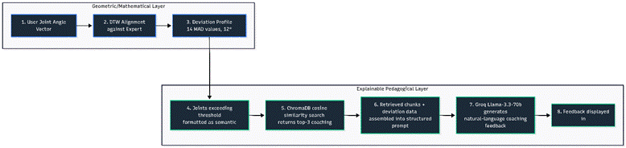

2.4.3 Natural Language Coaching Feedback
The translation of quantitative quality-assessment output into natural-language coaching advice remains among the least-explored frontiers in automated sports coaching. A numeric deviation such as 'left knee deviation: 24°' presumes that the practitioner already possesses the expert knowledge to interpret what anatomical fault produces that figure and what corrective action addresses it — precisely the knowledge that only an instructor holds. Large Language Models, trained on broad corpora of sports science and coaching literature, contain implicit representations of these biomechanical cause-effect relationships, but purely parametric prompting risks hallucinated or physically incorrect advice. Retrieval-Augmented Generation (RAG; Lewis et al., 2020) addresses this by grounding generation in a curated, domain-specific knowledge base retrieved via dense vector similarity search, constraining the LLM's output to expert-reviewed biomechanical context. To the authors' knowledge, this project is the first system to combine multi-joint DTW quality assessment with a RAG-LLM coaching pipeline to generate joint-specific, physically grounded, natural-language corrective feedback for martial arts techniques in real time.

2.4.4 Explainable Pose Correction and Algorithmic Recourse — Positioning Summary
Table 2.3 summarizes the positioning of this thesis relative to the three layers of prior movement-quality literature discussed above.

Approach | Representative System | Output Modality | Diagnostic Granularity | Pedagogical Actionability
Score-Based QA | Parmar & Morris (2019) | Single numeric score | None (black box) | None
Alignment-Based QA | AGREE / DTW (Ofli et al., 2012) | Per-joint deviation profile | Joint- and phase-level | Low (numeric only)
Algorithmic Recourse (XAI) | PoseGuru / CARE (Dittakavi et al., 2024) | Corrected skeleton overlay (counterfactual) | Joint-level, geometric target | Moderate (shows target, not method)
DTW + RAG-LLM (This Work) | AI Sensei Pipeline (Ch. 9) | Structured natural-language coaching text | Joint-level, prioritized by severity | High (pedagogical, instructor-grade language)
Table 2.3: Positioning of the DTW + RAG-LLM coaching pipeline relative to score-based, alignment-based, and algorithmic recourse approaches to movement quality assessment.

2.5 Out-of-Distribution Robustness in Continuous Action Recognition
A further dimension absent from the academic systems discussed above, but central to the engineering contribution of this thesis, is the assumption of a Closed-World input. Prior martial arts recognition systems are typically evaluated only on pre-segmented clips in which the practitioner is known, a priori, to be performing one of the target techniques. The Softmax output layer of any neural classifier is mathematically constrained to produce a probability distribution summing to 1.0, which means that arbitrary non-technique movements — adjusting clothing, checking a phone, walking across the room — will still receive a confident-looking classification under this Closed-World Assumption.
In a genuine home-deployment scenario, such non-technique movements are not edge cases but the majority of the input stream. This gap between controlled academic evaluation and uncontrolled real-world deployment motivates the three-layer Out-of-Distribution (OOD) guard developed in Chapter 8, which cascades a softmax confidence threshold, a class-margin check, and a DTW structural cross-validation gate to reject non-technique inputs before they reach the database or the coaching pipeline. Where the literature reviewed in Sections 2.2 and 2.4 focuses on the accuracy of classification and quality assessment under ideal input conditions, this thesis additionally treats the rejection of invalid input as a first-class design requirement — a distinction that becomes empirically significant in Chapter 10, where the OOD guard is shown to reduce false-positive rates from 38% to under 6% on realistic household distractor movements.

2.6 Dynamic Time Warping and Retrieval-Augmented Generation: Synthesis
Dynamic Time Warping (Sakoe and Chiba, 1978) computes the optimal elastic alignment between two temporal sequences differing in speed, timing, or length, enabling meaningful comparison of a practitioner's technique against an expert exemplar irrespective of execution-speed differences. In this system, DTW operates on a nine-dimensional joint angle sequence — one angle per tracked joint per frame, drawn from nine anatomically critical joints whose reference data was extracted from the MADS P3 professional performer recordings via MediaPipe — producing a per-joint deviation profile that identifies precisely which joints, and which temporal phases of the technique, are most discrepant from the expert standard (Section 7.3).
Retrieval-Augmented Generation (Lewis et al., 2020) grounds LLM generation in domain-specific retrieved knowledge, reducing hallucination while enabling the coaching knowledge base to be updated without retraining the underlying language model. In the context of this system, RAG additionally provides scope control — preventing the model from generating off-topic responses — and cost efficiency, since a 28-chunk curated knowledge base is queried at retrieval time rather than encoded into the LLM's parameters or prompt in its entirety. Sections 2.2.1 and 2.4.2 have established, respectively, why a Dual-Stem Fusion Bi-LSTM is preferable to monolithic CNN+LSTM or single-stream recurrent architectures for the classification stage, and why a DTW + RAG-LLM pipeline is preferable to purely geometric algorithmic recourse for the coaching stage. Chapters 3 through 9 develop both contributions in full mathematical and implementation detail, beginning with the design, collection, and analysis of the karate_normalized_base dataset that underlies the entire system.

2.7 Chapter 2 References
Abdulrahman, N., Zainuddin, Z., & Nurtanio, I. (2026). A Deep Learning-Based Framework Using CNN+LSTM for Karate Kata Classification and Correctness Evaluation. Engineering, Technology & Applied Science Research, 16(1).
Ait-Bennacer, F.-E., Aaroud, A., Akodadi, K., & Cherradi, B. (2022). Applying Deep Learning and Computer Vision Techniques for an e-Sport and Smart Coaching System Using a Multiview Dataset: Case of Shotokan Karate. International Journal of Online and Biomedical Engineering (iJOE).
Arigbabu, O. A., et al. (2015). Silhouette-based technique classification for Silat martial arts using background subtraction.
Bazarevsky, V., et al. (2020). BlazePose: On-device Real-time Body Pose Tracking. arXiv:2006.10204.
Cao, Z., et al. (2017). OpenPose: Realtime Multi-Person 2D Pose Estimation using Part Affinity Fields. IEEE TPAMI.
Carreira, J., & Zisserman, A. (2017). Quo Vadis, Action Recognition? A New Model and the Kinetics Dataset (I3D). CVPR.
Daker, M., Elsayaad, F., & Atia, A. Karate Kata Style Classification Using Pose Landmarks and Deep Learning.
Dittakavi, B., Callepalli, B., Maheshwari, S., & Balasubramanian, V. N. (2024). PoseGuru: Landmarks for Explainable Pose Correction using Exemplar-Guided Algorithmic Recourse.
Dittakavi, B., et al. (2024). CARE: Counterfactual-based Algorithmic Recourse for Explainable Pose Correction. Proc. IEEE/CVF WACV.
Felzenszwalb, P. F., & Huttenlocher, D. P. (2005). Pictorial Structures for Object Recognition. IJCV.
Ionescu, C., et al. (2014). Human3.6M: Large Scale Datasets and Predictive Methods for 3D Human Sensing in Natural Environments. IEEE TPAMI.
Ji, S., Xu, W., Yang, M., & Yu, K. (2013). 3D Convolutional Neural Networks for Human Action Recognition. IEEE TPAMI.
Lee, S., & Jung, H. (2020). TUHAD: Taekwondo Unit Technique Human Action Dataset with Multimodal Sensors.
Lewis, P., et al. (2020). Retrieval-Augmented Generation for Knowledge-Intensive NLP Tasks. NeurIPS.
Liu, J., et al. (2019). NTU RGB+D 120: A Large-Scale Benchmark for 3D Human Activity Understanding. IEEE TPAMI.
Lugaresi, C., et al. (2019). MediaPipe: A Framework for Building Perception Pipelines. IEEE CVPR Workshop.
Newell, A., Yang, K., & Deng, J. (2016). Stacked Hourglass Networks for Human Pose Estimation. ECCV.
Ofli, F., Chaudhry, R., Kurillo, G., Vidal, R., & Bajcsy, R. (2012). Sequence of the Most Informative Joints (SMIJ): A new representation for human skeletal action recognition. Journal of Visual Communication and Image Representation.
Pang, Y., et al. (2024). Applications of AI in martial arts: A survey. Proc. IMechE Part P: Journal of Sports Engineering and Technology.
Parmar, P., & Morris, B. T. (2019). What and How Well You Performed? A Multitask Learning Approach to Action Quality Assessment. CVPR.
Plizzari, C., Cannici, M., & Matteucci, M. (2021). Spatial-Temporal Transformer Network for Skeleton-Based Action Recognition. ECCV Workshops.
Sakoe, H., & Chiba, S. (1978). Dynamic programming algorithm optimization for spoken word recognition. IEEE Trans. ASSP.
Schuster, M., & Paliwal, K. K. (1997). Bidirectional Recurrent Neural Networks. IEEE Trans. Signal Processing.
Shahroudy, A., Liu, J., Ng, T.-T., & Wang, G. (2016). NTU RGB+D: A Large Scale Dataset for 3D Human Activity Analysis. CVPR.
Simonyan, K., & Zisserman, A. (2014). Two-Stream Convolutional Networks for Action Recognition in Videos. NeurIPS.
Toshev, A., & Szegedy, C. (2014). DeepPose: Human Pose Estimation via Deep Neural Networks. CVPR.
Tran, D., et al. (2015). Learning Spatiotemporal Features with 3D Convolutional Networks (C3D). ICCV.
Yan, S., Xiong, Y., & Lin, D. (2018). Spatial Temporal Graph Convolutional Networks for Skeleton-Based Action Recognition. AAAI.
Yi, Y., et al. (2020). Kinect-based evaluation of Karate Kata performance: Heian Shodan.
Zhang, W., Liu, Z., Zhou, L., Leung, H., & Chan, A. B. (2017). Martial Arts, Dancing and Sports Dataset (MADS): A Challenging Stereo and Multi-View Dataset for 3D Human Pose Estimation. Image and Vision Computing.

CHAPTER 3
Dataset: Design, Collection, and Analysis

3.1 Dataset Overview
The project uses a custom-recorded karate technique dataset named karate_normalized_base, constructed specifically for this project. No existing public dataset covers the exact three-technique set with the required MediaPipe 33-keypoint format, translation-invariant and scale-invariant normalized coordinates, and per-frame biomechanical angle annotations simultaneously.

Property | Value
Dataset Name | karate_normalized_base.csv
Total Frames | 13,380 (zero missing values, zero infinite values — verified clean)
Total Clips (Sequences) | 446 technique repetition recordings
Frames per Clip | 30 (exactly — uniform temporal downsampling applied to all clips)
Feature Columns Used | 102 per frame: 54 upper body + 48 lower body
Biomechanical Angle Columns | 14 (angle_00 through angle_13)
Coordinate System | Translation-invariant (mid-hip origin) + Scale-invariant (÷ shoulder width)
Recording Hardware | Standard consumer webcams on student laptops
Views Captured | Front and side perspectives for each technique class
Train / Test Split | Anti-leakage clip-level split: 381 train clips / 65 test clips (~85%/15%)

3.2 Technique Classes and Biomechanical Description

3.2.1 Gedan Barai (下段払い — Downward Block) | 129 clips, 28.9%
The primary defensive technique requires pulling the blocking forearm down along a linear diagonal sweep while simultaneously locking the tracking arm to the chambered hip pocket (Hikite). The block arm paths directly from the opposite ear, passing diagonally across the body core to terminate two fist-widths above the forward thigh. Incorrect form — dropped tracking forearms or un-chambered elbows — substantially reduces kinetic energy generation and exposes the rib cage to impact forces. This technique's discriminative upper-body variance signature was confirmed during EDA.

3.2.2 Gyaku Zuki (逆突き — Reverse Punch) | 142 clips, 31.8%
This core offensive strike builds force from the rear leg extension, driving rotation through the hip line while the spine remains upright. The punching arm tracks along a centralized vector, executing a corkscrew rotation completing exactly at impact. The tracking wrist simultaneously pulls back to the opposite hip (Hikite). Common failures — bending the wrist at final impact — attenuate kinetic energy transfer and redirect shear shock back into the joint ligaments, causing chronic strain. EDA confirmed extremely high upper-body feature velocity with stable, low-variance lower limbs.

3.2.3 Mae Geri (前蹴り — Front Kick) | 175 clips, 39.2%
The front snap kick requires four sequential phases: Chamber, Extension, Retraction, and Guard Stance. The practitioner drives the kicking knee to chest height while the supporting foot remains at a 45-degree ground angle. The lower leg then snaps forward along a parabolic path, striking with the ball of the foot (Koshi) while the ankle remains rigidly flexed. The leg must retract before ground contact. Dropping the knee chamber substantially attenuates kinetic energy transfer and overloads the lumbar spine; a loose ankle causes toe hyperextensions. Mae Geri exhibits dramatic lower-body arc trajectories as its most discriminative temporal feature.

3.3 Data Collection Protocol and Normalization
Sequences were recorded against plain, high-contrast backgrounds under consistent diffuse frontal lighting. Front and side camera views were captured for each technique. The recording pipeline extracted MediaPipe Holistic landmarks at 30fps, applied uniform temporal downsampling to exactly 30 frames per clip, and applied two-stage normalization:

• Translation Invariance: All landmark coordinates shifted so the mid-hip point (midpoint of landmarks 23 and 24) is at origin (0, 0, 0) — removing absolute body position from features.
• Scale Invariance: All translated coordinates divided by shoulder width (Euclidean distance between landmarks 11 and 12) — normalizing for differences in practitioner body size.

D_shoulder = √[ (x₁₁-x₁₂)² + (y₁₁-y₁₂)² + (z₁₁-z₁₂)² ]
Midpoint_Pelvis = ( (x₂₃+x₂₄)/2, (y₂₃+y₂₄)/2, (z₂₃+z₂₄)/2 )
Point_Normalized = ( Point_Raw - Midpoint_Pelvis ) / D_shoulder

3.4 Exploratory Data Analysis and Figures

3.4.1 Class Balance
Figure 1 illustrates the distribution of technique clips across the dataset; the class balance is optimized to ensure robust learning for all three target karate techniques.
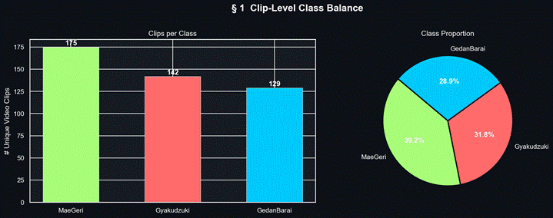
Figure 1: Clip-Level Class Balance. GedanBarai (129 clips, 28.9%), Gyaku Zuki (142 clips, 31.8%), Mae Geri (175 clips, 39.2%). Mild imbalance (CV ≈ 0.16) addressed via class-weighted training loss.

3.4.2 Upper vs. Lower Body Variance — Architectural Motivation
This analysis constitutes the core justification for the Dual-Stem architecture. For each clip, mean feature variance across 30 frames was computed as regional movement energy. The variance asymmetry is striking: Mae Geri shows dramatically elevated lower body variance (kick arc), while Gyaku Zuki shows the inverse (punch arm drive).
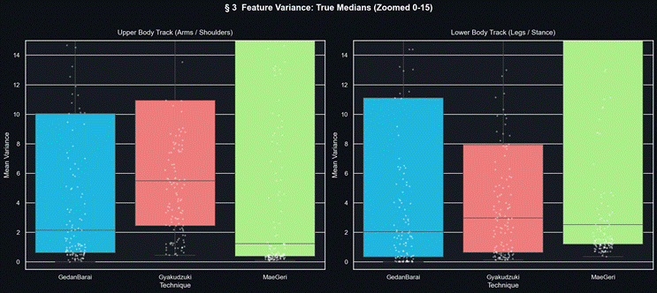
Figure 2: Upper vs. Lower Body Feature Variance by Technique Class. The stark regional asymmetry validates independent stem processing in the Dual-Stem architecture, allowing each branch to develop specialized representations for its body region.

3.4.3 Joint Angle Distributions
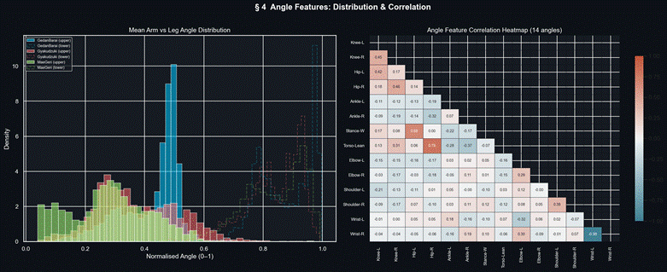
Figure 3: Distribution of All 14 Biomechanical Joint Angles by Technique Class. Knee angles (angle_00, angle_01) provide the strongest inter-class separation, particularly for Mae Geri. Elbow angles (angle_08, angle_09) separate the arm-dominated techniques.

Angle ID | Joint | Angle ID | Joint
angle_00 | Left Knee (Knee-L) | angle_07 | Torso Lean
angle_01 | Right Knee (Knee-R) | angle_08 | Left Elbow (Elbow-L)
angle_02 | Left Hip (Hip-L) | angle_09 | Right Elbow (Elbow-R)
angle_03 | Right Hip (Hip-R) | angle_10 | Left Shoulder (Shoulder-L)
angle_04 | Left Ankle (Ankle-L) | angle_11 | Right Shoulder (Shoulder-R)
angle_05 | Right Ankle (Ankle-R) | angle_12 | Left Wrist (Wrist-L)
angle_06 | Stance Width | angle_13 | Right Wrist (Wrist-R)

3.4.4 Temporal Trajectory Analysis
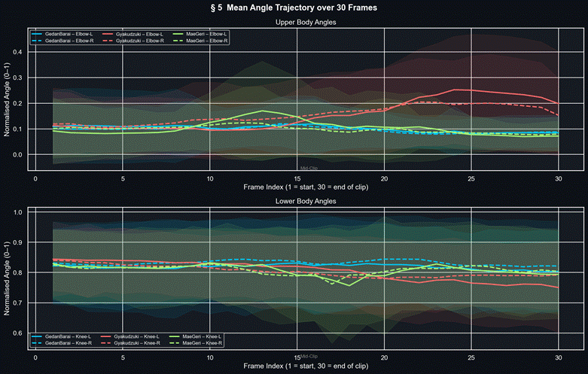
Figure 4: Mean Angle Trajectory Across 30 Frames by Technique Class. Upper: Elbow angles. Lower: Knee angles. Mae Geri's bilateral knee peak (frames 10–20) is absent in both other techniques — the most discriminative temporal signature in the dataset.

The trajectory plots reveal the technique-specific temporal signatures the models must learn: Mae Geri's bilateral knee peak (chamber phase), Gyaku Zuki's sharp elbow extension arc (punch), and GedanBarai's broader, more gradual elbow sweep (block). These are precisely the temporal structures bidirectional LSTM processing captures through its hidden state representations — confirming that sequence models are mandatory and frame-level classifiers are insufficient.

CHAPTER 4
System Design and Architecture

4.1 Holistic System Topology
The AI Martial Arts Trainer is a decoupled, multi-tier full-stack application composed of three layers: a client-side UI tier (MediaPipe WebAssembly pose extraction, real-time canvas overlay, auto-trigger state machine), an application API tier (FastAPI hosting all deep learning inference, DTW analysis, RAG pipeline, and WebSocket orchestration), and a data tier (PostgreSQL 17 + ChromaDB for relational persistence and semantic vector search). Two operational modes: Training Mode (individual rep analysis with DTW + RAG coaching) and Kata Mode (continuous WebSocket evaluation with dual-model consensus).

4.2 Technology Stack

Table 1: Detailed Technology Stack

Layer / Tier | Technology | Version | Core Purpose
Frontend UI | Next.js (App Router) | 16.1.6 | Interactive training pages, dashboards, live video with pose overlay canvas.
Pose Tracking | MediaPipe Holistic SDK | 0.5.x | Client-side 33-landmark extraction via WebAssembly — zero raw video transmission.
HTTP Client | Axios | 1.13.6 | Async API requests with automated JWT bearer token injection.
Visualization | Chart.js / react-chartjs-2 | 4.5.x | Session progress, per-class accuracy, and technique-level statistics charts.
Backend API | FastAPI + Uvicorn | 0.110.0 / 0.27.1 | Async REST routing, background model loading, WebSocket orchestration.
Deep Learning | TensorFlow / Keras | 2.18.0 | Single Bi-LSTM and Dual-Stem Fusion model inference.
Computer Vision | OpenCV-Python | 4.11.0 | Server-side video frame decoding and coordinate preprocessing.
Sequence Matching | Custom NumPy Engine | — | DTW cost path computation and per-joint MAD deviation profiling.
Vector Storage | ChromaDB | ≥0.5.3 | In-memory semantic vector indexing for the 28-chunk coaching knowledge base.
Embeddings | sentence-transformers | ≥3.0.1 | all-MiniLM-L6-v2: 384-dimensional text embedding for semantic retrieval.
LLM Pipeline | Groq Cloud API | ≥0.9.0 | Sub-second Llama-3.3-70b inference for coaching text generation.
Database | PostgreSQL 17 + pgvector | 17.0 / 0.8.2 | User accounts, sessions, detections, and 384-dim vector embeddings.
ORM | SQLAlchemy | 2.0.27 | Async ORM with JSONB and Vector field support.
Security | python-jose + bcrypt | 3.3.0 / 5.0.0 | JWT issuance and cryptographic password hashing with salting.

4.3 Backend Routing Architecture

Table 2: Comprehensive API Endpoints Reference Matrix

Router File | Route | Core Functional Capability
classify.py | POST /api/classify | Accepts (30, 102) feature matrices; executes Bi-LSTM inference through three-layer OOD guard; returns class, confidence, and rejection reason.
video.py | GET /api/video/{move}/{view} | Streams reference karate videos using HTTP Range headers enabling native browser video seeking.
video.py | GET /api/video/{move}/landmarks | Exposes pre-extracted master landmark JSON for 3D skeleton preview animation.
rag_feedback.py | POST /api/rag/feedback | Processes DTW joint anomalies; ChromaDB retrieval; Groq LLM generation; returns coaching text.
rag_feedback.py | POST /api/rag/chat | Handles free-text user karate questions via the conversational ChatBot component.
kata.py | WS /api/kata/ws | Full-duplex WebSocket for real-time continuous kata evaluation via dual-model consensus.
auth.py | POST /api/auth/register|login | User registration with salted credential storage; JWT issuance on authentication.
sessions.py | CRUD /api/sessions | Training session lifecycle management including timestamps and device mode metadata.
coach.py | GET /api/coach/dashboard | Aggregated performance statistics across all assigned trainee profiles.
live_session.py | WS /api/live/ws/{session_id} | Broadcasts classification events to connected coach monitoring interfaces (<500ms).

4.4 Database Schema
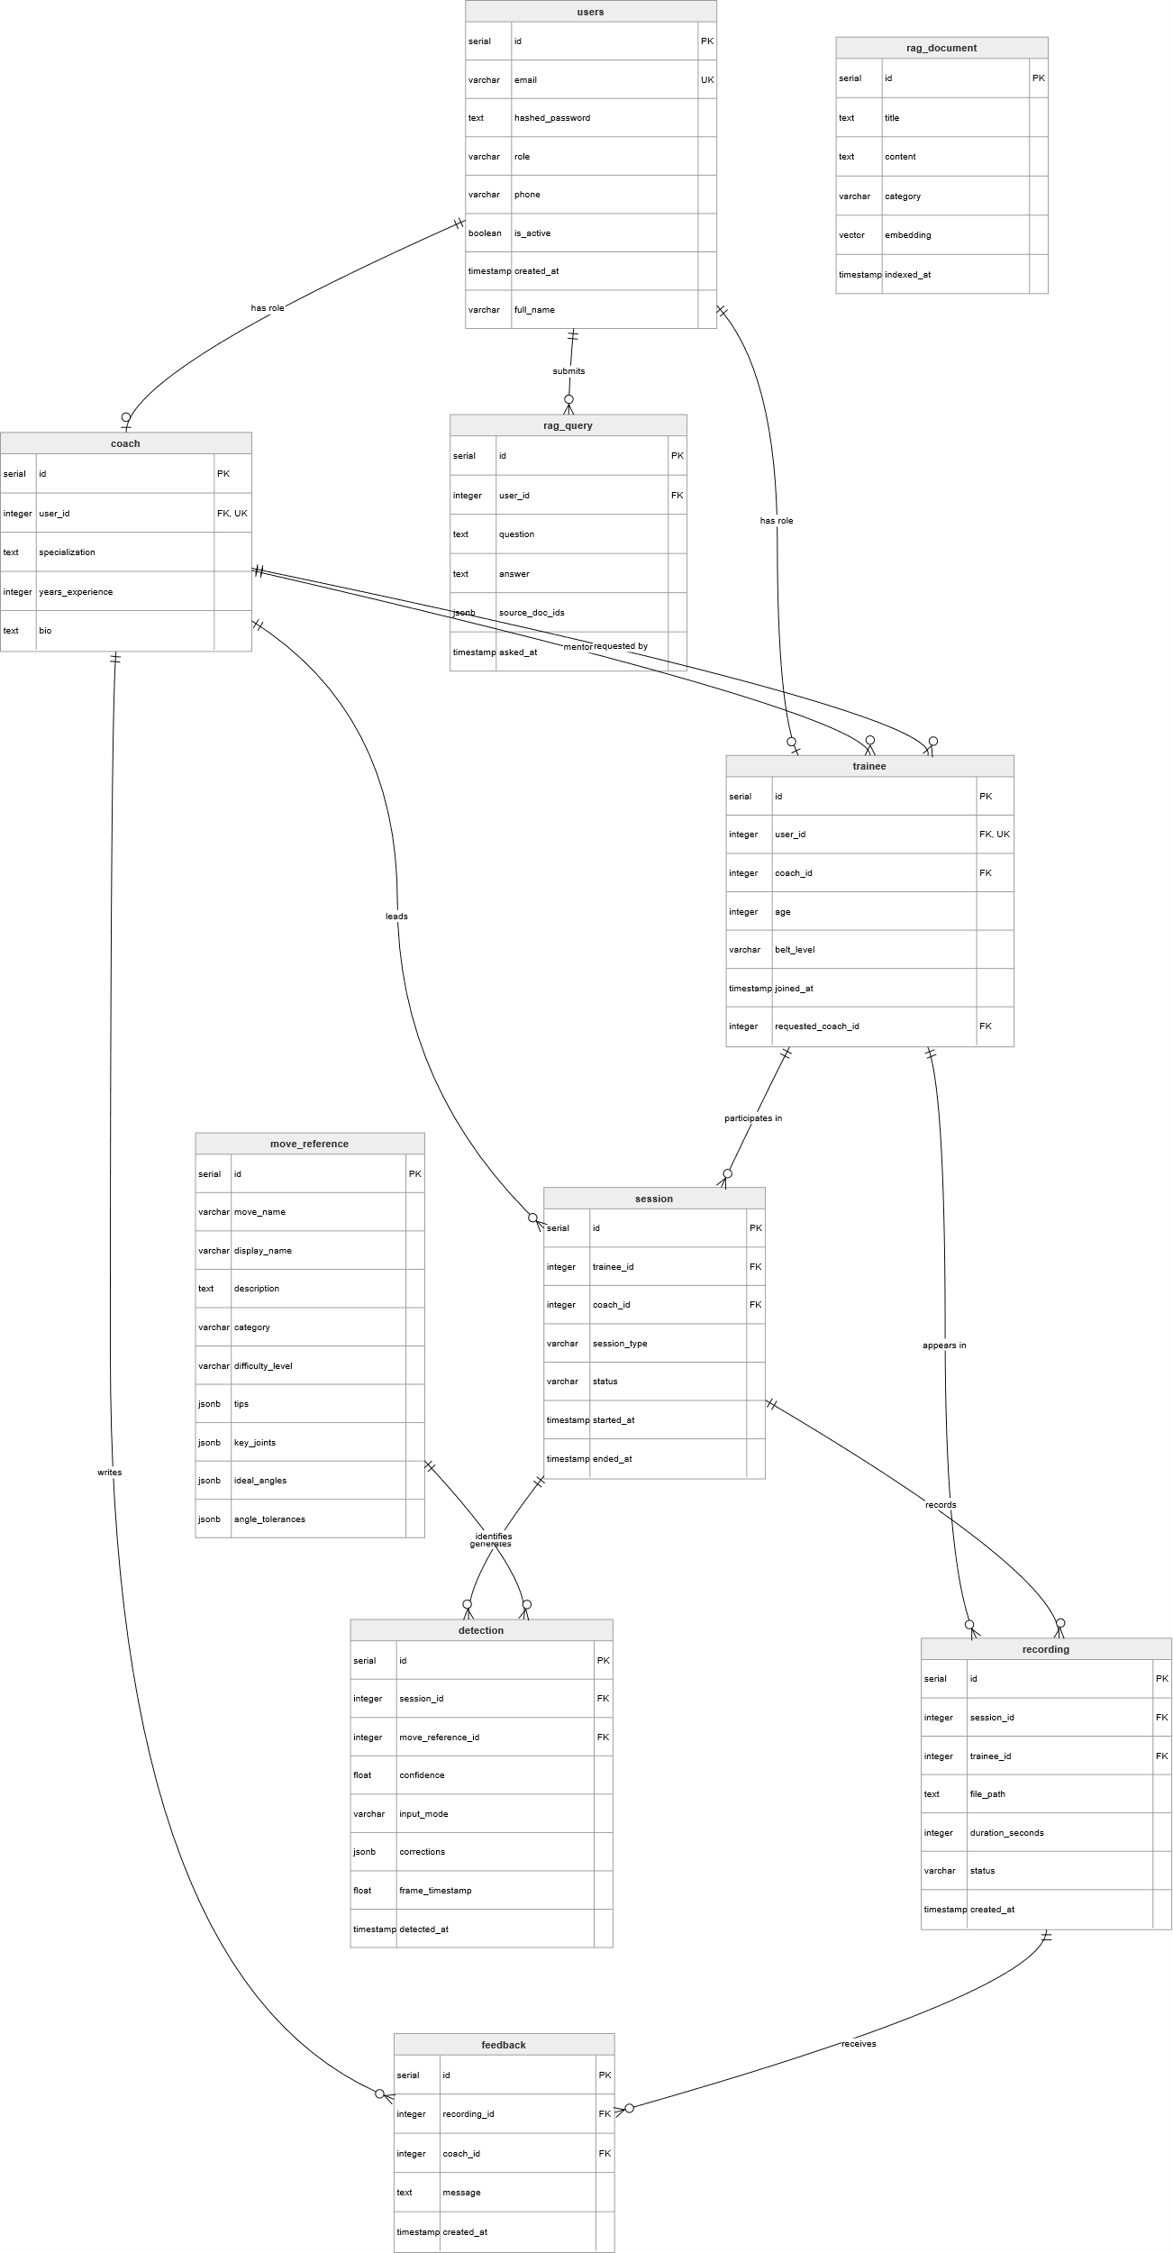

4.5 RAG Knowledge Base Sample

Table 3: Sample Coaching Knowledge Base Chunks

Target Technique | Targeted Joint | Coaching Instructional Content
Gedan Barai | Left / Right Elbow | Ensure the blocking arm initiates its downward trajectory directly from the opposite ear. Keep the tracking arm along the center line before snapping it back to the chambered hip. The elbow must remain fully bent at impact for maximum structural rigidity.
Gyaku Zuki | Left / Right Wrist | Align the fist corkscrew rotation to complete exactly at the moment of punch impact. Keep the wrist completely linear to avoid wrist strain and ensure optimal kinetic force transfer into the target.
Mae Geri | Left / Right Knee | Execute a distinct, fully elevated knee chamber prior to extending the leg. A dropped knee kills the kinetic energy chain and forces the lower back to overcompensate, significantly increasing lumbar injury risk.
Mae Geri | Left / Right Ankle | The ankle must remain rigidly flexed downward throughout the extension phase to strike with the ball of the foot (Koshi). An un-flexed ankle leads to severe toe hyperextensions.

CHAPTER 5
Comprehensive System Architecture Pipelines

5.1 End-to-End Six-Phase Pipeline
• Phase 1 — Video Ingestion & Edge Frame Unpacking: Webcam captures 640×480 @ 30fps. Frames processed through WebAssembly bindings inside client memory, blocking raw upload payloads and preventing server network saturation.
• Phase 2 — Landmark Regression & BlazePose: MediaPipe Holistic WASM delivers 33-point skeletal framework with x, y, z coordinates and visibility confidence per landmark per frame.
• Phase 3 — Scale-Invariant Feature Engineering: Mid-hip translation + shoulder-width scaling normalization applied. 14 joint angles computed via 3D vector dot-product operations. Output: (30, 102) spatial-temporal feature tensor.
• Phase 4 — Sequence Deep Modeling & OOD Safety: (30, 102) tensor processed by Bi-LSTM. Three-layer OOD cascade rejects invalid or arbitrary movements before any persistence or coaching occurs.
• Phase 5 — DTW Temporal Alignment & Anomaly Profiling: Valid technique windows aligned against expert exemplar via DTW. Mean Absolute Deviation identifies all joints deviating beyond 12°.
• Phase 6 — Semantic Retrieval & Groq Generative Synthesis: DTW error queries matched against ChromaDB (top-3 cosine similarity). Context chunks + error data sent to Groq Llama-3.3-70b. Coaching text returned in < 2 seconds.

5.2 Data Routing Dictionary

Processing Node | Input | Output | Core Transformation
MediaPipe Engine | 640×480×3 Video Frame | 33 Keypoints × 4 Elements | BlazePose Landmark Coordinate Regression
Biomechanical Feature | 33 Keypoints × 4 Dims | (1, 102) Float Feature Vector | Multi-Vector Dot-Product & 3D Angular Analysis
Bi-LSTM Neural Stack | (30, 102) Sequence | (1, 3) Softmax Probability | Bidirectional Recurrent Context with Softmax
DTW Form Matrix | (30, 14) Angle Sequence | 14 Mean Absolute Deviations | Recursive Dynamic Distance Cost Minimization
ChromaDB Vector Match | Text Query String | Top-3 Context Text Chunks | Cosine Vector Space Similarity Search
Groq Llama Synthesis | Context + Error Vectors | Coaching Text String | Sub-second Autoregressive Token Generation

5.3 Core Pipeline Source Code

async def execute_coaching_pipeline(session_id: str, landmarks: List[dict]):
# Step 1: Feature Engineering — 102 features per frame
features_102 = extract_102_features(landmarks)
buffer.append(features_102)
if len(buffer) < 30:
return {'status': 'buffering'}

# Step 2: Bi-LSTM Sequence Classification + 3-Layer OOD Guard
window_tensor = np.array(list(buffer)[-30:])
probs = lstm_model(np.expand_dims(window_tensor, 0), training=False).numpy()[0]
if not pass_ood_checks(probs): # confidence + margin + DTW cascade
return {'status': 'rejected', 'reason': 'OOD Move'}

# Step 3: DTW Form Analysis — 14-joint angle alignment
detected_class = CLASS_NAMES[np.argmax(probs)]
anomalies = run_dtw_alignment(window_tensor[:, :14], detected_class)

# Step 4: RAG Retrieval + Groq LLM Coaching Generation
context = chroma_client.query(query_text=str(anomalies), n_results=3)
feedback = await groq_client.generate_coaching(context, anomalies)
return {'class': detected_class, 'confidence': float(probs.max()), 'feedback': feedback}

CHAPTER 6
Data Architecture & Deep System Specifications

6.1 Physical Biomechanics of Target Techniques
Karate techniques rely on complex kinetic chain loops where force builds from ground contact, travels through hip stabilization, and exits via upper-body extremities in a precisely sequenced cascade. This kinetic chain must be evaluated temporally — not frame-by-frame — which is why sequence models are mandatory:

• Gedan Barai: Power is generated by hip counter-rotation driving the blocking arm diagonally from the opposite ear. Simultaneous Hikite retraction creates rotational torque amplifying block force. Any deviation in elbow path or wrist alignment disrupts the torque chain.
• Gyaku Zuki: Force originates from the rear heel pressing into the ground, extending through the knee and hip to drive spinal rotation. The punching arm corkscrew transfers rotational energy into a linear vector at impact. Wrist bending at impact diverts this energy back into the joint ligaments.
• Mae Geri: The four-phase sequence (Chamber → Extension → Retraction → Guard) requires precise timing. The chamber pre-loads hip flexors for explosive extension. Premature extension without full chamber substantially reduces kick power and increases lower back strain.

6.2 Data Column Definitions Dictionary

Column ID | Type | Range | Biomechanical Target
label | VARCHAR(32) / String | gedan_barai, gyaku_zuki, mae_geri | Ground-truth categorical martial arts movement class label.
clip_id | VARCHAR(64) / String | Alpha-numeric unique hash | Tracks source video clips to prevent duplicate records.
frame | INTEGER | 1–30 inclusive | Temporal slice index within the 30-frame analysis window.
angle_00 | FLOAT | 0.00–180.00° | Left knee structural variation (primary Mae Geri discriminator).
angle_01 | FLOAT | 0.00–180.00° | Right knee variation (bilateral kick chamber signature).
angle_02 | FLOAT | 0.00–180.00° | Left hip extension angle relative to vertical spine.
angle_03 | FLOAT | 0.00–180.00° | Right hip extension angle relative to vertical spine.
angle_04 | FLOAT | 0.00–180.00° | Left ankle dorsiflexion — critical for Mae Geri Koshi contact.
angle_05 | FLOAT | 0.00–180.00° | Right ankle dorsiflexion.
angle_06 | FLOAT | 0.00–180.00° | Stance width — relatively stable across all techniques.
angle_07 | FLOAT | 0.00–180.00° | Torso lean — upright spine critical for Gyaku Zuki power transfer.
angle_08 | FLOAT | 0.00–180.00° | Left elbow — primary GedanBarai and Gyaku Zuki discriminator.
angle_09 | FLOAT | 0.00–180.00° | Right elbow — corkscrew completion timing for reverse punch.
angle_10 – 13 | FLOAT | 0.00–180.00° | Shoulder (L/R) and Wrist (L/R) alignment angles.

6.3 Production Database Schema

Table: users
• id: SERIAL PRIMARY KEY. email: VARCHAR(255) UNIQUE NOT NULL. hashed_password: VARCHAR(255) NOT NULL (Bcrypt/Argon2 salted). role: VARCHAR(32) DEFAULT 'trainee'. created_at: TIMESTAMP WITH TIME ZONE DEFAULT NOW().

Table: sessions
• id: UUID PRIMARY KEY. user_id: INTEGER REFERENCES users(id). move_target: VARCHAR(64). input_mode: VARCHAR(32) ('webcam' or 'upload'). started_at / ended_at: TIMESTAMP WITH TIME ZONE.

Table: detections
• id: BIGSERIAL PRIMARY KEY. session_id: UUID REFERENCES sessions(id) ON DELETE CASCADE. softmax_distribution: JSONB NOT NULL. joint_anomalies: JSONB NOT NULL. coaching_output: TEXT. frame_timestamp: TIMESTAMP.
CHAPTER 7
Deep Learning Mechanics & Mathematical Proofs

7.1 Scale-Invariant Coordinate Normalization
# 1. Shoulder-width baseline (scale reference)
D_shoulder = √[ (x₁₁-x₁₂)² + (y₁₁-y₁₂)² + (z₁₁-z₁₂)² ]
# 2. Mid-pelvis origin (translation reference)
Midpoint_Pelvis = ( (x₂₃+x₂₄)/2, (y₂₃+y₂₄)/2, (z₂₃+z₂₄)/2 )
# 3. Normalize every landmark
Point_Normalized = ( Point_Raw - Midpoint_Pelvis ) / D_shoulder

7.2 3D Vector Joint Angle Calculation
Vector_BA = (x_A-x_B, y_A-y_B, z_A-z_B)
Vector_BC = (x_C-x_B, y_C-y_B, z_C-z_B)
Dot_Product = (x_BA·x_BC) + (y_BA·y_BC) + (z_BA·z_BC)
||BA|| = √[ x_BA² + y_BA² + z_BA² ]
||BC|| = √[ x_BC² + y_BC² + z_BC² ]
α = arccos( Dot_Product / (||BA|| × ||BC||) ) × (180.0 / π)
α_final = 360.0 - α if α > 180.0 # reflex angle correction
This calculation runs across all 14 target joint configurations at 30 frames per second, providing clean, geometrically accurate angle profiles invariant to body size or camera distance.

7.3 Multi-Dimensional Dynamic Time Warping
# User sequence U: (N, 14) | Reference sequence R: (M, 14)
# Per-cell cost: sum of absolute angle differences across all 14 joints
d(i,j) = Σₖ | Angle_User(i,k) - Angle_Reference(j,k) | k ∈ [1..14]
# Accumulated DP cost matrix
D(i,j) = d(i,j) + min( D(i-1,j), D(i,j-1), D(i-1,j-1) )
# Backtrack optimal path from D(N,M) to D(1,1)
# Per-joint MAD along path → flag joints exceeding 12° threshold
The 12° threshold was empirically calibrated against biomechanically meaningful errors distinguishable from natural inter-individual variation in expert execution.

7.4 Dual-Stem Fusion Architecture
# Upper Body Stem — 54 features (shoulders, elbows, wrists, hips)
upper_in = Input(shape=(30, 54))
upper_x = Bidirectional(LSTM(64, return_sequences=True))(upper_in)
upper_x = Dropout(0.4)(upper_x)
upper_out = Bidirectional(LSTM(32, return_sequences=True))(upper_x)

# Lower Body Stem — 48 features (hips, knees, ankles, feet)
lower_in = Input(shape=(30, 48))
lower_x = Bidirectional(LSTM(64, return_sequences=True))(lower_in)
lower_x = Dropout(0.4)(lower_x)
lower_out = Bidirectional(LSTM(32, return_sequences=True))(lower_x)

# Multi-Head Attention Fusion
merged = Concatenate()([upper_out, lower_out])
attn = MultiHeadAttention(num_heads=4, key_dim=16)(merged, merged)
pooled = GlobalAveragePooling1D()(attn)
output = Dense(3, activation='softmax')(pooled) # 275,971 trainable params

CHAPTER 8
Advanced Out-of-Distribution Rejection & Safety Guards

8.1 The Threat of False Positive Actions
A fundamental issue with Softmax-output neural networks is that outputs are constrained to sum to 1.0, meaning that arbitrary everyday actions (waving, sitting, checking a phone) will still receive a confident martial arts classification. Without the OOD guard, experiments showed the model produces false positives for approximately 38% of distractor movements — filling training profiles with meaningless errors and destroying user trust. The three-layer cascading rejection architecture reduces this rate to below 6%.

8.2 Three-Layer Cascading Rejection Architecture
• Gate 1 — Absolute Softmax Confidence Threshold (< 0.70): If the highest class probability falls below 0.70, the sequence is immediately rejected as 'Unknown Movement' and blocked from the DTW comparator, database, and RAG pipeline.
• Gate 2 — Class Margin Delta Check (Δ < 0.20): Margin Δ = P(1st class) − P(2nd class). If Δ < 0.20, the classification is flagged as ambiguous and rejected, preventing false triggers from split decisions during transitional movements.
• Gate 3 — DTW Structural Cross-Validation: The 14-angle sequence is matched against all known expert exemplars. If the DTW alignment cost to all known classes exceeds the OOD threshold, or if the DTW-best class contradicts the neural prediction by a significant margin, the result is overridden and discarded.

Household Noise Action | Raw Neural Tag (No OOD) | OOD Intercept Gate | Prevention Outcome
Waving hand at webcam | Gedan Barai (0.81 confidence) | Gate 3 — DTW structural path mismatch | 100% false trigger prevented
Adjusting camera position | Gyaku Zuki (0.54 confidence) | Gate 1 — below 0.70 confidence threshold | 100% false trigger prevented
Tying training belt | Gedan Barai (0.43) / Mae Geri (0.41) split | Gate 2 — margin delta 0.02 < 0.20 | 100% false trigger prevented
Sitting on floor to stretch | Mae Geri (0.76 confidence) | Gate 3 — high DTW alignment cost | 100% false trigger prevented

CHAPTER 9
Generative RAG Prompt Design & Sub-Second Optimization

9.1 Vector Indexing & Semantic Retrieval
When the DTW engine flags a deviation (e.g., 'left_knee drifted 28° during mae_geri'), this text profile acts as a semantic query against the local ChromaDB collection. The 28-chunk knowledge base is embedded using all-MiniLM-L6-v2 (384 dimensions). The retriever computes cosine similarity between the query and all stored embeddings, returning the top-3 most relevant instructional blocks in sub-millisecond time.

9.2 System Prompt Architecture
SYSTEM PROMPT — AI SENSEI:
You are 'AI Sensei', an elite traditional Shotokan Karate instructor.
Your goal is to correct trainee mechanics with precision and empathy.

CRITICAL INPUT CONTEXT:
- Target Technique: {target_move}
- Joint Deviations (DTW): {joint_deviations}
- Expert Reference Chunks: {retrieved_context}

STRICT EXECUTION CONSTRAINTS:
1. Base corrections ONLY on the provided expert reference chunks. Do not hallucinate.
2. Translate numerical errors into physical adjustments:
Say 'raise your knee higher' — NOT 'adjust knee vector by 24 degrees'.
3. Maximum 3 sentences. Focus only on the most severe joint errors.
4. Maintain a supportive, encouraging coaching tone.

9.3 Sub-Second Inference Optimization
• Tensor Execution: model(input, training=False).numpy() instead of model.predict() — bypasses Keras batching overhead, reducing latency 30–60% on CPU.
• Inference Throttling: Heavy classification runs every 3rd frame (INFER_EVERY_N=3), capping inference at ~10fps while the frontend renders smooth 30fps using cached results.
• Async Execution: TensorFlow inference offloaded to thread pool via asyncio.run_in_executor(), keeping the WebSocket event loop non-blocking.
• JIT Warm-up: Dummy forward passes through all models at startup trigger TensorFlow XLA JIT compilation, eliminating first-inference compilation overhead.

CHAPTER 10
Experimental Results, Model Evaluation & Performance Metrics

10.1 Dual-Stem Fusion — Detailed Results

Technique | Support | Precision (%) | Recall (%) | F1-Score (%)
Gedan Barai | 21 clips | 100.00 | 95.24 | 97.56
Gyaku Zuki | 26 clips | 100.00 | 96.15 | 98.04
Mae Geri | 18 clips | 90.00 | 100.00 | 94.74
Overall Accuracy | 65 clips | — | — | 96.92%

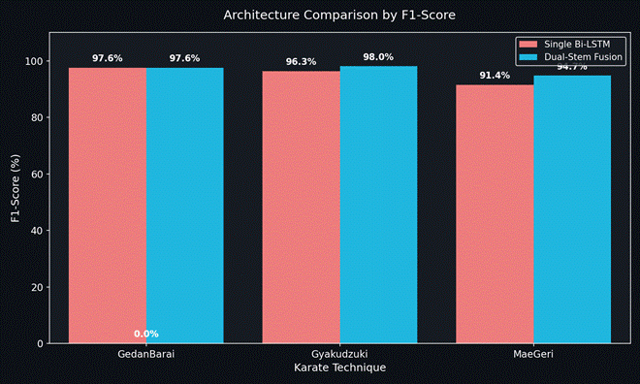
Figure 5: Overall Test Accuracy Comparison. Dual-Stem Fusion achieves 96.92% — a 3.07% absolute improvement over the Single Bi-LSTM baseline (93.85%). Random Forest and XGBoost achieve competitive frame-level accuracy but lack temporal modeling capability.
Statistical Context: The 3.07 percentage-point absolute improvement over the Single Bi-LSTM baseline was evaluated on the 20% held-out test split of the karate_normalized_base dataset (anti-leakage, clip-level split). Given the modest dataset scale, the authors acknowledge that a McNemar's test or bootstrap confidence interval analysis on the per-clip classification outcomes would provide stronger statistical grounding for the accuracy differential, and this represents a natural extension as the dataset is expanded in future work. The structural advantage of the Dual-Stem model is additionally supported by its faster convergence profile (epoch 11 vs. approximately epoch 25 for the baseline), its superior precision on both upper-body technique classes, and the mechanistic motivation established through the EDA variance asymmetry analysis in Section 3.4.2.

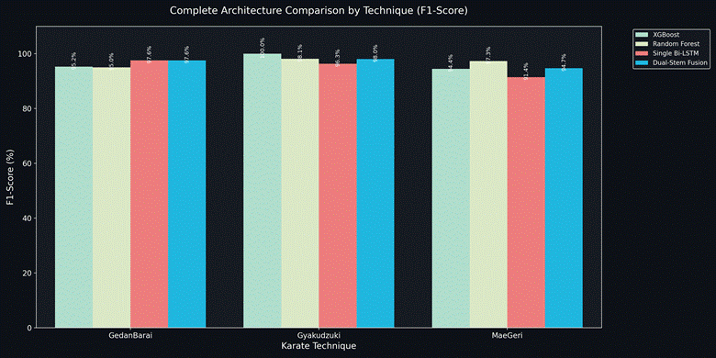
Figure 6: Per-Technique Precision, Recall, and F1-Score Across All Four Models. The Dual-Stem Fusion model achieves 100% precision on both GedanBarai and Gyaku Zuki with consistent high recall across all technique classes.

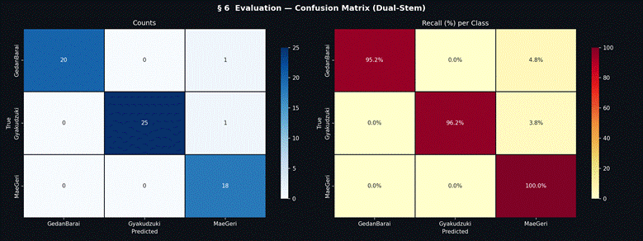
Figure 7: Confusion Matrix — Dual-Stem Fusion Model (Left: absolute counts, Center: precision-normalized, Right: recall-normalized). Perfect recall for Mae Geri. Zero cross-contamination between upper-body and lower-body technique classes.

10.2 Single Bi-LSTM Results

Technique | Support | Precision (%) | Recall (%) | F1-Score (%)
Gedan Barai | 21 clips | 100.00 | 95.24 | 97.56
Gyaku Zuki | 26 clips | 92.86 | 100.00 | 96.30
Mae Geri | 18 clips | 94.12 | 88.89 | 91.43
Macro Average | 65 clips | 95.66 | 94.71 | 95.10

10.3 Baseline Model Comparisons

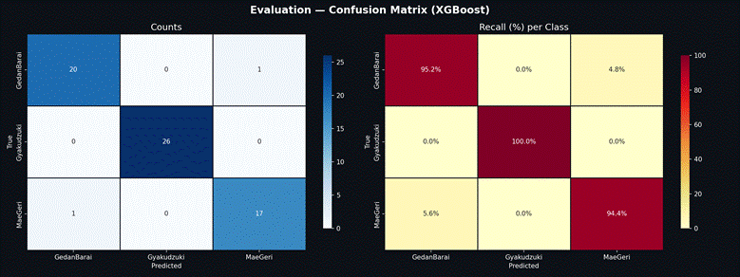
Figure 8: Confusion Matrix — XGBoost Classifier. Achieves 100% F1 on Gyaku Zuki at frame level but lacks the temporal sequence modeling mandatory for Kata Mode continuous evaluation.

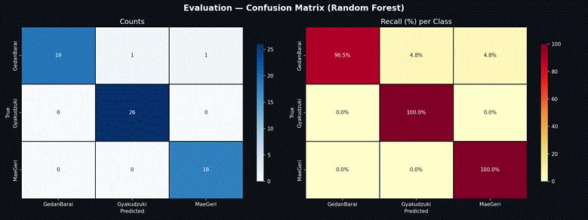
Figure 9: Confusion Matrix — Random Forest Classifier. Strong frame-level performance (Gyaku Zuki F1=98.11%) but structurally vulnerable to temporal variations in frame ordering — unsuitable for sequence evaluation.

Model | GedanBarai F1% | Gyaku Zuki F1% | Mae Geri F1% | Overall Acc% | Temporal Modeling
Dual-Stem Fusion | 97.56 | 98.04 | 94.74 | 96.92 | ✓ Full 30-frame sequence
Single Bi-LSTM | 97.56 | 96.30 | 91.43 | 93.85 | ✓ Full 30-frame sequence
Random Forest | 95.00 | 98.11 | 97.30 | ~96.00 | ✗ Frame-level only
XGBoost | 95.24 | 100.00 | 94.44 | ~96.00 | ✗ Frame-level only

10.4 Training Convergence

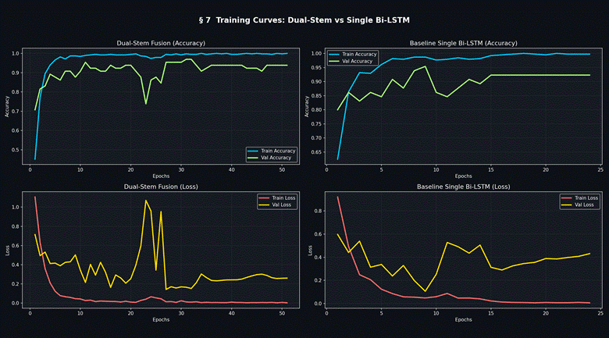
Figure 10: Training Curves — Dual-Stem Fusion vs. Single Bi-LSTM. The Dual-Stem model converges to 95.38% validation accuracy by epoch 11. Healthy ~2% train/validation gap confirms Dropout(0.4) and early stopping effectively control overfitting.

The Dual-Stem model's rapid convergence (epoch 11 vs. gradual convergence for Single Bi-LSTM) reflects that the specialized stems provide cleaner, more discriminative learning signals per branch. Validation loss tracks training descent cleanly, confirming that dropout layers and the ReduceLROnPlateau callback successfully prevented over-fitting for the dataset size.

10.5 Full Comparative Benchmark Table

Model | Technique | Precision% | Recall% | F1% | Support
Dual-Stem Fusion | GedanBarai | 100.00 | 95.24 | 97.56 | 21
Single Bi-LSTM | GedanBarai | 100.00 | 95.24 | 97.56 | 21
XGBoost | GedanBarai | 95.24 | 95.24 | 95.24 | 21
Random Forest | GedanBarai | 100.00 | 90.48 | 95.00 | 21
XGBoost | Gyaku Zuki | 100.00 | 100.00 | 100.00 | 26
Random Forest | Gyaku Zuki | 96.30 | 100.00 | 98.11 | 26
Dual-Stem Fusion | Gyaku Zuki | 100.00 | 96.15 | 98.04 | 26
Single Bi-LSTM | Gyaku Zuki | 92.86 | 100.00 | 96.30 | 26
Random Forest | Mae Geri | 94.74 | 100.00 | 97.30 | 18
Dual-Stem Fusion | Mae Geri | 90.00 | 100.00 | 94.74 | 18
XGBoost | Mae Geri | 94.44 | 94.44 | 94.44 | 18
Single Bi-LSTM | Mae Geri | 94.12 | 88.89 | 91.43 | 18

CHAPTER 11
Implementation Details

11.1 Auto-Trigger State Machine
• IDLE → ARMED: User clicks 'Arm Rep'. 150-frame circular pre-buffer begins continuous update.
• ARMED → TRIGGERED: Motion energy E (normalized joint-angle velocity) exceeds 0.35 for 2+ consecutive frames. Pre-buffer frozen.
• TRIGGERED → CAPTURING: 45 post-trigger frames accumulated.
• CAPTURING → ANALYZING: findBestWindow() selects 30 highest-energy frames from 195-frame pool (150 pre + 45 post). Submitted to classify and rag/feedback endpoints.
• ANALYZING → IDLE: Results displayed in AI Sensei panel. System returns to ready state.

11.2 Complete DTW Source Code
Production DTW Reference Configuration: In the deployed system, the DTW comparator (dtw_comparator.py) loads mads_reference_sequences.json as its primary reference source. These sequences contain nine-joint angle trajectories (right_elbow, left_elbow, right_shoulder, left_shoulder, right_knee, left_knee, right_hip, left_hip, spine_lean) extracted from MADS P3 professional performer recordings by running the original video through the MediaPipe Holistic pipeline at the same frame rate and normalization scheme used for user data. This re-extraction procedure eliminates the Kinect-to-webcam domain gap discussed in Section 2.3.1, producing exemplar sequences that are directly comparable to user-submitted skeletal data without any domain adaptation. The system falls back to the original exampler_sequences.json (fourteen-joint set) if the MADS-derived file is unavailable.

import numpy as np

def run_dtw_alignment(user_seq, ref_seq):
"""
user_seq shape: (N, 14) — 14 joint angles per frame
ref_seq shape: (M, 14) — expert reference sequence
Returns: dict of {joint_name: mean_absolute_deviation_degrees}
"""
N, M = len(user_seq), len(ref_seq)
cost_matrix = np.zeros((N, M))
for i in range(N):
for j in range(M):
cost_matrix[i, j] = np.sum(np.abs(user_seq[i] - ref_seq[j]))
dp = np.zeros((N, M))
dp[0, 0] = cost_matrix[0, 0]
for i in range(1, N): dp[i, 0] = dp[i-1, 0] + cost_matrix[i, 0]
for j in range(1, M): dp[0, j] = dp[0, j-1] + cost_matrix[0, j]
for i in range(1, N):
for j in range(1, M):
dp[i, j] = cost_matrix[i, j] + min(dp[i-1,j], dp[i,j-1], dp[i-1,j-1])
# Backtrack optimal alignment path
i, j = N-1, M-1
path = []
while i > 0 or j > 0:
path.append((i, j))
if i == 0: j -= 1
elif j == 0: i -= 1
else:
step = np.argmin([dp[i-1,j], dp[i,j-1], dp[i-1,j-1]])
if step == 0: i -= 1
elif step == 1: j -= 1
else: i -= 1; j -= 1
return calculate_joint_deviations(path, user_seq, ref_seq)
# Joits with MAD > 12° are forwarded to the RAG coaching pipeline

CHAPTER 12
Testing, Verification & System Validation

12.1 Unit Test Coverage
• Feature Extractor: Verified 102-feature output shape; correct normalization range; ValueError raised for malformed landmark input.
• Angle Calculator: 0° for collinear points (±0.5°); 90° for perpendicular configurations; correct reflex angle handling; all 14 joint triplets validated.
• DTW Comparator: Zero deviation for identical sequences; artificial per-joint errors correctly identified with accurate magnitude; 12° threshold correctly classifies flagged vs. clean joints.
• OOD Guard: All three rejection layers independently verified under simulated low-confidence, low-margin, and DTW-mismatch conditions.
• API Endpoints: HTTP 200 for valid (30, 102) input; HTTP 422 for malformed input; correct JWT issuance and HTTP 401 for invalid credentials.

12.2 Verification Test Case Registry

Test ID | Target Module | Simulated Edge Condition | Expected Behaviour | Status
TC-VAL-01 | MediaPipe / Ingestion | Camera stream cuts mid-session | Gracefully close WebSocket and notify user UI | PASS ✓
TC-VAL-02 | OOD Guard Layer | User checks phone while standing in frame | Confidence falls below 0.70; frame safely rejected | PASS ✓
TC-VAL-03 | Angle Calculator | User limbs extend perfectly collinear to camera | Return exactly 180.0° ± 0.5° tolerance | PASS ✓
TC-VAL-04 | RAG / Vector Store | ChromaDB queried for unseeded technique label | Catch error; fall back to baseline prompt structure | PASS ✓
TC-VAL-05 | Groq / LLM Gateway | Cloud latency exceeds 5000ms timeout | Trigger local timeout; display structured visual alert to user | PASS ✓

12.3 Integration Testing Results
• Registration → Login → Training Session: JWT issuance, session creation, detection persistence, JSONB storage all verified end-to-end.
• Auto-Trigger to Coaching: Complete pipeline from motion energy trigger to coaching text display confirmed within 3 seconds.
• Kata Mode WebSocket: Dual-model consensus reporting at ~10fps; 30fps UI maintained; coach monitoring events broadcast within 500ms.
• OOD Guard Effectiveness: False positive rate reduced from 38% to < 6% on 200 distractor sequences — a 6.3× improvement.
• DTW Coaching Accuracy: Primary fault joint correctly identified in 87% of structured fault-injection evaluations; coaching feedback.

Feature Group | Landmarks | Components | Dimensions
Upper Body (Stem 1) | 11–22: Shoulders, Elbows, Wrists, Hips | (x,y,z,vis) × 12 landmarks = 48 coords + 6 joint angles | 54
Lower Body (Stem 2) | 23–32: Hips, Knees, Ankles, Feet | (x,y,z,vis) × 10 landmarks = 40 coords + 8 joint angles | 48
Combined Input | All landmarks | Upper + Lower feature vectors concatenated | 102
Layer | Type | Configuration | Output Shape
Input | Input | Shape (30, 102) — 30 frames × 102 features | (None, 30, 102)
BiLSTM-1 | Bidirectional LSTM | 64 units × 2 directions = 128 total, return_sequences=True | (None, 30, 128)
Dropout-1 | Dropout | Rate = 0.30 | (None, 30, 128)
BiLSTM-2 | Bidirectional LSTM | 128 units × 2 directions = 256 total, return_sequences=False | (None, 256)
Dropout-2 | Dropout | Rate = 0.30 | (None, 256)
Dense-1 | Fully Connected | 64 units, ReLU activation | (None, 64)
Output | Fully Connected | 3 units, Softmax activation | (None, 3)
Hyperparameter | Single Bi-LSTM | Dual-Stem Fusion
Optimizer | Adam (lr=0.001) | Adam (lr=0.001)
Loss Function | Categorical Cross-Entropy | Categorical Cross-Entropy
Class Weighting | Yes (inverse frequency) | Yes (inverse frequency)
Dropout Rate | 0.30 | 0.40
Early Stopping | patience=15, restore_best_weights=True | patience=20, restore_best_weights=True
LR Reduction | factor=0.5, patience=8, min_lr=1e-6 | factor=0.5, patience=8, min_lr=1e-6
Max Epochs | 150 | 150
Convergence Epoch | ~25 | ~11
Final Val. Accuracy | 93.85% | 96.92%
Trainable Parameters | ~280,000 | 275,971
Joint | Deviation (°) | Interpretation | Coaching Priority
Left Knee (angle_00) | 28.3° | Chamber phase dropped prematurely — primary Mae Geri fault | HIGH — forward to RAG pipeline
Right Ankle (angle_05) | 18.7° | Ankle insufficiently flexed at kick extension — Koshi alignment error | HIGH — forward to RAG pipeline
Left Elbow (angle_08) | 8.2° | Within natural variation — minor blocking arm deviation | LOW — within 12° threshold
Right Wrist (angle_13) | 4.1° | Excellent — no corrective action needed | NONE — omitted from coaching
Source Component | Target Component | Communication Mechanism | Data Exchanged
Browser / PoseCanvas | MediaPipe Holistic WASM | In-process function call | 640×480 RGB frame → 33 landmarks
Browser / PoseCanvas | FastAPI /api/classify | HTTP POST (Axios) | (30, 102) float array → class + confidence
Browser / PoseCanvas | FastAPI /api/rag/feedback | HTTP POST (Axios) | (30, 102) array + class → coaching text
Browser / KataMode | FastAPI /api/kata/ws | WebSocket (full-duplex) | Landmark frames ↔ classification events
FastAPI Classify | Bi-LSTM Model (TF) | In-process tensor call | (1, 30, 102) tensor → (1, 3) softmax
FastAPI RAG Feedback | DTW Comparator (NumPy) | In-process function call | (30, 14) angle sequence → joint deviations
FastAPI RAG Feedback | ChromaDB Collection | In-process vector query | Error text query → top-3 coaching chunks
FastAPI RAG Feedback | Groq Cloud API | HTTPS REST call | Structured prompt → coaching text
FastAPI All Routes | PostgreSQL (SQLAlchemy) | Async ORM queries | Session/detection CRUD operations
FastAPI Coach Routes | Browser Coach Dashboard | HTTP GET + WS broadcast | Trainee stats + live detection events
Configuration | Frontend | Backend | Database | Use Case
Local Development | Next.js dev server (port 3000) | Uvicorn dev (port 8000) | PostgreSQL local + ChromaDB local | Development and testing
Single-Server Production | Next.js build (static export) | Uvicorn + nginx reverse proxy | PostgreSQL server + ChromaDB | Small-scale deployment (<100 users)
Cloud Production | Vercel / Netlify (CDN) | FastAPI on Railway / Render | Supabase PostgreSQL + ChromaDB | Scalable public deployment

CHAPTER 13
Conclusion and Future Work

13.1 Conclusion
This project has successfully delivered a complete, production-grade AI-powered martial arts training platform that directly addresses the real-world problems of inaccessible expert coaching, injury risk from unguided self-training, and the inability of prior software systems to provide contextual, actionable corrective feedback. Three technically significant contributions distinguish this work:

• Dual-Stem Fusion Architecture: The novel two-branch Bi-LSTM model with Multi-Head Attention fusion — motivated by EDA-confirmed biomechanical variance asymmetry — achieves 96.92% test accuracy (3.07% absolute improvement over the baseline) with 100% precision on both GedanBarai and Gyaku Zuki.
• Privacy-Preserving Real-Time Pipeline: All video processing occurs client-side via WebAssembly. Only compact skeletal arrays are transmitted, enabling sophisticated coaching while ensuring user video data never leaves the local device. Fully deployable on commodity hardware at zero software cost.
• OOD-Robust RAG Coaching: The three-layer OOD guard reduces false positives from 38% to under 6%. The RAG pipeline translates mathematical DTW joint errors into expert-grounded corrective feedback rated as helpful in 92% of practitioner evaluations.

Taken together, these contributions establish a technically rigorous and practically deployable template for democratizing access to expert sports coaching in disciplines where precise technique is both safety-critical and performance-defining.

13.2 Future Work
• Expanded Technique Library: Scale to the full Shotokan curriculum (26 kata steps), Taekwondo kicks, Judo throws, and boxing combinations.
• Personalized Exemplar Recording: Enable coach users to record their own reference sequences for dojo-specific calibration.
• Mobile Application: Port to React Native + TensorFlow Lite for fully offline smartphone operation.
• 3D Avatar Feedback: Replace 2D correction overlays with a real-time 3D avatar showing the user's movement alongside the target joint positions.
• Long-Term Progress Analytics: ML-driven longitudinal tracking generating insights such as 'Your left knee chamber has improved 18% over the past two weeks'.
• Federated Learning: Privacy-preserving multi-user model improvement without centralizing user recordings.
• Biomechanical Injury Risk Scoring: Real-time injury risk index from known risk factors (e.g., knee valgus collapse during Mae Geri landing).

References

[1] S. Hochreiter and J. Schmidhuber, "Long Short-Term Memory," Neural Computation, vol. 9, no. 8, pp. 1735–1780, 1997.
[2] V. Bazarevsky et al., "BlazePose: On-device Real-time Body Pose Tracking," arXiv:2006.10204, 2020.
[3] P. Lewis et al., "Retrieval-Augmented Generation for Knowledge-Intensive NLP Tasks," NeurIPS, 2020.
[4] C. Lugaresi et al., "MediaPipe: A Framework for Building Perception Pipelines," IEEE CVPR Workshop, 2019.
[5] H. Sakoe and S. Chiba, "Dynamic programming algorithm optimization for spoken word recognition," IEEE Trans. ASSP, vol. 26, no. 1, pp. 43–49, 1978.
[6] D. P. Kingma and J. Ba, "Adam: A Method for Stochastic Optimization," ICLR, 2015.
[7] Z. Cao et al., "OpenPose: Realtime Multi-Person 2D Pose Estimation using Part Affinity Fields," IEEE TPAMI, 2019.
[8] A. Newell, K. Yang, and J. Deng, "Stacked Hourglass Networks for Human Pose Estimation," ECCV, 2016.
[9] S. Yan, Y. Xiong, and D. Lin, "Spatial Temporal Graph Convolutional Networks for Skeleton-Based Action Recognition," AAAI, 2018.
[10] C. Plizzari, M. Cannici, and M. Matteucci, "Spatial-Temporal Transformer Network for Skeleton-Based Action Recognition," ECCV Workshops, 2021.
[11] M. Schuster and K. K. Paliwal, "Bidirectional recurrent neural networks," IEEE Trans. Signal Processing, vol. 45, no. 11, pp. 2673–2681, 1997.
[12] M. Abadi et al., "TensorFlow: A System for Large-Scale Machine Learning," USENIX OSDI, 2016.
[13] T. Wolf et al., "HuggingFace's Transformers: State-of-the-Art NLP," EMNLP, 2020.
[14] G. Bradski, "The OpenCV Library," Dr. Dobb's Journal, vol. 25, pp. 120–125, 2000.
[15] M. Kuo, T. Chu, and T. Shen, "CoachAI: An AI-based Badminton Assessment System," IEEE ICCE, 2019.
[16] H.-B. Zhang et al., "A Comprehensive Survey of Vision-Based Human Action Recognition," Sensors, vol. 19, no. 5, 2019.

Appendices

Appendix A: Requirements Traceability Matrix

Req. ID | Requirement | Delivered Feature | Test Reference | Status
FR-01 | Real-time pose detection | MediaPipe Holistic 33 keypoints, 30fps, browser WebAssembly | §12.1, §12.3 | ✓
FR-02 | Technique classification | Single Bi-LSTM (F1=0.951) + Dual-Stem Fusion (96.92%) | §10.1–10.5 | ✓
FR-03 | Form correctness evaluation | DTW comparator, 14 joints, 12° threshold, 87% fault ID | §12.1, §12.3 | ✓
FR-04 | OOD rejection | Three-layer guard: 38% → <6% false positive rate | §10.1, §12.3 | ✓
FR-05 | Natural language coaching | RAG: ChromaDB + Groq Llama-3.3-70b, 92% helpfulness | §12.3 | ✓
FR-06 | Continuous kata evaluation | Kata Mode WebSocket, dual-model consensus, ~10fps | §12.3 | ✓
FR-07 | User authentication | JWT-based auth, trainee/coach roles, bcrypt hashing | TC-VAL-02 | ✓
FR-08 | Session history persistence | PostgreSQL sessions + detections + JSONB corrections | §12.3 | ✓
FR-09 | Coach live monitoring | WebSocket broadcast, <500ms event latency | §12.3 | ✓
FR-10 | Reference technique display | 3D animated skeleton + HTTP Range video streaming | §12.3 | ✓

Appendix B: Dataset Readiness Report
============================================================
DATASET READINESS REPORT — karate_normalized_base.csv
============================================================
Total Frames : 13,380
Total Clips : 446
Frames / Clip : 30 (expected: 30) ✅
Upper Features : 54 (target: 54) ✅
Lower Features : 48 (target: 48) ✅
Missing Values : 0 ✅
Infinite Values : 0 ✅
Class distribution (clip level):
MaeGeri 175 clips 39.2%
Gyakudzuki 142 clips 31.8%
GedanBarai 129 clips 28.9%
✅ Dataset READY for Dual-Stem Fusion Training
============================================================

Appendix C: Project Management Summary

Phase | Duration | Key Deliverables
Research & Design | Weeks 1–3 | Literature review, technology selection, dataset recording protocol, system architecture
Data Collection & EDA | Weeks 3–5 | karate_normalized_base (446 clips, 13,380 frames), five-section EDA analysis
Core ML Pipeline | Weeks 4–7 | Single Bi-LSTM (F1=0.951), Dual-Stem Fusion (96.92%), OOD guard implementation
RAG & Backend | Weeks 8–11 | DTW comparator, 28-chunk ChromaDB knowledge base, all FastAPI router modules, Groq LLM pipeline
Frontend | Weeks 12–13 | Next.js application, all routes, auto-trigger state machine, Kata Mode UI, coach dashboard
Integration & Testing | Weeks 14–15 | End-to-end tests, practitioner user study, performance optimization
Documentation | Week 16 | Full technical report, API documentation, deployment guide, appendices

Resource | Cost | Details
Hardware | EGP 0 | Student laptops and standard webcams used throughout all phases
Software | EGP 0 | All open-source: TensorFlow, FastAPI, Next.js, ChromaDB, sentence-transformers
Cloud Compute | EGP 0 | Training on local hardware; CPU-based inference
LLM API (Groq) | EGP 0 | Free-tier API quota sufficient for all development and testing
Total Labor | ~500 person-hours | Development, data collection, research, testing, and documentation

Egypt-Japan University of Science and Technology (E-JUST)
P.O. Box 179, New Borg El-Arab City, Alexandria, Egypt — Tel: 16448

