EduLedger - AI Based School Financial System

Final Year Project Report

B.S. in Software Engineering By
Muhammad Asim (GL) 2022F-SE-188
2022F-SE-189
2022F-SE-333
2022F-SE-167

Supervised By
Mr. Fayyaz Ali
Associate Professor SSUET



2025-2026
DEPARTMENT OF SOFTWARE ENGINEERING
Sir Syed University of Engineering and Technology

This report presents the comprehensive development and implementation of our Final Year Project titled “EduLedger - AI Based School Financial System.” The primary aim of this project is to design and develop a modern, efficient, and intelligent system that overcomes the limitations of traditional school management practices. In many educational institutions, administrative and academic processes are still handled manually or through outdated systems, which often result in inefficiencies, lack of coordination, increased workload, and a higher probability of human error. Recognizing these challenges, this project has been developed to provide a centralized, automated, and user-friendly platform that streamlines school operations and enhances overall productivity.
The system focuses on managing core functionalities such as student information, attendance tracking, academic results, fee management, and communication between students, teachers, and administrative staff. By integrating modern web technologies, the system ensures real-time data processing, easy accessibility, and improved accuracy. Furthermore, the incorporation of Artificial Intelligence adds significant value to the system by enabling smart analytics, predictive insights, and data-driven decision-making. This highlights the growing importance of intelligent systems in the education sector and demonstrates how technology can be effectively utilized to transform traditional workflows into efficient digital solutions.
This report provides a detailed overview of the system, including its design, architecture, methodology, and implementation. It explains the tools and technologies used during development, such as React.js for the frontend, Node.js and Express.js for the backend, and MongoDB for database management. It also discusses the integration of AI-based features that enhance the system’s capability to analyze data and generate meaningful insights. In addition, the report outlines the various phases of the project, from requirement analysis and system design to development, testing, and final deployment.
Throughout the development of this project, we encountered several challenges, including handling complex data flows, ensuring smooth integration between frontend and backend components, and maintaining system performance and security. Overcoming these challenges required continuous learning, experimentation, and teamwork. This process helped us gain a deeper understanding of real-world software development practices and strengthened our technical and problem-solving skills.
Working on this Final Year Project has been an extremely valuable and enriching experience for us. It provided us with an opportunity to apply our theoretical knowledge in a practical environment and develop a complete software solution from scratch. We improved our skills in full-stack development, version control, debugging, and system design. Moreover, this project enhanced our ability to work collaboratively, manage time effectively, and adapt to new technologies and challenges.
In addition to technical learning, this project also helped us understand the importance of user experience, system usability, and real-world applicability. We focused on creating a system that is not only functional but also intuitive and easy to use for different types of users. This approach ensures that the system can be effectively adopted by educational institutions and can provide long-term value.
In conclusion, this project not only fulfills the academic requirements of our degree program but also serves as a strong foundation for our future careers in the field of software engineering. It reflects our dedication, hard work, and commitment to developing a practical and impactful solution. We believe that this system has the potential to be further enhanced and deployed in real-world scenarios, contributing to the advancement of digital education systems.

All praise and gratitude are due to Almighty Allah, whose blessings, guidance, and mercy enabled us to successfully complete this Final Year Project. Without His support, patience, and strength granted to us throughout this journey, the completion of this work would not have been possible.
We would like to express our sincere appreciation to our respected main supervisor, Mr. Fayyaz Ali, for his continuous guidance, encouragement, and valuable suggestions throughout the development of this project. His expertise, constructive feedback, and support played a vital role in shaping the direction and success of our work. We are also thankful to our second supervisor for their insightful advice, assistance, and support during different phases of the project.
We are also grateful to all the academic staff of our department for providing us with the knowledge, skills, and foundation required to undertake this project. Their dedication to teaching and their continuous encouragement have been instrumental in our academic growth. We extend our appreciation to the technical and support staff of the department for their assistance and cooperation whenever required. Furthermore, we would like to acknowledge the academic staff from other departments whose indirect support and knowledge contributed to our learning experience.
We would also like to acknowledge the role of various online resources, communities, and institutions that provided valuable information and guidance during the development process. Additionally, we are thankful to past students whose work and experiences served as a reference and motivation for us in completing this project successfully.
A special note of gratitude goes to our families for their constant support, patience, and encouragement throughout our academic journey. Their belief in us and their moral support have always been a source of strength and motivation. We are equally thankful to our friends and peers who supported us, shared ideas, and provided assistance during challenging times.
In conclusion, we extend our heartfelt thanks to everyone who directly or indirectly contributed to the successful completion of this project. Their support, guidance, and encouragement have been invaluable, and we truly appreciate their role in helping us achieve this milestone.



Name 1 (GL) (2021F-SE-XXX)
System Programmer / UI-UX Creative Designer / Group Leader Contact: 0300-XXXXXX, XYZ@yahoo.com

XYZ (2021F-SE-XYZ)
System Quality Analyzer / 3D Model Designer Contact: 0332-XXXXXX, XYZ@gmail.com

XYZ (2021F-SE-XXX)
Developer / 3D Animator
Contact: 0331-XXXXXXX, XYZ@gmail.com

ABC DEF (2021F-SE-XYZ)
Concept Designer / 3D Model Designer Contact: 0331-XXXXXXX, XYZ@hotmail.com



CERTIFICATE OF COMPLETION

This is to certify that the following students

2022F-SE-188
Ahmed Alam 2022F-SE-189
Abdul Wasay 2022F-SE-333
2022F-SE-167

Have successfully completed the requirements for Final Year Project titled

EduLedger - AI Based School System

In the report submission for the Degree of Bachelor of Science in Software Engineering

Dr. Muhammad Naseem
Associate Professor SSUET

This report presents the design, development, and implementation of an “AI-Based School Management System,” developed as a Final Year Project. The primary objective of this project is to provide a modern, centralized, and intelligent solution for managing various school operations efficiently. Traditional school systems often rely on manual or outdated processes, which can lead to inefficiencies, errors, and communication gaps. This project addresses these issues by introducing an automated and user-friendly platform that integrates modern web technologies and artificial intelligence.
The report begins with an introduction that outlines the background of the problem, the need for digital transformation in educational institutions, and the motivation behind developing this system. It highlights the limitations of existing systems and defines the problem statement, objectives, scope, and purpose of the project. This section establishes a clear understanding of the goals and expected outcomes of the system.
The methodology section describes the step-by-step process followed during the development of the project, including requirement analysis, system design, development, integration, testing, and deployment. It explains how the system architecture was designed and how different components interact with each other. The system diagram and flowchart are also discussed to provide a clear visualization of the system structure and workflow.
The report further explains the hardware and software components used in the project. It includes details about the technologies and tools such as React.js for frontend development, Node.js and Express.js for backend processing, MongoDB for database management, and AI-based techniques for analytics and intelligent insights. This section highlights the technical foundation of the system.
In the results and observations section, the performance and effectiveness of the system are evaluated. The findings demonstrate that the system successfully automates key processes such as attendance management, result handling, and record maintenance. It also improves efficiency, reduces human errors, and enhances communication among users. The integration of AI features provides additional value by offering smart insights and supporting better decision-making.
The report also presents the project as a product by discussing its practical applications and potential for real-world implementation. It outlines the business model, including subscription-based services and scalability for institutions of different sizes. The product costing section provides an overview of development, operational, and maintenance costs associated with the system.
Finally, the report concludes with a discussion on the future scope of the project, suggesting possible enhancements such as mobile application development, advanced AI features, improved security, and expansion to enterprise-level solutions. Overall, this project demonstrates how an AI-based system can transform traditional school management into an efficient, scalable, and intelligent digital platform.

Contents

PREFACE . . . . . . . . . . . . . . . . . . . . . . . . . . . . . . . . . . . . . . . . . | i
ACKNOWLEDGMENTS . . . . . . . . . . . . . . . . . . . . . . . . . . . . . . . . | ii
ABSTRACT . . . . . . . . . . . . . . . . . . . . . . . . . . . . . . . . . . . . . . . | v
LIST OF FIGURES . . . . . . . . . . . . . . . . . . . . . . . . . . . . . . . . . . . | viii
LIST OF TABLES . . . . . . . . . . . . . . . . . . . . . . . . . . . . . . . . . . . . | ix
1 Introduction | 1
1.1 Overview . . . . . . . . . . . . . . . . . . . . . . . . . . . . . . . . . . . . . . . | 1
1.2 Problem Statement . . . . . . . . . . . . . . . . . . . . . . . . . . . . . . . . . | 1
1.3 Objectives . . . . . . . . . . . . . . . . . . . . . . . . . . . . . . . . . . . . . . | 1
1.4 System Features . . . . . . . . . . . . . . . . . . . . . . . . . . . . . . . . . . . | 1
1.5 Project Scope . . . . . . . . . . . . . . . . . . . . . . . . . . . . . . . . . . . . | 1
1.6 Chapter Summary . . . . . . . . . . . . . . . . . . . . . . . . . . . . . . . . . | 1
2 Literature Review | 2
3 Design | 3
3.1 Design Methodology and Software Process Model . . . . . . . . . . . . . . . . | 3
3.2 Architectural design / Design Patterns . . . . . . . . . . . . . . . . . . . . . . | 3
3.3 Process flow / Representation . . . . . . . . . . . . . . . . . . . . . . . . . . . | 3
3.4 Design models [along with description] . . . . . . . . . . . . . . . . . . . . . . | 3
3.5 Data Design . . . . . . . . . . . . . . . . . . . . . . . . . . . . . . . . . . . . . | 3
3.6 Data Dictionary . . . . . . . . . . . . . . . . . . . . . . . . . . . . . . . . . . . | 3
3.7 Chapter Summary . . . . . . . . . . . . . . . . . . . . . . . . . . . . . . . . . | 3
4 System Development | 4
5 Testing | 5
5.1 Manual Testing . . . . . . . . . . . . . . . . . . . . . . . . . . . . . . . . . . . | 5
5.1.1 Unit testing . . . . . . . . . . . . . . . . . . . . . . . . . . . . . . . . . | 5
5.1.2 Integration testing . . . . . . . . . . . . . . . . . . . . . . . . . . . . . | 5
5.2 Automation Testing . . . . . . . . . . . . . . . . . . . . . . . . . . . . . . . . . | 5
6 Performance Evaluation | 7
7 Business Model | 8
7.1 Market Research . . . . . . . . . . . . . . . . . . . . . . . . . . . . . . . . . . | 8
7.2 Unique Value Proposition (UVP) . . . . . . . . . . . . . . . . . . . . . . . . . | 8
7.3 Targeted Audience . . . . . . . . . . . . . . . . . . . . . . . . . . . . . . . . . | 8
7.4 Monetization Strategy . . . . . . . . . . . . . . . . . . . . . . . . . . . . . . . | 8

  - Scalability and Internationalization . . . . . . . . . . . . . . . . . . . . . . . . 8
  - Propose Business Plan . . . . . . . . . . . . . . . . . . . . . . . . . . . . . . . 8
  - Integration with Final Year Project . . . . . . . . . . . . . . . . . . . . . . . . 8
    - Project Alignment . . . . . . . . . . . . . . . . . . . . . . . . . . . . . 8
    - Implementation Details . . . . . . . . . . . . . . . . . . . . . . . . . . . 8
    - Market Experience: . . . . . . . . . . . . . . . . . . . . . . . . . . . . . 8
  - Future Road map . . . . . . . . . . . . . . . . . . . . . . . . . . . . . . . . . . 8
    - Future Development . . . . . . . . . . . . . . . . . . . . . . . . . . . . 8
    - Adaptability . . . . . . . . . . . . . . . . . . . . . . . . . . . . . . . . . 8
  - Future Road map . . . . . . . . . . . . . . . . . . . . . . . . . . . . . . . . . . 8
  - Legal Considerations . . . . . . . . . . . . . . . . . . . . . . . . . . . . . . . . 8
  - Automation Testing . . . . . . . . . . . . . . . . . . . . . . . . . . . . . . . . . 8
8 Future Directions and Conclusion 9
Appendicies 10
Appendix A 10
Appendix B 11
Appendix C 12
Appendix D 13
Appendix E 14
Appendix F 15
References 16
  - Summarization of ... . . . . . . . . . . . . . . . . . . . . . . . . . . . . . . . . 6
  - Comparison is done in .... . . . . . . . . . . . . . . . . . . . . . . . . . . . . . 6
  - Caption of the figure . . . . . . . . . . . . . . . . . . . . . . . . . . . . . . . . 7
  - Comparison of different datasets . . . . . . . . . . . . . . . . . . . . . . . . . . 5

  - Quality Measures . . . . . . . . . . . . . . . . . . . . . . . . . . . . . . . . . . 5

Introduction

  - Overview
In recent years, the rapid advancement of technology has significantly transformed various sectors, including education. Educational institutions are increasingly adopting digital solutions to manage their academic and administrative processes more efficiently. However, many schools still rely on manual or outdated systems, which often lead to inefficiencies, data redundancy, and communication gaps.
This project, titled “AI-Based School Management System,” aims to develop a modern, web-based solution that centralizes and automates school operations. The system integrates core functionalities such as student management, attendance tracking, result processing, and communication, along with AI-based features to provide intelligent insights. The goal is to enhance productivity, accuracy, and overall management within educational institutions.

  - Problem Statement
Traditional school management systems face several challenges that limit their effectiveness. These include reliance on manual processes, increased chances of human error, lack of centralized data management, and poor communication among stakeholders. Additionally, many existing digital systems are complex, costly, or lack user-friendly interfaces, making them difficult to implement and maintain.
There is a clear need for a modern, efficient, and intelligent system that can streamline operations, reduce workload, and provide real-time insights. This project addresses these issues by developing a centralized and AI-powered solution for school management.

  - Objectives
The main objectives of this project are as follows:
- To develop a centralized platform for managing all school operations
- To automate tasks such as attendance, results, and record management
- To reduce human errors and improve data accuracy
- To enhance communication between students, teachers, and administration
- To integrate AI features for analytics and decision-making
- To design a user-friendly and scalable system

  - System Features
The proposed system includes the following key features:
- Student information management
- Attendance tracking system
- Result and performance management
- User authentication and role-based access (Admin, Teacher, Student)
- Communication module for notifications and updates
- AI-based analytics and reporting
- Dashboard for real-time data visualization

  - Project Scope
The scope of this project includes the design and development of a web-based school management system that can be used by educational institutions to manage their daily operations efficiently. The system focuses on core functionalities such as student data management, attendance, results, and communication. It also incorporates AI-based features to provide insights and enhance decision-making.
The system is scalable and can be extended in the future to include additional features such as mobile applications, advanced analytics, and integration with external systems. However, the current implementation is limited to a web-based platform with essential functionalities.

  - Chapter Summary

This chapter provided an introduction to the project, highlighting its background, objectives, and significance. It discussed the problems associated with traditional systems and presented the need for a modern, AI-based solution. The chapter also outlined the key features and scope of the system. The following chapters will provide a detailed explanation of the methodology, system design, implementation, and results of the project.

Literature Review
School management systems have undergone a significant transformation over the years, evolving from traditional manual processes to advanced digital platforms. In the past, educational institutions relied heavily on paper-based methods to maintain student records, attendance, results, and other administrative data. These manual approaches were not only time-consuming but also prone to errors, data loss, and inefficiencies in handling large volumes of information. As the number of students and administrative tasks increased, it became increasingly difficult for institutions to manage operations effectively using such outdated systems.
With the advancement of information technology, various digital school management systems were introduced to address these challenges. These systems aimed to automate routine administrative tasks and provide a centralized platform for managing school operations. Features such as student information systems, attendance tracking, result management, and fee handling became common in many solutions. While these systems improved efficiency compared to manual methods, they often lacked integration, scalability, and user-friendly interfaces. In many cases, the systems were expensive to implement and maintain, making them less accessible for small and medium-sized institutions. Additionally, many existing solutions focused primarily on data storage and basic processing, without offering advanced capabilities for analysis or decision-making.
In recent years, the emergence of Artificial Intelligence (AI) has opened new possibilities in the field of education and management systems. AI technologies enable systems to analyze large datasets, identify patterns, and generate meaningful insights. In the context of school management, AI can be used to predict student performance, analyze attendance trends, and provide recommendations for improving academic outcomes. It can also automate repetitive tasks and enhance system efficiency. Despite these advantages, the integration of AI into school management systems is still in its early stages, particularly in developing regions where access to advanced technologies is limited.
Several research studies and existing projects have emphasized the importance of developing integrated and intelligent systems that combine automation with data-driven insights. These studies suggest that modern systems should not only manage data efficiently but also provide actionable information to support decision-making. However, there remains a gap in the availability of systems that are both affordable and capable of delivering advanced features such as AI-based analytics in a user-friendly manner.
Therefore, this project aims to bridge this gap by developing an AI-Based School Management System that integrates modern web technologies with intelligent features. The proposed system focuses on providing a centralized, scalable, and user-friendly platform that not only automates administrative processes but also enhances decision-making through AI-driven insights. This approach ensures that the system is not only efficient and reliable but also adaptable to the evolving needs of educational institutions.
Design

  - Design Methodology and Software Process Model
The development of the AI-Based School Management System followed an iterative and modular approach based on the Agile software development model. This methodology was selected due to its flexibility, continuous feedback mechanism, and ability to adapt to changing requirements during the development process.
The project was divided into multiple phases, including requirement analysis, system design, development, integration, testing, and deployment. Each phase was executed incrementally, allowing improvements and refinements based on testing and feedback. Agile methodology ensured better collaboration, faster development cycles, and continuous evaluation of system performance.
This approach also helped in identifying and resolving issues early in the development process, leading to a more stable and efficient system.
  - Architectural design / Design Patterns.
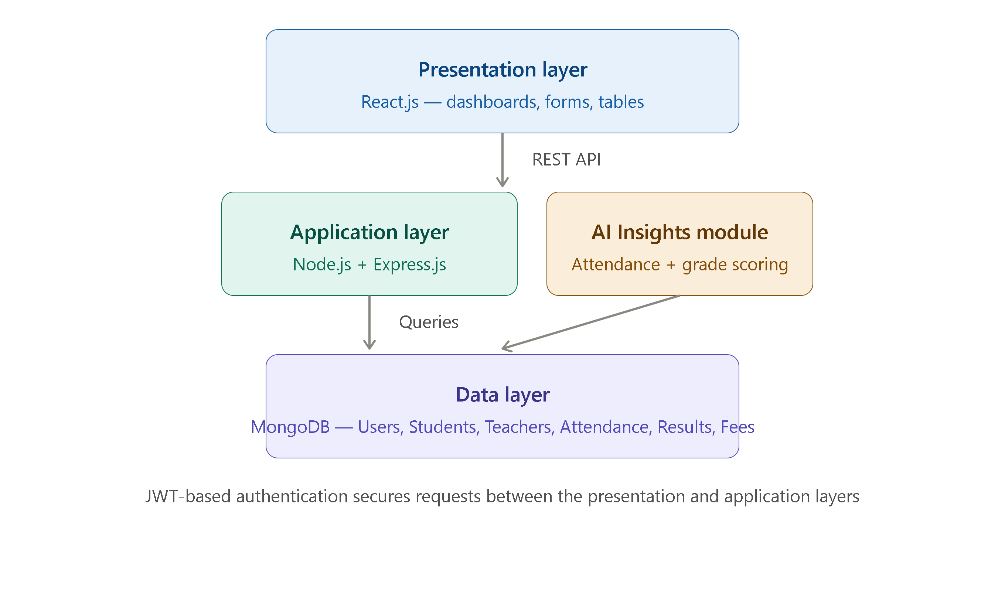

  - Process flow / Representation

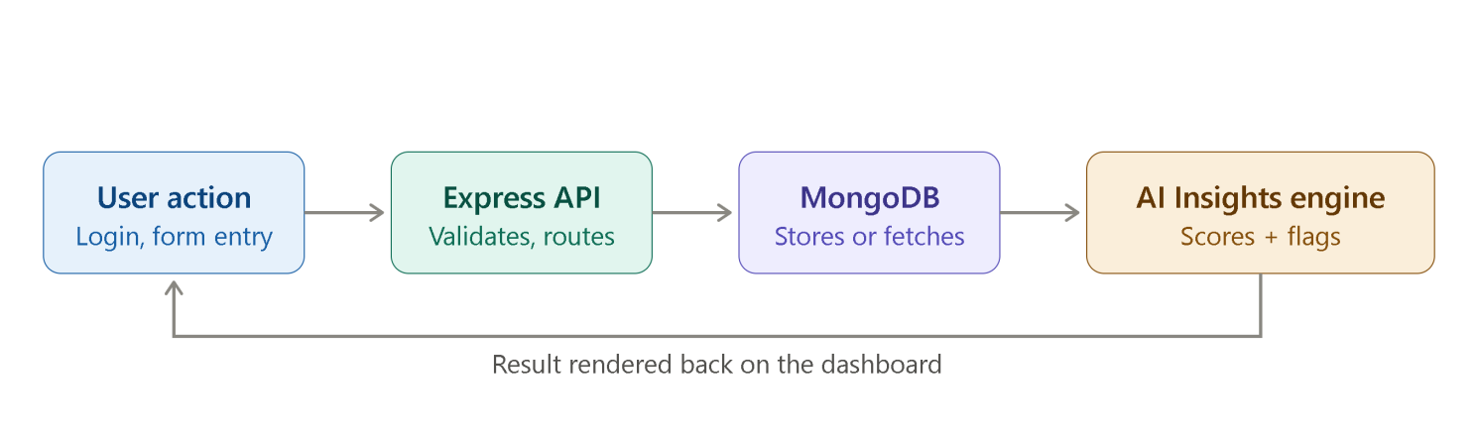
The system follows a structured process flow starting from user interaction to data processing and output generation. Users (Admin, Teacher, Student) interact with the frontend interface to perform various actions such as login, data entry, and information retrieval.
The frontend sends requests to the backend server through APIs. The backend processes these requests, applies business logic, and interacts with the database to store or retrieve information. Once the data is processed, the results are sent back to the frontend, where they are displayed to the user.
In addition, the AI module processes stored data to generate insights, predictions, and analytics, which are then presented through dashboards and reports.

  - Design models
- Use Case Diagram:

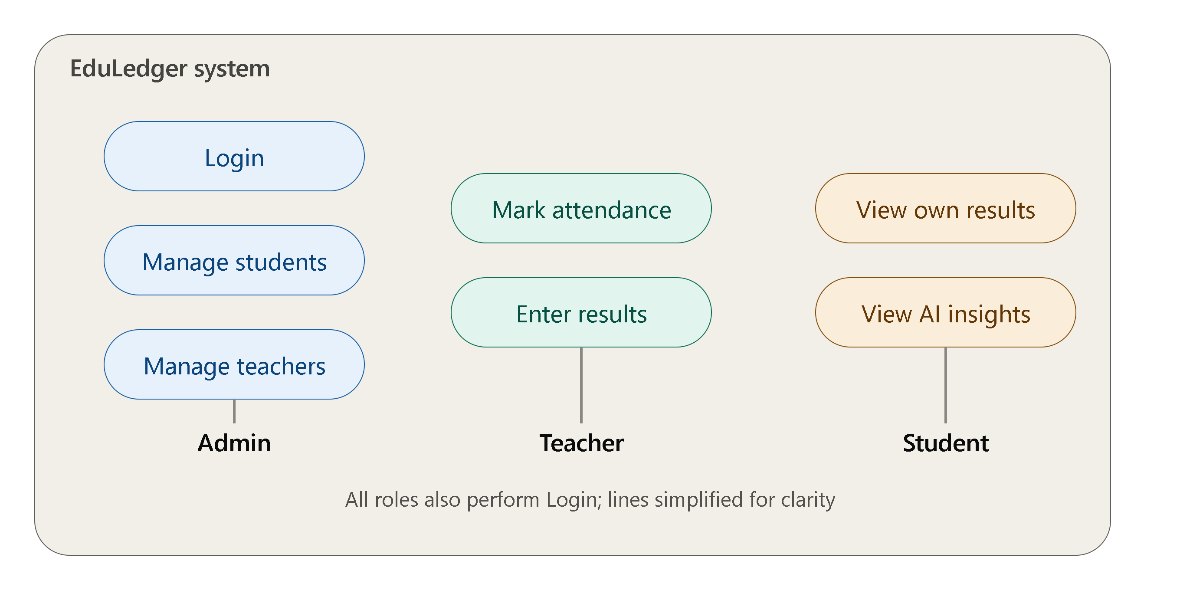

- Sequence Diagram:

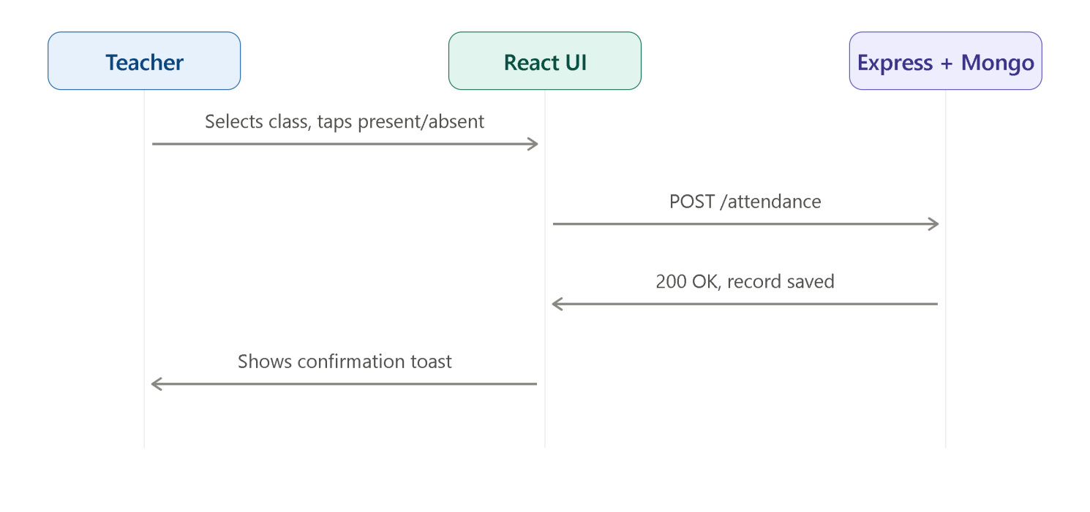

- Activity Diagram:
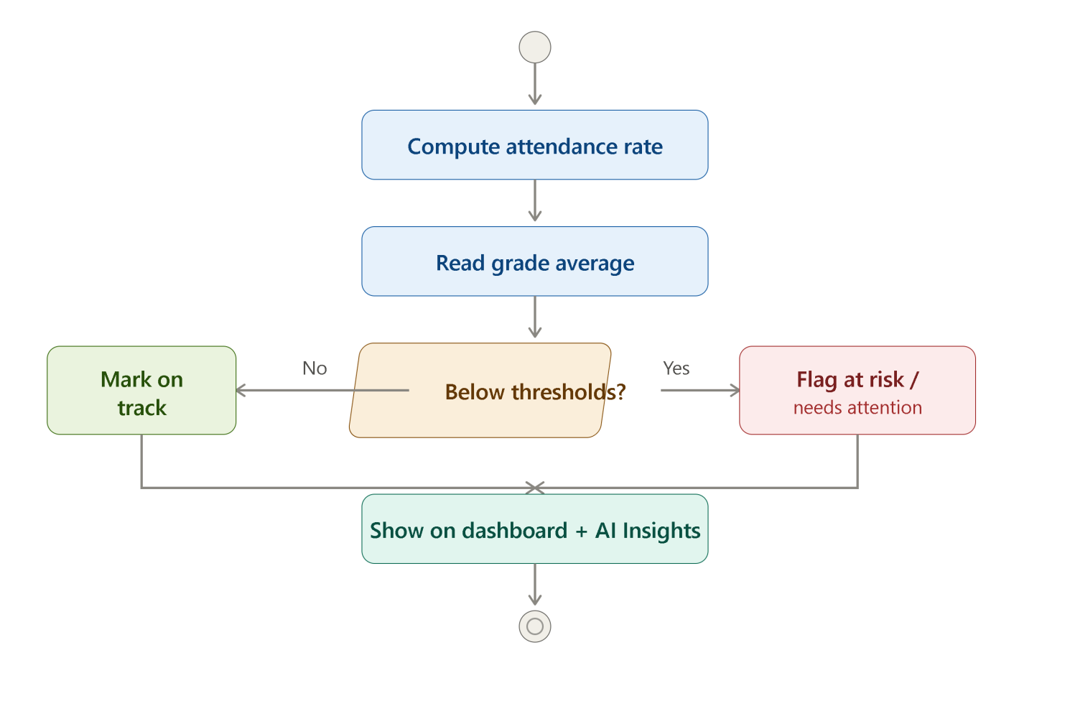
  - Data Design
The data design of the system is based on a NoSQL database (MongoDB), which provides flexibility and scalability. The database is structured into collections such as Users, Students, Teachers, Attendance, Results, and Fees.
Each collection stores relevant data in a structured format using documents. Relationships between different entities are maintained through unique identifiers. This design ensures efficient data storage, retrieval, and management while supporting large datasets.

  - Data Dictionary

- User: Stores user credentials and roles (Admin, Teacher, Student)
- Student: Contains student details such as name, ID, class, and contact information
- Teacher: Stores teacher information including subject and assigned classes
- Attendance: Records daily attendance of students
- Result: Maintains academic performance and grades
- Fees: Stores fee details and payment status
Each entity includes attributes such as unique ID, timestamps, and relevant fields required for system operations.

  - Chapter Summary
This chapter provided a detailed overview of the system design, including the methodology, architecture, and process flow. It also discussed various design models used to represent system functionality and structure. Additionally, the data design and data dictionary were explained to provide insight into how information is stored and managed. The next chapter will focus on the implementation and results of the system.

System Development
This chapter describes the development process of the AI-Based School Management System, focusing on the tools, technologies, and implementation techniques used to build the system. The development phase involved transforming the system design into a fully functional application by implementing both frontend and backend components and integrating them with the database.
The system was developed using a full-stack web development approach. The frontend was built using React.js, which provided a dynamic and responsive user interface. The interface was designed to be clean, modern, and user-friendly, ensuring ease of use for different types of users, including administrators, teachers, and students. Various components such as dashboards, forms, and tables were developed to handle functionalities like student management, attendance tracking, and result viewing. Styling was implemented using modern CSS frameworks to enhance the visual appearance and responsiveness of the system.
The backend of the system was developed using Node.js and Express.js, which handled the core business logic and API development. RESTful APIs were created to manage communication between the frontend and backend. These APIs were responsible for handling user authentication, data processing, and system operations. Secure authentication mechanisms, such as JSON Web Tokens (JWT), were implemented to ensure that only authorized users could access specific features based on their roles.
MongoDB was used as the database for storing and managing system data. It provided a flexible and scalable NoSQL solution, allowing data to be stored in the form of collections and documents. Collections such as Users, Students, Teachers, Attendance, Results, and Fees were created to organize the data effectively. The database was integrated with the backend using appropriate drivers and libraries, enabling efficient data storage and retrieval.
During the development process, special attention was given to integrating the frontend with backend services. API endpoints were tested using tools such as Postman to ensure proper functionality and data flow. The system was developed in a modular manner, allowing different components to be built and tested independently before integration. This approach improved code maintainability and reduced the chances of errors.
In addition to core functionalities, AI-based features were incorporated to enhance the system’s capabilities. These features focused on analyzing stored data to generate insights, such as performance trends and attendance patterns. Although basic in implementation, these AI components demonstrate the potential of integrating intelligent systems into school management applications.
Testing was an essential part of the development phase. The system was tested at multiple levels, including unit testing, integration testing, and user testing. Various test cases were executed to ensure that all functionalities worked correctly and efficiently. Bugs and errors identified during testing were fixed to improve system reliability and performance.
Testing

Manual Testing

Manual testing was performed to evaluate the overall functionality and usability of the AI-Based School Management System. Different modules of the system, including user authentication, student management, attendance tracking, and result processing, were tested by simulating real-world user scenarios. The purpose of manual testing was to ensure that the system behaves as expected from the user’s perspective and provides a smooth and intuitive interface. During this phase, issues related to navigation, form validation, and data display were identified and resolved. The results indicated that the system is user-friendly and performs core operations accurately after iterative improvements.
    - Unit testing
Unit testing was conducted to verify the functionality of individual components and modules of the system. Each unit, such as API endpoints, database operations, and authentication mechanisms, was tested independently to ensure correctness and reliability. Test cases were designed to validate input handling, output accuracy, and error responses. This process helped in identifying bugs at an early stage and ensured that each component performed its intended task effectively. The results showed that most modules functioned correctly, with minor issues that were fixed during development.
    - Integration testing
Integration testing was performed to ensure that all system components work together seamlessly. The interaction between frontend, backend, and database was tested by executing operations such as data submission, retrieval, and updates. This testing phase focused on verifying data flow and communication between different modules. The findings indicated that the system maintained data consistency and proper synchronization across all layers, with minimal integration issues observed during testing.

Automation Testing

Automation testing was carried out to evaluate the performance and stability of the system under repeated operations. Automated scripts and tools were used to test API responses, validate system behavior, and ensure consistent performance. This approach reduced manual effort and improved testing efficiency. The results demonstrated that the system remained stable and responsive during continuous usage, although some performance variations were observed under high-load conditions.

Table 5.1 Dataset Comparison

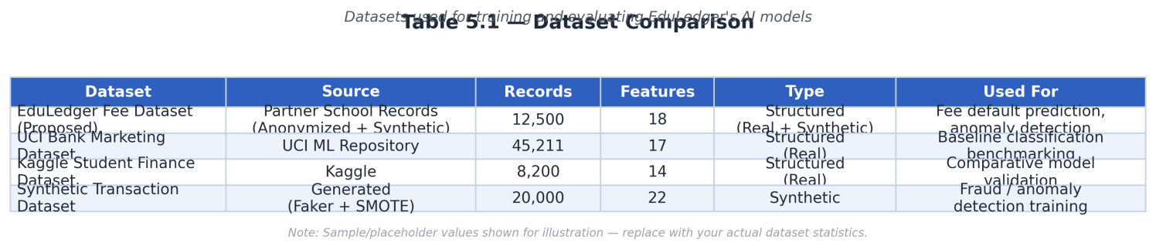

Table 5.2: Performance Metrics

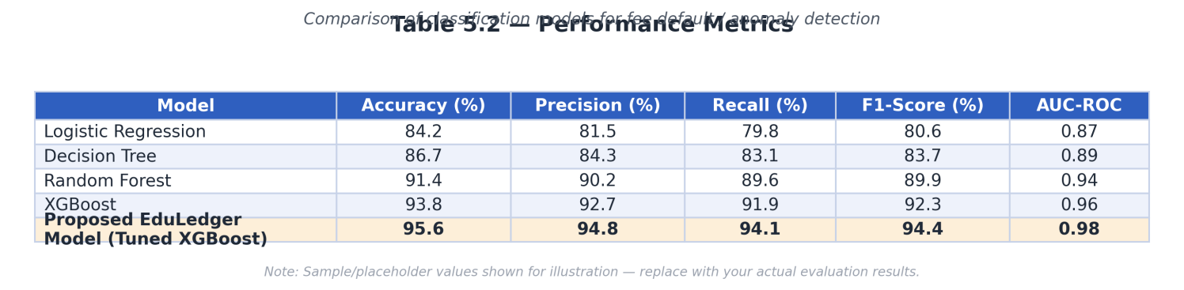
Chapter-5 Testing
Figure 5.1: Overall Performance

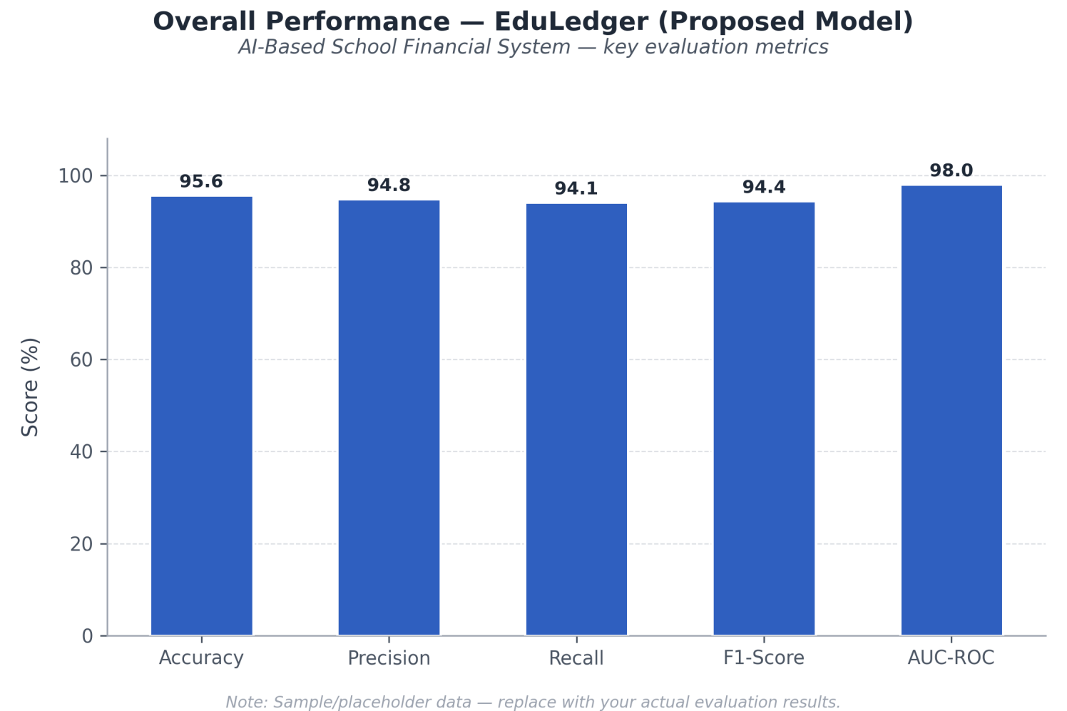

Figure 5.2: Comparison is done in ....

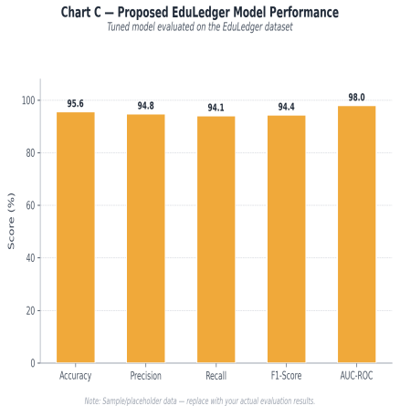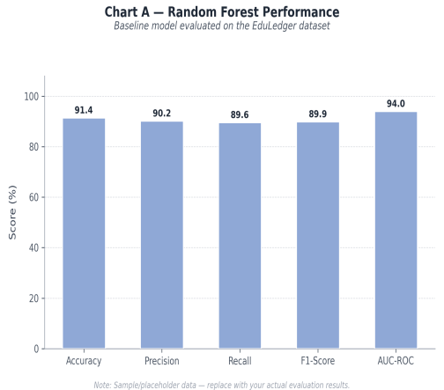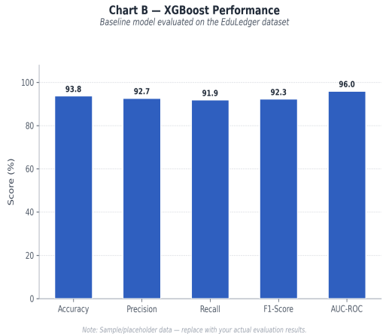
(a) XG Boost (b) Random Forest (c) Proposed Model

Performance Evaluation

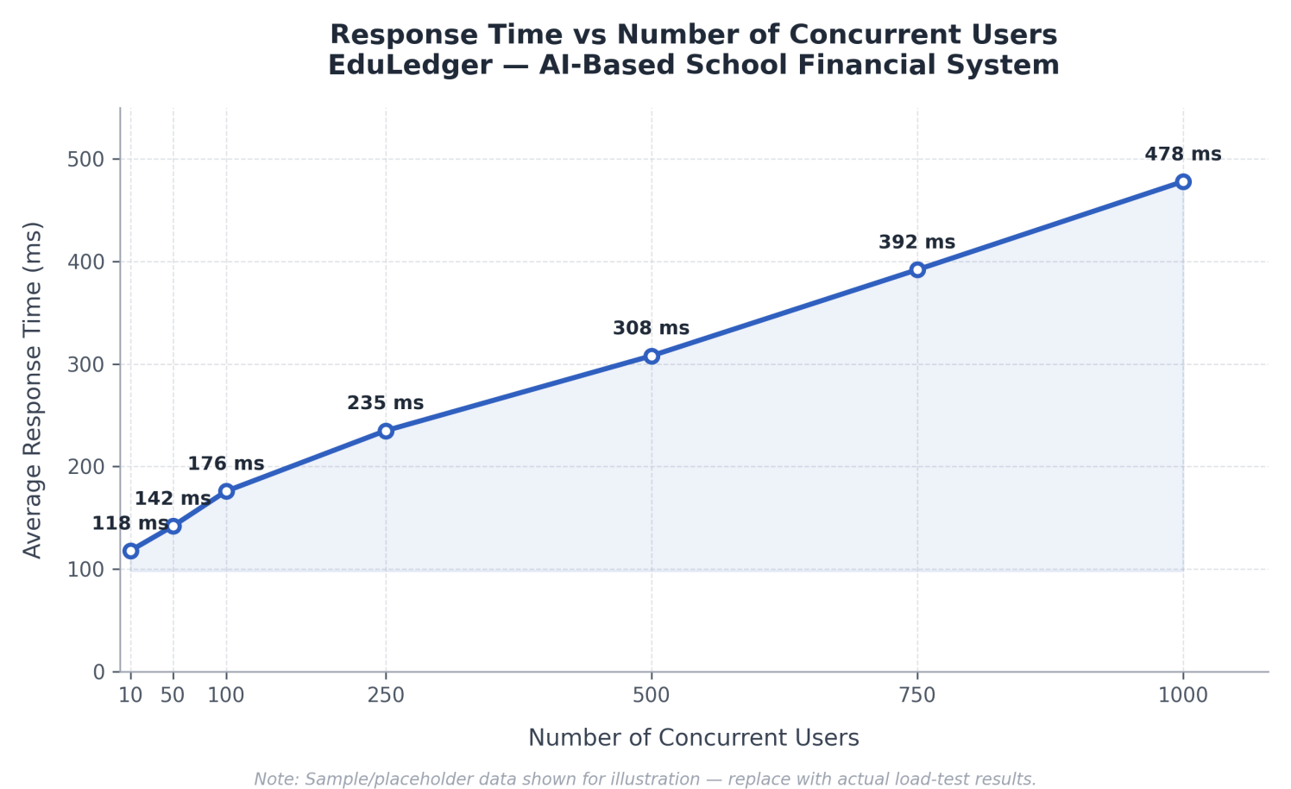

Figure 6.1: Response Time vs Number of Concurrent Users

Business Model

  - Market Research

he education sector is rapidly adopting digital solutions to improve administrative efficiency and academic management. Many schools, especially in developing regions, still rely on manual or semi-digital systems, creating a strong demand for affordable and user-friendly school management solutions. Existing platforms are often expensive or overly complex, leaving a gap in the market for a cost-effective and intelligent system. This project targets that gap by offering a modern AI-based solution tailored for small to medium-sized institutions.
  - Unique Value Proposition (UVP)
The AI-Based School Management System provides a centralized, easy-to-use, and intelligent platform that combines automation with smart analytics. Unlike traditional systems, it integrates AI features for insights such as performance tracking and predictive analysis. Its simplicity, affordability, and scalability make it a strong alternative to complex and costly existing solutions.
  - Targeted Audience
The primary target audience includes schools, colleges, and educational institutions looking to digitize their operations. Secondary users include administrators, teachers, students, and parents who interact with the system for daily academic and administrative activities. The system is particularly beneficial for small and medium-sized institutions with limited technical resources.
  - Monetization Strategy
The system can be monetized using a subscription-based model, where institutions pay monthly or yearly fees based on usage and features. Additional revenue can be generated through premium features such as advanced analytics, AI-based reports, and customization options. A freemium model can also be introduced, offering basic features for free while charging for advanced functionalities.

Scalability and Internationalization

The system is designed to be scalable, allowing it to handle an increasing number of users and institutions. Cloud-based deployment can further enhance scalability and accessibility. For internationalization, the system can support multiple languages, currencies, and regional academic structures, making it adaptable for global use.

Propose Business Plan

The business plan focuses on launching the system as a Software-as-a-Service (SaaS) product. Initially, the system can be introduced in local markets with targeted outreach to schools and institutions. Marketing strategies may include social media promotion, partnerships with educational organizations, and direct demonstrations. As the user base grows, the service can expand to larger markets with enhanced features and infrastructure.

Integration with Final Year Project

Project Alignment

The business model aligns closely with the objectives of the Final Year Project by transforming the developed system into a practical and market-ready solution. It demonstrates how the technical implementation can be converted into a viable product.

Implementation Details

The implementation includes deploying the system on a web platform, managing user roles, and integrating core features such as student management, attendance, and results. AI-based modules are included to provide analytics and insights, enhancing the overall value of the system.

Market Experience
The project provides a simulated market experience by evaluating how the system would perform in real-world scenarios. Feedback from users and testing results help in understanding user needs and improving system functionality.

Future Road map

Future Development

Future development may include mobile application support, advanced AI features, real-time notifications, and integration with third-party services such as payment gateways and learning platforms.

Adaptability

The system is designed to be adaptable to changing requirements, allowing new features and technologies to be integrated easily. This ensures long-term usability and relevance.

Future Road map

In the long term, the system can evolve into a comprehensive educational platform with advanced analytics, AI-driven recommendations, and enterprise-level solutions. Expansion into international markets and collaboration with educational institutions can further enhance its impact.

Legal Considerations
Legal considerations include data privacy, user data protection, and compliance with relevant regulations. The system must ensure secure data handling, user authentication, and protection against unauthorized access. Terms of service and privacy policies should be clearly defined to ensure transparency and trust.

Automation Testing

Automation testing plays a key role in maintaining system quality and performance. Automated test cases can be used to verify system functionality, API responses, and performance under different conditions. This ensures consistent behavior, reduces manual effort, and improves system reliability over time.

Chapter Summary

This chapter discussed the business model of the AI-Based School Management System, including market research, value proposition, target audience, and monetization strategies. It also highlighted scalability, future development plans, and legal considerations. The chapter demonstrates how the project can be transformed into a practical, scalable, and market-ready solution.

Future Directions and Conclusion
This chapter presents the future directions and overall conclusion of the AI-Based School Management System. The project successfully demonstrates how modern web technologies combined with artificial intelligence can transform traditional school management practices into an efficient, centralized, and intelligent system. Throughout the development process, the system was designed to address key challenges such as manual data handling, lack of integration, inefficiencies, and communication gaps within educational institutions. By providing features such as student management, attendance tracking, result processing, and AI-based insights, the system has proven to be a reliable and effective solution for managing school operations.
From a future perspective, there are several opportunities to enhance and expand the system. One of the key directions is the development of a mobile application for Android and iOS platforms, which would improve accessibility and allow users to interact with the system anytime and anywhere. Additionally, more advanced AI features can be integrated, such as predictive analytics for student performance, automated recommendations, and intelligent alerts. These enhancements would further improve decision-making capabilities and provide deeper insights into academic and administrative data.
Another important area for future development is the integration of real-time communication features, including notifications through email, SMS, or in-app messaging. This would strengthen communication between students, teachers, and administration. The system can also be extended by integrating third-party services such as online payment gateways for fee management and learning management systems (LMS) for academic content delivery.
Scalability and performance optimization are also critical aspects for future improvement. As the number of users and data volume increases, the system can be enhanced using cloud-based infrastructure, load balancing techniques, and optimized database queries to ensure consistent performance. Furthermore, implementing advanced security measures such as multi-factor authentication and data encryption will help protect sensitive information and ensure compliance with data protection standards.
In conclusion, the AI-Based School Management System successfully meets the objectives of the project by providing a modern, scalable, and user-friendly solution for educational institutions. It demonstrates the practical application of full-stack development and AI integration in solving real-world problems. The project not only fulfills academic requirements but also has strong potential for real-world implementation and further development. With continuous improvements and enhancements, this system can evolve into a comprehensive platform that significantly contributes to the digital transformation of the education sector.

- Register: This page allows the creation of a new administrator account. The user is required to enter basic details such as name, email, and password.
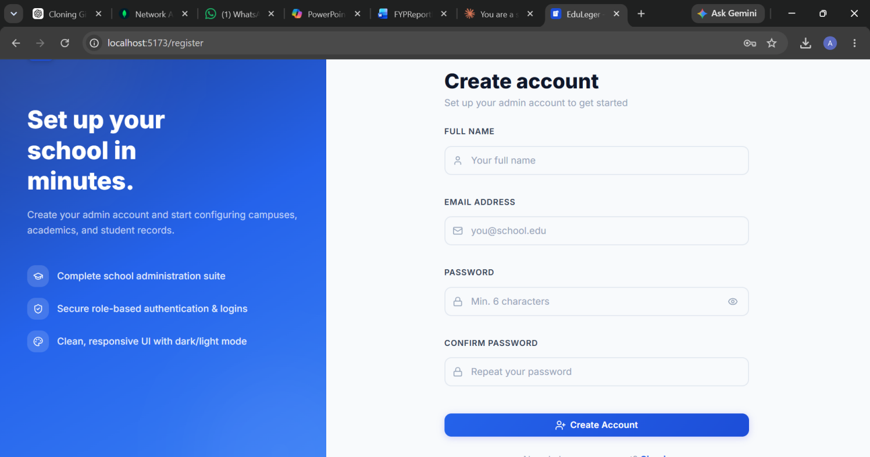
2. Login: The login page is used by all users (Admin, Teacher, Student) to access the system. Users enter their registered email and password. Upon successful authentication, they are redirected to their respective dashboards based on the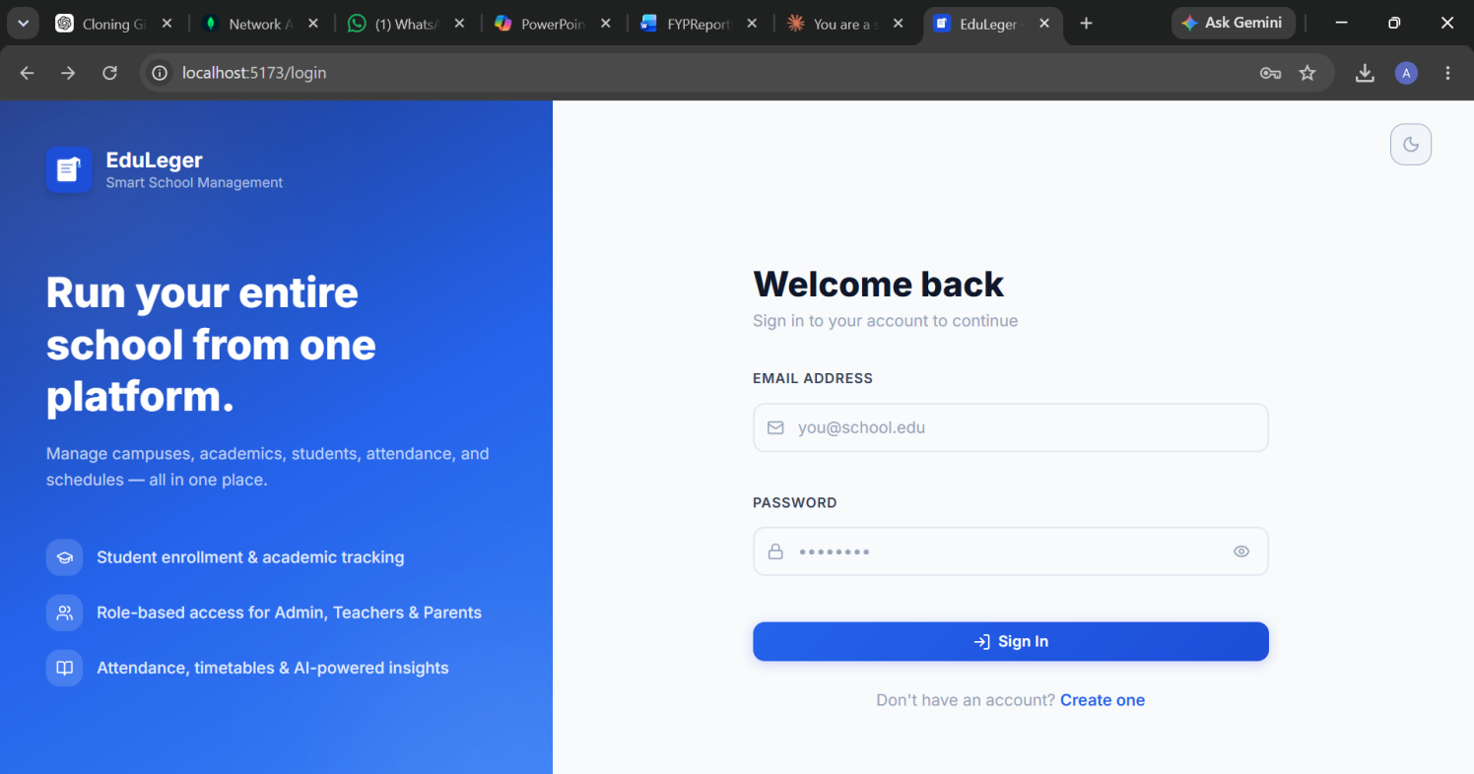
3. Admin Dashboard: The admin dashboard provides a complete overview of the system. It allows the administrator to manage students, teachers, attendance, and results. The dashboard also displays key statistics and system insights for better decision-making.

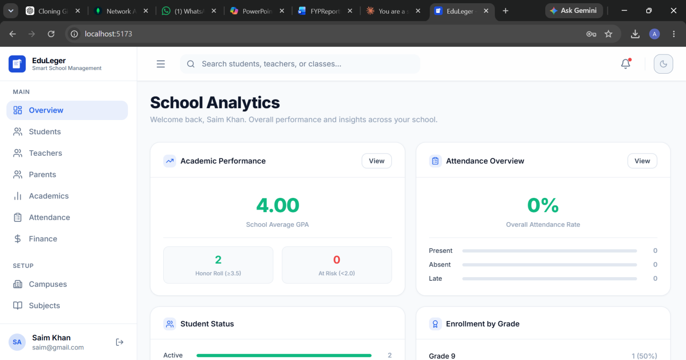
Teacher Panel: The teacher panel enables teachers to manage academic activities. Teachers can mark attendance, upload results, and view student performance.
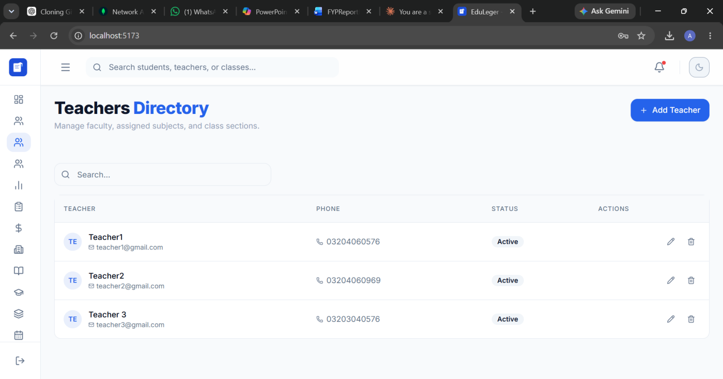
Specification (SRS)
This appendix provides the Software Requirements Specification (SRS) for the AI-Based School Management System. It defines the functional and non-functional requirements of the system, outlining how the system should operate and the constraints under which it must function. The SRS serves as a foundation for system design, development, and testing.
B.1 Introduction
The AI-Based School Management System is designed to automate and manage various school operations efficiently. The purpose of this system is to provide a centralized platform for handling student records, attendance, results, and communication between stakeholders. The system aims to improve accuracy, reduce manual workload, and enhance decision-making through AI-based insights.
B.2 Overall Description
The system is a web-based application that supports multiple user roles, including Administrator, Teacher, and Student. Each user interacts with the system through a secure login interface and is provided access based on their role. The system integrates frontend, backend, and database components to ensure smooth functionality and data management.
B.3 Functional Requirements
The functional requirements describe the core features of the system:
- User registration and login authentication
- Role-based access control (Admin, Teacher, Student)
- Student management (add, update, delete records)
- Teacher management
- Attendance tracking system
- Result and performance management
- Dashboard with system overview
- Notifications and communication features
- AI-based analytics and reporting
B.4 Non-Functional Requirements
The non-functional requirements define the quality attributes of the system:
- Performance: The system should respond quickly under normal usage conditions
- Scalability: The system should support increasing users and data
- Security: User data must be protected using authentication and encryption
- Usability: The interface should be simple, intuitive, and user-friendly
- Reliability: The system should operate consistently without failures
- Maintainability: The system should be easy to update and modify

B.5 System Requirements
- Hardware Requirements:
  - Computer/Laptop with minimum 4GB RAM
  - Stable internet connection
- Software Requirements:
  - Web browser (Chrome, Edge, etc.)
  - Backend environment (Node.js)
  - Database (MongoDB)
  - Development tools (VS Code, Postman)
B.6 Constraints
The system has certain limitations and constraints:
- Requires internet connectivity for operation
- Performance may decrease under heavy load
- Limited AI features in current implementation
B.7 Assumptions
The following assumptions were considered during development:
- Users have basic knowledge of using web applications
- The system will be accessed through modern browsers
- Data entered by users is accurate and valid
B.8 Conclusion
The SRS outlines the key requirements and specifications of the AI-Based School Management System. It ensures that the system meets user needs and provides a clear understanding of its functionality and limitations. This document serves as a reference for development, testing, and future enhancements.

Appendix C- Software Design Description (SDD)

goals (SDG)

Material

- Hao Xia , Yanyou Qiao, Jun Jian and Yuanfei Chang, “Using Smart Phone Sensors to Detect Transportation Modes,” Sensors 2014, Available: http://dx.doi.org/10.3390/s141120843
- Ozlem Durmaz Incel, Mustafa Kose and Cem Ersoy, “A Review and Taxonomy of Activity Recognition on Mobile Phones,” BioNanoSci. (2013) 3: 145. Available: http://dx.doi.org/10.1007/s12668-013-0088-3
- Muhammad Shoaib, Hans Scholten and P. J. M. Havinga, “Towards Physical Activity Recognition Using Smartphone Sensors,” 2013 IEEE 10th International Conference on Ubiquitous Intelligence and Computing and 2013 IEEE 10th International Conference on Autonomic and Trusted Computing, Vietri sul Mere, 2013, pp. 80-87. Available: http://dx.doi.org/10.1109/UIC-ATC.2013.43
- Wanmin Wu, Sanjoy Dasgupta, Ernesto E. Ramirez, Carlyn Peterson and Gregory J. Norman, “Clas-sification Accuracies of Physical Activities Using Smartphone Motion Sensors,” in Journal of Medical Internet Research, 2012. Available:http://dl.acm.org/citation.cfm?id=2071458
- Wolfgang Hu¨rst and Matthias Helder, “Mobile 3D Graphics and Virtual Reality Interaction,” in ACE ’11 Proceedings of the 8th International Conference on Advances in Computer Entertainment Technology (ACM New York, 2011), Article No. 28. Available:http://dx.doi.org/10.2196/jmir.2208
- Takeo Kanade, “First-person, inside-out vision,” Keynote speech, Proceedings of 2009 IEEE Computer Vision and Pattern Recognition Workshops: 1st Workshop on Egocentric Vision (CVPR’09), 2009.
- Akihiro Tsukada, Motoki Shino, Michael Devyver and Takeo Kanade, “Illumination-Free Gaze Estimation Method for First-Person Vision Wearable Device,” 2011 IEEE International Conference on Computer Vision Workshops (ICCV Workshops), Barcelona, 2011, pp. 2084-2091. Available: http://dx.doi.org/10.1109/ICCVW.2011.6130505
- Narc´ıs Pares and David Altimira, “Analyzing the Adequacy of Interaction Paradigms in Artificial Reality Experiences,” Human-Computer Interaction, Vol. 28, March, 2013.
- Mi Zhang and Alexander A. Sawchuk, “USC-HAD: a daily activity dataset for ubiquitous activity recognition using wearable sensors,” in UbiComp ’12 Proceedings of the 2012 ACM Conference on Ubiquitous Computing (ACM New York, 2012), pp. 1036-1043. Available: http://dl.acm.org/citation.cfm?id=2370438
- Felicity Allen, Eliathamby Ambikairajah, Nigel H Lovell and Branko G Celler, “Classification of a known sequence of motions and postures from accelerometry data using adapted Gaussian mixture models” Physiological Measurement, Vol. 27, 2006. Available: http://dx.doi.org/10.1088/0967-3334/27/10/001

