NETWORKING LAB NOTES
Configuring Complex VPNs on MPLS
HBL Head Office and HBL Branch talking privately across a provider network, explained step by step in plain English
The network we are building
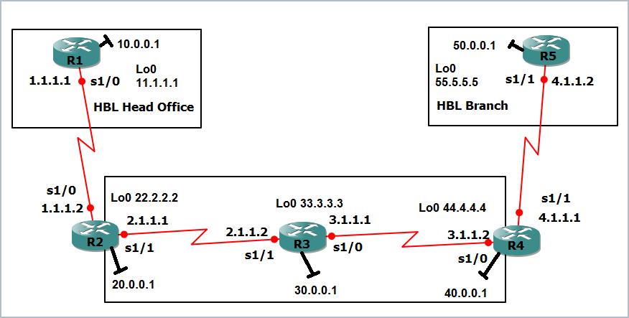
R1 and R5 are the two customer sites. R2, R3 and R4 are the provider. R3 in the middle never learns a single customer route.
PREPARED BY  Ahmed Abbas | TOPIC  MPLS Layer 3 VPN | TOOLS  Cisco IOS routers, GNS3 style lab
What is inside this file
- Part 1: the big idea in plain English, the words you must know, and the order of the lab
- Part 2: both topology diagrams and the full addressing table
- Step 5.0: the IP address commands for every port of all five routers
- Steps 5.1 to 5.10: every configuration step with the output screenshots and a trace of how each result comes about
- Part 3: revision tables, common mistakes and exam questions with model answers
- Corrections: every command in the original sheet that was misspelled or wrong, and the fixed version
- Appendix: the complete final configuration of R1 to R5, ready to paste

PART 1 The Big Picture (start here)
If MPLS VPN feels scary, forget the commands for a minute. This part explains the whole idea from zero. Once the idea is clear, every command in the lab will make sense.

What problem are we solving?
HBL has a Head Office and a Branch in different places. They must reach each other like they are on one private network. But the cables between them belong to a provider (a telecom company) that also carries traffic for other customers. So we need two things at the same time:
- Privacy: the provider must keep each customer separate, even if two customers use the same IP addresses.
- Speed and simplicity: the routers in the middle of the provider network should not need to know every customer route.
An MPLS Layer 3 VPN does both.

The courier analogy
PLAIN ENGLISH Think of a courier company
The provider is a courier company. HBL Head Office posts a parcel (an IP packet) to HBL Branch. The courier puts the parcel in an envelope and sticks two stickers on it:
Inner sticker (VPN label): tells the last depot which customer shelf the parcel belongs to (VRF A or VRF B).
Outer sticker (MPLS label): tells the middle depots which road to take to reach the last depot. The middle depots read only this sticker and never open the envelope.
That is why R3, the middle router, does not need any customer routes.

Who is who: the words you must know
Word | Plain-English meaning | In this lab
CE  Customer Edge | The customer's own router at the edge of their site. | R1 (Head Office), R5 (Branch)
PE  Provider Edge | The provider's router that touches the customer. It is the smart one: it knows the customer routes. | R2 and R4
P  Provider | A provider router inside the core. It only swaps labels. | R3
MPLS | Forwarding by a short label stuck in front of the packet instead of reading the IP address at every hop. | R2, R3, R4
LDP | The protocol neighbours use to tell each other: "for network X, use label Y". | Runs between R2-R3 and R3-R4
LFIB | The label table of a router. Shown with show mpls forwarding-table. | R2, R3, R4
VRF | A private routing table inside one router, like a virtual router. One VRF per customer. | VRF A on R2, VRF B on R4
RD  Route Distinguisher | A stamp added in front of a route so two customers with the same address never clash. | 12:1 on R2, 12:2 on R4
RT  Route Target | A tag on a route that says who is allowed to take it. Export = "I attach this tag". Import = "I accept routes with this tag". | 1:1 for Head Office, 1:2 for Branch
MP-BGP  VPNv4 | BGP that can carry VPN routes (RD + address + label) between PEs. | R2 and R4, AS 10

MEMORY TRICK Two easy tricks
RD = Route Different. It makes the route different (unique). RT = Route Target. It decides who the route is aimed at.
CE / PE / P: C is the Customer, P is the Provider. The E in the middle is Edge. The lonely P in the centre of the network is the plain core router.

The order of the lab (memorise this line)
The lab has nine building steps and one verification step. The first letters of this sentence match the nine steps in order:
MEMORY TRICK "Our Modern Villa Always Offers Big Rooms In Reserve"
OSPF core (5.1) MPLS (5.2) VRF create (5.3) Assign VRF (5.4) OSPF on customers (5.5) BGP (5.6) Redistribute OSPF into BGP (5.7) Import RT (5.8) Redistribute BGP into OSPF (5.9). Then 5.10 is the check.

Before step 5.1 there is a preparation step, 5.0, where we put an IP address on every port of every router. Nothing else works until this is done.
Step | What we do | Routers | Why we need it
5.0 | Assign IP addresses to every port | R1 to R5 | Routers cannot talk without addresses
5.1 | Run OSPF 1 in the provider core | R2, R3, R4 | So the PEs and P can reach each other's loopbacks
5.2 | Turn on MPLS and LDP | R2, R3, R4 | So the core can forward using labels
5.3 | Create VRFs with RD and RT | R2 (A), R4 (B) | To build one private table per customer
5.4 | Put the customer-facing interfaces into the VRFs | R2, R4 | So customer traffic uses its own table
5.5 | Run OSPF 10 between CE and PE | R1-R2, R5-R4 | So each PE learns its customer's routes
5.6 | Bring up MP-BGP between the PEs | R2, R4 | A road to carry VPN routes across the core
5.7 | Redistribute OSPF 10 into BGP | R2, R4 | Put customer routes onto that road
5.8 | Import each other's route-target | R2, R4 | So Head Office and Branch accept each other's routes
5.9 | Redistribute BGP back into OSPF 10 | R2, R4 | So R1 and R5 learn the far-side routes
5.10 | Verify and trace a packet | All | Prove it works and see the labels

PART 2 Topology and Addressing
Two pictures describe the lab. The first shows the real cables and IP addresses. The second shows the logical design: which routing protocol lives where.
Figure 1. Physical topology with interface names and IP addresses
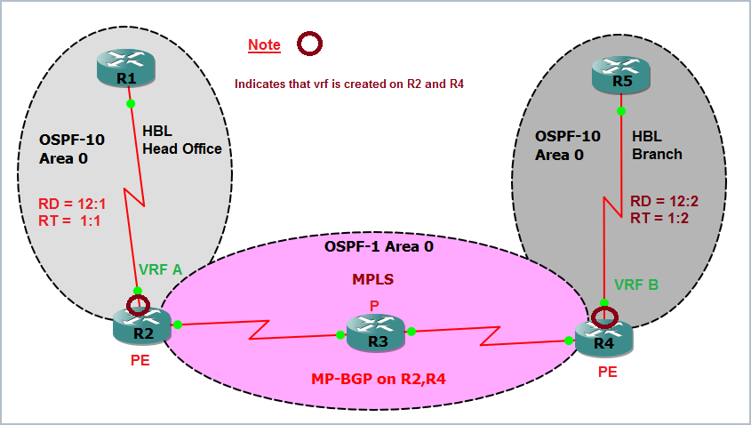
Figure 2. Logical design: OSPF areas, VRFs, RD and RT values, MP-BGP between the PEs
PLAIN ENGLISH How to read the logical picture
The grey bubbles are the two customers. The pink oval is the provider (OSPF 1 plus MPLS). The red ring on R2 and R4 means "a VRF is created here". The text RD and RT next to each customer are the values you will configure in step 5.3.

Addressing table
Every interface uses a /8 mask (255.0.0.0) and every loopback is a /32. The exact commands that put these addresses on every port are in Step 5.0, right after this page.
Router | Role | Serial links | FastEthernet 0/0 | Loopback 0 (/32)
R1 | CE, HBL Head Office | S1/0 1.1.1.1 | 10.0.0.1 | 11.1.1.1
R2 | PE (VRF A) | S1/0 1.1.1.2 (to R1)  S1/1 2.1.1.1 (to R3) | 20.0.0.1 | 22.2.2.2
R3 | P (core) | S1/1 2.1.1.2 (to R2)  S1/0 3.1.1.1 (to R4) | 30.0.0.1 | 33.3.3.3
R4 | PE (VRF B) | S1/0 3.1.1.2 (to R3)  S1/1 4.1.1.1 (to R5) | 40.0.0.1 | 44.4.4.4
R5 | CE, HBL Branch | S1/1 4.1.1.2 | 50.0.0.1 | 55.5.5.5

Which protocol runs where
Zone | Protocol | Routers | Networks
Provider core | OSPF process 1, area 0 | R2, R3, R4 | 2.0.0.0, 3.0.0.0, 20/30/40.0.0.0 and the three loopbacks
Customer 1 (Head Office) | OSPF process 10, area 0 | R1 and R2 (inside VRF A) | 1.0.0.0, 10.0.0.0, 11.1.1.1
Customer 2 (Branch) | OSPF process 10, area 0 | R5 and R4 (inside VRF B) | 4.0.0.0, 50.0.0.0, 55.5.5.5
Between the PEs | MP-BGP, AS 10 (iBGP) | R2 and R4 loopbacks | VPNv4 routes for both customers

IMPORTANT Same number, different worlds
Both customers use "OSPF 10". That is fine. An OSPF process number is only a local name on one router. Customer 1 and Customer 2 never meet in the same routing table.
Notice that the customer links 1.0.0.0 and 4.0.0.0 are not advertised in OSPF 1. Customer networks must stay out of the core.

STEP 5.0 Assign IP Addresses on Every Port
Goal: give every interface of every router its address from the addressing table, and switch it on. Each router has three kinds of port: a Loopback0 (a virtual port that never goes down), a FastEthernet0/0 (the small LAN behind the router) and one or two Serial ports (the long links between routers). Loopbacks use a /32 mask (255.255.255.255). Everything else uses /8 (255.0.0.0).
PLAIN ENGLISH Two commands you must not forget
ip address <address> <mask> gives the port its address. no shutdown switches the port on. A router port is off by default, so an address alone is not enough.

R1 (3 ports: Loopback0, Fa0/0, Serial1/0)
Router>enable
Router#configure terminal
Router(config)#hostname R1
R1(config)#interface Loopback0
R1(config-if)#ip address 11.1.1.1 255.255.255.255
R1(config-if)#exit
R1(config)#interface FastEthernet0/0
R1(config-if)#ip address 10.0.0.1 255.0.0.0
R1(config-if)#no shutdown
R1(config-if)#exit
R1(config)#interface Serial1/0
R1(config-if)#ip address 1.1.1.1 255.0.0.0
R1(config-if)#no shutdown
R1(config-if)#exit

R2 (4 ports: Loopback0, Fa0/0, Serial1/0 to R1, Serial1/1 to R3)
Router(config)#hostname R2
R2(config)#interface Loopback0
R2(config-if)#ip address 22.2.2.2 255.255.255.255
R2(config-if)#exit
R2(config)#interface FastEthernet0/0
R2(config-if)#ip address 20.0.0.1 255.0.0.0
R2(config-if)#no shutdown
R2(config-if)#exit
R2(config)#interface Serial1/0
R2(config-if)#ip address 1.1.1.2 255.0.0.0
R2(config-if)#no shutdown
R2(config-if)#exit
R2(config)#interface Serial1/1
R2(config-if)#ip address 2.1.1.1 255.0.0.0
R2(config-if)#no shutdown
R2(config-if)#exit

R3 (4 ports: Loopback0, Fa0/0, Serial1/1 to R2, Serial1/0 to R4)
Router(config)#hostname R3
R3(config)#interface Loopback0
R3(config-if)#ip address 33.3.3.3 255.255.255.255
R3(config-if)#exit
R3(config)#interface FastEthernet0/0
R3(config-if)#ip address 30.0.0.1 255.0.0.0
R3(config-if)#no shutdown
R3(config-if)#exit
R3(config)#interface Serial1/1
R3(config-if)#ip address 2.1.1.2 255.0.0.0
R3(config-if)#no shutdown
R3(config-if)#exit
R3(config)#interface Serial1/0
R3(config-if)#ip address 3.1.1.1 255.0.0.0
R3(config-if)#no shutdown
R3(config-if)#exit

R4 (4 ports: Loopback0, Fa0/0, Serial1/0 to R3, Serial1/1 to R5)
Router(config)#hostname R4
R4(config)#interface Loopback0
R4(config-if)#ip address 44.4.4.4 255.255.255.255
R4(config-if)#exit
R4(config)#interface FastEthernet0/0
R4(config-if)#ip address 40.0.0.1 255.0.0.0
R4(config-if)#no shutdown
R4(config-if)#exit
R4(config)#interface Serial1/0
R4(config-if)#ip address 3.1.1.2 255.0.0.0
R4(config-if)#no shutdown
R4(config-if)#exit
R4(config)#interface Serial1/1
R4(config-if)#ip address 4.1.1.1 255.0.0.0
R4(config-if)#no shutdown
R4(config-if)#exit

R5 (3 ports: Loopback0, Fa0/0, Serial1/1)
Router(config)#hostname R5
R5(config)#interface Loopback0
R5(config-if)#ip address 55.5.5.5 255.255.255.255
R5(config-if)#exit
R5(config)#interface FastEthernet0/0
R5(config-if)#ip address 50.0.0.1 255.0.0.0
R5(config-if)#no shutdown
R5(config-if)#exit
R5(config)#interface Serial1/1
R5(config-if)#ip address 4.1.1.2 255.0.0.0
R5(config-if)#no shutdown
R5(config-if)#exit

IMPORTANT Two things to know
On R2 Serial1/0 and R4 Serial1/1 the address is typed again in step 5.4, because moving a port into a VRF erases its address. Typing it here first matches the original lab, and the router prints a warning when the VRF removes it.
If you use real serial cables instead of GNS3, add clock rate 64000 on the DCE end of each serial link. GNS3 does not need it.

Quick check: did the addresses go in?
Check commands
R1#show ip interface brief
R1#ping 1.1.1.2
R2#ping 2.1.1.2
R3#ping 3.1.1.2
R4#ping 4.1.1.2

Every port should show up / up, and each ping to the neighbour at the other end of the cable should show five exclamation marks. If a port shows administratively down, you forgot no shutdown.

STEP 5.1 Configure OSPF in the Provider Core
Goal: make R2, R3 and R4 able to reach each other, especially their loopbacks (22.2.2.2, 33.3.3.3, 44.4.4.4). Later, LDP and BGP will use those loopbacks as their identity. OSPF process 1, area 0, is run on R2, R3 and R4 only.
R2
R2(config)#router ospf 1
R2(config-router)#network 2.0.0.0 0.255.255.255 area 0
R2(config-router)#network 22.2.2.2 0.0.0.0 area 0
R2(config-router)#network 20.0.0.0 0.255.255.255 area 0
R2(config-router)#exit

R3
R3(config)#router ospf 1
R3(config-router)#network 2.0.0.0 0.255.255.255 area 0
R3(config-router)#network 3.0.0.0 0.255.255.255 area 0
R3(config-router)#network 33.3.3.3 0.0.0.0 area 0
R3(config-router)#network 30.0.0.0 0.255.255.255 area 0
R3(config-router)#exit

R4
R4(config)#router ospf 1
R4(config-router)#network 3.0.0.0 0.255.255.255 area 0
R4(config-router)#network 44.4.4.4 0.0.0.0 area 0
R4(config-router)#network 40.0.0.0 0.255.255.255 area 0
R4(config-router)#exit

PLAIN ENGLISH Reading a network command
network 2.0.0.0 0.255.255.255 area 0 means: "any interface whose address starts with 2 joins OSPF area 0". In the wildcard mask, 0 means the number must match and 255 means I do not care. So 0.255.255.255 matches the whole 2.x.x.x block, while 0.0.0.0 matches one exact address (used for loopbacks). The lab types a 0, which is just a short form of area 0.

Result: the routing tables (5.1.1)
Command used on every router: show ip route. R1 and R5 only show directly connected networks, because they are customers and OSPF 10 is not running yet.
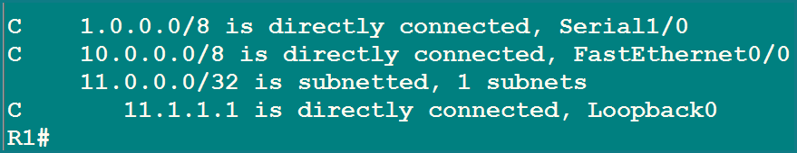
Figure 3. R1 routing table: connected routes only
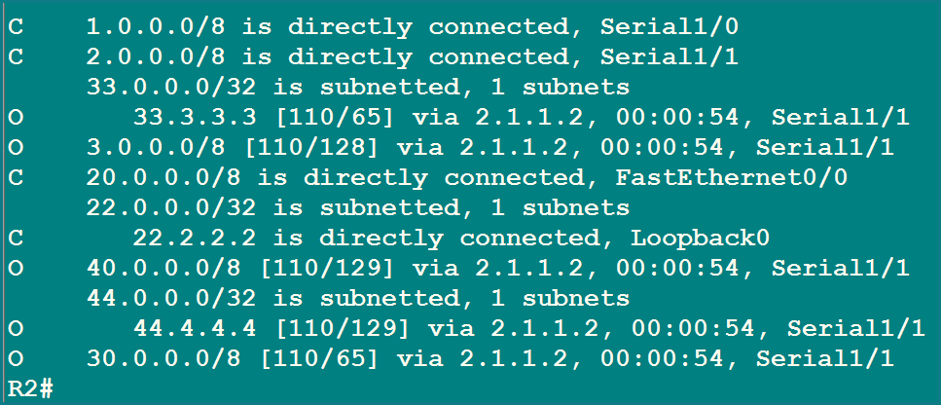
Figure 4. R2 routing table: learns 33.3.3.3, 3.0.0.0, 30.0.0.0, 40.0.0.0, 44.4.4.4 through OSPF
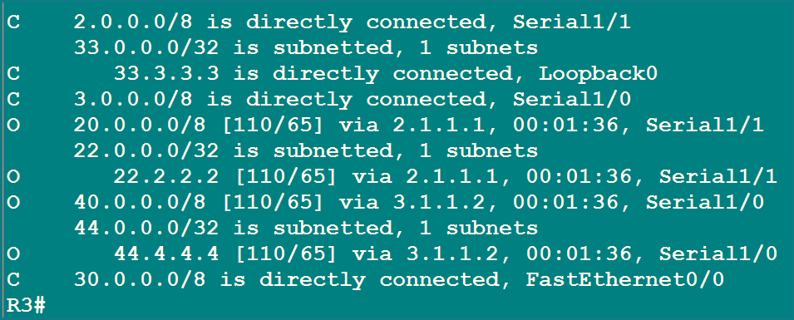
Figure 5. R3 routing table: learns both sides of the core
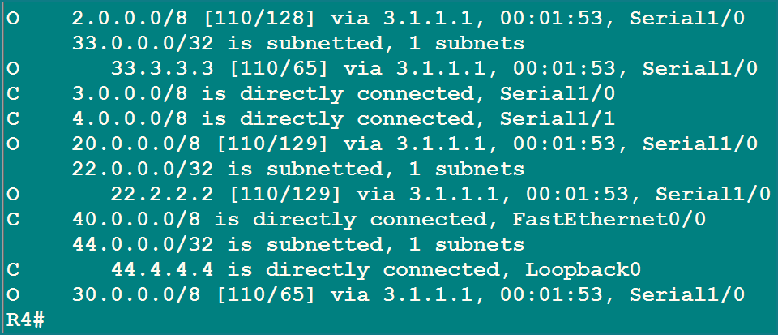
Figure 6. R4 routing table: learns 2.0.0.0, 20.0.0.0, 22.2.2.2 and the rest
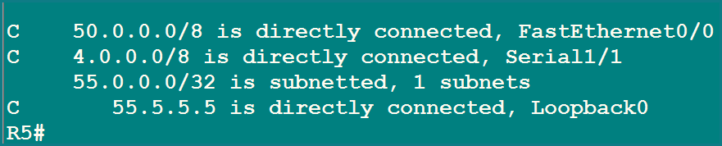
Figure 7. R5 routing table: connected routes only

Trace: where do the metric numbers come from?
OSPF cost is a score, and lower is better. A serial link (1.544 Mbps) costs 64. FastEthernet and loopback cost 1. Add the cost of every link on the way. Look at R2's table:
Route on R2 | Metric | How it is built
33.3.3.3/32 (R3 loopback) | 65 | 64 (serial R2 to R3) + 1 (loopback) = 65
30.0.0.0/8 (R3 LAN) | 65 | 64 (serial R2 to R3) + 1 (FastEthernet) = 65
3.0.0.0/8 (R3-R4 link) | 128 | 64 + 64 (two serial links) = 128
44.4.4.4/32 (R4 loopback) | 129 | 64 + 64 + 1 (loopback) = 129
40.0.0.0/8 (R4 LAN) | 129 | 64 + 64 + 1 (FastEthernet) = 129

MEMORY TRICK Cost trick
Serial = 64, everything fast (FastEthernet, loopback) = 1. Count the serial hops, multiply by 64, then add 1 at the end.

STEP 5.2 Configure MPLS (LDP)
Goal: let the three provider routers forward packets using labels. MPLS is turned on only on the links inside the provider. The customer-facing interfaces (R2 S1/0 and R4 S1/1) stay without MPLS.
R2
R2(config)#ip cef
R2(config)#mpls ip
R2(config)#mpls label protocol ldp
R2(config)#mpls ldp router-id Loopback0
R2(config)#interface Serial1/1
R2(config-if)#mpls ip
R2(config-if)#mpls label protocol ldp
R2(config-if)#exit

R3
R3(config)#ip cef
R3(config)#mpls ip
R3(config)#mpls label protocol ldp
R3(config)#mpls ldp router-id Loopback0
R3(config)#interface Serial1/1
R3(config-if)#mpls ip
*Sep 10 01:01:15.771: %LDP-5-NBRCHG: LDP Neighbor 22.2.2.2:0 (1) is UP
R3(config)#interface Serial1/0
R3(config-if)#mpls ip
R3(config-if)#exit

R4
R4(config)#ip cef
R4(config)#mpls ip
R4(config)#mpls label protocol ldp
R4(config)#mpls ldp router-id Loopback0
R4(config)#interface Serial1/0
R4(config-if)#mpls ip
R4(config-if)#exit
*Sep 10 01:02:54.295: %LDP-5-NBRCHG: LDP Neighbor 33.3.3.3:0 (1) is UP

Command | What it does in plain English
ip cef | Turns on the fast forwarding engine. MPLS needs it, so always type it first.
mpls ip | Switches MPLS on (globally, and then on each core interface).
mpls label protocol ldp | Chooses LDP as the way to share labels with neighbours.
mpls ldp router-id Loopback0 | Uses the loopback as the LDP identity. A loopback never goes down, so the identity stays stable.
interface ... / mpls ip | Tells the router to send and receive labelled packets on this link.

PLAIN ENGLISH What the log message says
The message "LDP Neighbor 22.2.2.2:0 is UP" appears on R3 as soon as R2 and R3 both have MPLS on the link. The address is the neighbour's LDP router-id (its loopback), and the :0 is the label space number. The second message on R4 says R4 and R3 became LDP neighbours.

Result: the label table, LFIB (5.2.1)
Command: show mpls forwarding-table. Each router builds a table saying: "if a packet arrives with this local label, do this."
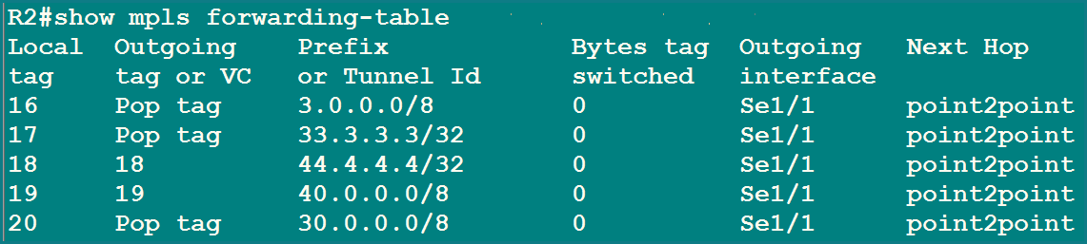
Figure 8. R2 label table
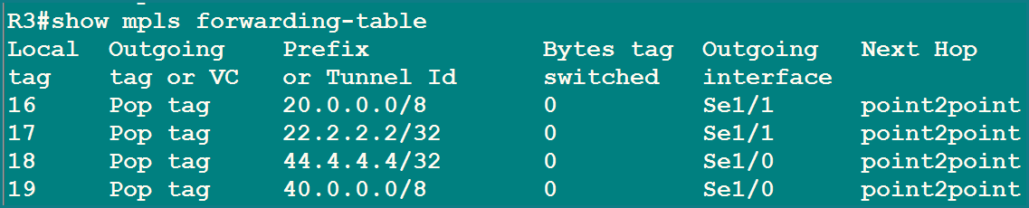
Figure 9. R3 label table
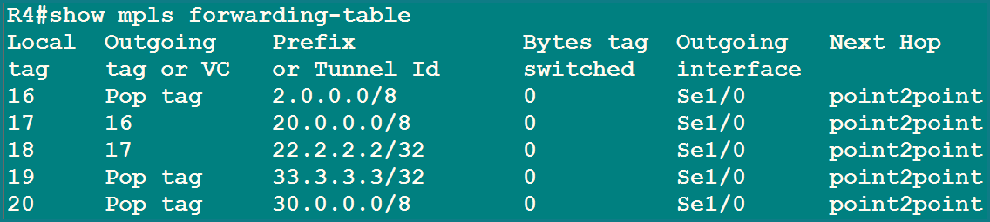
Figure 10. R4 label table

How to read one line
Column | Meaning
Local tag | The label this router gave out. Neighbours put this label on packets they send here.
Outgoing tag or VC | What to do next. A number means "swap to this label". Pop tag means "remove the label" (the next router is the end of the road for this prefix).
Prefix | The network this label belongs to.
Bytes tag switched | How many bytes have been forwarded by label so far.
Outgoing interface / Next hop | Which link the packet leaves from. "point2point" is shown because serial links have no MAC address.

Trace: proving the labels chain together
Take R2 sending traffic to R4's loopback and LAN. R2 uses the label that R3 promised. Compare the tables:
Prefix | R2 sends label (outgoing) | R3 announced (local label)
44.4.4.4/32 | 18 | 18, Pop tag, out Se1/0. Match.
40.0.0.0/8 | 19 | 19, Pop tag, out Se1/0. Match.

The same check works from the other side. R4 sends label 16 for 20.0.0.0/8 and label 17 for 22.2.2.2/32, and R3's local labels 16 and 17 are exactly those prefixes. Because R3 is the last hop before R4, R3 pops the label for R4's prefixes. This is called penultimate hop popping.
MEMORY TRICK Pop = drop the sticker
"Pop tag" means the router peels the label off. Swap means replace the old sticker with a new one.

IMPORTANT Your label numbers may differ
The label numbers are handed out by each router when it boots. In the later verification (5.10) the tables show slightly different numbers, for example R2 uses label 19 for 44.4.4.4/32 there. Always read the numbers from the table you are looking at; the logic is what matters.

STEP 5.3 Creating VRFs
Goal: on the two PE routers, create one private routing table per customer. A VRF (Virtual Routing and Forwarding instance) is like a separate mini-router living inside R2 (for Head Office) and inside R4 (for Branch).
R2
R2(config)#ip vrf A
R2(config-vrf)#rd 12:1
R2(config-vrf)#route-target 1:1
R2(config-vrf)#exit

R4
R4(config)#ip vrf B
R4(config-vrf)#rd 12:2
R4(config-vrf)#route-target 1:2
R4(config-vrf)#exit

Router | VRF name | RD | Route-target
R2 | A (Head Office) | 12:1 | 1:1
R4 | B (Branch) | 12:2 | 1:2

PLAIN ENGLISH RD and RT are not the same thing
RD (12:1, 12:2) is glued to the front of every route from that VRF, so identical addresses from different customers stay different inside BGP.
RT (1:1, 1:2) is a tag riding with the route. route-target 1:1 with no extra word means both directions: export 1:1 and import 1:1. Right now each VRF only accepts its own tag, so the two customers cannot see each other yet. Step 5.8 fixes that on purpose.

Result: the empty virtual routing tables (5.3.1)
Command: show ip route vrf A (on R2) and show ip route vrf B (on R4). Both are empty, because no interface has been placed in a VRF yet.
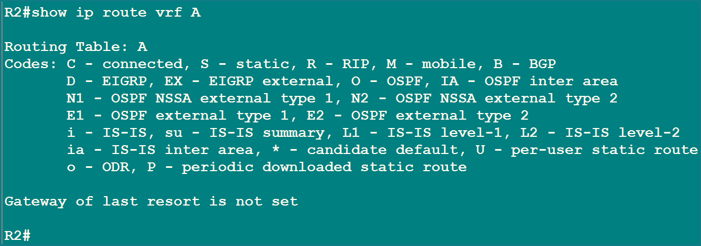
Figure 11. R2: VRF A exists but has no routes
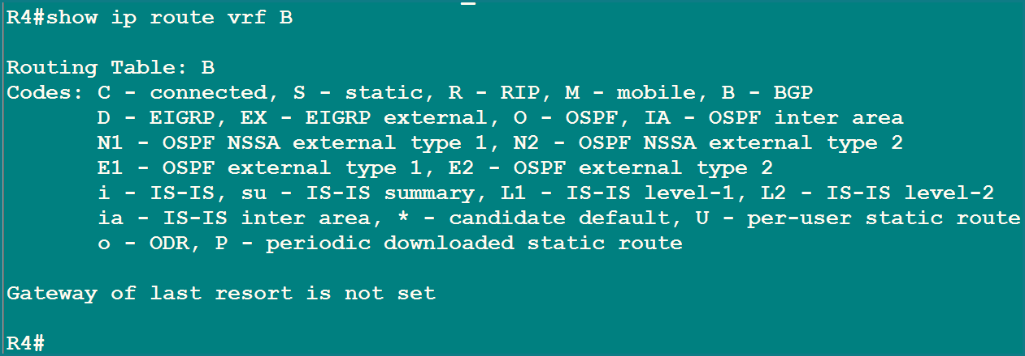
Figure 12. R4: VRF B exists but has no routes

STEP 5.4 Assigning VRFs to Interfaces
Goal: move the customer-facing interface of each PE into its VRF. Now traffic from R1 arrives in VRF A, and traffic from R5 arrives in VRF B.
R2
R2(config)#interface Serial1/0
R2(config-if)#ip vrf forwarding A
% Interface Serial1/0 IP address 1.1.1.2 removed due to enabling VRF A
R2(config-if)#ip address 1.1.1.2 255.0.0.0
R2(config-if)#exit

R4
R4(config)#interface Serial1/1
R4(config-if)#ip vrf forwarding B
% Interface Serial1/1 IP address 4.1.1.1 removed due to enabling VRF B
R4(config-if)#ip address 4.1.1.1 255.0.0.0
R4(config-if)#exit

IMPORTANT The IP address disappears, so type it again
The router warns that the IP address was removed. This always happens when you change an interface's VRF. Just type the same address again straight after.

Result: global table versus virtual table (5.4.1)
Commands: show ip route and show ip route vrf A. Network 1.0.0.0/8 has moved out of the global table on R2 and into VRF A. In the same way 4.0.0.0/8 has moved from the global table into VRF B on R4.
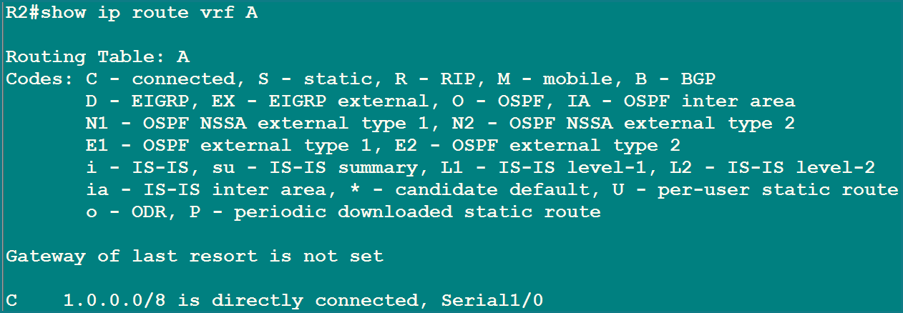
Figure 13. R2 VRF A now holds 1.0.0.0/8
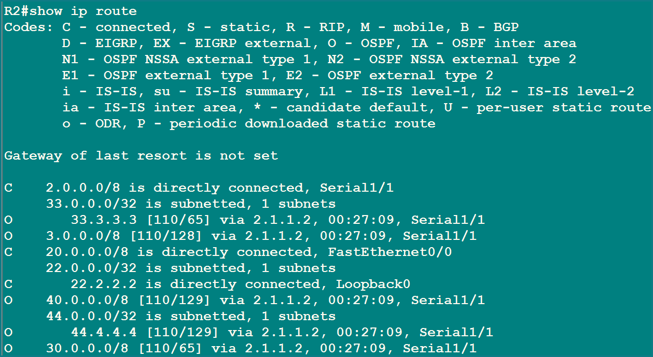
Figure 14. R2 global table: 1.0.0.0/8 is gone
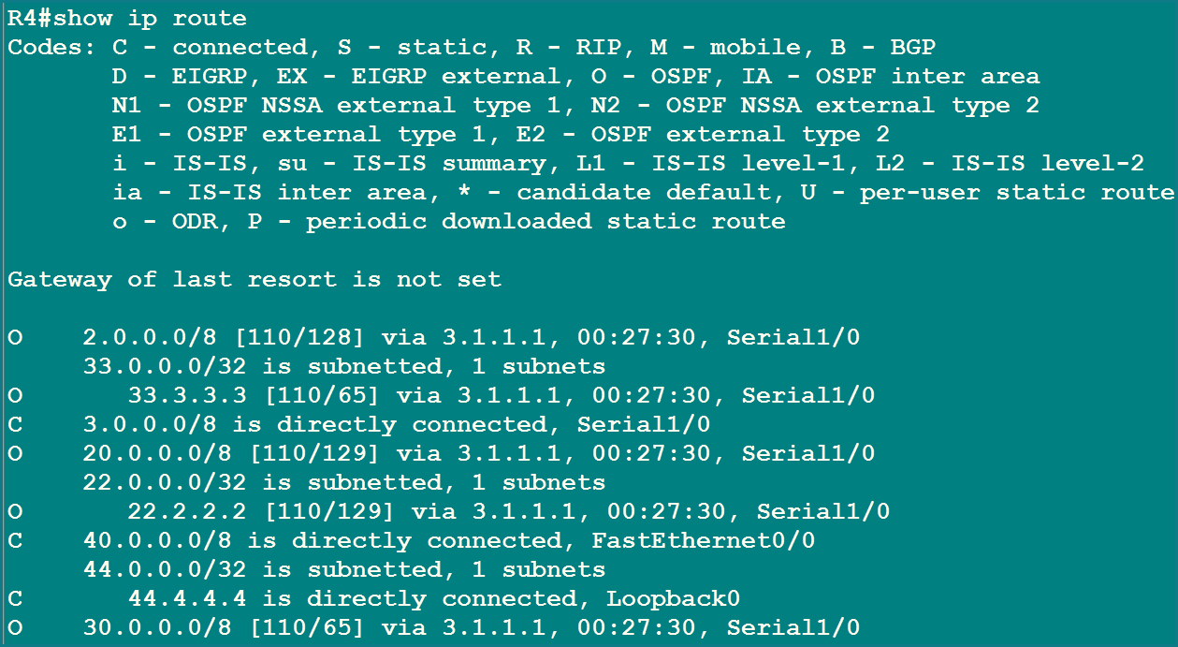
Figure 15. R4 global table: 4.0.0.0/8 is gone
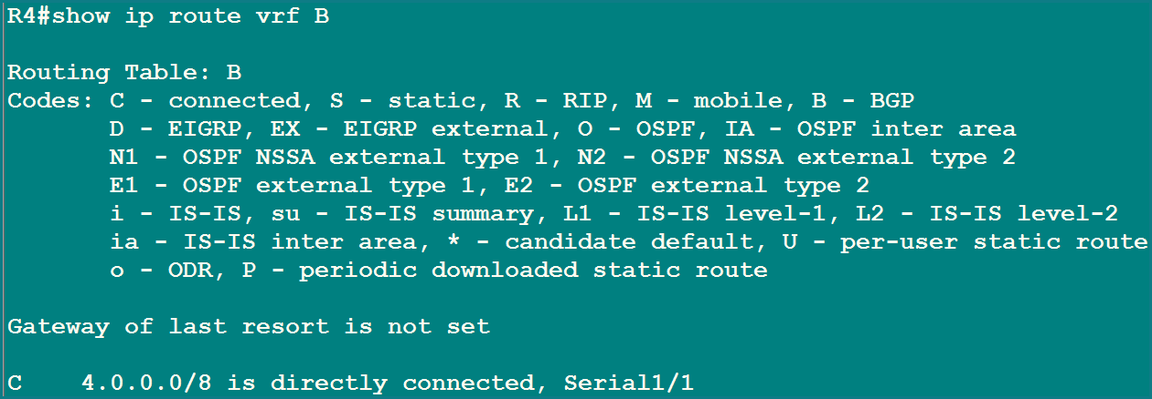
Figure 16. R4 VRF B now holds 4.0.0.0/8

Ping tests: the six experiments
# | Command | Result | Why
1 | R1# ping 1.1.1.2 | Success (100%) | R1 has 1.0.0.0/8 connected, so it can send. R2 receives it on a VRF A interface and answers using the VRF A table.
2 | R2# ping 1.1.1.1 | Fail (0%) | A normal ping searches the global table, and 1.0.0.0/8 is no longer there.
3 | R2# ping vrf A 1.1.1.1 | Success (100%) | The ping is told to look inside VRF A, where 1.0.0.0/8 lives.
4 | R5# ping 4.1.1.1 | Success (100%) | Same idea as test 1 for the branch side.
5 | R4# ping 4.1.1.2 | Fail (0%) | Same idea as test 2: 4.0.0.0/8 is inside VRF B, not the global table.
6 | R4# ping vrf B 4.1.1.2 | Success (100%) | Same idea as test 3.

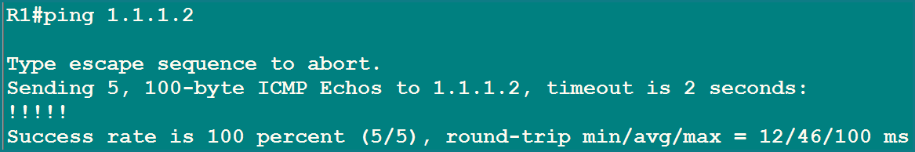
Figure 17. Test 1: R1 pings R2, 5/5 replies
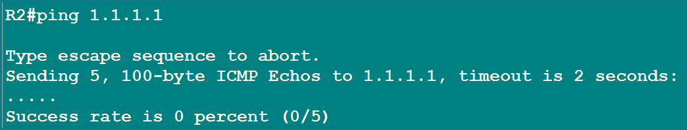
Figure 18. Test 2: R2 pings R1 without the VRF, 0/5
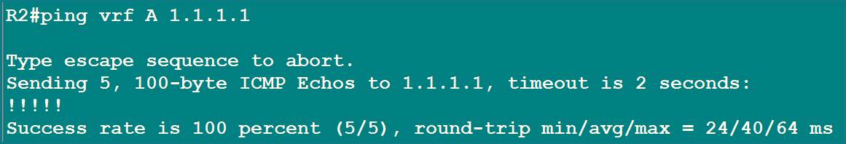
Figure 19. Test 3: R2 pings R1 through VRF A, 5/5
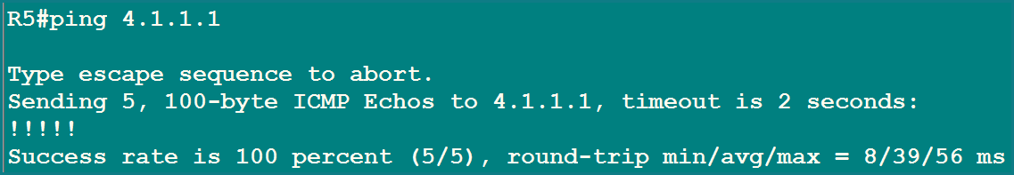
Figure 20. Test 4: R5 pings R4, 5/5
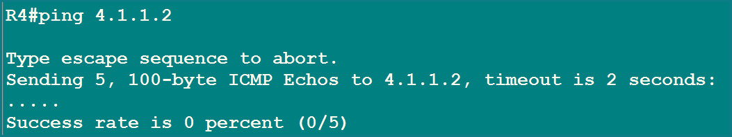
Figure 21. Test 5: R4 pings R5 without the VRF, 0/5
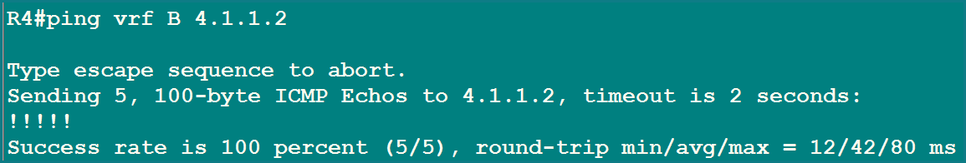
Figure 22. Test 6: R4 pings R5 through VRF B, 5/5
MEMORY TRICK The VRF rule
Once an interface joins a VRF, the global table forgets it. From then on, add the VRF name to your tools: ping vrf A ..., show ip route vrf A.

STEP 5.5 OSPF 10 on the Customer Ends
Goal: let each PE learn its customer's routes. R1 and R5 run a normal OSPF 10, area 0. On the PE side, OSPF is started inside the VRF with the extra word vrf A or vrf B.

HBL Head Office (R1 and R2)
R1 (customer router)
R1(config)#router ospf 10
R1(config-router)#network 1.0.0.0 0.255.255.255 area 0
R1(config-router)#network 11.0.0.0 0.255.255.255 area 0
R1(config-router)#network 10.0.0.0 0.255.255.255 area 0
R1(config-router)#exit

R2 (PE, inside VRF A)
R2(config)#router ospf 10 vrf A
R2(config-router)#network 1.0.0.0 0.255.255.255 area 0
R2(config-router)#exit
*Sep 10 02:46:10.907: %OSPF-5-ADJCHG: Process 10, Nbr 11.1.1.1 on Serial1/0

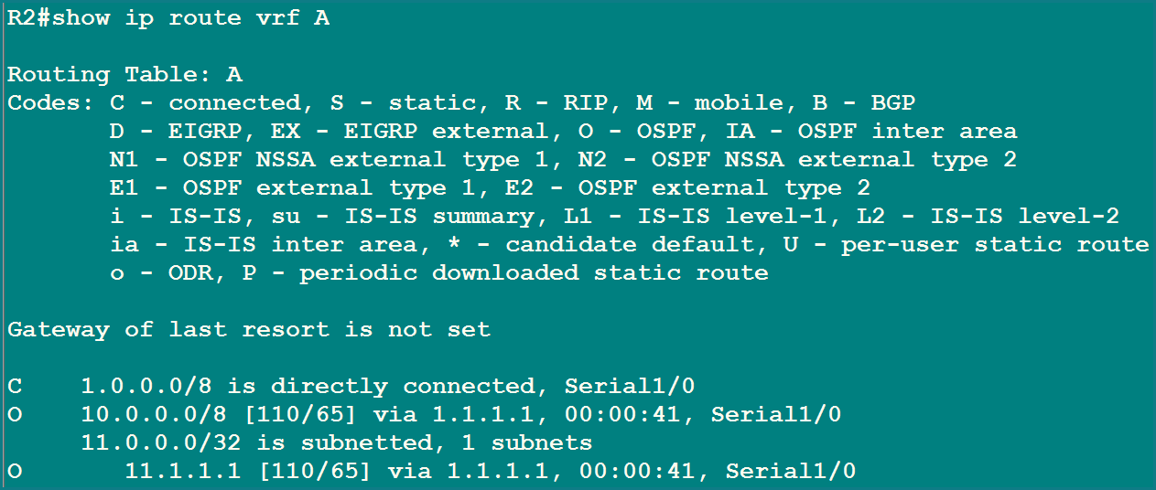
Figure 23. R2 VRF A table: 10.0.0.0/8 and 11.1.1.1/32 learned from R1 by OSPF
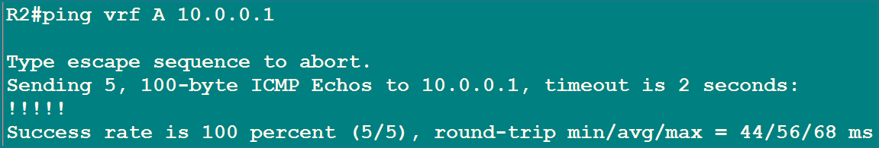
Figure 24. R2 pings R1's LAN 10.0.0.1 through VRF A: 5/5

HBL Branch (R5 and R4)
R5 (customer router)
R5(config)#router ospf 10
R5(config-router)#network 4.0.0.0 0.255.255.255 area 0
R5(config-router)#network 55.5.5.5 0.0.0.0 area 0
R5(config-router)#network 50.0.0.0 0.255.255.255 area 0
R5(config-router)#exit

R4 (PE, inside VRF B)
R4(config)#router ospf 10 vrf B
R4(config-router)#network 4.0.0.0 0.255.255.255 area 0
R4(config-router)#exit
*Sep 10 02:52:53.323: %OSPF-5-ADJCHG: Process 10, Nbr 55.5.5.5 on Serial1/1

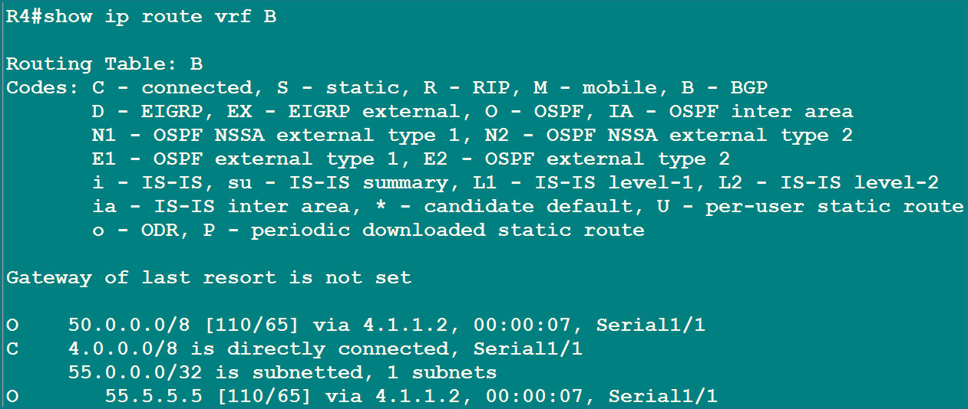
Figure 25. R4 VRF B table: 50.0.0.0/8 and 55.5.5.5/32 learned from R5 by OSPF
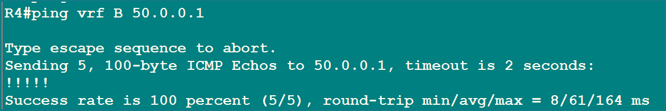
Figure 26. R4 pings R5's LAN 50.0.0.1 through VRF B: 5/5
PLAIN ENGLISH What just happened
The ADJCHG log lines mean the OSPF neighbourship between the CE and the PE came up. Each PE now knows its own customer's networks, but only inside its VRF. The other customer is still invisible.

STEP 5.6 Configure MP-BGP
Figure 27. Checkpoint: provider OSPF and MPLS done, both customer OSPFs done. Next is MP-BGP between R2 and R4
Where we are: the provider has OSPF 1 and MPLS. Each customer has OSPF 10. What is missing: a way to carry customer routes from R2 to R4. We must do it without putting customer routes on the core router R3, so everything in the middle stays label switched.
How: R2 and R4 become BGP neighbours (AS 10, so this is iBGP) and exchange a special kind of route called VPNv4. R3 does not run BGP at all.
R2
R2(config)#router bgp 10
R2(config-router)#no auto-summary
R2(config-router)#no synchronization
R2(config-router)#neighbor 44.4.4.4 remote-as 10
R2(config-router)#neighbor 44.4.4.4 update-source Loopback0
R2(config-router)#address-family vpnv4
R2(config-router-af)#neighbor 44.4.4.4 activate
R2(config-router-af)#neighbor 44.4.4.4 send-community extended
R2(config-router-af)#exit-address-family

R4
R4(config)#router bgp 10
R4(config-router)#no auto-summary
R4(config-router)#no synchronization
R4(config-router)#neighbor 22.2.2.2 remote-as 10
R4(config-router)#neighbor 22.2.2.2 update-source Loopback0
*Sep 10 03:18:01.371: %BGP-5-ADJCHANGE: neighbor 22.2.2.2 Up
R4(config-router)#address-family vpnv4
R4(config-router-af)#neighbor 22.2.2.2 activate
R4(config-router-af)#neighbor 22.2.2.2 send-community extended
*Sep 10 03:18:04.519: %BGP-5-ADJCHANGE: neighbor 22.2.2.2 Down Address family activated
*Sep 10 03:18:06.819: %BGP-5-ADJCHANGE: neighbor 22.2.2.2 Up
R4(config-router-af)#exit-address-family

Command | Plain-English meaning
router bgp 10 | Start BGP in autonomous system 10. Both PEs use 10, so they are iBGP neighbours.
no auto-summary, no synchronization | Old-style safety settings: do not group routes into classful blocks, and do not wait for the IGP. Standard in labs.
neighbor 44.4.4.4 remote-as 10 | Declare R4's loopback as a BGP neighbour in the same AS.
neighbor ... update-source Loopback0 | Talk to the neighbour from our loopback. The loopback is reachable through OSPF 1 and never goes down.
address-family vpnv4 | Enter the section that carries VPN routes.
neighbor ... activate | Actually switch on the exchange of VPNv4 routes with this neighbour.
neighbor ... send-community extended | Send the extended community, which is where the route-target travels. Forget it and the RT is lost.

PLAIN ENGLISH Why did the session go Down and Up again?
On R4 the first "Up" is the plain IPv4 BGP session. When neighbor ... activate adds the VPNv4 address family, the two routers must renegotiate what they support, so the session drops for a moment and comes back. The message says "Down Address family activated". That is normal, not an error.

Result: BGP neighbourship (5.6.1)
Command: show ip bgp summary. Both routers show their neighbour with a live Up/Down timer and 0 prefixes for now.
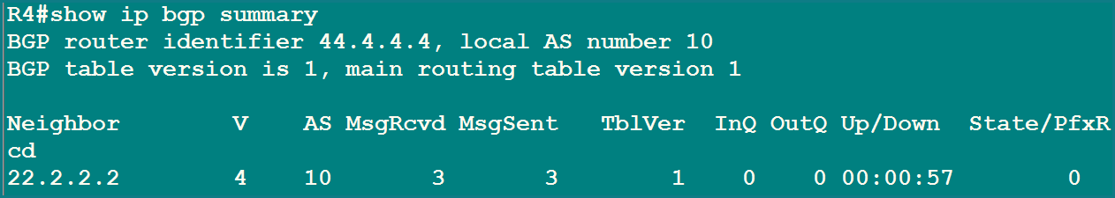
Figure 28. R4: neighbour 22.2.2.2 in AS 10, up for 00:00:57
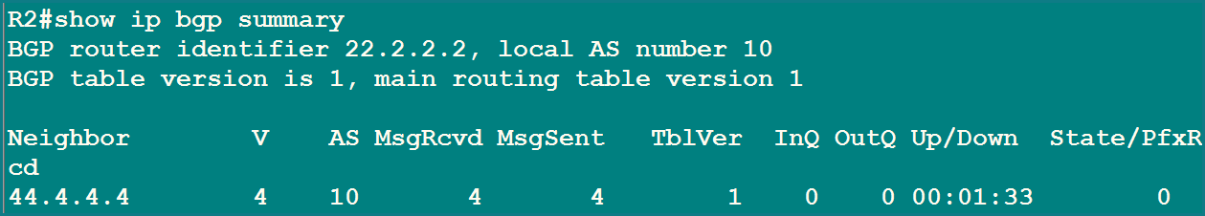
Figure 29. R2: neighbour 44.4.4.4 in AS 10, up for 00:01:33
MEMORY TRICK Reading the summary
V = BGP version (4). AS = neighbour's AS (10). Up/Down = how long it has been up. The last column is a number (prefixes received) when the session is healthy, and a word such as Idle or Active when it is not.

STEP 5.7 Redistribution of OSPF 10 into BGP 10
Goal: move each customer's routes from OSPF into BGP, inside its own VRF. Head Office routes go into BGP from VRF A on R2. Branch routes go into BGP from VRF B on R4. Redistribution means "take routes learned one way and hand them to another protocol".
R2
R2(config)#router bgp 10
R2(config-router)#address-family ipv4 vrf A
R2(config-router-af)#redistribute ospf 10 match internal external 1 external 2
R2(config-router-af)#exit-address-family

R4
R4(config)#router bgp 10
R4(config-router)#address-family ipv4 vrf B
R4(config-router-af)#redistribute ospf 10 match internal external 1 external 2
R4(config-router-af)#exit-address-family

match internal external 1 external 2 means: take every kind of OSPF route (routes inside the area and both types of external routes).

Result: the VPNv4 table (5.7)
Command: show ip bgp vpnv4 all. Routes are grouped under their RD.
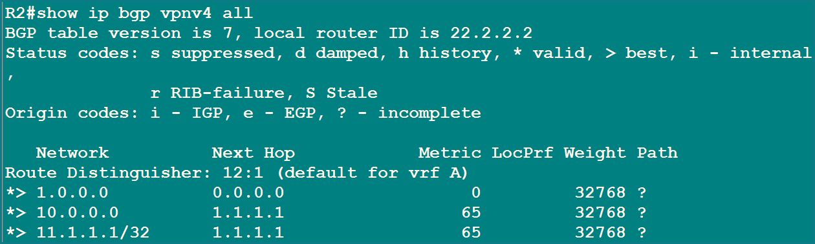
Figure 30. R2 VPNv4 table: only Head Office routes, under RD 12:1
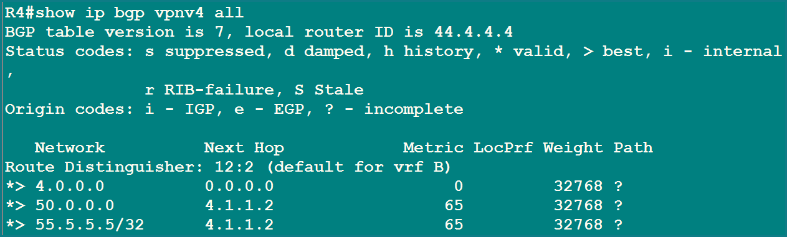
Figure 31. R4 VPNv4 table: only Branch routes, under RD 12:2
Route on R2 | Next hop | Meaning
1.0.0.0 | 0.0.0.0 | The PE's own connected link to R1. Next hop 0.0.0.0 and weight 32768 mean "originated on this router".
10.0.0.0 | 1.1.1.1 | R1's LAN, learned from R1 by OSPF. Metric 65 is the OSPF cost (64 serial + 1 FastEthernet).
11.1.1.1/32 | 1.1.1.1 | R1's loopback, metric 65 in the same way.

R4 shows the mirror image: 4.0.0.0 (own link), 50.0.0.0 and 55.5.5.5/32 via 4.1.1.2 (R5), all with metric 65.
IMPORTANT Why does R2 not show R4's routes yet?
R4 does send its routes, but R2 throws them away. R2's VRF A only accepts route-target 1:1, and R4's routes carry 1:2. A PE drops VPN routes that no VRF asked for. Step 5.8 changes exactly this.

MEMORY TRICK Symbols in the BGP table
* valid, > best, i learned from an iBGP neighbour, ? origin unknown (typical for redistributed routes), weight 32768 means "my own route".

STEP 5.8 Import Route-Targets
Goal: let Head Office and Branch accept each other's routes. Each VRF already exports its own tag. Now each VRF is told to also import the other one's tag.
R2
R2(config)#ip vrf A
R2(config-vrf)#route-target import 1:2
R2(config-vrf)#exit

R4
R4(config)#ip vrf B
R4(config-vrf)#route-target import 1:1
R4(config-vrf)#exit

VRF | Exports | Imports | Effect
A on R2 (before) | 1:1 | 1:1 | Sees only Head Office routes
A on R2 (after) | 1:1 | 1:1 and 1:2 | Now also accepts Branch routes
B on R4 (before) | 1:2 | 1:2 | Sees only Branch routes
B on R4 (after) | 1:2 | 1:2 and 1:1 | Now also accepts Head Office routes

MEMORY TRICK The RT handshake
My export must equal your import, and your export must equal my import. Think of it as a passport: I stamp my routes with 1:1, and you only let in stamps you have listed.

Result: routes now cross the core
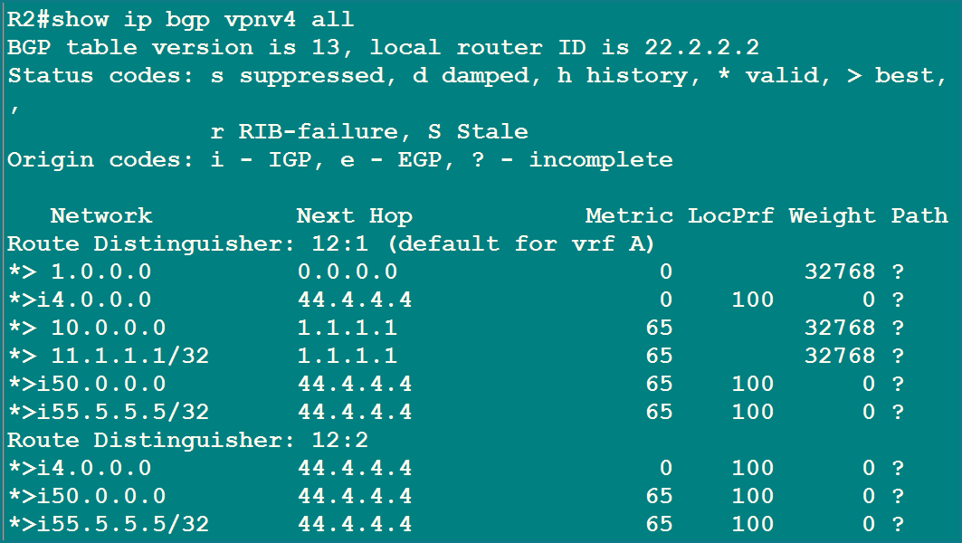
Figure 32. R2 VPNv4 table: Branch routes (4.0.0.0, 50.0.0.0, 55.5.5.5/32) arrive from 44.4.4.4
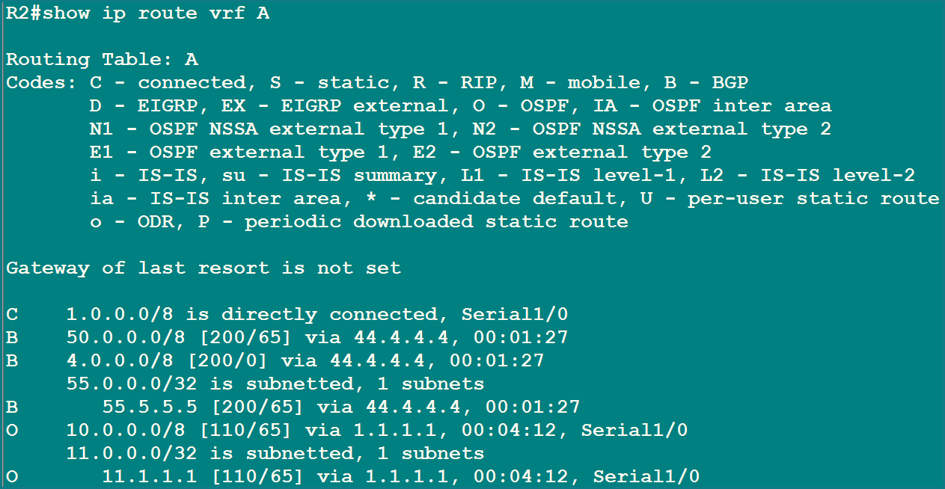
Figure 33. R2 VRF A table: three new BGP (B) routes
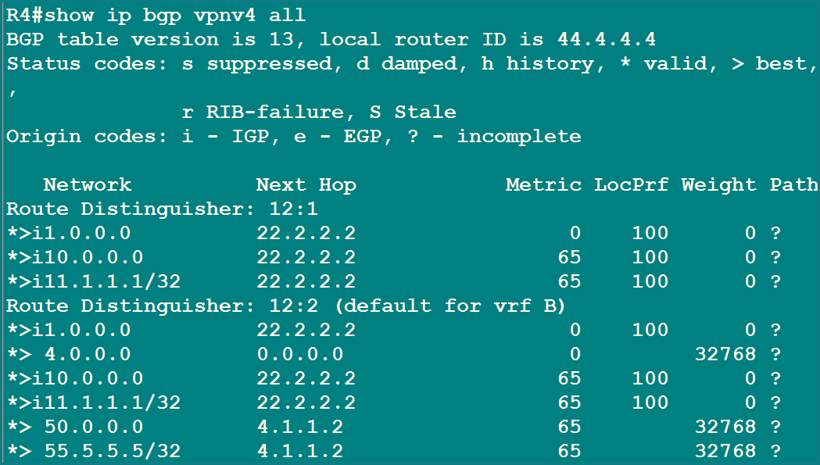
Figure 34. R4 VPNv4 table: Head Office routes (1.0.0.0, 10.0.0.0, 11.1.1.1/32) arrive from 22.2.2.2
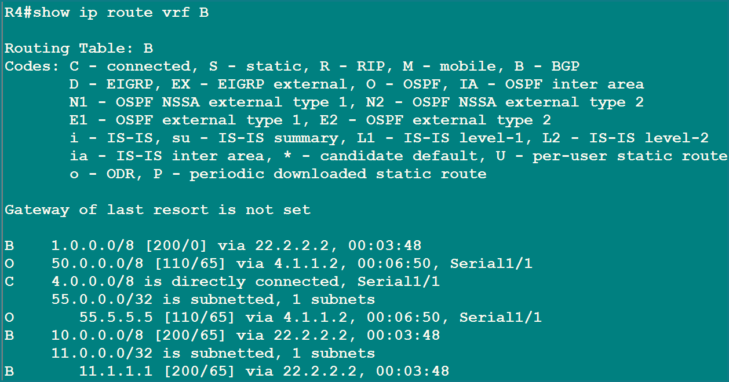
Figure 35. R4 VRF B table: three new BGP (B) routes
WHAT TO NOTICE Look closely at these tables
On R2, routes 4.0.0.0, 50.0.0.0 and 55.5.5.5/32 now appear with the letter B and next hop 44.4.4.4. Their distance is [200/...], which is the iBGP distance. Routes learned from R1 stay O (OSPF, distance 110).
In the VPNv4 table the Branch routes are listed twice: once under their original RD 12:2, and once under RD 12:1 because they were imported into VRF A. Routes learned over iBGP show an i, LocPrf 100 and weight 0.
The same thing happens mirrored on R4: Head Office networks 1.0.0.0, 10.0.0.0 and 11.1.1.1/32 arrive with next hop 22.2.2.2.

MEMORY TRICK Distance numbers
OSPF 110, iBGP 200, eBGP 20. A route with the letter B and [200/x] in a VRF came through the core from the other PE.

STEP 5.9 Redistribute BGP 10 into OSPF 10
Goal: hand the far-side routes to the customer routers. R1 and R5 speak only OSPF, so each PE must translate BGP back into OSPF inside its VRF.
R2 (towards HBL Head Office)
R2(config)#router ospf 10 vrf A
R2(config-router)#redistribute bgp 10 subnets
R2(config-router)#exit

R4 (towards HBL Branch)
R4(config)#router ospf 10 vrf B
R4(config-router)#redistribute bgp 10 subnets
R4(config-router)#exit

PLAIN ENGLISH Why the word "subnets"?
Without subnets, OSPF redistributes only classful networks and ignores subnetted ones. The loopbacks 11.1.1.1/32 and 55.5.5.5/32 are subnets of their classful network, so they would be missed. Always add subnets.

The whole journey of a route now looks like this:
IMPORTANT Route journey (Branch LAN 50.0.0.0 to Head Office)
R5 (OSPF 10) → R4 VRF B → redistributed into BGP → VPNv4 across the core → R2 VRF A imports it → redistributed into OSPF 10 → R1

Result: the customer routers learn the far side
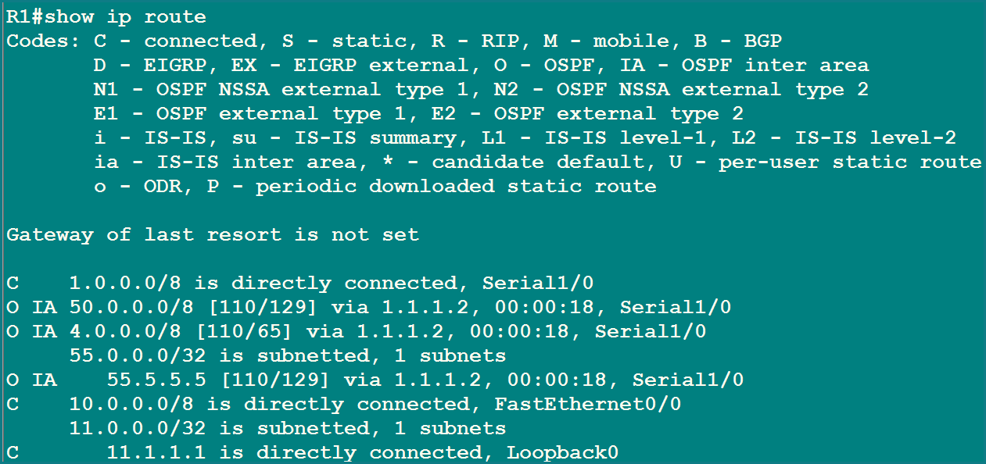
Figure 36. R1 routing table: O IA routes for 50.0.0.0/8, 4.0.0.0/8 and 55.5.5.5/32
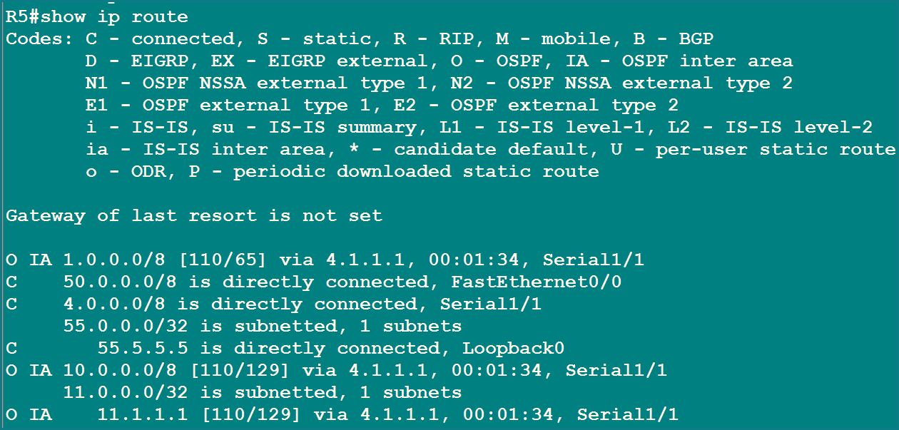
Figure 37. R5 routing table: O IA routes for 1.0.0.0/8, 10.0.0.0/8 and 11.1.1.1/32
PLAIN ENGLISH Why "O IA" and not an external route?
Both PEs use the same OSPF process number, 10, so OSPF treats the two customer sites as one OSPF network joined by the provider. The routes from the other site therefore arrive as inter-area (O IA) routes.

The final proof
R1 pings R5's loopback 55.5.5.5, using its own loopback 11.1.1.1 as the source. It works. Then we look at the core router R3, and it holds no customer route at all: only 2.0.0.0, 3.0.0.0, 20/30/40.0.0.0 and the three provider loopbacks.
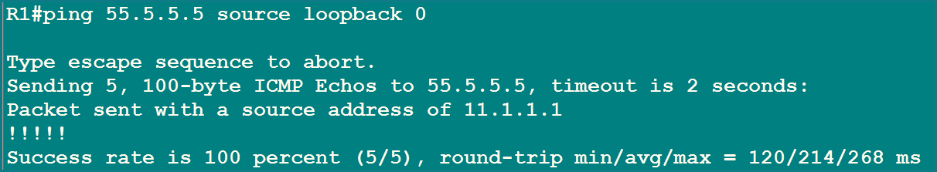
Figure 38. R1 pings 55.5.5.5 from Loopback 0: 5/5 success
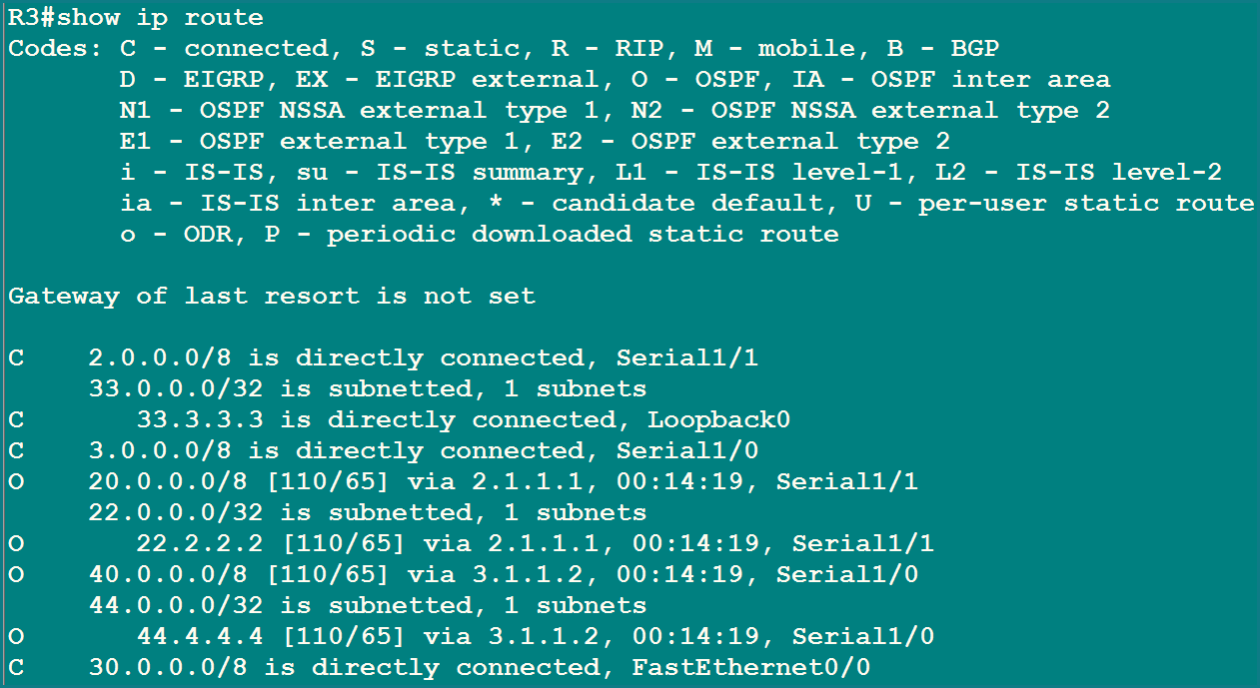
Figure 39. R3 routing table: not a single customer route

STEP 5.10 Verification: Follow One Packet
Now we follow one packet from R1 to 55.5.5.5 (R5's loopback) and watch what every router does. Keep this trace in your head for the exam: it is the heart of MPLS VPN.
Stage | Where | What the packet looks like
1 | R1 | Plain IP packet to 55.5.5.5
2 | R2 inside VRF A | Same plain IP packet, now found in the VRF table
3 | R2 after BGP label | [ VPN label 23 | IP packet ]
4 | R2 after LDP label | [ MPLS label 19 | VPN label 23 | IP packet ]
5 | R3 after popping | [ VPN label 23 | IP packet ]
6 | R4 after removing VPN label | Plain IP packet again, sent out of VRF B

Stage 1: R1 sends it to R2
R1 looks in its own table. 55.5.5.5 is there as an O IA route with next hop 1.1.1.2, which is R2. R1 knows nothing about MPLS; it just sends a normal IP packet.
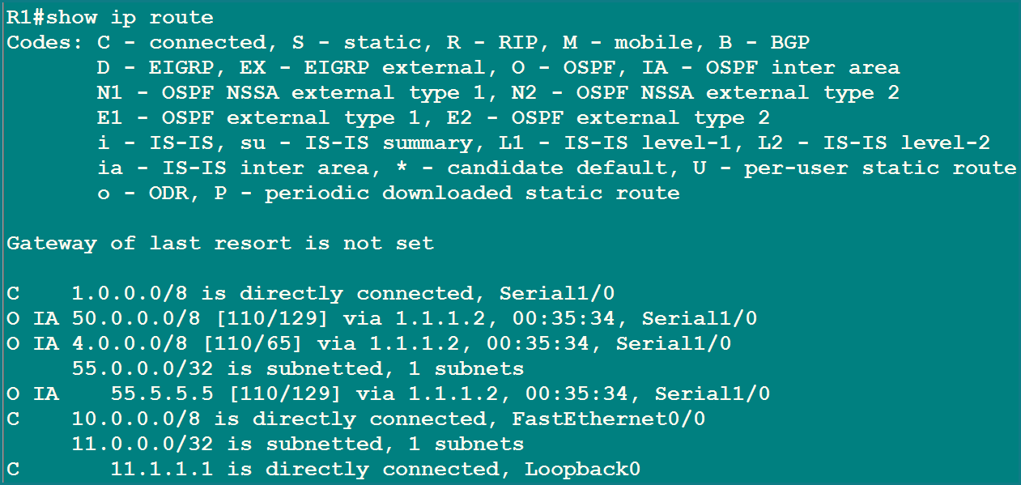
Figure 40. R1 routing table: 55.5.5.5/32 via 1.1.1.2

Stage 2: R2 looks inside VRF A
The packet arrives on Serial1/0, which belongs to VRF A, so R2 searches VRF A, not the global table. It finds 55.5.5.5/32 as a BGP route with next hop 44.4.4.4 (R4's loopback).
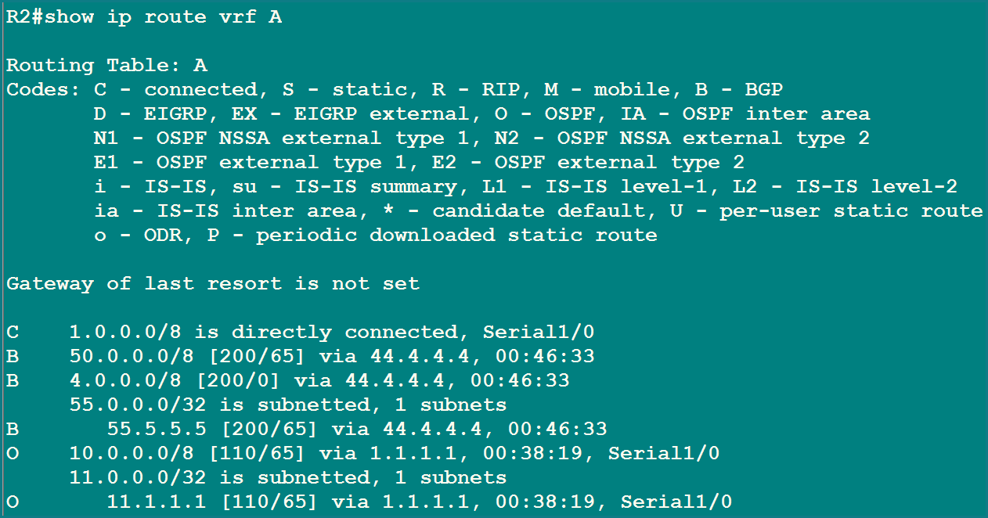
Figure 41. R2 VRF A table: 55.5.5.5/32 via 44.4.4.4 (BGP)

Stage 3: R2 pushes the VPN label (inner sticker)
BGP does not only carry the route; it also carries a VPN label. In the table below, the column "In label / Out label" shows that for 55.5.5.5/32 the out label is 23. This is the label R4 asked for, so R4 will know the packet belongs to the Branch customer.
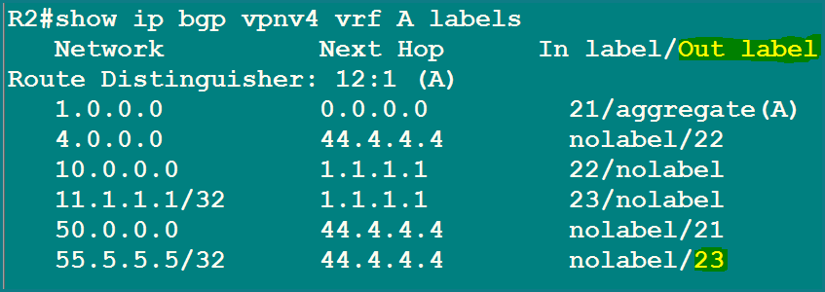
Figure 42. R2: the out label for 55.5.5.5/32 is 23
VPN label | IP packet
23 | 55.5.5.5

Stage 4: R2 pushes the MPLS label (outer sticker)
The next hop 44.4.4.4 must be reached through the core. The global table says: go via 2.1.1.2. Because this is the MPLS domain, R2 looks in its label table and finds that the outgoing label for 44.4.4.4/32 is 19. The packet now carries two labels.
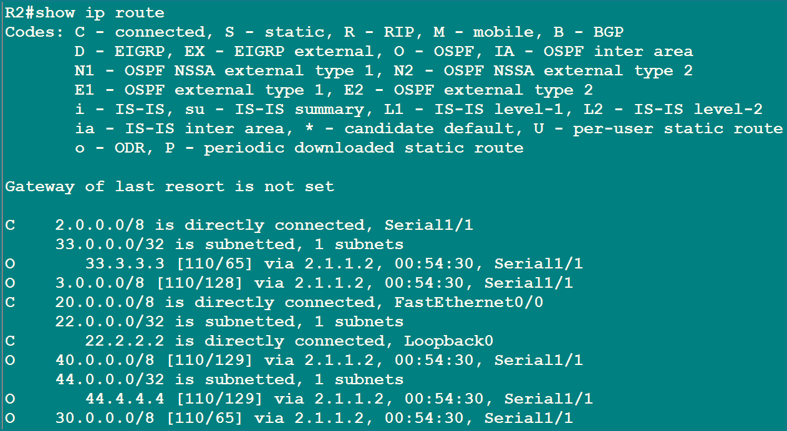
Figure 43. R2 global table: 44.4.4.4/32 via 2.1.1.2
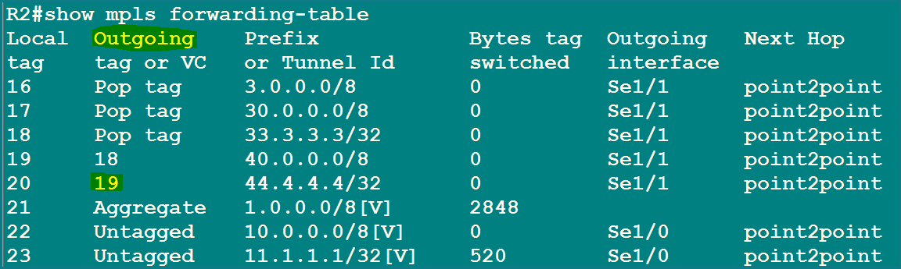
Figure 44. R2 label table: outgoing label 19 for 44.4.4.4/32 (highlighted)
MPLS label | VPN label | IP packet
19 | 23 | 55.5.5.5

Stage 5: R3 only looks at the outer label
R3 receives label 19. Its own table says: local label 19 means prefix 44.4.4.4/32, action Pop tag, send out of Serial1/0. R3 removes the outer label and forwards. It never reads the inner label or the customer address.
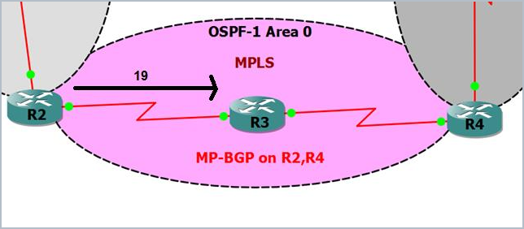
Figure 45. Label 19 travels from R2 towards R3
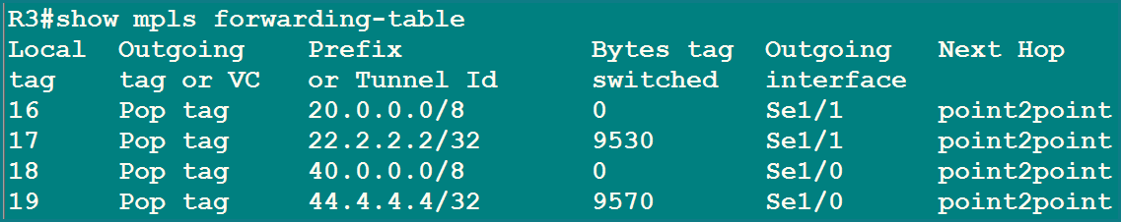
Figure 46. R3 label table: local label 19 is popped for 44.4.4.4/32
VPN label | IP packet
23 | 55.5.5.5

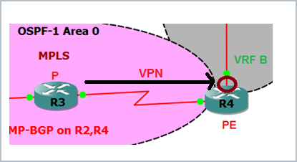
Figure 47. The packet, with only the VPN label left, reaches R4

Stage 6: R4 removes the VPN label and picks the VRF
R4 receives the packet with only VPN label 23. R4 handed out that label itself for 55.5.5.5/32 in VRF B: in the table below the in label is 23 and the out label is "nolabel", meaning "no label from here on". R4 removes label 23 and continues with a plain IP packet in VRF B.
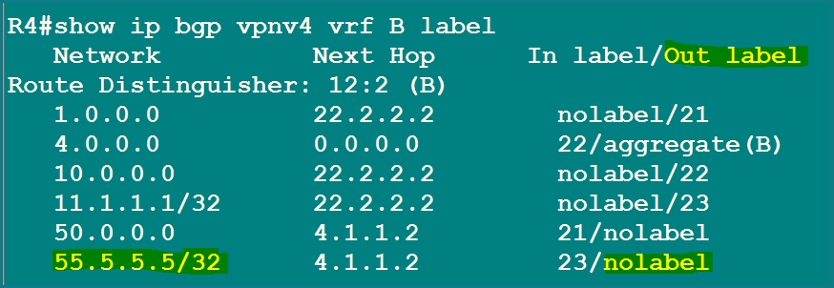
Figure 48. R4: in label 23 belongs to 55.5.5.5/32 in VRF B
IP packet
55.5.5.5

MEMORY TRICK Label numbers are local
R2 has its own label 23 (for 11.1.1.1/32, pointing towards R1) and R4 has a different label 23 (for 55.5.5.5/32). The same number on two routers is just a coincidence. A label only has meaning to the router that handed it out.

Stage 7: R4 delivers it to R5
Inside VRF B, 55.5.5.5/32 is an OSPF route with next hop 4.1.1.2, which is R5, out of Serial1/1. The packet reaches its destination, where 55.5.5.5 is a directly connected loopback.
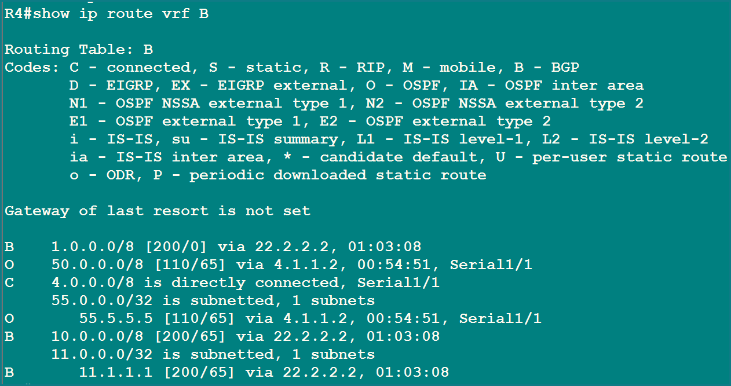
Figure 49. R4 VRF B table: 55.5.5.5/32 via 4.1.1.2 (R5)

Stage 8: the traceroute
A traceroute from R1 to 55.5.5.5 confirms the path hop by hop: R2 (1.1.1.2), R3 (2.1.1.2), R4 (4.1.1.1), and finally R5 (4.1.1.2).
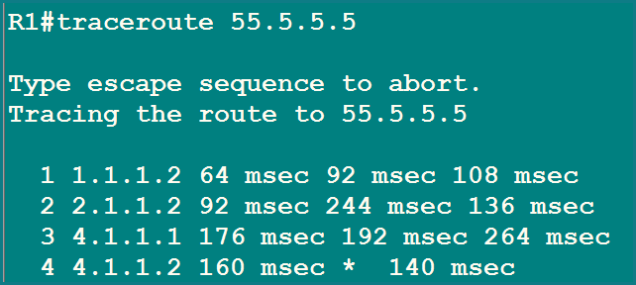
Figure 50. Traceroute from R1 to 55.5.5.5
Hop | Address | Router | Comment
1 | 1.1.1.2 | R2 (PE) | Entry into the provider, VRF A
2 | 2.1.1.2 | R3 (P) | Core router, label switching only
3 | 4.1.1.1 | R4 (PE) | Exit from the provider, VRF B
4 | 4.1.1.2 | R5 (CE) | The destination, HBL Branch

PART 3 Cheat Sheets for Revision

Verification commands: what to type and what it proves
Command | What it shows
show ip route | The global routing table of the router
show ip route vrf A | The private routing table of VRF A
ping vrf A x.x.x.x | A ping that searches inside the VRF
show mpls forwarding-table | The LFIB: local labels, outgoing labels, actions (swap or pop)
show ip bgp summary | BGP neighbours and whether they are up
show ip bgp vpnv4 all | All VPN routes, grouped by RD
show ip bgp vpnv4 vrf A labels | The VPN labels for routes in VRF A (in and out)
traceroute x.x.x.x | The hop-by-hop path

Common mistakes and what they cause
Mistake | What goes wrong
Forgetting ip cef | MPLS will not work properly
Turning MPLS on for customer-facing interfaces | Not needed, and not what the design intends
Not retyping the IP after ip vrf forwarding | The interface has no address, so OSPF and pings fail
Forgetting send-community extended | The route-target is not sent, so the import fails
Forgetting route-target import on the other VRF | The sites never see each other's routes (the state in step 5.7)
Forgetting subnets in redistribution into OSPF | Loopbacks and other subnetted routes are missing
Using ping without the VRF name on a PE | Fails because the network is not in the global table

Exam questions with short model answers
Q1. Why does R3 not need any customer route?
It forwards using only the outer MPLS label. The customer packet is hidden behind the labels, so the core stays free of customer routes.
Q2. What is the difference between RD and RT?
RD makes a route unique (so overlapping addresses do not clash). RT controls which VRFs export and import the route.
Q3. Why two labels?
The outer label carries the packet across the core to the right PE. The inner VPN label tells that PE which VRF to use.
Q4. Why do we use loopbacks for LDP and BGP?
A loopback never goes down and is reachable through OSPF, so LDP and BGP stay stable.
Q5. Why is send-community extended required?
The route-target is an extended community. Without this command it is not sent.
Q6. What does "Pop tag" mean?
The router removes the top label. R3 does this because it is the last router before the PE (penultimate hop popping).
Q7. Why does the IP address vanish after ip vrf forwarding?
Moving an interface into another routing table clears its Layer 3 settings, so it must be retyped.
Q8. Why do R1 and R5 show O IA routes?
Both PEs use the same OSPF process number, so the two sites look like one OSPF network with the provider as the link between them.
Q9. Why does a PE reject VPN routes at step 5.7?
No VRF on it imports the route-target those routes carry, so it discards them.
Q10. Which command shows the VPN label?
show ip bgp vpnv4 vrf A labels

CHECKED Corrections Made to the Original Lab
Every command in the original lab sheet was checked. Almost all of the mistakes are missing spaces between words (the text was run together) and shortened words. They would be rejected or misread if typed exactly as printed. The correct form is used everywhere in these notes.
As printed | Correct command | What was wrong
ipcef | ip cef | Missing space. IOS says: Unrecognized command.
mplsip | mpls ip | Missing space (used globally and on the interface).
mplsldp router-id lo0 | mpls ldp router-id Loopback0 | Missing space. The short name lo0 works, but the full name Loopback0 is clearer.
ipvrf A  ipvrf B | ip vrf A  ip vrf B | Missing space.
ipvrf forwarding A | ip vrf forwarding A | Missing space.
ip add 1.1.1.2 255.0.0.0 | ip address 1.1.1.2 255.0.0.0 | Shortened word. It works, but the full word is better for notes and exams.
network ... a 0 | network ... area 0 | Shortened word for area. Works, but written in full here.
int s 1/1, int serial 1/0 | interface Serial1/1, interface Serial1/0 | Shortened word for interface. Works, but written in full here.
update-source lo0 | update-source Loopback0 | Short name. Written in full.
exit inside address-family | exit-address-family | exit also works, but exit-address-family is the proper way to close an address family.
show ip bgp vpnv4 vrf B label | show ip bgp vpnv4 vrf B labels | The keyword is spelled labels. Both spellings were accepted by the router in the screenshot, but the full word is safest.
ping 55.5.5.5 source loopback 0 | ping 55.5.5.5 source Loopback0 | Written in full to match interface naming.
Interface addresses not shown | Full ip address and no shutdown on every port | The original never listed the address commands. Step 5.0 adds them for all five routers.

WHAT TO NOTICE What was already correct
The design itself is correct: the RD and RT values, route-target import 1:2 on VRF A and route-target import 1:1 on VRF B, send-community extended, redistribute ospf 10 match internal external 1 external 2, and redistribute bgp 10 subnets are all right.
One thing to remember when you compare screenshots: label numbers change. The LFIB screenshot in step 5.2 and the one in step 5.10 show different numbers (for example the label for 44.4.4.4/32 on R2) because the labels were handed out again after LDP restarted. Always read the label from the table you are looking at.
A small extra: if LDP was already running when you change the router-id, add the word force (mpls ldp router-id Loopback0 force) so it takes effect at once. In this lab LDP was not running yet, so it was not needed.

APPENDIX Complete Configuration of Every Router
All commands from the lab, collected per router in the order they were typed. This time the interface IP addresses are included at the top of each router, so every block can be pasted as a whole.
R1 (CE, HBL Head Office)
hostname R1
interface Loopback0
ip address 11.1.1.1 255.255.255.255
interface FastEthernet0/0
ip address 10.0.0.1 255.0.0.0
no shutdown
interface Serial1/0
ip address 1.1.1.1 255.0.0.0
no shutdown
! 5.5 OSPF
router ospf 10
network 1.0.0.0 0.255.255.255 area 0
network 11.0.0.0 0.255.255.255 area 0
network 10.0.0.0 0.255.255.255 area 0

R2 (PE, VRF A)
hostname R2
interface Loopback0
ip address 22.2.2.2 255.255.255.255
interface FastEthernet0/0
ip address 20.0.0.1 255.0.0.0
no shutdown
interface Serial1/0
no shutdown
interface Serial1/1
ip address 2.1.1.1 255.0.0.0
no shutdown
! Serial1/0 gets its address in step 5.4, inside VRF A
! 5.1 OSPF core
router ospf 1
network 2.0.0.0 0.255.255.255 area 0
network 22.2.2.2 0.0.0.0 area 0
network 20.0.0.0 0.255.255.255 area 0
! 5.2 MPLS
ip cef
mpls ip
mpls label protocol ldp
mpls ldp router-id Loopback0
interface Serial1/1
mpls ip
mpls label protocol ldp
! 5.3 VRF
ip vrf A
rd 12:1
route-target 1:1
! 5.4 assign VRF
interface Serial1/0
ip vrf forwarding A
ip address 1.1.1.2 255.0.0.0
! 5.5 OSPF towards customer
router ospf 10 vrf A
network 1.0.0.0 0.255.255.255 area 0
! 5.6 MP-BGP
router bgp 10
no auto-summary
no synchronization
neighbor 44.4.4.4 remote-as 10
neighbor 44.4.4.4 update-source Loopback0
address-family vpnv4
neighbor 44.4.4.4 activate
neighbor 44.4.4.4 send-community extended
exit-address-family
! 5.7 OSPF into BGP
address-family ipv4 vrf A
redistribute ospf 10 match internal external 1 external 2
exit-address-family
! 5.8 import Branch route-target
ip vrf A
route-target import 1:2
! 5.9 BGP into OSPF
router ospf 10 vrf A
redistribute bgp 10 subnets

R3 (P router, no VRF and no BGP)
hostname R3
interface Loopback0
ip address 33.3.3.3 255.255.255.255
interface FastEthernet0/0
ip address 30.0.0.1 255.0.0.0
no shutdown
interface Serial1/1
ip address 2.1.1.2 255.0.0.0
no shutdown
interface Serial1/0
ip address 3.1.1.1 255.0.0.0
no shutdown
router ospf 1
network 2.0.0.0 0.255.255.255 area 0
network 3.0.0.0 0.255.255.255 area 0
network 33.3.3.3 0.0.0.0 area 0
network 30.0.0.0 0.255.255.255 area 0
ip cef
mpls ip
mpls label protocol ldp
mpls ldp router-id Loopback0
interface Serial1/1
mpls ip
interface Serial1/0
mpls ip

R4 (PE, VRF B)
hostname R4
interface Loopback0
ip address 44.4.4.4 255.255.255.255
interface FastEthernet0/0
ip address 40.0.0.1 255.0.0.0
no shutdown
interface Serial1/0
ip address 3.1.1.2 255.0.0.0
no shutdown
interface Serial1/1
no shutdown
! Serial1/1 gets its address in step 5.4, inside VRF B
! 5.1 OSPF core
router ospf 1
network 3.0.0.0 0.255.255.255 area 0
network 44.4.4.4 0.0.0.0 area 0
network 40.0.0.0 0.255.255.255 area 0
! 5.2 MPLS
ip cef
mpls ip
mpls label protocol ldp
mpls ldp router-id Loopback0
interface Serial1/0
mpls ip
! 5.3 VRF
ip vrf B
rd 12:2
route-target 1:2
! 5.4 assign VRF
interface Serial1/1
ip vrf forwarding B
ip address 4.1.1.1 255.0.0.0
! 5.5 OSPF towards customer
router ospf 10 vrf B
network 4.0.0.0 0.255.255.255 area 0
! 5.6 MP-BGP
router bgp 10
no auto-summary
no synchronization
neighbor 22.2.2.2 remote-as 10
neighbor 22.2.2.2 update-source Loopback0
address-family vpnv4
neighbor 22.2.2.2 activate
neighbor 22.2.2.2 send-community extended
exit-address-family
! 5.7 OSPF into BGP
address-family ipv4 vrf B
redistribute ospf 10 match internal external 1 external 2
exit-address-family
! 5.8 import Head Office route-target
ip vrf B
route-target import 1:1
! 5.9 BGP into OSPF
router ospf 10 vrf B
redistribute bgp 10 subnets

R5 (CE, HBL Branch)
hostname R5
interface Loopback0
ip address 55.5.5.5 255.255.255.255
interface FastEthernet0/0
ip address 50.0.0.1 255.0.0.0
no shutdown
interface Serial1/1
ip address 4.1.1.2 255.0.0.0
no shutdown
! OSPF
router ospf 10
network 4.0.0.0 0.255.255.255 area 0
network 55.5.5.5 0.0.0.0 area 0
network 50.0.0.0 0.255.255.255 area 0

