|  |  |
| --- | --- |
| **العربية** | Communication and Electronics Department Analog Communication - EEC 381  Fall 2023 - 2024 |

REPORT

|  |  |
| --- | --- |
| **Name** | **ID** |
| Abdel-Rahman Hesham Mohamed Desoky  Mostafa Mohamed Abdel-Azeem Hassanen  Ahmed Abdel-Hakeem Abdel-Salam Ali  Ahmed Kamel Mohamed Abdel-Gelel  Omar Shahin | 2001  20011950  2001  2001  19 |
|  |  |
| **Section:** | 8 |
|  |  |
| **Department:** | **Communication and Electronics** |

**Experiment One: Double Sided Band Modulation: -**

**Signal in frequency domain:**

**Filtered Signal:**

**Filtered Signal in Time Domain:**

**Double Sideband Suppressed Carrier:**

**Double Sideband Transmitted Carrier:**

* **Envelop Detection: -**

1. **Envelop Detection of Double Sideband Suppressed Carrier:**

1. **Envelop Detection of Double Sideband Transmitted Carrier:**

-In this point our observations are while playing the sound in case of DSB-SC the sound wasn’t clear and good enough to hear the whole message as there is a lot of attenuation, distortion and phase reversal, in contrast to DSB-TC case the sound was excellent and we can hear the message clearly without distortion or attenuation or phase reversal because of the modulation index which is less than 1, so in summary the envelop detector receiver is much better with DSB-TC but in cases where modulation index is less than (Under modulation) or equal (Critical modulation) 1 other than these cases the envelop detector will be bad choice to receive a DSB signal and coherent detector will be better.

* **Coherent Detection:**

1. **SNR = 0:**

**Signal in Time Domain:**

**Signal in Frequency Domain:**

1. **SNR = 10:**

**Signal in Time Domain:**

**Signal in Frequency Domain:**

1. **SNR=30:**

**Signal in Time Domain:**

**Signal in Frequency Domain:**

1. **Frequency Shift and SNR=0:**

**Signal in Time Domain:**

**Signal in Frequency Domain:**

1. **Frequency Shift and SNR=10:**

**Signal in Time Domain:**

**Signal in Frequency Domain:**

1. **Frequency Shift and SNR=30:**

**Signal in Time Domain:**

**Signal in Frequency Domain:**

-For proper detection with coherent detector it shouldn’t be any phase or frequency errors between the transmitter and the receiver so in our case we have here shift in frequency which leads to distortion in the received message and this phenomenon is called Beat effect.

1. **Phase Error and SNR=0:**

**Signal in Time Domain:**

**Signal in Frequency Domain:**

1. **Phase Error and SNR=10:**

**Signal in Time Domain:**

**Signal in Frequency Domain:**

1. **Phase Error and SNR=30:**

**Signal in Time Domain:**

**Signal in Frequency Domain:**

**Experiment Two: Single Side Band Modulation: -**

**Signal in frequency domain:**

**Filtered Signal:**

**Filtered Signal in Time Domain:**

**Double Sideband Suppressed Carrier:**

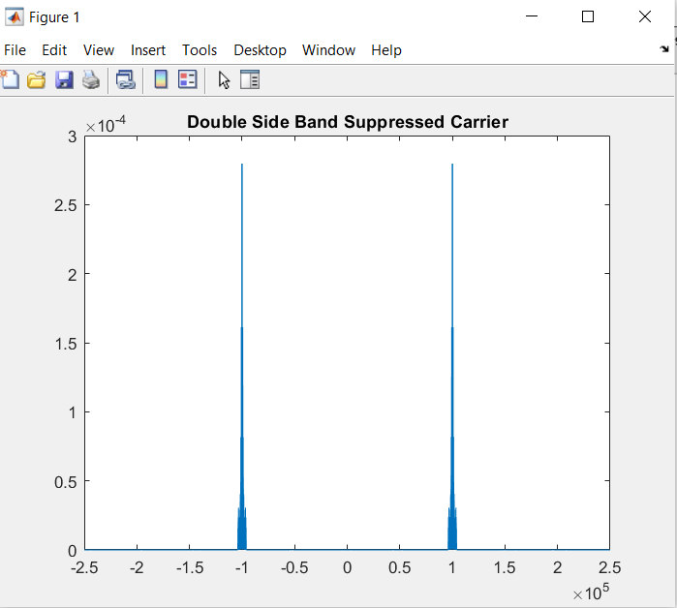

**Single Sided Band (LSB only):**

**Demodulated signal spectrum:**

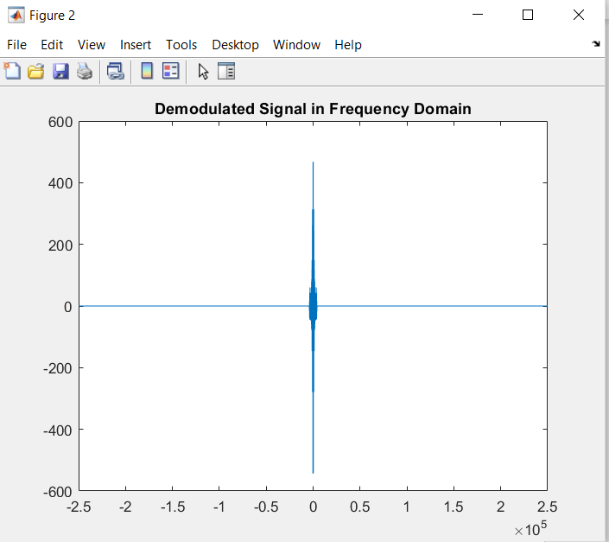

**Demodulated signal in time domain:**

**Demodulated signal spectrum Using a practical 4th order Butterworth filter:**

**Demodulated signal spectrum Using a practical 4th order Butterworth filter in time domain:**

* **Coherent Detection:**

1. **SNR = 0:**

**Signal in Time Domain:**

**Signal in Frequency Domain:**

1. **SNR = 10:**

**Signal in Time Domain:**

**Signal in Frequency Domain:**

1. **SNR=30:**

**Signal in Time Domain:**

**Signal in Frequency Domain:**

**Single Sided Band Transmitted Carrier:**

**Demodulated signal using Envelop detection:**

**Experiment Three: Frequency Modulation: -**

**Signal in frequency domain:**

**Filtered Signal:**

**Filtered Signal in Time Domain:**

**Modulated NBFM signal in Frequency Domain:**

**Demodulated NBFM signal in Frequency Domain:**

