I. NUMERICAL DATASET

1. Project Introduction

**a. Dataset Name**

(What is the dataset used?)

Exam Scores

**Linear Regression Model:**

* ***General Information on dataset:***

Number of classes: 5

Class “Gender” of Labels: 0,1

Class “parental_edu_score_rubric” of Labels: 0,1,2,3,4,5

Class “race_rubric ” of Labels: 0,1, 2 , 3 ,4.

Class “lunch_rubric” of Labels: 0,1

Class “course_rubric” of Labels: 0,1

The Total Number of Samples in Dataset: 1000

The Total Number of Samples used in training: 800.

The Total Number of Samples used in Testing: 200.

* ***Implementation details:***

**Features**: **gender, parental Edu, lunch, test prep, race, reading**

**score, writing score.**

* **Results:**

1. Accuracy Curve:

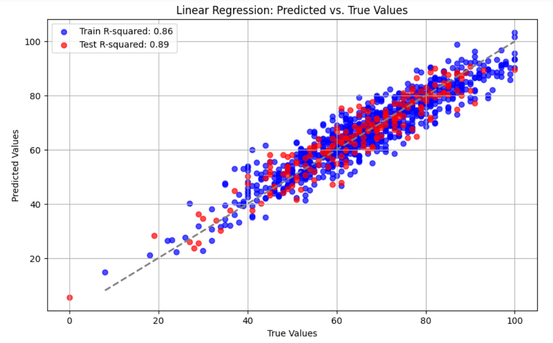

1. Loss Curve:

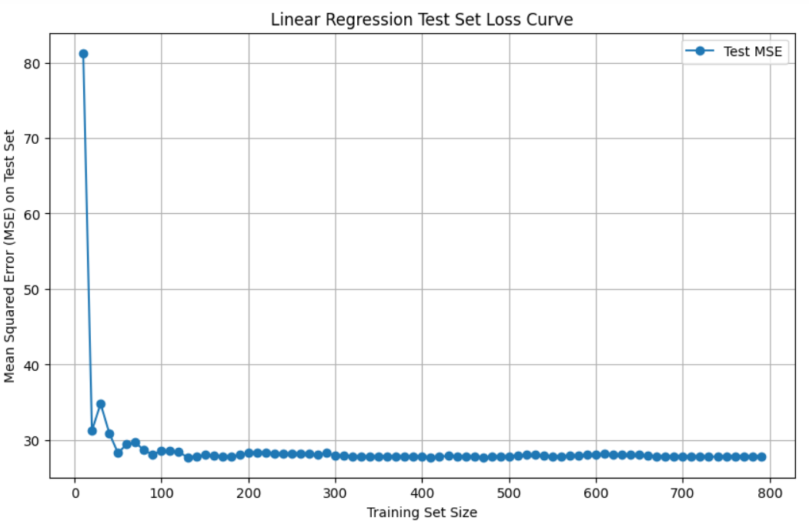

**KNN Model:**

* ***General Information on dataset:***

Number of classes: 5

Class “Gender” of Labels: 0,1

Class “parental_edu_score_rubric” of Labels: 0,1,2,3,4,5

Class “race_rubric ” of Labels: 0,1, 2 , 3 ,4.

Class “lunch_rubric” of Labels: 0,1

Class “course_rubric” of Labels: 0,1

The Total Number of Samples in Dataset: 1000

The Total Number of Samples used in training: 800.

The Total Number of Samples used in Testing: 200.

* ***Implementation details:***

**Features**: **gender, parental Edu, lunch, test prep, race, reading**

**score, writing score.**

* Results:

1. Accuracy Curve:

1. Loss Curve:

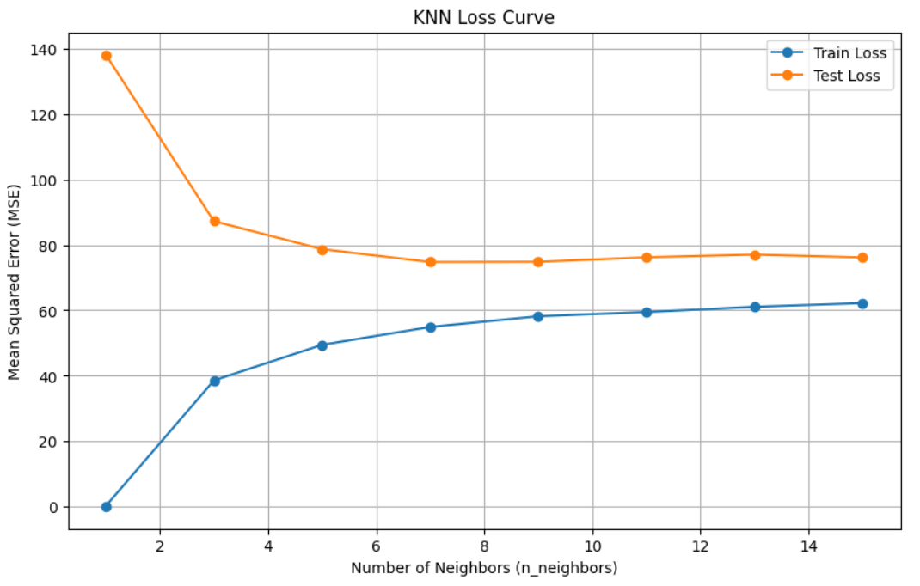

I. IMAGE DATASET

1. Project Introduction

**a. Dataset Name**

(What is the dataset used?)

Traffic Signs

**b. Number of classes and their labels**

(Specify number of classes and their labels.)

Number of Classes: 6

Labels: 0000, 0001, 0002, 0003, 0004, 0005

**c. Dataset Images Numbers and size**

(The total number of images in dataset and the size of each.)

Number of images: 2,743

Size: (28 x 28)

**d. Training, Validation and Testing**

(The number of images used in training, validation and testing.)

Training: 1731

Testing: 414

2. Implementation Details

**a. Extracted Features**

(How many features were extracted, their names, the dimension of resulted features)

Number of extracted features: 1

Extracted feature: Mean Pixel Of RGB

Dimensions: (28x28)

Logistic Regression:

* Confusion Matrix Before HOG:

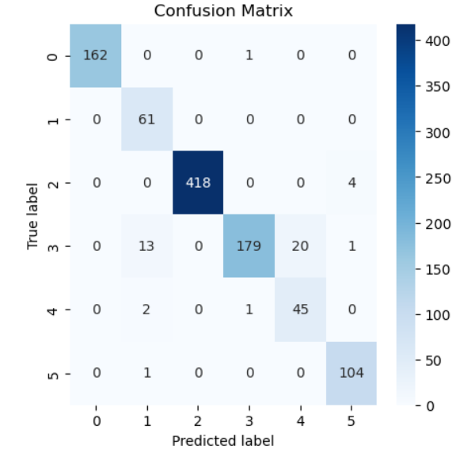

* ROC Before HOG:

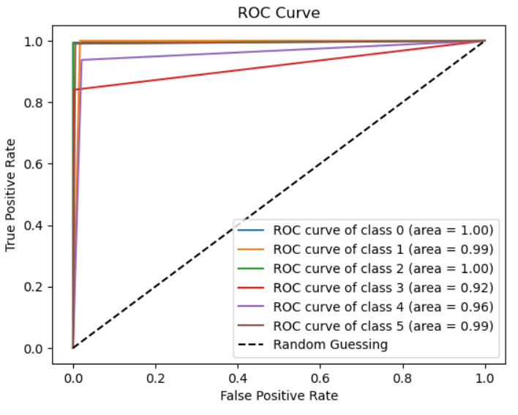

Accuracy of logistic regression without HOG features: 0.9575098814229249

* Confusion Matrix After HOG:

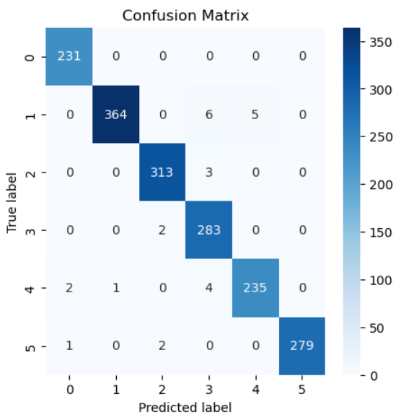

* ROC After HOG:

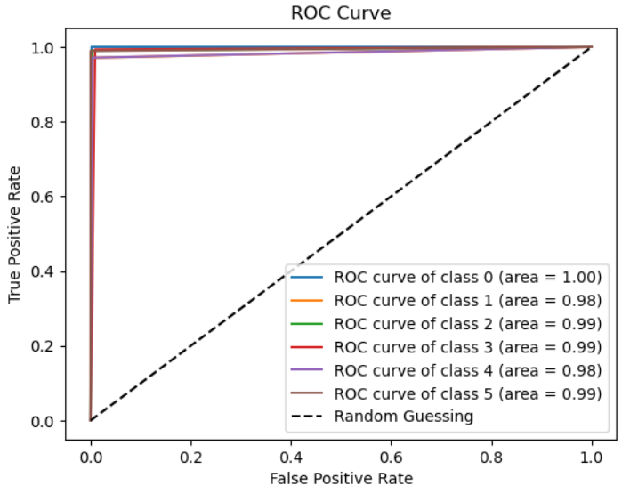

Accuracy of logistic regression with HOG features:

0.9849797804737146

K-MEANS:

* K-means Predicted Clusters vs Actual Classes

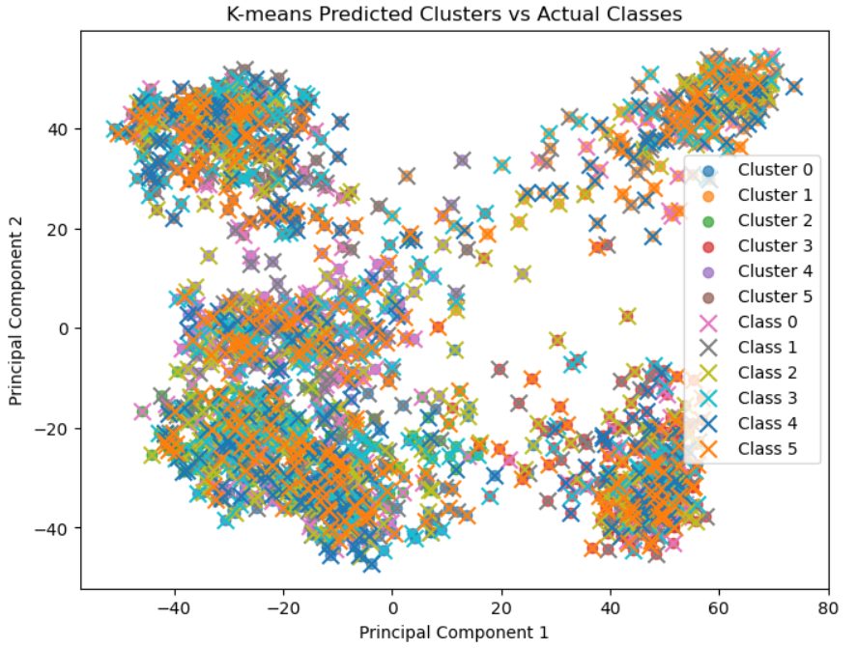

* K-means Inertia (Loss) vs. Number of Clusters

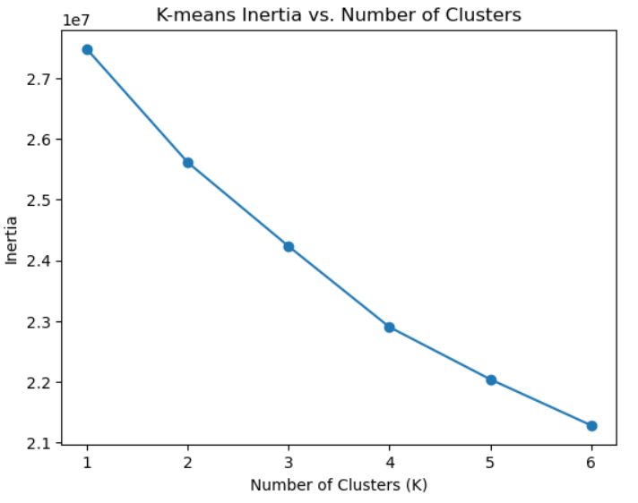

**Artificial Neural Network (ANN)**

 **Hyper-parameters**

(Specify all the hyper-parameters (initial learning rate, optimizer, regularization, batch size, no. of epochs…) with their specified value in implementation)

Epochs: 20

Learning Rate: 0.0001

Batch size: 5

Optimizer: adam

Validation splits: 0.2

Hidden layer: 512

Loss: categorical_crossentropy

**a. ANN Results**

* Loss Curve:

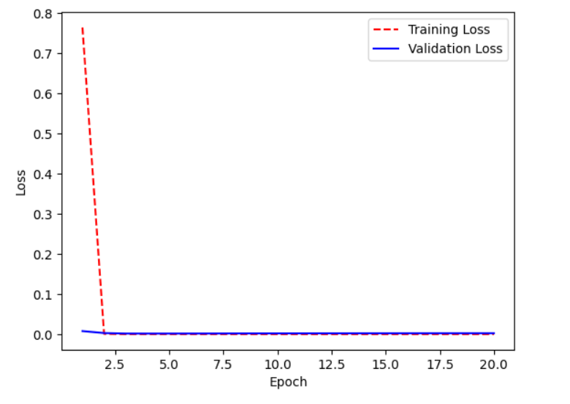

* Accuracy Curve:

