LCL SHIPMENTS INSPECTION REPORT
Cases Reference: SACO – LCL –16 / 2026
Date of Inspection: 15-06-2026 | Shippers : TBA
Container No. : CMAU2459884 | ISO Code/Type : 20 G1
Seal No. : B144056 | Condition :INTACT
Port of Shipping : HAMBURG | Receivers: SACO SHIPPING EGYPT .(Egypt)
Place of inspection : Port Said West Port | Port of discharge : Port Said (Egypt)
MBL No. : TBA | No. of HBL :9
Total Manifest No. of PKGS: 15 Pkg | Total Actual No. of PKGS : 15 Pkg
Vessel: CMA CGM NANSHA | Arrival Date: 8-06-2026
No. | HBL No. | Manifest Qty | Actual Qty | Sound | Unsound | Missing | Notes
1 | B/L: 10929351 | 2 PALLETS | 2 PALLETS | 2 PALLETS | _ | _ | There is a box containing its application.
2 | B/L: 10930055 | 2 PALLETS | 2 PALLETS | 2 PALLETS | _ | _
3 | B/L: 17451257 | 2 PALLETS | 2 PALLETS | 2 PALLETS | _ | _
4 | B/L: 17452512 | 1 CRATE | 1 CRATE | 1 CRATE | _ | _ | _
5 | B/L: 17453449 | 2 PALLETS | 2 PALLETS | 2 PALLETS | _ | _ | _
6 | B/L: 27746913 | 1 CASE | 1 CASE | 1 CASE | _ | _ | _
7 | B/L: GCANR26040024 | 1 PACKAGE | 1 PACKAGE | 1 PACKAGE | _ | _ | _
8 | B/L: GCHAM26040433 | 2 PACKAGE | 2 PACKAGE | 2 PACKAGE | _ | _ | _
9 | B/L: PSD207975 | 2 DRUMS | 2 DRUMS | 2 DRUMS | _ | _ | _

Photos In Yard
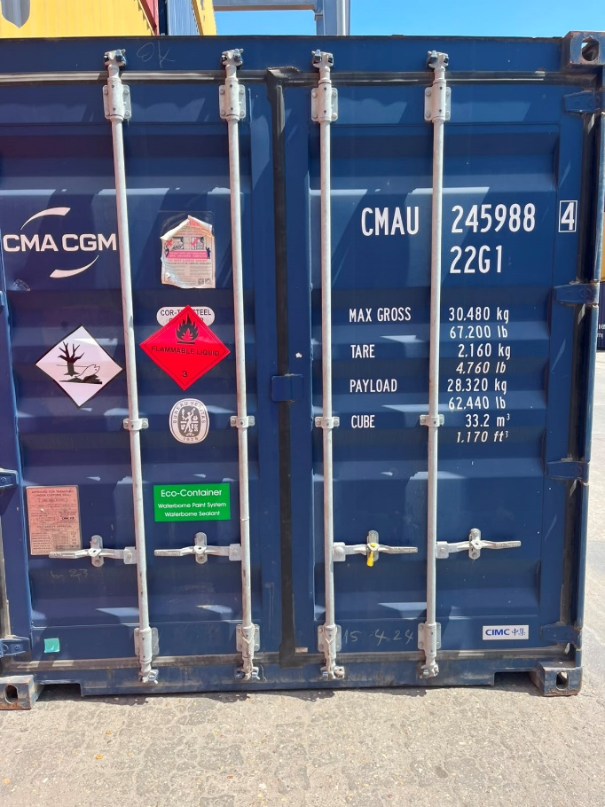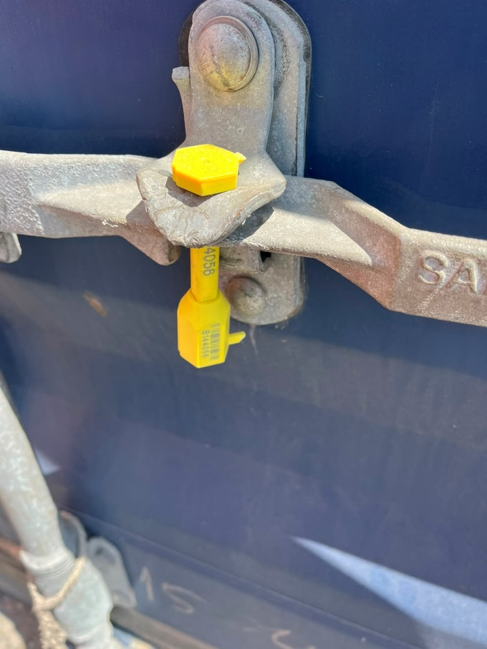

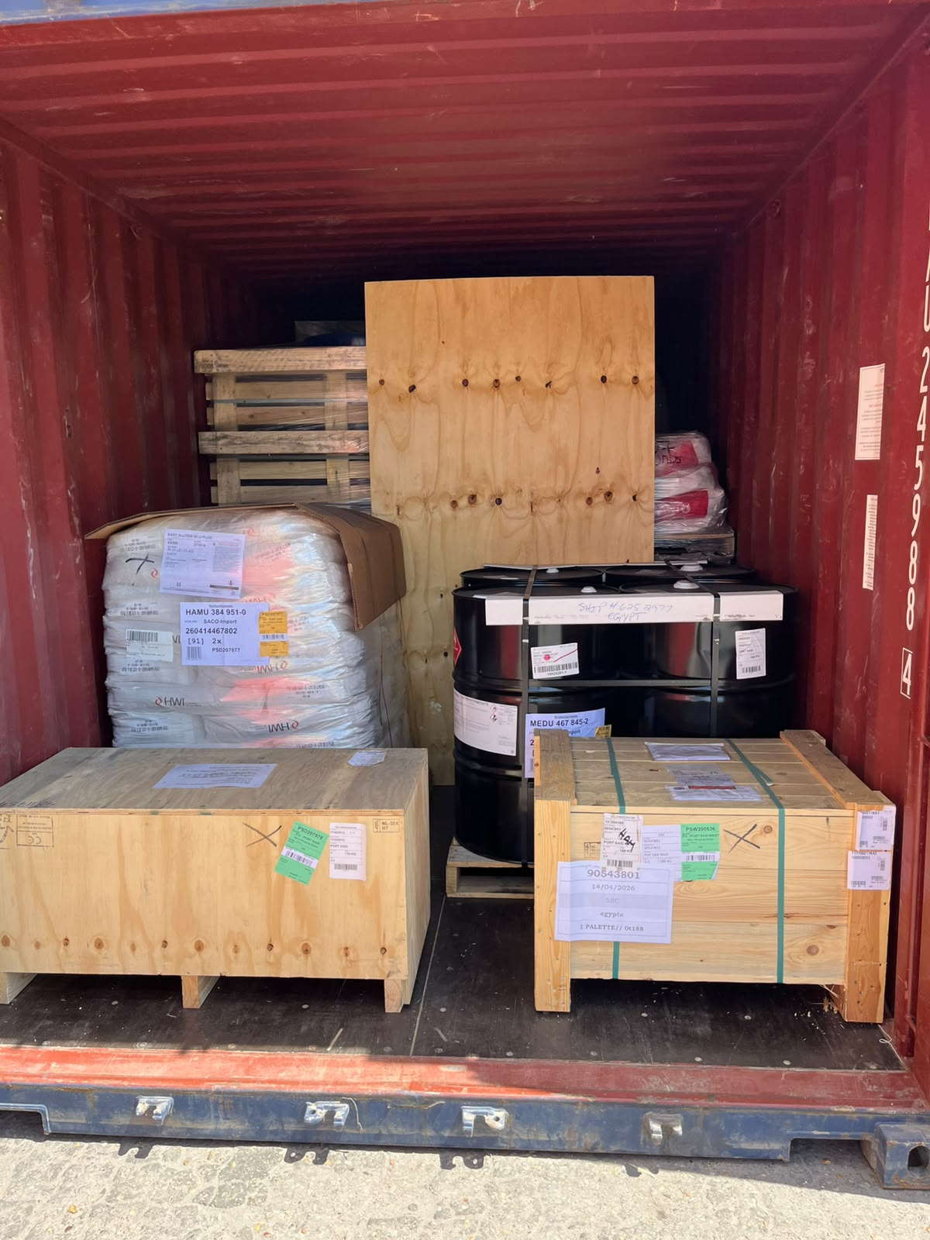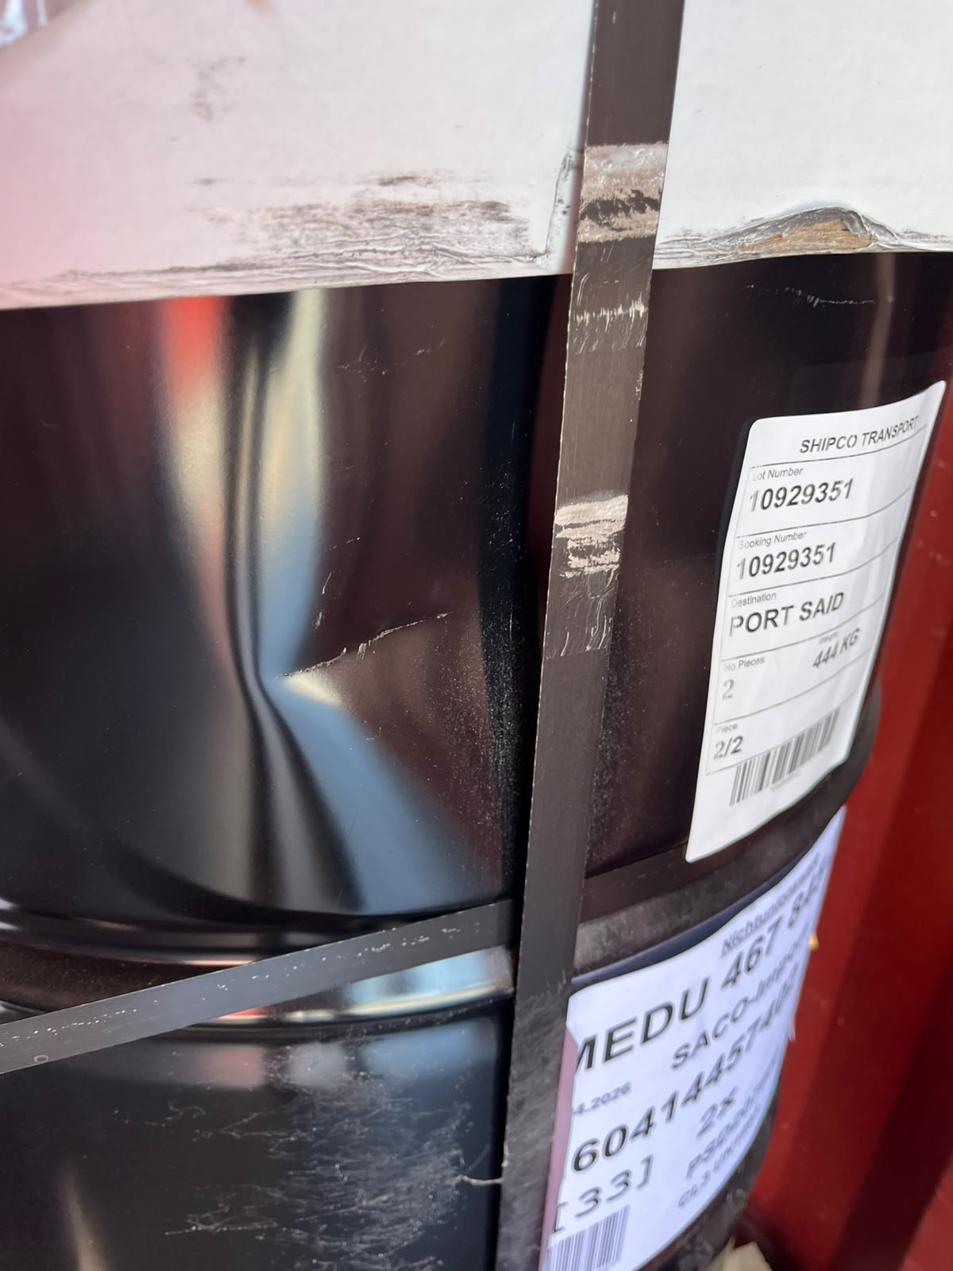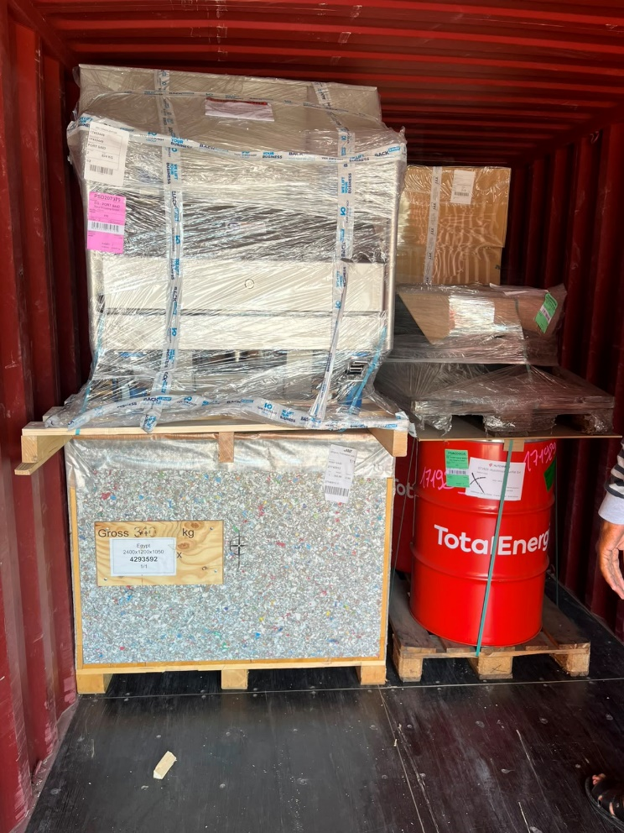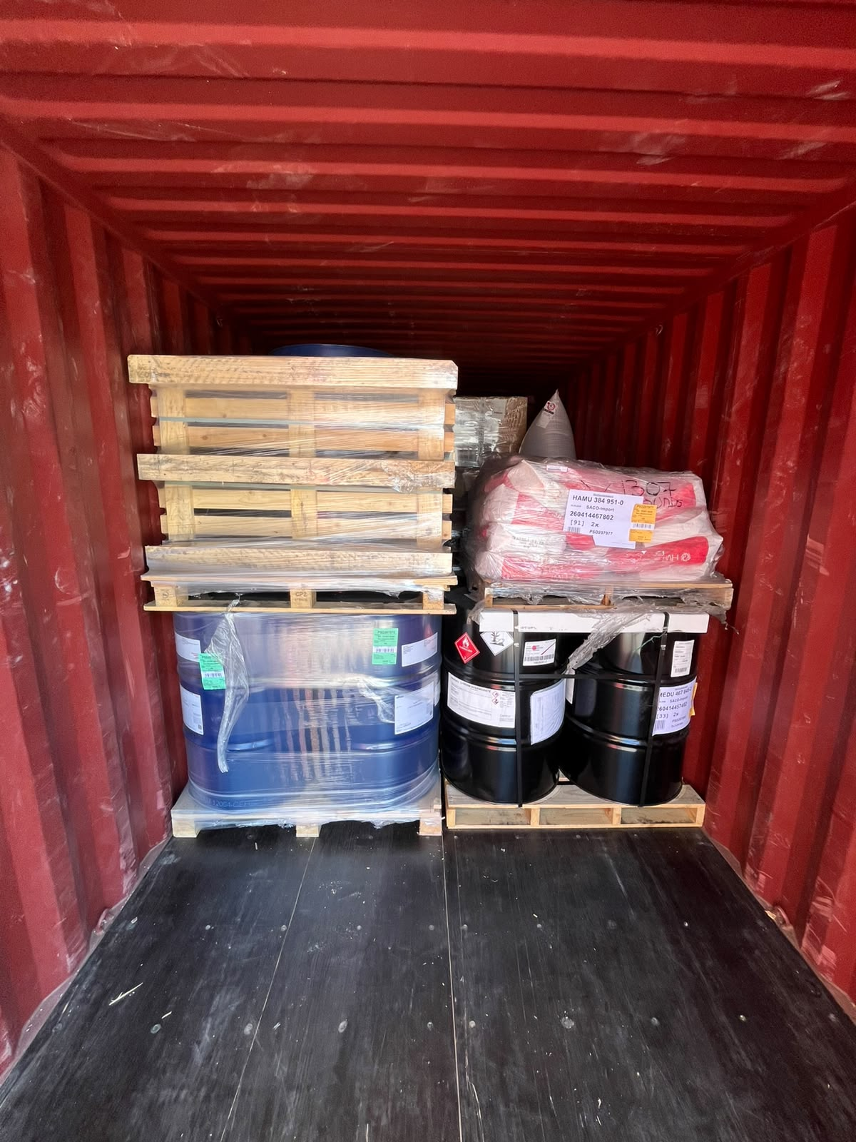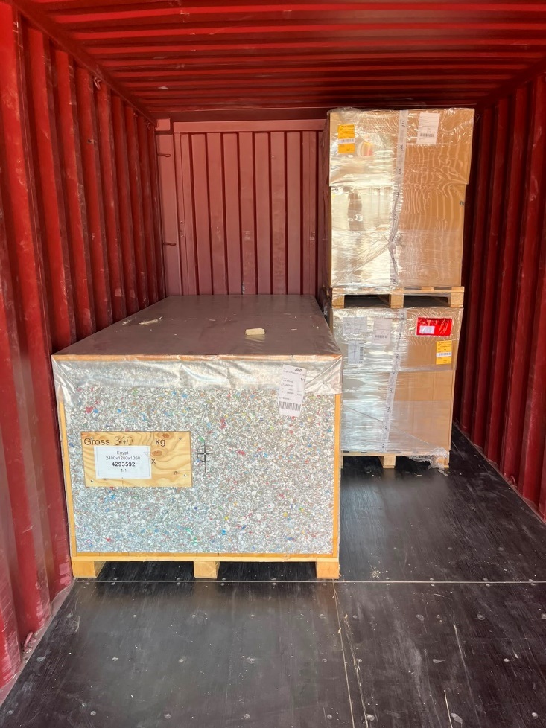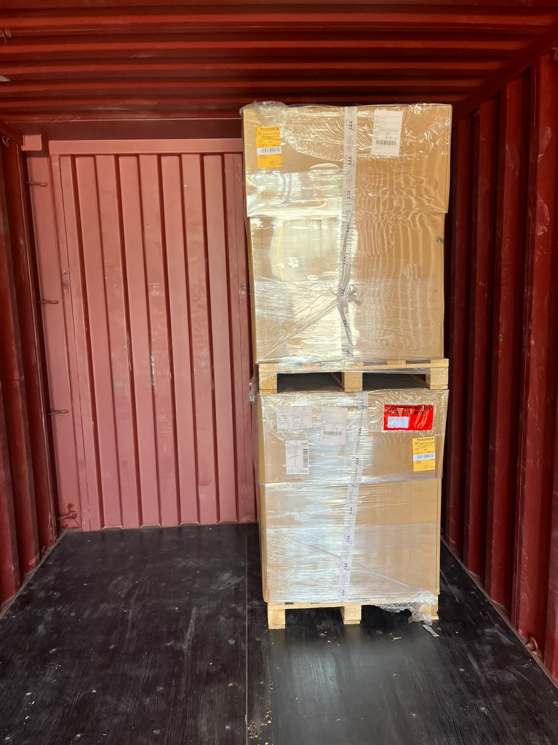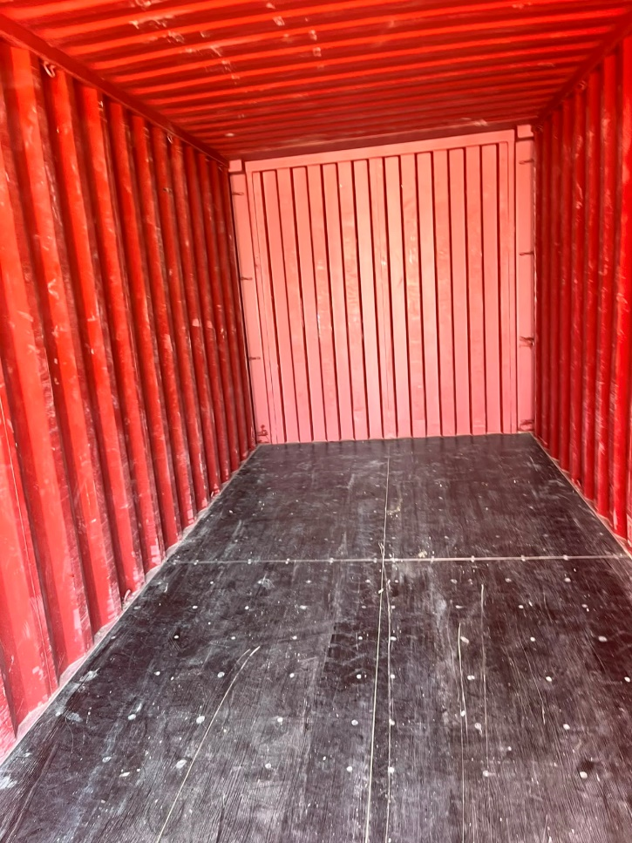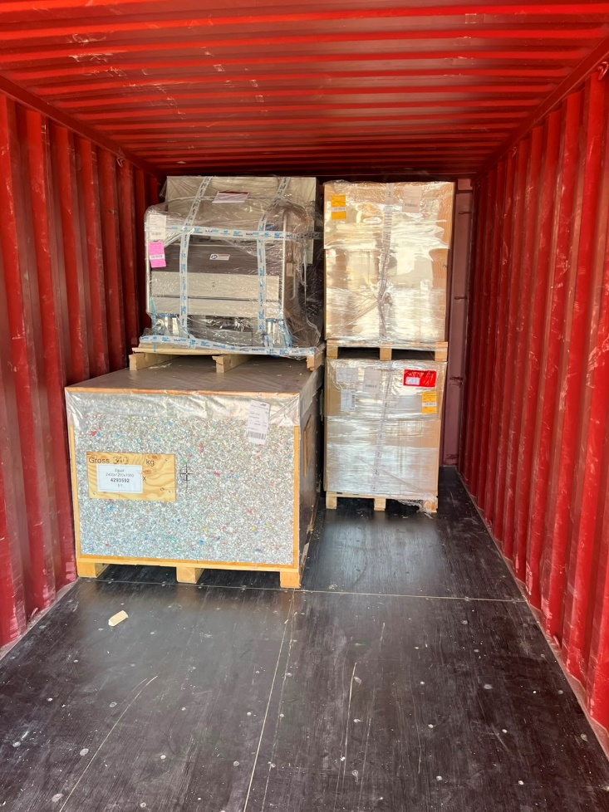

Photos In Cargo
