LCL SHIPMENTS INSPECTION REPORT
Cases Reference: SACO – LCL –25 / 2026
Date of Inspection: 00-06-2026 | Shippers : TBA
Container No. : GESU 1121146 | ISO Code/Type : 20 G1
Seal No. : B019445 | Condition :INTACT
Port of Shipping : HAMBURG | Receivers: SACO SHIPPING EGYPT .(Egypt)
Place of inspection : Port Said West Port | Port of discharge : Port Said (Egypt)
MBL No. : TBA | No. of HBL :5
Total Manifest No. of PKGS: 28 Pkg | Total Actual No. of PKGS : 28 Pkg
Vessel: CMA CGM KHAO SOK | Arrival Date: 00-06-2026
No. | HBL No. | Manifest Qty | Actual Qty | Sound | Unsound | Missing | Notes
1 | B/L: 90527958 | 2  PALLETS | 2  PALLETS | 2  PALLETS | _ | _ | Some of the cartons are torn and damaged.
2 | B/L: ALY249878 | 10  BOX | 10  BOX | 10  BOX | _ | _
3 | B/L: PSD207928 | 3  PALLETS | 3  PALLETS | 3  PALLETS | _ | _
4 | B/L: PSD207931 | 12  BOXES | 12  BOXES | 12  BOXES | _ | _ | _
5 | B/L: PSW200494 | 1  PALLET | 1 PALLET | 1  PALLET | _ | _ | _

Photos In Yard
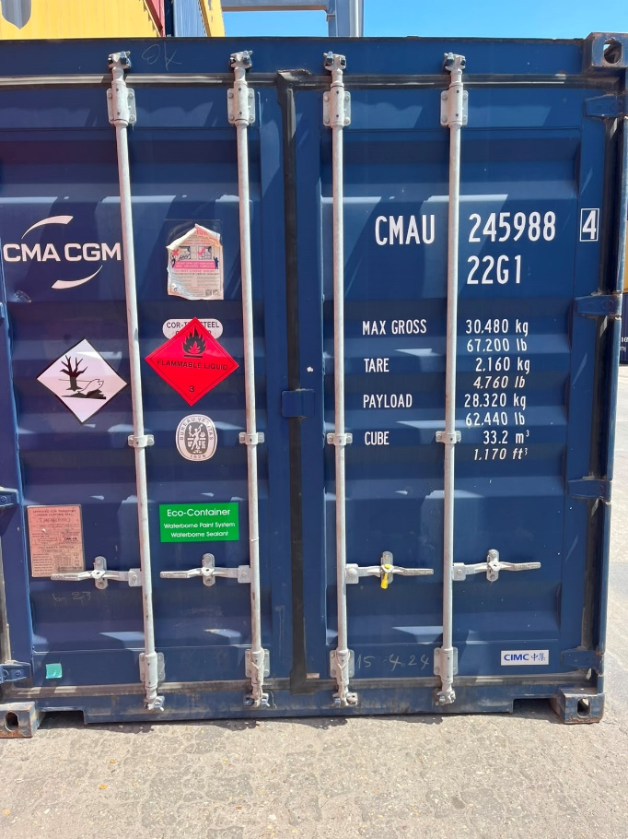

Photos In Cargo


