

**Faculty of engineering - Shoubra**

**Benha University**

**Research Project**

in fulfillment of the requirements of

|  |  |
| --- | --- |
| **Department** | Engineering Mathematics and Physics |
| **Division** | **------------** |
| **Academic Year** | 2019 – 2020 Preparatory |
| **Course name** | Computer |
| **Course code** | ECE006 |

**Title: -**

**Report of the website on Artificial Intelligence**

By:

|  |  |  |  |
| --- | --- | --- | --- |
|  | Name | Edu mail | B. N |
| 1 | أحمد جمال سعيد أحمد | ahmed195043@feng.bu.edu.eg | 42 |

**Approved by:**

|  |  |
| --- | --- |
| Examiners committee | Signature |
| Dr. Ahmed Bayoumi |  |
| Dr.Shady Elmashad |  |
| Dr. Abdelhamid Attaby |  |

**Table of contents**

|  |  |
| --- | --- |
| **Subject / section** | **Page** |
| Application Brief | **2** |
| Screenshots of web pages | **3** |
| Screenshots of Source Code | **7** |

**Application Brief**

Now, most people are interested in technology and recent developments. People always look forward to living an easy life so, they always like to have new advanced devices and machines which facilitate their lives. all this interest in technological development, most people do not know anything about the technologies used in the design and development of these modern devices. One of these technologies is Artificial Intelligence (AI) and this is the cause why I choosed this topic.

Artificial Intelligence (AI) helps computers to learn from experience, adapt to new stimuli, and perform tasks of a human nature. Many AI examples you hear of today – from chess-playing machines to self-driving cars – rely heavily on deep learning and the processing of natural languages. Using these technologies, computers can be trained to perform specific tasks by processing large amounts of data and recognizing patterns in the data.

AI has been dominant in various fields such as **Gaming, Natural Language Processing, Expert Systems, Vision Systems, Speech Recognition, Handwriting Recognition, and Intelligent Robots.**

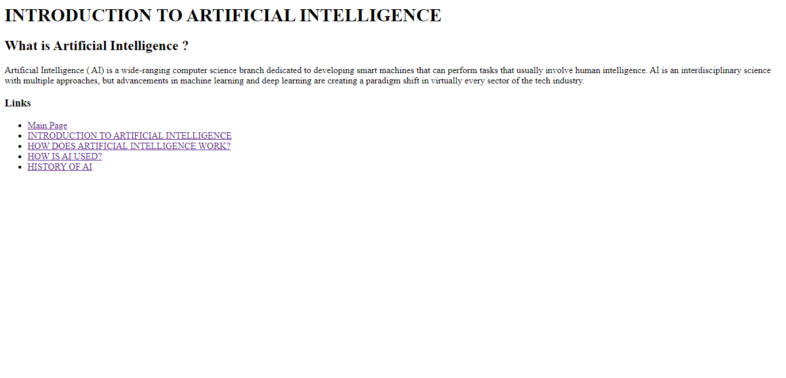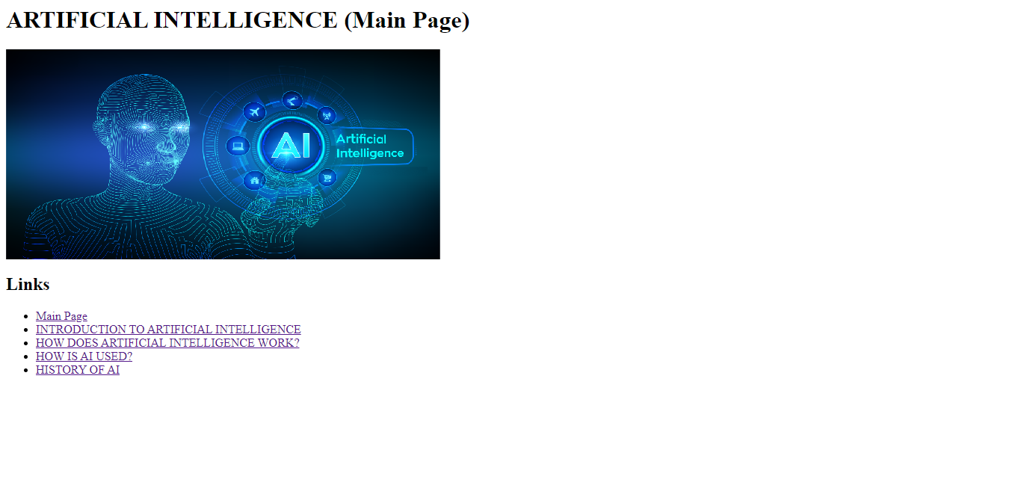**Screenshots of web pages**

**Page.1**

**Main page**

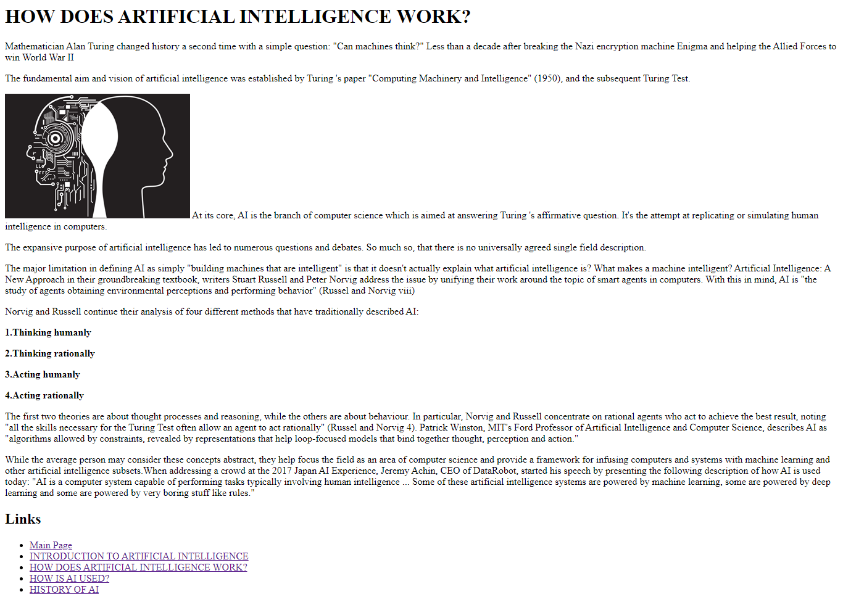

**Page.2**

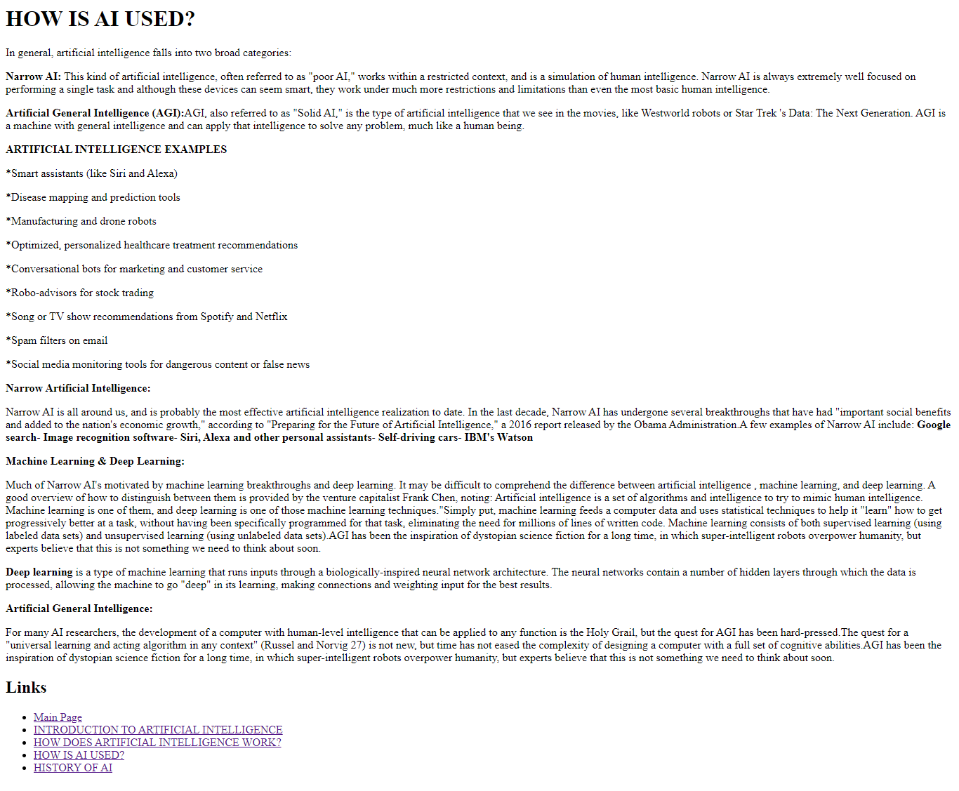

**Page.3**

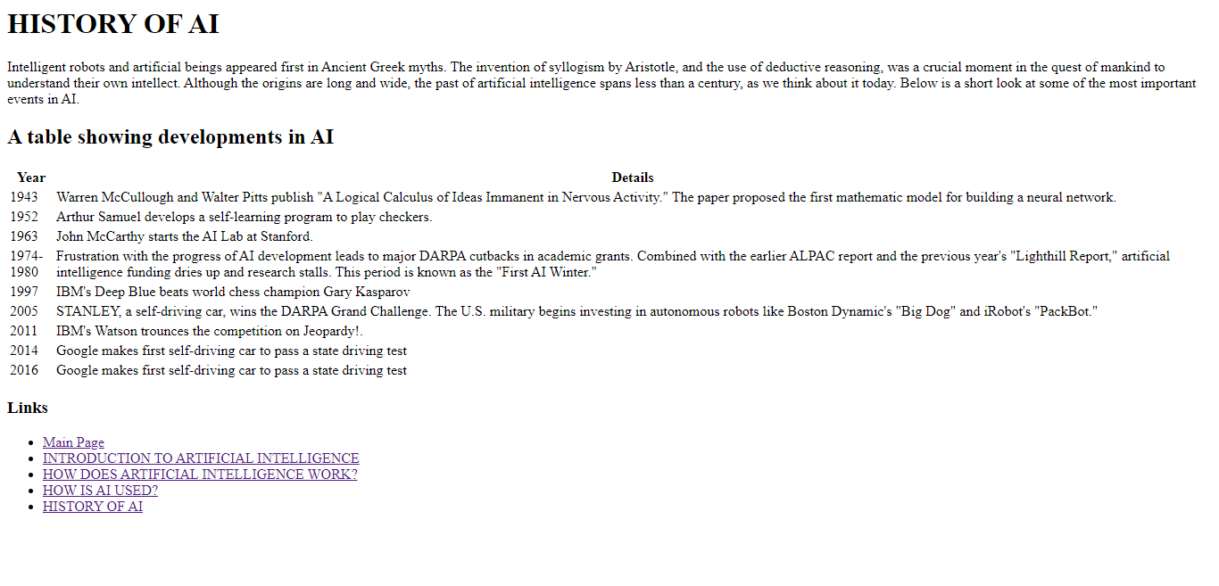

**Page.4**

**Screenshots of Source Code**

**Main page**

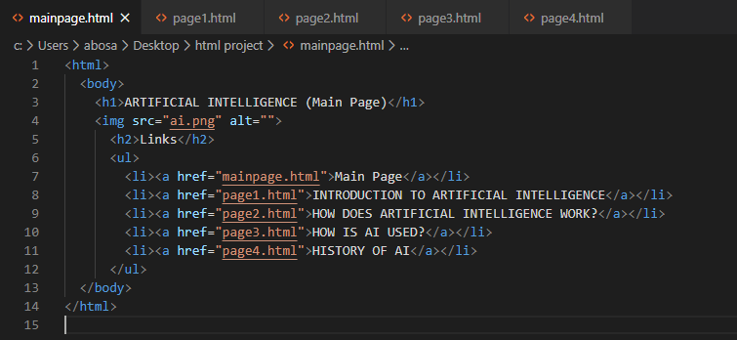

**Page.1**

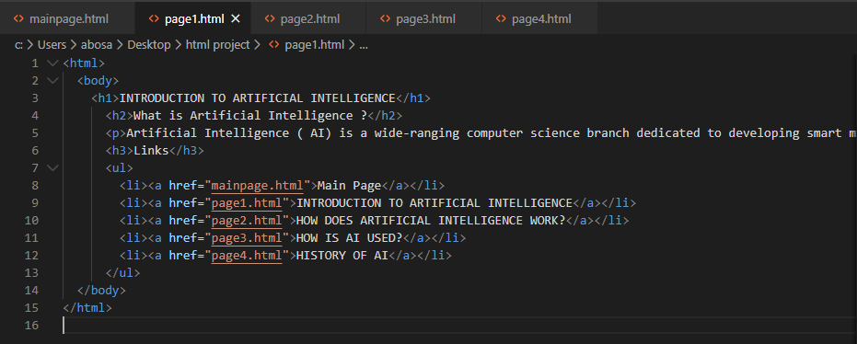

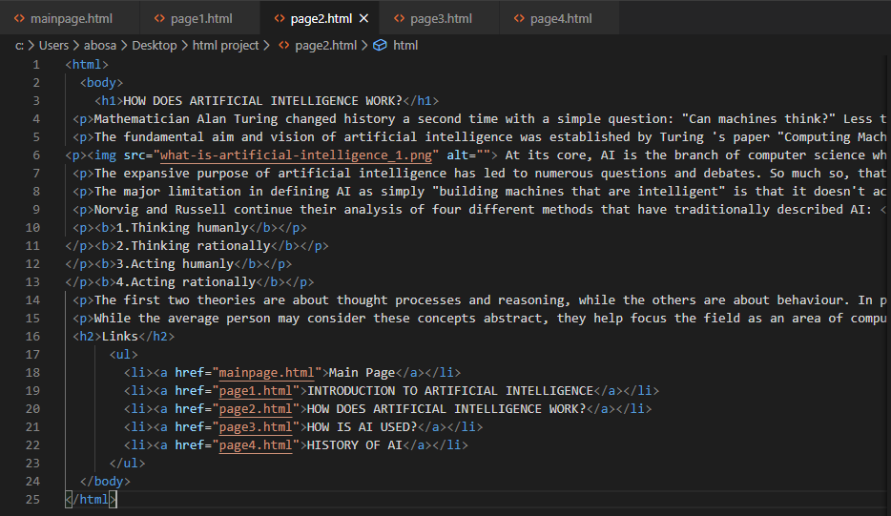

**Page.2**

**Page.3**

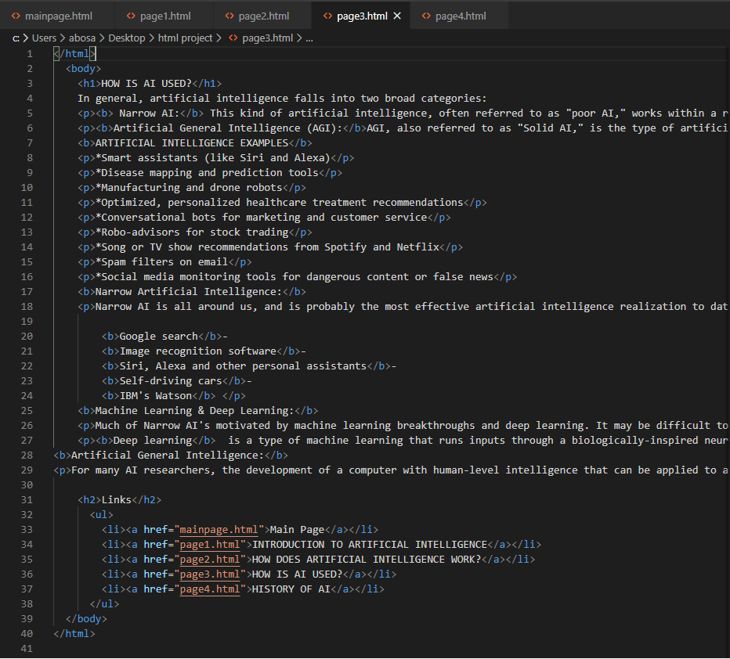

**Page.4**

