**Virtualisation Definition**

It is the process of separating a software from the hardware

A virtual server is a server that doesn’t exist in physical form, it exists in virtual form.

Hypervisor (A.K.A virtual machine) works is the intermediate between the VMs and the host.

**Virtualisation Types**

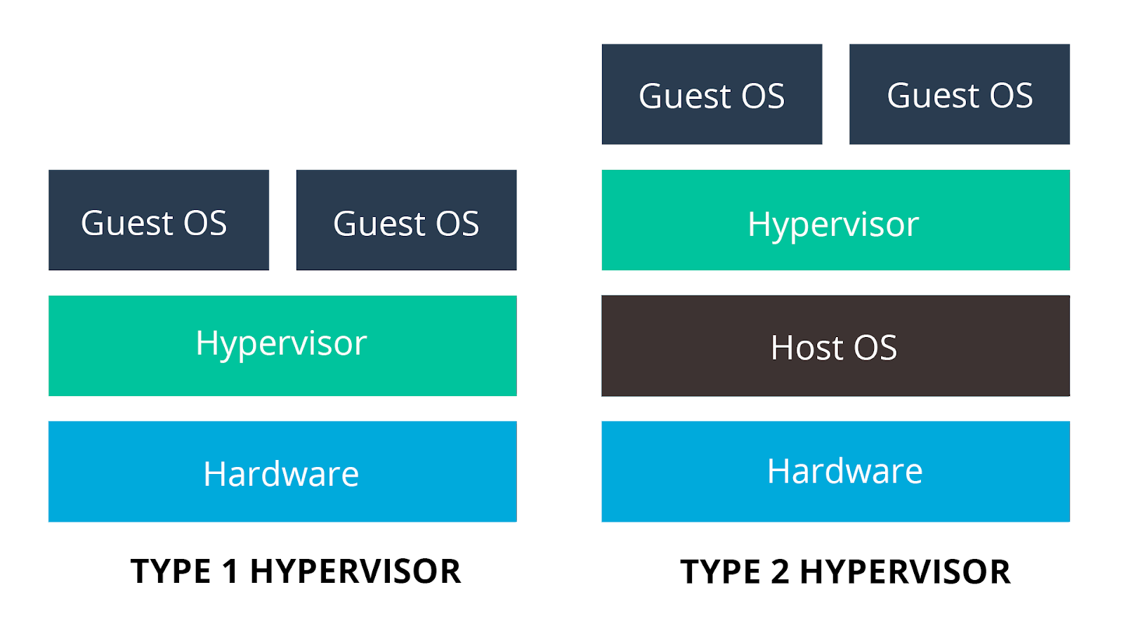

**Type 1**

Technique – The Hypervisor is running directly on the host machine hardware without the existence of any operating systems.

**Type 2**

Technique - The host machine is running under a conventional operating system, such as Microsoft Windows, Linux, Mac OS.

**Virtualisation & Linux**

**Linux Architecture**

Composed of 3 components:

1. Kernel contains all the drives and libraries that communicates with the hardware.
2. Shell is a command-line interpreter and is the interface between the user and the kernel. The user can enter commands to the shell. Then it interprets the commands to perform the required task.
3. Application is the browser, software, programs.

**Linux Distributions**

Linux Distribution is **a version of the open source Linux operating system** that is packaged with other components, such as an installation programs, management tools and additional software such as the KVM hypervisor.

Why are there so many variation?

**Linux Filesystem**

A filesystem is the system that control how store and retrieve data from the storage device such as hard disk or flash memory.

Linux works on the concept that everything starts at the root

The concept if Everything is a file

Commands and names of files and directories are Case Sensitive

Hidden files / directories start with “.”

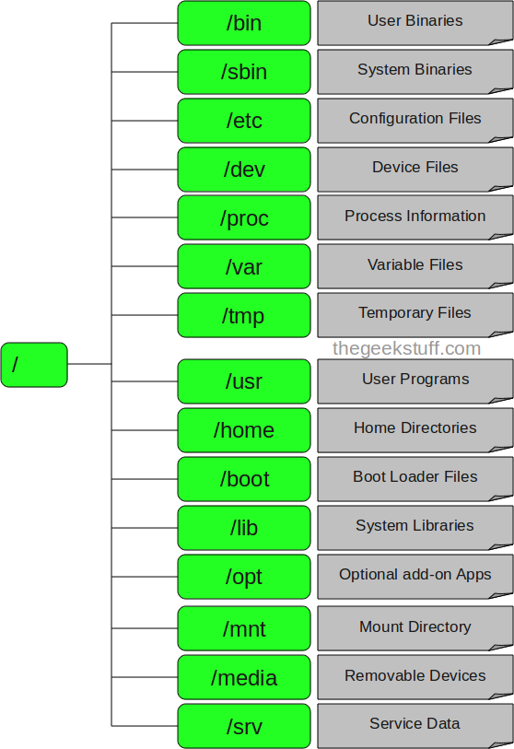

**Files permission & Ownership**

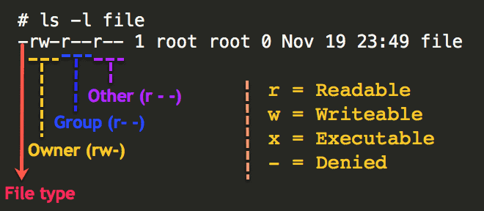



**Linux Logging Basics**

Operating system logs provide a wealth of diagnostic information about your computer, and Linux is no exception. Everything from kernel events to user actions are logged by Linux, allowing you to see almost any action performed on your servers. In this section, we’ll explain what Linux logs are, where you can find them, and how to interpret them.