Retail Sales Analysis Project Summary
MySQL, Microsoft Power BI and Excel
Prepared by Ahmed Adebowale Akeeb | Portfolio project summary
Project Overview
This project analyses retail sales data to identify sales performance, customer activity and product-category trends. The work follows an end-to-end analytics process: data review and validation in MySQL, structured business analysis through SQL queries, and visual reporting in Microsoft Power BI.
Project Objectives
- Prepare and validate the retail sales dataset for analysis.
- Answer business questions about transactions, customers and product categories using SQL.
- Create an interactive dashboard that presents the main findings clearly.
- Demonstrate practical capability in SQL, Excel and Power BI.
Tools and Dataset
Area | Details
Tools | MySQL, Microsoft Power BI and Microsoft Excel
Transactions | 1,987 retail transaction records
Customers | 155 unique customers
Product categories | Beauty, Clothing and Electronics
Key data fields | Transaction ID, sale date and time, customer ID, gender, age, category, quantity, price per unit, cost of goods sold and total sales
Methodology
- Reviewed the dataset and checked the available categories, total records and distinct customers.
- Standardised incorrect column names and adjusted data types for dates, times and text fields.
- Checked for missing values and duplicate transaction identifiers, then assigned the transaction identifier as the primary key.
- Used SQL queries to analyse sales by category, high-value transactions, customer sales, category reach and gender-category patterns.
- Created a reusable retail_dashboard view and visualised the findings in Power BI.
Key Findings
Measure | Result | Interpretation
Top category by sales | Electronics: 311,445 | Electronics recorded the strongest sales result.
Closest category | Clothing: 309,995 | Clothing was close behind Electronics.
High-value transactions | 306 | Transactions with total sale above 1,000.
Top customer | Customer 3: 38,440 | Highest total sales among the five leading customers.
Largest customer base | Clothing: 149 customers | Clothing had the highest count of unique customers.
Beauty customer age | 40.42 years | Average age of customers in the Beauty category.

Power BI Dashboard

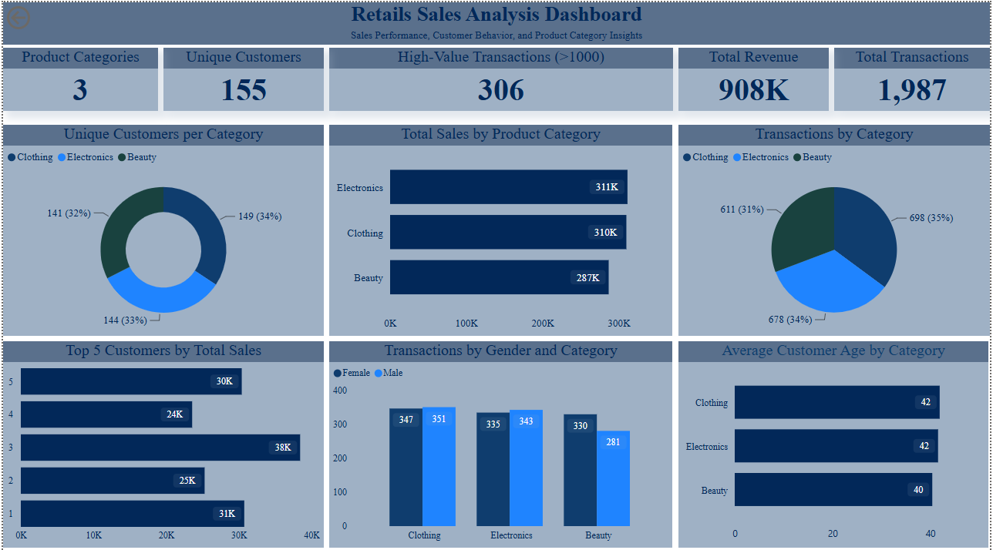
Figure 1. Retail Sales Analysis dashboard created in Microsoft Power BI.
Business Interpretation
- Electronics and Clothing are the strongest sales categories, with very similar total sales performance.
- The high-value transaction count provides a clear segment for further investigation, such as identifying high-spend products or customers.
- Customer 3 contributed the highest sales value and could be considered in customer-retention analysis.
- The customer reach across categories is relatively balanced, with Clothing having the broadest unique-customer base.
Portfolio Evidence
The supporting portfolio repository contains the prepared dataset, SQL analysis script, Power BI dashboard file, dashboard PDF and this project summary. Together, these items demonstrate data preparation, SQL querying, dashboard development and communication of business insight.
Conclusion
The project demonstrates an end-to-end retail analytics workflow. It combines data validation and SQL analysis with a Power BI dashboard to produce clear findings about sales performance, customer activity and category trends.

