Phone
Play
Play
Produce
Appears at
Name
ID
Name
Key
Title
Author
Id
Title
Date
Address
Musician
Instrument
Album
Song
M
M
M
M
1
M
1
M..……

City
St

ID
Manage
NUM
Name
1
1

Employee
Sales office
Loc
Work
List
Has
Add
ID
Name
Loc
City
State
Zip
ID
Property
Owner
M
1
M
1
M
M

Percent-owned

Name
Assigned to
Name
ID
DOB
ID
Dosage
Time
Date
ID
ID
M
1
1
1
1
M
1
M
N
M
M
N
K

Examines
Patient
Consultant

Hosts

Gives
Name

Ward
Drug

Code
Rec Dosage
Brand
Supervises

Serve in
Nurse
Name
Note: Aircraft can use the same route in different dates

Name
Address
ID
Birthday
Day
Month
Year
Contact Person
Address
Phones
Position
ID
Name

Qualifications

Works in
Airline
Employee
Gender
1
M
Aircraft
ID
Capacity
Model
Transaction
ID
Desc.
Date
Amount
Owns
Assigned
Has
Maj. Pilot
Ass. Pilot
Hostess1
Hostess2
Records
#passe
Time spent
ArrDateTime
Route

ID
Origin
Destination
Classification
Distance
Price/pass
1
M
1
M
1
M
1
M

Crew

Dept DateTime
Crew_ID

Company Database Schema

- Create Database using wizard with the following schema then
Create DB Diagram and insert at least 2 rows per table
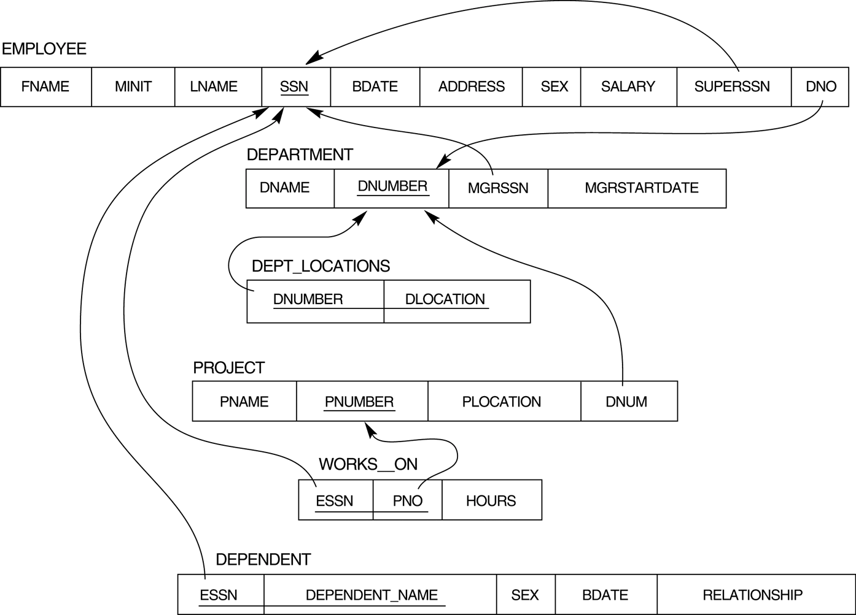

- Restore Company DB then
Try to create the following Queries:

- Display all the employees Data.
- Display the employee First name, last name, Salary and Department number.
- Display all the projects names, locations and the department which is responsible about it.
- If you know that the company policy is to pay an annual commission for each employee with specific percent equals 10% of his/her annual salary .Display each employee full name and his annual commission in an ANNUAL COMM column (alias).
- Display the employees Id, name who earns more than 1000 LE monthly.
- Display the employees Id, name who earns more than 10000 LE annually.
- Display the names and salaries of the female employees
- Display each department id, name which managed by a manager with id equals 968574.
- Dispaly the ids, names and locations of the pojects which controled with department 10.

