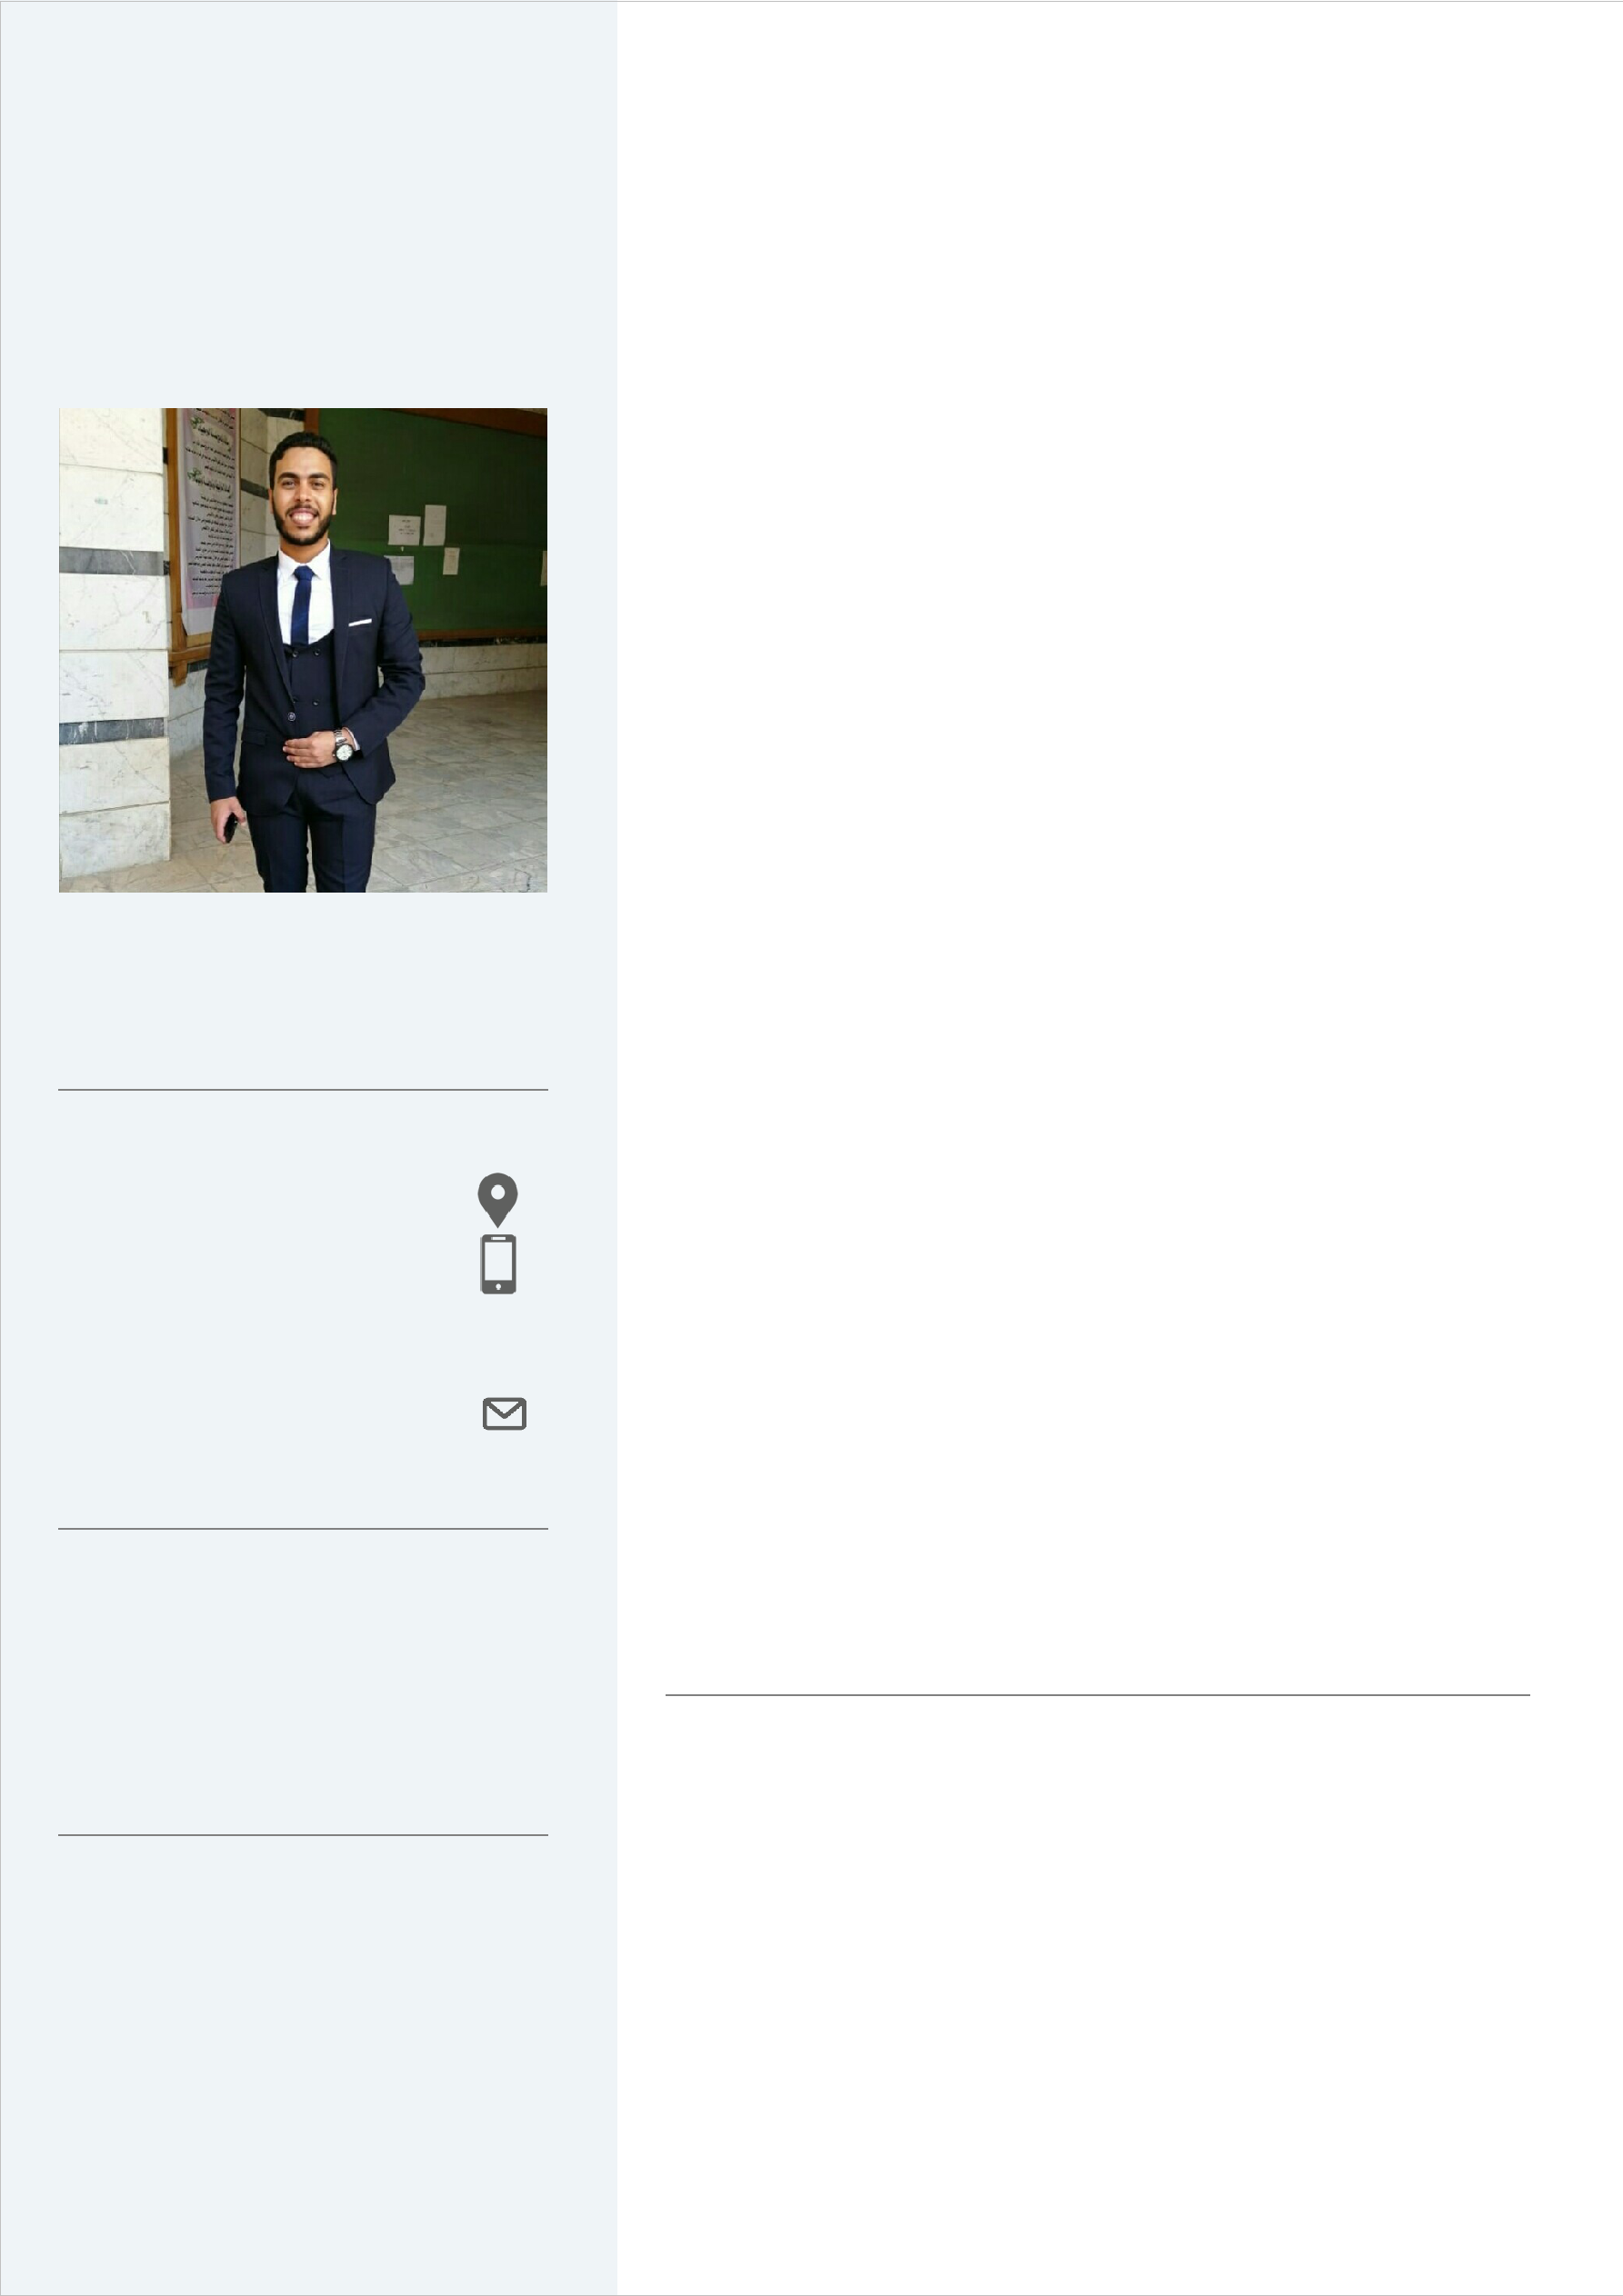

**Ahmed Adel**

**CONTACT**

40, Saad Mabrouk Street imbaba - Giza

01128674864

adel.eng20@gmail.com

**PERSONAL INFORMATION**

|  |  |  |
| --- | --- | --- |
| Date of birth : | | 06/10/1996 |
|  |  |  |

Nationality : Egyptian

**LANGUAGES**

Arabic : Mother Tongue

English : Very Good Writing

, Good Speaking

**[Software engineer]**

**PROFESSIONAL SUMMARY**

Ahmed Adel Saad Full-Stack Developer with 2 years of experience in Front-End and Back-End Programming, Seeking for a job in a fast-growing company.

**WORK EXPERIENCE**

**Developer of IT department @ Belquis Tours Comapny, Egypt** 2016 - 2018

Initially joining the company as a trainee, I participated in the work of the website of the company using php-laravel and also participated in the work of the application of the company using android - java - XML.

**Software engineer @ Dejavu company** 2019 - still working

Working as Full-stack Developer and I developed some projects as

- HR portal website for HR department using php-Laravel Framework with Mobile App Using React Native To Manage Company Employees.

-Sales App for Company Stores With many Features Using React Native and php API.

-Using PHP for crating tool that use Shopify Api to fetch all orders from Shopify website as XML and make integration with Retail-Pro for Create Invoices.

-System To Manage all daily Stores Sales details with total Cash, total Visa with Visa Card Name, total Net-Deposit, total deductions and all other details for Finance Department Using PHP native with java-Script.

-Work on Internal Website that mange customers Tickets and manage customer service department employees with dashboards and Api’s Using PHP.

**IT member @ Geeks Student activity at FCI helwan universirt, Egypt**

2017 - 2019

I am joining to the student activity as it member and I participated in some works such as making Bot using node js and java script, and participated in the work of website using php – CodeIgniter web framework.

**Student Activities**

**---------------------------------**

**IT** member at geeksstudent activity

**Social profile**

**---------------------------------**

**LinkedIn:**

https://www.linkedin.com/in/ahme d-adel-320796174/

**EDUCATION**

**-------------------------------------------------------------------------------**

|  |  |
| --- | --- |
| **College** | : Faculty of computer science, Helwan University |
| **Major** | : information system and computer science |
| **Graduation Year:** 2019 | |
| **Cumulative Grade:** Very Good | |
| **GPA** | : 3.2 |

**Graduation Project:** Abu el 3oref android application

**TECHNICAL SKILLS**

**-------------------------------------------------------------------------------**

|  |  |  |  |
| --- | --- | --- | --- |
|  | PHP | : very good | |
|  | Laravel framework | : very good | |
|  | React native | : very good | |  |
|  | React JS  AJAX  CSS/CSS3 HTML/HTML5  Bootstrap Java Script  Expo | : very good  : very good  : very good  : very good  : good  : very good : good | |
|  | MYSQL/mongo DB/Firebase | : | very good |
|  | Android studio | : | very good |
|  | object oriented programming | : | very good |
|  | Git | : | very good |
|  | Dart language | : | good |
|  | Flutter framework | : | Beginner |

|  |  |  |
| --- | --- | --- |
|  | Analysis and design | : very good |
|  | Java language | : good |
|  | Android programming | : very good |

**PERSONAL SOFT SKILLS**

**-------------------------------------------------------------------------------**

*Team work spirit and cooperation. *ability of smart work.

*communication, presentation, and leadership skill *Planning and time management

*Self-motivated

*Hard worker under stress

*Ability to face & solve problems *Flexibility



|  |  |  |  |
| --- | --- | --- | --- |
| **Projects**  ------------------ |  |  |  |
| Project name |  | Abo el 3oref App | |
| Duration | 2018 - 2019 | |  |
| Description |  | implemented as a **Android** | |
|  |  | **application** with a simple user | |
|  |  | interface . | |
|  |  | this app helps people who want | |
|  |  | to **find new places or lost their** | |
|  |  | **ways** while searching for new | |
|  |  | places. | |
|  |  | helps the users to **ask** | |
|  |  | **questions** and get answers | |
|  |  | from another users who knows | |
|  |  | more about these places and | |
|  |  | lives in the area. | |
|  |  | helps the users to **make** | |
|  |  | **challenge** between them | |
|  |  |  |  |
| technologies |  | Android with java | |
|  |  | Firebase | |
|  |  | Android studio | |
|  |  | Xml | |
|  |  | Google map APIs | |
| Project link |  | https://github.com/AhmedAdel19/lastVersi | |

|  |  |  |  |  |  |
| --- | --- | --- | --- | --- | --- |
|  |  |  | | |  |
| Project name |  | Faculty system App | | |  |
| Duration | 2017 - 2018 | | | |  |
| Description |  | implemented as a **Android** | | |  |
|  |  |  | ***application*** *.* | |  |
|  |  | help students to **communicate** | | |  |
|  |  |  | **with** doctors and teacher Assis- | |  |
|  |  |  | tants . | |  |
|  |  |  | students can **register courses** | |  |
|  |  |  | they need. | |  |
|  |  |  | **view student grade.** | |  |
|  |  | Student can **make complain** | | |  |
| technologies |  | Android with java | | |  |
|  |  | Sqlite |  |  |  |
|  |  | Android studio | | |  |
|  |  | Xml |  |  |  |
|  |  |  | | |  |
| Project name |  | E-Pharmacy system (website) | | |  |
| Duration | 2016 - 2017 | | | |  |
| Description |  |  | E-Pharmacy system (website) | |  |
|  |  | Using php na ve, HTML, CSS, | | |  |
|  |  |  | jquery, Java script and Ajax. | |  |
|  |  | Website allow people to make | | |  |
|  |  |  | reserva on for anything and buy | |  |
|  |  |  | it from to any pharmacy. | |  |
|  |  |  |  | |  |
| technologies |  | Php native | | |  |
|  |  | mysql database | | |  |
|  |  | oop |  |  |  |
|  |  |  | |  |  |
|  |  |  | | |  |
| Project name |  | Bus Reserva on system | | |  |
| Duration | 2017 - 2018 | | | |  |
| technologies |  | Using Asp. Net en ty framework code- | | |  |
|  |  | first MVC, SQL server, Java script, | | |  |
|  |  | HTML, |  |  |  |
|  |  | CSS, jquery, HTML helpers, bootstrap | | |  |
|  |  | for front-end, ajax | | |  |
|  |  |  | | |  |
| Project name |  | Square puzzle (Ai game) | | |  |
| Duration | 2017 - 2018 | | | |  |
| Description |  | Making ar ficial intelligence | | |  |
|  |  |  | game that solve squar puzzle at | |  |
|  |  |  | specific me and with | |  |
|  |  |  | ideal solution. | |  |
| technologies |  | Using python and Heuris c "Best-First- | | |  |
|  |  | Search" | | |  |
|  |  |  |  |  |  |
|  |  |  |  |  |  |

|  |
| --- |
|  |
| Project name | |  | HR Portal System (web app and mobile app) | | |  |
| Duration | | 2020 - 2020 | | | |  |
| Description | |  |  |  | |  |
|  | |  | Using php Laravel Framework, API  MVC,routing , Events and Listeners Real Time Chat using (Broadcast , Pusher and Vue Js), bootstrap ,HTML, CSS, | | |  |
|  | |  |  | jQuery, Java script and Ajax. | |  |
|  | |  | this web app allow HR department to manage all employees of the company such as employee balances ,salaries , complains ,groups , notifications to all employees or individual employee or to specific group of employees and employee can send complain to HR and he can identifying himself or not and can chat with employees using the real time chatting and this web app  calling mobile app using laravel api  so any employee can login to the mobile app and show updated balance and general notifications and HR notification sent to him and also form the mobile app can send complain and show his complain replies from the HR department. | | |  |
|  | |  |  | |  |  |
| Web app URL | |  | <https://www.kanah-sa.com/Development/samry/hr/HR_Portal/public/> | |  |  |