Classification of Classical Music Composers Using LSTM and CNN Architectures
Ahmed Eldahmy, Tony Diehl Verdugo, and Andrea Thomas
Department of Applied Artificial Intelligence, University of San Diego
AAI 511-03: Neural Networks and Deep Learning
August 2026

Authors' Note
Ahmed Eldahmy was responsible for dataset organization, preprocessing, feature extraction, visualizations, and saved model-ready outputs. Tony Diehl Verdugo was responsible for the LSTM model development, training, and evaluation. Andrea Thomas was responsible for the CNN model development, training, evaluation, final comparison, and report integration.
Abstract
This project explored the use of deep learning to classify classical music composers from MIDI files. The dataset included the four required composers: Bach, Beethoven, Chopin, and Mozart. The working dataset contained 1,630 MIDI files, and 1,628 files were successfully processed into feature records. The data was split at the file level into training, validation, and test sets before any LSTM windows were created. This was done to prevent data leakage between the splits. Two input formats were prepared from the same MIDI files: note and chord event sequences for the LSTM model and binary piano-roll matrices for the CNN model. The LSTM data used a training-only vocabulary with 23,612 tokens and a sliding window of 100 events. The CNN data used fixed 128 x 128 piano-roll matrices with one channel. These outputs were saved so the modeling team could train and compare the LSTM and CNN models using the same cleaned dataset.
Keywords: MIDI classification, composer identification, LSTM, CNN, preprocessing, music information retrieval

Classification of Classical Music Composers Using LSTM and CNN Architectures
The data engineering and preprocessing portion of the final project focused on taking the raw MIDI files, cleaning and organizing them, and converting them into input formats that could be used by the LSTM and CNN models. This work was important because both models needed consistent labels, clean splits, and reusable processed files before training could begin.
Dataset Description
The dataset was sourced from the Kaggle MIDI Classic Music collection (Blanderbuss, 2019). The original collection includes classical MIDI files from many composers. Based on the project requirement, the working dataset was filtered to include only Bach, Beethoven, Chopin, and Mozart. The notebook used one folder per composer and recursively searched each folder for files ending in .mid or .midi.
After filtering, the working dataset contained 1,630 MIDI files. Bach had the largest number of files, while Chopin had the fewest. This imbalance was important to document because a classifier can learn the majority class more easily if the imbalance is not considered during model evaluation. Table 1 shows the number of MIDI files used for each composer.
Table 1
MIDI File Count by Composer
Composer | MIDI files
Bach | 1,024
Beethoven | 213
Chopin | 136
Mozart | 257
Total | 1,630
Note. Counts are from the final Team Member 1 preprocessing notebook.
Figure 1 also shows the same distribution visually. The large number of Bach files and the smaller number of Chopin files were kept in mind when preparing the evaluation data for the team.
Figure 1
MIDI File Count by Composer
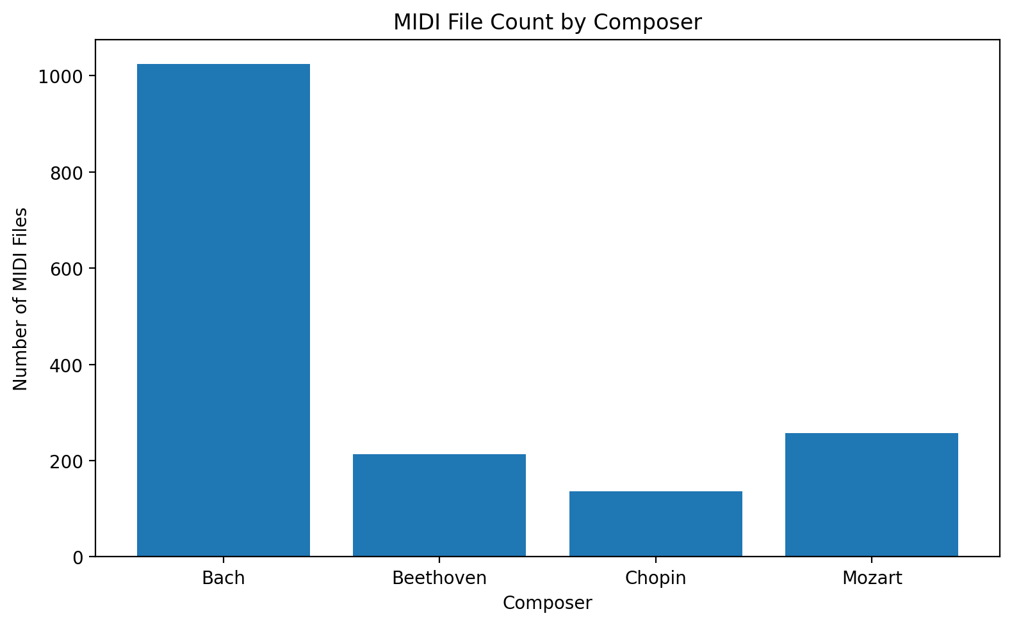
Note. The chart was generated in the preprocessing notebook before model training.
Data Preprocessing
The preprocessing pipeline was written in Python and used music21, pretty_midi, pandas, NumPy, scikit-learn, and Matplotlib. The main purpose was to create a clean and repeatable process that the other team members could use without redoing the raw MIDI parsing (Cuthbert & Ariza, 2010; Pedregosa et al., 2011; Raffel & Ellis, 2014).

File Validation and Cleaning
The notebook first collected every MIDI file path and assigned a composer label based on the folder name. Each file was then checked to make sure it could be parsed. All 1,630 files passed the first validation step. During feature extraction, two files were skipped because they did not produce usable feature records. The final processed dataset therefore contained 1,628 usable records: 1,139 for training, 243 for validation, and 246 for testing.
Train, Validation, and Test Split
The data was split using a 70%, 15%, and 15% structure for training, validation, and testing. The split was done at the file level and was stratified by composer. This means each composer was represented in each split while keeping complete MIDI files in only one split.
Splitting at the file level was important because the LSTM inputs were later created with overlapping sliding windows. If the windows had been created before the split, windows from the same MIDI file could have appeared in both the training and test data. That would create data leakage and make the model results look stronger than they really are (Kaufman et al., 2012). By splitting files first, the notebook avoided this issue.
Feature Extraction
Two feature representations were created from the same MIDI files. The LSTM model needed ordered musical sequences, while the CNN model needed image-like piano-roll matrices. Creating both formats from the same file splits allowed the team to compare the models fairly.
Note and Chord Sequences for LSTM
For the LSTM model, each MIDI file was parsed with music21. The notebook extracted notes and chords in order. Individual notes were stored as pitch tokens, such as C4 or G#5. Chords were stored as dot-separated MIDI pitch values, such as 60.64.67, after sorting the chord pitches. Sorting the chord pitches helped make the chord token consistent even if the notes appeared in a different internal order inside the MIDI file.
The notebook also extracted tempo when it was available. When no tempo marking was found, the default value was set to 120 beats per minute. Other summary values were collected for reporting, including sequence length, total duration in quarter lengths, mean pitch, and normalized mean pitch.
The LSTM vocabulary was built from the training set only. This produced 23,612 unique tokens. Using only the training set for the vocabulary avoided information leakage from the validation and test sets. Unknown tokens were mapped to the reserved index 0. The notebook then created fixed-length windows of 100 events with a step size of 10. This produced 279,349 training windows, 53,757 validation windows, and 68,694 test windows.
Sequence length varied a lot by composer, especially for Beethoven and Mozart. Figure 2 shows this variation and helps explain why fixed-length LSTM windows were needed.

Figure 2
Sequence Length by Composer
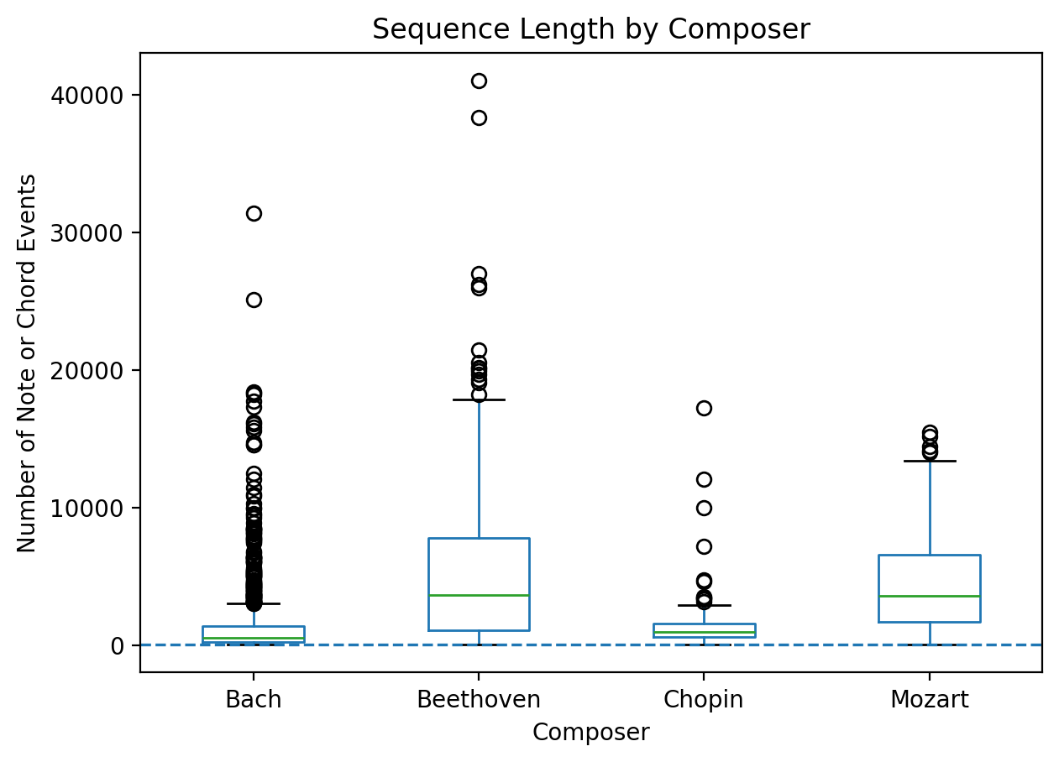
Note. Sequence length is measured by the number of note or chord events extracted from each usable MIDI file.
Piano-Roll Matrices for CNN
For the CNN model, each MIDI file was converted into a binary piano-roll matrix using pretty_midi. A piano roll represents music as a grid where pitch is on one axis and time is on the other. The notebook used 128 MIDI pitch values and sampled time at 10 frames per second. A value of 1 means a pitch was active at that frame, and a value of 0 means it was not active.
To keep the CNN input consistent, every piano roll was converted to a fixed 128 x 128 shape. Longer rolls were truncated to 128 frames, and shorter rolls were padded with zeros. A channel dimension was then added, making the final CNN input shape (128, 128, 1). Each usable MIDI file produced one CNN matrix. The final CNN arrays contained 1,139 training samples, 243 validation samples, and 246 test samples.

Figure 3 shows examples of piano-roll matrices from the preprocessing notebook. This helped confirm that the CNN input was being generated correctly before the model training step.
Figure 3
Sample Piano-Roll Matrices
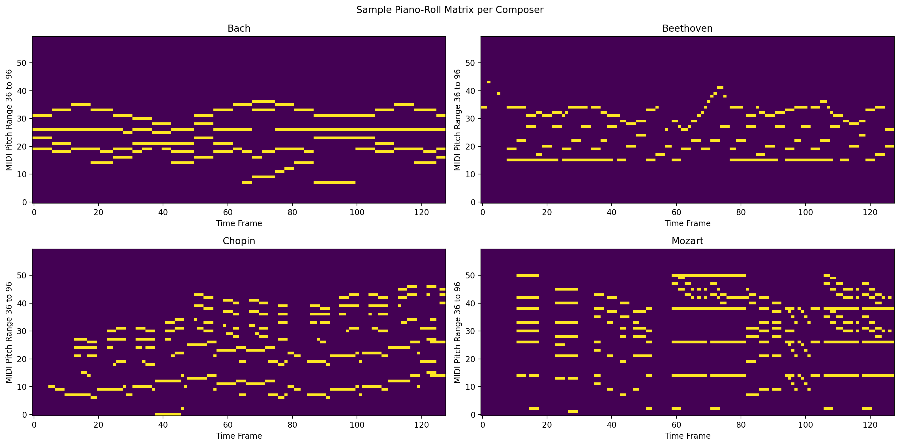
Note. The visualizations show binary pitch activity over time for sample MIDI files from the four composers.
Prepared Outputs for the Team
After preprocessing and feature extraction, the notebook saved the final arrays and metadata files in the processed_data folder. These files were shared with the team so the LSTM and CNN notebooks could load the processed data directly. This made the project easier to reproduce and helped keep the modeling sections consistent.
Table 2
Saved Model-Ready Outputs
Output group | Files | Purpose
LSTM arrays | X_seq_train, X_seq_val, X_seq_test; y_seq_train, y_seq_val, y_seq_test | Sequence inputs and labels for LSTM training and evaluation
CNN arrays | X_cnn_train, X_cnn_val, X_cnn_test; y_cnn_train, y_cnn_val, y_cnn_test | Piano-roll inputs and labels for CNN training and evaluation
Metadata | label_classes.npy, token_to_int.json, dataset_summary.json | Label mapping, vocabulary, and preprocessing settings
Reports and splits | feature_summary.csv, file_level_splits.csv | Feature-level summary and file-level split tracking
Figures | composer_distribution.png, sequence_length_by_composer.png, note_frequency_by_composer.png, sample_piano_rolls.png | Visual checks and report figures
Note. File names are shown without the .npy extension when grouped for readability.
Data Pipeline Summary and Future Improvements
The preprocessing section produced a clean and reusable dataset pipeline for the full project. The same MIDI files were turned into two model-ready formats: note and chord sequences for the LSTM model and piano-roll matrices for the CNN model. The notebook also saved the label encoding, vocabulary, split file, feature summary, and visualizations so the team could reproduce the work later.
A key finding from the data preparation stage was that the dataset was not balanced across composers. Bach had far more files than the other composers, while Chopin had the fewest. This should be considered when interpreting model results. Accuracy alone may not be enough, so the final model evaluation should also review precision, recall, F1-score, and the confusion matrix.
Future improvements could include adding more Chopin, Beethoven, and Mozart MIDI files to reduce class imbalance, testing longer piano-roll windows for the CNN, and trying additional musical features such as note density, rhythm patterns, and key signatures. Another useful improvement would be data augmentation, such as pitch shifting, as long as it is applied only to the training set to avoid leakage.

References
Blanderbuss. (2019). MIDI classic music [Data set]. Kaggle. https://www.kaggle.com/datasets/blanderbuss/midi-classic-music
Cuthbert, M. S., & Ariza, C. (2010). music21: A toolkit for computer-aided musicology and symbolic music data. In Proceedings of the 11th International Society for Music Information Retrieval Conference (pp. 637-642). https://zenodo.org/records/1416114
Kaufman, S., Rosset, S., Perlich, C., & Stitelman, O. (2012). Leakage in data mining: Formulation, detection, and avoidance. ACM Transactions on Knowledge Discovery from Data, 6(4), 1-21. https://doi.org/10.1145/2382577.2382579
Pedregosa, F., Varoquaux, G., Gramfort, A., Michel, V., Thirion, B., Grisel, O., Blondel, M., Prettenhofer, P., Weiss, R., Dubourg, V., VanderPlas, J., Passos, A., Cournapeau, D., Brucher, M., Perrot, M., & Duchesnay, E. (2011). Scikit-learn: Machine learning in Python. Journal of Machine Learning Research, 12, 2825-2830. https://www.jmlr.org/papers/v12/pedregosa11a.html
Raffel, C., & Ellis, D. P. W. (2014). Intuitive analysis, creation and manipulation of MIDI data with pretty_midi. Proceedings of the 15th International Society for Music Information Retrieval Conference Late Breaking and Demo Papers. https://colinraffel.com/publications/ismir2014intuitive.pdf

