Classification of Classical Music Composers Using LSTM and CNN Architectures
Ahmed Eldahmy, Tony Diehl Verdugo, and Andrea Thomas
Department of Applied Artificial Intelligence, University of San Diego
AAI 511-03: Neural Networks and Deep Learning
August 2026

Authors' Note
Ahmed Eldahmy was responsible for dataset organization, preprocessing, feature extraction, visualizations, and saved model-ready outputs. Tony Diehl Verdugo was responsible for the LSTM model development, training, and evaluation. Andrea Thomas was responsible for the CNN model development, training, evaluation, final comparison, and report integration.
Abstract
This project explored the use of deep learning to classify classical music composers from MIDI files. The dataset included the four required composers: Bach, Beethoven, Chopin, and Mozart. The working dataset contained 1,630 MIDI files, and 1,628 files were successfully processed into feature records. The data was split at the file level into training, validation, and test sets before any LSTM windows were created. This was done to prevent data leakage between the splits. Two input formats were prepared from the same MIDI files: note and chord event sequences for the LSTM model and binary piano-roll matrices for the CNN model. The LSTM data used a training-only vocabulary with 23,612 tokens and a sliding window of 100 events. The CNN data used fixed 128 x 128 piano-roll matrices with one channel. These outputs were saved so the modeling team could train and compare the LSTM and CNN models using the same cleaned dataset.
Keywords: MIDI classification, composer identification, LSTM, CNN, preprocessing, music information retrieval

Classification of Classical Music Composers Using LSTM and CNN Architectures
The data engineering and preprocessing portion of the final project focused on taking the raw MIDI files, cleaning and organizing them, and converting them into input formats that could be used by the LSTM and CNN models. This work was important because both models needed consistent labels, clean splits, and reusable processed files before training could begin.
Dataset Description
The dataset was sourced from the Kaggle MIDI Classic Music collection (Blanderbuss, 2019). The original collection includes classical MIDI files from many composers. Based on the project requirement, the working dataset was filtered to include only Bach, Beethoven, Chopin, and Mozart. The notebook used one folder per composer and recursively searched each folder for files ending in .mid or .midi.
After filtering, the working dataset contained 1,630 MIDI files. Bach had the largest number of files, while Chopin had the fewest. This imbalance was important to document because a classifier can learn the majority class more easily if the imbalance is not considered during model evaluation. Table 1 shows the number of MIDI files used for each composer.
Table 1
MIDI File Count by Composer
Composer | MIDI files
Bach | 1,024
Beethoven | 213
Chopin | 136
Mozart | 257
Total | 1,630
Note. Counts are from the final Team Member 1 preprocessing notebook.
Figure 1 also shows the same distribution visually. The large number of Bach files and the smaller number of Chopin files were kept in mind when preparing the evaluation data for the team.
Figure 1
MIDI File Count by Composer
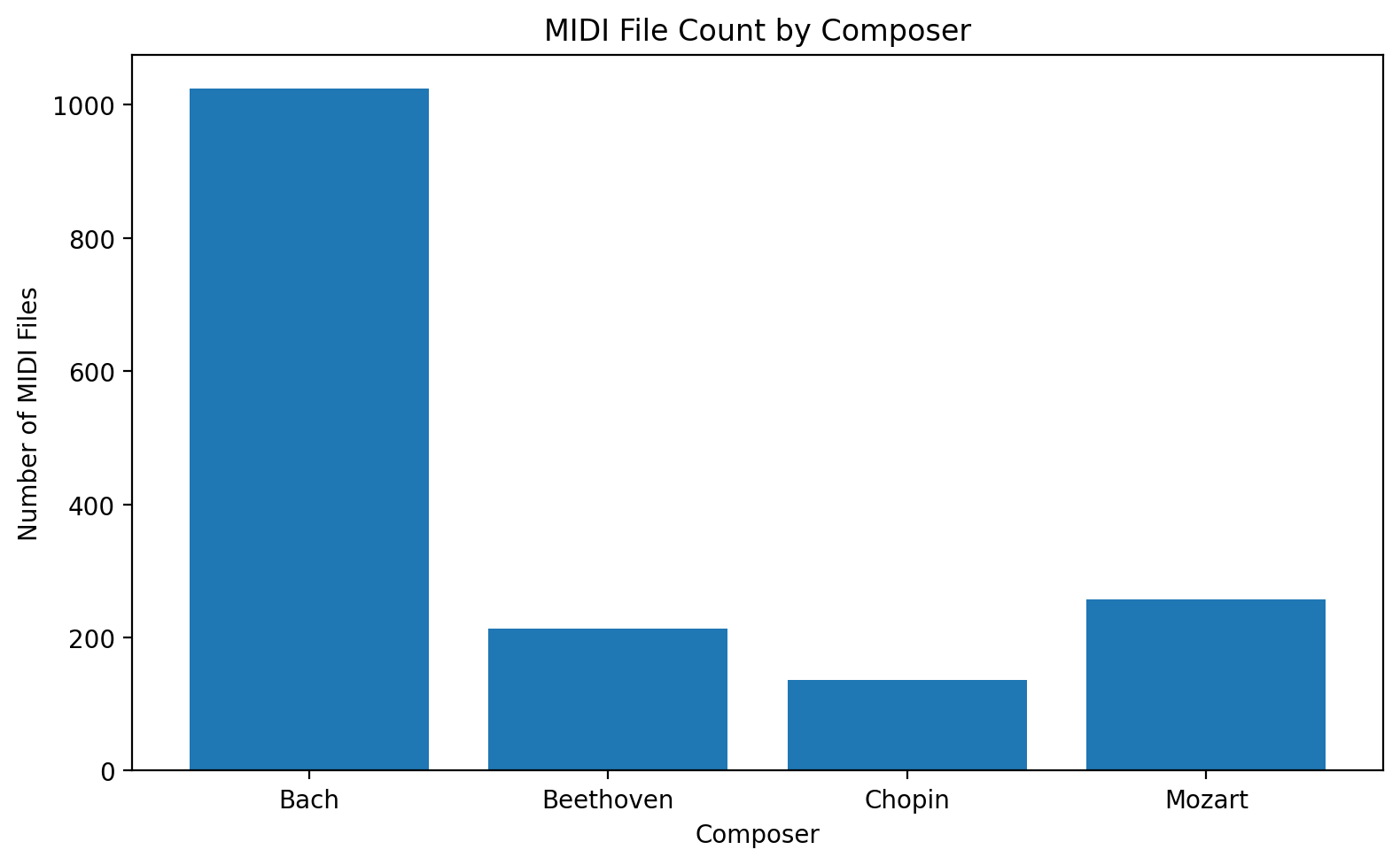
Note. The chart was generated in the preprocessing notebook before model training.
Data Preprocessing
The preprocessing pipeline was written in Python and used music21, pretty_midi, pandas, NumPy, scikit-learn, and Matplotlib. The main purpose was to create a clean and repeatable process that the other team members could use without redoing the raw MIDI parsing (Cuthbert & Ariza, 2010; Pedregosa et al., 2011; Raffel & Ellis, 2014).

File Validation and Cleaning
The notebook first collected every MIDI file path and assigned a composer label based on the folder name. Each file was then checked to make sure it could be parsed. All 1,630 files passed the first validation step. During feature extraction, two files were skipped because they did not produce usable feature records. The final processed dataset therefore contained 1,628 usable records: 1,139 for training, 243 for validation, and 246 for testing.
Train, Validation, and Test Split
The data was split using a 70%, 15%, and 15% structure for training, validation, and testing. The split was done at the file level and was stratified by composer. This means each composer was represented in each split while keeping complete MIDI files in only one split.
Splitting at the file level was important because the LSTM inputs were later created with overlapping sliding windows. If the windows had been created before the split, windows from the same MIDI file could have appeared in both the training and test data. That would create data leakage and make the model results look stronger than they really are (Kaufman et al., 2012). By splitting files first, the notebook avoided this issue.
Feature Extraction
Two feature representations were created from the same MIDI files. The LSTM model needed ordered musical sequences, while the CNN model needed image-like piano-roll matrices. Creating both formats from the same file splits allowed the team to compare the models fairly.
Note and Chord Sequences for LSTM
For the LSTM model, each MIDI file was parsed with music21. The notebook extracted notes and chords in order. Individual notes were stored as pitch tokens, such as C4 or G#5. Chords were stored as dot-separated MIDI pitch values, such as 60.64.67, after sorting the chord pitches. Sorting the chord pitches helped make the chord token consistent even if the notes appeared in a different internal order inside the MIDI file.
The notebook also extracted tempo when it was available. When no tempo marking was found, the default value was set to 120 beats per minute. Other summary values were collected for reporting, including sequence length, total duration in quarter lengths, mean pitch, and normalized mean pitch.
The LSTM vocabulary was built from the training set only. This produced 23,612 unique tokens. Using only the training set for the vocabulary avoided information leakage from the validation and test sets. Unknown tokens were mapped to the reserved index 0. The notebook then created fixed-length windows of 100 events with a step size of 10. This produced 279,349 training windows, 53,757 validation windows, and 68,694 test windows.
Sequence length varied a lot by composer, especially for Beethoven and Mozart. Figure 2 shows this variation and helps explain why fixed-length LSTM windows were needed.

Figure 2
Sequence Length by Composer
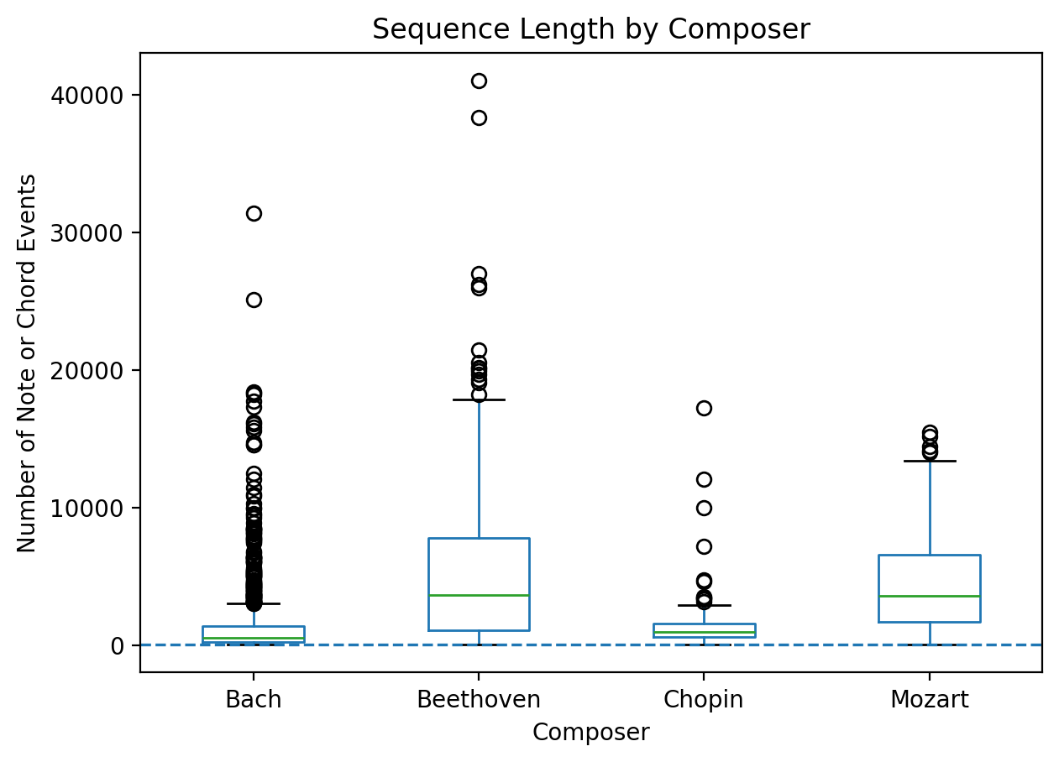
Note. Sequence length is measured by the number of note or chord events extracted from each usable MIDI file.
Piano-Roll Matrices for CNN
For the CNN model, each MIDI file was converted into a binary piano-roll matrix using pretty_midi. A piano roll represents music as a grid where pitch is on one axis and time is on the other. The notebook used 128 MIDI pitch values and sampled time at 10 frames per second. A value of 1 means a pitch was active at that frame, and a value of 0 means it was not active.
To keep the CNN input consistent, every piano roll was converted to a fixed 128 x 128 shape. Longer rolls were truncated to 128 frames, and shorter rolls were padded with zeros. A channel dimension was then added, making the final CNN input shape (128, 128, 1). Each usable MIDI file produced one CNN matrix. The final CNN arrays contained 1,139 training samples, 243 validation samples, and 246 test samples.

Figure 3 shows examples of piano-roll matrices from the preprocessing notebook. This helped confirm that the CNN input was being generated correctly before the model training step.
Figure 3
Sample Piano-Roll Matrices
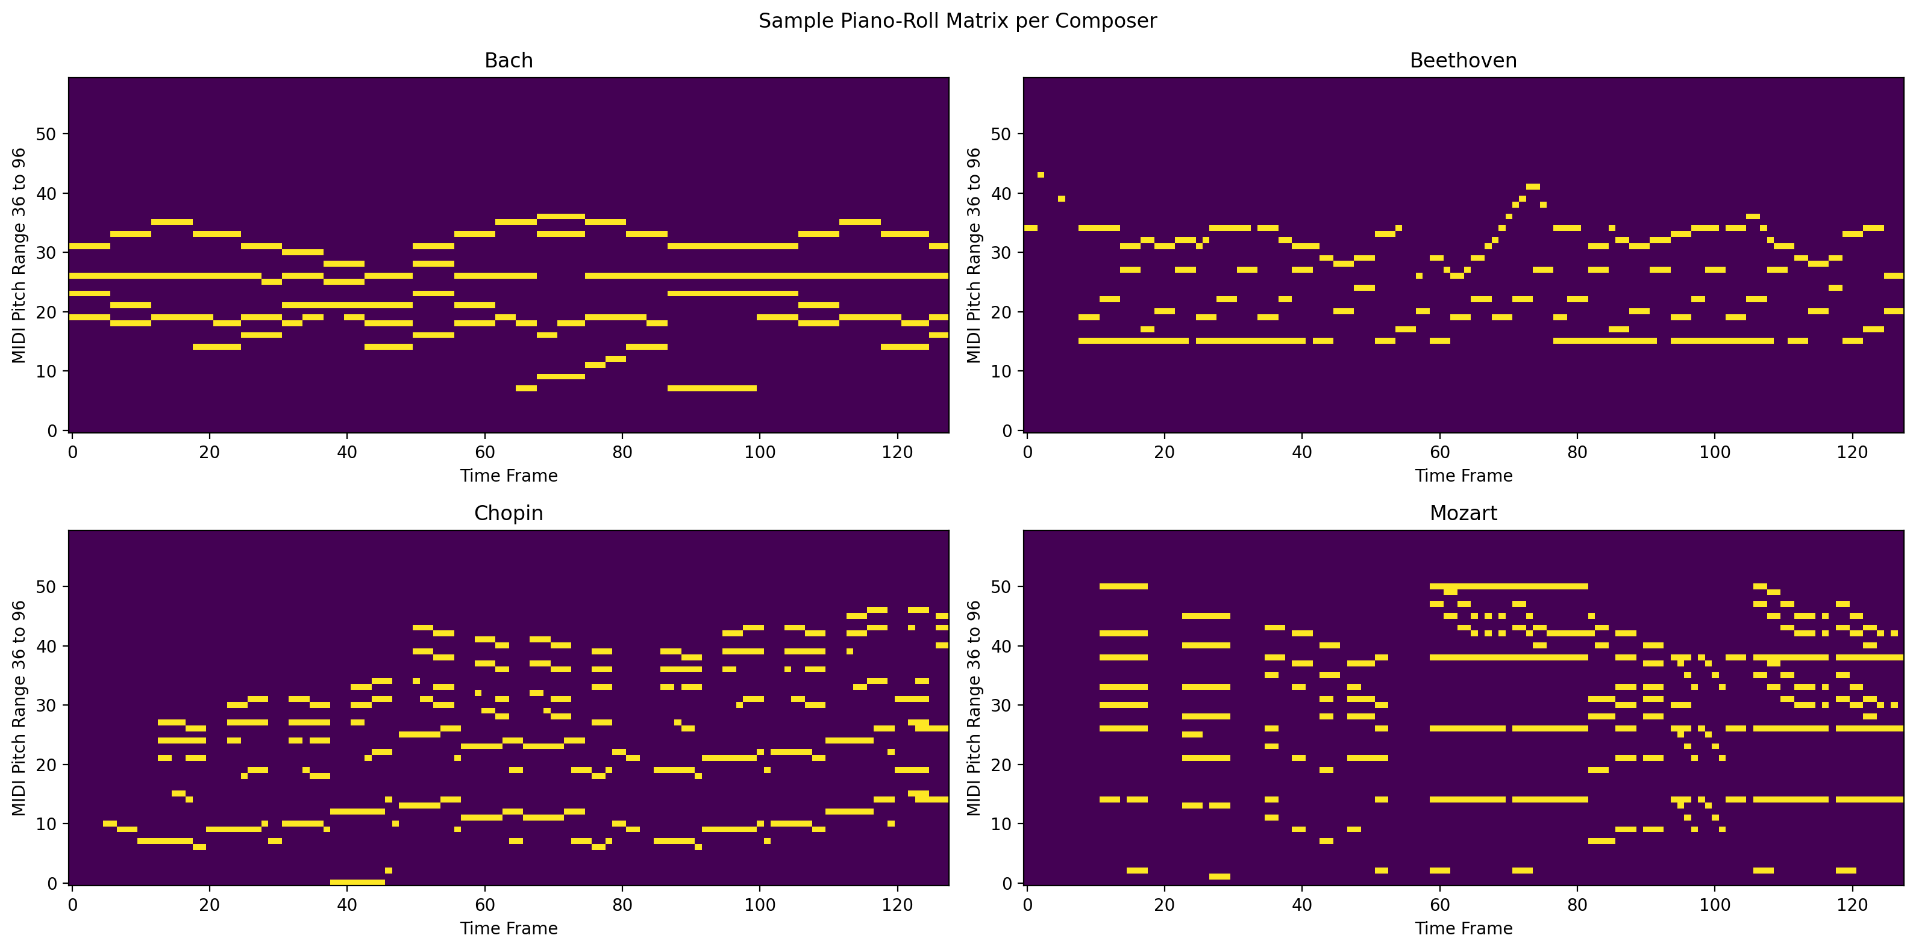
Note. The visualizations show binary pitch activity over time for sample MIDI files from the four composers.
Prepared Outputs for the Team
After preprocessing and feature extraction, the notebook saved the final arrays and metadata files in the processed_data folder. These files were shared with the team so the LSTM and CNN notebooks could load the processed data directly. This made the project easier to reproduce and helped keep the modeling sections consistent.
Table 2
Saved Model-Ready Outputs
Output group | Files | Purpose
LSTM arrays | X_seq_train, X_seq_val, X_seq_test; y_seq_train, y_seq_val, y_seq_test | Sequence inputs and labels for LSTM training and evaluation
CNN arrays | X_cnn_train, X_cnn_val, X_cnn_test; y_cnn_train, y_cnn_val, y_cnn_test | Piano-roll inputs and labels for CNN training and evaluation
Metadata | label_classes.npy, token_to_int.json, dataset_summary.json | Label mapping, vocabulary, and preprocessing settings
Reports and splits | feature_summary.csv, file_level_splits.csv | Feature-level summary and file-level split tracking
Figures | composer_distribution.png, sequence_length_by_composer.png, note_frequency_by_composer.png, sample_piano_rolls.png | Visual checks and report figures
Note. File names are shown without the .npy extension when grouped for readability.
Data Pipeline Summary and Future Improvements
The preprocessing section produced a clean and reusable dataset pipeline for the full project. The same MIDI files were turned into two model-ready formats: note and chord sequences for the LSTM model and piano-roll matrices for the CNN model. The notebook also saved the label encoding, vocabulary, split file, feature summary, and visualizations so the team could reproduce the work later.
A key finding from the data preparation stage was that the dataset was not balanced across composers. Bach had far more files than the other composers, while Chopin had the fewest. This should be considered when interpreting model results. Accuracy alone may not be enough, so the final model evaluation should also review precision, recall, F1-score, and the confusion matrix.
Future improvements could include adding more Chopin, Beethoven, and Mozart MIDI files to reduce class imbalance, testing longer piano-roll windows for the CNN, and trying additional musical features such as note density, rhythm patterns, and key signatures. Another useful improvement would be data augmentation, such as pitch shifting, as long as it is applied only to the training set to avoid leakage.

LSTM Model Development

LSTM Methodology
The Long Short-Term Memory (LSTM) model was developed to classify symbolic musical sequences into one of four composer classes: Bach, Beethoven, Chopin, and Mozart. Unlike the CNN model, which uses piano-roll images, the LSTM model processes sequential note and chord events extracted from the MIDI files. Each musical event was converted into an integer representation using the vocabulary generated during preprocessing. Unknown musical events were assigned to a reserved token to maintain consistency across the validation and test datasets.
The processed input sequences consisted of fixed-length windows of 100 musical events. These integer-encoded sequences were loaded directly from the preprocessing outputs created by Team Member 1. Because the dataset contained an uneven distribution of composers, balanced class weights were calculated from the training labels and incorporated during model training to reduce bias toward the majority class. The resulting training vocabulary contained 23,612 unique musical tokens, which formed the input vocabulary for the embedding layer.

LSTM Architecture
The baseline LSTM architecture consisted of an embedding layer with 128 dimensions, followed by a single LSTM layer containing 128 hidden units. A dropout layer with a rate of 0.30 was applied after the LSTM layer to reduce overfitting. A fully connected dense layer with 64 neurons and ReLU activation further transformed the learned sequence representation before the final softmax output layer predicted one of the four composer classes.
The model was compiled using the Adam optimizer with an initial learning rate of 0.001 and sparse categorical cross-entropy loss. Sparse categorical cross-entropy was selected because the composer labels were stored as integer values rather than one-hot encoded vectors.

Training Procedure
The baseline LSTM model was trained using a batch size of 128 for a maximum of 15 epochs. Three callback functions were incorporated to improve training performance and reduce overfitting. Early stopping monitored validation loss and restored the best-performing model weights once validation performance stopped improving. Model checkpointing automatically saved the best model during training, while ReduceLROnPlateau decreased the learning rate whenever validation loss plateaued. Training and validation accuracy and loss were monitored throughout the training process to evaluate convergence and identify potential overfitting.

Figure 4
Baseline LSTM Training and Validation Accuracy
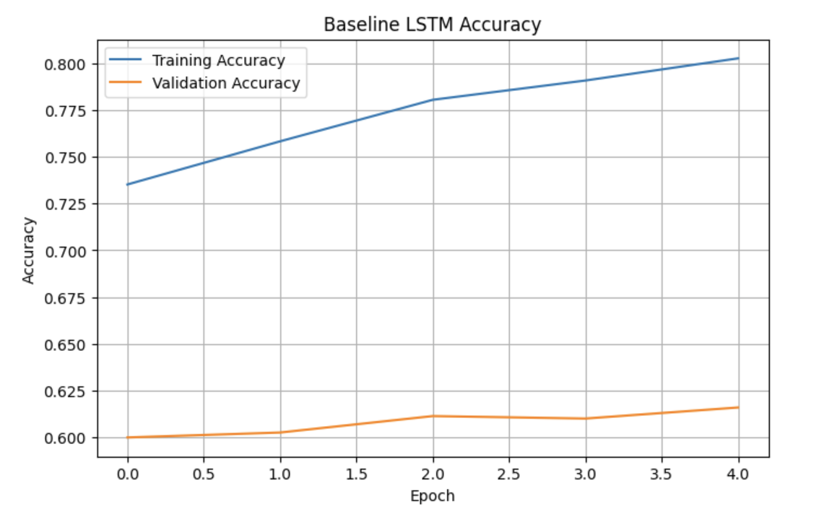 Note. Training and validation accuracy for the baseline LSTM model over 15 training epochs.

Baseline LSTM Results
The baseline LSTM successfully learned meaningful sequential patterns from the encoded musical data. Final training accuracy reached 80.28%, while validation accuracy reached 61.59%. Evaluation on the unseen test dataset produced a test accuracy of 60.09% with a test loss of 1.0991. Although the model demonstrated reasonable classification performance, comparison of the training and validation learning curves indicated moderate overfitting. Training accuracy continued to improve throughout training, while validation performance stabilized after the early epochs. Early stopping restored the model weights from the epoch that achieved the lowest validation loss, helping reduce additional overfitting during training. Figure 5 illustrates the baseline confusion matrix and shows that Bach was classified more accurately than the remaining composers.
Figure 5
Baseline LSTM Confusion Matrix
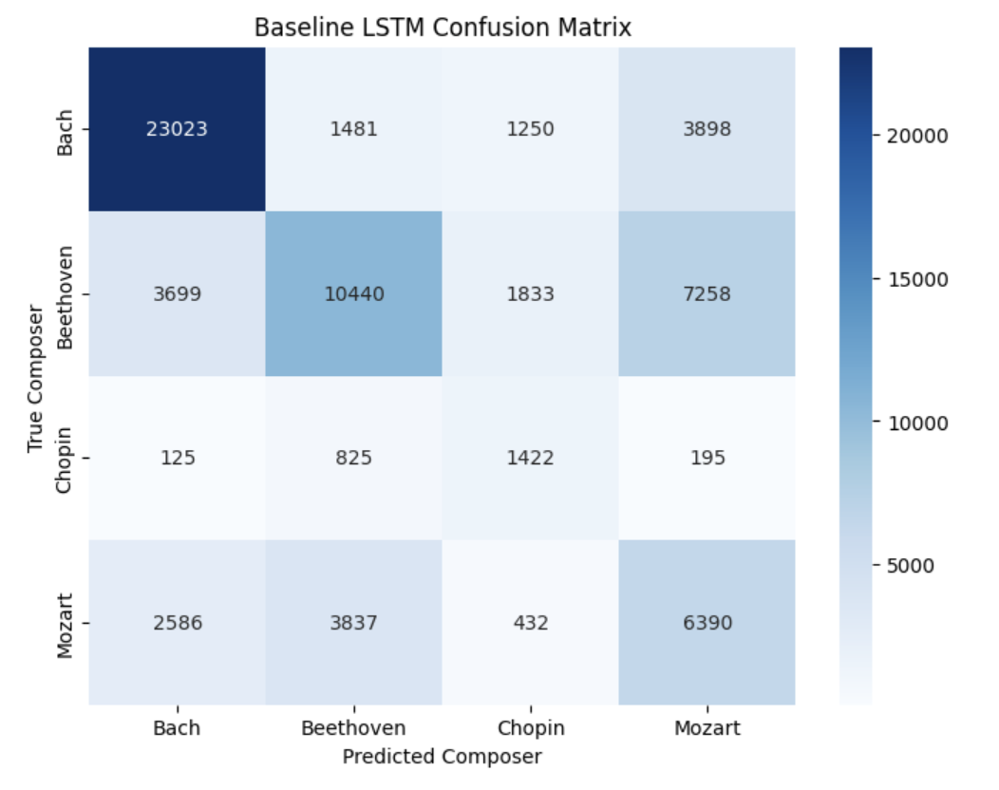 Note. Confusion matrix showing the baseline LSTM composer classifications on the test dataset.

Figure 6
Baseline LSTM Training and Validation Loss
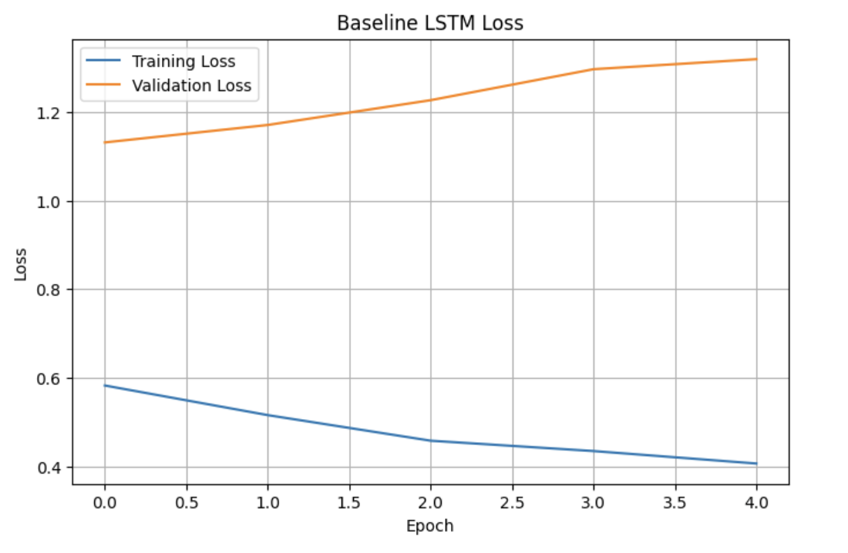 Note. Training and validation loss for the baseline LSTM during model training.

Improved LSTM Model
To investigate whether additional model complexity could improve performance, a second LSTM architecture was developed. The embedding dimension was increased from 128 to 256, and a second LSTM layer containing 64 hidden units was added after the first LSTM layer. Dropout regularization was increased from 0.30 to 0.40 throughout the network, and the dense hidden layer was expanded from 64 to 128 neurons. The learning rate was reduced to 0.0005 to promote more stable optimization during training.
The improved model was trained using the same preprocessing pipeline, batch size, class weights, callbacks, and evaluation procedures as the baseline model to ensure a fair comparison.

Improved LSTM Results
The improved architecture achieved a higher final training accuracy of 84.81% and a slightly higher validation accuracy of 62.89%. However, evaluation on the unseen test dataset produced a lower test accuracy of 56.61%, despite achieving a slightly lower test loss of 1.0724.
These results indicate that the additional model complexity increased the model's ability to fit the training data but did not improve its ability to generalize to unseen musical sequences. Validation loss increased after the first epoch despite continued improvements in training accuracy, demonstrating stronger overfitting than the baseline architecture. Early stopping restored the best-performing model weights before evaluation on the test dataset. Figure 7 shows that the improved architecture produced similar classification patterns despite its greater model complexity.

Figure 7
Improved LSTM Confusion Matrix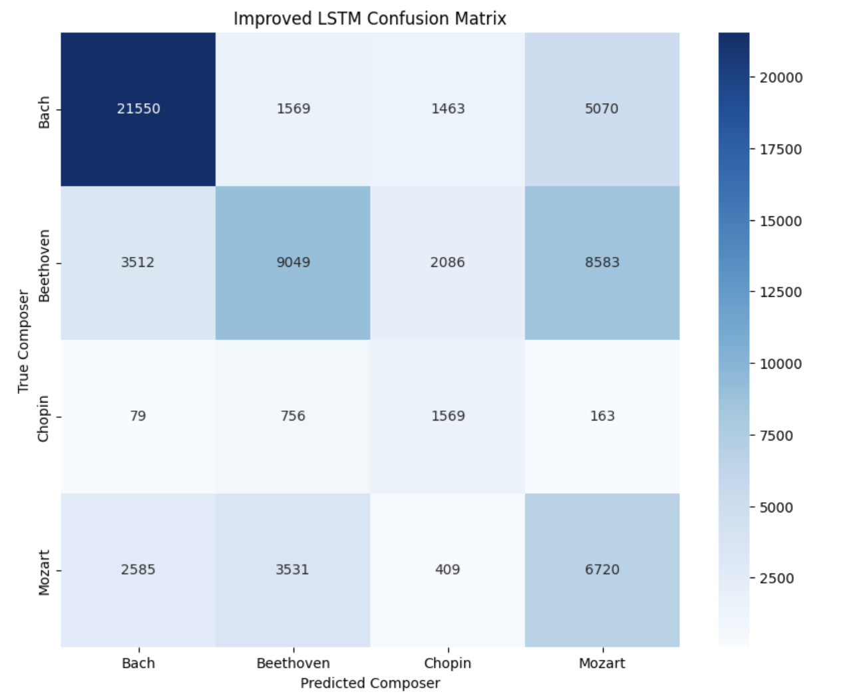
Note. Confusion matrix for the improved LSTM model evaluated on the test dataset.

LSTM Model Discussion
The baseline and improved LSTM architectures were compared to evaluate the effect of increasing model complexity. While the improved architecture achieved higher training accuracy and slightly higher validation accuracy, these improvements did not translate into improved performance on the independent test dataset. The baseline model achieved the higher test accuracy (60.09%) and demonstrated better overall generalization than the improved architecture.
These findings illustrate an important principle in deep learning: increasing network depth and model capacity does not necessarily improve predictive performance. Additional complexity can increase the likelihood of overfitting when the available training data is limited or imbalanced. Based on the evaluation metrics, the baseline LSTM was selected as the stronger sequence model for this project.
Table 3
Comparison of Baseline and Improved LSTM Models
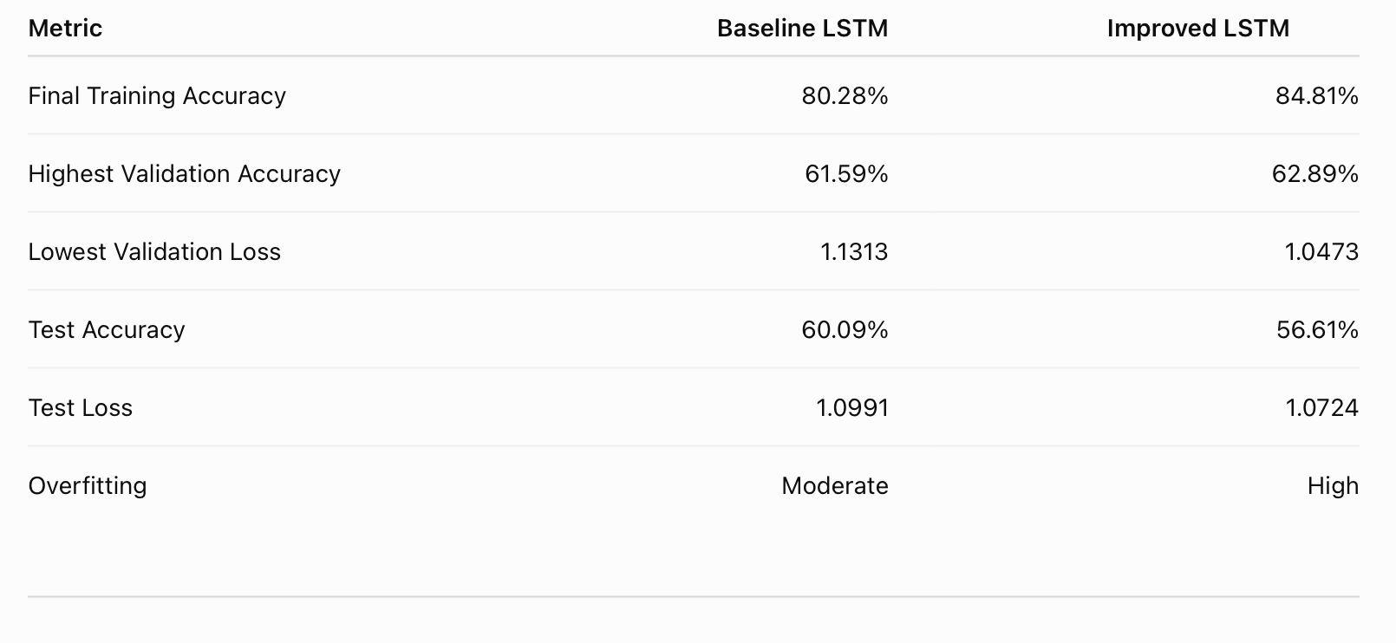
References
Blanderbuss. (2019). MIDI classic music [Data set]. Kaggle. https://www.kaggle.com/datasets/blanderbuss/midi-classic-music
Cuthbert, M. S., & Ariza, C. (2010). music21: A toolkit for computer-aided musicology and symbolic music data. In Proceedings of the 11th International Society for Music Information Retrieval Conference (pp. 637-642). https://zenodo.org/records/1416114
Kaufman, S., Rosset, S., Perlich, C., & Stitelman, O. (2012). Leakage in data mining: Formulation, detection, and avoidance. ACM Transactions on Knowledge Discovery from Data, 6(4), 1-21. https://doi.org/10.1145/2382577.2382579
Pedregosa, F., Varoquaux, G., Gramfort, A., Michel, V., Thirion, B., Grisel, O., Blondel, M., Prettenhofer, P., Weiss, R., Dubourg, V., VanderPlas, J., Passos, A., Cournapeau, D., Brucher, M., Perrot, M., & Duchesnay, E. (2011). Scikit-learn: Machine learning in Python. Journal of Machine Learning Research, 12, 2825-2830. https://www.jmlr.org/papers/v12/pedregosa11a.html
Raffel, C., & Ellis, D. P. W. (2014). Intuitive analysis, creation and manipulation of MIDI data with pretty_midi. Proceedings of the 15th International Society for Music Information Retrieval Conference Late Breaking and Demo Papers. https://colinraffel.com/publications/ismir2014intuitive.pdf

