etisalat logo

**Etisalat Misr**

*ABC Process*

**Document ID**: EM-ZZ-YY-XXXX

**Revision:** YY.XX

**EM-TM-CO-1010 – R(02.00)**

**Private Public Effective Date:** Mon. dd, yyyy

|  |  |  |  |
| --- | --- | --- | --- |
| Table Of Contents | | | |
| Section # | Section Name | Section Not Included (X)  (For Optional Sections) | Page No. |
| 01 | Document Approval |  | 3 |
| 02 | Document History | (X) | 4 |
| 03 | Document Accessibility “if Private” |  | 5 |
| 04 | Process Summery |  | 6 |
| 05 | Process Activity Description |  | 7 |
| 06 | Process Flow Chart |  | 8 |
| 07 | Service Level Agreement (SLA) Detailed Description | (X) | 9 |
| 08 | Key Performance Indicators (KPI) Detailed Description | (X) | 10 |
| 09 | Abbreviations & Glossary | (X) | 11 |
| 10 | Appendix 1 | (X) | 12 |
| 11 | Appendix X | (X) | ?? |

|  |  |  |
| --- | --- | --- |
| Section - 01 | Document Approval | Mandatory Section |

|  |  |  |  |  |
| --- | --- | --- | --- | --- |
|  | Job Title | Name | Signature | Date |
| Prepared by: |  |  |  |  |
|  |  |  |  |
|  |  |  |  |
|  |  |  |  |
| Owned by: |  |  |  |  |
| Document Control |  |  |  |  |
| Reviewed and Approved by: |  |  |  |  |
|  |  |  |  |
|  |  |  |  |

|  |  |  |
| --- | --- | --- |
| Section - 02 | Document History | Mandatory Section |

|  |  |  |  |  |
| --- | --- | --- | --- | --- |
| Rev. | Change Requester | Main Changes* | Reason for Change | Date |
| 01.00 |  |  |  |  |
| 02.00 |  |  |  |  |
| 03.00 |  |  |  |  |
| 04.00 |  |  |  |  |
| 05.00 |  |  |  |  |

* List changes if it’s minor & if major changes are imposed; don’t list changes, just write “Major Changes”

|  |  |  |
| --- | --- | --- |
| Section - 03 | Document Accessibility “if Private” | Optional Section |

|  |  |
| --- | --- |
| # | Accessibility to (Department Name, Team Name or Position Name) |
| 01 |  |
| 02 |  |
| 03 | **This is an optional section**  **If you need to use it, kindly delete the cloud and fill the cells.** |
| 04 |  |
| 05 |  |
| 06 |  |
|  |  |
|  |  |
|  |  |
|  |  |

|  |  |  |
| --- | --- | --- |
| Section - 04 | Process Summery | Mandatory Section |

|  |  |
| --- | --- |
| Process  Objective |  |
| Process  Scope |  |
| Process  KPI’s |  |

|  |  |  |
| --- | --- | --- |
| Section - 05 | Process Activity Description | Mandatory Section |

|  |  |  |  |  |  |  |  |
| --- | --- | --- | --- | --- | --- | --- | --- |
| Activity  ID | Input | Detailed Activity Description | Output* | Activity by | Duration (SLA) | Used Forms  (Tool)* | References* |
| PA01 |  |  |  |  |  |  |  |
| PA02 |  |  |  |  |  |  |  |
|  |  |
|  |  |
| PA03 |  |  |  |  |  |  |  |
| PA04 |  |  |  |  |  |  |  |
| PA05 |  |  |  |  |  |  |  |

(*) Optional Field(s) - When optional; columns could not be deleted from tables

|  |  |  |
| --- | --- | --- |
| Section - 06 | Process Flow Chart | Mandatory Section |

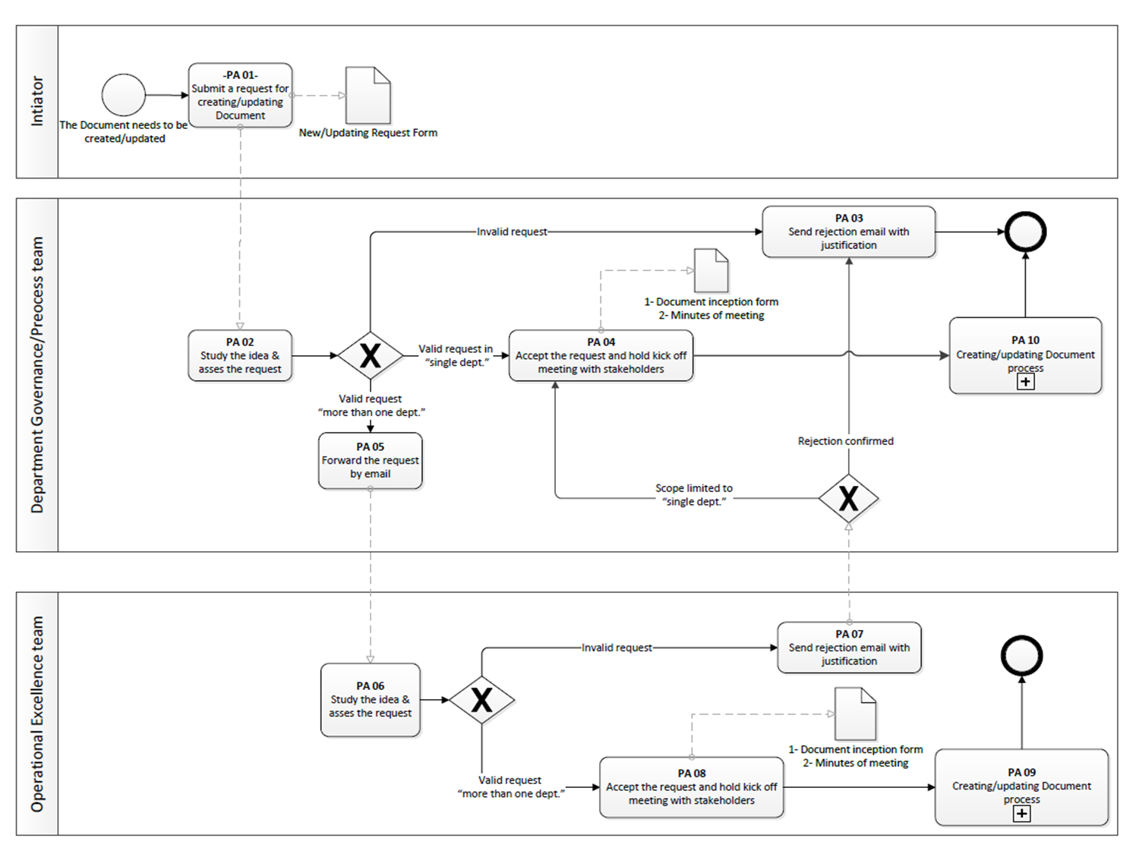

**Please paste your flowchart here**

|  |  |  |
| --- | --- | --- |
| Section - 07 | Service Level Agreement (SLA) Detailed Description | Optional Section |

|  |  |  |  |  |  |  |  |
| --- | --- | --- | --- | --- | --- | --- | --- |
| Activity  ID | Duration | (I/P-O/P) Rules | Accumulated Duration | | | Batch Size | Extra Batch handling |
| Path 1 | Path 2 | Path 3 |
| PA01 |  |  |  |  |  |  |  |
| PA02 |  |  |  |  |  |  |  |
| PA03 |  | **This is an optional section**  **If you need to use it, kindly delete the cloud and fill the cells.** |  |  |  |  |  |
| PA04 |  |  |  |  |  |  |  |
| PA05 |  |  |  |  |  |  |  |
| PA06 |  |  |  |  |  |  |  |
| PA07 |  |  |  |  |  |  |  |
| PA08 |  |  |  |  |  |  |  |
| PA09 |  |  |  |  |  |  |  |
|  |  | **Total Time** |  |  |  |

|  |  |  |
| --- | --- | --- |
| Section - 08 | Key Performance Indicators (KPI) Detailed Description | Optional Section |

|  |  |  |  |  |  |  |  |  |  |
| --- | --- | --- | --- | --- | --- | --- | --- | --- | --- |
| KPI # | KPI Name | KPI Wight | Unit of Measure | Calculation Formula | Target | Related SLA (if applicable) | Frequency of Reporting | Reporting Owner (SPOC) | Performance Owner (1st Accountable) |
| PI01 |  |  |  |  |  |  |  |  |  |
| PI02 |  |  |  |  |  | **This is an optional section**  **If you need to use it, kindly delete the cloud and fill the cells.** |  |  |  |
| PI03 |  |  |  |  |  |  |  |  |  |
| PI04 |  |  |  |  |  |  |  |  |  |

|  |  |  |
| --- | --- | --- |
| Section - 9 | Abbreviations & Glossary | Optional Section |

|  |  |
| --- | --- |
| Abbreviation | Stands For (Description) |
|  |  |
|  | **This is an optional section**  **If you need to use it, kindly delete the cloud and fill the cells.** |
|  |  |
|  |  |
|  |  |

|  |  |
| --- | --- |
| Used Term  (Glossary) | Description |
|  |  |
|  |  |
|  |  |
|  |  |

|  |  |  |
| --- | --- | --- |
| Section - 10 | Appendix 1 | Optional Section |

Optional Appendices may include:

* Process Guidelines
* RACI matrix
* Roles and Responsibilities
* Etc.