Software Requirements Specifications
Mini Craigslist

Ahmed Abdul Kareem Karanath Banda BharatKumar Deepanshu Sapra
Indian Institute of Technology Mandi

Email ID :
b13104@students.iitmandi.ac.in b13113@students.iitmandi.ac.in b13116@students.iitmandi.ac.in

NOVEMBER 3 ,2014

Revision History :
(No version updates till now)

CONTENTS
1. Introduction
1.1.Need and Purpose.......................................................................................................................... 1
1.2.Intended Audiance ........................................................................................................................ 1
1.3.References .................................................................................................................................... 1
2. Overall Description
2.1.Product Features and Functions ....................................................................................................1
2.2. Users..............................................................................................................................................1
2.3.Operating Environment .................................................................................................................2
2.3.1.Minimum Software Requirements............................................................................................ .2
2.3.3Minimum Hardware Requirements.............................................................................................3
3. Specific Requirements
3.1.Performance Requirements......................................................................................................... 3
3.2 Use Case Diagram......................................................................................................................4-5

1 Introduction
1.1 Purpose
The purpose of this software requirement specification document is to describe the behaviour and functionalities of the Mini Craigslist system. The Mini Craigslist is designed to be an online auction and trading site with built-in real-time communication tools between potential bidders and the auction owner , items wanted .The document is intended to serve as the guideline and intended goals for the implementation of the various functions of the program.
1.2 Intended Audiance
For the functionality of the auction and trade, the application will be limited to being only the mediator between users in terms of communication and will not participate in the actual exchange of the goods. The application will not be implemented to prevent nor will it take responsibility for any fraudulent acts by any users. Photo sharing services will be provided .
1.3 Reference s
- IEEE 830-1998 standard for writing a SRS document.
- An Integrated Approach Software Engineering Third Edition by Pankaj Jalote.

2 Overall Description
2.1 Product Features and Functions
The Mini Craigslist system is an auction and trading , jobs , goods for sale, items wanted website. It provides communication between users of the site in order to exchange information such as prices and contact information to facilitate trading between users. Mini Craigslist will allow the users to upload photos to advertise their products. It will also provide users to add the list of items which they want to buy , sell .Users will be able to create and manage site accounts, as well as post and manage their auctions, place bids on auctions. Auctions and posts will be classified into categories for easier product searching.
2.2Users
Any person who wants to sell or buy some products can use Mini Craigslist online software. They can make there user account .Having basic knowledge of internet browsing.
1
2.3 Operating Environment
The Mini Craigslist website will be accessed through a web browser by the user from his or
her computer/laptops.
2.3.1 Minimum Software Requirements
- Operating System :Ubuntu 14.04
- Language :PHP 5.5 , Java Script(front end), HTML
- Database : My SQL server (back end)
The Mini Craigslist software works on any of the graphical browsers on any hardware and OS :
1. Google Chrome 2.0
2. Firefox 5.0
3. Safari 3.6
4. Internet Explorer 8.0
2.3.2 Minimum Hardware Requirements
- Processor : Pentium four 700MHz
- RAM : 256MB
- Monitor : 14.5” Colour monitor
3. Specific Requirements
3.1.Performance Requirements
On a pc acting as server the maximum time for any online request must be less than 2 seconds.

2

3.2 Use Case Diagram
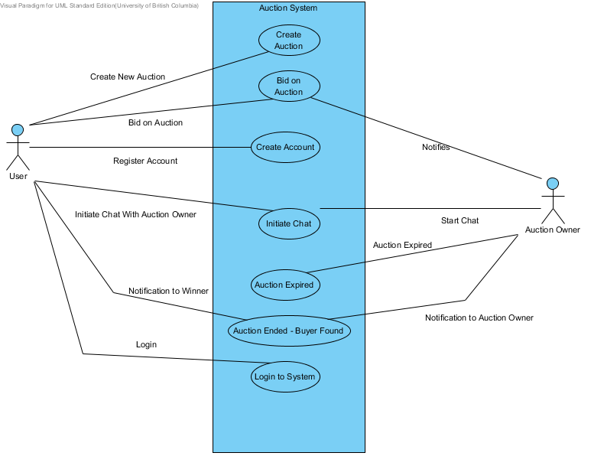

3
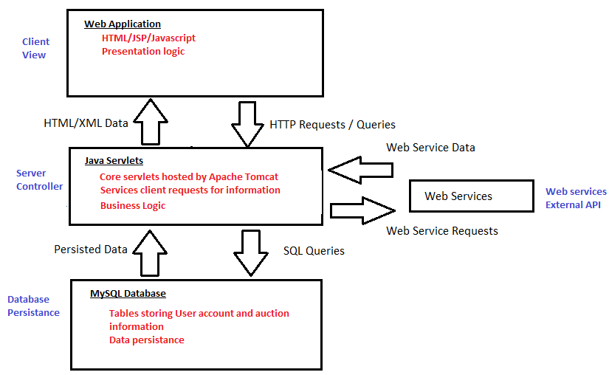

4

