Software Design Document

Deepanshu Sapra Ahmed Karanath Bharath Kumar
Computer Science & Engineering
Indian Institute of Technology Mandi
E-mail: b13104@students.iitmandi.ac.in, b13113@students.iitmandi.ac.in, b13116@students.iitmandi.ac.in
November 2014
The Mini-Craigslist
Design Document

Revision History
Version | Date | Author(s) | Description
v1.0 | 17/11/14 | Deepanshu, Ahmed, Bharath | Initial version

Table of Contents
1Introduction 2
1.1Design Overview 2
1.2Intended Audience 2
1.3References 2
2Detailed Design 3
2.1Architecture 3
Components 4
Interfaces 4
2.2Algorithms and Data Structures 4
2.3External Data 4
Databases 4
2.4Performance 4
2.5Test Scripts 4
3Appendix A 5
3.1Database Schema for craigslist 5

Introduction

Design Overview
The Mini-Craigslist system uses an RDBMS (Relational Database Management System), so can be customised with minimal programming. It has an easy-to-use Web interface for all users, including the administrators and the public user.

Intended Audience
This document is intended for software managers, coders and testers.

References
[1] Deepanshu Sapra, Ahmed Karanath, Bharath Kumar, The Mini-Craigslist Reservation System Requirements Specifications document, IIT Mandi, 17/11/2014.
[2] Creating a Secure Login System the Right Way, http://tinsology.net/2009/06/creating-a-secure-login-system-the-right-way/, accessed on 12/11/2014.
[3] Chacon & Straub, Pro Git: Everything You Need to Know about Git, The Expert's Voice, 2008.
[4] Elmasri & Navathe, Fundamentals of Database Systems, Addison Wesley

Detailed Design

Architecture

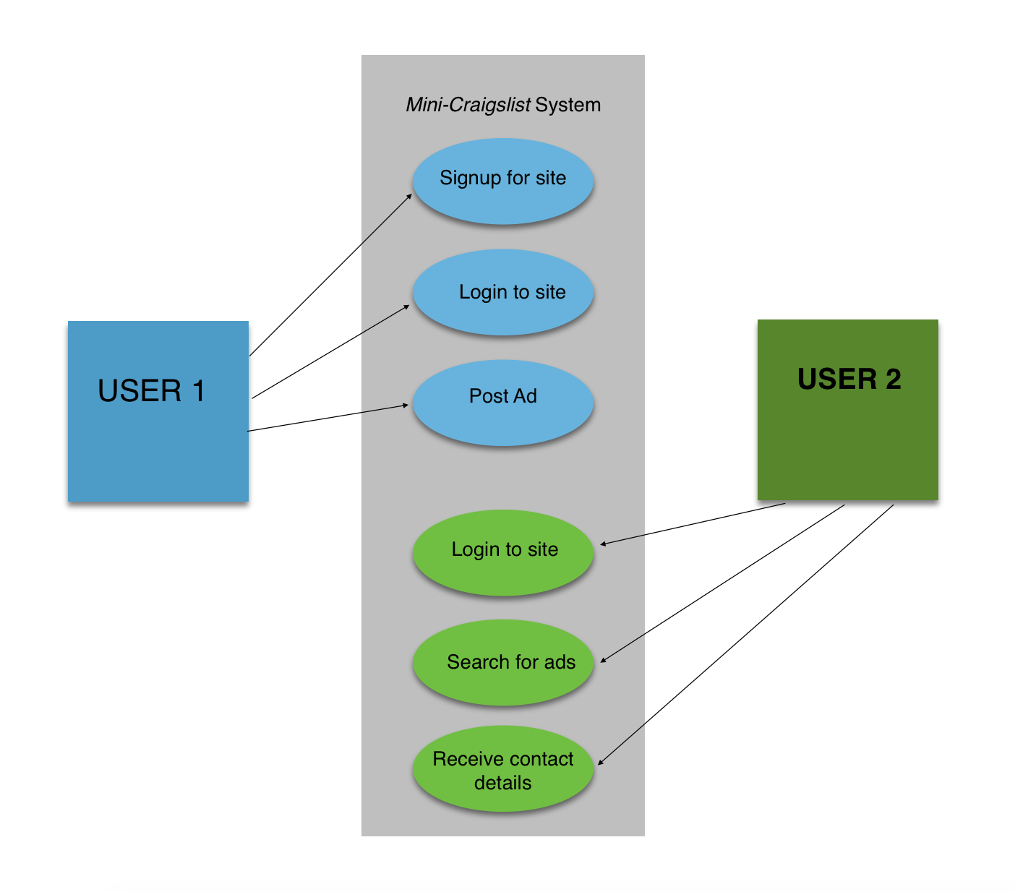
Figure 1 illustrates the working of the Mini-Craigslist classifieds system.
Figure 1

Components
The phpMyAdmin and mysql tools are used as-is. All tables are created using the built-in facility.
The various categories of users access Mini-Craigslist through a browser. Authentication is done via username and password for each internal user and for administrators. External users (public) get access to ads, but cannot post new ads. Passwords are encrypted for security.

Interfaces
The interface between the browser and the Mini-Craigslist GUI is HTML over HTTP. The internal interfaces are custom made.

Algorithms and Data Structures
There are no significant algorithms developed for this product. Relational databases are used to store information in tables in mysql.

External Data

Databases
Mini-Craigslist uses a database called craigslist to store data. It has the following tables:
Admin
category
for_sale
users

The database schema for craigslist is given in Appendix A.

Performance
The product can be benchmarked on different entry-level and server-class PCs. This will result in a table giving the PC configuration required for each class of classifieds (i.e., number of ads).

Test Scripts
Test scripts are not required, since the functionality of mini-craigslist can be tested with a few entries in every table.

Appendix A

Database Schema for craigslist

Database schema for craigslist is as follows:

Table structure for table Admin
Column | Type | Null | Default | Comments
user_id | int(11) | No
adminid | int(11) | No

Table structure for table category
Column | Type | Null | Default | Comments
c_no | int(11) | No
category_name | varchar(100) | No

Table structure for table for_sale
Column | Type | Null | Default | Comments
u_id | int(11) | No
itemno | int(11) | No
status | int(11) | No
category_no | int(11) | No
item_desc | varchar(1070) | No
item_name | varchar(100) | No

Table structure for table users
Column | Type | Null | Default | Comments
fname | varchar(20) | No
lname | varchar(20) | Yes | NULL
sex | varchar(1) | No
username | varchar(10) | No
emailid | varchar(40) | No
userid | int(11) | No
contactno | bigint(10) | No
password | varchar(32) | No

ER Schema for craigslist

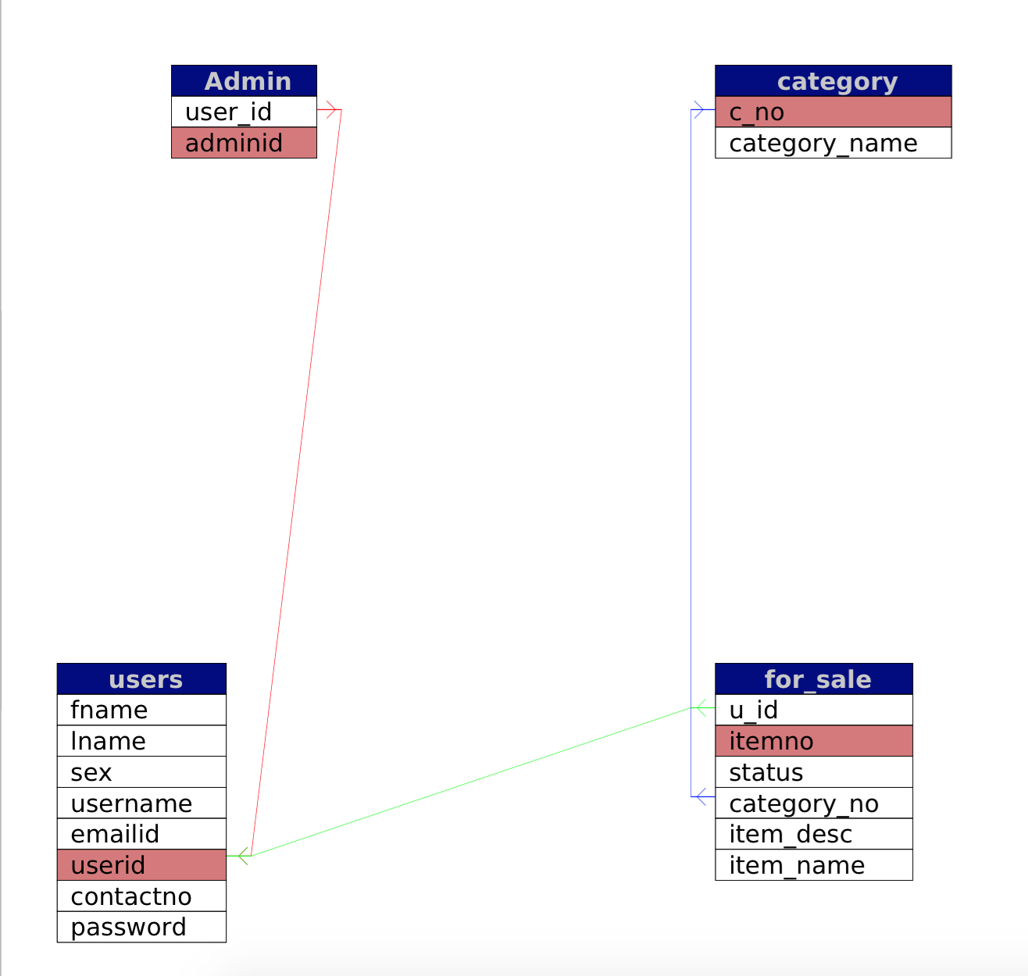
The following diagram is the relational schema for craigslist:

