***E-Commerce Platform – Qat3***

**Project idea:** local E-Commerce Platform

**Project Description:** A local online shopping platform that contains different local brands in various categories.

**Project Features:**

* It helps to strengthen the local economy of Egypt by displaying many local products.
* It helps spread Egyptian products and makes it easier for people to know local products.
* It helps to maintain and encourage people to boycott products hostile to the Palestinian cause.
* It makes finding local products easy and makes the user sure 100% that these products aren't at the boycott.
* It is Provide high competitiveness in the market among local products.

**Team Members**

|  |  |  |  |
| --- | --- | --- | --- |
| Name | Department | Track | Tech |
| Ahmed Algrgawy | CS | Front-End | React |
| Sandreen Kotb | CS | Front-End | React |
| Mostafa Negm | CS | Mobile | Flutter |
| Sara Elkholy | CS | Mobile | Flutter |
| Ali El-Beltagy | IT | Cyber Security | Penetration Tester |

**Our Values**

* **Support the local economy:** We help develop and support Egyptian products by displaying only local products on the website.
* **Support the Palestinian cause: We support the cause by displaying the most famous products under the boycott and displaying and providing non-boycotted products.**
* **Convenience:** Shop from the comfort of your home, 24/7, without needing to travel to physical stores.
* **Wider selection:** Access a wider variety of products than what might be available in local stores, including those from other regions or smaller businesses.
* **Comparison shopping:** Easily compare prices and features of products from different sellers.
* **Timesaving:** Save time by avoiding traffic, parking, and lines.
* **Available quantities:** Access to any number of products there is no limit or a minimal amount
* **Potential for faster delivery:** Depending on the website and chosen delivery option, products may arrive sooner than from traditional stores.
* **Reach a wider audience:** Sell products to customers beyond their local area, potentially increasing sales and revenue.

**Benchmarking**

|  |  |  |
| --- | --- | --- |
| **Qat3** | **VS** | **صنع في مصر** |
| Typically offer a smaller, curated selection focused on local brands, products relevant to the region, and the most important value that we provide Products that are not boycotted, and we warn about products that are under the boycott framework | **Selection** | Focuses specifically on promoting and selling products made in Egypt, potentially limiting selection but ensuring all products originate from the country. |
| Prices may be more competitive for smaller quantities, especially considering potential import duties and shipping costs from صنع في مصر . Additionally, Qat3 may offer promotions and discounts specific to your region. | **Price** | Aims to support Egyptian businesses and potentially offer products at competitive prices, although direct comparisons might be difficult due to the specific focus on locally made goods. |
| Generally offer faster delivery times, especially for local products, as they don't involve international shipping processes. | **Delivery** | Delivery times might depend on the specific seller and their location within Egypt. Since they focus on local products, delivery times within the country are likely comparable to other local websites. |
| we provide more personalized customer service, with easier communication and potentially faster resolution of any issues. | **Customer service** | Customer service experience might depend on the specific sellers featured on the platform. It's crucial to check individual seller policies and reviews for an accurate picture. |

**Use Case Diagram**

**Use case Report**

**Actors:**

- Customer

- Admin

**Customer**:

-Register:

If a customer is new user, he can request to register page. A register page open and asks total information about customer and also asks to customer to choose login (email address) and password.

- Login

The customer can login by enter name and password. The system verifies the name and password matches. If not matches, error messages shows to the customer.

- Start Shopping (includes "view product" and "search products")

This use case describes the customer browsing the website to view products. It includes functionalities like browsing products by category or using the search function to find

specific products.

- View Product Details

This use case expands on the browse function, allowing the customer to see detailed information about a particular product, including descriptions, prices, and images.

-Manage Cart (includes "delete product" and "add product")

This use case allows the customer to manage the items in their shopping cart. They can delete unwanted items, update the quantities of desired products, and potentially view the total cost of their order.

- Check out

The customer completes the shopping he request to checkout. If the payment information exists the credit card information sends to Credit Verification Company. If credit card information not matches it shows enter valid information or cancel order. If the credit card is valid, the order form will be processed by the system and checkout is complete.

- Place Order

This use case represents the final step in the checkout process where the customer confirms their order.

- Make Payment (included in Checkout)

This use case involves the customer securely paying for their order using a credit card or other online payment method. It would likely connect to a separate payment processing system.

Admin:

- Login:

The admin can login by enter name and password. The system verifies the name and password matches. If not matches, error messages shows to the admin.

- Manage Products

This use case allows the admin to add, edit, and remove products from the website. This would include managing product descriptions, prices, images, and inventory levels.

- Manage Orders

This use case allows the admin to view, process, and fulfill customer orders. This may include marking orders as received, preparing orders for delivery or pick-up, and managing any returns or exchanges.

- Manage Promotions

This use case allows the admin to create and manage promotional offers such as discounts, coupons, and special bundles.

- Update Content

This use case allows the admin to edit website content such as product descriptions, store information, and contact details.

- Generate Reports

This use case allows the admin to generate reports on website traffic, sales figures, and customer behavior. This data can be used to gain insights into customer behavior and improve the website.

**Class Diagram**

**Business Use Case Diagram**

**Functional Requirements**

**Product Management:**

* Users can browse a catalog of products offered by local businesses.
* Products should have detailed descriptions, including images, specifications, and variations (size, color, etc.).
* Inventory management system to track stock levels and prevent overselling.

**User Management:**

* + User registration and login functionalities.
  + User profiles to store addresses, preferences, and order history.
  + Display content and prices in the local currency.

**Search and Filtering:**

* + Users can search for products by keyword, category, or brand.
  + Ability to filter products based on price, category, availability, and other relevant attributes.

**Shopping Cart and Checkout:**

* + Users can add products to a shopping cart and adjust quantities.
  + Users can remove and clear products of the shopping cart.
  + Secure checkout process with various payment option

**Order Management:**

* + Order confirmation with detailed information.
  + Order tracking system for users to monitor order status.

**Communication and Reviews:**

* + Contact form to communicate.

**Non-Functional Requirements**

**Performance:**

* The platform should load quickly and be responsive across different devices (desktop, mobile, tablets).
* Ability to handle high traffic volumes during peak periods.

**Security:**

* Secure user authentication and data encryption to protect privacy.
* Compliance with relevant data security regulations.

**Scalability:**

* + The platform should be able to accommodate growth in users, products, and orders.
  + Easy integration of new features and functionalities.

**Usability:**

* + Users should be able to find what they need quickly and easily.
  + User-friendly interface with intuitive navigation and clear instructions.
  + Mobile-friendly and clear and consistent design

**Functional Diagram**

**Context Diagram**

**Data Flow Diagram**

**ERD**

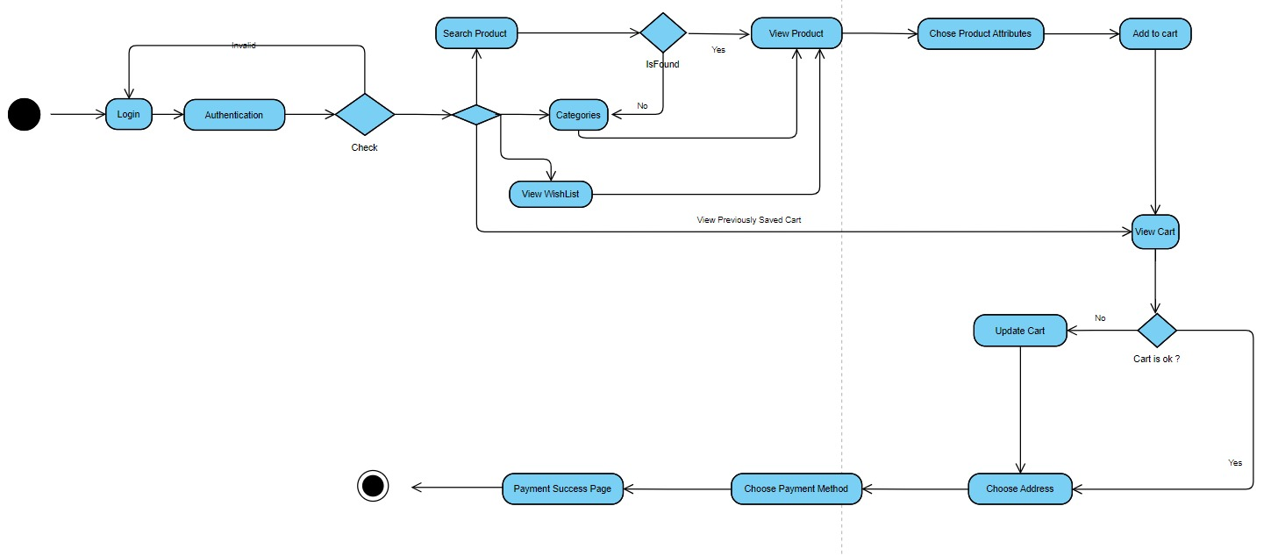**Activity Diagram**

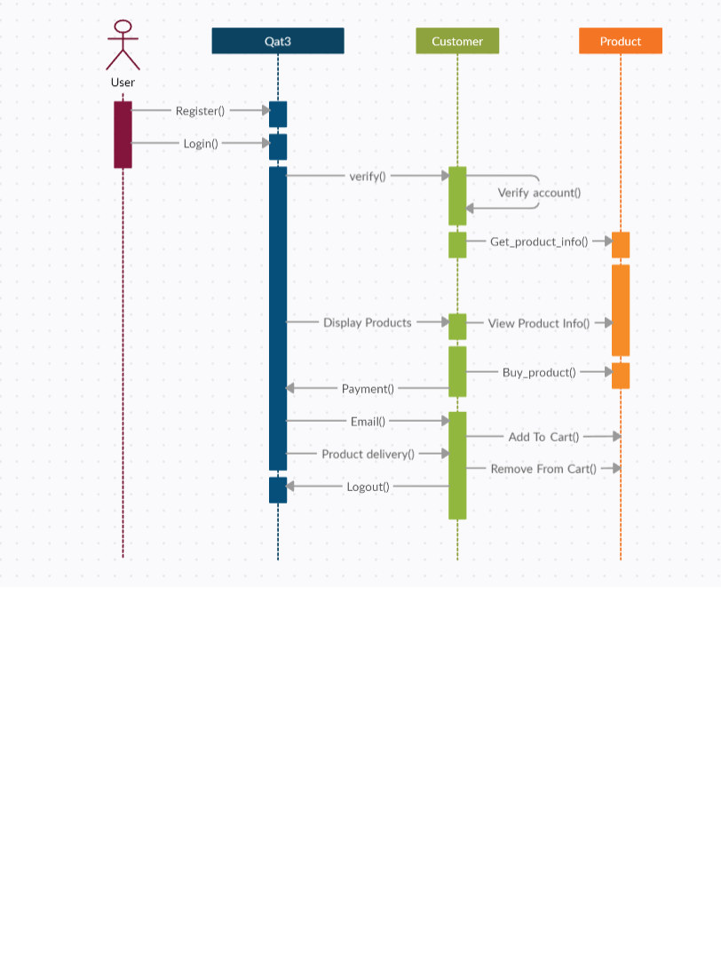**Sequence Diagram**

**Architecture Design Report**

E-commerce architecture is the foundation of a successful online store. It defines how the various components of the platform work together,

from the user interface customers interact with to the back-end systems that handle transactions and data storage.

A well-designed architecture ensures a smooth user experience, high performance, scalability, and security for your e-commerce business.

Enhanced User Experience: A well-structured architecture enables fast loading times, intuitive navigation, and a seamless shopping journey for customers, ultimately driving sales.

Improved Performance: A scalable architecture can handle high traffic volumes and ensure your website remains operational during peak periods.

Security and Reliability: A secure architecture protects sensitive customer data and ensures system stability to prevent downtime and data breaches.

Flexibility and Scalability: A well-designed architecture allows for future growth and integration of new features and functionalities as your business evolves.

Client Tier: This layer consists of the user interface (UI) accessible through web browsers or mobile apps. It interacts with the API Gateway for all requests.

API Gateway: This acts as a single entry point for all API requests coming from the client tier. It routes the requests to the appropriate microservices based on functionality.

Authentication Service: This service handles user login, registration, and session management. It ensures secure access to user accounts and resources.

Product Catalog Service: This service manages product information, including details, images, inventory levels, and pricing.

Order Management Service: This service processes customer orders, manages shopping carts, and handles checkout functionalities. It interacts with the Payment Gateway and Inventory Service.

Payment Gateway: This service securely processes customer payments through integrations with various payment providers.

Inventory Service: This service tracks product availability in real-time, ensuring accurate stock levels and preventing overselling.

Content Management System (CMS): This allows for managing website content, such as product descriptions, blog posts, and marketing pages.

User Management Service: This service handles user profiles, addresses, and wishlists. (Can be integrated with Authentication Service)

Search Service: This service facilitates product search functionality based on keywords, filters, and categories. (Can be integrated with Product Catalog Service)

Recommendation Service: This service recommends products to users based on browsing history and purchase behavior. (Optional)

Database: This stores all application data, managed by a database management system like MySQL or PostgreSQL.