Software Requirements Specification

For

Store Management System (SMS)

# **Team Members**

|  |  |  |
| --- | --- | --- |
| **SN** | **Student Name** | **Section Number** |
| **1** | **أحمد حسين بدر رشاد** | **1** |
| **2** | **أحمد علي فهمي محمد** | **1** |
| **3** | **عبد الرحمن محسن خليل ابراهيم** | 2 |
| **4** | **عبد الرحمن هلال صالح عبد العزيز** | 2 |
| **5** | **عبد الله عيد السيد عمار** | 2 |

Software Engineering Course, 3rd CSE

Faculty of Engineering, Helwan University

30-11-2023

# **Table of Contents**

**Team Members** 1

**Table of Contents** 2

**Table of Figures** 4

**1.** **Preface** 5

1. 1 Document purpose 5

1. 2 Target users 5

1. 3 Revision 5

**2.** **Introduction** 5

2. 1 Purpose 5

2. 2 Scope 6

2. 3 Overview 7

**3.** **Glossary** 7

3. 1 Acronyms, Definitions, and Abbreviations 7

**4.** **System Users** 7

4. 1 Stockholder 7

4. 2 User Objective 8

**5.** **User Requirements Definitions** 8

5. 1 System Functions 8

5. 2 Constraints 9

**6.** **System Architecture** 9

**7.** **System Functional Requirements** 9

7. 1 Add product to categories 9

7. 2 Remove product 9

7. 3 Show all products 10

7. 4 Add to cart 10

7. 5 Remove from cart 10

7. 6 View all orders 10

7. 7 Login 10

7. 8 Registration 11

7. 9 Confirm the buying order/ purchase orders 11

7. 10 Is the order delivered 11

7. 11 Deliver Order 11

**8.** **Interface Requirements** 12

8. 1 User Interface 12

8. 2 Software Interface 17

**9.** **Non-functional Requirements** 17

9. 1 Performance Requirements 17

9. 2 Reliability Requirements 17

9. 3 Usability Requirements 17

9. 4 Security Requirements 17

**10.** **System Models and Diagrams** 18

10. 1 Use-Case Diagram 18

10. 2 Class Diagram 19

10. 3 ER Diagram 20

10. 4 Sequence Diagram 21

# **Table of Figures**

Figure 1: System Architecture 9

Figure 2: Home page for customer. 12

Figure 3: Categories page for customers. 13

Figure 4: Each category page. 13

Figure 5: Cart page for customer. 14

Figure 6: Each product page. 14

Figure 7: Login page. 15

Figure 8: Registration page. 15

Figure 9: Admin page. 16

Figure 10: Delivery page. 16

Figure 11: Use Case Diagram 18

Figure 12: Class Diagram 19

Figure 13: ER Diagram 20

Figure 14: Scenario1 of admin interaction 21

Figure 15: Scenario2 of admin interaction 21

Figure 16: Scenario1 of customer interaction 22

Figure 17: Scenario2 of customer interaction 23

Figure 18: Scenario3 of customer interaction 24

Figure 19: Scenario4 of customer interaction 25

Figure 20: Scenario1 of delivery interaction 26

# **Preface**

## Document purpose

The purpose of this document is to provide a detailed and complete specification of the store management system (SMS).

First, there is an overview of the system in the first section the details will appear in the next sections.

## Target users

* Customer: search for products and services, add products to the cart, remove products from the cart, purchase orders, and show history of all orders.
* Administrator: manage products (add new products and remove existing products) and control database.
* Delivery: deliver an order to the customer and show all orders.

## Revision

|  |  |  |  |
| --- | --- | --- | --- |
| Version | Author | Description | Date |
| 0.1 | B3B3 | Initial | 30-11-2023 |
| 0.2 | B3B3 | Use-Case Added | 11-12-2023 |
| 0.3 | B3B3 | Class-Diagram Added | 17-12-2023 |
| 0.4 | B3B3 | Sequence-Diagram Added | 21-12-2023 |

# **Introduction**

## Purpose

Store system (SS) aims to automate the shopping process and find an easy way for customers to find their needs.

The system will achieve the following:

* Get customer's personal information (authentication)
* Help customers to find their needs.
* Help the manager control the work.
* Find solutions to improve customer service.
* Provide a way to deliver products to customers.
* Provide a payment when receiving service.

## Scope

The Store Management System (SMS) is designed to automate and streamline the shopping process, catering to the needs of customers, administrators, and delivery personnel. The system encompasses the following key functionalities:

* Customer Management:
* Capture and authenticate customer personal information for secure transactions.
* Facilitate customers in searching for products and services.
* Enable customers to add and remove products from the shopping cart.
* Allow customers to place purchase orders and view their order history.
* Administrator Management:
* Empower administrators to manage the product inventory.
* Facilitate the addition of new products and removal of existing products.
* Provide control over the database to ensure data accuracy and security.
* Delivery Management:
* Enable delivery personnel to view and fulfill customer orders.
* Provide a comprehensive view of all orders to streamline the delivery process.

## Overview

The Store Management System (SMS) provides a centralized platform that seamlessly integrates various aspects of store operations. This includes customer interactions, product management, order fulfillment, and administrative control. The system aims to enhance the shopping experience by providing efficient tools for customers and administrators.

# **Glossary**

## Acronyms, Definitions, and Abbreviations

FOEHU: Faculty of Engineering, Helwan University.

B3B3: Team Name.

SMS: Store Management System.

SQlite3: Database Used in System.

# **System Users**

## Stockholder

* System Engineer (Developer)
* Responsible for requirements gathering.
* Responsible for development.
* Responsible for deployment and support.
* Customer
* Add products to the cart.
* Confirm buying the orders in the cart.
* Delivery man
* Delivery orders to customers.
* Communicate with customers.
* Administrator
* Add new products or remove existing products in store.
* Set discounts for Palestinian and Egyptian products.
* Treatment with customer feedback.

## User Objective

* System Engineer (Developer)
* Gain Experience in software engineering and development.
* Customer
* Saving time and money on shopping.
* Find easy ways to meet their needs.
* Delivery man
* Get salary from delivering the orders.
* Administrator
* He finds a more conformable way to control his store.
* Find out leakage ear.

# **User Requirements Definitions**

## System Functions

* + 1. Add products to categories.
    2. Remove product.
    3. Show all products.
    4. Add to cart.
    5. Remove from cart.
    6. View all orders.
    7. Login.
    8. Registration.
    9. Confirm the buying order/purchase orders.
    10. Is the order delivered?
    11. Deliver order.

## Constraints

* User Authentication Constraint
* Ensure secure user authentication within the desktop application.
* Data Security Constraint
* Safeguard user data and sensitive information stored on the local machine.

# **System Architecture**

Figure : System Architecture

# **System Functional Requirements**

## Add product to categories

This function enables administrators to add new products to existing or new categories within the store with the following information:

* Main information about the product (name and price).
* The number of pieces of this product that will be added.
* If there is a discount on this product.
* The category to which this product belongs.

## Remove product

This function allows administrators to remove a product from the store.

## Show all products

This function allows administrators to access and show all product details in the store.

## Add to cart

This function allows registered users to create an order for products with the following information:

* User identifier (email and id).
* Product identifier.
* Product category.
* Date of order.

If the user enters the add to cart button, it will go to the cart with other orders to confirm.

## Remove from cart

This function allows registered users to remove a product from the cart frame.

## View all orders

This function allows registered users to view all past orders that he/her make in the store.

## Login

This function enables users to log into the system with the valid following information:

* Email.
* Password.

If the user enters the right email and password, then the main window will appear to him.

## Registration

This function allows users to register for a new account in the system with the following information:

* Email.
* Password.
* Address.
* Password.
* Gender.

If the user enters a unique email with correct information, he will be successfully added to the database.

## Confirm the buying order/ purchase orders

This function allows users to confirm all orders they make in the cart, and they will get the orders they make in the cart frame in the application.

## Is the order delivered

This function allows users to check the status of their orders to determine if they have been delivered.

If the order is delivered successfully, then it will appear to the user in the orders window.

## Deliver Order

This function allows delivery to confirm the delivered option of the user's order.

# **Interface Requirements**

## User Interface

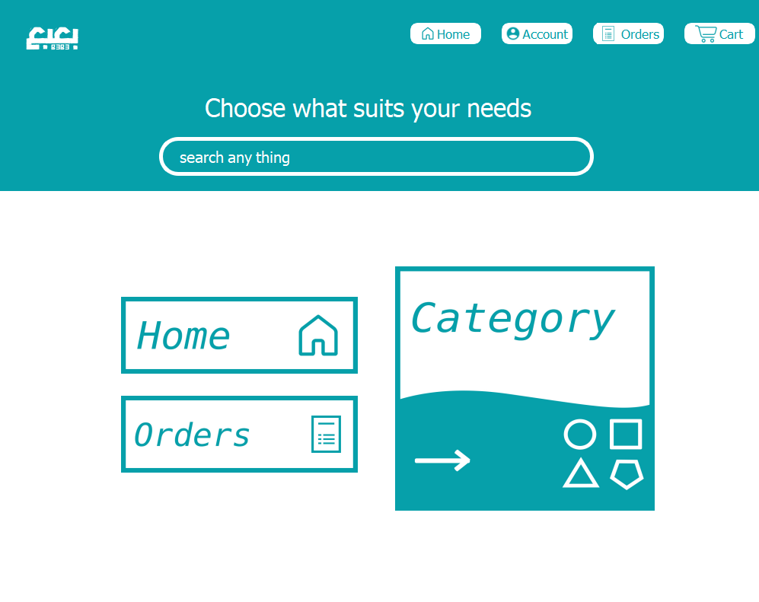

Figure : Home page for customer.

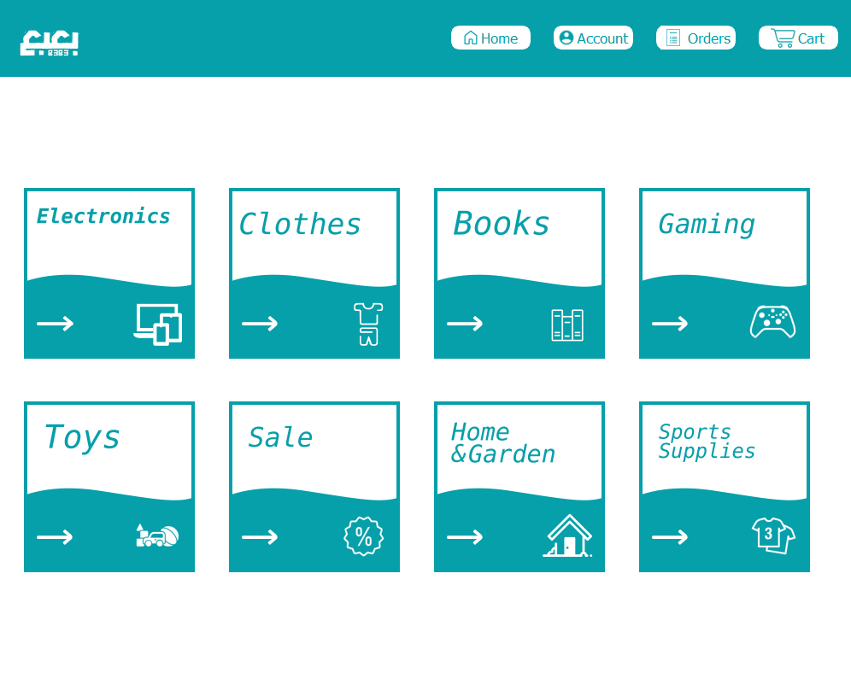

Figure : Categories page for customers.

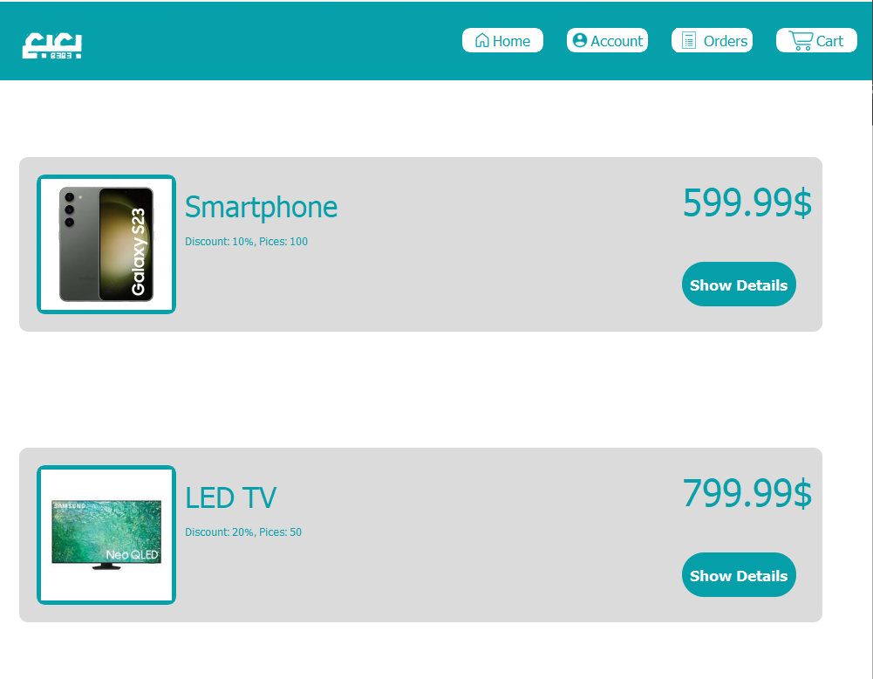

Figure : Each category page.

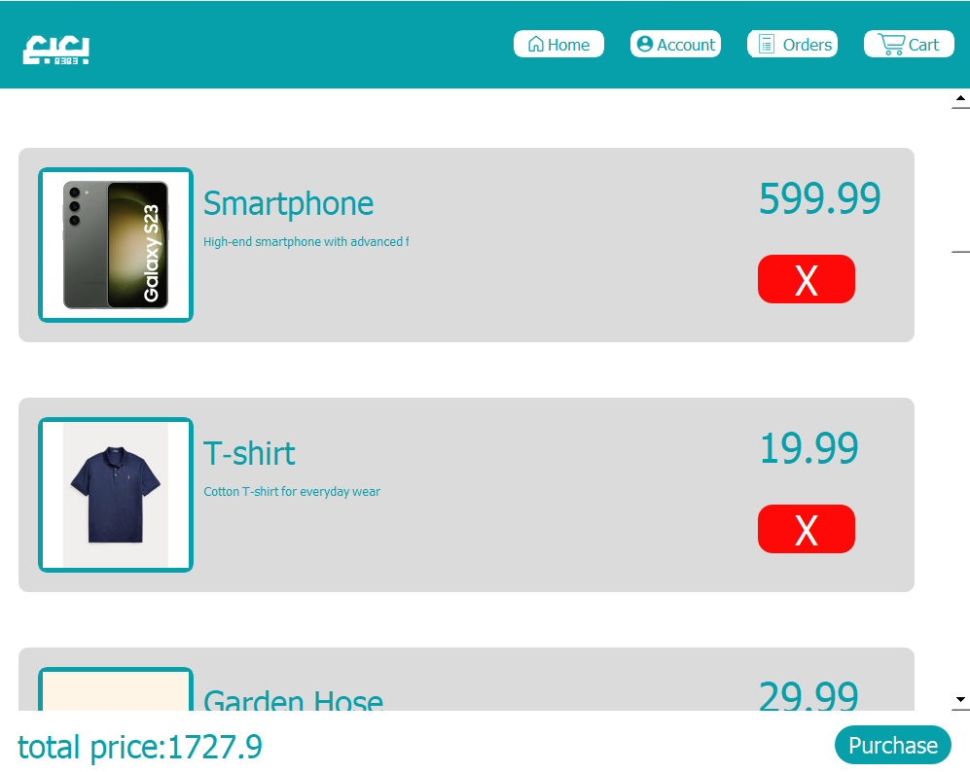

Figure : Cart page for customer.

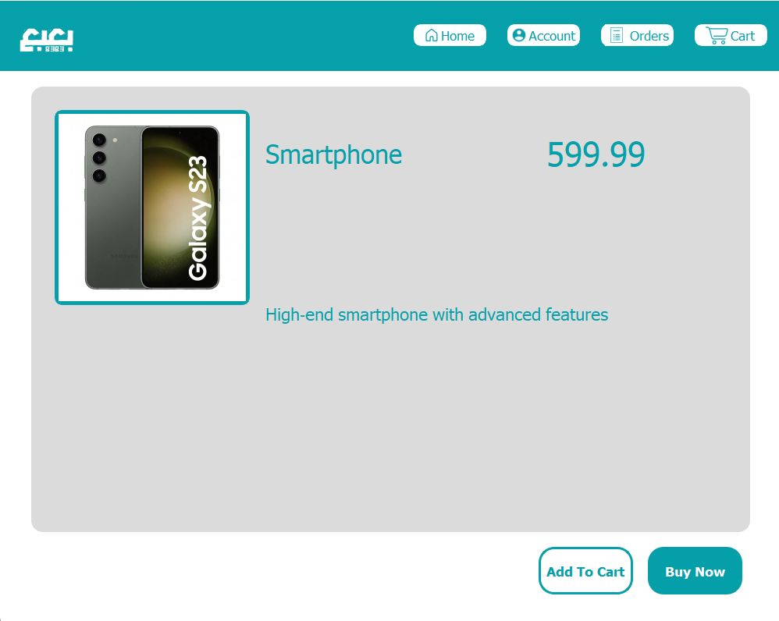

Figure : Each product page.

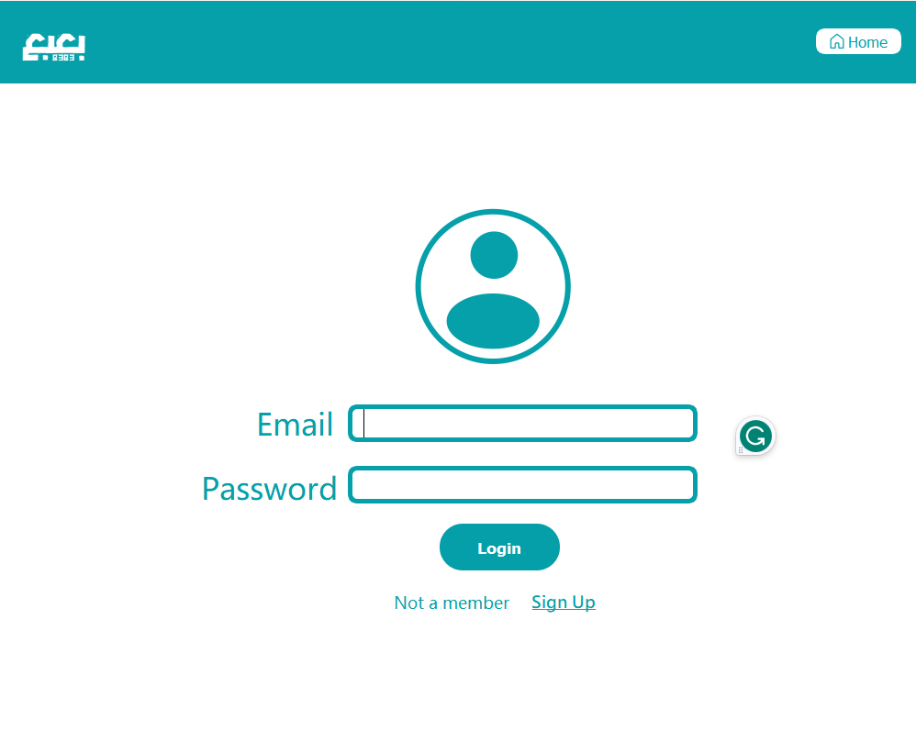

Figure : Login page.

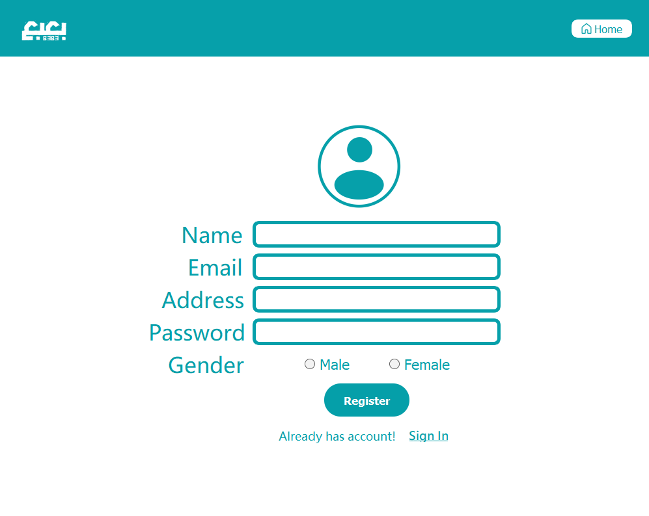

Figure : Registration page.

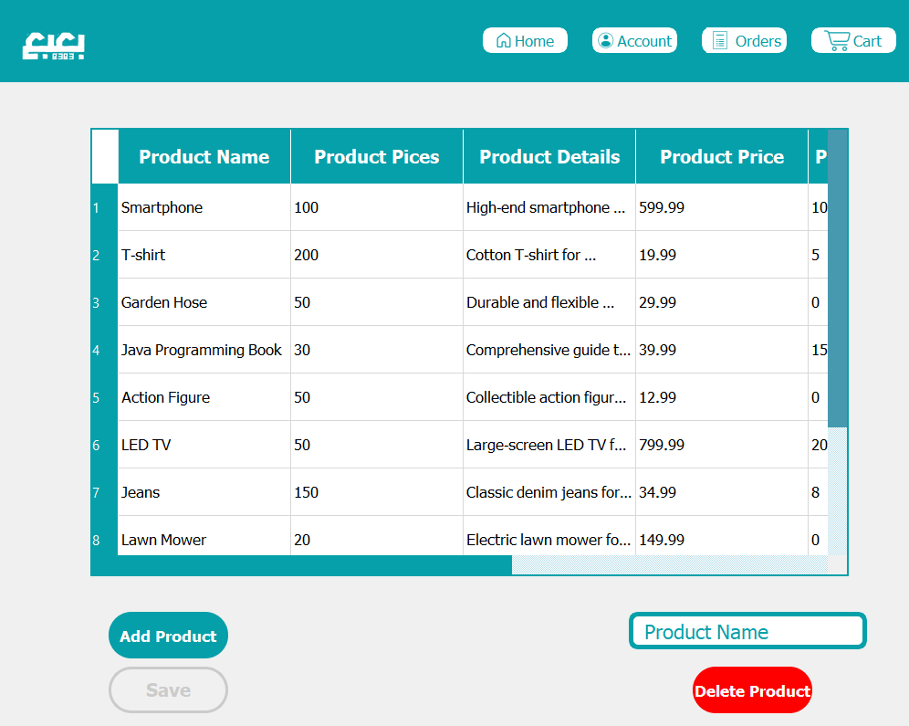

Figure : Admin page.

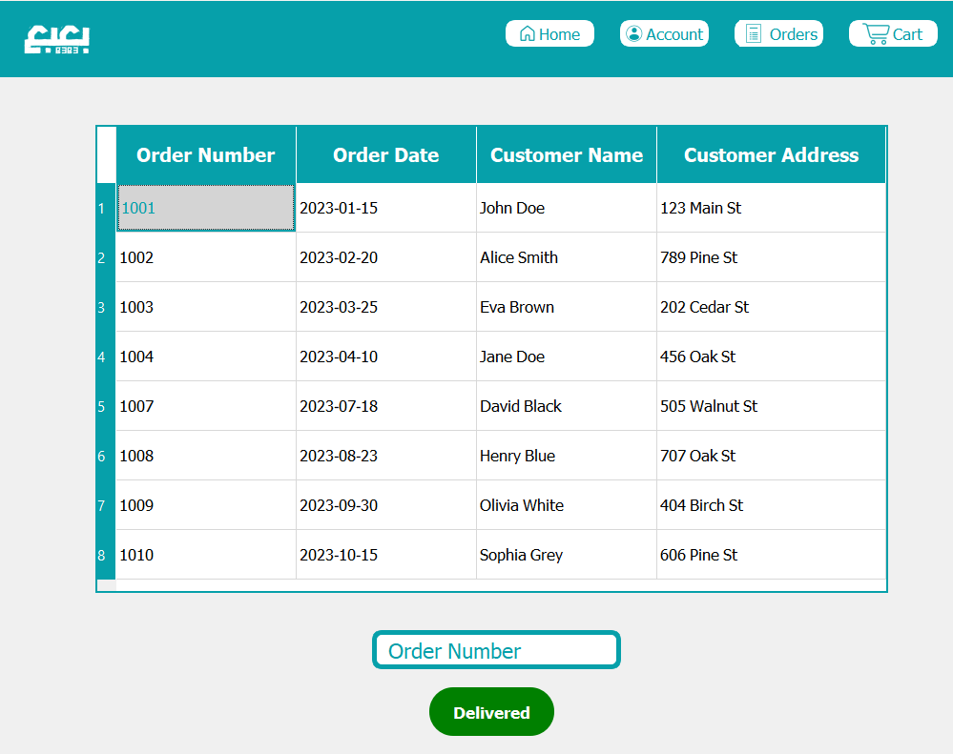

Figure : Delivery page.

## Software Interface

Database access using SQLite3 server.

# **Non-functional Requirements**

## Performance Requirements

The desktop application should respond to user interactions quickly.

## Reliability Requirements

Ensures that the application is consistently available, minimizing disruptions for users.

## Usability Requirements

The user interface should adhere to industry usability standards and guidelines.

## Security Requirements

All information about users must be hidden from all except the administrator.

# **System Models and Diagrams**

## Use-Case Diagram

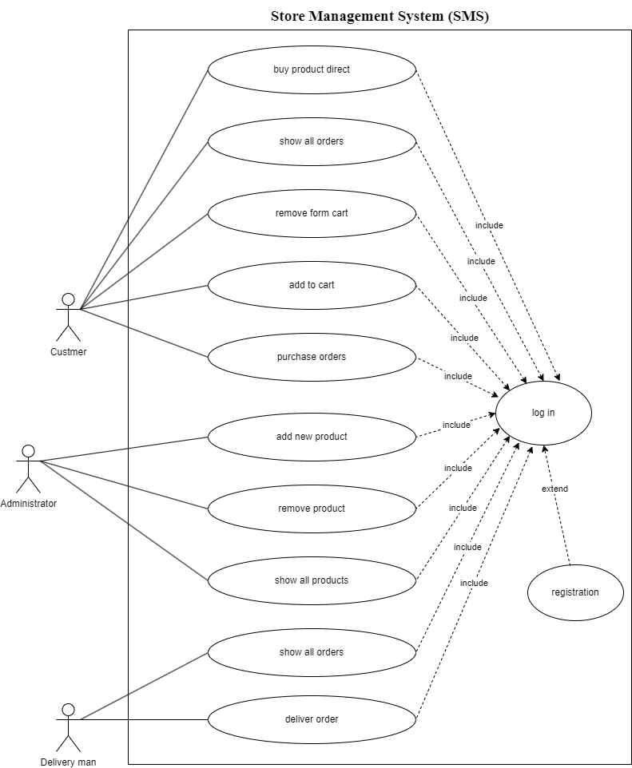

Figure : Use Case Diagram

## Class Diagram

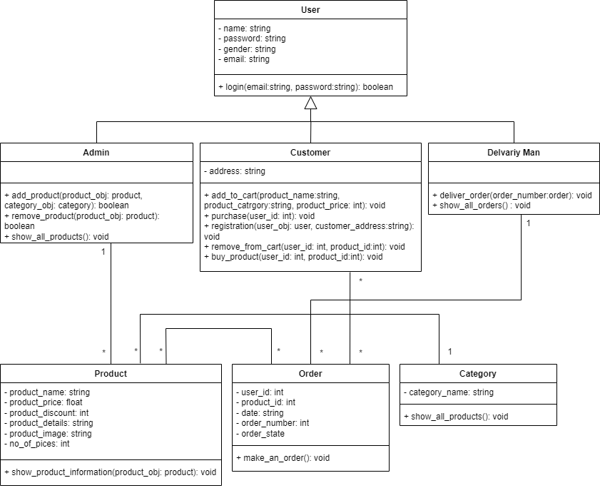

Figure : Class Diagram

## ER Diagram

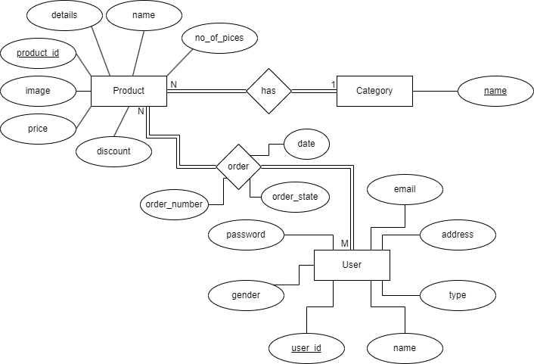

Figure : ER Diagram

## Sequence Diagram

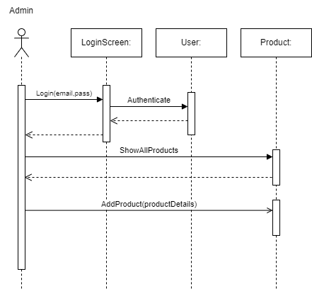

Figure : Scenario1 of admin interaction

Figure : Scenario2 of admin interaction

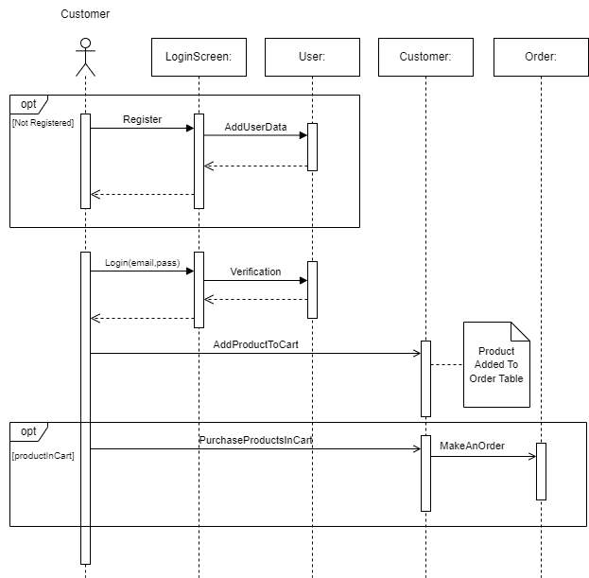

Figure : Scenario1 of customer interaction

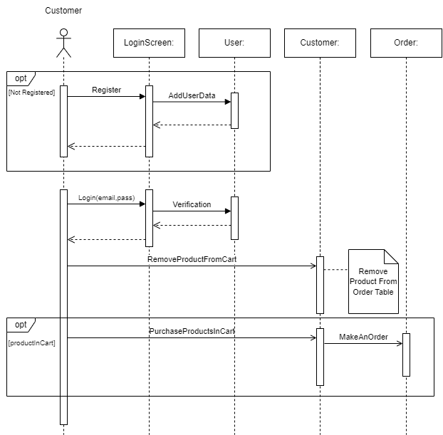

Figure : Scenario2 of customer interaction

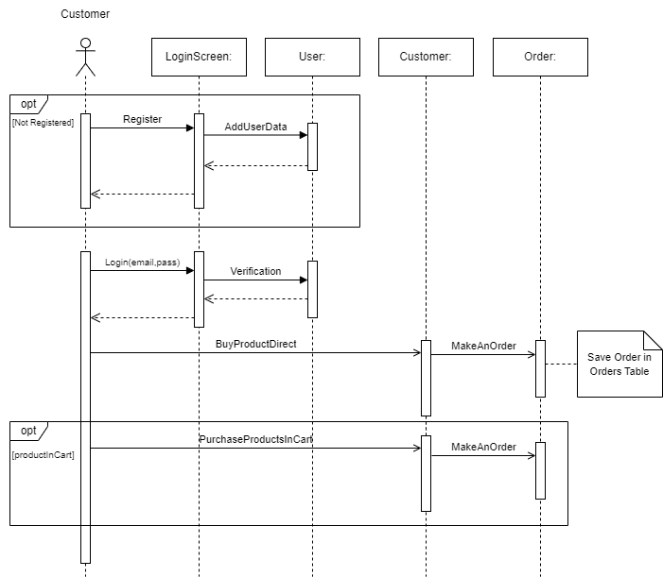

Figure : Scenario3 of customer interaction

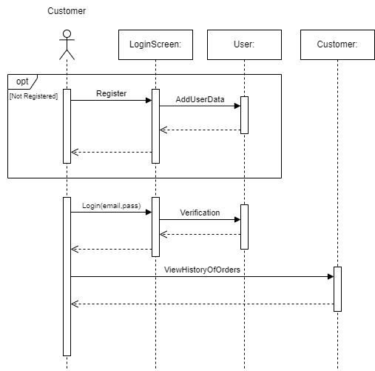

Figure : Scenario4 of customer interaction

Figure : Scenario1 of delivery interaction