Game Design Document

Fill up the following document

1. Write the title of your project.

Volleybrawl

1. What is the goal of the game?

To score points against the opponent

1. Write a brief story of your game.

Two friends having a friendly game of volleyball , with abilities

1. Which are the playing characters of this game?

* Playing characters are the ones who respond to the user based on the input from the user.
* Cars, monkeys, dinos, wizards, etc., are the playing characters in the game.

|  |  |  |
| --- | --- | --- |
| Number | Character Name | What can this character do? |
| 1 | User1 | Move , jump hit the ball |
| 2 | User2 | Move , jump hit the ball |
| 3 |  |  |
| 4 |  |  |
| 5 |  |  |
| 6 |  |  |
| 7 |  |  |
| 8 |  |  |

1. Which are the Non-Playing Characters of this game?

* Non-Playing characters are the ones that don't have an action or behavior when the user interacts with the game.
* Hurdles, stones, bananas, coins, etc., are non-playing characters in the game.

|  |  |  |
| --- | --- | --- |
| Number | Character Name | What can this character do? |
| 1 | ball | Bounce around |
| 2 | net | Block the ball and player |
| 3 | score | Keep track of score |
| 4 | powerups | Abilities that drop |
| 5 | timer | time |
| 6 |  |  |
| 7 |  |  |
| 8 |  |  |

Draw your imagination of this game. What does this game look like?

* Draw the game either on your computer or on paper.
* Add images of the game scenes to show each of the playing and non-playing characters at least once.

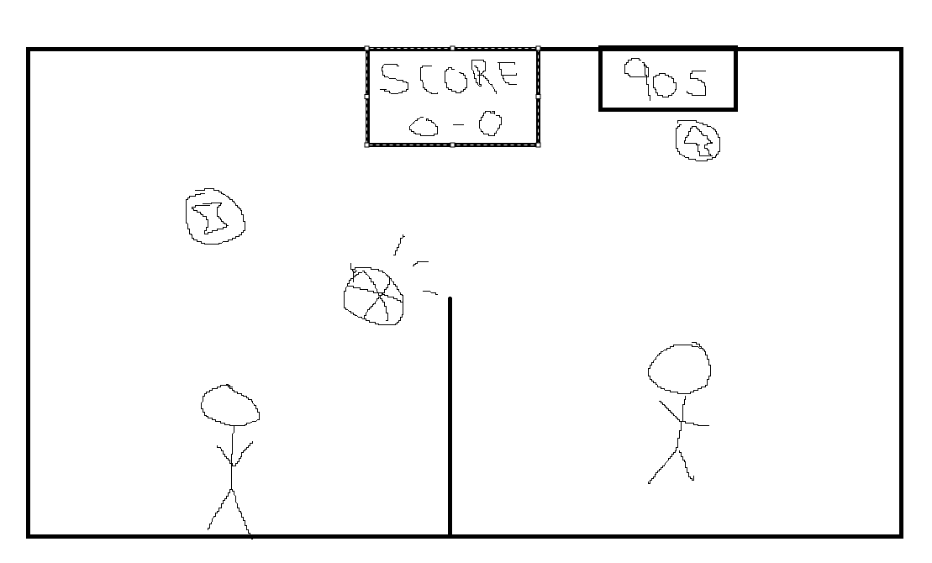 How do you plan to make your game engaging?

Ball speeds up after every bounce making it fast pased , keeping the players focused on making perfect moves .

Powerups to add round winning moves and combos

Timer so the game cant be stalled by one player