Introduction

Engineering design is the technique used by engineers to identify and solve problems. It has been described and illustrated in several ways, but all descriptions have some common attributes: construction design is a process. This powerful troubleshooting method is flexible enough to work properly in almost all cases. This report will include the design of the hardware differential robot that on which the ROS and Gazebo models will be applied, including the robot chassis, and electric components such as power supplies, actuators, processors (Arduino + ROS-enabled processor as Raspberry pi) sensors for the modules that will be implemented on the hardware.

Solidwork design for the robot chassis

The design for our robot consists of two parallel plates on which 4 DC motors are mounted. As a differential robot each two wheels will be controlled via one control signal, for example, the two DC motors of the right wheels will be controlled by one control signal, so they perform the same motion. The DC motors, the motor drivers, the Arduino controller and the Raspberry pi will be fixed on the lower plate. The four robot wheels tires will be mounted on the motors’ shafts.The IMU sensor and the bread board will be fixed on the upper plate for angle and steering control . Three ultrasonic sensors will be fixed vertically between the two plates, in addition two limit switch sensors for obstacle avoiding tasks.
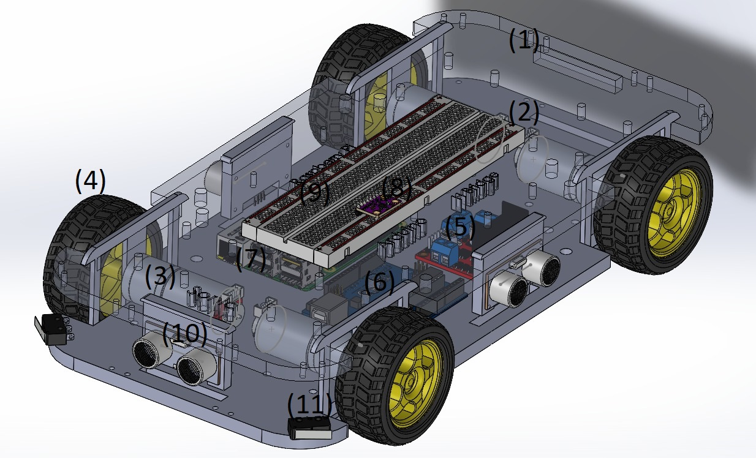
Figure 1: The differential robot chassis
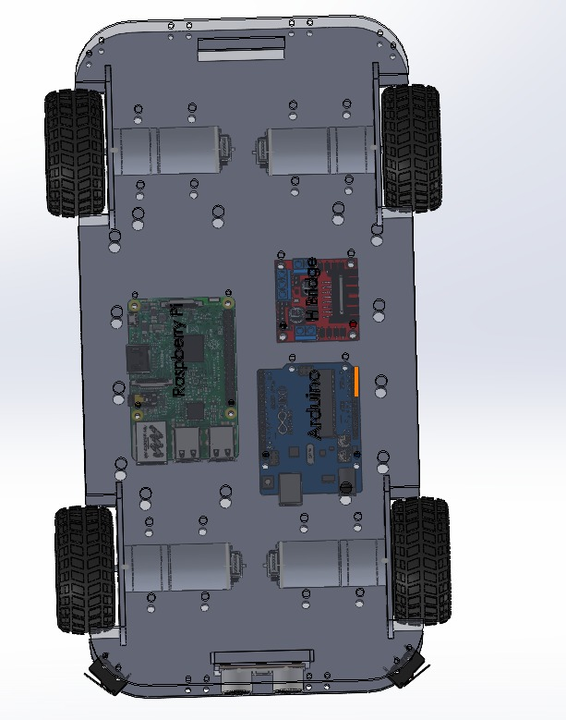
Figure 2: The differential robot chassis top view
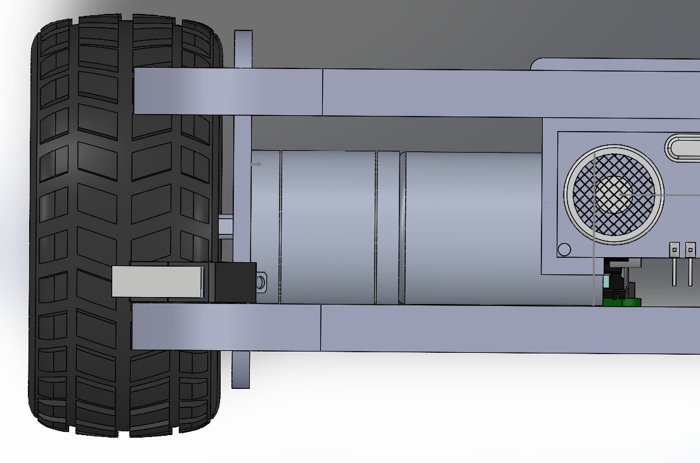
Figure 3: The differential robot motor mount
Table 1 will contain the hardware components as shown and numbered in Figure 1 including the robot chassis and the electrical components:
No. | Name | Description
1 | Upper plate | An acrylic plate on which sensors, breadboard are mounted.
2 | Lower plate | An acrylic plate on which motors, wheels and controllers are mounted.
3 | 4 DC motor | DC Geared motor with Metal Gear (3.2 Kg/cm-250 RPM-6V)
4 | 4 Wheels | Robot wheels (Tires) with brass coupler
5 | H-bridge | L298 Dual motor driver module (12-40V) 2A.
6 | Arduino uno | The Arduino UNO Rev.3 board is a microcontroller board based on the ATmega328.
7 | Raspberry pi | Raspberry Pi Model 3 B+
8 | IMU-6050 sensor | Accelerometer sensor that feeds the control loop with a feedback value of the x, y, and z channel at the same time based on the I2C bus of the microcontroller.
9 | Breadboard | Breadboard 840 pin
10 | Ultrasonic sensor x3 | Distance measurement sensor based on the measurement of time flight of ultrasonic pulse, which is reflected by an object.
11 | Limit switch sensor | Microswitch of control circuit with rated value of 250V and 1A.  Dimensions of this limit switch is 12.8 x 5.7 x 5.4 mm.

Table 1: Robot hardware component

