**Fuzzy control**

Overview:

The fuzzy logic control for the inverted pendulum is considered as the alternative to the classic PID control method. This method is based on Gray code, a binary number system in digital logic [1] i.e. to attain a finer resolution by deriving a intermediate logic state without having to obtain a higher computational bit processor.

In fuzzy control the input values are converted into these intermediate logic state known as fuzzy sets then the signal coming out of the controller gets de-fuzzified and value gets output as solid crisp sets.

The advantages of using fuzzy logic lies in the fact that the system can be taught to behave as a human operator. By asserting certain behavioural rules the system responds much quicker and have more control to change in parameters. The human knowledge link comes in as by these behavioural rules expressed in linguistic manner which are further elaborated in the subsequent section.

By utilising fuzzy logic sets the overshoot of the system’s response is significantly reduced without oscillation. Moreover the further complex a system becomes the more bulky the computational tasks of the PID control which in turn could hinder its performance

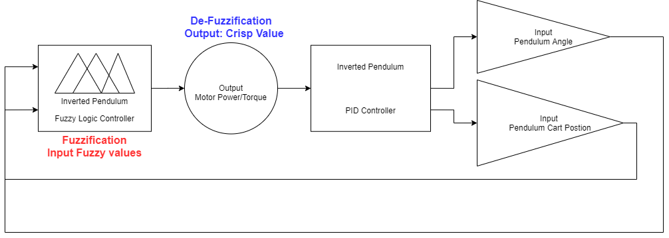

Fig 1: Block Diagram: 2 inputs and 1 Output based FLC(Fuzzy Logic control) System

Design brief

The implementation of the controller was carried out in MATLAB via graphical fuzzy logic toolbox editor.

This system as can be seen will be a Multiple Input Single Ouput (MISO).

|  |  |  |
| --- | --- | --- |
| **Parameters** | **Type** | **Range** |
| Pendulum Angle_θ | Input | -42 to +42 |
| Angular Velocity_dps (Degree per second) | Input | -9 to +9 |
| Force_N (to be applied to the motor) | Output | -28 to +28 |

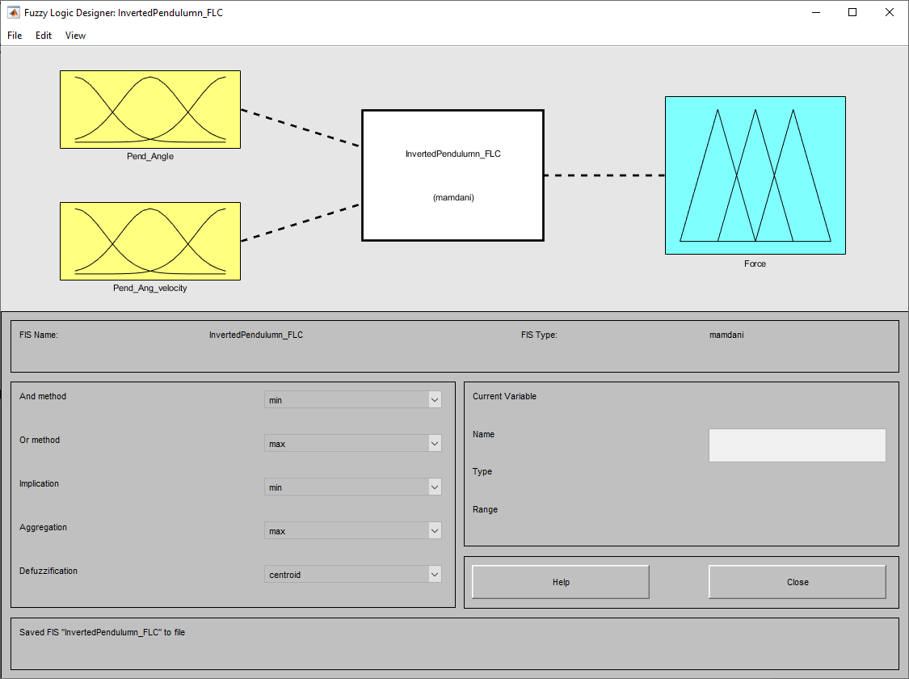

Fig 2: MATLAB Fuzzy logic toolbox editor

Membership functions:

Triangle – for all the parameters the triangle function is utilised which uses an Minimum and Maximum datum in X-axis, followed by a median datum point in Y-axis.

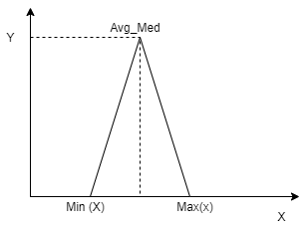

Fig 3: Triangle Function data points.

This function is commonly used in atleast one part of a control system. For our application this function seemed suffice to extract the output accordingly.

The tuning of the system initially can be tested with fewer membership function then upon the performance review. If the system still pertains to be unstable additional functions can be added to the particular parameter to fine tune and gain more control.

The inference engine of the FLC can be described as a grouped membership functions for each parameter with specific operating region. Negative Big (NB), Negative Medium(NM), Negative Small,

Zero error (Z), Positive small (PS), Positive Medium (PM) and Positive Big (PB). These seven membership functions are defined in the FIS (Fuzzy Inference System) editor which can be seen below in figure 3.5 and 3.6.

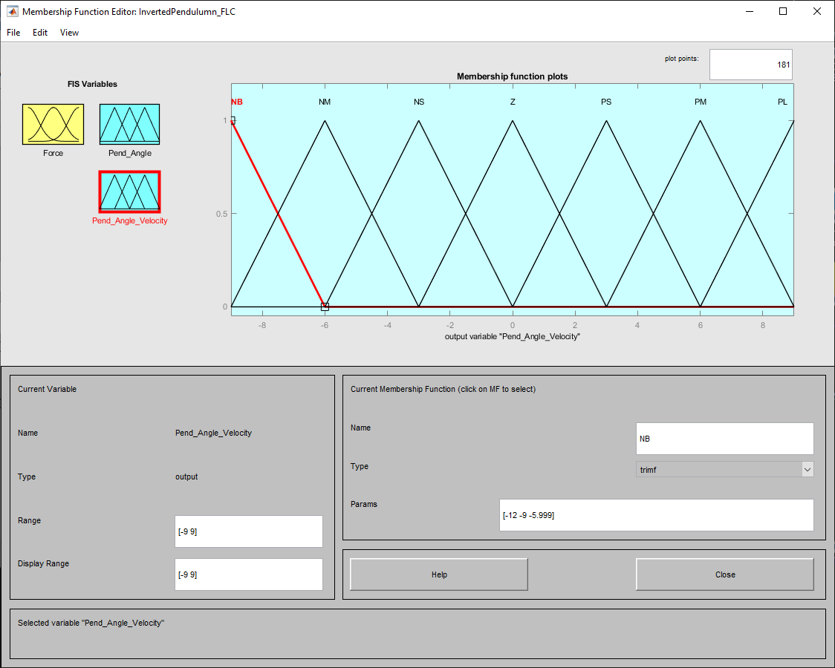

Fig 3.5 FIS editor: Angular velocity

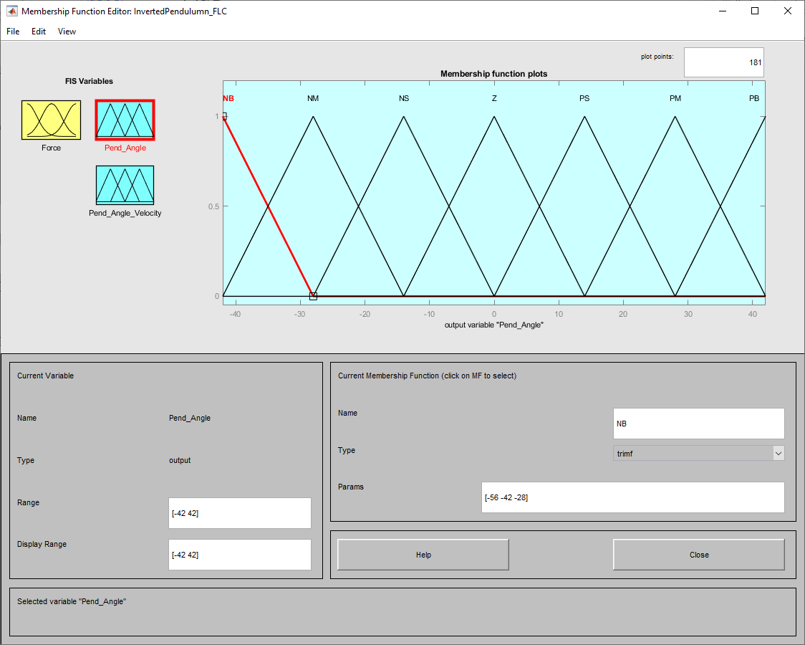

Fig 3.6 FIS editor: Pendulum_Angle

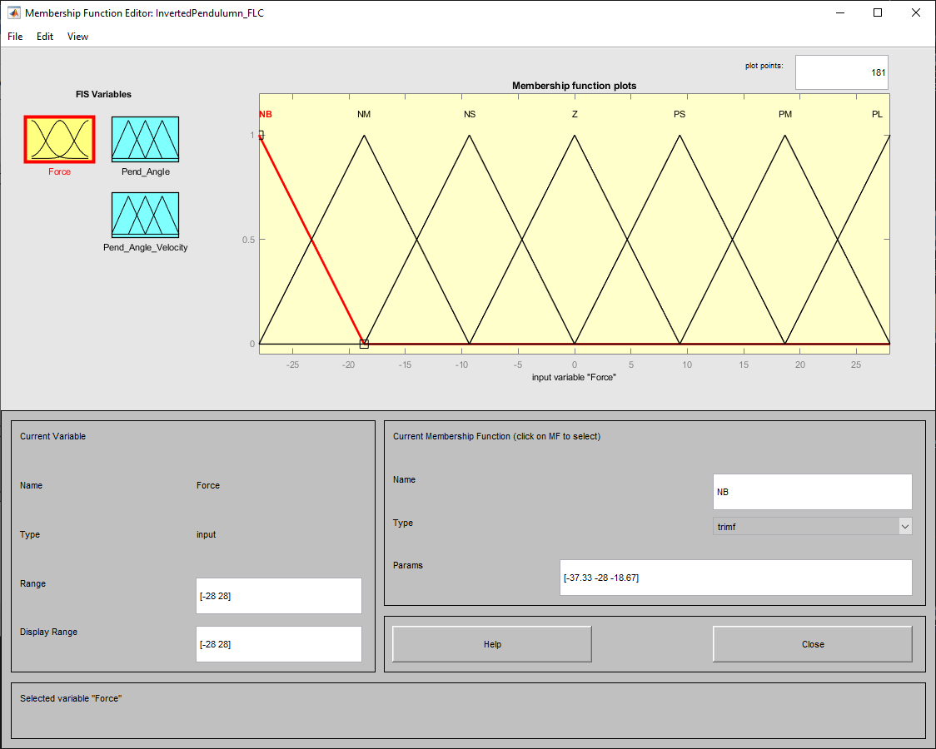

Fig 3.7 FIS editor: Output_Force

Behavioural Rules:

The system uses ‘AND’ logic for comparison between two inputs and gives a decision with ‘then’ as output. Based on the 7 membership functions, 49 behaviour rules have been expressed in the rule table below:

|  |  |  |  |  |  |  |  |
| --- | --- | --- | --- | --- | --- | --- | --- |
| **Inverted Pendulum Fuzzy logic Rule table:** Negative Big (NB), Negative Medium(NM), Negative Small,  Zero error (Z), Positive small (PS), Positive Medium (PM) and Positive Big (PB). | | | | | | | |
| Ang_Vel  θ | NB | NM | NS | Z | PS | PM | PB |
| NB | NB | NB | NM | NM | NS | NS | NS |
| NM | NB | NM | NM | NS | NS | NM | NM |
| NS | NM | NS | NS | NS | PS | PS | PS |
| Z | NB | NM | NS | NS | PS | PM | PB |
| PS | PM | PS | PM | PS | Z | NS | NS |
| PM | PB | PM | PS | PM | PS | Z | Z |
| PB | PB | PM | PM | PS | PS | PM | PS |

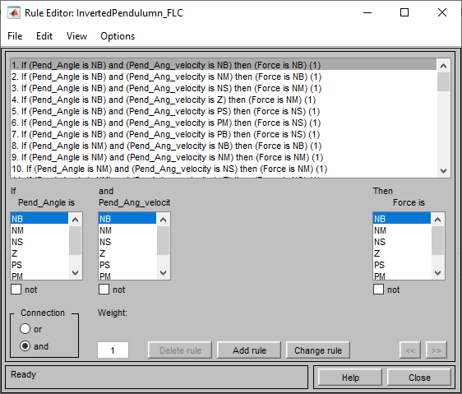

Fig 3.8 Behavioural Rule Editor

Analysis of Results:

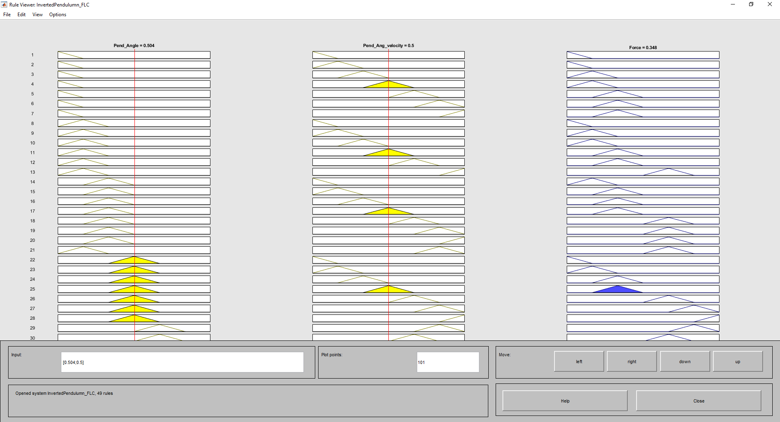

Fig 4: Rule Viewer

This red line Illustrates the weightage of the input with respect to consequential output.

The Rule viewer shows the weightage placed on each parameter and by moving the red line placed on the input, change in output can be observed accordingly. This will verify the asserted behavioural rules defined for the system.

The surface viewer illustrates the three dimensional behaviour model of the system based on the implemented fuzzy rules. This illustration mainly comes in handy when you want to display more than to parameters in one plot.

The transition of the system’s operation from bottom to top contains a mix of flat region and smooth contour. As annotated the flat region seems to be collating multiple input combination of fuzzy sets for one output value and the smoother contours exhibits progressive linearity in output.

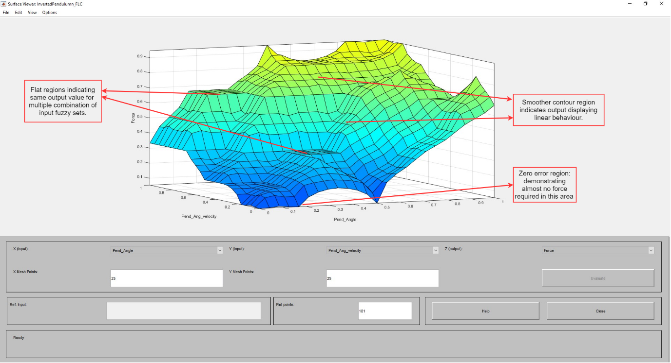

Fig 4.1: 3-D Surface Viewer

Reference:

1. <https://en.wikipedia.org/wiki/Gray_code>, Accessed: 24th April 2020
2. M.M.Gouda, S.Danaher, C.P.Underwood, (2000) *Journal Fuzzy Logic Control Versus Conventional PID Control for Controlling Indoor Temperature of a Building Space*
3. F. Martin McNeill (1994) Fuzzy Logic A Practical Approach,

* Provide the printout the Fuzzy design.
* Compare and discuss the results with respect to task 4.