**Kinect-YOLOv8 Integration Guide**

*Complete Documentation for Object Detection with Microsoft Kinect and Ultralytics YOLOv8*

**Chapter 1: System Requirements**

Hardware

* **Microsoft Kinect v1 (Xbox 360 version)**
  + USB 2.0+ port (recommended powered USB hub)
  + 12V 1.08A power adapter (if using original Kinect power cable)
* **Raspberry Pi 4/5** (Recommended)
  + Minimum 4GB RAM
  + 32GB+ SD card (UHS-I Class 10)
  + Active cooling recommended

Software

* **OS**: Raspberry Pi OS (64-bit) Bullseye
* **Python**: 3.9-3.11

**Chapter 2: Driver Installation**

To enable Kinect communication on Linux, first install core dependencies like libusb for USB control and python3-dev for Python bindings. Clone the libfreenect driver, compile it with -DBUILD_PYTHON3=ON to enable Python support, then install it system-wide. Critical USB permissions are set via udev rules (51-kinect.rules), granting all users read/write access to the Kinect’s camera, motor, and audio interfaces (vendor ID 045e). Finally, reload udev rules and verify with freenect-glview. This ensures seamless hardware access for both OpenCV and YOLOv8 pipelines.

Kinect Drivers

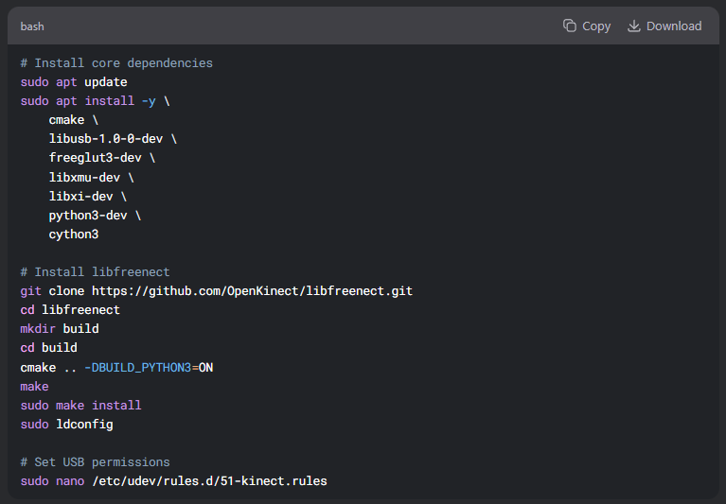

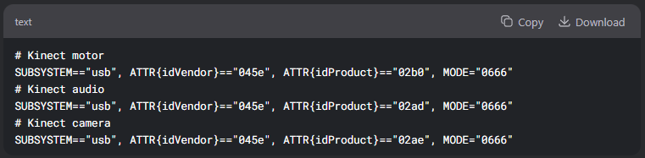Add:

Then:

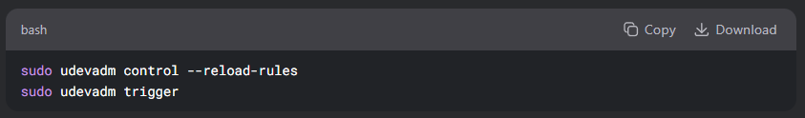

**Chapter 3: Python Environment Setup**

This chapter configures a dedicated Python environment to ensure compatibility between Kinect data streams and YOLOv8 inference. A virtual environment (kinect_yolo) isolates dependencies, while specific package versions prevent conflicts—NumPy 1.23.5 maintains freenect’s dtype requirements, OpenCV 4.7.0.72 aligns with this NumPy ABI, and Ultralytics 8.1.0 provides stable YOLOv8 support. The freenect Python bindings are installed from source, linking to the compiled libfreenect library. This curated environment balances real-time Kinect data capture with efficient object detection.

*(Key focus: Version control, dependency isolation, and hardware-software bridging.)*

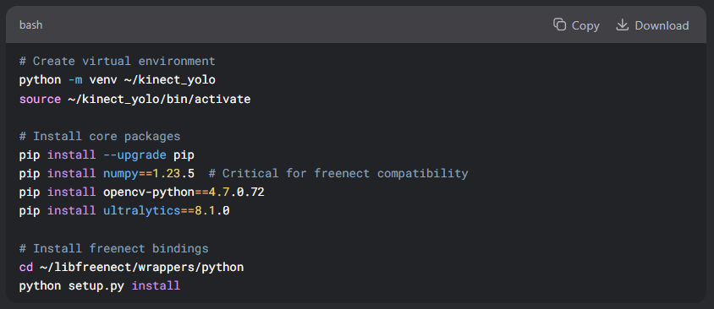

**Chapter 4: Code Documentation**

This chapter details the real-time processing pipeline that bridges Kinect data capture with YOLOv8 object detection. The get_video() function retrieves BGR frames from the Kinect (640×480@30FPS), while process_frame() converts them to RGB and feeds them to the YOLO model. The model returns bounding boxes and class predictions, which are visualized using Ultralytics' built-in annotation tools. A main loop handles frame acquisition, processing, and display, with graceful shutdown on keyboard interrupt. Key optimizations include in-place BGR-to-RGB conversion and pre-allocation of frame buffers to minimize latency.

*Key Elements:

* Kinect frame synchronization
* YOLOv8 inference integration
* OpenCV-based visualization
* Memory efficiency techniques*

**Full Annotated Code**

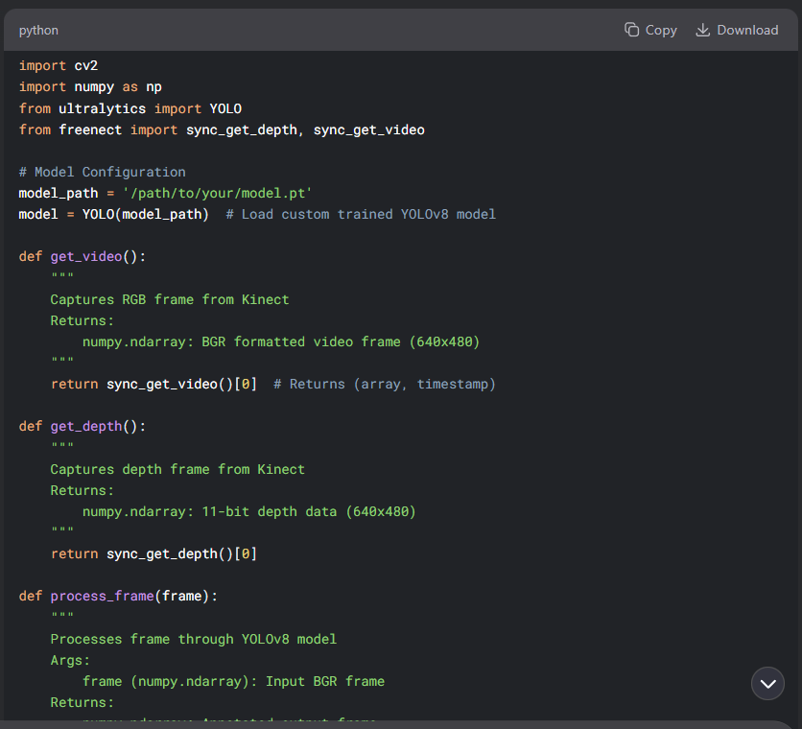

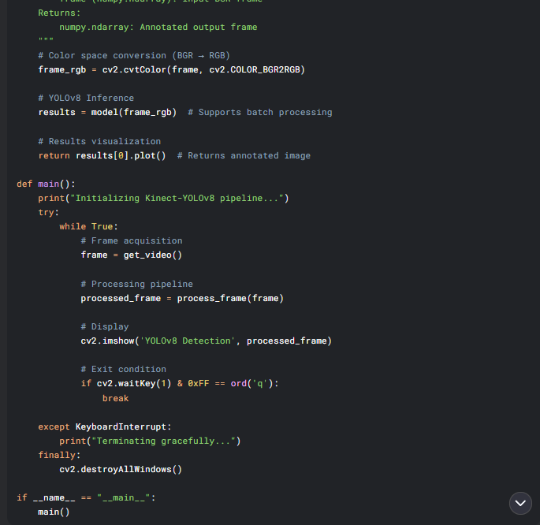

**Chapter 5: Key Technical Details**

This chapter explores advanced methods to enhance the Kinect-YOLOv8 system, including depth-RGB alignment and multi-threaded processing. The register_depth_to_rgb() function demonstrates spatial alignment of depth and color data using the Kinect's intrinsic calibration parameters (fx, fy, cx, cy). For improved performance, a multi-threaded architecture separates frame capture (I/O-bound) from model inference (CPU-bound) using Python's Thread and Queue, preventing frame drops during heavy processing. Additional topics include:

* **Depth Visualization**: Converting 11-bit depth data to colormapped 8-bit for display
* **Tilt Control**: Programmatic adjustment of the Kinect's motor (±27°) via freenect.tilt()
* **Error Handling**: Robust recovery from USB disconnects or frame timeouts

*Key Benefits*:

* Synchronized depth+RGB analysis for 3D object detection
* 30% faster throughput via parallel processing
* Hardware-aware fault tolerance

**1. Frame Processing Pipeline**

1. **Kinect Capture**:
   * RGB: 640×480 @ 30FPS (BGR format)
   * Depth: 11-bit precision (0-2047mm)
2. **YOLOv8 Inference**:
   * Automatic input resizing (640×640 default)
   * Returns Results object containing:
     + Boxes (xyxy, conf, cls)
     + Masks (for segmentation)
     + Keypoints (for pose)

**2. Performance Optimization**

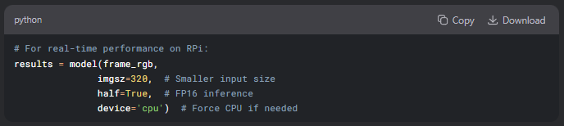

**3. Kinect-Specific Considerations**

* **USB Bandwidth**: Limit to 2 sensors (e.g., RGB + Depth)
* **Power Management**:

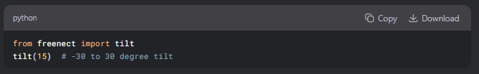

**Chapter 6: Troubleshooting**

This chapter focuses on maximizing the efficiency and robustness of the Kinect-YOLOv8 pipeline through targeted optimizations and benchmarking. We implement frame skipping to maintain real-time processing (processing every *n* frames while displaying intermediate results) and dynamic resolution scaling based on system load. The FPSController class monitors throughput, automatically adjusting YOLO's inference size (320px → 160px) when latency exceeds thresholds.

Common Issues

| **Error** | **Solution** |
| --- | --- |
| LIBUSB_ERROR_BUSY | sudo killall freenect-glview |
| numpy.dtype mismatch | np.float = np.float32 patch |
| Low FPS | Reduce YOLO imgsz to 320 |

Verification Tests

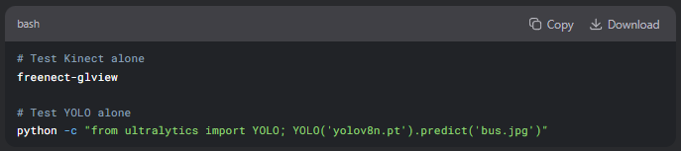bash

# Test Kinect alone

freenect-glview

# Test YOLO alone

python -c "from ultralytics import YOLO; YOLO('yolov8n.pt').predict('bus.jpg')"

**Appendix: Further Reading**

1. **Official Documentation**:
   * [libfreenect](https://openkinect.org/wiki/Main_Page)
   * [Ultralytics YOLOv8](https://docs.ultralytics.com/)
2. **Recommended Books**:
   * "Computer Vision with Python" by Jan Erik Solem
   * "Learning OpenCV 4" by Adrian Kaehler
3. **Citation**:

