**CATEGORIES**

Activewear's Of All Kinds

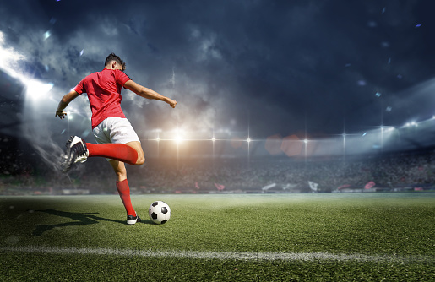

**Football**

Football is a family of team sports that involve, to varying degrees, kicking a ball to score a goal. Unqualified, the word football normally means the form of football that is the most popular where the word is used. Sports commonly called football include association football (known as soccer in North America, Ireland and Australia); gridiron football (specifically American football or Canadian football); Australian rules football; rugby union and rugby league; and Gaelic football.

Shop Collection

**Cricket**

Lorem ipsum dolor sit amet, consectetur adipiscing elit, sed do eiusmod tempor incididunt ut labore et dolore magna aliqua. Ut enim ad minim veniam, quis nostrud exercitation ullamco laboris nisi ut aliquip ex ea commodo consequat. Duis aute irure dolor in reprehenderit in voluptate velit esse cillum dolore

Shop Collection

**Basketball**

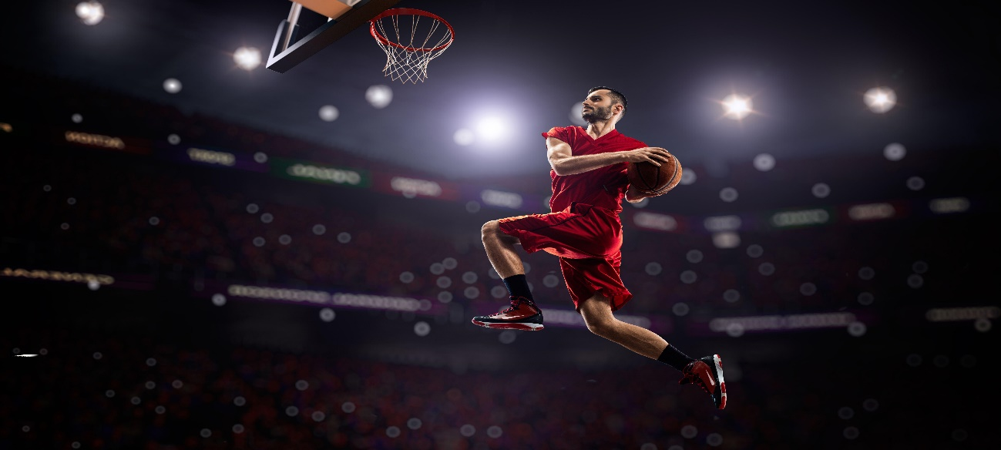

Lorem ipsum dolor sit amet, consectetur adipiscing elit, sed do eiusmod tempor incididunt ut labore et dolore magna aliqua. Ut enim ad minim veniam, quis nostrud exercitation ullamco laboris nisi ut aliquip ex ea commodo consequat. Duis aute irure dolor in reprehenderit in voluptate velit esse cillum dolore

Shop Collection

**GOLF**

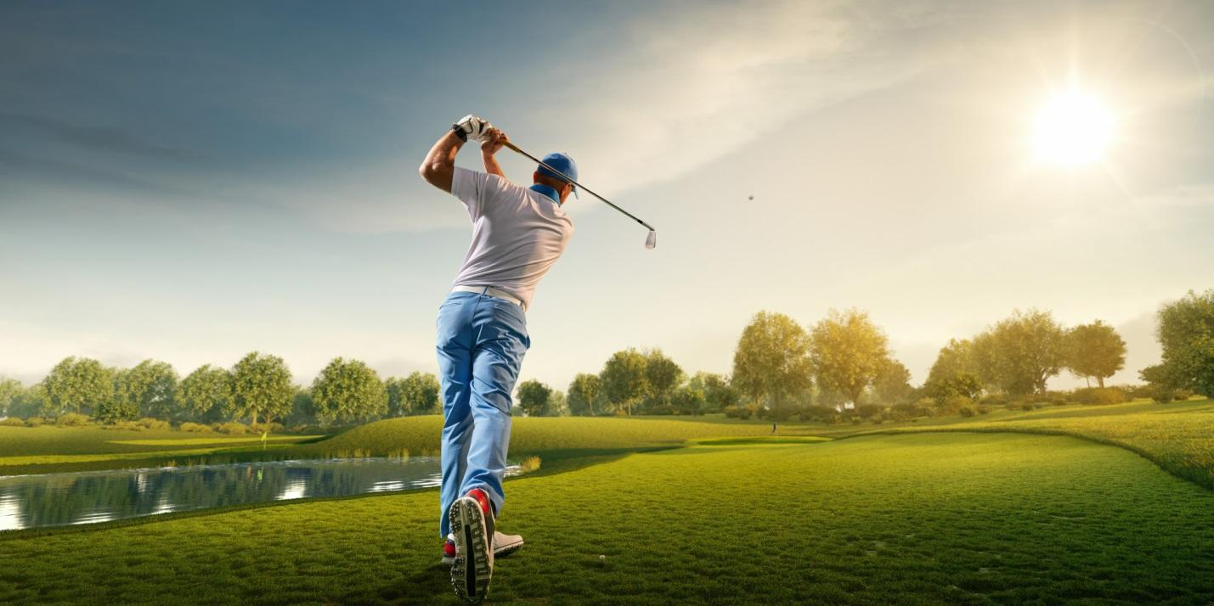

Lorem ipsum dolor sit amet, consectetur adipiscing elit, sed do eiusmod tempor incididunt ut labore et dolore magna aliqua. Ut enim ad minim veniam, quis nostrud exercitation ullamco laboris nisi ut aliquip ex ea commodo consequat. Duis aute irure dolor in reprehenderit in voluptate velit esse cillum dolore

Shop Collection

**TENNIS**

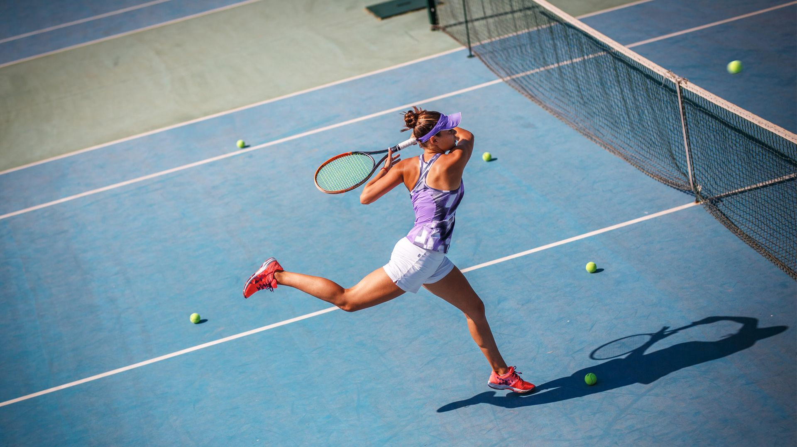

Lorem ipsum dolor sit amet, consectetur adipiscing elit, sed do eiusmod tempor incididunt ut labore et dolore magna aliqua. Ut enim ad minim veniam, quis nostrud exercitation ullamco laboris nisi ut aliquip ex ea commodo consequat. Duis aute irure dolor in reprehenderit in voluptate velit esse cillum dolore

Shop Collection