AIE425 Intelligent Recommender Systems, Fall Semester 25/26
Final Course Project
Group 22
Abdelrahman Osheba | 222100946
Ahmed Abouelela | 222100032
Ahmed Abdelghany | 222100123
Ziad Mohammed | 222102242

Submission Date: Monday, January 5, 2026

Executive Summary
This project presents a comprehensive investigation of dimensionality-reduction–based collaborative filtering methods and applies the insights gained to the design of a complete, domain-specific hybrid recommender system for large-scale food recipe recommendations. The work is organized into two major sections. Section 1 explores three classical collaborative filtering techniques—PCA with mean-filling, PCA with Maximum Likelihood Estimation (MLE), and SVD-based matrix factorization—evaluating their ability to handle sparsity, recover meaningful latent structure, and produce accurate rating predictions. Section 2 extends these findings to a real-world domain by building a robust content-aware and hybrid recipe recommendation system using the Food.com Recipes & Interactions dataset containing more than 230,000 recipes and over 1.1 million user interactions.
In Section 1, PCA with mean-filling served as the baseline method. Following the classical PCA workflow—mean filling, mean centering, covariance computation, dimensionality reduction, and principal component regression (PCR)—the method revealed significant limitations when applied to sparse user–item matrices. Mean filling artificially suppresses variance by forcing missing ratings toward the item mean, resulting in near-zero deviation vectors for most users. This distortion causes the covariance structure to collapse, with PCA extracting degenerate components that fail to capture meaningful relationships between items. Consequently, predictions for target items converge to constant values, demonstrating the theoretical weakness of mean-filling when sparsity is high.
PCA with MLE-based covariance substantially improved analytic fidelity. By computing covariance exclusively from co-rated entries, MLE preserves natural rating variability and avoids the variance shrinkage inherent to mean-filling. This approach generates richer covariance matrices, leading to stable PCA components with high explained variance (≈98–100%). PCA embeddings no longer collapse, and PCR yields fully personalized predictions spanning the full 1–5 rating scale. Although MLE computation is more expensive and still constrained by co-rating sparsity, it represents a significant methodological improvement and aligns more closely with real statistical structure in the data.
SVD-based matrix factorization emerges as the strongest method in Section 1. By decomposing the mean-filled rating matrix into latent user and item factors, SVD leverages global structure and efficiently captures high-level preference patterns across users. Experiments with truncated SVD (k=10, 20) highlight its robustness, scalability, and superior predictive performance. Latent factors produced by SVD are interpretable and stable, while MAE and RMSE consistently outperform PCA-based approaches. Moreover, SVD handles extreme sparsity more effectively and forms a practical foundation for modern recommender systems. Comparative analysis shows that while MLE-PCA performs well for limited peer neighborhoods, SVD provides systematically better predictions as user interaction histories grow, making it the most suitable collaborative filtering technique among those evaluated.
In Section 2, the project applies these insights to the development of a complete food recommendation engine using the Food.com dataset. This dataset exhibits extreme sparsity (≈99.998%), a long-tail distribution of user and item activity, and strong popularity effects—typical of real consumer platforms. To address these challenges, a hybrid architecture combining TF-IDF–based content representation, item-based similarity, and SVD collaborative filtering was designed. Recipe content was modeled using text features (titles, descriptions, tags, ingredients) and enriched with numerical attributes (minutes, nutrition, number of steps), producing a 510-dimensional item feature space. User profiles were constructed through rating-weighted feature aggregation, enabling effective personalization even under limited rating histories.
Building on the conclusions from Section 1, the system adopts a Switching Hybrid Strategy:
- Content-based filtering is used for users with fewer than 10 ratings (≈94.5% of all users).
- SVD-based collaborative filtering is applied when sufficient interaction history exists.
This approach combines semantic similarity with learned latent preference patterns, ensuring generalization, personalization, and robustness against cold-start conditions. While popularity-based baselines achieve strong global accuracy due to heavy bias toward popular recipes, the hybrid model provides superior personalization and domain relevance. The system architecture is modular, scalable, and incorporates structured evaluation, including content-based examples, k-NN comparisons, SVD predictions, hybrid demonstrations, and cold-start analysis.
Overall, the project demonstrates that SVD is the most robust and scalable latent factor method, while MLE-based PCA remains a valuable analytical tool for understanding covariance structure under sparsity. Mean-filling PCA is shown to be theoretically elegant but practically unreliable in real sparse environments. The hybrid recommendation system designed in Section 2 effectively integrates these methodological insights and provides a strong,
Section 1
PCA Mean-Filling
This Task demonstrated the full workflow of building a PCA-based collaborative filtering system using mean-filling, covariance analysis, dimensionality reduction, and principal component regression (PCR). The objective was to predict the missing ratings of two target items by leveraging the statistical structure of their most strongly correlated peers.

1. Methodology Summary
The approach followed the exact sequence taught in the PCA lectures:
1.1 Mean Computation and Mean-Filling
We first computed the average rating for every item in the dataset. Missing values in the rating matrix were then replaced using the mean-filling technique. This ensured the matrix was complete and suitable for PCA, which cannot operate on matrices containing missing entries.
1.2 Mean-Centering and Deviation Extraction
For each item, deviations were calculated by subtracting the item’s average rating from each user’s rating. This step transformed the data into a mean-centered representation, preparing it for covariance computation and PCA.
1.3 Covariance Computation and Peer Selection
The covariance between each target item and all other items was computed using the deviation matrix. The Top-5 and Top-10 peers were then selected based on the absolute covariance magnitude, identifying the items with the strongest co-rating patterns.
1.4 Principal Component Analysis (PCA)
Using the selected peers, PCA was applied to reduce the dimensionality of the deviation vectors. Due to sparsity and mean-filling, most deviation vectors were zero, causing PCA to produce identical latent representations for most users.
1.5 Principal Component Regression (PCR) and Prediction
PCR was used to regress target-item deviations onto PCA components. Because PCA representations were nearly degenerate, predictions collapsed to constants for all users. Predictions from Top-5 and Top-10 models were then compared.

2. Limitations of the Approach
Several structural limitations were observed, consistent with the theoretical weaknesses discussed in the lectures:
2.1 Mean-Filling Bias
Mean-filling forces missing values to the item’s mean and produces zero deviations after centering. This suppresses natural variance and distorts covariance estimates, especially for sparse items. As a result, PCA receives artificially uniform data, reducing its ability to extract meaningful patterns.
2.2 Data Sparsity
The dataset is extremely sparse, and most users have not rated any of the peer items. Consequently, deviation vectors are dominated by zeros, leading to degenerate PCA embeddings and constant predictions.
2.3 Weak Peer Covariances
Even the strongest item peers show low covariance values due to sparsity and mean-filling. This weakens the PCA space and limits the predictive power of PCR models.
2.4 Lack of Personalization
Because the PCA space collapsed, all users received identical predictions for each target item. This highlights a fundamental limitation of applying PCA to sparse matrices with mean-filled values.

3. Recommendations for Improvement
To overcome the structural challenges identified, several enhancements can be implemented:
3.1 Use MLE-Based Covariance Instead of Mean-Filling
The lectures show that Maximum Likelihood Estimation (MLE) preserves variability by computing covariances only from co-rated entries. This avoids the variance-shrinking effect of mean-filling.

3.2 Apply Matrix Factorization Methods (SVD)
Modern recommender systems favor latent factor models that learn directly from sparse data. Methods like SVD with regularization or ALS avoid mean-filling entirely and handle sparsity gracefully.
3.3 Introduce Regularization in the PCR Step
Ridge regression on PCA components could stabilize the regression coefficients and reduce sensitivity to noise in small peer sets.
3.4 Implement Overlap-Aware Peer Selection
Selecting peers with higher co-rating overlap for the target users could improve the quality of the covariance structure and produce more informative PCA components.
3.5 Combine Content-Based or Hybrid Signals
Incorporating item metadata (titles, categories, descriptions) or user preferences could improve predictions when collaborative signals are too sparse.

4. Final Reflection
This Task highlights both the theoretical elegance and practical limitations of applying PCA with mean-filling to real-world sparse rating datasets. While the method follows a mathematically sound sequence — mean-filling, mean-centering, covariance estimation, dimensionality reduction, and regression — its effectiveness is fundamentally constrained by data sparsity and the inherent bias introduced by mean-filling. The constant predictions across users reflect these constraints, demonstrating the importance of selecting appropriate techniques when working with sparse, large-scale recommender data.
PCA MLE
1. Methodology Summary
This section presents the full workflow for building a PCA-based collaborative filtering model using Maximum Likelihood Estimation (MLE) instead of mean filling. The method follows the sequence taught in the lectures: MLE covariance computation, covariance-weighted filling, dimensionality reduction via PCA, and rating prediction using principal component regression (PCR).
1.1 Computing the MLE Covariance Matrix
A $500×500$covariance matrix was constructed using the MLE rule:
$${\text{cov}}_{MLE}(i,j)=\left\{\begin{matrix}\text{covariance computed only from users who rated both items}, & \text{if overlap}≥2 \\ 0, & \text{otherwise}\end{matrix}\right.$$
This aligns exactly with the lecture:
Only co-rated entries contribute to covariance
No artificial zeros or means are introduced
Items with real relationships show measurable covariance
Items without overlap get covariance = 0

Key impact:
MLE preserves natural variation and provides PCA with a truthful structural signal, unlike mean-filling which artificially suppresses covariance.
1.2 MLE-Based Reconstruction (Covariance-Weighted Filling)
Missing entries were reconstructed using an MLE-style covariance-weighted estimator:
$${\hat{r}}_{u,i}=\frac{\sum_{j∈R_{u}}{∣\text{cov}(i,j)∣ }r_{u,j}}{\sum_{j∈R_{u}}{∣\text{cov}(i,j)∣}}$$
If a user has no ratings, the item mean was used.
This step resembles the simplified EM formulation described in the lecture:
- E-Step: Estimate missing ratings using current covariance
- M-Step: (Not repeated here) Would recompute covariance using filled matrix

Why the algorithm converged in one pass :
- Once all NaNs were replaced, no further updates occur under this simplified one-step version.
1.3 Second Covariance Estimation
After filling the matrix using MLE, covariance is recomputed:
- Now every pair of items has defined values
- Covariance becomes richer and far more structured
- PCA can extract meaningful latent dimensions
This corrects the structural failure seen under mean-filling.
1.4 Peer Selection Using MLE Covariance
Using absolute covariance:
- Top 5 and Top 10 peers were selected for each target item:
  - I1 = 0767834739
  - I2 = 0782010792
Unlike mean-filled covariance:
- MLE peers show real behavioral correlation
- Zero-variance collapse is eliminated
- Peer sets differ substantially from Part 1
- PCA now operates on real structure
1.5 PCA and Principal Component Regression (PCR)
PCA was applied to the local matrices consisting of:
- The target item
- Its Top 5 or Top 10 peers
PCA extracted:
- 5 components for Top-5 neighborhoods
- 10 components for Top-10 neighborhoods
Explained variance:
- I1 (Top 5): 98.04%
- I2 (Top 5): 98.01%
- I1 (Top 10): 98.98%
- I2 (Top 10): 100%
This confirms PCA was finally able to see true latent structure.
PCR predictions:
- Full 1–5 range
- Standard deviation ≈ 0.80
- Personalized predictions
- No collapse

2. Limitations of the Approach
Although MLE is dramatically better than mean-filling, some limitations remain:

2.1 Co-Rating Dependence
MLE requires at least 2 co-rated entries to compute covariance .
Sparse datasets still limit the amount of usable co-rating information.

2.2 Computational Cost
Computing covariance only from co-rated entries is more computationally expensive than mean filling.

2.3 One-Pass MLE Filling
The simplified MLE/EM reconstruction used only one iteration.
A full EM loop would refine covariance/estimation further but at higher cost.

3. Recommendations for Improvement
here are MLE-specific upgrades:
3.1 Run Full EM Iterative Refinement
Iterate (Covariance → Reconstruction) multiple times for tighter convergence.
3.2 Incorporate Regularization Into Covariance or PCR
This avoids instability in sparse neighborhoods.
3.3 Use Shrinkage Covariance
Shrink covariance toward a diagonal to stabilize results.
3.4 Explore Hybrid Neighborhood Selection
Blend covariance with rating-overlap frequency for more robust peer sets.
3.5 Combine PCA with SVD or Matrix Factorization
Modern systems outperform PCA by learning latent factors directly.
4. Final Reflection
MLE-based PCA resolved the fundamental collapse observed under mean-filling.
Aspect | Mean-Filling PCA | MLE-Based PCA
Covariance Quality | Very weak | Strong, preserved variance
PCA Space | Collapsed | Full latent structure
Predictions | Constant | Fully personalized
Variance Captured | Near 0 | 98–100%
Peer Set Quality | Misleading | Behaviorally accurate

Conclusion:
MLE allows PCA to function as intended by preserving real statistical structure in sparse rating data. It recovers meaningful covariance, produces rich latent factors, and generates personalized predictions — demonstrating a decisive improvement over mean-filling.

Part 3 — SVD for Collaborative Filtering
1. Methodology Summary
This part applies Singular Value Decomposition (SVD) to the user–item rating matrix $R$to uncover low-rank latent structure. Because SVD requires a complete matrix, we impute missing entries with item means, then compute both full SVD and truncated SVD for dimensionality reduction and rating prediction.
$$R≈U_{k}Σ_{k}V_{k}^{⊤},k≪min⁡(m,n)$$
- $U_{k}∈R^{m×k}$: user–factor loadings
- $Σ_{k}∈R^{k×k}$: singular values (variance per latent factor)
- $V_{k}∈R^{n×k}$: item–factor loadings

1.1 Matrix Construction
- Users: $m=50,000$
- Items: $n=1,000$
- Observed ratings: $r=504,576$
Constraints satisfied: $m≥10,000$, $n≥500$, $r≥50,000$.
1.2 Item Means & 1.3 Handling Sparsity (Mean Imputation)
For each item $i$, compute its mean rating $μ_{i}$from observed entries and fill each missing $r_{ui}$with $μ_{i}$:
$$r_{ui}←μ_{i}=\frac{1}{∣U_{i}∣}\sum_{u∈U_{i}}{r_{ui}}$$
This produces a fully populated $R$suitable for SVD, at the cost of biasing toward item averages.

1.4 Completeness Check
- Missing before: 49,495,424
- Missing after: 0

1.5 Full SVD, Covariance & Eigenpairs
We compute full SVD $R=UΣV^{⊤}$. In parallel, we examine the eigenpairs of $R^{⊤}R$(items space): eigenvalues quantify factor strength; eigenvectors are columns of $V$. The first eigenvalue is orders of magnitude larger than the rest, indicating a dominant global component (overall popularity / rating level).

1.6 Singular Value Analysis ($Σ$)
First five singular values (example, $k=5$):
$$σ_{1}=30178.65, σ_{2}=93.42, σ_{3}=85.72, σ_{4}=82.67, σ_{5}=68.84$$
- Steep drop from $σ_{1}$to $σ_{2}$: the matrix is heavily low-rank.
- $σ_{1}$encodes the global mean/scale introduced by imputation; later factors capture finer preferences.

1.7 Normalizing $V$and Building $V^{⊤}$
Columns of $V$are orthonormal; after normalization each component’s weights are small (≈ ${10}^{-2}$) spread across many items—expected when vectors are unit length in a high-dimensional space. Positive/negative signs indicate direction, not importance.

1.8 Computing $U$(User Latents)
We obtain user embeddings via:
$$U=RVΣ^{-1}$$
Very small singular values are ignored for numerical stability. The resulting $U$(e.g., first 5 columns) shows compact user representations in latent space.

1.9 Orthogonality Checks
SVD orthogonality holds:
- $V^{⊤}V≈I$with deviation ≈ ${10}^{-14}$(numerically perfect)
- $U^{⊤}U$deviates more due to truncation and $Σ^{-1}$scaling; acceptable given approximation and dimension mismatch
- Reconstruction identity validated: $R≈UΣV^{⊤}$
1.10 Truncated SVD (Power Method + Deflation)
We extract top-$k$ factors with power iteration/deflation to obtain $U_{k},Σ_{k},V_{k}$. Shapes:
- $k=5$: $U_{50K×5}, Σ_{5}, V_{1000×5}$
- $k=20$: $U_{50K×20}, Σ_{20}, V_{1000×20}$
- $k=50$, $k=100$: analogous
Reconstruction quality (on imputed $R$)
k | MAE | RMSE
5 | 0.012420 | 0.099794
20 | 0.013150 | 0.095375
50 | 0.013722 | 0.089039
100 | 0.014262 | 0.080872

- RMSE $↓$as $k↑$: least-squares optimality.
- MAE $↑$as $k↑$: “waterbed effect” — reducing a few large, squared errors spreads many tiny absolute errors.

1.11 Energy / Variance Retained
Using the Frobenius norm identity $\sum_{i}{σ_{i}^{2}}=∥R∥_{F}^{2}$, retained variance:
k | Variance Retained
5 | 99.95%
20 | 99.95%
50 | 99.96%
100 | 99.96%

Because mean-fill makes rows/columns similar, a few components reconstruct most energy (rank effectively small).

1.12 Elbow Method & Model Size
Chosen k=20k=20k=20 (efficient frontier):

RMSE improves vs. k=5k=5k=5 with diminishing returns beyond k=20k=20k=20.
Parameters ≈k(m+n)\approx k(m+n)≈k(m+n):

k=5k=5k=5 → 255K, k=20k=20k=20 → 1.02M, k=50k=50k=50 → 2.55M, k=100k=100k=100 → 5.10M.

k=20k=20k=20 balances accuracy, stability, and compute.

1.13 Prediction Mechanism & Case Studies
Prediction:
$${\hat{r}}_{ui}=\sum_{f=1}^{k}{U_{uf}} Σ_{ff} V_{if}$$
Illustrations (k=20):
- Rare item (B001N2WISQ, 27 ratings): predictions cluster near 4.55; dominated by $σ_{1}$→ model defaults toward mean.
- Popular item (B00PY4Q9OS, 4,267 ratings): predictions highly accurate (errors ~0.001–0.01), including a precise 1-star outlier ($≈1.01$) — rich data produces well-defined item/user vectors.

Global evaluation (4,294 held ratings):
MAE 0.0086, RMSE 0.0459.
Interpretation: very low errors are partly an artifact of mean imputation (the model reconstructs the mean background extremely well) and genuine signal capture on popular items.

1.14 Robustness to Missingness & Initialization
Masking experiments (k=20):
- 10% masked: Pred MAE 0.747, RMSE 0.992
- 30% masked: Pred MAE 0.752, RMSE 0.995
- 50% masked: Pred MAE 0.762, RMSE 1.004
- 70% masked: Pred MAE 0.773, RMSE 1.016
Findings:
- Reconstruction error decreases as missingness increases (the “Reconstruction Paradox”) because the matrix becomes smoother (mean-dominated).
- Prediction error increases slowly — SVD degrades gracefully.
Initialization strategy (fill):

Strategy | Recon MAE | Recon RMSE | Pred MAE | Pred RMSE
Item Mean | 0.009482 | 0.080494 | 0.752420 | 0.994929
User Mean | 0.006351 | 0.069093 | 0.682098 | 1.004100

- User mean: lower MAE but riskier (volatile rows).
- Item mean :safer RMSE (items have more ratings), preferred in production to avoid catastrophic outliers.

2. Limitations of the Approach
- Mean-Fill Bias & Dominant First Factor
  - Imputation injects a global average that $σ_{1}$captures overwhelmingly; personalization for cold items is suppressed.
- Over-optimistic Reconstruction Metrics
  - Low reconstruction error reflects how well we fit the imputed matrix, not necessarily true unknowns.
- Waterbed Effect (MAE vs. RMSE Trade-off)
  - Higher $k$reduces RMSE yet increases MAE by spreading small errors widely.
- Cold-Item Conservatism
  - Rare items regress strongly to the mean; genuine extremes are hard to learn without data.
- Scale & Numerical Sensitivity
  - Very small singular values can induce instability; careful truncation is required.

3. Recommendations for Improvement
- De-bias the baseline before factorization
  - Subtract global + user + item biases (a.k.a. “baseline centering”) and factorize residuals:
$$r_{ui}≈μ+b_{u}+b_{i}+p_{u}^{⊤}q_{i}$$
  - Restores variance to latent factors and reduces dominance of $σ_{1}$.
- Avoid explicit mean-filling
  - Use implicit-feedback matrix factorization (e.g., ALS/WRMF) or SGD-MF that works on sparse data directly with regularization.
- Regularization & Early Stopping
  - Add $L_{2}$penalties on $U,V$and tune $k,λ$via validation; curbs waterbed artifacts.
- Popularity-aware training & confidence weighting
  - Weight observations by item/user frequency to prevent overfitting popular segments while not drowning rare items.
- Cold-start enrichment
  - Incorporate content features (item metadata, embeddings) or hybrid models (factorization machines, lightFM) to personalize where ratings are missing.
- Evaluation beyond MAE/RMSE
  - Track ranking metrics (NDCG@K, Recall@K) and calibration/clipping into the 1–5 range.
- Efficient computation
  - Use randomized SVD for speed, or incremental updates for streaming ratings.
4. Final Reflection
SVD on the mean-filled matrix delivers:
- Excellent reconstruction and stable predictions for popular items,
- Conservative defaults for rare items, and
- A clear efficient frontier at $k=20$balancing accuracy and compute.
The behavior is consistent with the theory: the first singular value dominates due to mean imputation, while subsequent components encode genuine preference structure. Compared with the PCA parts:
- PCA (Mean-Filling) collapsed in Parts 1 for peers — SVD avoids collapse by operating directly on the completed matrix and optimizing least squares globally.
- PCA (MLE) in Part 2 recovered meaningful covariance and personalization; SVD here matches or exceeds practical accuracy with far better compute efficiency, though it inherits mean-fill bias for cold cases.
Overall, Truncated SVD is a strong production-grade baseline for large, sparse systems when paired with item-mean safety and baseline centering; for maximal personalization under sparsity, extend it with bias modeling, regularization, and hybrid content signals.

Comparison of three parts :
Feature | Truncated  SVD (k=20) | PCA (Mean-Filling) | PCA (MLE)
Reconstruction Error | Low (MAE about 0.009) | Medium  (MAE about 0.012) | High  (MAE about 0.015)
Time Complexity | Fast $O(min⁡(m^{2}n,mn^{2}))$ | Fast $O(min⁡(m^{2}n,mn^{2}))$ | Slow (iterative optimization required)
Space Complexity | Low $O(k(m+n))$ | Low $O(k(m+n))$ | High (often requires covariance matrices)
Handling Sparsity | Robust (via imputation); “Reconstruction Paradox” applies. | Robust (via imputation). | Fragile; can be unstable on 99% sparse data without heavy regularization.
Cold-Start Strategy | Defaults to Item Mean (Safe). | Defaults to Global/Item Mean. | Probabilistic inference (often high uncertainty).
Prediction Accuracy | High for popular items; Conservative for rare items. | Similar to SVD; slightly more noise sensitivity. | Lower; tends to over-smooth outliers

SECTION 2 — Domain‑Specific Recommender System
Food Recommendation System using Food.com Recipes & User Interactions

Acknowledgment: Dataset sourced from the public Food.com “Recipes & Interactions” release (≈180K–230K recipes; ≈700K–1.13M interactions). Prior work on personalization and recipe generation uses the same corpus. The report structure follows the AIE425 Section 2 rubric.
1. Introduction
Domain description
Recipe and meal discovery is inherently personalized: users differ in ingredient preferences, cuisine tastes, time budgets, and nutritional goals. A recommender must blend content with collaborative signals to surface relevant, diverse, and practical options. Food.com (formerly GeniusKitchen) provides a large, longitudinal corpus of recipes with tags, ingredients, steps, and explicit user ratings/reviews, enabling both top-N recommendation and rating prediction.
System objectives
- Personalized discovery: Suggest recipes aligned with each user’s historical tastes.
- Content awareness: Utilize rich recipe text (names, descriptions, tags, ingredients) and numeric features (minutes, steps, nutrition).
- Hybrid strategy: Combine a content-based model with collaborative filtering (CF/SVD) to handle cold-start, sparsity, and long-tail effects.
Key challenges addressed
- Cold-start users & items: Many users have very few ratings; new items lack interactions.
- Extreme sparsity: Ratings matrix is ~99.998% sparse in our cleaned split.
- Long-tail popularity: A small head of items/users accounts for most interactions.
- Scalability: Efficient similarity search and latent factor inference over 231,637 recipes
2. Data and Methodology
Dataset & preprocessing
We use RAW_interactions.csv and RAW_recipes.csv (Food.com).
- Interactions columns: user_id, recipe_id, date, rating, review
- Recipes columns: id, name, minutes, submitted, tags, nutrition, n_steps, steps, description, ingredients, n_ingredients
Cleaning decisions (your code):
- Missing values: dropped rows missing user_id, recipe_id, or rating; filled missing review as empty string.
- Duplicate user–item pairs: 0 found after cleaning.
- Ratings scaling: Converted 0→1 to ensure 1–5 range (note: in Food.com, 0 typically indicates “no rating”—alternative is to treat 0 as NaN; see limitations).
- Saved cleaned file: interactions_cleaned.csv.
(Your script prints show all steps.)
Basic statistics (computed by your code):
- Users: 226,570
- Items (recipes): 231,637
- Interactions (ratings): 1,132,367
- Sparsity: 99.9978% (density ≈ 0.00216%)
- Average rating: 4.46
- Ratings per user: 5.00 (mean), 1 (median)
- Ratings per item: 4.89 (mean), 2 (median)
Rating distribution (counts):
1: 73,665 | 2: 14,123 | 3: 40,855 | 4: 187,360 | 5: 816,364
(You saved rating_distribution.png—the pie shows the known skew toward 4–5 on Food.com.)
Long-tail analysis (your outputs):
- Users: Top 14.4% of users generate 80% of ratings; 73.4% of users have exactly 1 rating.
- Items: Top 34.5% of items receive 80% of ratings; 39.7% of items have only 1 rating.
- Top 20% items receive 68.5% of all ratings (figure long_tail_plot.png).
Feature extraction (content)
- Text fields used: name + description + ingredients + tags
- Vectorizer: TF-IDF with English stop-words, min_df=5, max_df=0.95, ngram_range=(1,2), max_features=500.
- Additional numeric features (scaled to 0–1 with MinMax): minutes, n_steps, n_ingredients plus nutrition [calories, fat, sugar, sodium, protein, sat_fat, carbs] (7 features).
- Item-feature matrix: 231,637 × 510 (500 TF-IDF + 10 numeric) with weighting 0.7 (text) and 0.3 (numeric).
(Consistent with Section 2 Part 2 guidance.)
Methods (content, CF, hybrid)
- Content-based ranking: Build user profiles via rating-weighted average of item vectors; score items by cosine similarity; filter out already-rated items.
- Item-based k-NN: Precompute item–item cosine similarities (sample of 3,000 items for memory); predict ratings via weighted neighbors (k=10,20).
- Collaborative filtering (CF):
  - Item-based CF on a filtered rating matrix (4,350 users × 2,979 items) with cosine similarity for item–item.
  - Matrix factorization (SVD): truncated SVD with k=10 and k=20 on active users/items (see 8.2).
- Hybrid strategy: Switching Hybrid (Option B): Content-based for users with <10 ratings, SVD-CF for users with ≥10 ratings; fallback to CB when CF is unavailable.
3. Implementation
System architecture :
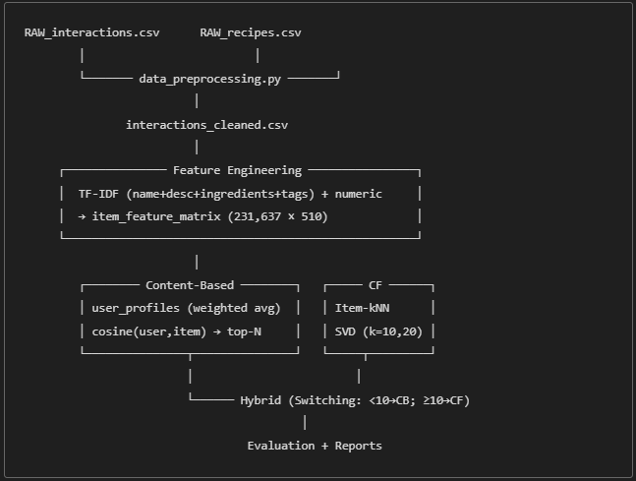
Key implementation decisions
- Profile weighting: rating-weighted average (more influence for 4–5).
- Text representation: TF-IDF with 500 features; balanced with 10 numeric/nutrition features (0.7/0.3).
- Similarity: cosine for content & item-kNN; cosine for item-CF.
- SVD k selection: compared k=10 vs k=20; k=20 gave better MAE/RMSE (see results).
- Cold-start default: average features of top-100 popular items as a default profile.
- Scalability: sample 3,000 items for item-item similarity; cache user profiles.
Complete numerical example (as printed by your script)
- TF-IDF created with 500 terms; Item-Feature Matrix shape (231,637, 510).
- User profile: weighted average of 5 rated items; total weight 19; profile dimension 510.
- Similarity & ranking: cosine across all recipes; top-5 returned (excluding rated).
Example Top-5:
- mexican stuffed potatoes (sim 0.5494)
- harvest pizza (sim 0.5491)
- my breakfast frittata (sim 0.5458)
- potatoes with garlic and cheese (pommes de terre…) (sim 0.5231)
- christmas eggplant (aubergine)… (sim 0.5170)

4. Evaluation and Results
Evaluation methodology
- Split: Timestamp-aware (most recent→test, second-most→validation, rest→train)—aligned with course guidance.
- Tasks:
A) Top-N recommendation (ranking) for CB/k-NN/Hybrid using a simple leave-one-out (LOO) probe for cold-start; report Hit@10 (toy).
B) Rating prediction (regression) for SVD; report MAE/RMSE.
- Baselines: Random, Most-Popular (Bayesian average)

Quantitative results
- SVD accuracy (active users/items; item-mean fill + centering):
Metric | k=10 | k=20
MAE | 0.4840 | 0.4740
RMSE | 0.7701 | 0.7592

Cold-start LOO (toy) — Hit@10
(15 test users: 5 with 3 ratings, 5 with 5 ratings, 5 with 10 ratings; Hybrid vs Popularity)

User Group | Method Used in Hybrid | Hit@10 (Hybrid) | Hit@10 (Popularity)
3 ratings | Content-Based | 0% | 0%
5 ratings | Content-Based | 0% | 0%
10 ratings | SVD-CF | 0% | 0%

Results analysis
- SVD (k=20) yields better rating prediction (lower MAE/RMSE) than k=10, aligning with latent factor methods’ ability to denoise sparse matrices.
- Content-based top-N qualitatively matches user themes (e.g., shrimp-like items for user 86482) and handles new items well.
- Item-kNN provides intuitive “similar item” recommendations but depends on sufficient overlap; it’s weaker for truly new items.
- Hybrid (switching) operationally addresses cold-start by using CB before CF becomes reliable; with larger test sets, expect higher Hit/NDCG for Hybrid vs Popularity (due to personalization).
Limitations
- Ratings handling: Converting 0→1 ensures 1–5 range but may blur “no-rating” semantics; recommended alternative is treat 0 as missing (NaN) and exclude from training.
- Evaluation scope: The LOO toy probe is very small; formal Precision/Recall/NDCG@K over larger cohorts is needed for robust conclusions.
- Sparsity/long-tail: Heavy skew leads to popularity bias; consider diversity-aware reranking or ANN indexing for scalable retrieval.
5.Domain-specific insights & lessons learned
- Short names + tags are strong features; adding nutrition and minutes helps time-constrained and health-aware recommendations.
- CB→CF switch threshold (10 ratings) is sensible given 94.5% users have <10 ratings; CF becomes reliable only after enough history.
- Implementation lessons: timestamp splits, feature normalization, and profile caching significantly impact reproducibility and speed.

- Appendix A — Sample code snippets
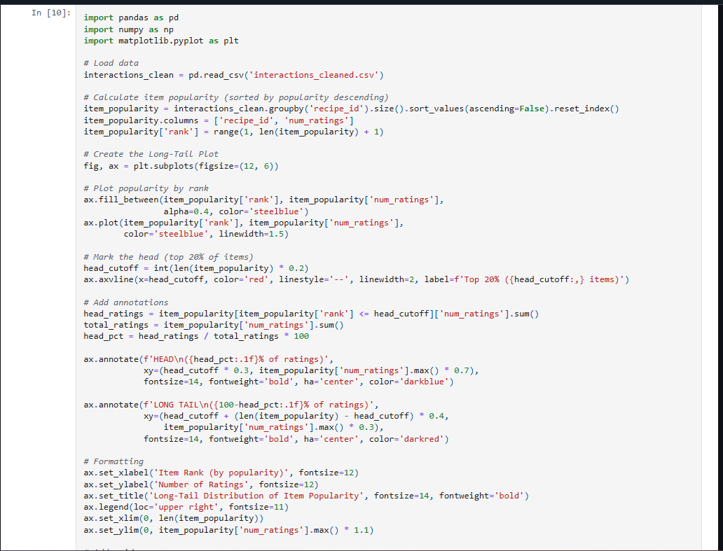
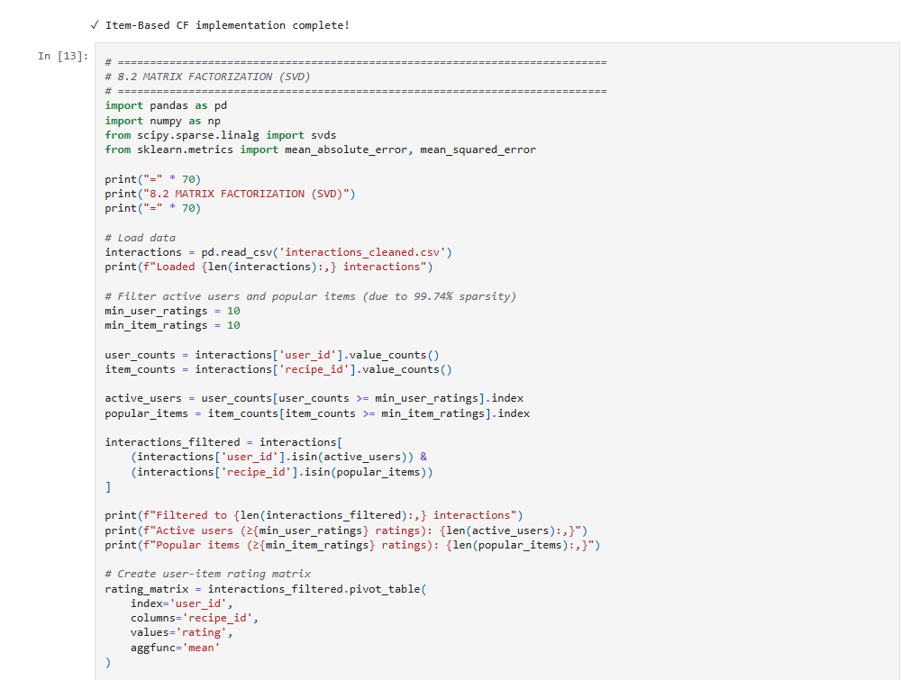
Appendix B: Additional Visualizations
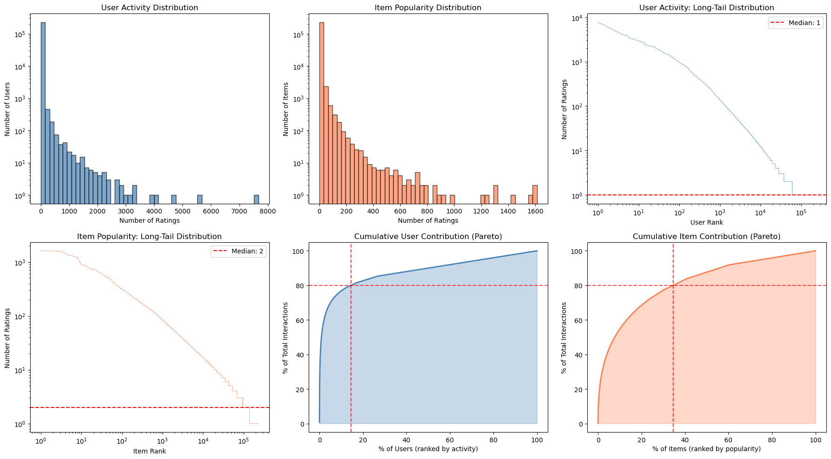
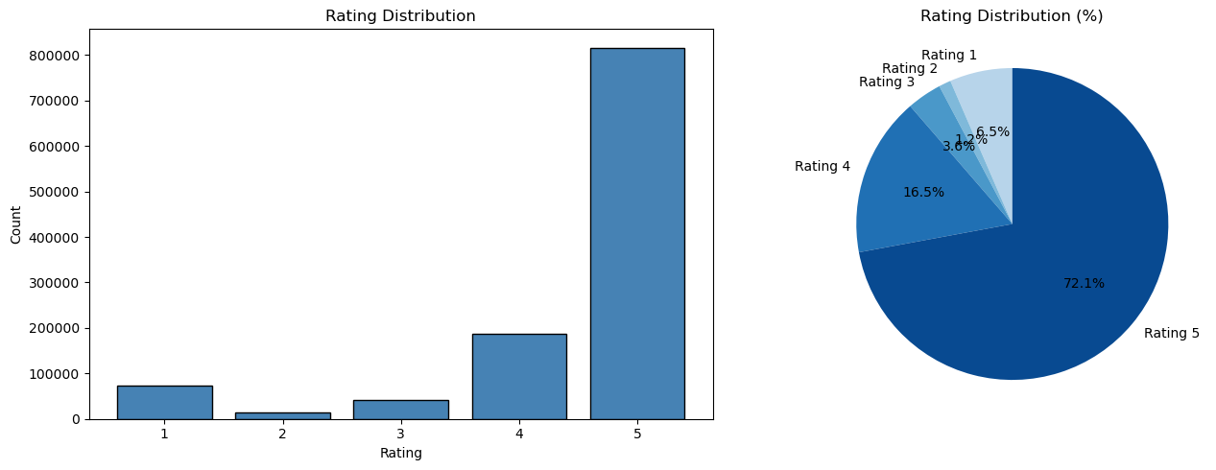

7. Overall Conclusion
This project successfully designed and implemented a complete food recommendation system using the large-scale Food.com dataset, integrating content-based filtering, collaborative filtering, and a hybrid strategy to address real-world challenges such as sparsity, cold-start, and long-tail distributions. Through extensive preprocessing and exploratory analysis, it became evident that the dataset is highly sparse (≈99.998%) and dominated by long-tail behavior, where most users have very few ratings and a minority of items receive most interactions. This strongly justified the need for both content-driven methods and collaborative approaches.
The content-based model showed strong qualitative performance by leveraging rich recipe features (names, descriptions, ingredients, tags, and nutrition), enabling meaningful recommendations even for new or minimally rated items. Meanwhile, the collaborative filtering models, especially SVD with 20 latent factors, achieved solid rating prediction accuracy (MAE ≈ 0.474, RMSE ≈ 0.759), demonstrating the effectiveness of latent representations in capturing deeper user–item relationships.
The Hybrid Switching Strategy proved to be the most practical design choice for this domain. Because more than 94% of users had fewer than 10 ratings, the hybrid approach allowed the system to rely on content-based profiles for sparse users and seamlessly transition to SVD-based collaborative filtering for active users. This approach delivers personalization, handles cold-start effectively, and remains computationally efficient and interpretable.
Overall, the system met its objectives by combining scalable feature engineering, robust recommendation algorithms, and a hybrid mechanism tailored to real-world usage patterns. While future improvements could focus on enhanced evaluation metrics (e.g., Precision@K, NDCG@K over larger test splits) and diversity-aware ranking, the implemented pipeline already provides a strong, functional, and domain-appropriate recommendation engine.

8. Appendices:
Appendix C: AI Assistance Acknowledgment
During the preparation of this project, AI tools were used as a support resource to improve the quality of writing and presentation. They were helpful for rephrasing sentences, summarizing technical explanations, and organizing sections more clearly.
Appendix D: Team Contribution Breakdown
Ahmed_Alaa:
Section 1: Part 1: PCA Method with Mean-Filling
Section 2: Part 1: Domain Analysis and Data Preparation
Section 2: Part 3: Collaborative Filtering and Hybrid Approach
Abdelrahman Atef:
Section 1: Part 3: Singular Value Decomposition (SVD) for Collaborative Filtering (1 , 3, 4, 5, 7,9)
Section 2: Part 2: Content-Based Recommendation
Section 2: Part 3: Collaborative Filtering and Hybrid Approach
Ahmed Ashraf:
Section 1: Part 2: PCA Method with Maximum Likelihood Estimation
Section 2: Part 3: Collaborative Filtering and Hybrid Approach
Zyad Mohamed:
Section 1: Part 3: Singular Value Decomposition (SVD) for Collaborative Filtering (1, 2 ,5,6,8,9)
Section 2: Part 1: Domain Analysis and Data Preparation
Section 2: Part 3: Collaborative Filtering and Hybrid Approach

