
Faculty of Computers & Benha University
Artificial Intelligence

Alzheimer’s Detection with Generative AI
Artificial intelligence, department
Team members
- Ahmed Ashraf Ahmed Alsayed (Leader).
- Ahmed Hussien Shokry Mohammed.
- Ahmed Elsayed Ahmed Hassan.
- Ahmed Elsayed Mahmoud Arafat.
- Abdelrahman Abdo Hassan Ahmed.
- Hani Yasser ElMetwaly Sorour Ahmed.
- Radwa Mohamed Said Abd El- Shafi.
- Shrouk Salama Mahmoud Mohamed.
- Nada Adel Ismael Hussainen Shahin.
Under Supervision of
Dr. Sara Sweidan.
Eng. Sahar Mohamed.

بِسْمِ اللَّهِ الرَّحْمَـٰنِ الرَّحِيم
" وَيَسْأَلُونَكَ عَنِ الرُّوحِ قُلِ الرُّوحُ مِنْ أَمْرِ رَبِّي وَمَا أُوتِيتُمْ مِنَ الْعِلْمِ إِلَّا قَلِيلًا "
صدق الله العظيم

Acknowledgment
The success of any project will not happen without the help of many people around us. First, we thank God for giving us the ability to complete our project, we thank our family, friends, doctors, and instructors that help us to complete the project successfully, we want to thank Specially Dr. Sara Swidan for his encouragement, guidance, patience, and his advice for us that have helped us to help us to achieve the success in our project.

In addition, many thanks go to Eng. Sahar Mohamed and Eng. Ahmed Ashraf for their inspirational thoughts, valuable guidance, and assistance throughout this work and for their patience. Finally, we are very grateful to the many people who helped us with contributions to complete this project. , We thank every person in Banha Faculty of Computer and artificial intelligence who may have helped in the tiniest ways possible in this project as well as along the duration of the educational time in college., We deeply thank our parents and siblings for the support and encouragement along the four years of college time.

Table Of Contents
Chapter 1→ Introduction & Background 10
1. Introduction 10
2. Problem Definition 14
3. Scope Initiation 17
4. Summary 18
Chapter 2 → Analysis and Design 19
1. Introduction 19
2. User and System Requirements 21
2.1 User Requirements 21
2.2 System Requirements 21
2.2.1 Functional Requirements 22
2.2.2 Non – Functional Requirements 23
3. System Design 24
3.1 System Architecture 24
3.2 Use Cases Diagram 25
3.3 Activity Diagrams 26
3.3.1 Login Diagram 26
3.3.2 User Diagram 27
3.3.3 Doctor Diagram 28
3.4 Class Diagrams 29
3.5 Sequence Diagrams 30
3.5.1 User Diagram 30
3.5.2 Doctor Diagram 31
3.6 Gantt chart 32
3.7 Data Flow Diagram (DFD) 33
3.7.1 Context Diagram (Level 0) 33
3.7.2 DFD (Level 1) 34
3.8 State Diagram 35
3.9 Entity Relationship Diagram (ERD) 36
4. Technologies and Tools 37
5. Summary 37
Chapter 3 → Alzheimer’s Model (4 class of Images) Analysis & Visualization 38
1. Libraries 38
2. Dataset Gathering 38
3. Read Data 39
4.1 Data preprocessing 40
4.2 Analyzing & Visualization 40
4.3 Split Data 40
4.5 Data Augmentation 43
5. Model training 45
5.1 CNN 46
5.1.1 CNN build steps. 46
5.1.2 Model Architecture. 47
5.1.4 Training the model. 48
5.1.5 Model Performance 48
5.1.6 Evaluate the Model 49
5.1.7 Model score 50
5.1.8 Model Evaluation 50
5.1.8.1 Confusion Matrix 50
5.1.8.2 Classification Report 50
5.2 VGG16 51
5.2.1 Model Architecture 51
5.2.2 Model Scratch 52
5.2.3 Model Performance 53
5.2.4 Evaluate the Model 54
5.2.5 Model Score 55
5.2.6.1 Confusion Matrix 55
5.2.6.2 Classification Report 55
5.3 DenseNet201 56
5.3.1 Model Architecture 56
5.3.2 Model Scratch 57
5.3.3 Model Performance 58
5.3.4 Evaluate the Model 59
5.3.5 Model Score 60
5.3.6 Model Evaluation 60
5.3.6.1 Confusion Matrix 60
5.3.6.2 Classification Report 60
5.4 ResNet152V2 61
5.4.1 Model Architecture 61
5.4.2 Model Scratch 62
5.4.3 Model Performance 63
5.4.4 Evaluate the Model 64
5.4.5 Model Score 65
5.4.6 Model Evaluation 65
5.4.6.1 Confusion Matrix 65
5.4.6.2 Classification Report 65
5.5 MobileNetV2 66
5.5.1 Model Architecture 66
5.5.2 Model Scratch 67
5.5.3 Model Performance 68
5.5.4 Evaluate the Model 69
5.5.5 Model Score 70
5.5.6 Model Evaluation 70
5.5.6.1 Confusion Matrix 70
5.5.6.2 Classification Report 70
5.6 Model predictions 71
5.7 Summary 72
Chapter 4 → UI Design 73
Chapter 5 → Generative AI Chatbot 81
5.1 Introduction 81
5.2 Libraries 81
5.2 Load Data 81
5.3 Split Data 82
5.4 Model training 82
5.4.1 Transformer 83
5.4.1.1 Text Vectorization 83
5.4.1.2 Positional Embedding 84
5.4.1.3 Scaled Dot-Product Attention 84
5.4.1.4 Causal Masking 85
5.4.1.5 Multi-Head Attention 86
5.4.1.6 Encoder 87
5.4.1.7 Decoder 87
5.4.1.8 Transformer Block for Encoder and Decoder 88
5.4.1.9 Training the Transformer 89
5.4.1.10 Model Evaluation 91
5.4.2 Pre-Trained GPT-2 93
5.4.2.1 Helper Function for GPT-2 93
5.4.2.2 Training GPT-2 95
5.4.2.3 Evaluation GPT-2 96
5.4.2.4 Generation Using Custom GPT-2 96
References 98

List Of Figure
Figure (1) System Architecture 24
Figure (2) Use Cases Diagram 25
Figure (3) Login Diagram 26
Figure (4) User Diagram 27
Figure (5) Doctor Diagram 28
Figure (6) Class Diagrams 29
Figure (7) User Sequence Diagram 30
Figure (8) Doctor Sequence Diagram 31
Figure (9) Gantt chart 32
Figure (10) Context Diagram (Level 0) 33
Figure (11) DFD (Level 1) 34
Figure (12) State Diagram 35
Figure (13) ERD 36
Figure (14) Machine Learning Process 38
Figure (15) Train Data 41
Figure (16) Test Data 42
Figure (17) Validation Data 42
Figure (18) Data Visualization 44
Figure (19) CNN Model 46
Figure (20) CNN Model Scratch 47
Figure (21) CNN Evaluation 49
Figure (22) CNN Confusion Matrix 50
Figure (23) VGG16 Model 51
Figure (24) VGG16 Model Scratch 52
Figure (25) VGG16 Evaluation 54
Figure (26) VGG16 Confusion Matrix 55
Figure (27) DenseNet201 Model 56
Figure (28) DenseNet201 Model Scratch 57
Figure (29) DenseNet201 Evaluation 59
Figure (30) DenseNet201 Confusion Matrix 60
Figure (31) ResNet152V2 Model 61
Figure (32) ResNet152V2 Model Scratch 62
Figure (33) ResNet152V2 Evaluation 64
Figure (34) ResNet152V2 Confusion Matrix 65
Figure (35) MobileNetV2 Model 66
Figure (36) Model Scratch 67
Figure (37) MobileNetV2 Evaluation 69
Figure (38) MobileNetV2 Confusion Matrix 70
Figure (39) Model predictions. 71
Figure (40) Models Summary 72
Figure (41) Transformer Data Split 82
Figure (42) Transformer Block 88
Figure (43) Training the Transformer 90
Figure (44) Training GPT-2 95

Chapter 1→ Introduction & Background
- Introduction
Alzheimer's disease (AD), named after the German psychiatrist and neuropathologist Alois Alzheimer who first described it in 1906, is a progressive neurodegenerative disorder characterized by cognitive decline and memory impairment. It is the most common cause of dementia, contributing to approximately 60-70% of all cases.
The disease typically begins with subtle memory problems, such as difficulty remembering recent events or conversations, and progresses over time, affecting various cognitive functions including language, reasoning, and judgment. As the condition advances, individuals may experience disorientation, mood swings, changes in behavior, and difficulty performing everyday tasks. In the later stages, individuals may lose the ability to recognize loved ones, communicate effectively, and care for themselves.
The underlying cause of Alzheimer's disease is not fully understood, but it is believed to involve a complex interplay of genetic, environmental, and lifestyle factors. Pathologically, Alzheimer's is characterized by the accumulation of abnormal protein deposits in the brain, namely beta-amyloid plaques and tau tangles, which lead to the destruction of nerve cells and disruption of neural communication.
Currently, there is no cure for Alzheimer's disease, and available treatments aim to alleviate symptoms and slow down disease progression. Research into potential treatments and preventive strategies continues, driven by the urgent need to address the growing impact of Alzheimer's on individuals, families, and society as a whole.

1.1 Background
A major cause of Alzheimer's disease has not yet been identified, but there are some factors that increase the risk of developing it, including the following:
- Age, where the risk of developing the disease increases with age, as most people with this disease are over 65 years old.
- Family history, the risk of Alzheimer's increases if a person's family member has the disease.
- Genes, where some genes have been linked to causing Alzheimer's disease.
- Other factors, such as head injuries, heart health and related diseases, increase the risk of Alzheimer's disease in people with health conditions that cause damage to the heart or blood vessels, such as strokes, high blood pressure, diabetes, and others.
The course of the disease is divided into three stages, with a progressive pattern of cognitive and functional impairment.
Early stage: Mild symptoms.
The early stage of Alzheimer's disease begins with mild symptoms such as memory loss and mental confusion. During this period, a person may have difficulty remembering newly acquired information, and may make mistakes in puzzles and games in which they were previously successful. Sometimes they may lose some objects in their environment or at home and have difficulty finding them.
These symptoms, which do not affect a person's daily life, are usually noticed by their inner circle. At this stage, the person can still do their job in daily life and live a normal life. However, more severe symptoms may appear if the disease is not diagnosed during this period. Family doctors or neurologists are usually the first to be visited because of mild symptoms.
The diagnosis of the disease in the early stage is usually made using a series of tests and imaging methods. These tests include cognitive tests, neuropsychological tests, and imaging tests such as magnetic resonance imaging (MRI).
Middle stage: Symptoms that affect daily life.
The middle stage of Alzheimer's disease is characterized by memory loss and severe loss of cognitive abilities. At this stage, symptoms that affect a person's daily life begin to appear and they may lose their independence. A person may forget the names of people they know, have trouble remembering places in their immediate surroundings, and have difficulty performing simple tasks they've done before.
Cognitive and emotional difficulties in a person increase in the middle stage. A person may have serious difficulties understanding and communication and may have difficulty understanding speech. Changes in personality and behavior can be observed due to changes occurring in a person's mind. For example, a person may be moody, irritable, or anxious.
In the intermediate stage, the disease is diagnosed and medical support is sought. Treatment is carried out to slow the progression of the disease and a specific care plan is prepared for the patient. Patients during this stage need more help and their caregivers need a plan as well.
Advanced stage: the condition that needs care.
The advanced stage of Alzheimer's disease leads to a person being completely dependent on others. At this stage, he develops severe symptoms such as severe memory loss, language impairment, and walking difficulties. A person becomes having difficulty performing activities of daily living and needs full-time care and support.
As the symptoms of the disease increase in the advanced stage, personal and behavioral changes increase significantly. Patients may become more anxious or afraid. Speech and communication skills may also be affected, and the patient may be completely dependent on caregivers for daily activities and personal care.
Because the patient is now completely dependent on others, home care may not be possible, and the patient may need to be transferred to a specialized care center for care. These care centers provide specialized services provided by healthcare professionals, specialists in daily activities and personal care of patients.
As of my last update in January 2022, global statistics for Alzheimer's disease may vary based on different sources and methodologies used for data collection. However, I can provide some general information:
Prevalence: Alzheimer's disease and other dementias are significant public health concerns globally, with millions of people affected. According to estimates from the World Health Organization (WHO), there were approximately 50 million people worldwide living with dementia in 2019, with Alzheimer's disease being the most common cause of dementia. This number is expected to increase significantly in the coming years due to aging populations and other factors.
Future Projections: With population aging and increasing life expectancy, the prevalence of Alzheimer's disease is projected to rise substantially in the coming decades. Some projections suggest that the number of people living with dementia worldwide could reach 152 million by 2050 if no effective interventions are implemented to prevent or slow the progression of the disease.

- Problem Definition
Alzheimer's disease entails progressive cognitive decline, memory loss, and daily function impairment, imposing emotional, financial burdens, and global healthcare challenges, necessitating early detection, effective treatment, and support.

2.1 The Importance of This Problem
The problem of Alzheimer's disease is of paramount importance due to its devastating impact on individuals and society. Alzheimer's patients face progressive cognitive decline, impacting memory, reasoning, and daily functioning. As the disease advances, patients require increasing levels of care, often placing strain on families and caregivers. Alzheimer's disease is the leading cause of dementia, affecting millions worldwide. It poses significant challenges to healthcare systems, requiring specialized resources for diagnosis, treatment, and support.
The emotional toll on patients and their loved ones is profound, as cherished memories and relationships fade away. Addressing Alzheimer's is essential for preserving quality of life and dignity for affected individuals. Research into prevention, early detection, and effective treatments is critical to combatting this growing public health crisis. Supporting Alzheimer's patients and their families is crucial for ensuring compassionate care and support throughout the disease journey.

2.2 The Current Solutions
This is a sample of some applications that help Alzheimer's patients:
- Memory Stimulation Apps:
    - My Reef 3D: Interactive game with virtual fish to improve memory.
    - Reminiscence: Displays pictures from the past to stimulate memories.
    - Lumosity: Training games to enhance memory and cognitive skills.
- Communication Apps:
    - Timeless: User-friendly app for remembering events and staying connected with family and friends.
    - Talking Point: Communication platform for Alzheimer's patients and their families.
    - Ava: Writing and speech assistance app to aid communication.
- Daily Assistance Apps:
    - Caregiver Smart: Smart assistant for caregivers of Alzheimer's patients.
    - Medisafe: App to remind patients to take their medication.
    - WanderSafe: GPS tracking system to prevent patients from wandering off.
- Diagnostic Apps:
    - SimBrain: Brain imaging analysis tool for early detection of Alzheimer's signs.
    - Akili Interactive: Interactive games to assess cognitive abilities.
    - Cogito: Digital tests for diagnosing Alzheimer's disease.
- Other Apps:
    - HappyNeuron: Training games to stimulate cognitive functions.
    - BrainHQ: Games and activities to improve memory and focus.
    - Pzizz: Music and soundscapes to enhance sleep.

2.3 Project Objectives
The primary objective of this project is to leverage state-of-the-art Deep Learning methodologies for the purpose of medical image analysis, focusing on the precise detection of Alzheimer's disease. By employing advanced neural network architectures, we aim to develop a robust diagnostic tool capable of accurately identifying the presence of Alzheimer's pathology within medical imaging data.
In addition to the deployment of Deep Learning models, we propose the integration of a Generative model component into our framework. This Generative model serves a dual purpose: firstly, to corroborate the findings of disease detection through the synthesis of supplementary visual data, thus enhancing the reliability of diagnostic outcomes. Secondly, the Generative model serves to mitigate patient anxiety and stress associated with medical examinations by providing personalized, visually coherent representations of diagnostic results.
The utilization of cutting-edge Deep Learning techniques underscores our commitment to achieving high levels of accuracy and reliability in disease detection within medical imaging contexts. Through rigorous model training and validation processes, we endeavor to establish a robust and clinically viable tool for Alzheimer's diagnosis, with the potential for broader applications in medical image analysis.
Furthermore, the incorporation of a Generative model component reflects our holistic approach to addressing not only diagnostic accuracy but also patient-centered care. By prioritizing the reduction of patient stress and anxiety through innovative technological solutions, we aim to enhance the overall patient experience within the realm of medical imaging diagnostics.
The interdisciplinary nature of this project necessitates collaboration between experts in Deep Learning, medical imaging, and healthcare. Through close collaboration and knowledge exchange, we aim to leverage the collective expertise of diverse stakeholders to drive meaningful advancements in Alzheimer's disease detection and patient care.
Our project adheres to the highest standards of ethical conduct and data privacy, ensuring that patient confidentiality and consent are paramount throughout all stages of research and development. By upholding these principles, we demonstrate our commitment to responsible innovation and the well-being of patients and individuals involved in our study.
- Scope Initiation
Our project's scope focuses on assisting individuals aged 50 to 85 who are in the early and middle stages of Alzheimer's disease. With a primary aim to support both patients and healthcare providers, our initiative serves as a crucial assistant to doctors in diagnosing and managing the disease.
Through innovative technologies and tailored interventions, we aim to help patients refresh their memory and enhance cognitive function, thereby improving their quality of life. By targeting this specific demographic, we acknowledge the critical need for early intervention and support in Alzheimer's care.
Our scope encompasses the development of assistive tools and applications that aid healthcare professionals in accurate diagnosis and personalized treatment planning. Additionally, we aim to empower patients by providing them with accessible resources and support systems to navigate their journey with Alzheimer's disease.
By focusing on the early and middle stages of the disease, we aim to intervene at a crucial juncture where timely assistance can significantly impact disease progression and patient outcomes. Through collaborative efforts with medical experts and caregivers, we aspire to optimize care delivery and enhance patient well-being.
Our scope initiation emphasizes a holistic approach to Alzheimer's disease management, encompassing medical, psychological, and social aspects of care. By addressing the needs of both patients and healthcare providers, we aim to foster a supportive ecosystem that promotes early detection, effective intervention, and improved outcomes for individuals living with Alzheimer's disease.
- Summary
Now we have finished the first chapter of our project, which helped us understand and know all the information on which the project is based, starting with a clear and concise introduction to Alzheimer's disease (AD), its progressive nature, and its crippling effects on memory and thought. It emphasizes the significant impact on millions globally, highlighting the lack of a cure and the urgency for solutions.
The chapter acknowledges the existing efforts in supporting patients and caregivers, outlining various applications that assist with memory stimulation, communication, and daily tasks. However, it recognizes the limitations of these solutions and paves the way for our innovative project.
This section introduces our ambitious project utilizing cutting-edge Deep Learning for precise AD detection through medical image analysis. It goes beyond mere diagnosis, incorporating a Generative AI component to create personalized visualizations for patient comfort and understanding.
Our focus isn't solely on technology; it's about people. We target the crucial early and middle stages, empowering both patients and healthcare providers with personalized tools and plans. Collaboration and ethical considerations are paramount as we strive for a holistic approach encompassing medical, psychological, and social aspects of care.

Chapter 2 → Analysis and Design
- Introduction
Analysis is defined as the process of identifying problems and organizing the facts and details of a system. Analysis can also be described as the careful breakdown of a system into its organized components or parts. This process helps you to know the ins and outs of the system. It is important to know what works with what, what makes something work or fail, and what can work independently.
Importance of analysis:
Analysis is important because it provides a means to the solutions in the system through the various tasks involved in performing the analysis graphs. Through these various tasks, which makes it easy to implement the project because it serves as a map of everything that is involved in the project and the overall quality of the system can be easily modified or improved, and the occurrence of errors can be reduced in the end.

There are a set of procedures and steps to create this analysis summarized as follows:
1. Determinations of requirements: We prepare user and system requirements and have 2 types:
    - Functional requirements
    - Non – functional requirements
2. Stack holders: Determine the people who benefit or are interested in the project such as:
- Doctors
- Users (Patients)

3. System Design: It consists of a set of Diagrams that describe the entire project and a working mechanism such as:
- System Architecture
- Use Cases
- Activity Diagram
- Class Diagram
- Sequence Diagrams
- Database Design
4. Application of the system
5. System evaluation (as we will see in next chapter)
6. Modify the system (as we will see in next chapter)

2. User and System Requirements

2.1 User Requirements
User requirements are just what the name implies. They are requirements set by the end user. These requirements express how an application should perform in terms of the functions to be done. User requirements provide information that serves as the basis for further specification and design.
User Requirements
contains a model that detection Alzheimer's disease
contains intelligent chat for Alzheimer's.
Provides a lot of tests besides chatting to diagnose the patient's condition.
Provides a list of histories containing all test results.
Be easy, simple, and understandable for all age groups.
Provide the possibility communicate with a specialized doctor if necessary.

2.2 System Requirements
The requirements that specify criteria that can be used to judge that the system operates as expected.

2.2.1 Functional Requirements
Requirements | Description
User authentication | An application for users to log in and register, either through an email and password combination.
Alzheimer's detection interface | Interface for users for Alzheimer's classification. This should be intuitive and easy to use.
Chat interface | A chat interface for users to communicate with the chatbot. This should be intuitive and easy to use.
Natural Language Processing (NLP) and understanding | A chatbot must be able to understand user input and respond to it in a conversational manner, and chatbot must be able to track the context of a conversation and provide relevant responses.
Personalized recommendations | Based on the user's assessment, the chatbot should be able to provide personalized recommendations for self-care, therapy, and other mental health resources.
Notification system | The system should have a notification system to alert users about scheduled assessments, follow-ups, or important information related to Alzheimer's detection and care.

2.2.2 Non – Functional Requirements
Requirements | Description
Response Time | The system should provide quick responses to user inputs, with a maximum response time of X seconds for both the chat interface and Alzheimer's detection interface.
Usability | for both the generative model and Alzheimer's detection model must be user-friendly and provide a smooth and intuitive experience for users.
Maintainability | for both the generative model and Alzheimer's detection model must be easy to maintain and upgrade as necessary.
Reliability | The application should be reliable and available, so users can access support whenever they need it.
Scalability | Design the system to handle a growing user base by ensuring scalability. The generative and detection models should be scalable to accommodate larger datasets and evolving requirements.
Security | Ensure that all sensitive data, especially health-related information, is encrypted.

3. System Design
It consists of a set of Diagrams that describe the entire project and a working mechanism.

3.1 System Architecture
A system architecture is the Conceptual model that defines the structure, behavior, and more views of a system. An architecture description is a formal description and representation of a system, organized in a way that supports reasoning about the structures and behaviors of the system.
- Diagram in Figure (1) describes the structure of the system and all the functions.
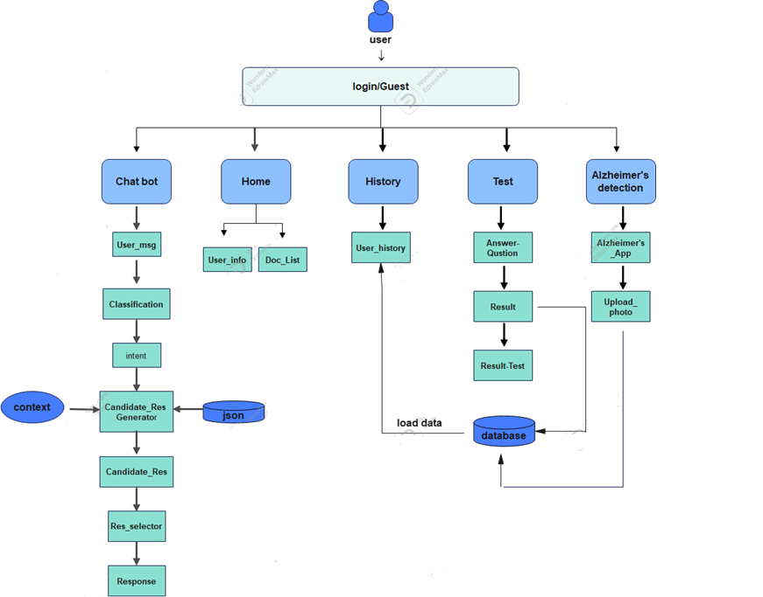
Figure (1) System Architecture

3.2 Use Cases Diagram
The Use Case in Figure (2) contains three actors User, Doctor, and AI Doctor, each actor has some of the process he performs, such as that the User can login and chose a doctor and the talk with the Chabot. And that the Doctor can login and be responsible for choosing the date for patients.

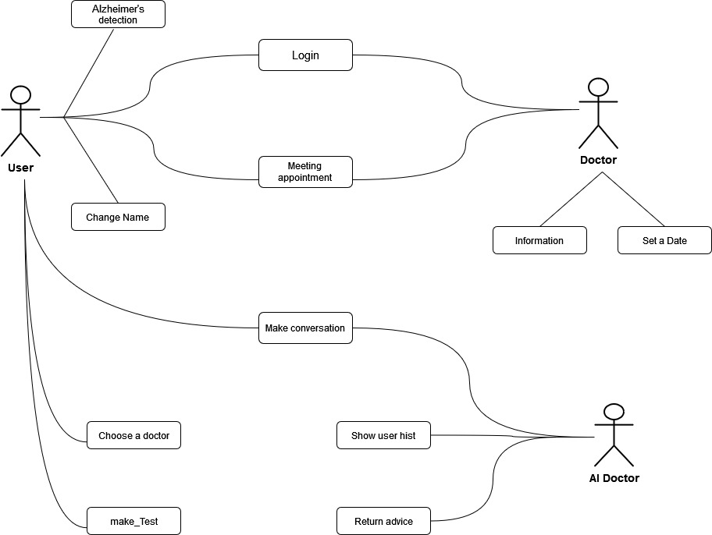
Figure (2) Use Cases Diagram

3.3 Activity Diagrams

The Activity Diagram in Figure (3), Figure (4), and Figure (5) explains the operations that are carried out on each process, and I see the validation, the powers, and how the system will work, In the case of success, one thing is done, and in case of failure, another thing is done.

3.3.1 Login Diagram

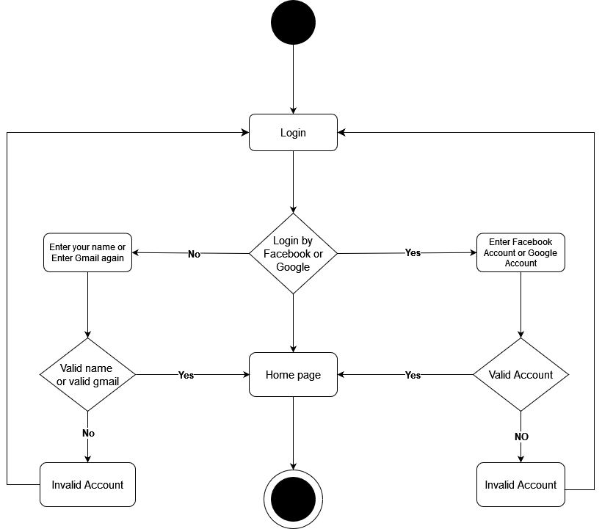
Figure (3) Login Diagram

3.3.2 User Diagram

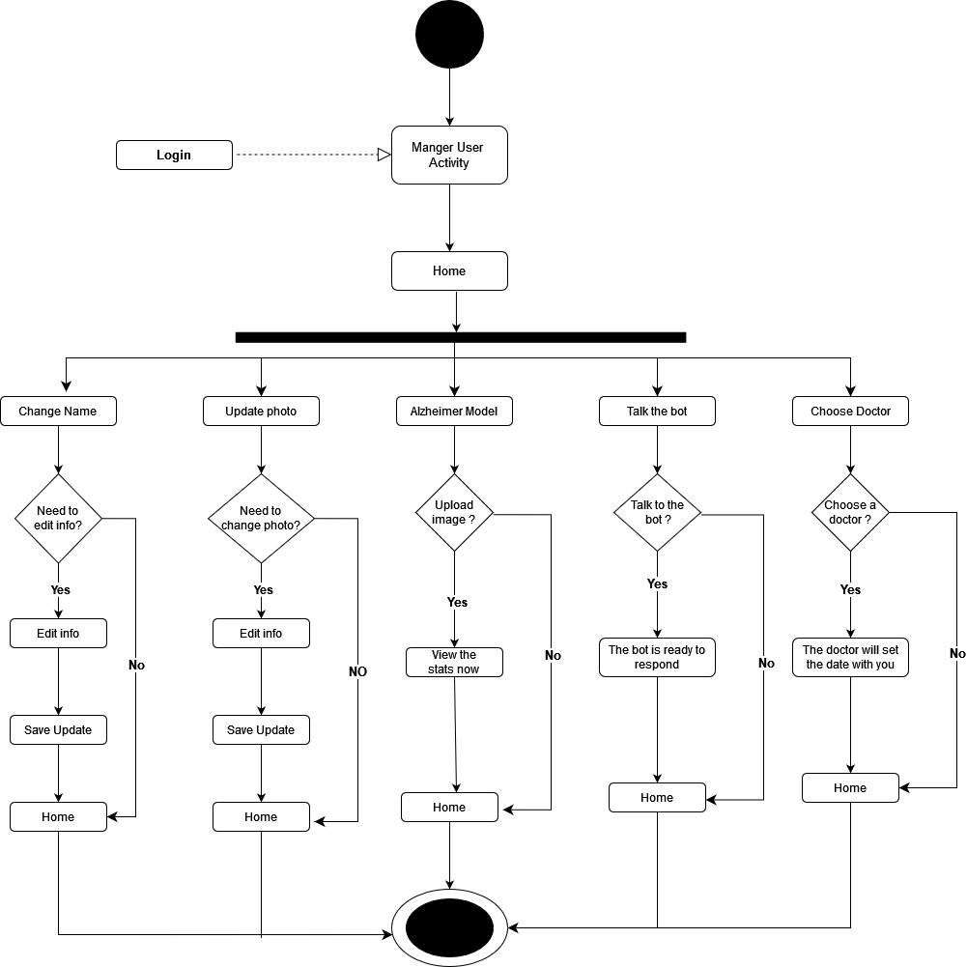
Figure (4) User Diagram

3.3.3 Doctor Diagram
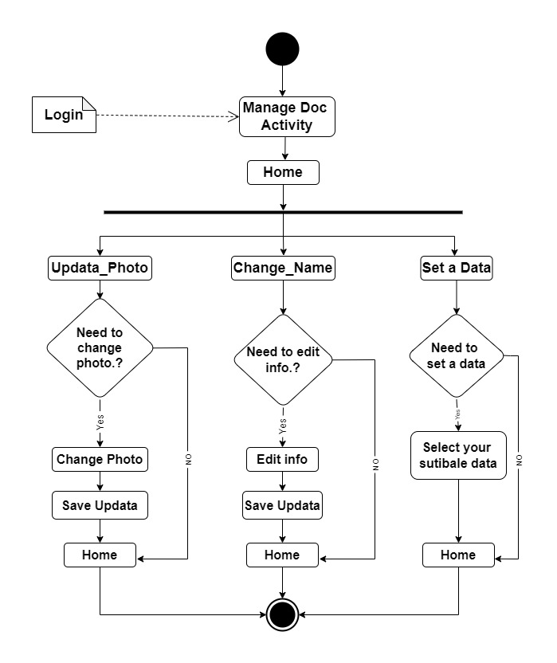
Figure (5) Doctor Diagram

3.4 Class Diagrams

The Class Diagram in Figure (6) is the one that describes the classes that the database, is a type of static structure diagram that describes the structure of a system by showing the system's classes, their attributes, operations (and methods), and the relationships among objects.

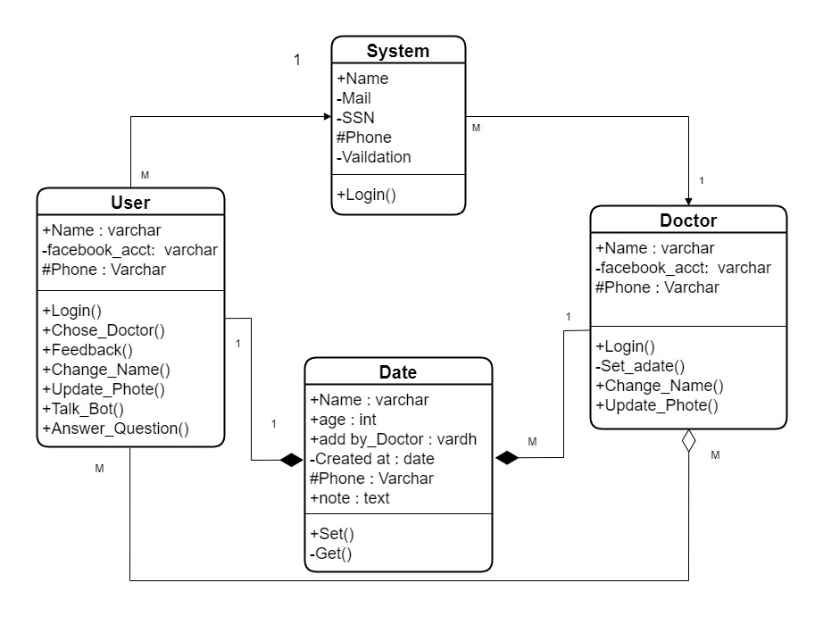Figure (6) Class Diagrams

3.5 Sequence Diagrams
Sequence diagram, in Figure (7), Figure (8), which is that I see processes behind each other for each action process that happens to it, and this will have a complete and comprehensive description of any activity that occurs in the system. They capture the interaction between objects in the context of a collaboration. Sequence Diagrams are time focus and they show the order of the interaction visually by using the vertical axis of the diagram to represent time what messages are sent and when.

3.5.1 User Diagram

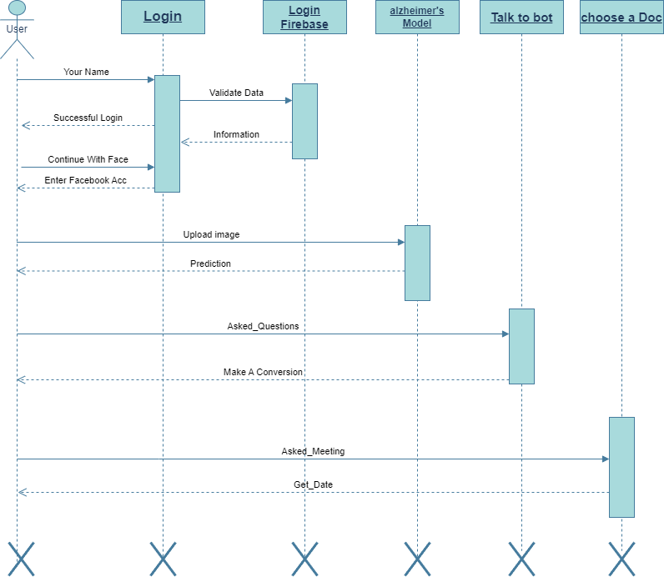
Figure (7) User Sequence Diagram

3.5.2 Doctor Diagram

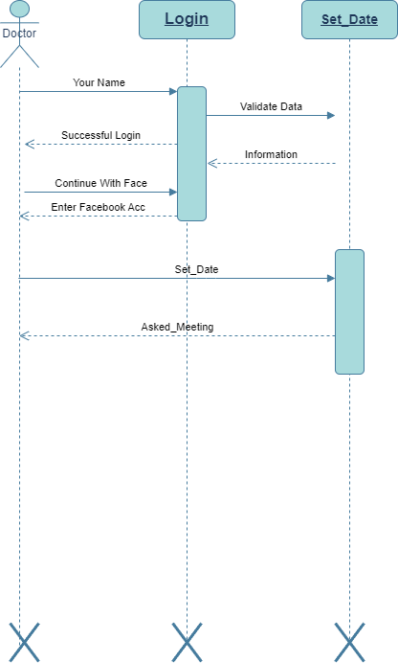
Figure (8) Doctor Sequence Diagram

3.6 Gantt chart
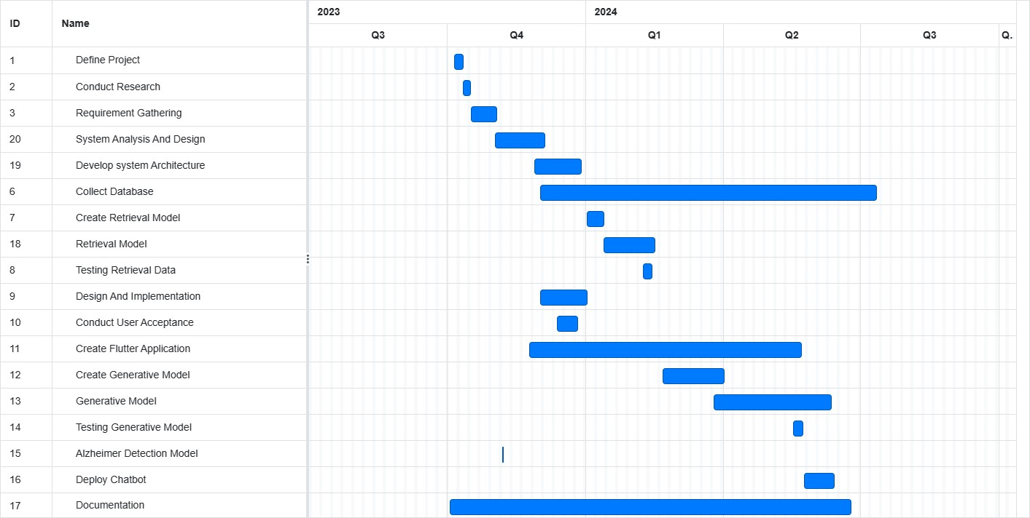
Figure (9) Gantt chart

3.7 Data Flow Diagram (DFD)

Can be divided into logical and physical. The logical data flow diagram describes a flow of data through a system to perform certain functionality of a business. The physical data flow diagram describes the implementation of the logical data flow.

3.7.1 Context Diagram (Level 0)
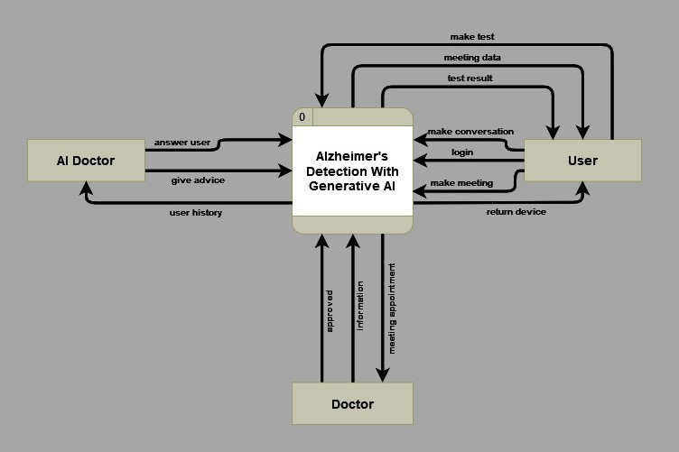
Figure (10) Context Diagram (Level 0)
"Data flow diagrams (DFDs) serve as visual representations depicting the intricate flow of data within a business information system. In the context of an Alzheimer's detection model empowered by generative AI, DFDs outline the processes involved in transferring, analyzing, and interpreting data, from initial input through various stages, ultimately culminating in the identification and reporting of potential markers for Alzheimer's disease."

3.7.2 DFD (Level 1)
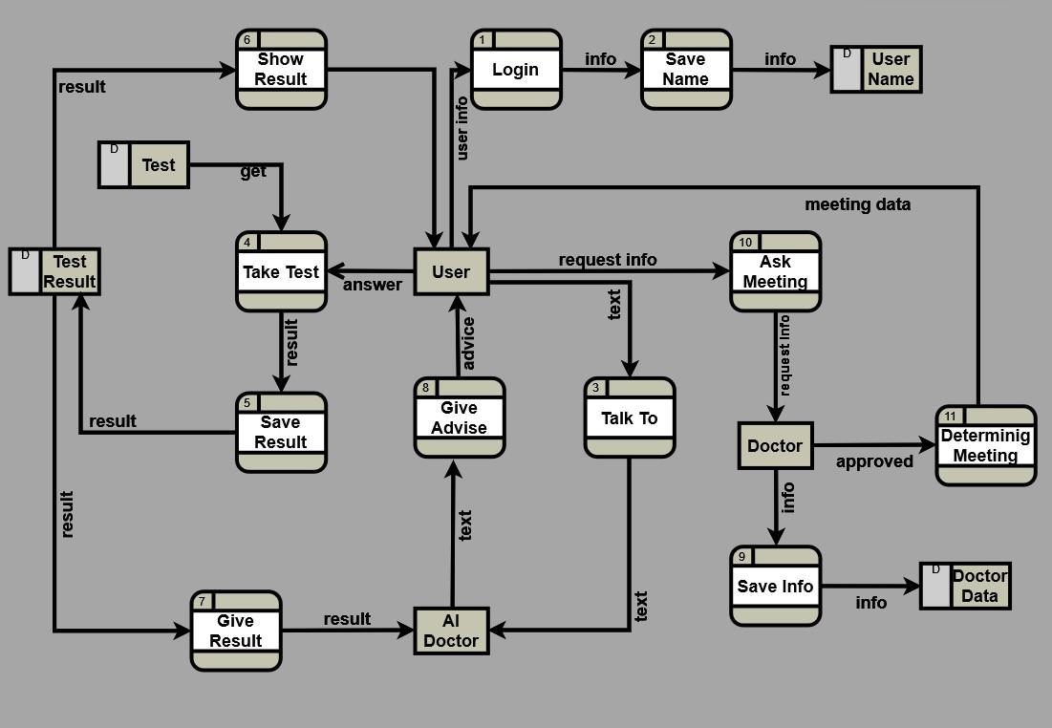
Figure (11) DFD (Level 1)

3.8 State Diagram

State Diagrams in Figure (12) is a type of diagram used in computer science and related fields to describe the behavior of systems. State diagrams require that the system described is composed of a finite number of states; sometimes, this is indeed the case, while at other times this is a reasonable abstraction. Many forms of state diagrams exist, which differ slightly and have different semantics.
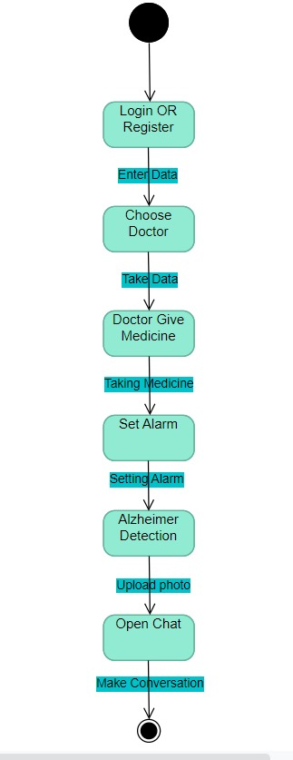
Figure (12) State Diagram

3.9 Entity Relationship Diagram (ERD)
ERD (Entity-Relationship Diagram) in Figure (13) is a visual representation of entities and their relationships to each other. It is used to describe the data and relationships between entities in a database or application. An ERD represents Users, Tests questions, Answer Tests, Topic, and Results entities. These entities have relationships with each other such as a User taking a test question, or a User having many Results. The ERD also shows the attributes and data types of each entity, such as the User's name and email.

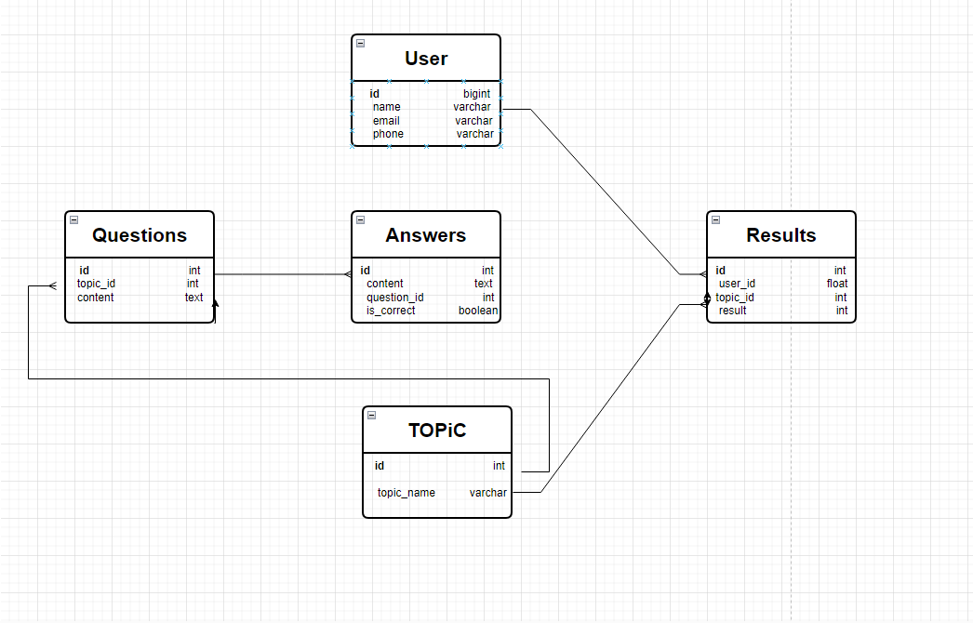
Figure (13) ERD

4. Technologies and Tools
Tools
Programming language (Python)
Machine Learning (ML)
Deep Learning (DL)
Natural Language Processing (NLP)
Natural Language Understanding (NLU)
Mobile Development
Flask
Firebase and local database

5. Summary
In this chapter We talk about the complete analysis of all the functions that the application performs, and this analysis is represented in a set of diagrams that in turn make it easier for us to understand and implement the project and the ease of modification to it. Each diagram is different from the rest and represents the functions and how the application performs them in a sequential manner. We also know who the owners are the interest of that application, which is the doctor, the user, and the enabler of the developer because he has an interest because of the return on him from using the application. One of the most important parts in this chapter is knowing the requirements of this project, which is represented in the required functions that the project or application does not exist except in their presence and non-required functions. Also, we have become fully aware of the requirements of both the user and the system requirements as well.

Chapter 3 → Alzheimer’s Model (4 class of Images) Analysis & Visualization
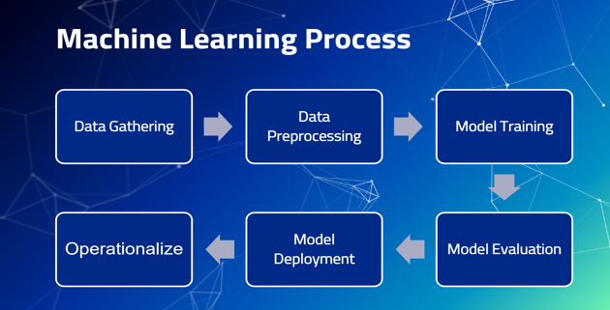
Figure (14) Machine Learning Process

1. Libraries
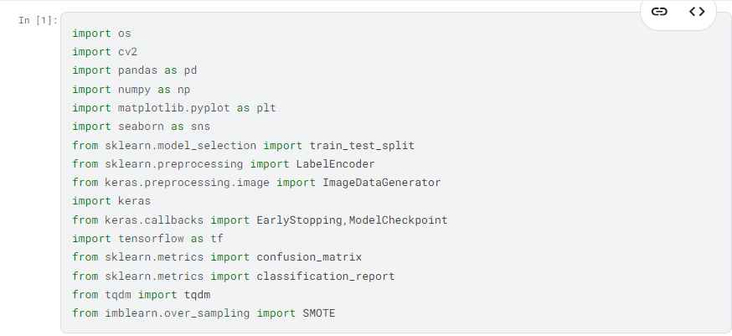

2. Dataset Gathering
-This data show four classes: -
1- Alzheimer’s disease
2- Cognitively normal
3- Early mild cognitive impairment
4- Late mild cognitive impairment
-The data consists of two columns: -
• images
• labels

3. Read Data
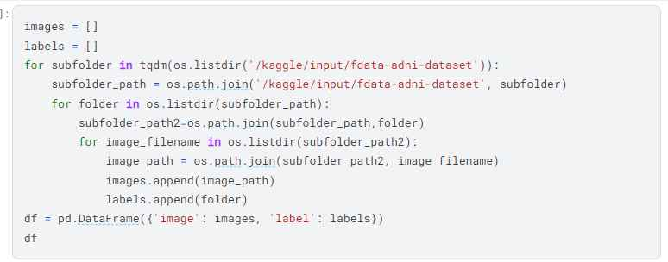
-Show Data Frame: -
A Data Frame is a two-dimensional, tabular data structure commonly used in data analysis and statistics.
-Found 33984 validated image filenames belonging to 4 classes.
-We have in our data 33984 rows and 2 columns as shown in the figure below.
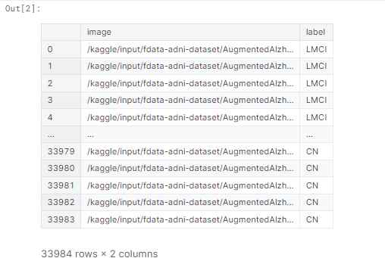
]4. Visualization & Analysis of Dataset (data preprocessing)

4.1 Data preprocessing
Data preprocessing is a crucial step in the data analysis and machine learning pipeline. It involves cleaning and transforming raw data into a format that is suitable for analysis or model training.

4.2 Analyzing & Visualization
- The Number of Samples for Each Class:
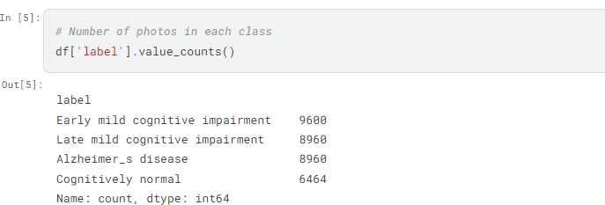

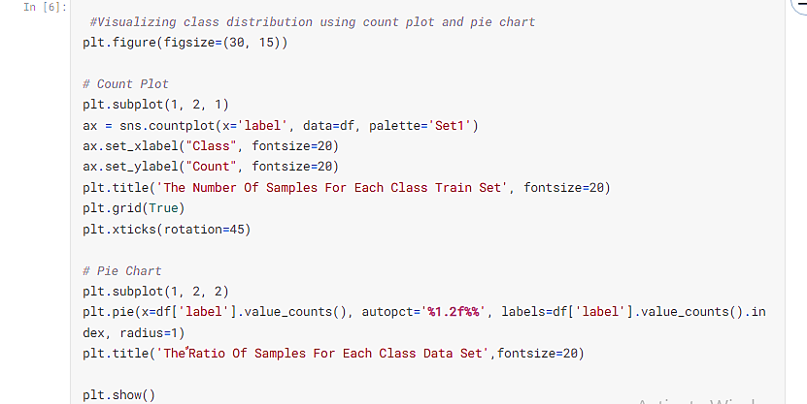
4.3 Split Data
- 80% train
- 10% test
- 10% validation
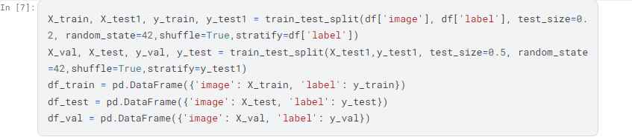
4.3.1 In Train
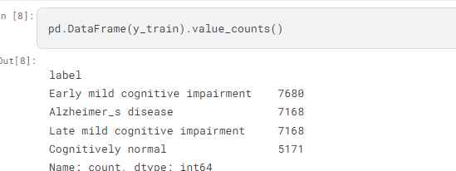

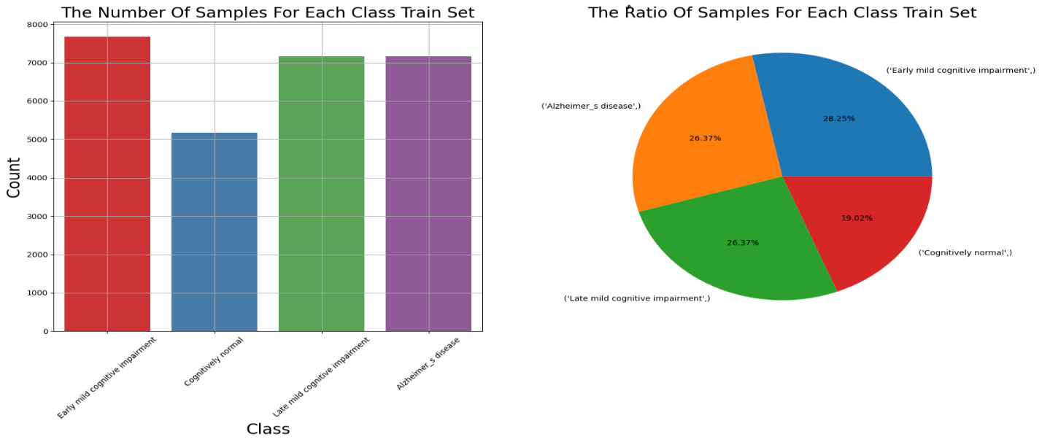
Figure (15) Train Data

4.3.2 In Test
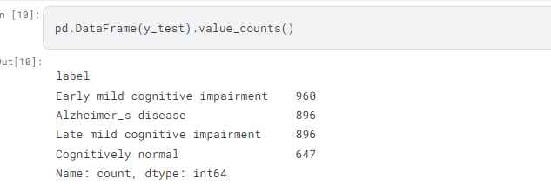

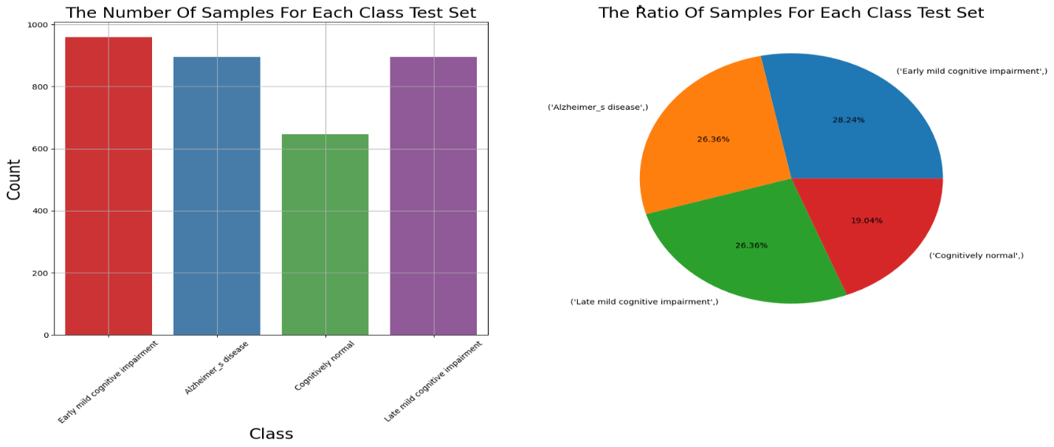
Figure (16) Test Data

4.3.3 In Validation

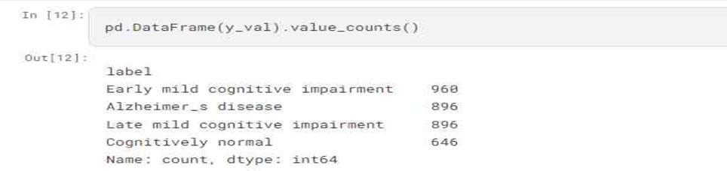
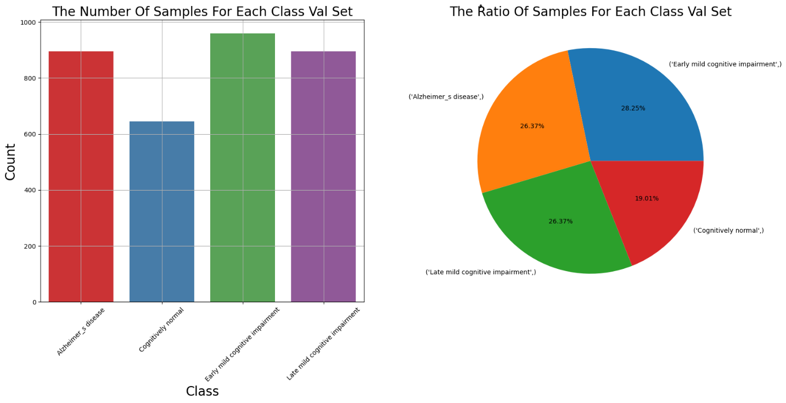
Figure (17) Validation Data

4.5 Data Augmentation
Data augmentation is a technique commonly used in machine learning and deep learning to artificially increase the size of a training dataset by applying various transformations to the existing data. Common image augmentations include:
- Rotation
- Flip (horizontal and vertical)
- Zooming
- Scaling
- Cropping (etc.)
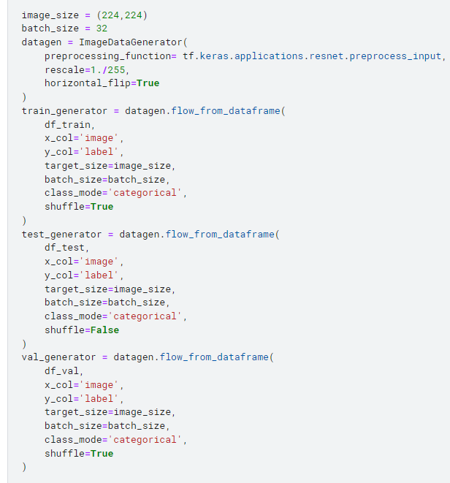
Now we show four classes an image: -
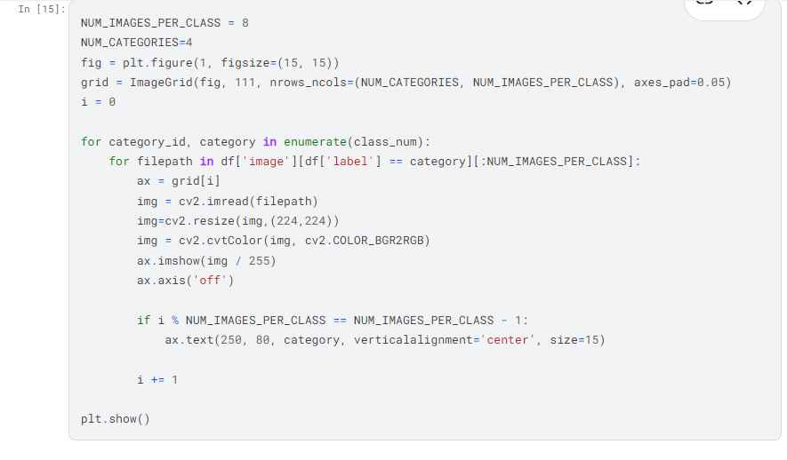

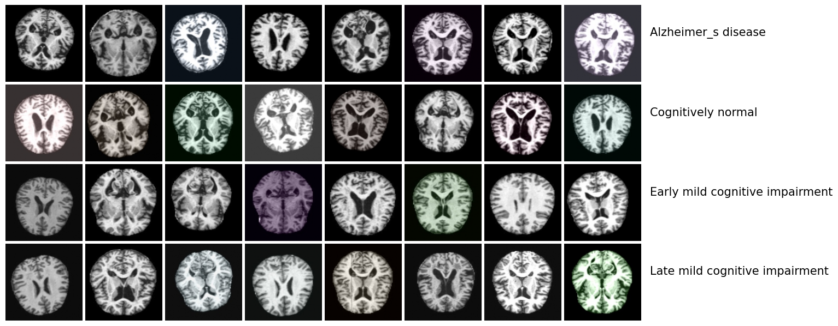
Figure (18) Data Visualization

5. Model training

Convolutional Neural Networks (CNNs) revolutionize medical imaging, offering swift and accurate disease diagnosis, even in emergency situations lacking human expertise. By analyzing X-ray images, CNNs efficiently detect and classify diseases like Alzheimer's, reducing diagnostic errors and saving valuable time. Traditional diagnostic methods, often time-consuming and exhausting for professionals, are replaced by CNNs, enhancing efficiency and precision in medical image classification. This advancement in artificial intelligence, particularly in deep learning algorithms like CNNs, transforms disease diagnosis by enabling rapid and precise identification of abnormalities, ultimately improving patient outcomes, and saving lives.

We Use Four Models
- Convolutional Neural Network (CNN).
- ResNet152V2
- VGG16
- DenseNet201
- MobileNetV2

5.1 CNN
A convolutional neural network (CNN) is a powerful type of deep learning for image processing often used in computer vision that includes image and video recognition. CNN consists of a set of layers, namely, the input layer, the output layer, and a hidden layer consisting of multiple convolutional layers, pooling layers, and fully connected layers. These layers will be explained in the following:
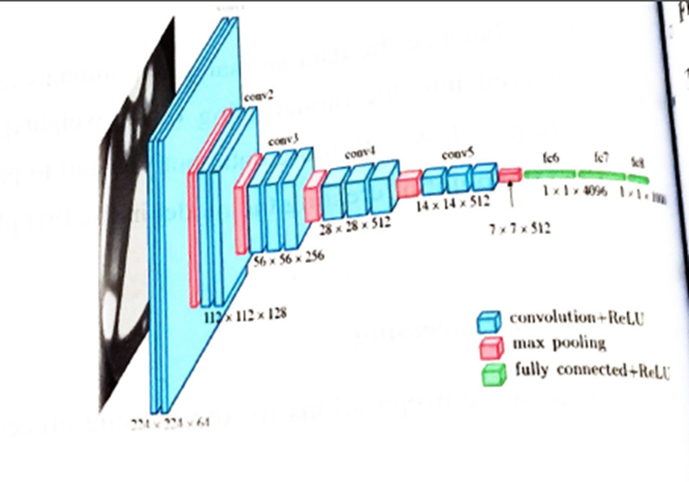

Figure (19) CNN Model

5.1.1 CNN build steps.
- Using Keres Libraries
  - Initialize the CNN
  - Add a convolutional layer.
  - Pooling operation
  - Add more convolutional layers.
  - Flattening operation
  - Fully connected layer
  - Output layer (SoftMax)

5.1.2 Model Architecture.
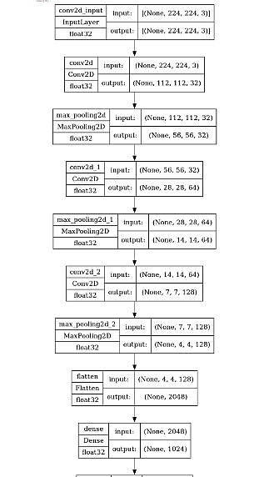
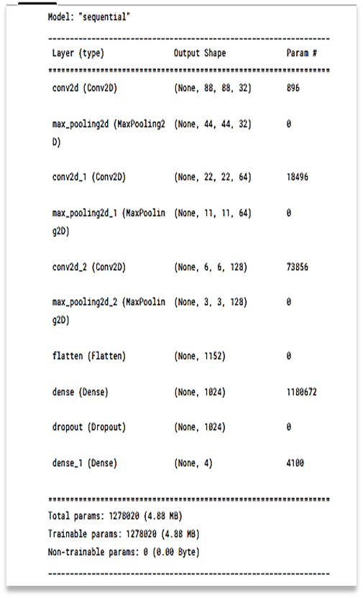
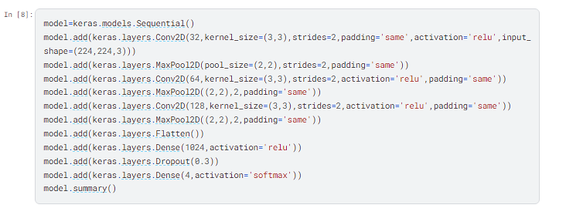5.1.3 Model Scratch.
Figure (20) CNN Model Scratch

5.1.4 Training the model.
Now, let's discuss training and evaluation of the Convolutional neural network. We will be discussing this section in 3 steps:
- The Compile models.
- Fit model on training set
- Evaluate Result

5.1.5 Model Performance
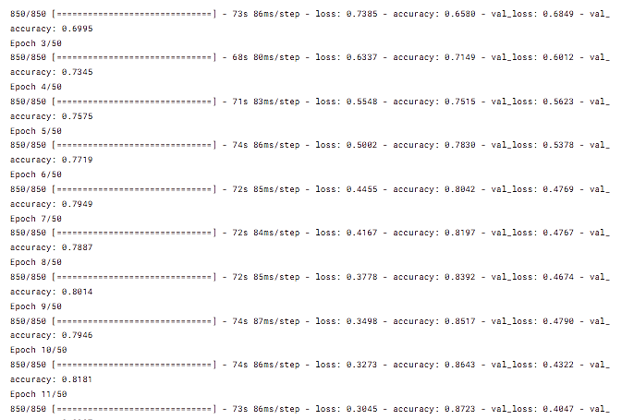
We have 50 Epoch.

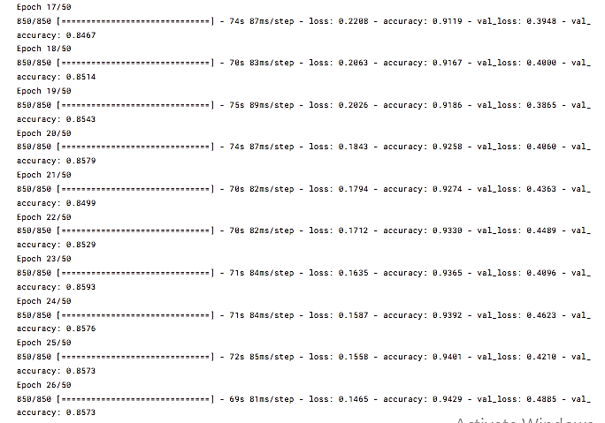

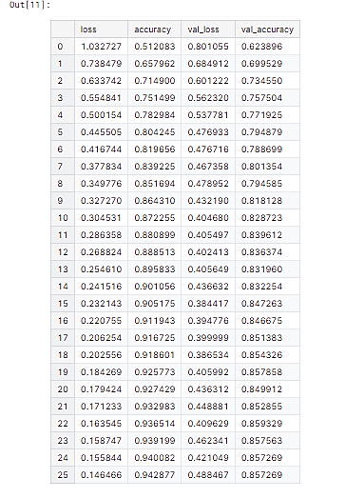
5.1.6 Evaluate the Model

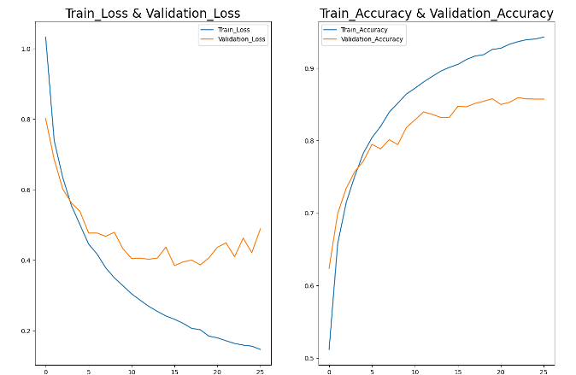
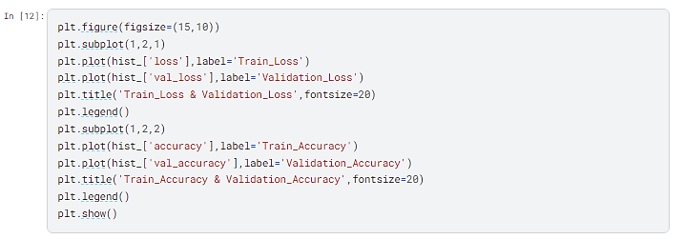
Figure (21) CNN Evaluation

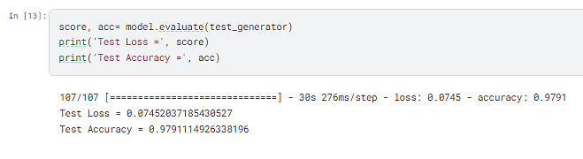
5.1.7 Model score

5.1.8 Model Evaluation

5.1.8.1 Confusion Matrix
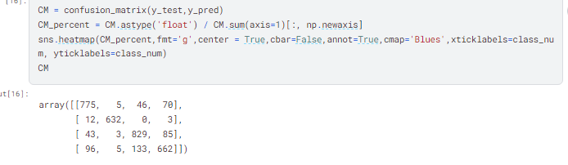

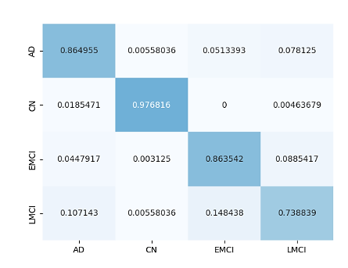

Figure (22) CNN Confusion Matrix

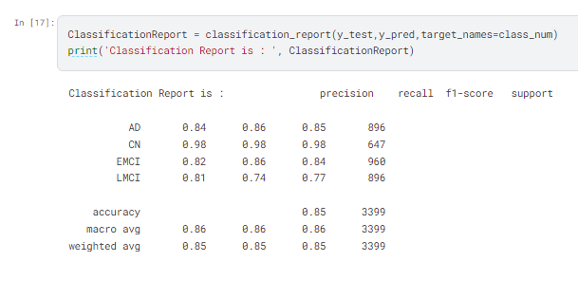
5.1.8.2 Classification Report

5.2 VGG16
The VGG-16 model in machine learning refers to convolutional.
neural network (CNN) architecture that was proposed by the Visual Geometry Group (VGG) at the University of Oxford. It was introduced in the paper titled "Very Deep Convolutional Networks for Large-Scale Image Recognition" by Karen Simonyan and Andrew Zisserman in 2014.

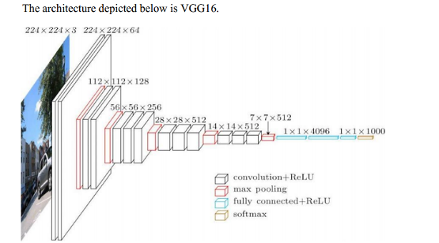

Figure (23) VGG16 Model

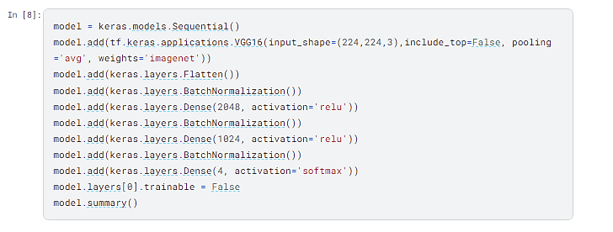
5.2.1 Model Architecture

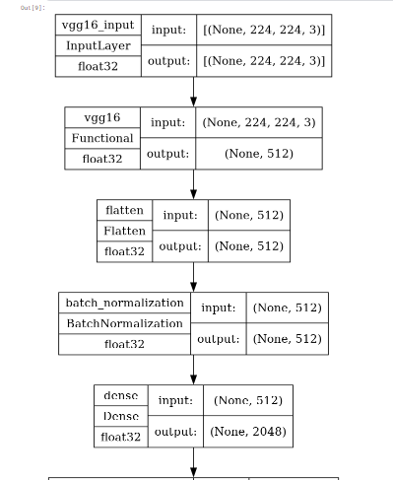
5.2.2 Model Scratch
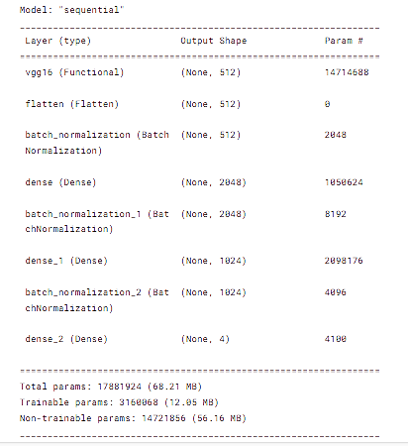

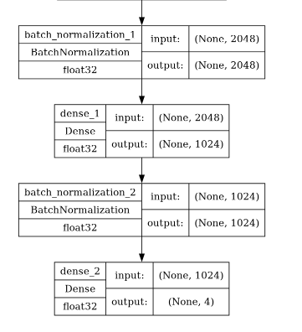

Figure (24) VGG16 Model Scratch

5.2.3 Model Performance
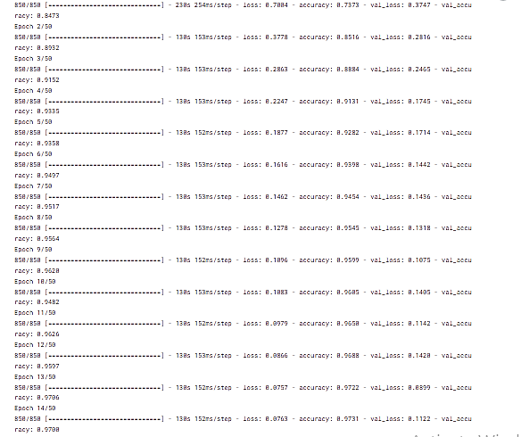

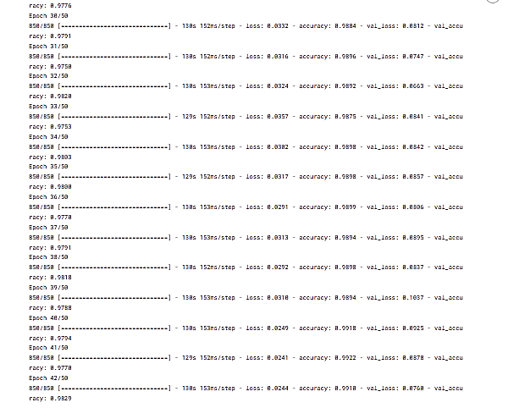

5.2.4 Evaluate the Model
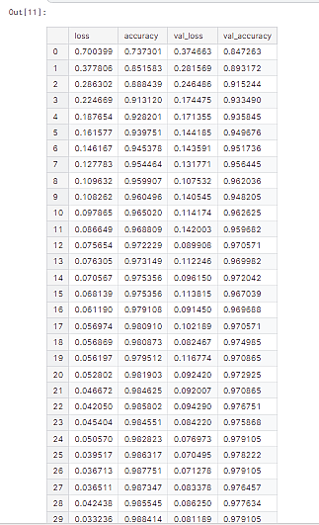

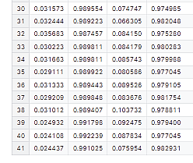

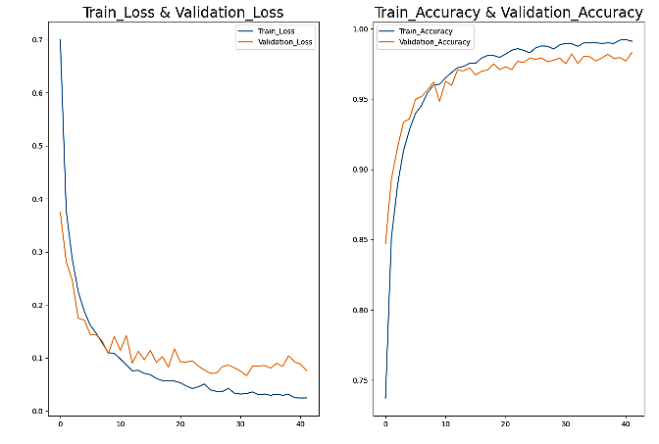
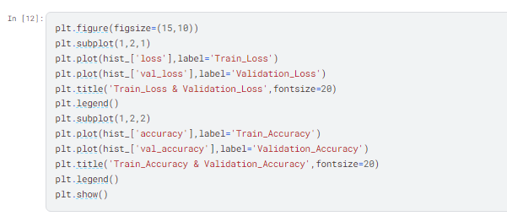
Figure (25) VGG16 Evaluation

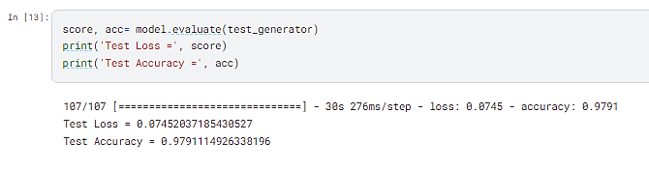
5.2.5 Model Score

5.2.6 Model Evaluation

5.2.6.1 Confusion Matrix
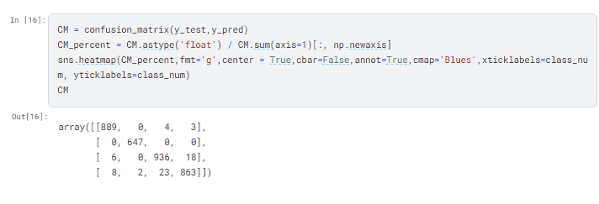

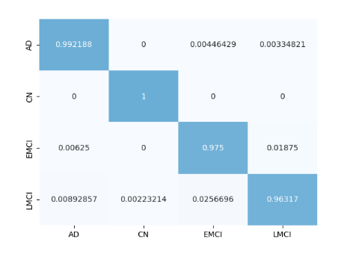

Figure (26) VGG16 Confusion Matrix

5.2.6.2 Classification Report
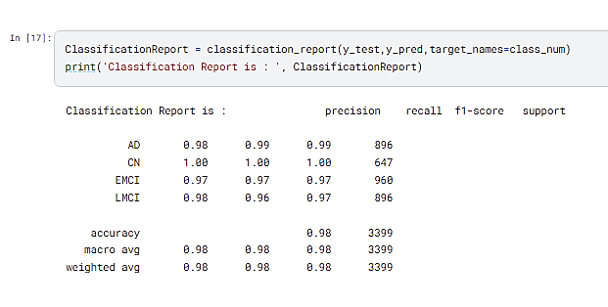

5.3 DenseNet201
DenseNet-201 is a convolutional neural network that is 201 layers deep and is a flexible architecture applicable to a variety of computer vision applications including picture classification, object identification, and semantic segmentation. Among the most prevalent uses of DenseNet are NLP: Used in translation, sentiment analysis, and text generation.
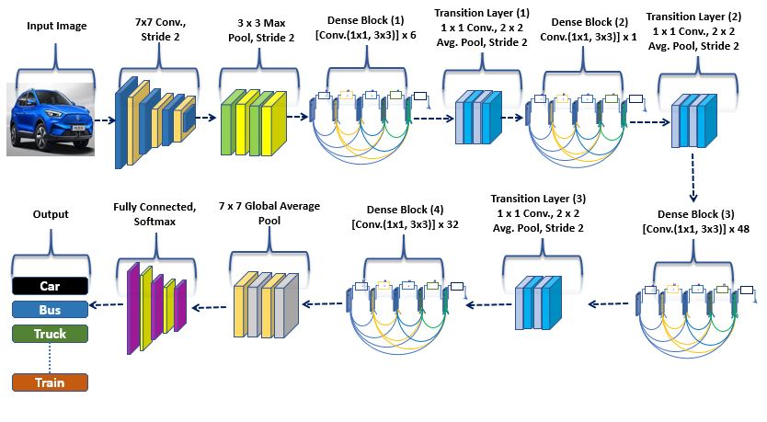
Figure (27) DenseNet201 Model

5.3.1 Model Architecture
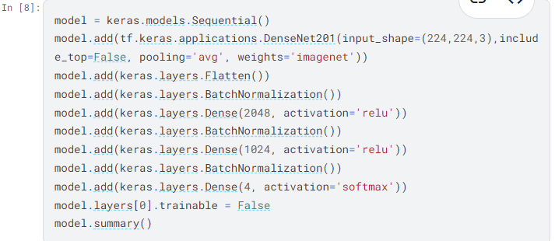

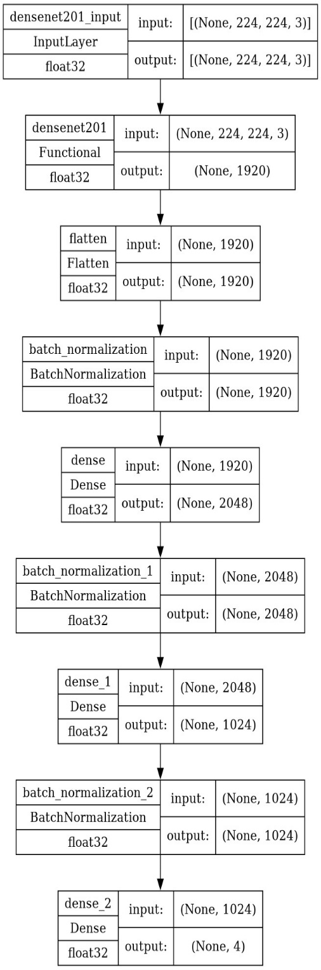
5.3.2 Model Scratch
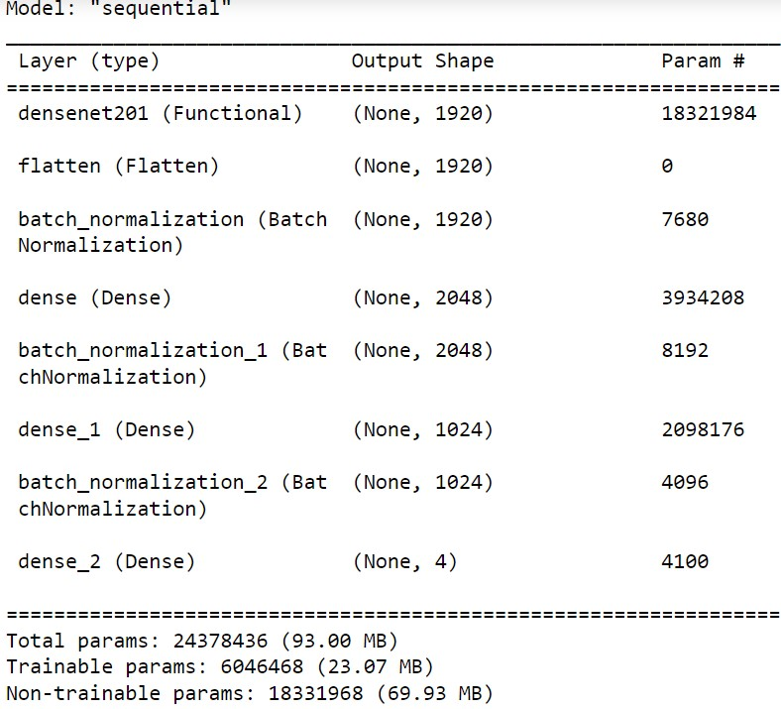
Figure (28) DenseNet201 Model Scratch

5.3.3 Model Performance
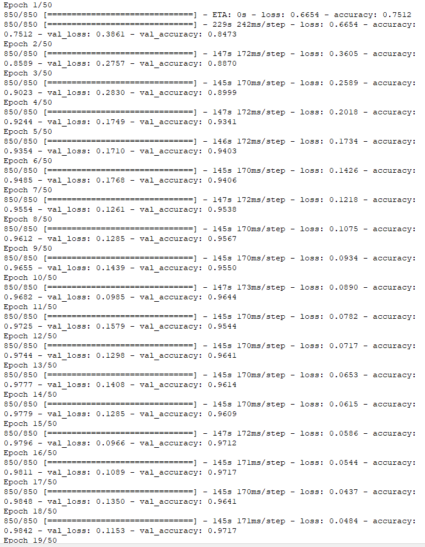
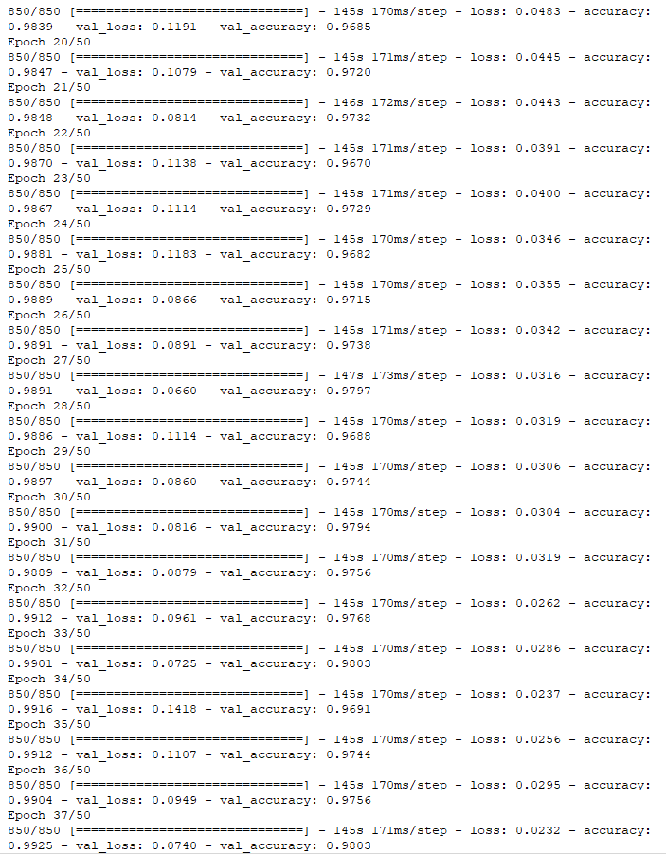

5.3.4 Evaluate the Model
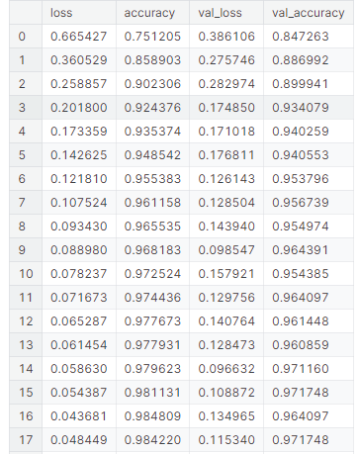
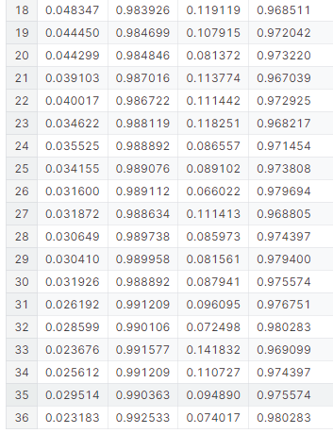
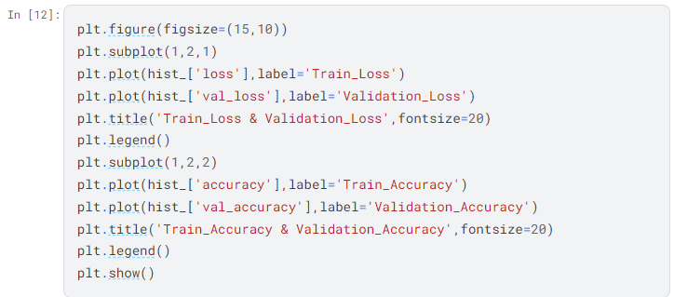
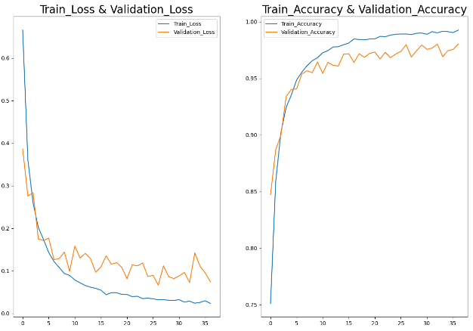
Figure (29) DenseNet201 Evaluation

5.3.5 Model Score
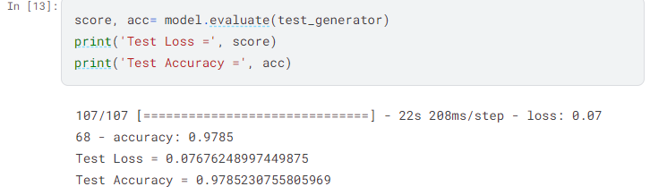

5.3.6 Model Evaluation

5.3.6.1 Confusion Matrix
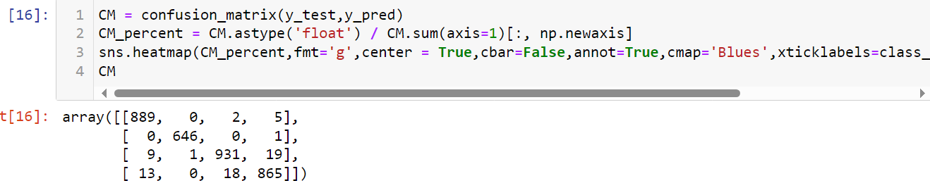
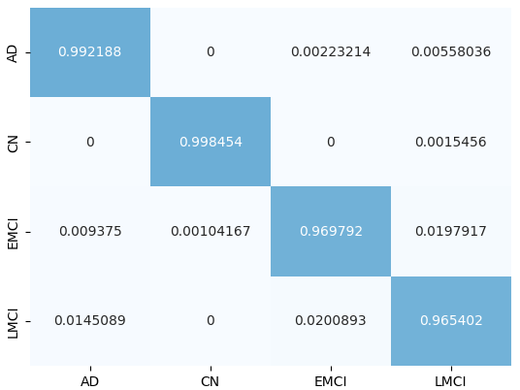
Figure (30) DenseNet201 Confusion Matrix

5.3.6.2 Classification Report
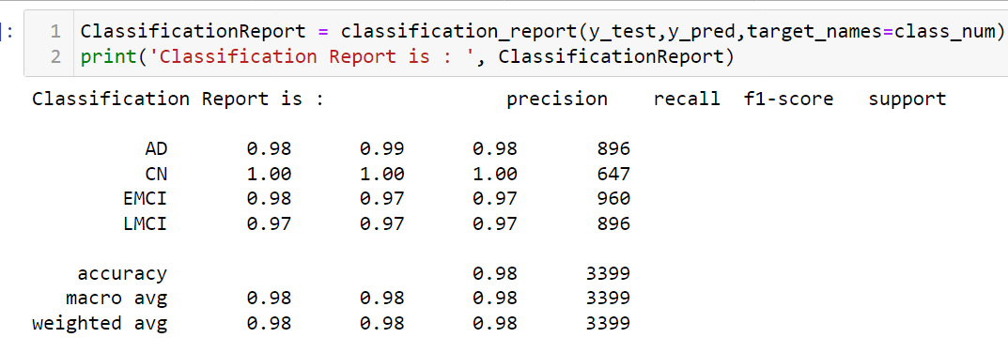

5.4 ResNet152V2
ResNet-v2 is a convolutional neural architecture that builds on the Inception family of architectures but incorporates residual connections (replacing the filter concatenation stage of the Inception architecture). Source: Inception-v4, Inception-ResNet and the Impact of Residual Connections on Learning.

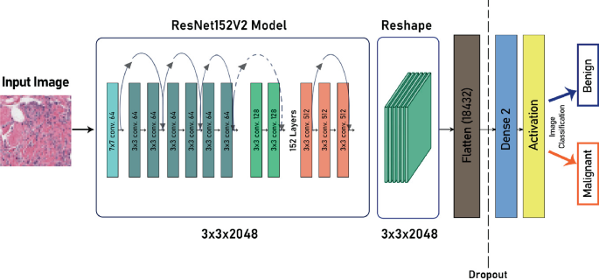
Figure (31) ResNet152V2 Model

5.4.1 Model Architecture
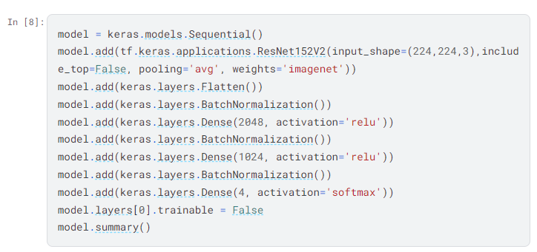

5.4.2 Model Scratch
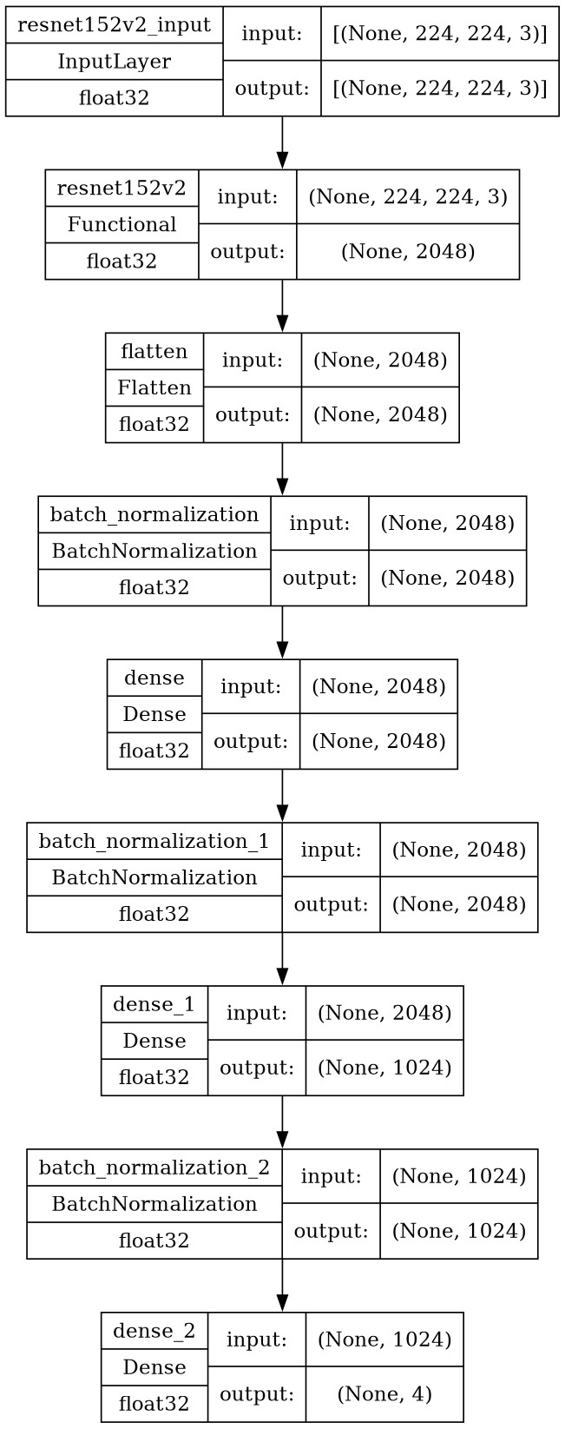
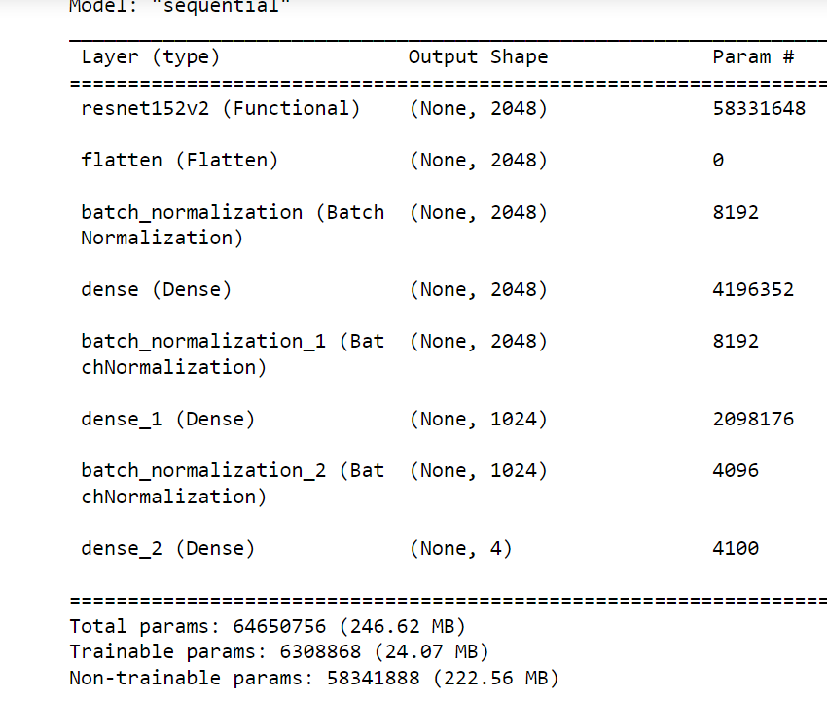
Figure (32) ResNet152V2 Model Scratch

5.4.3 Model Performance

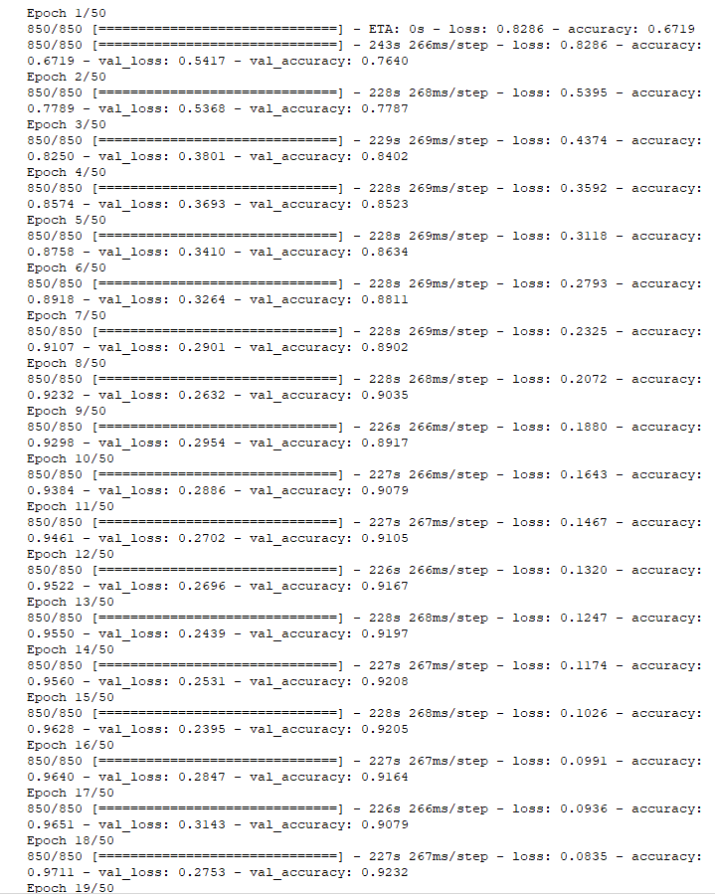
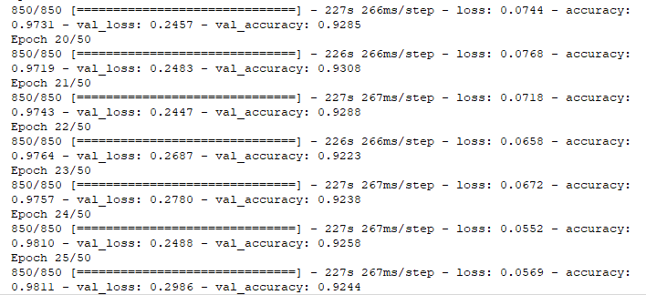

5.4.4 Evaluate the Model

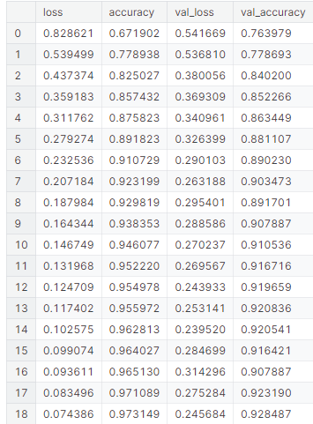
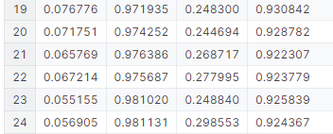

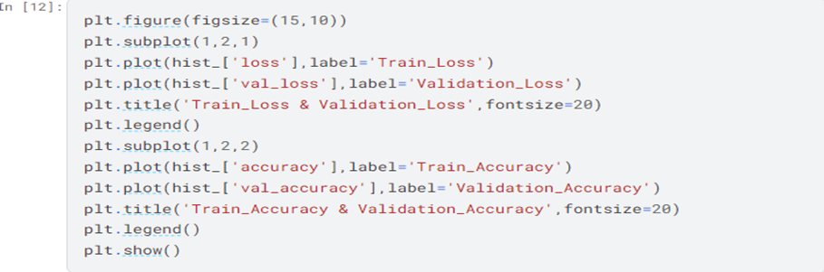

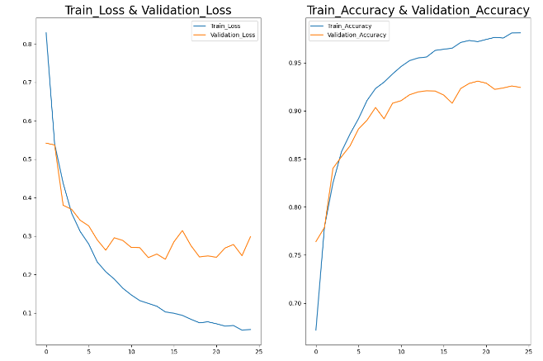
Figure (33) ResNet152V2 Evaluation

5.4.5 Model Score
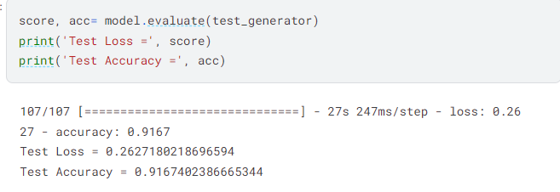

5.4.6 Model Evaluation

5.4.6.1 Confusion Matrix
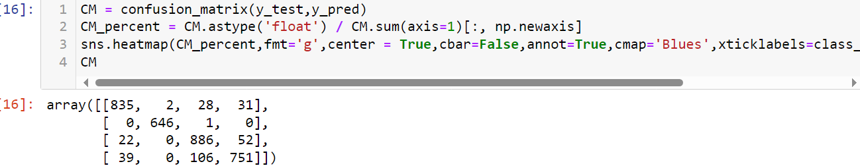
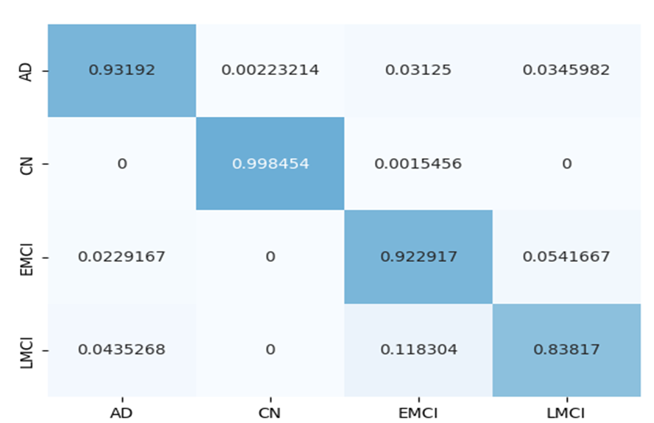
Figure (34) ResNet152V2 Confusion Matrix

5.4.6.2 Classification Report
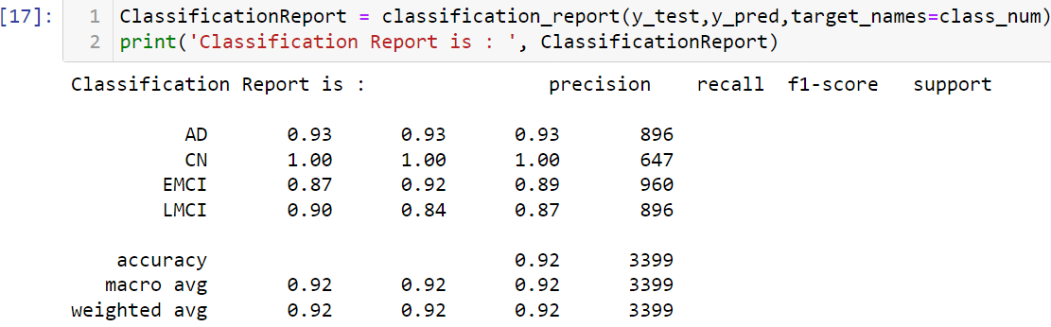

5.5 MobileNetV2
MobileNetV2 is a deep learning model designed for computer vision tasks on mobile devices such as smartphones and tablets. It is an improvement over the original MobileNet model and was developed by researchers at Google. MobileNetV2 aims to enhance model efficiency so that it can run efficiently on resource-constrained devices like mobile phones without sacrificing performance or accuracy. It relies on the idea of using repeated building blocks for construction, making it robust and suitable for a variety of computer vision applications on resource-limited devices.
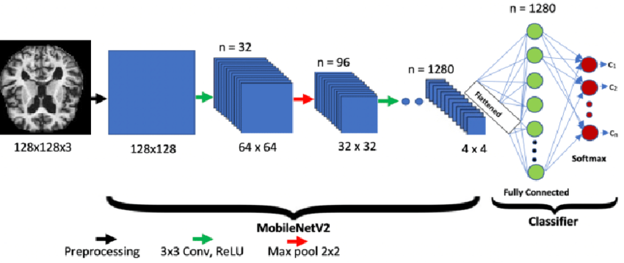
Figure (35) MobileNetV2 Model

5.5.1 Model Architecture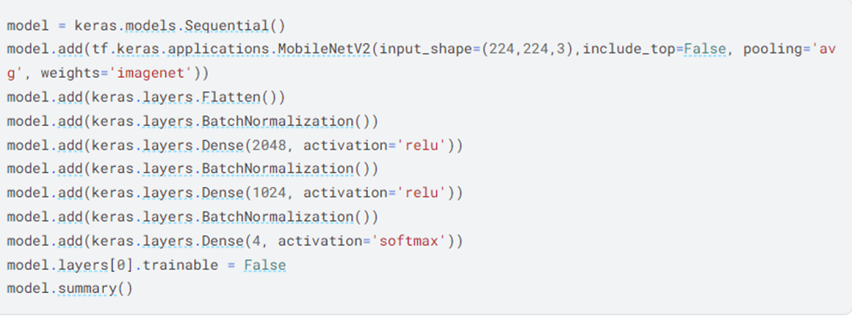

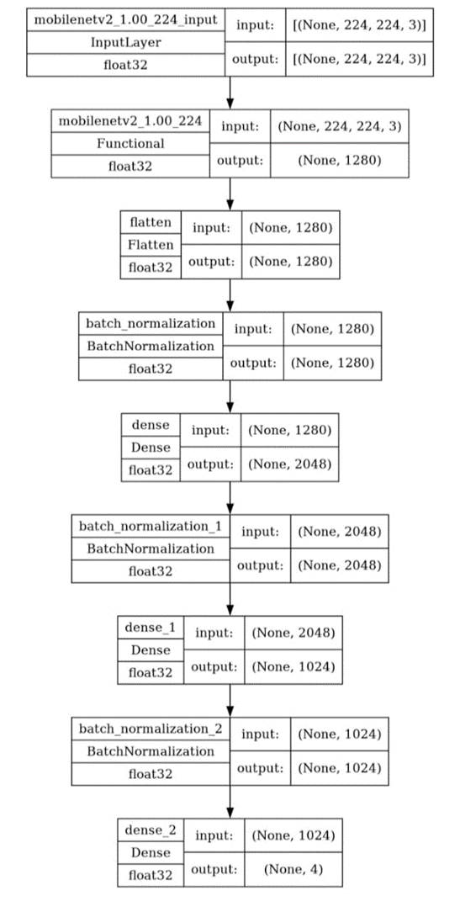
5.5.2 Model Scratch
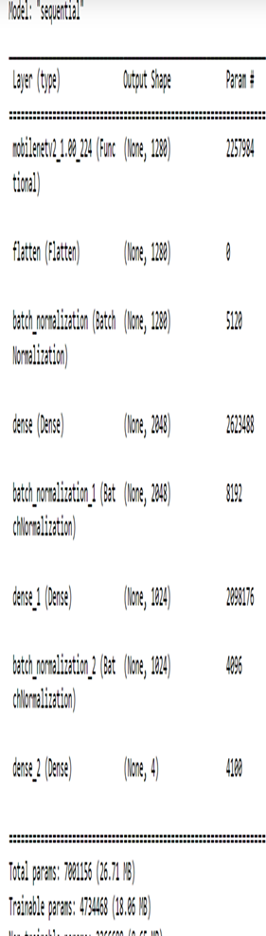
Figure (36) Model Scratch

5.5.3 Model Performance
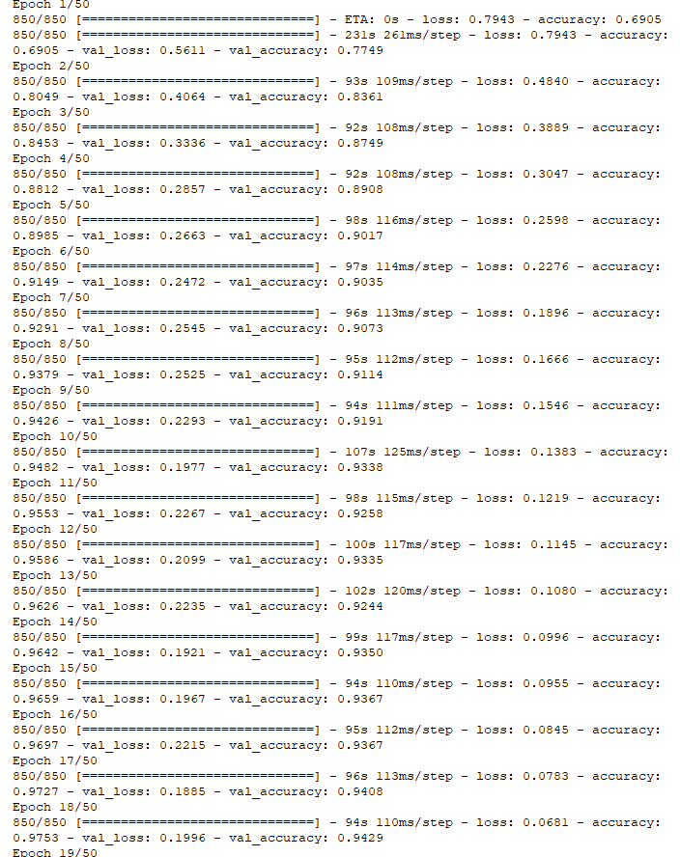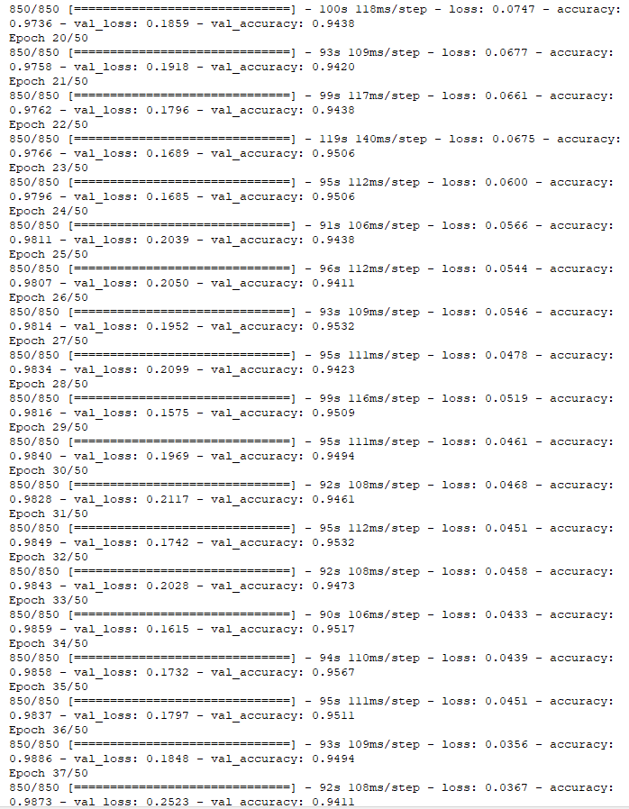

5.5.4 Evaluate the Model
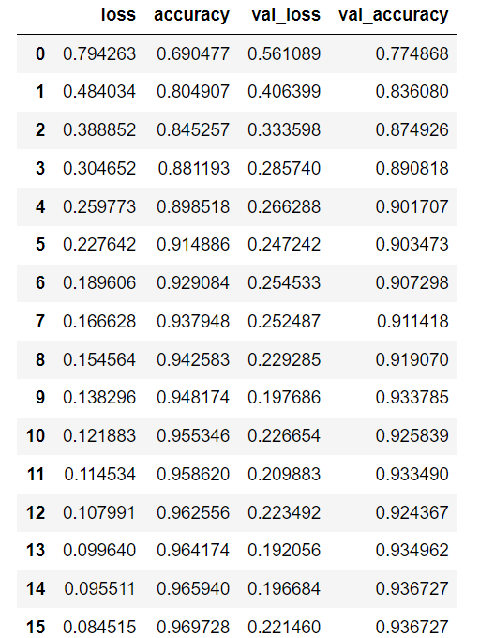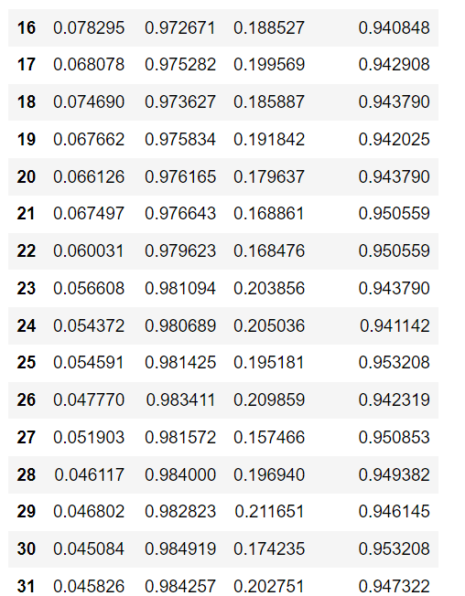
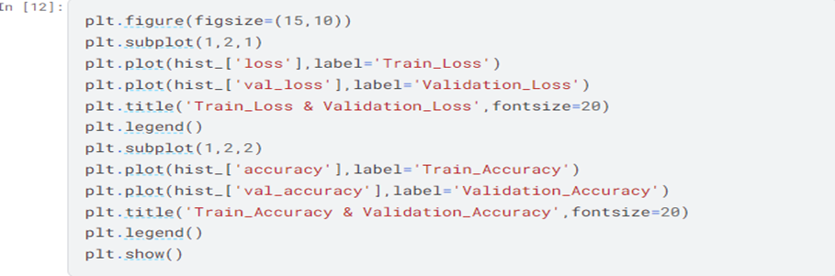
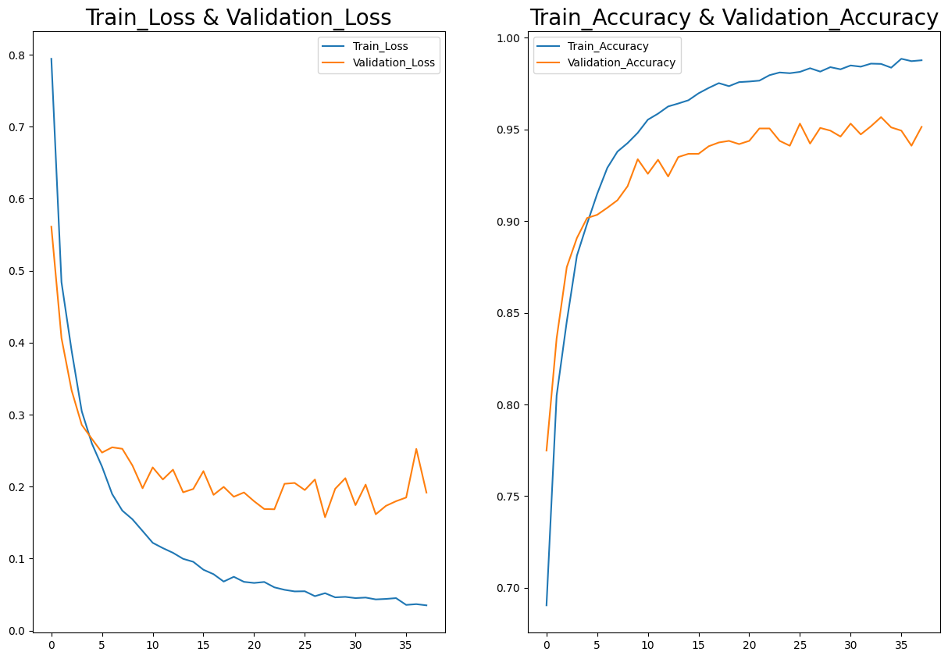
Figure (37) MobileNetV2 Evaluation

5.5.5 Model Score
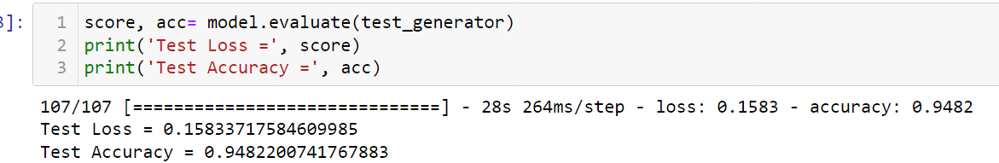

5.5.6 Model Evaluation

5.5.6.1 Confusion Matrix
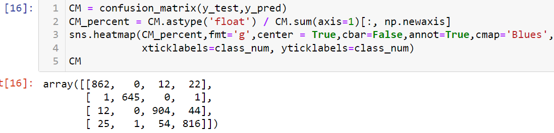
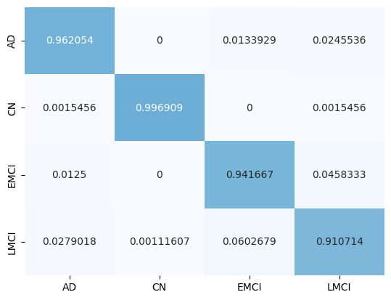
Figure (38) MobileNetV2 Confusion Matrix

5.5.6.2 Classification Report
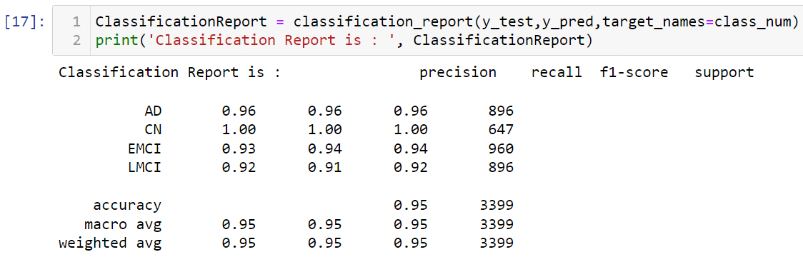

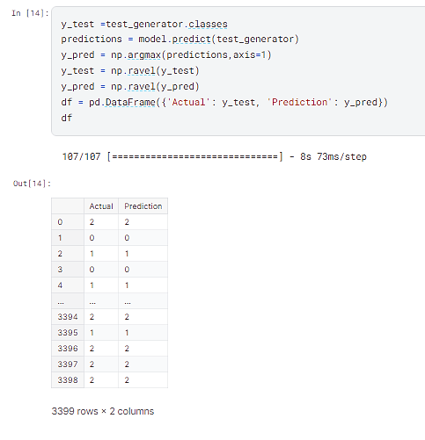
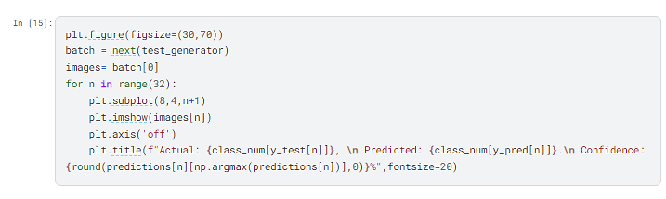
5.6 Model predictions
Figure (39) Model predictions.

5.7 Summary
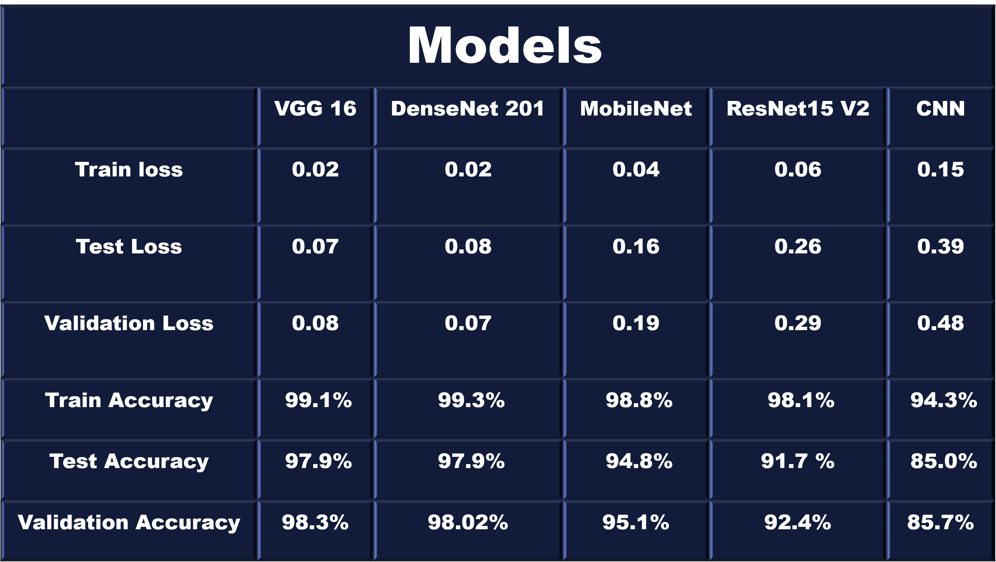
Figure (40) Models Summary

Chapter 4 → UI Design
- Start page.
On the first page we can do:
• sign in.
• sign up.
• Initial registration for the application by Phone number, when registering for the first time, you will move to the sign-up page.

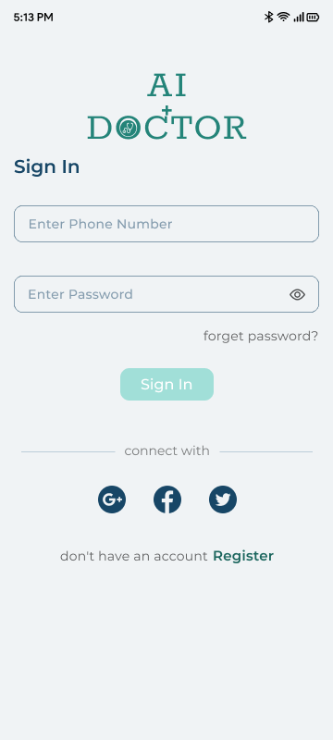
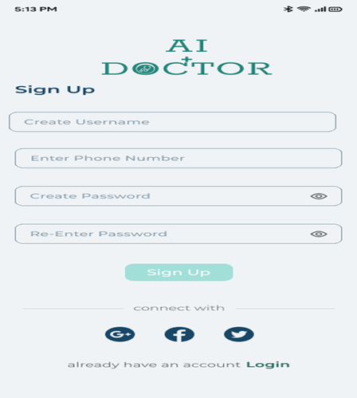

- Home Page:
At the beginning of the application, the dashboard appears, And There are also notifications to confirm the appointment with the doctor.
- part One
News as API
- Part two
It shows the Services to help the patient choose what he wants, these are the following: AI chatbot, chatbot, alarm, chats, Alzheimer’s MRI
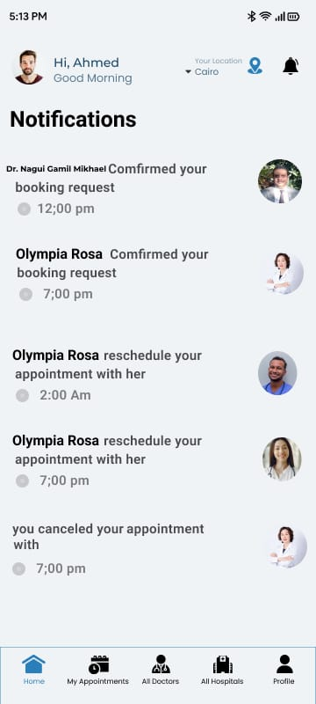

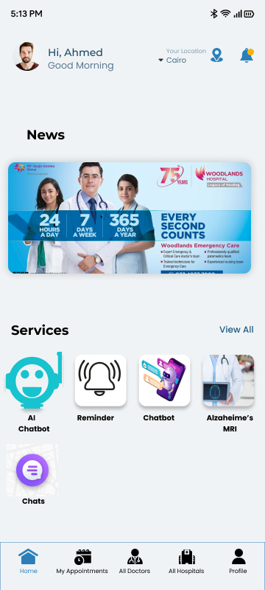

3. Models (Alzheimer’s MRI)
In this section, the ray image is uploaded, and the models process this image and show us the type of disease with the percentage of its presence, and it shows the results.

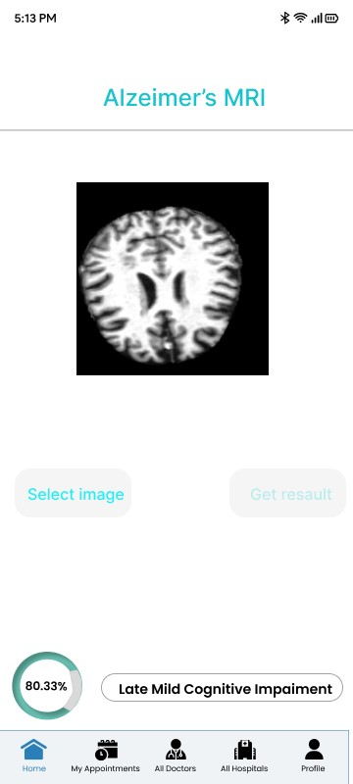

4. chatbot AI
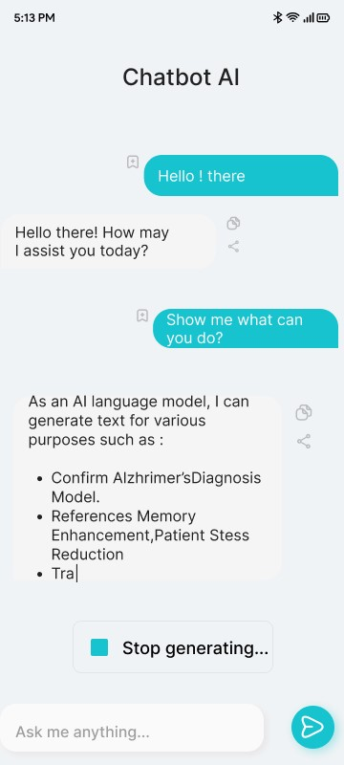

In this section, its generation AI, the patient can confirm the result of the rays by the model. He can talk to it to learn a lot about his illness, treatment, and lifestyle.

5- chats
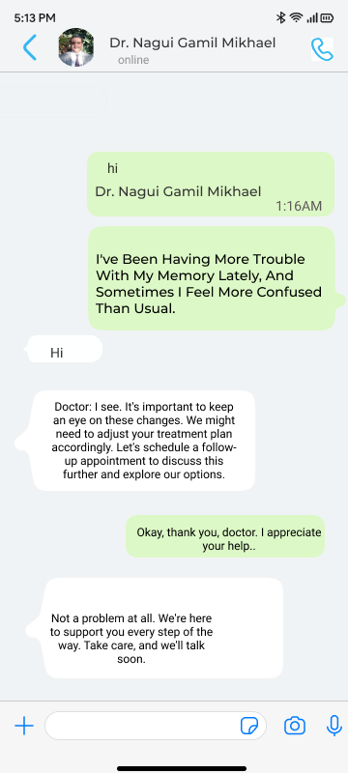
In this section, the patient can talk to the doctor, book an appointment, and learn about the His illness and treatment easily, and this facilitates communication between him and the doctor.
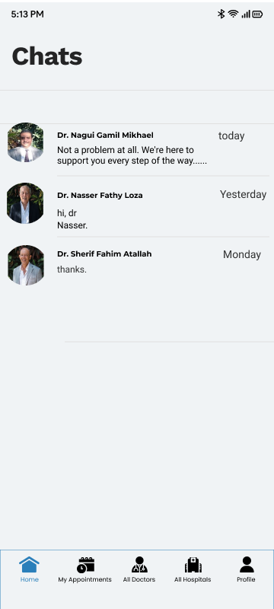

6. book Now

In this section, the patient can book an appointment. He can know the top doctors and hospitals and what hospitals can provide to the patient and choose what suits him.
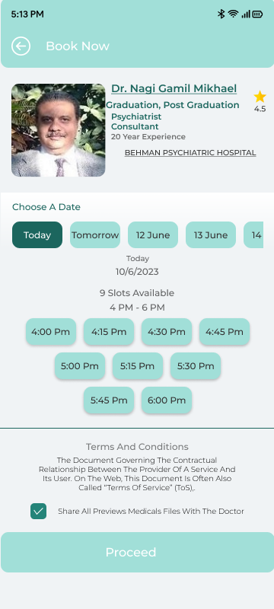
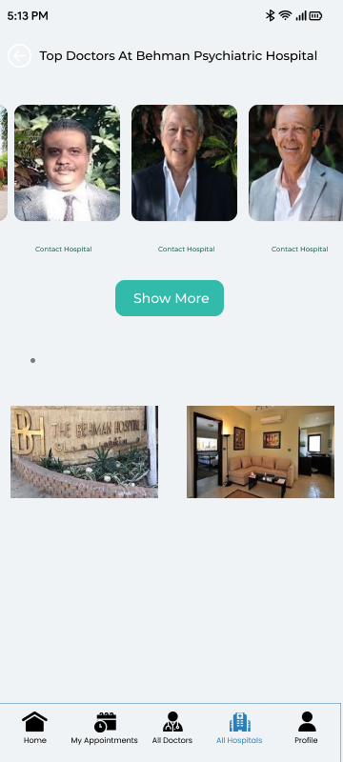

7.Payment
The patient can pay in most ways, such as cash or Visa. After your booking is successfully completed you can download invoice and can view doctor location in map.

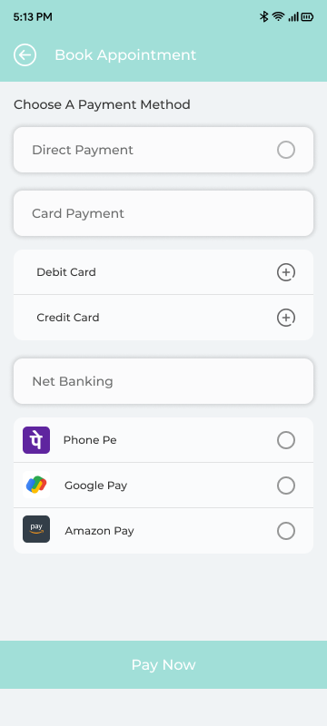

8. Map
The map determines the Doctor closest to me. It also determines the time taken to go to it, either by walking or transportation. Displays the location of any hospital on the map when pressed. He shows me the hospitals in order of the closest to the person according to his location.
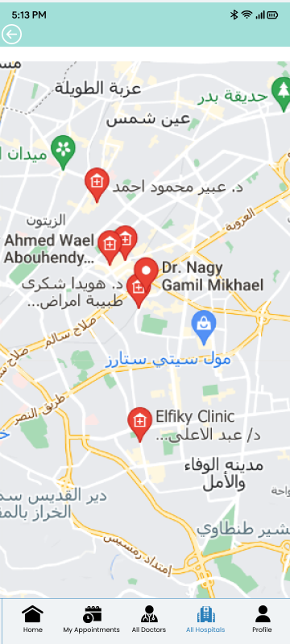

Chapter 5 → Generative AI Chatbot

5.1 Introduction

In the realm of healthcare, diagnosing medical conditions can induce significant stress for patients. Leveraging technology like generative models presents an opportunity to alleviate this burden. These models can simulate medical conditions and provide informative feedback, potentially reducing patient anxiety. By developing a generative model that confirms detection and minimizing stress.

5.2 Libraries

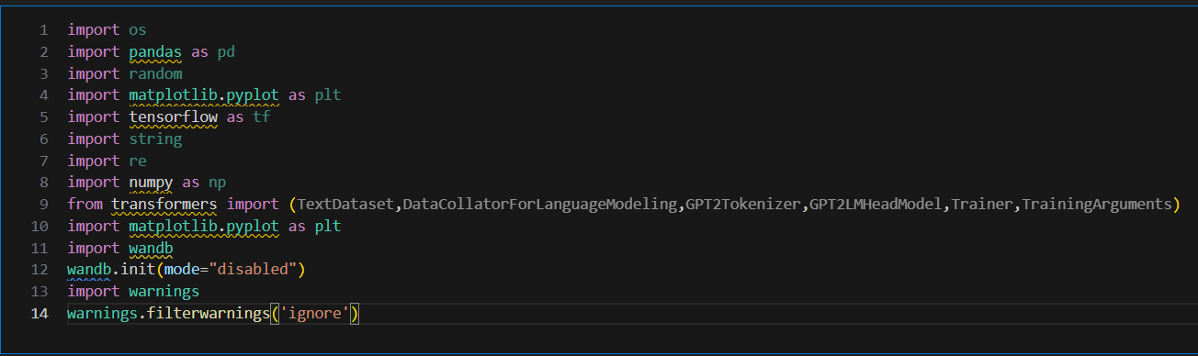

5.2 Load Data

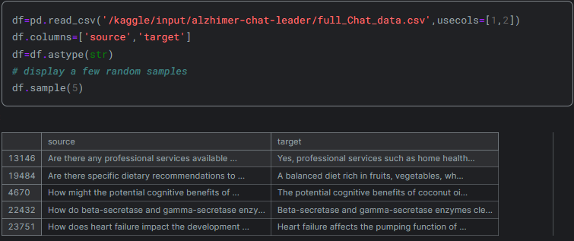

5.3 Split Data

we split data into: -
- 90% train
- 5% test
- 5% validation
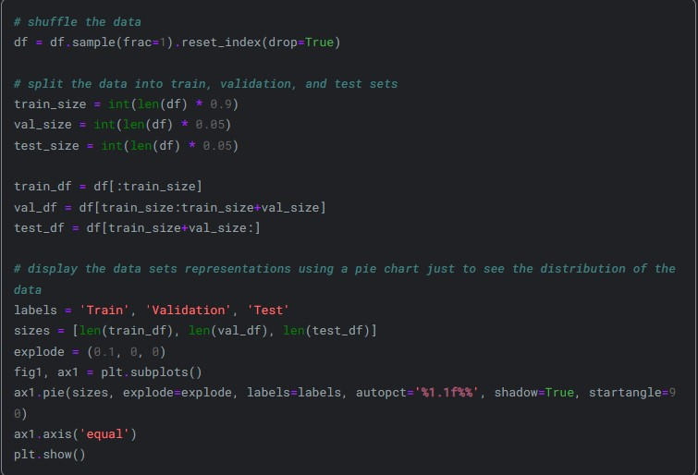
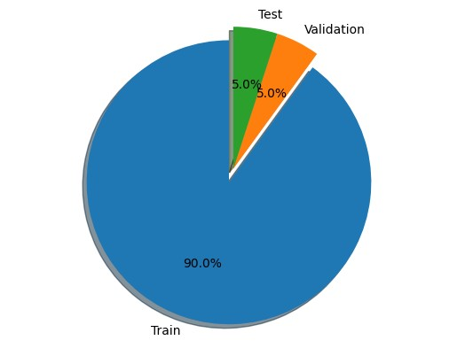
Figure (41) Transformer Data Split

5.4 Model training
- Transformer
- Pre-Trained GPT-2

5.4.1 Transformer

5.4.1.1 Text Vectorization
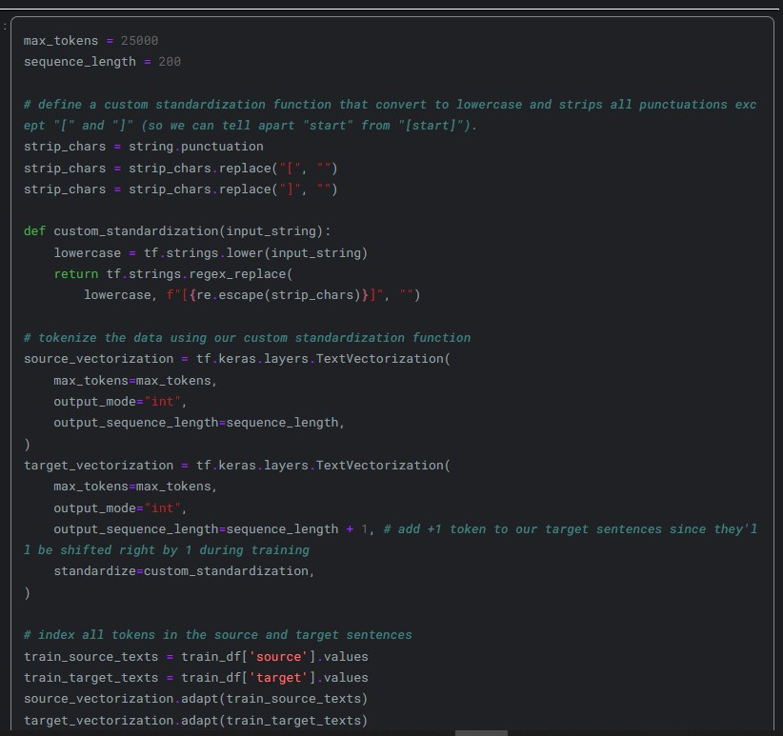

5.4.1.2 Positional Embedding
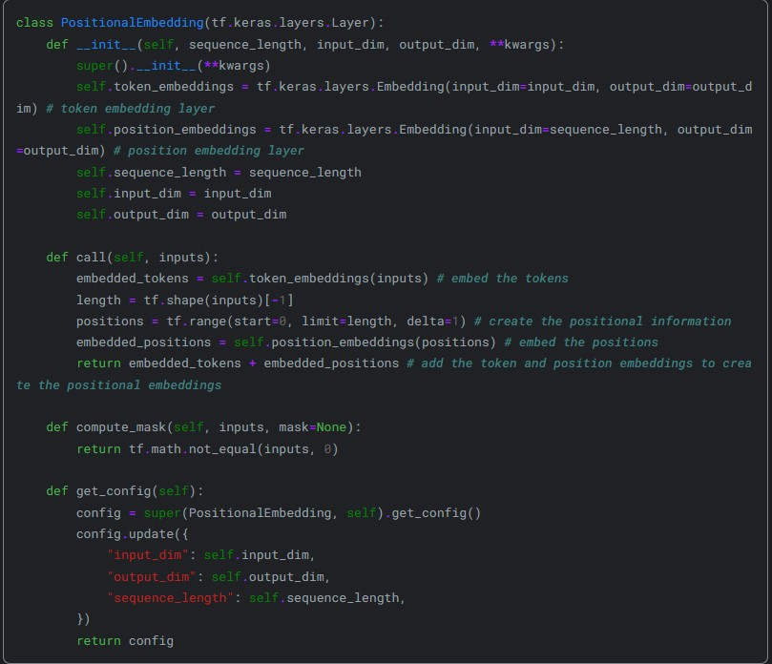

5.4.1.3 Scaled Dot-Product Attention
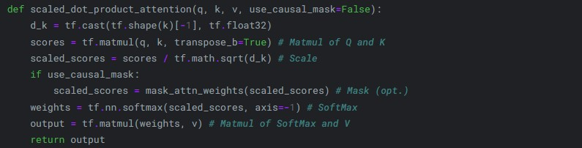

5.4.1.4 Causal Masking
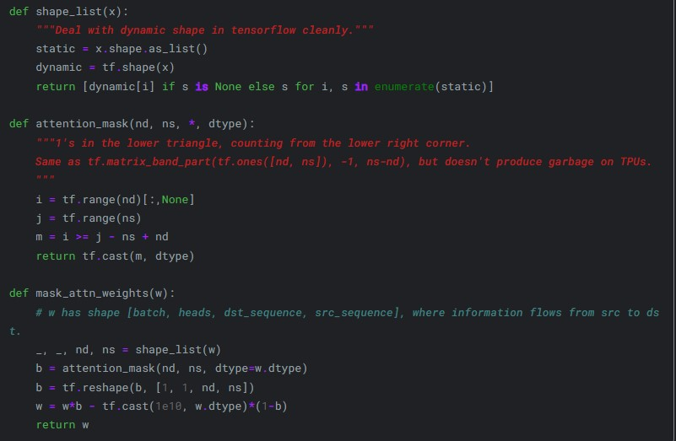

5.4.1.5 Multi-Head Attention
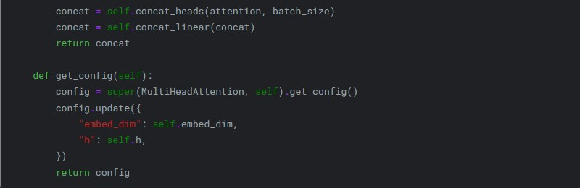
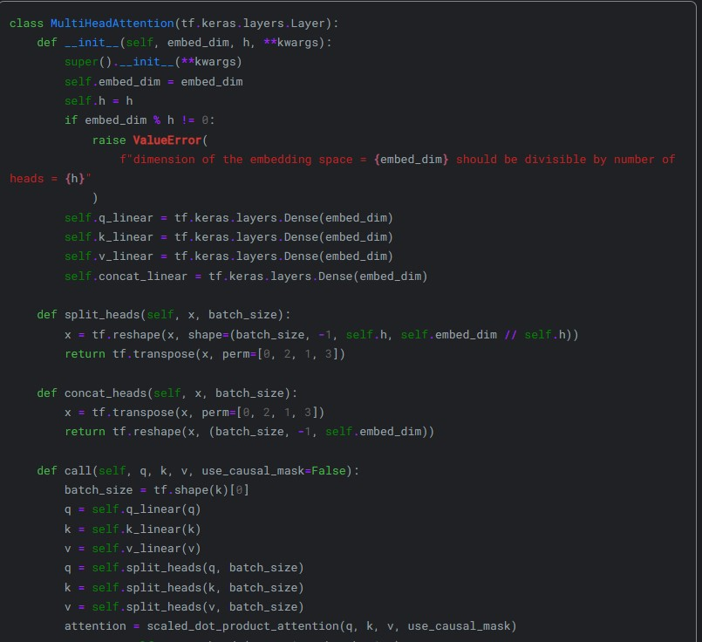

5.4.1.6 Encoder

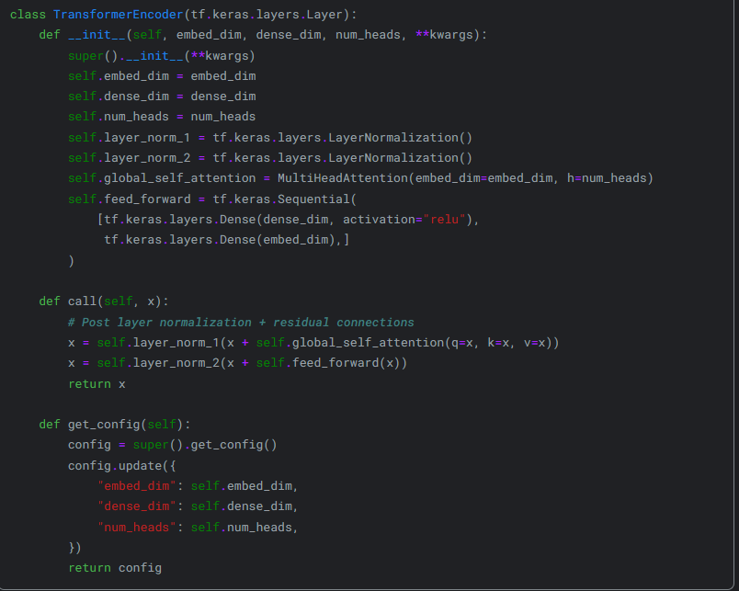

5.4.1.7 Decoder
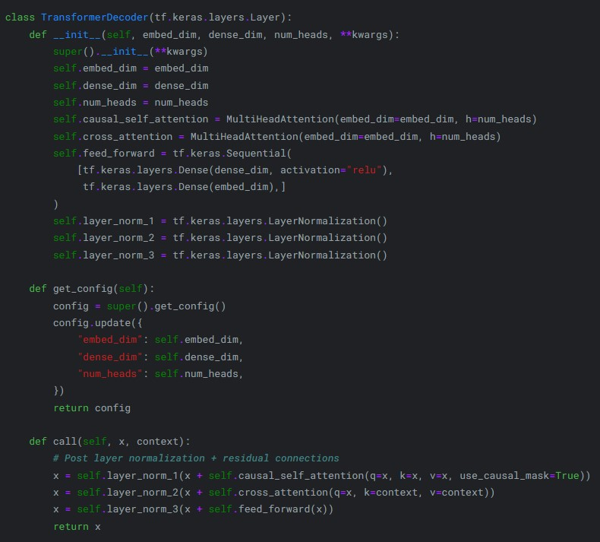

5.4.1.8 Transformer Block for Encoder and Decoder
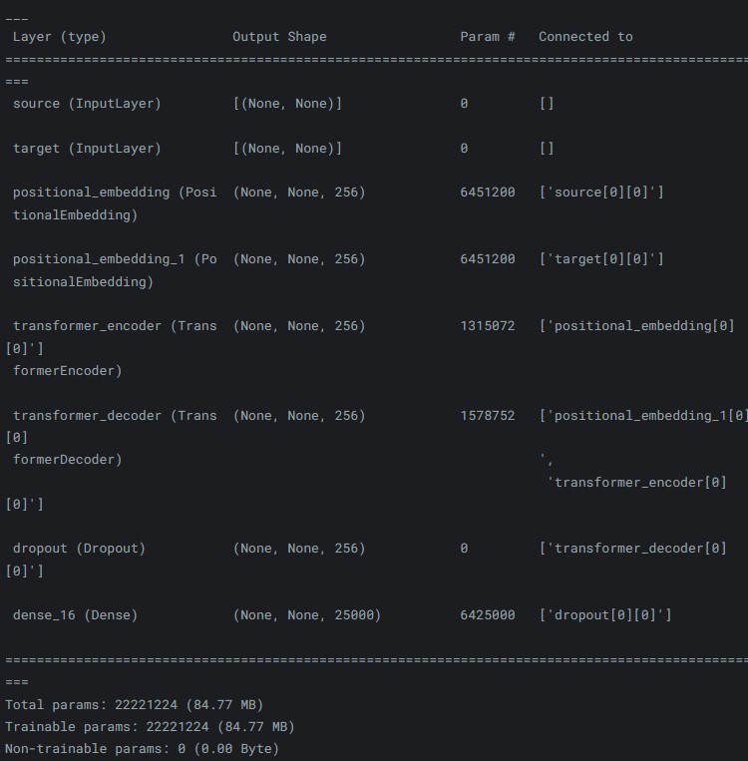
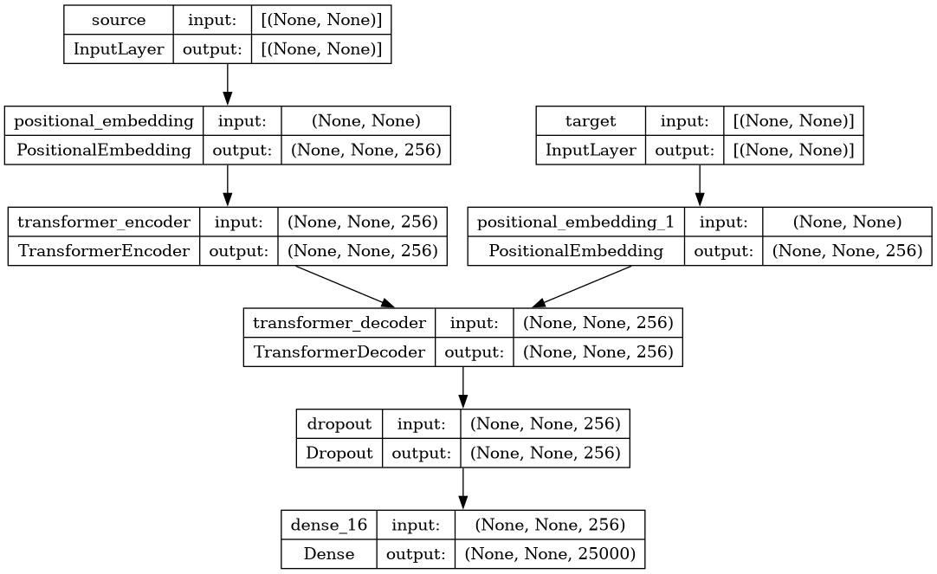
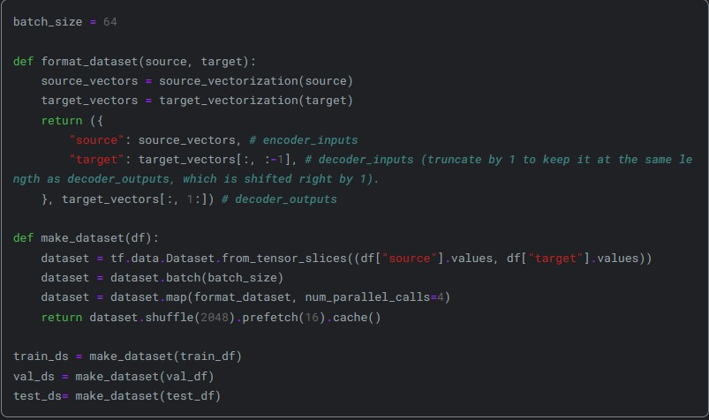
Figure (42) Transformer Block

5.4.1.9 Training the Transformer
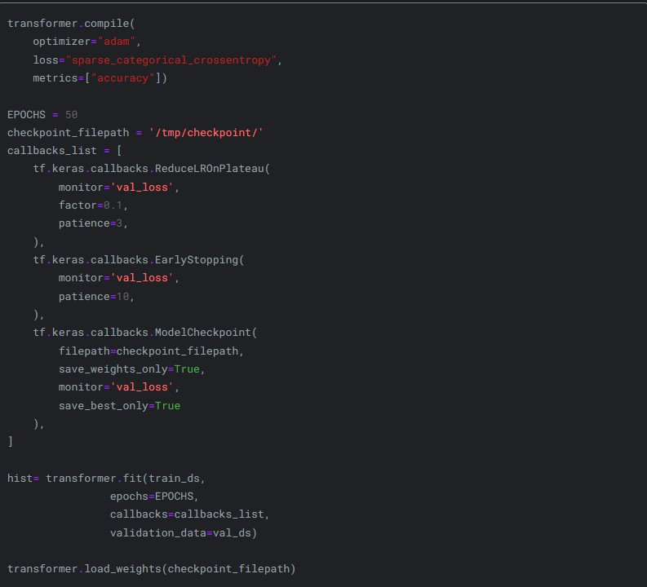
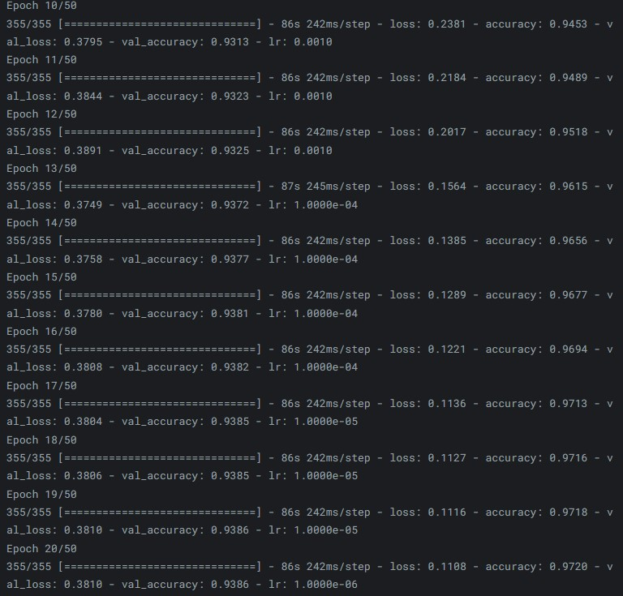
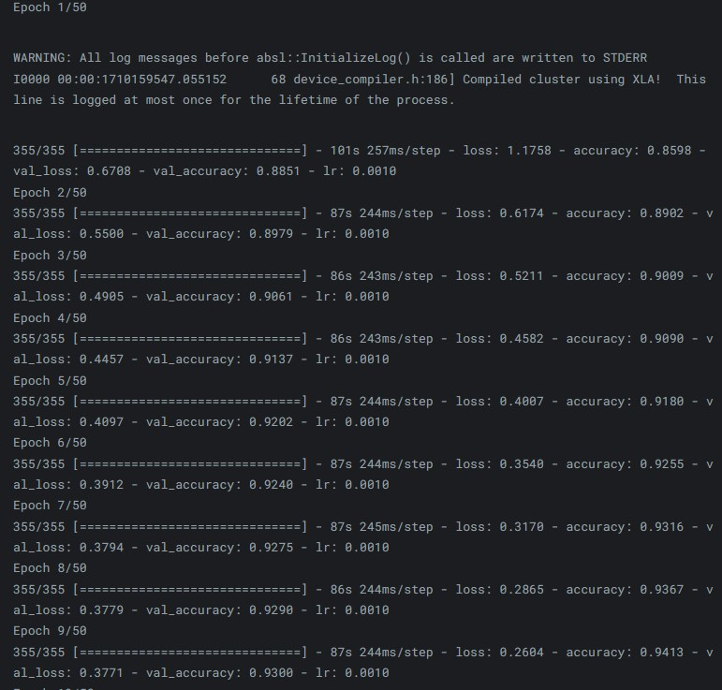
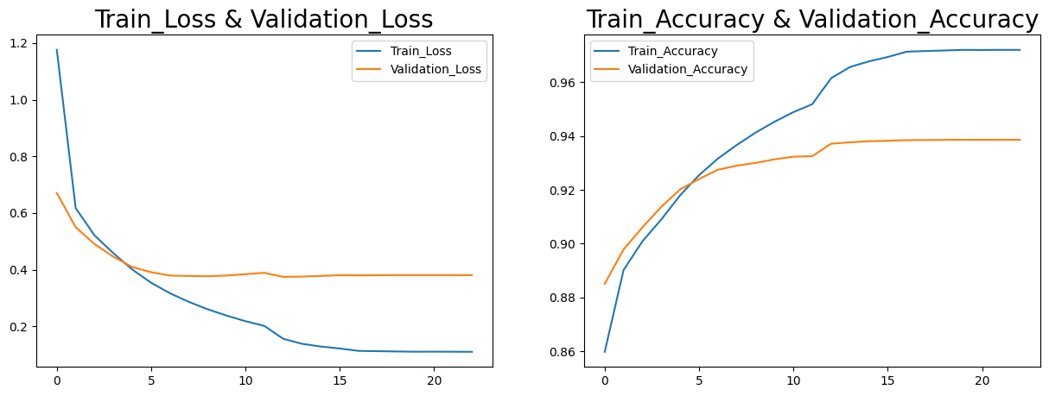
Figure (43) Training the Transformer

5.4.1.10 Model Evaluation
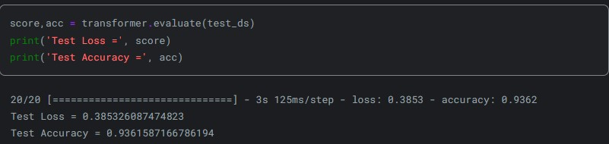
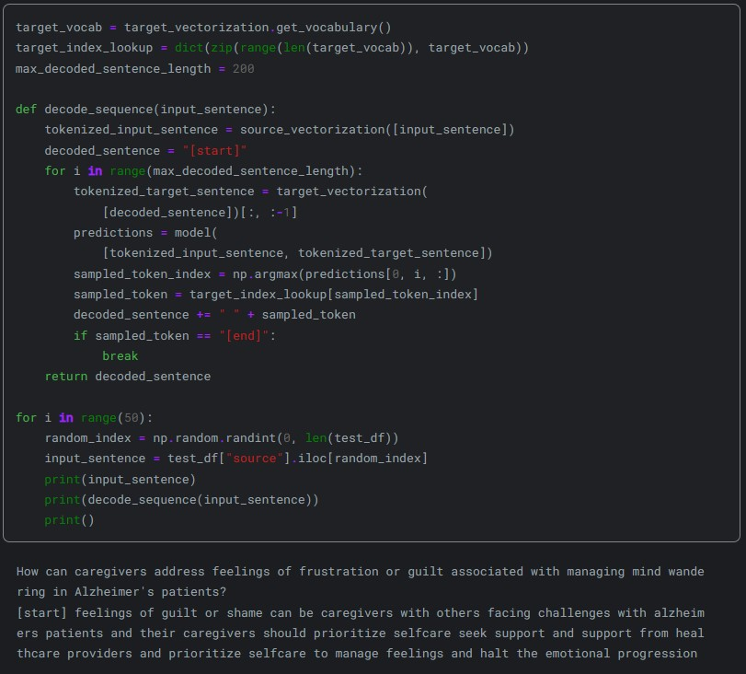
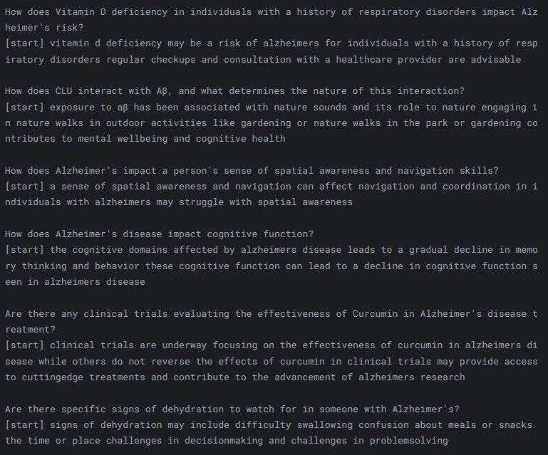
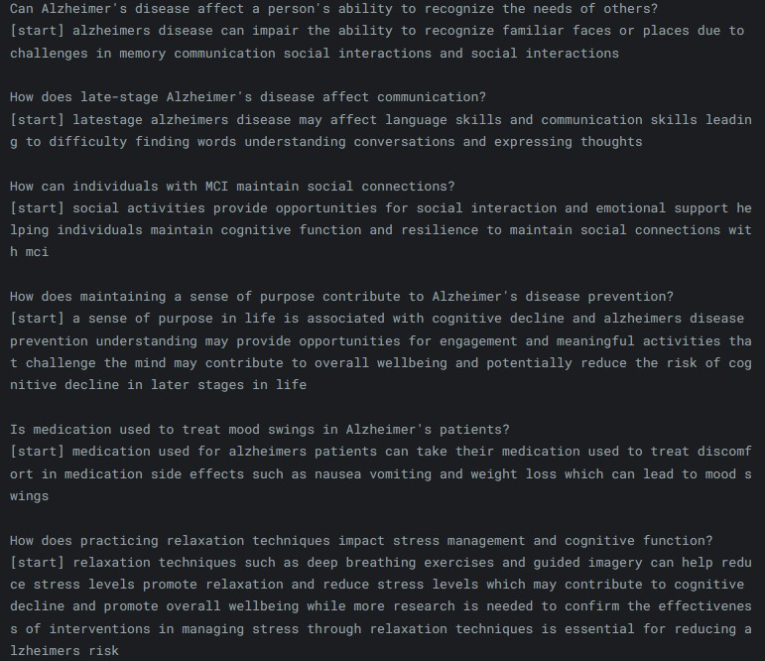

5.4.2 Pre-Trained GPT-2

5.4.2.1 Helper Function for GPT-2
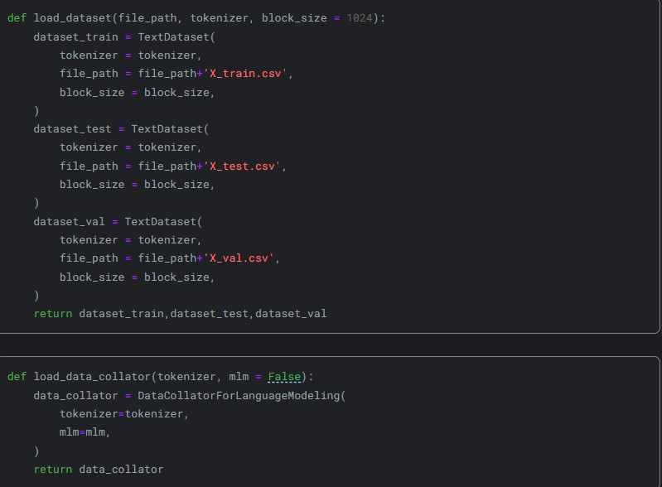
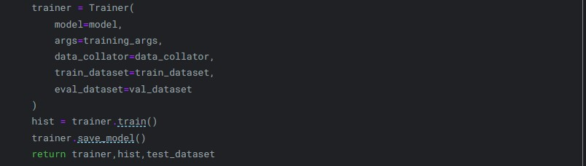
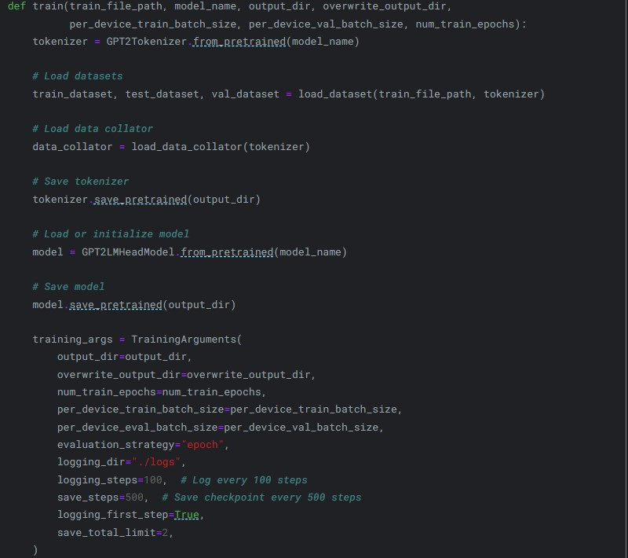

5.4.2.2 Training GPT-2
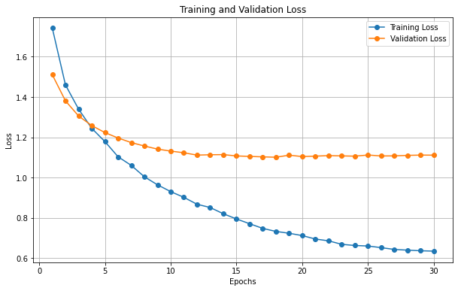
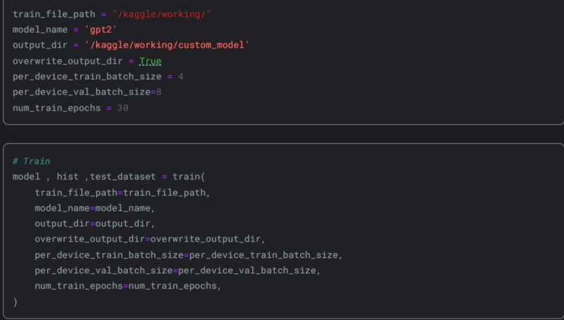
Figure (44) Training GPT-2

5.4.2.3 Evaluation GPT-2
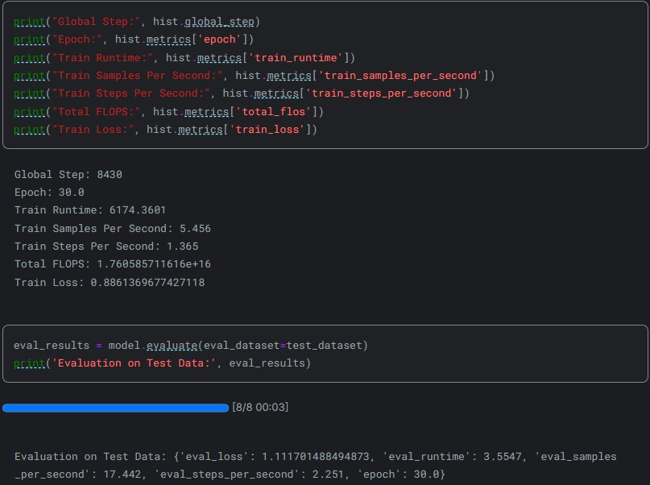

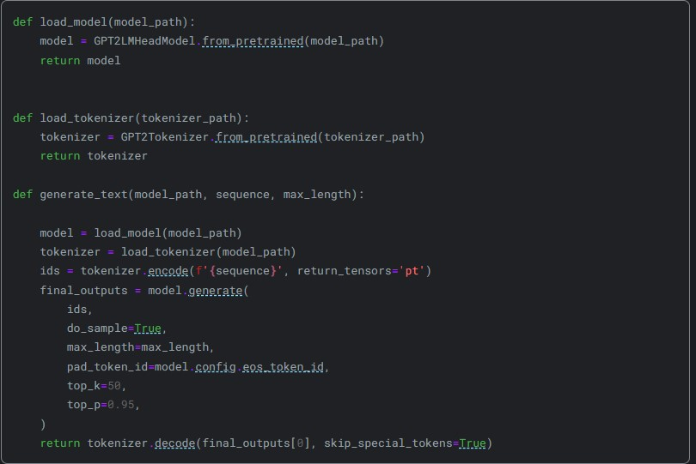
5.4.2.4 Generation Using Custom GPT-2

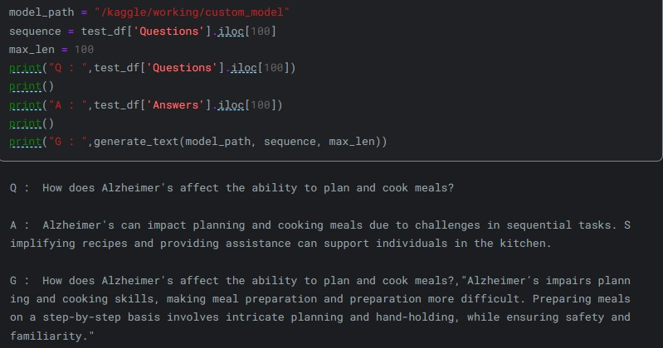
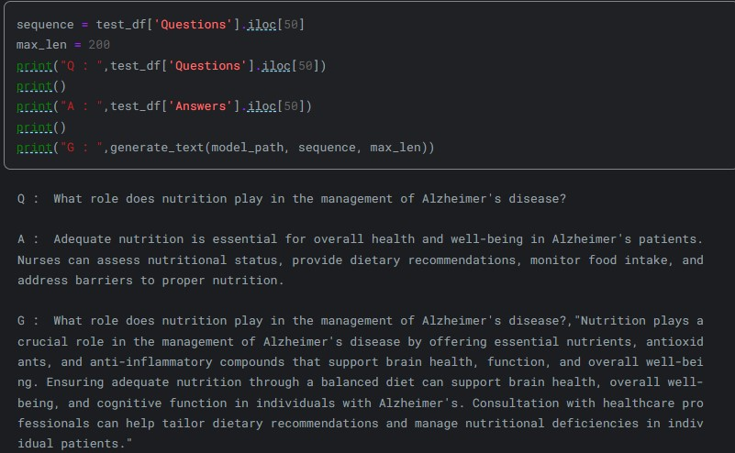
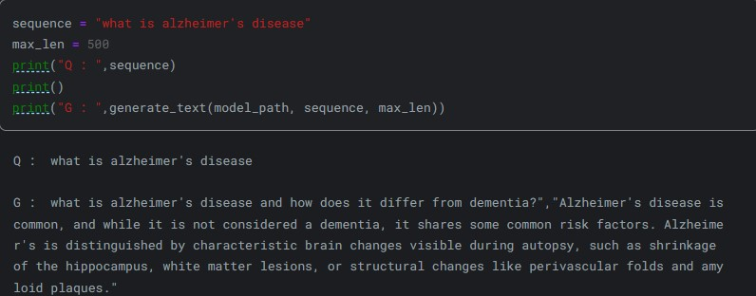

References
[1] https://www.kaggle.com/ahmedashrafahmed
[2] https://www.tensorflow.org/?hl=ar
[3] https://adni.loni.usc.edu/
[4] https://scikit-learn.org/stable/tutorial/index.html
[5] https://sigma.software/services/ui-ux-design
[6] https://arxiv.org/abs/1706.03762
[7] https://www.tensorflow.org/text/tutorials/transformer
[8] https://github.com/openai/gpt-2/blob/master/src/model.py
[9] https://github.com/karpathy/minGPT/blob/master/mingpt /model.py
[10] https://livebook.manning.com/book/deep-learning-with-python-second-edition/chapter-11
[11] https://github.com/fchollet/deep-learning-with-python-notebooks/blob/master/chapter11_part03_transformer.ipynb
[12] https://github.com/fchollet/deep-learning-with-python-notebooks/blob/master/chapter11_part04_sequence-to-sequence-learning.ipynb
[13] https://www.oreilly.com/library/view/natural-language-processing/9781098136789/ch03.html
[14] https://github.com/nlp-with transformers / notebooks / blob/main/03_transformer-anatomy.ipynb

