Sample Dashboard.

file:///D:/Learning/PMPHRM/agile1/byteshrm_dev/BytesHrmWeb/web/template/dashboard_2.html#

The dash board of HRM system show have below information .

**Leave**

|  |  |  |  |  |  |
| --- | --- | --- | --- | --- | --- |
| Emp# | Emp Name | From Date | To Date | Approval Status | Days |
| EMP001 | Feroz Khan | 8/12/2018 | 8/15/2018 | Approved | 4 |
|  |  |  |  |  |  |
|  |  |  |  |  |  |

The Status of the leave could be , PENDING, APPROVED, REJECTED.

Populate data to the best of control used from template.

The table will show only 5 latest rows and more link will be there to open full list.

**Document**

|  |  |  |  |  |  |
| --- | --- | --- | --- | --- | --- |
| Emp# | Emp Name | Expiry Date | Doc Type | Approval Status | Days Left |
| EMP001 | Feroz Khan | 8/12/2018 | VISA | ACTIVE | 4 |
|  |  |  |  |  |  |
|  |  |  |  |  |  |

The Doc Type could be VISA, PASSPORT, DL

Status will be ACTIVE , EXPIRED based on the date of expiry.

The table will show only 5 latest rows and more link will be there to open full list.

**Attendance**

|  |  |  |  |  |  |
| --- | --- | --- | --- | --- | --- |
| Emp# | Emp Name | Date | IN/OUT | Status | Remarks |
| EMP001 | Feroz Khan | 8/12/2018 | IN | ABSENT | Employee IN date time not captured |
|  |  |  |  |  |  |
|  |  |  |  |  |  |

Employee based on Department

Used similar Pie

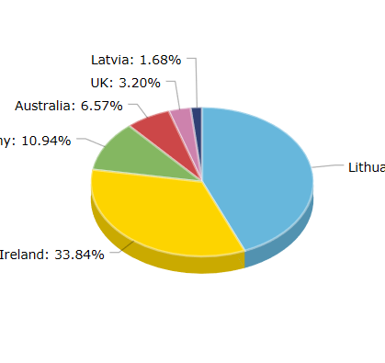

**Message to Admin.**

**This is similar to chat window , this link is in dashboard keep same.**

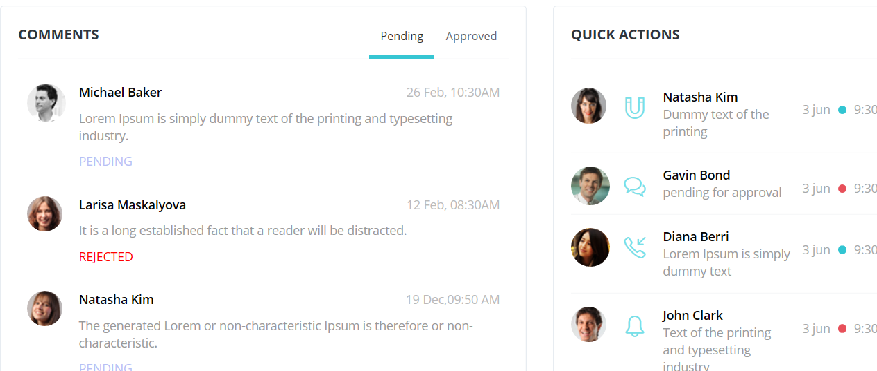

RECE NT JOINEE

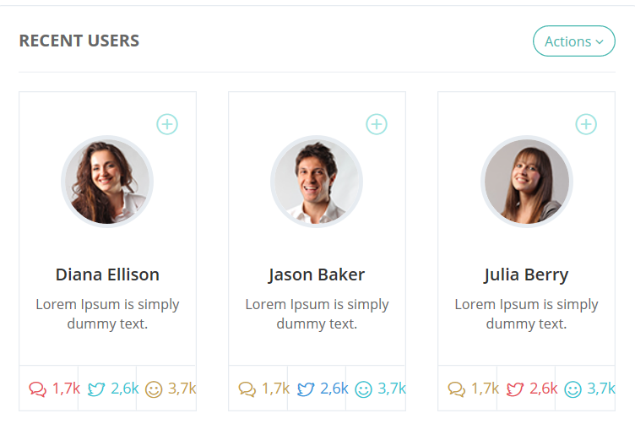

Holiday Calender Show be there ,

Call holiday service and get all the holidays for current years.