PIM-Configuration-Reporting Methods

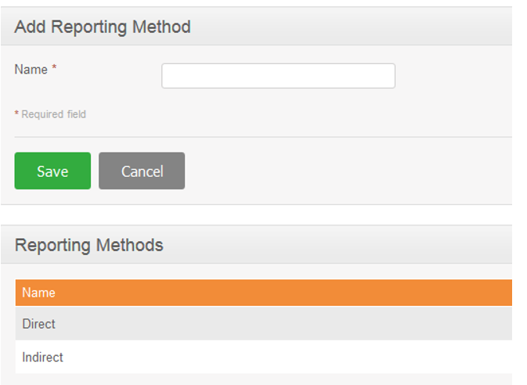

Service Name: com.bytes.hrm.service.pim.EmpReportingMethodService

|  |  |
| --- | --- |
| Add | create |
| Update | update |
| Search | findAll |
|  |  |