PIM-Configuration-Termination Reasons

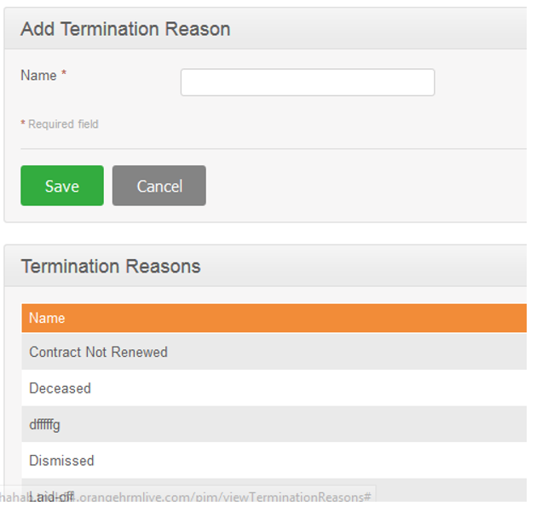

Object : EmpTerminationReason

Service Name : com.bytes.hrm.service.pim.EmpTerminationReasonService

|  |  |
| --- | --- |
| Add | create |
| Search | findAll | |
| Update | update | |