**Status**: Ready For Development. **Pending with** : Shahid

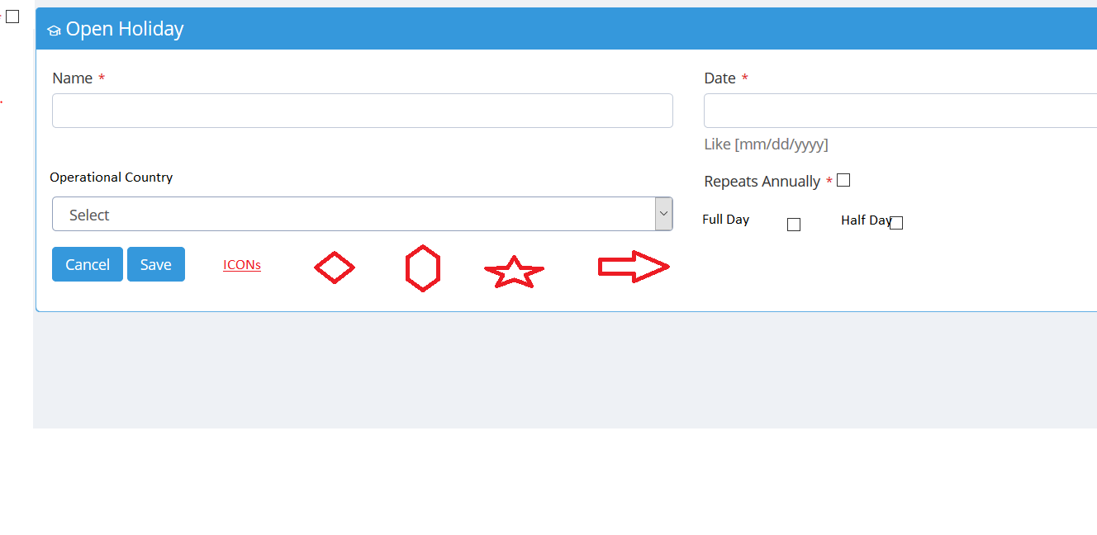

Acceptance Criteria

1. User will be able to select operational country , from table operational_country

As of now default country will be displayed and selected Oman. Icon will be based on country.

All Status Data are available in RefDto. Similarly Country are shown. This Object is available on all screen without writing any action code .

1. Full Day will go in DB as 1 and Half Day will go as 0.

For full day Add -1 and 0 for Half Day. Take dada from UI constant file

1. Holiday Icons will be opened in Popup or icons can be added below the table to select.

As of now only design the page. New filed will be added in DB

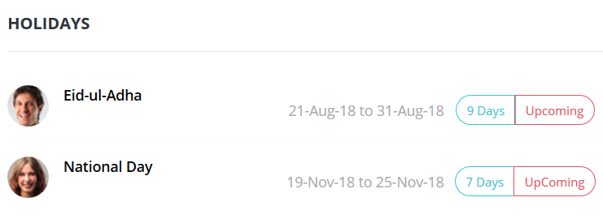

**Service Details**

package com.bytes.hrm.service.leave;

import com.bytes.hrm.dao.entity.Holiday;

import java.util.List;

/**

*

* @author Shahid

*/

public interface HolidayService {

Holiday create(Holiday t);

Holiday read(Integer id);

Holiday update(Holiday t);

void delete(Integer id);

List<Holiday> findAll();

}

|  |  |
| --- | --- |
| Add | Create |
| Search | findAll | |
| Update | Update | |