1. Asset Management-Vendor

**Add Vendor**

Top of Form

Id *

Name *

Contact No

Email

Website

Address

Bottom of Form

1. Asset Mangement- Category

**Add Category**

Top of Form

Id *

Name *

*\** Required field

Bottom of Form

1. Asset Management- Brand

**Add Brand**

Top of Form

Id *

Name *

*\** Required field

Bottom of Form

1. Asset Management-Asset

**Asset Details**

Top of Form

Asset Id *

Serial Number *

Brand

Vendor

Model

Category

Location

▼                

Acquired

Warranty Starts

Warranty Ends

Description

Asigen employee

Assign date

Status

1. Asset Management-Assets

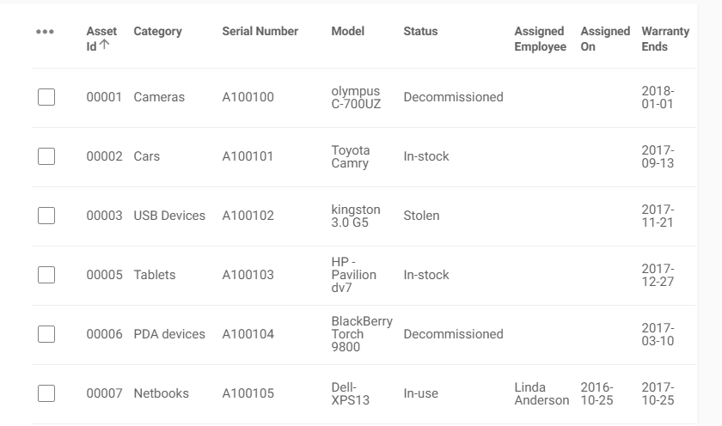

Bottom of Form