Following screen should be build.

1. Need to search employee and show his balance before applying
2. Employee will be searched based on Employee ID in employee table.

DB logic,

When you save transaction table

leave_request leave_leave_entitlementand leaves will be updated

Default status will be id for PENDING APPROVAL from leave_status table.

Default duration_type =8

1. Add two more data field in leave table

start_date

end_date

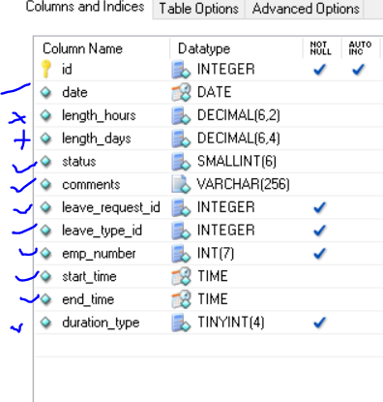

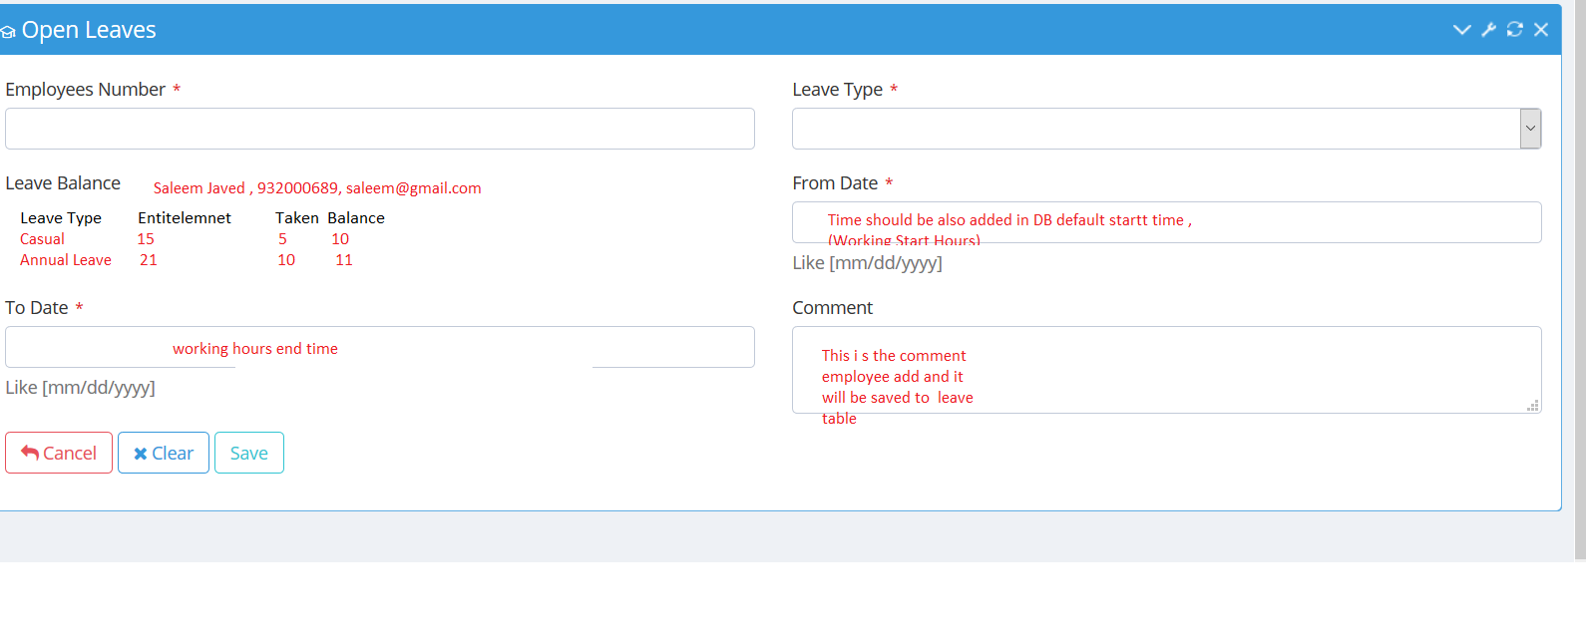

The calculate, actual leave applicable.

1. Remove holidays in applied time span.
2. Calculate how much remaining and update entitlement table.
3. If he do not have leave balance, show message apply other leave for loss of pay. Then user will apply other leave loss of pay if he want, for this salary will be deducted.