Recruitment > Vacancy

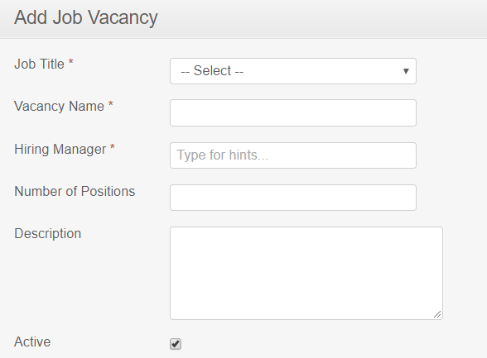

Search List

