|  |  |
| --- | --- |
| **Author** | **Asim Ahmed (SP17-MSCS-0016)** |
| **Course** | **Design Patterns** |
| **Assignment #** | **5** |

**Note: All the diagrams created from https://www.draw.io/**

**State Machine**

A state machine is a concept used in designing computer programs or digital logic. There are two types of state machines: finite and infinite state machines. The former is comprised of a finite number of states, transitions, and actions that can be modeled with flow graphs, where the path of logic can be detected when conditions are met. The latter is not practically used. A state machine is any device storing the status of something at a given time. A finite state machine has finite internal memory. Input symbols are read in a sequence producing an output feature in the form of a user interface. Following is the simple diagram of finite state machine.

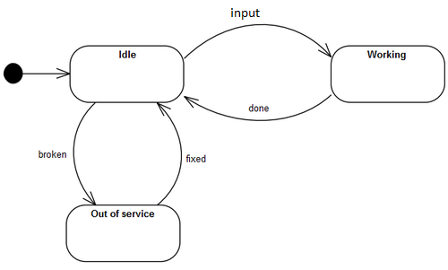

**-------------------------------------------------------- XXXXXXXXXXXXXXXXXXXXXXX------------------------------------------------------**

**ATM Machine States & Actions**

**Actions**

1) Turn On/ Startup 2) Turn Off/Shutdown 3) Card Inserted

4) Self Maintenance 5) Pin Code Entered 6) Cancel Card

7) Authorize Customer 8) Transaction Selected 9) Process Transaction

10) Eject Card

**States**

1) Startup 2) Shutdown 3) Idle

4) Out of Service 5) Pin Code Enter 6) Customer Authentication

7) Transaction Selection 8) Process Transaction 9) Card Ejection

**-------------------------------------------------------- XXXXXXXXXXXXXXXXXXXXXXX------------------------------------------------------**

**ATM Machine’s States & Actions Matrix**

|  |  |  |  |  |  |  |  |  |  |  |
| --- | --- | --- | --- | --- | --- | --- | --- | --- | --- | --- |
| **States/Actions** | **Shutdown** | **Startup** | **Card Inserted** | **Self Maintenance** | **Pin Code**  **Entered** | **Cancel Card** | **Authorize Customer** | **Transaction Selected** | **Process Transaction** | **Eject Card** |
| **Shutdown** | Shutdown | Startup | - | - | - | - | - | - | - | - |
| **Startup** | Shutdown | Idle | - | - | - | - | - | - | - | - |
| **Idle** | Shutdown | - | Pin Code Enter | - | - | - | - | - | - | - |
| **Out Of Service** | Shutdown | - | - | Idle | - | - | - | - | - | - |
| **Pin code Enter** | Shutdown | - | - | - | Customer Authentication | Eject Card | - | - | - | - |
| **Customer Authentication** | Shutdown | - | - | - | - | Eject Card | Transaction Selection | - | - | - |
| **Transaction Selection** | Shutdown | - | - | - | - | Eject Card | - | Process Transaction | - | - |
| **Process Transaction** | Shutdown | Startup | - | - | - | Eject Card | - | - | Eject Card | - |
| **Eject Card** | Shutdown | Startup | - | - | - | - | - | - | - | Idle |

**-------------------------------------------------------- XXXXXXXXXXXXXXXXXXXXXXX------------------------------------------------------**

**States Diagram of ATM Machine**

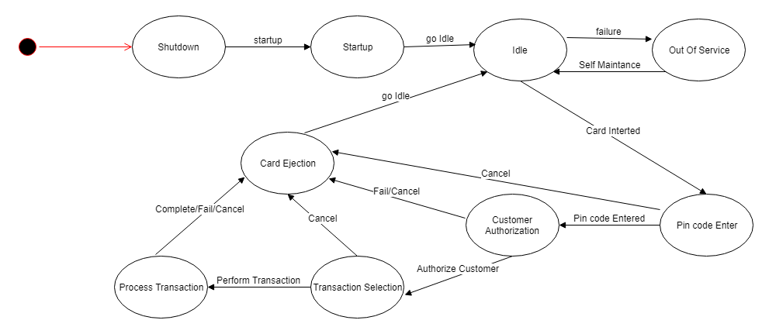

**ATM Machine’s Class Diagram**

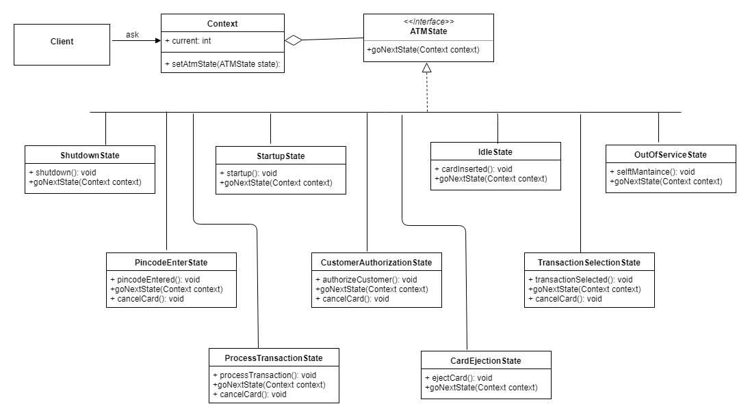

**-------------------------------------------------------- XXXXXXXXXXXXXXXXXXXXXXX------------------------------------------------------**