POWER BI PORTFOLIO CASE STUDY
Ahmed Aslam | Business Intelligence Portfolio | August 2026
Real public data | Illustrative business scenario | Portfolio project
GCC Port Efficiency &
Diversion Readiness
A decision support dashboard built from World Bank CPPI data, 2020-2025

Executive Summary
- The dashboard consolidates six years of CPPI data into a clear view of GCC port performance, deterioration risk and regional peer positioning.
- The 2025 GCC average recovered to 55.98 from 47.38 in 2024, but performance remained uneven: Salalah led the region at 135.87 while two ports deteriorated year on year.
- For a Jebel Ali disruption scenario, the model shortlisted 11 data eligible alternatives and ranked Salalah first with a readiness score of 89.0. The score is a performance screen, not a substitute for operational feasibility assessment.

Headline metrics
2025 GCC average CPPI: 55.98
Top GCC score - Salalah: 135.87
Ports deteriorating YoY: 2
Eligible alternatives: 11

BUSINESS CONTEXT

The region recovered in 2025, but the headline average masks material variation
The scenario assumes a regional importer needs an early warning view of port efficiency and a repeatable way to screen alternatives when a primary gateway is disrupted. The report was designed to support three decisions: where performance is weakening, how a selected port compares with relevant peers, and which alternatives warrant operational review.
The 2025 GCC average rose by 8.60 points from the 2024 low but remained 31.61 points below the 2020 average. Salalah, Hamad Port and Khalifa Bin Salman Port led the 2025 ranking. Dammam and Shuaiba were the two ports with a negative year on year movement.
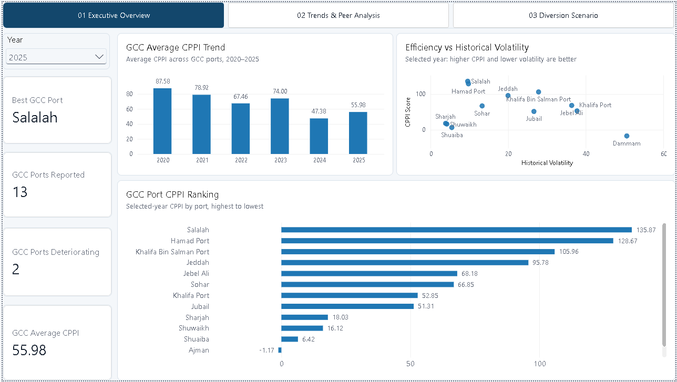
Figure 1. Executive overview - selected-year GCC performance, volatility and ranking.
Decision use
The overview works as a monitoring layer. It directs attention to outliers and deteriorating ports before a user moves into peer diagnostics or disruption planning.

DATA AND SEMANTIC MODEL

A compact star schema separates reusable dimensions from annual and diagnostic facts
The source is the World Bank CPPI 2025 Annex, which contains 426 port records and 20 fields, including CPPI scores for 2020-2025, maritime service regions, 2025 ranking and diagnostic index components. The portfolio scenario focuses on six GCC countries. Thirteen ports have a reported 2025 score, King Abdullah Port is present historically but has no 2025 score.
In Power Query, the annual score columns were reshaped into a port year fact table while the 2025 diagnostic fields were retained at port grain. Port and year dimensions provide consistent filtering across both facts. Disconnected selector tables support scenario logic without creating ambiguous relationships.
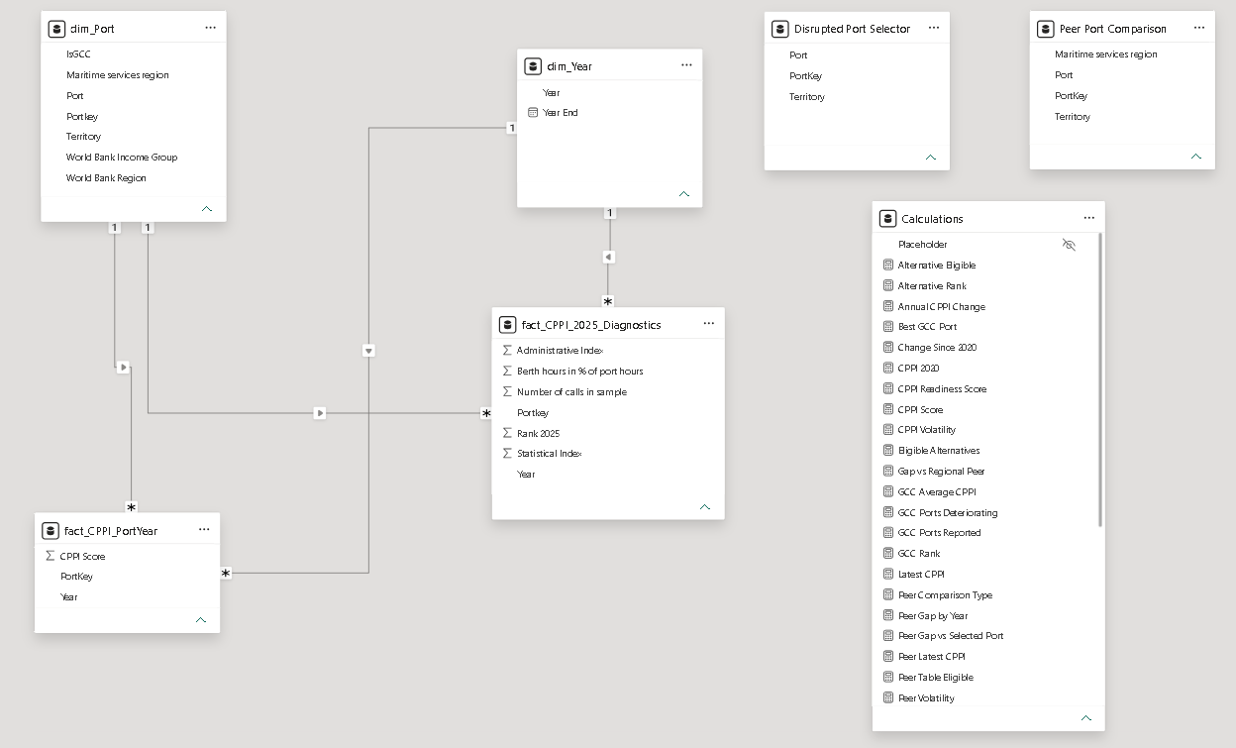
Figure 2. Power BI semantic model - dimensions, fact tables, scenario selectors and measure table.
- Grain control: annual trends are stored at one row per port and year, 2025 diagnostics remain at one row per port.
- Filter design: one to many, single direction relationships keep context predictable and reduce double counting risk.
- Measure governance: business calculations are grouped in a dedicated Calculations table rather than spread across source tables.

TREND AND PEER ANALYSIS

Jebel Ali's 2025 rebound is strong, but the six-year pattern remains volatile
Jebel Ali improved from -7.00 in 2024 to 68.18 in 2025, a year-on-year increase of 75.18 points. Its latest score sits 28.30 points above the 39.88 average for other ports in the same maritime services region.
The recovery should not be interpreted in isolation. Jebel Ali remains 33.82 points below its 2020 score and has a six-year volatility measure of 36.39. The report therefore presents both current performance and historical stability, avoiding a recommendation based on a single year rebound.
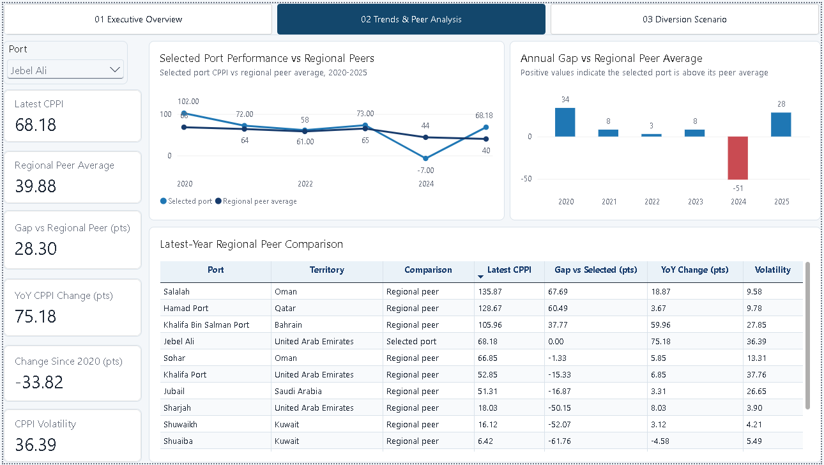
Figure 3. Selected port trend, annual peer gap and latest year peer comparison.
Interpretation
The current position is encouraging, but the volatility and remaining gap to the 2020 level justify continued monitoring rather than treating the recovery as established.

DIVERSION SCENARIO

The readiness model narrows the candidate set; it does not make the routing decision
The disruption page uses a disconnected port selector so the selected gateway can be removed from the candidate set without filtering away the alternatives. Candidates also require enough current and historical data to calculate the component measures.
The readiness score combines the latest CPPI (50%), historical stability (30%), and recent trends (20%). For Jebel Ali, 11 alternatives qualify. Salalah ranks first at 89.0, followed by Hamad Port at 71.0 and Khalifa Bin Salman Port at 66.0. Because the components are balanced, the output is not simply a restatement of the latest CPPI ranking.
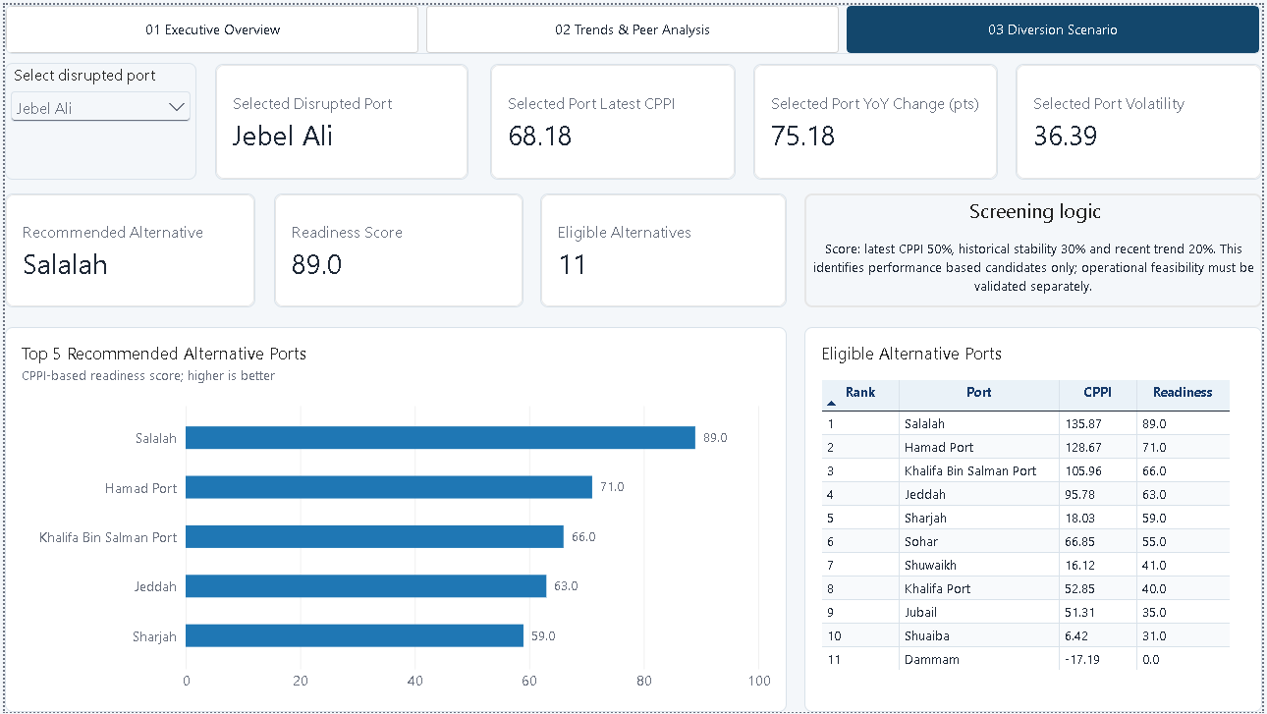
Figure 4. Diversion scenario - weighted readiness screen and eligible alternatives.
Control point
Before any diversion decision, the shortlist must be tested for spare capacity, sailing distance, service coverage, cargo compatibility, customs, inland transport and total cost.

DRILLTHROUGH AND EXPLAINABILITY

Salalah combines the strongest current score with comparatively low volatility
The drillthrough page provides evidence behind the recommendation. Salalah records a 2025 CPPI score of 135.87, ranks first among the GCC ports in scope and is 101.63 points above its regional peer average. Its volatility measure of 9.58 is materially lower than Jebel Ali's 36.39.
Salalah also improved by 18.87 points year on year, although its latest score remains 5.13 points below 2020. Showing the full annual history allows a user to distinguish a strong candidate from a flawless one and avoid hiding counterevidence.
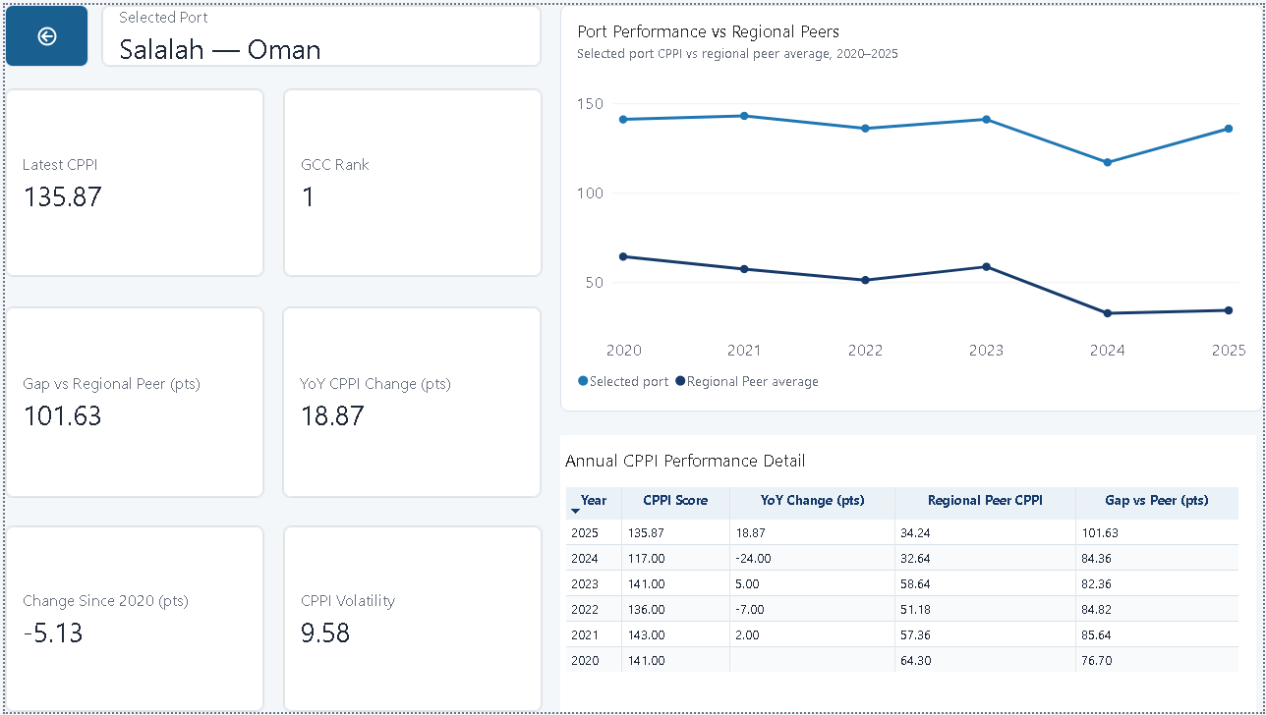
Figure 5. Port drillthrough - annual performance, GCC rank, peer gap and volatility.
User experience
Right click drillthrough keeps the overview uncluttered while giving analysts and managers a consistent route from a ranking to the supporting port history. The back button returns the user to the originating page.

TECHNICAL IMPLEMENTATION

The solution uses context-aware measures and clear metric definitions
Power Query handles reshaping, data typing, port keys, and the GCC scope. DAX measures respond to year, port and scenario selections while preserving the comparison population required for ranks and peer averages. The report uses dynamic filters, conditional color for negative peer gaps, sorted ranking visuals, and a hidden drillthrough page.

Metric definitions
GCC average CPPI. Unweighted mean of nonblank port scores for the selected year. Tracks regional direction.
YoY change (pts). Selected year CPPI less than the previous year score. Flags for improvement or deterioration.
Change since 2020 (pts). The latest/selected score is less than 2020 baseline. Shows longer term recovery or decline.
CPPI volatility. Sample standard deviation of available annual CPPI scores, 2020-2025. Separates stable from erratic performance.
Regional peer average. Average for the same maritime service region, excluding the selected port. Provides a context aware benchmark.
Gap vs peer (pts). Selected-port score less its regional peer average. Quantifies relative position.
Readiness score. Weighted screen: latest CPPI 50%, stability 30%, recent trend 20%. Prioritizes alternatives for validation.

Quality assurance
- Reconciled the 2025 GCC average to 55.98 across the 13 ports with a reported current score.
- Spot checked year-on-year changes, changes since 2020, peer gaps, and sample volatility for Jebel Ali and Salalah.
- Tested slicer behavior, ranking order, selected port exclusion, drillthrough context and back button navigation.
- Standardized point units, decimal precision, colors, visual titles, and page navigation across the report.

RECOMMENDATIONS AND LIMITATIONS

Use the report as an early warning and screening layer, then add operational evidence
The dashboard is useful for monitoring and shortlisting. It becomes stronger when paired with operational, route, and cost data that can confirm whether a high performing port is genuinely viable for a specific shipment profile.

Recommended next steps
- Investigate the drivers behind Dammam's and Shuaiba's 2025 deterioration before the next planning cycle.
- Validate Salalah, Hamad Port and Khalifa Bin Salman Port against capacity, service schedules, cargo constraints, customs, inland connectivity and total landed cost.
- Add call volumes, berth waiting time, route distance and disruption status to move from performance screening toward operational decision support.
- Refresh the model with each annual CPPI release and monitor missing data coverage before comparing year-on-year results.

Caveats and assumptions
- The CPPI is a port level benchmark based on vessel time in port. It identifies performance gaps but does not establish their causes.
- External conditions - including route changes, weather, labor constraints and geopolitical disruption - can affect scores.
- The GCC average is an unweighted port level mean, and historical averages use the observations available each year.
- The readiness score is a transparent performance screen; it does not measure route feasibility, cargo compatibility, capacity, or cost.
DATA ATTRIBUTION
World Bank CPPI 2025 overview and dataset
World Bank CPPI 2025 publication
CPPI Methodology Note, June 10, 2026

