|  |  |
| --- | --- |
| A picture of a winding road and trees  document part I | project name  Image encryption and compression  Course  Algorithms analysis and design |

Contents

NAMES SECTION’S NUMBER 1

• Encryption and Decryption 3

Functions 3

outputs 6

* Encryption and Decryption andddddddddddddddddddddddddddddddddddddand

## Functions

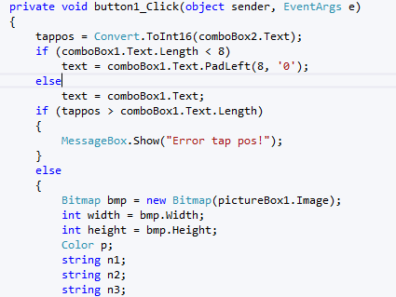

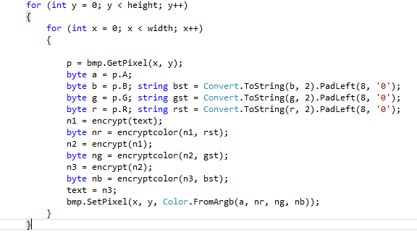 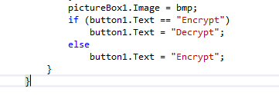

--We tried to decrease the running time as possible which is =ceta (height*width) =>worst case =O(n^2)

--Knowing that function encrypt color iterates till a constant value which is 8 so O(8)=1

The complexity for the if and else part=max(case1,case2)=o(1)

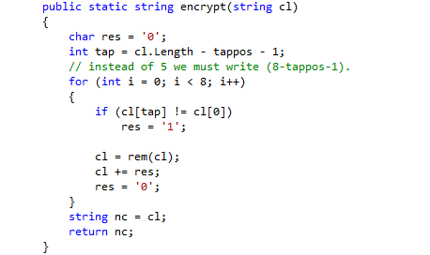

The complexity of the above function is O(8*N)=O(N)

All other thing inside loop are O(1)

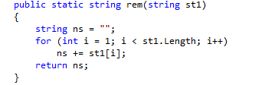

The complexity of the above function is O(N)

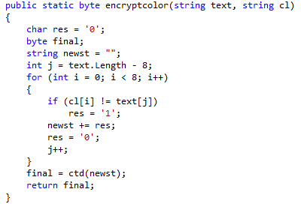

The complexity of that function is =O(8)=O(1) because each time iterating 8 times only

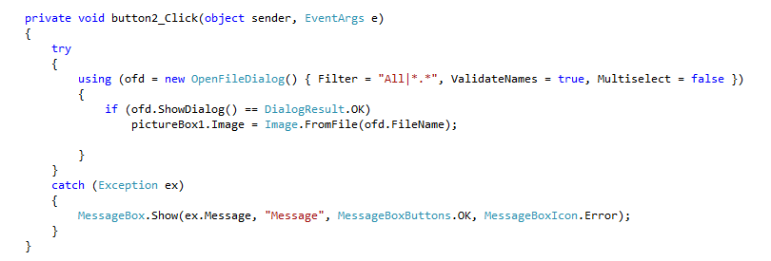

## outputs

