

**Faculty of engineering - Shoubra**

**Benha University**

**Research Article**

in fulfillment of the requirements of

|  |  |
| --- | --- |
| **Department** | **Engineering Mathematics and Physics** |
| **Division** |  |
| **Academic Year** | **2019-2020 Preparatory** |
| **Course name** | **COMPUTER** |
| **Course code** | **ECE001** |

**Title: -**

**Artificial intelligence**

By:

|  |  |  |  |
| --- | --- | --- | --- |
|  | Name | Edu mail | B.N |
| 1 | Ahmed awad okasha elsayed | Ahmed195106@feng.bu.edu.eg | 103 |

**Approved by:**

|  |  |
| --- | --- |
| Examiners committee | Signature |
| Dr.Ahmed Bayoumi |  |
| Dr.Shady Elmashad |  |
| Dr. Abdelhamid Attaby |  |
|  |  |
|  |  |

**Abstract**

Artificial intelligence (AI) is the simulation of human intelligence processes by machines, especially computer systems. Specific applications of AI include expert systems, natural language processing (NLP), speech recognition and machine vision.

Some industry experts believe the term artificial intelligence is too closely linked to popular culture, and this has caused the general public to have improbable expectations about how AI will change the workplace and life in general. Some researchers and marketers hope the label augmented intelligence, which has a more neutral connotation, will help people understand that most implementations of AI will be weak and simply improve products and services.

artificial intelligence was founded as an academic discipline in 1955, and in the years since has experienced several waves of optimism, followed by disappointment and the loss of funding followed by new approaches, success and renewed funding.[11][14] For most of its history, AI research has been divided into sub-fields that often fail to communicate with each other. These sub-fields are based on technical considerations, such as particular goals, the use of particular tools ("logic" or artificial neural networks), or deep philosophical differences. Sub-fields have also been based on social factors (particular institutions or the work of particular researchers).

Artificial Intelligence is likely the foremost complex and astonishing creations of humankind however. Which is neglecting the fact that the field remains to a great extent unexplored, which implies that each astounding AI application that we see nowadays speaks to just the tip of the AI ice sheet, because it were. Whereas this reality may have been expressed and rehashed numerous times, it is still difficult to comprehensively gain point of view on the potential affect of AI within the future. The reason for this can be the progressive affect that AI is having on society, indeed at such a moderately early arrange in its advancement.

Source code:

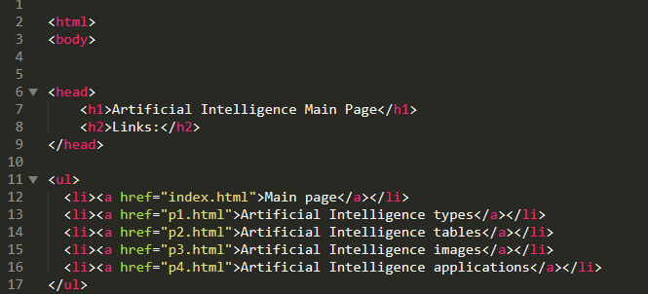

Screenshots:

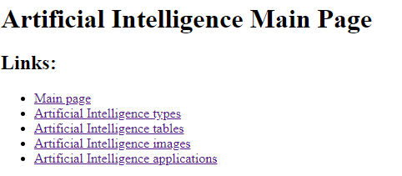

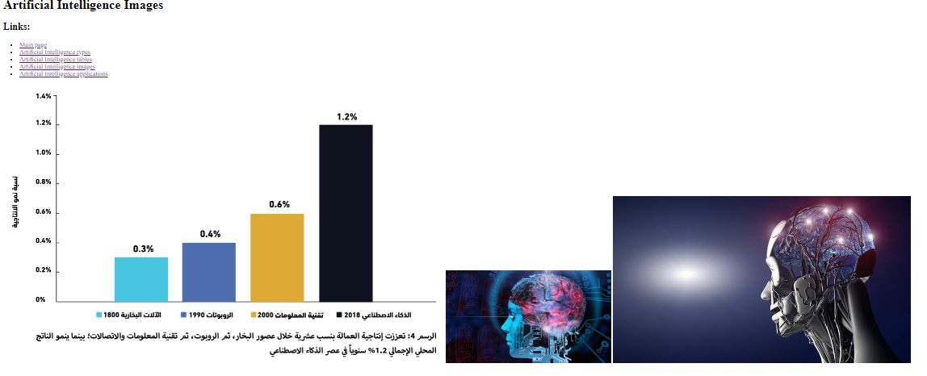

**Layout and formatting**

**(Guide, don’t include this page in your research)**

Use this template

**Paper:** A4

**Margins:** 2.5 cm all from top and bottom

**1.**9 cm from left and right

**Line spacing:** 1.5

**Font:** Time New Roman

**Font size:** 14 (Except headings)

**No of pages:**Between 5 and 10 pages (Not including cover)