**Name : ahmed awad okasha elsayed**

**B.N: 103**

**Date : 22/5/2020**

**Topic:** artificial intelligence

**Github link :**

**Github page :**

**Application brief :** Artificial intelligence (AI) is the simulation of human intelligence processes by machines, especially computer systems. Specific applications of AI include expert systems, natural language processing (NLP), speech recognition and machine vision.

Some industry experts believe the term artificial intelligence is too closely linked to popular culture, and this has caused the general public to have improbable expectations about how AI will change the workplace and life in general. Some researchers and marketers hope the label augmented intelligence, which has a more neutral connotation, will help people understand that most implementations of AI will be weak and simply improve products and services.

**Screenshots:**

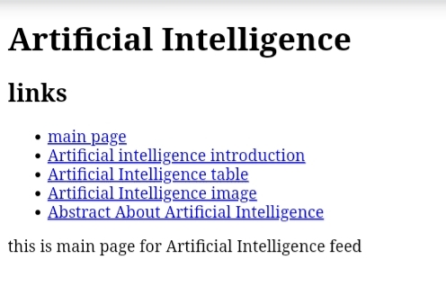

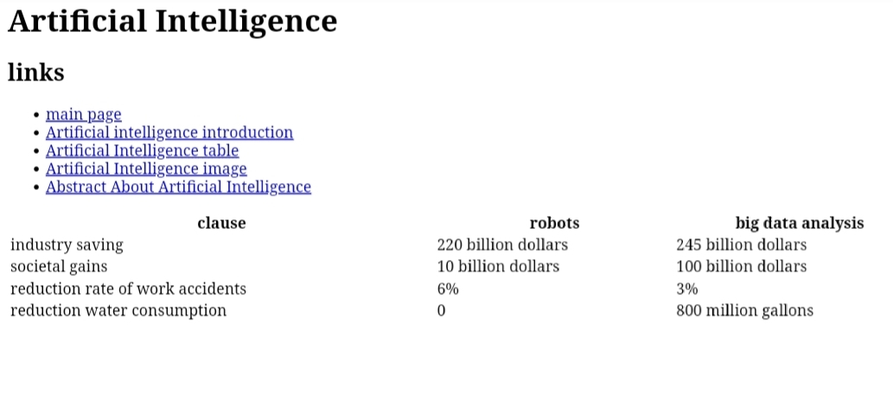

**Source code:**

