|  |
| --- |
| JB Games |
| Unity Final Project |
| **Desert Escape** |
| Version #01  All work Copyright © 2015 by AJ Games.  All rights reserved. |
| **By: Benzir Ahmed & Jefferson Chin** |
|  |

|  |
| --- |
| Monday, October 5, 2015 |

**Table of Contents**

|  |  |
| --- | --- |
| 1. Version History | 3 |
| 1. Game Overview | 4 |
| 1. Gameplay Mechanics 2. Controls 3. Interface Sketch 4. Menu and Screen Descriptions | 4  4  5  6 |
| 1. Levels 2. Characters 3. Enemies 4. Items | 6  6  6  7 |
| 1. Scoring 2. Sound Index 3. Story Index 4. Art / Multimedia Index 5. Future Features 6. Optional Game Features | 7  7  7  8  8  8 |
|  |  |
|  |  |
|  |  |
|  |  |
|  |  |

1. **Version History**

**GITHUB LINK:**

**September 25, 2015:**

1. Asset collection:
2. Map: https://www.assetstore.unity3d.com/en/#!/content/25935
3. Coin: <https://www.assetstore.unity3d.com/en/#!/content/38689>
4. Plane: <https://www.assetstore.unity3d.com/en/#!/content/23913>
5. Mine: https://www.assetstore.unity3d.com/en/#!/content/37653
6. Music
7. Collision with obstacle & Collect Coin:
8. Game Background Music:
9. Collect Life Sound:
10. Assignment 3, 3D game project created:
11. Project folders
12. Imported Assets
13. Created Main Scene
14. Created Player, Obstacle, Background, Coin

**December 1, 2015**

Added 5 game scripts:

1. PlayerCollider.cs (Controls player collisions, audio, life, score)
2. CoinController (Destroys the coin game object on collision)
3. MineController (Destroys the mine game object on collision)
4. **Game Overview**

This game is a simple 3D game built on the Unity 5.2 Version. In this 3D game you will control a player and your main objective will be to collect as many coins as you can while you avoid colliding with the enemy. Collecting a gold coin will award you 10 points. An item in a shape of a heart will randomly spawn on some platforms, collecting it will add 10 hit points to your counter. Your player will have life counters and each time your player collides with an enemy the life counter will decrease by 20 HP. Falling from the platform will result in an instant game over. When you have no more remaining lives left the game will end. The player can restart at any time or when the game ends by pressing the letter ‘R’.

1. **Game Play Mechanics**

Collecting a gold coin will award you 10 points. An item in a shape of a heart will randomly spawn, collecting it will add 10 HP to your counter. Your player will have 100 HP and each time he collides with an enemy the life counter will decrease by 20 HP, when you have no more remaining lives left the game will end. If the player falls off the platform he will instantly lose all his remaining lives and the game will end. The player can restart the game whenever the game ends by pressing the letter ‘R’.

1. **Controls**

The controls will be keyboard only. The following controls are:

* LEFT: A or the ← arrow key
* RIGHT: D or the → arrow key
* FORWARD: W or the ↑ arrow key
* BACK: S or the Down key

1. **Interface Sketch**
2. **Menu and Screen Descriptions**

This is a screenshot of the game when it is in the start state:

This is a screenshot of the game when it is in the gameplay state:

This is a screenshot of the game when it is in the end state

1. **Levels**

There will be three levels in our game. The first level will be a basic level to introduce you to the game. There will be enemies and coins for you to collect. At the end there will be a portal to teleport you to the next level.

1. **Characters**

The main character you will be playing as is a bodiless character.

1. **Enemies**

The main enemy in level 1 will be mine. The mine will spawn across the platform. As you move on to the next levels you will face more challenging enemies.

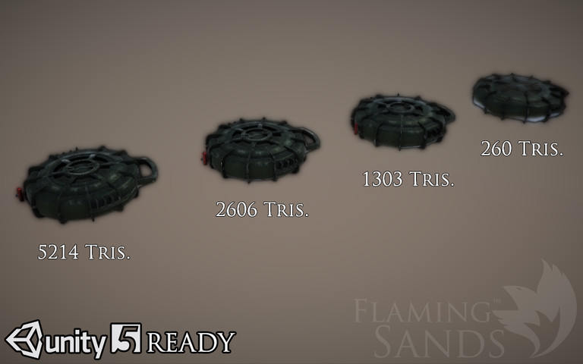

1. **Items**

Gold Coin – Awards 10 points

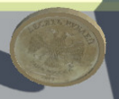

Extra Life – Awards 10 Life

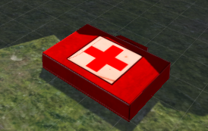

1. **Scoring**

The player can score by collecting the coins that keep spawning across the map. A gold coin awards 10 points. There is also a chance to get an extra life from collecting a first aid shaped icon.

1. **Sound Index**

These are all the songs we used in our game:

None at moment

1. **Story Index**

You are playing as a lost person who is the lone survivor from plane crash. You trying to find a way out of the desert. You are travelling towards the structures to look for shelter and a way out.

1. **Art / Multimedia Index**

Below are all the images we used to create the first level:

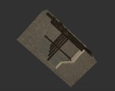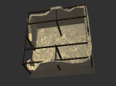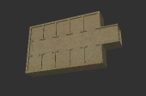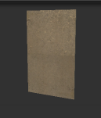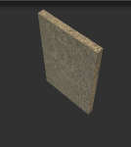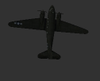

1. **Future Features**

For our future levels we plan to add traps, as well as faster and stronger enemies to beat that follows you. The map structure will also be more challenging to navigate.

1. **Optional Game Features (i.e. Potential Bonus Marks).**

We have added an optional game feature which is a survival mode. When the player faces countless AI monsters.