ASUS

[Company name]  [Company address]

Statistics-projectby R-language



|  |  |  |
| --- | --- | --- |
|  | Name | Section |
| First Member | **Nasser Abdullah Muhammad** | **18** |
| Second Member | **Ahmed Ibrahim Ahmed Ali Badawy** | **1** |
| Third Member | Muhammad Fathy Abd El Aziz | 14 |
| Fourth Member | **Mayar Ashraf Zakarya** | **18** |
| Fifth Member | **Nada Muhammad Kamal** | **18** |

**Resources**

* Links

1-<https://uc-r.github.io/t_test>

2-<https://rpubs.com/moeransm/intro-iris>

3-<https://www.statmethods.net/>

* You_tube
* https://www.youtube.com/watch?v=X67No4239Ys&list=PL6gx4Cwl9DGCzVMGCPi1kwvABu7eWv08P

**Step 1. Descriptive Statistics**

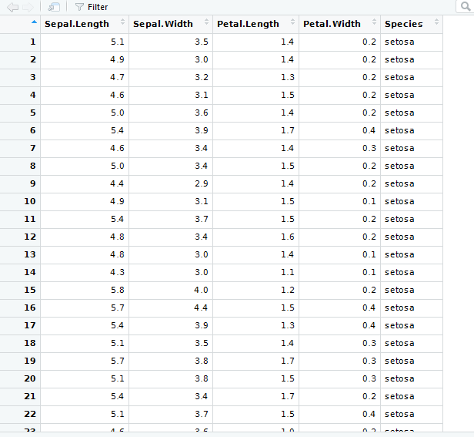

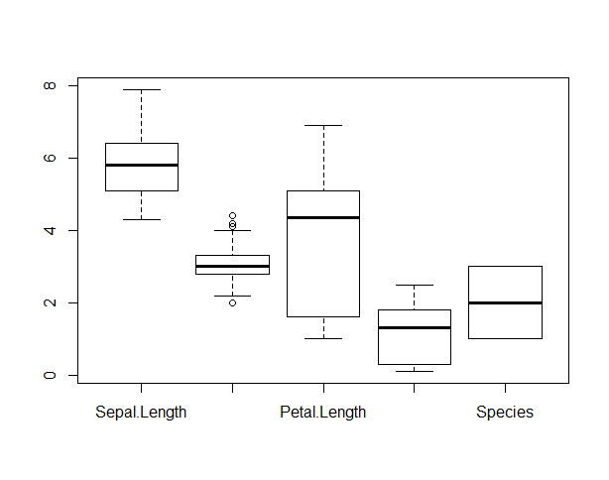

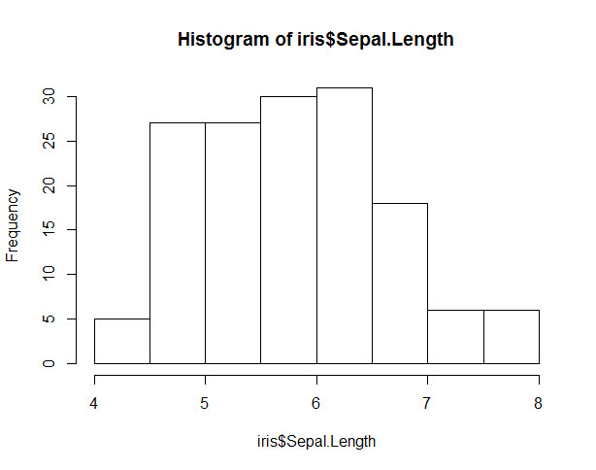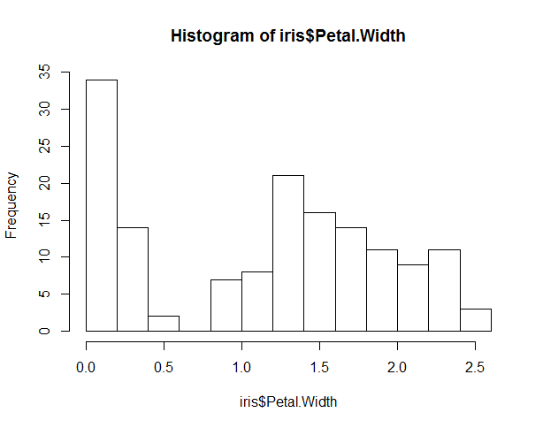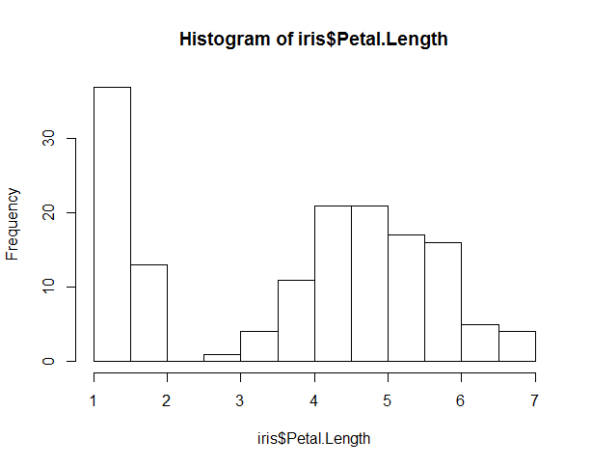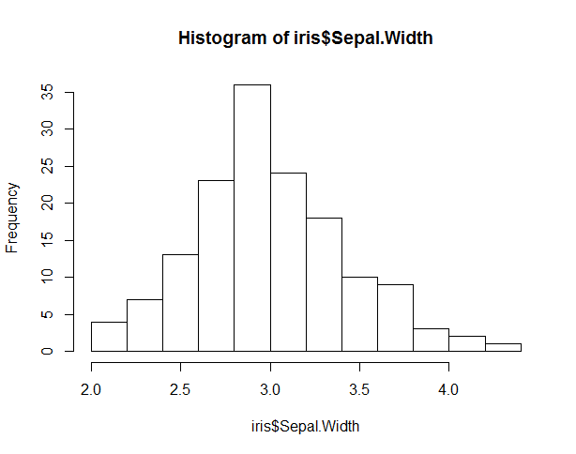

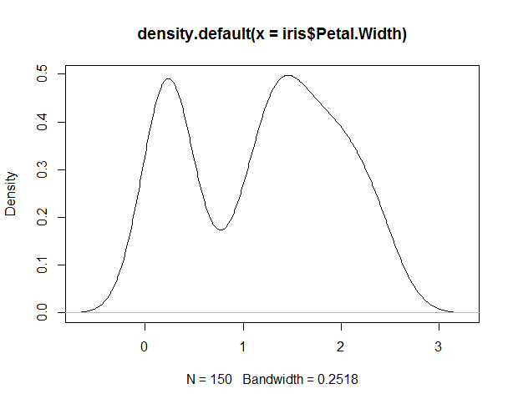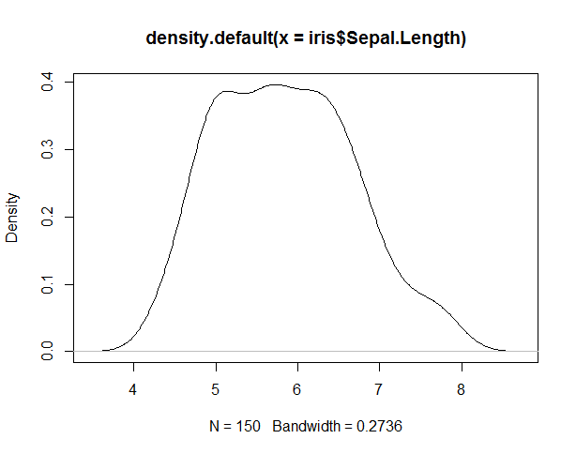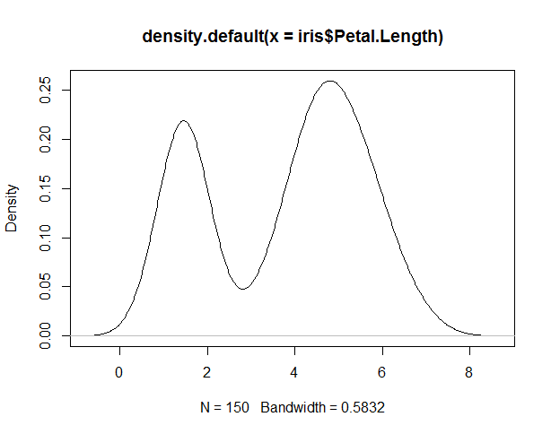

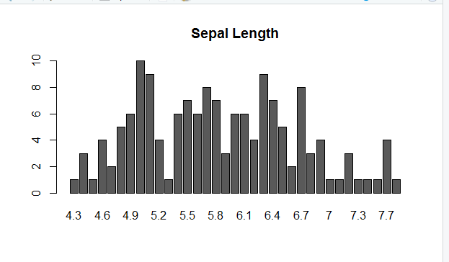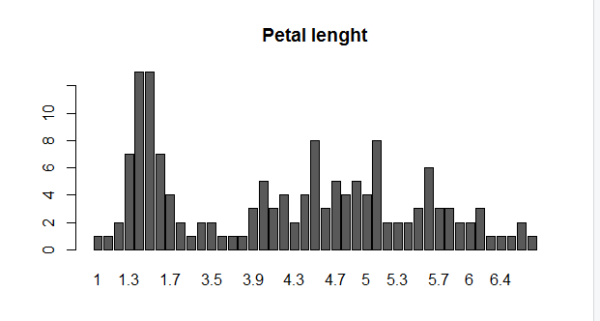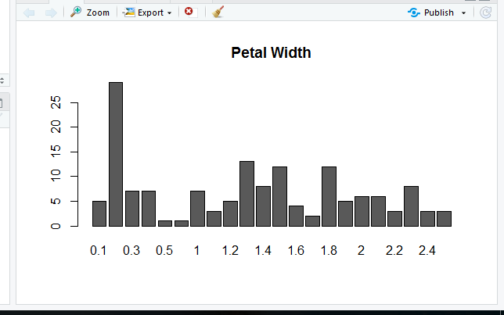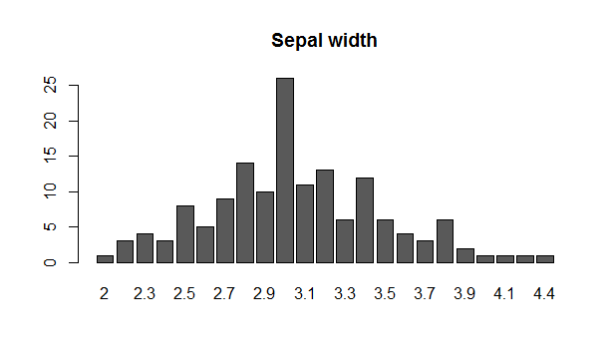

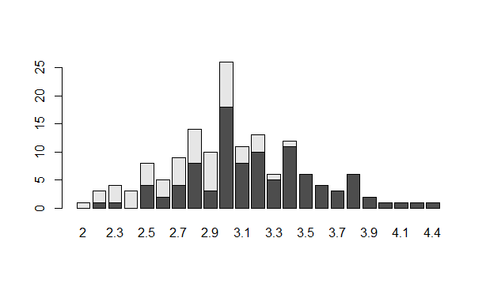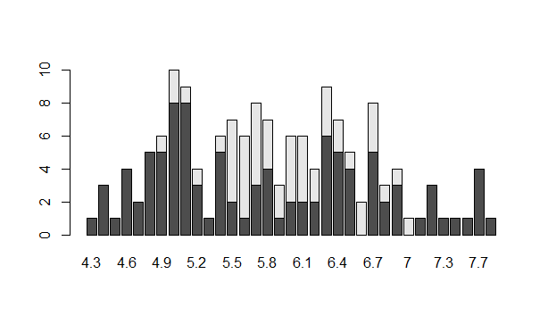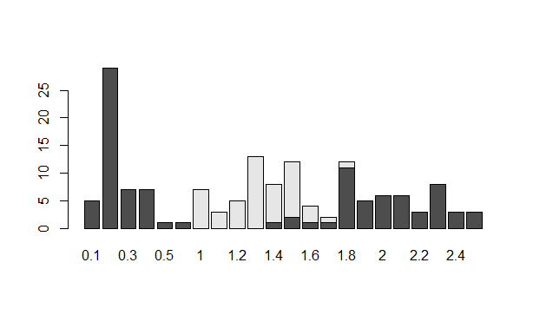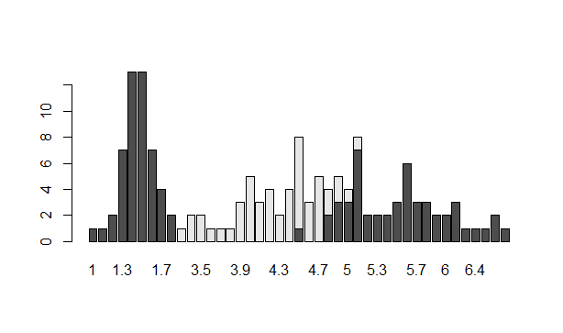

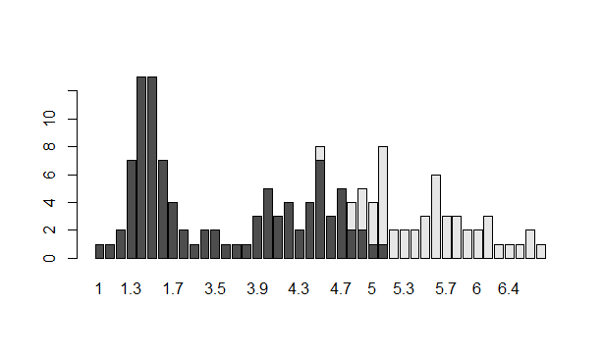

**Step 2. Correlations**

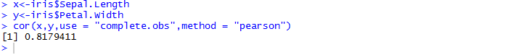

**Step 3. Inferential Statistics**

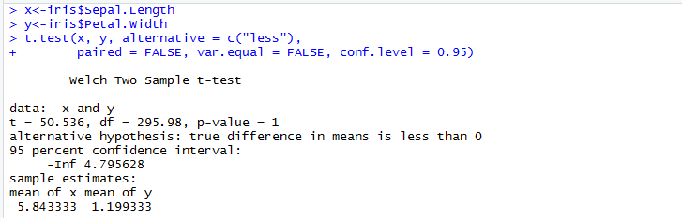

Summary

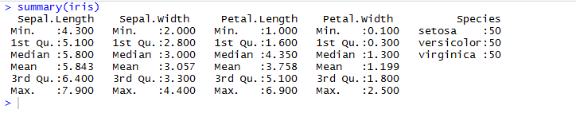**Bonus tasks**:

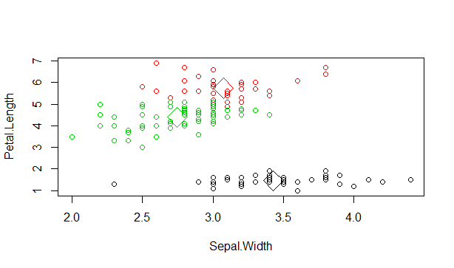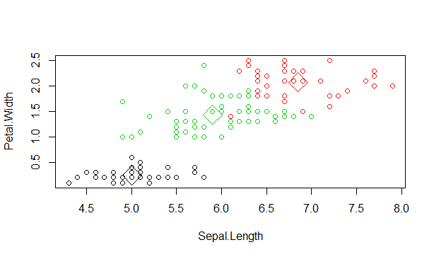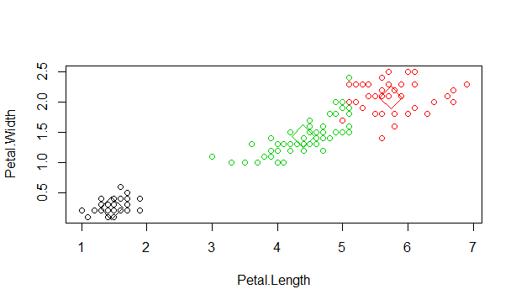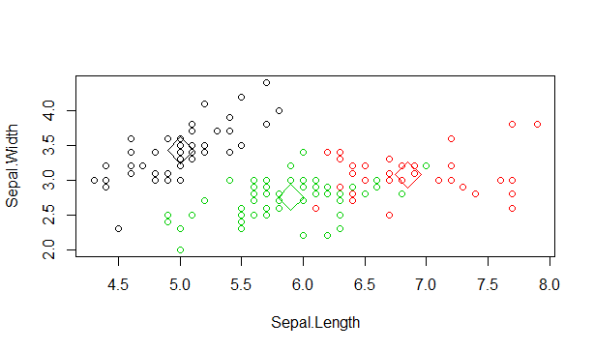

***conclusion***

From this analysis, we can determine some statistical properties contained within a dataset. For instance, in looking at the Petal Length data, we can see that for a mean value of 3.76, the variance (spread of the distribution) is large at 3.0. Another example is with the Sepal Width. With a mean value of 3.0, the variance is very small at .18. You would expect the clusters of data points to be centered around the mean. In evaluating the Iris dataset, We found it important to be able to reference graphs of the data with the statistical analysis run from the application. In the future, it would be a nice feature to be able to add visualization with the analysis, instead of static graphs generated in Excel. Along with the framework mentioned earlier in the article, having the data stored in R render the data would be a nice step in creating interactive visualizations of the data.