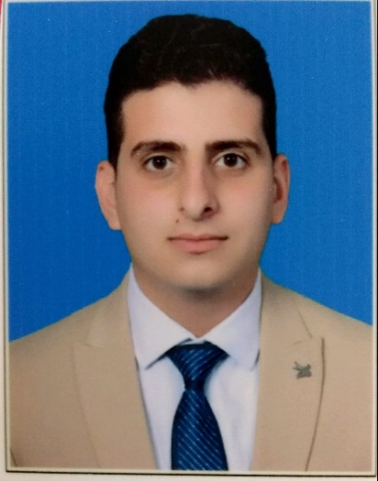

**Summary**

Junior back-end web systems developer, with a background in systems analysis and web application development.

**Technical skills**

|  |  |
| --- | --- |
| * C#. * Asp.net core. * Asp.net core MVC. * Database analysis. * Git. | * Familiar with Angular. * Microsoft SQL Server. * OOP. |

**Skill Highlights**

|  |  |
| --- | --- |
| * Computer proficiency. * Leaders. * Complex problem solver. * Analysis and discussion. | * Communication. * Teamwork. * work under pressure. * Programing. |

**Work Experience**

* Balousha Foundation, System Developer **12,2021-1,2022**

Building law firm management application.

* Working for the crazy car company to building a car rental company management application2/2022-4/2022.
* Working on building a restaurant application and executing orders for 11/2022 - until now.
* Work for the Hult Prize Foundation- 9/2020 to 2/2021 Social media manger.
* Work for the Ana Jawwal Program-09/ 2019 - 03 2020 Social media manager and Content writer.

**Business**

* [Ahmed B. - Web Develober - Upwork Freelancer from Gaza, Palestinian Territories](https://www.upwork.com/freelancers/~01618df24edc3a8c60)
* [Ahmed Faraj Balousha | مستقل (mostaql.com)](https://mostaql.com/u/ahmed_bal)
* [ahmedbalousha (ِAhmed Balousha) (github.com)](https://github.com/ahmedbalousha)
* [(21) Ahmed Balousha | LinkedIn](https://www.linkedin.com/in/ahmed-balousha-789a811b8/)

**AHMED-FARAJ BALOUSHA**

Back-End Web Developer

**Contact**

**Address:**

Gaza, Palestine

**Phone:**

+970592554516

**Postal Code:**

P860

**Email:**

[abalousha4@gmail.com](mailto:abalousha4@gmail.com)

**Date of Birth:**

24/1/2000

**Languages**

English –medium

Arabic-mother language

**Referees**

Abeer AL Abyad

+972599445349

Upon request