

**كلية العلوم الحاسوبية والمعلوماتية**

Faculty of CSI

Skill Hub

*Students:*

|  |  |
| --- | --- |
| * Ahmed Mohamed Fayez Al-Mahmoud 202220296 * Rahaf Majed Omar AbuShawish 202220368 * Sahar Wesam Hasan Hasan   202220185 |  |
|  |  |

*Supervisor:*

Dr. Ahmad Al-Ajarameh

*Amman - Jordan*

*2024/2025*

**Table of Contents**

1.1 Problem Statement and project Scope page 1

1.2 Project Plan and Schedule

2. System Analysis page 2

2.1 Functional Requirements

2.2 Use Case Diagram

3. System Design page 3

3.1 Class Diagram

3.2 ER-Diagram (if a database will be used)

3.3 User Interface

* 1. Problem Statement and project Scope

The system has been facing problems due to its paper-based appointment

system. With the increase in the number of patients visiting, it has

become diﬃcult to manage the appointment system manually. Recording

of appointments and creating registers by pen and paper has become a

Problem Statement : Many individuals face challenges in securing job opportunities when trying to offer their services and skills directly. Additionally, limited resources are available for them to effectively promote their work and attract potential clients.

The scope of the SkillHup : platform includes creating a user-friendly and visually appealing environment that allows individuals to showcase their skills and services effectively. It aims to increase job opportunities by providing tools to promote their work and attract potential clients. Additionally, the platform facilitates communication and collaboration among individuals from diverse backgrounds, fostering knowledge exchange and cooperation across various fields.

* 1. Project Plan and Schedule

Figure 1: Gantt Chart of project

This Gantt Chart illustrates the sequence of tasks and activities for the project, along with the time duration for each.

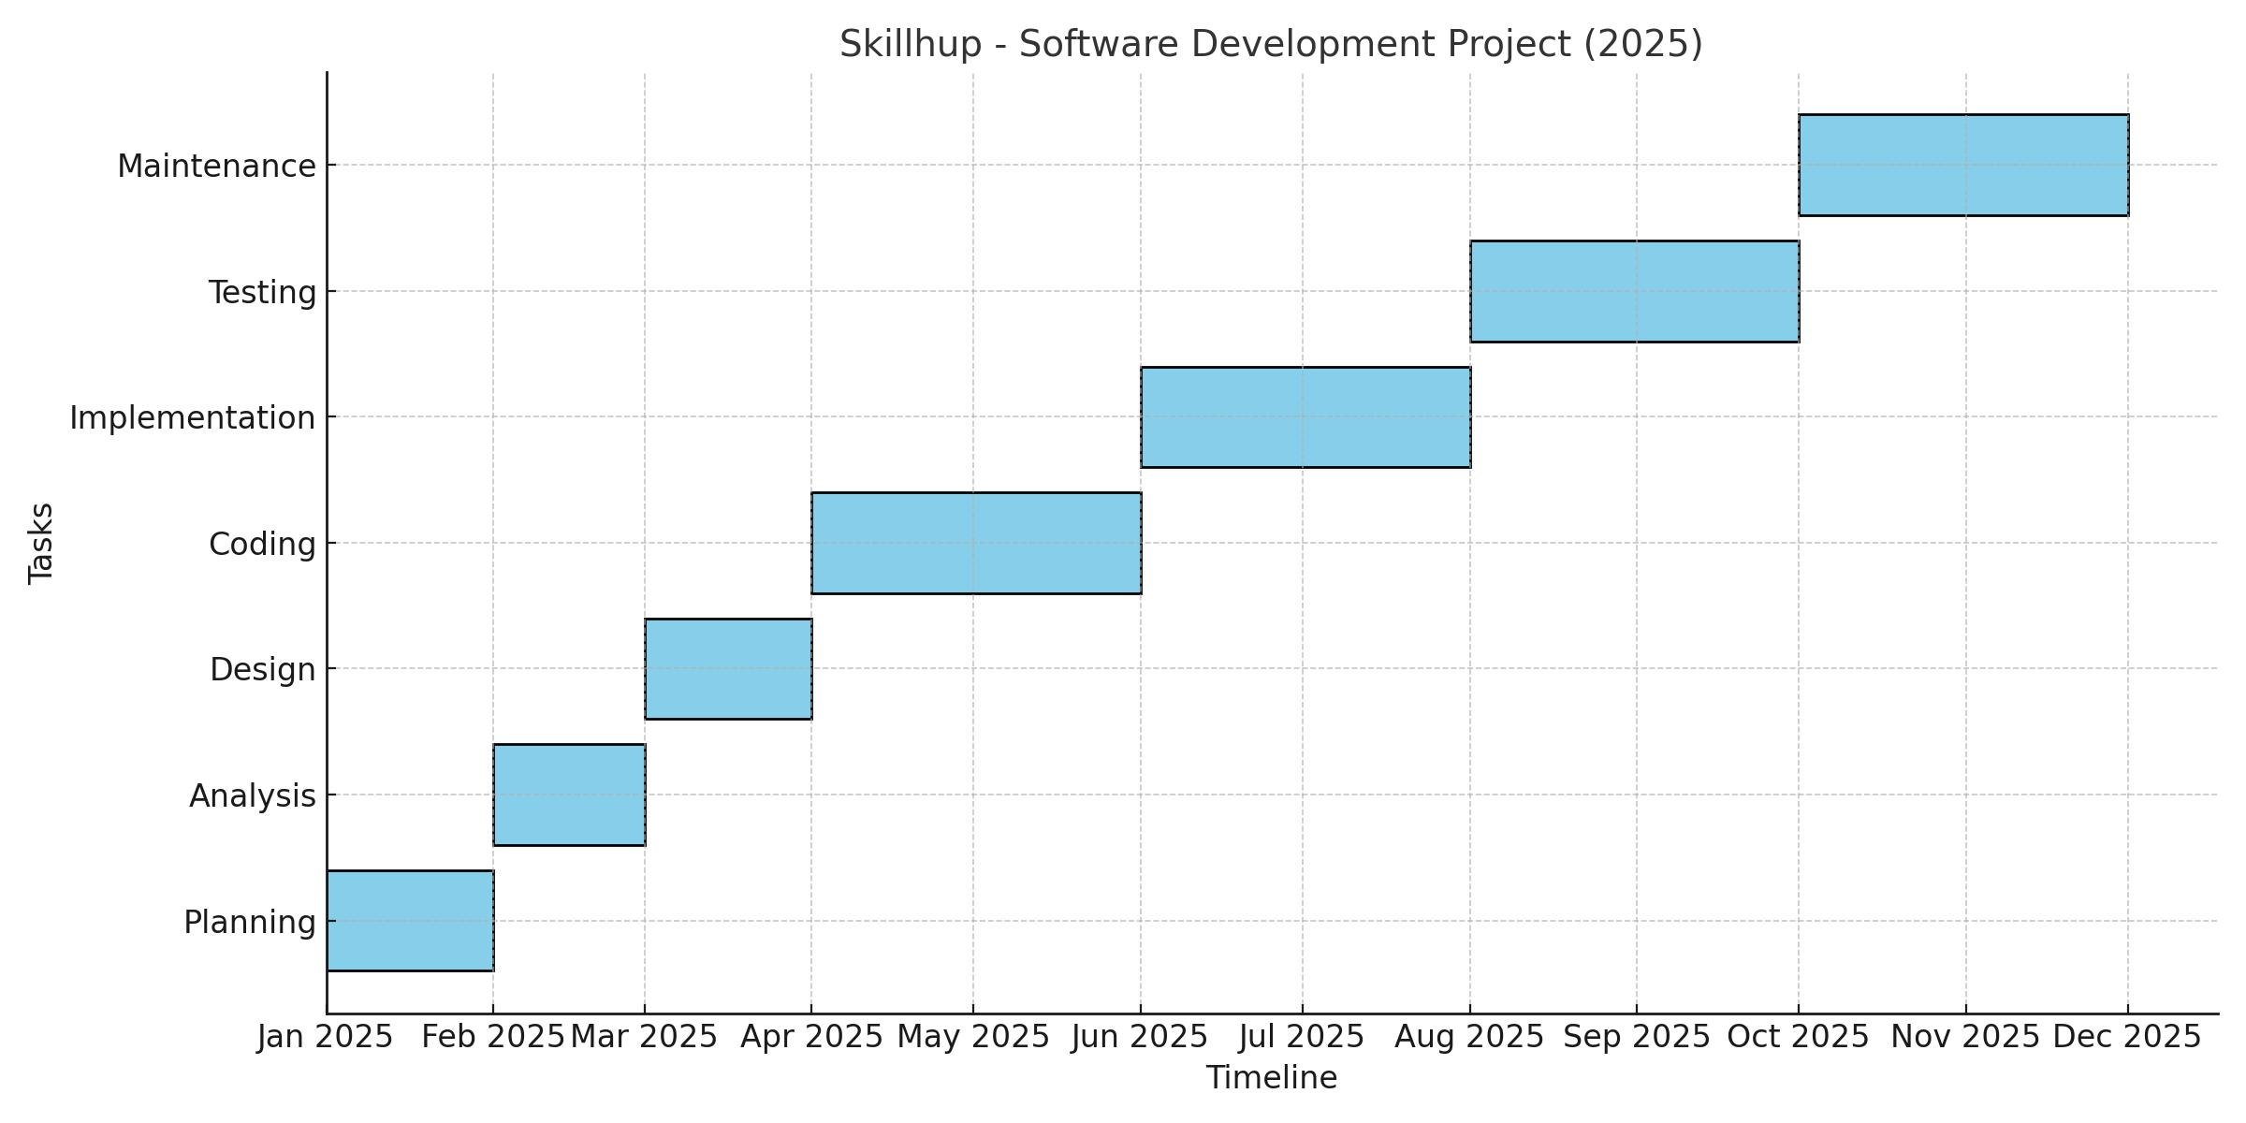

* 1. 2. System Analysis

2.1 Functional Requirements

1. Registration and Login Page

1.1. Provide a registration interface for new users and a login option for previously registered users.

2. Profile Page

2.1. Display user information, resume, and offered services, allowing clients to understand their capabilities and skills.

3. Settings Page

3.1. Customize app settings for each user according to their personal preferences.

4. Home Page

4.1. Show links to the user profile, a box for posting updates and images, a link for notifications, and a chat link.

5. Search Page

5.1. Facilitate searching for other users or specific services within the app.

6. Notifications Page

6.1. Show notifications received from the app, such as new messages or post updates.

7. Chat Page

7.1. Provide an interface for direct communication and chatting with other users.

8. Logout Page

8.1. Enable users to securely log out from their accounts.

2.2 Use Case Diagram

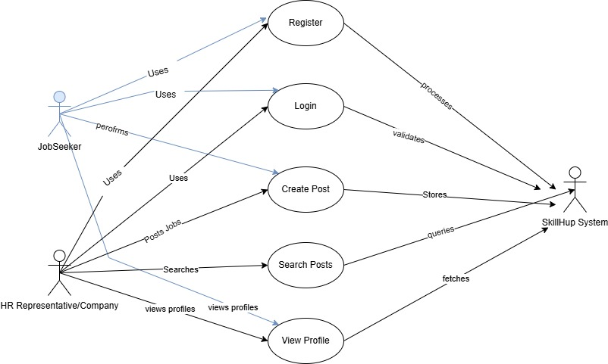

Figure 2: Use Case diagram of system

Figure 3: Class diagram of Appointment system

3.2 ER-Diagram

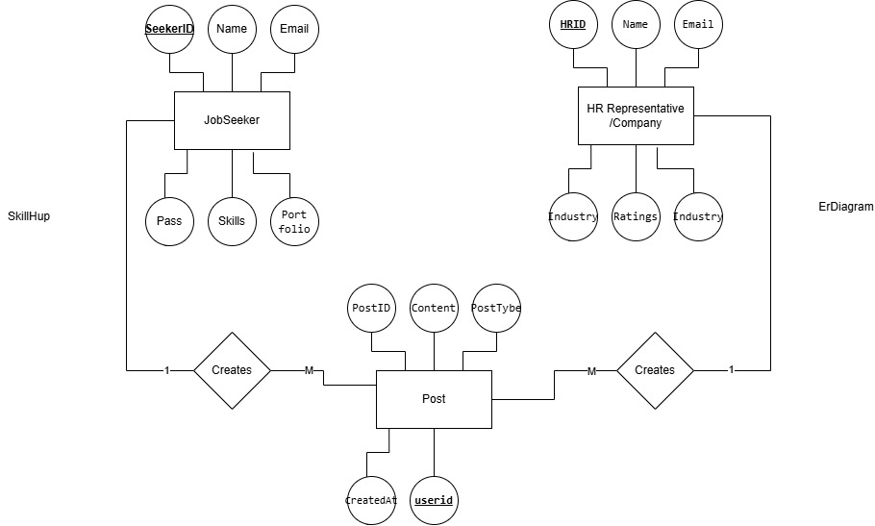

Figure 4: ER diagram of Appointment system

3.3 User Interface

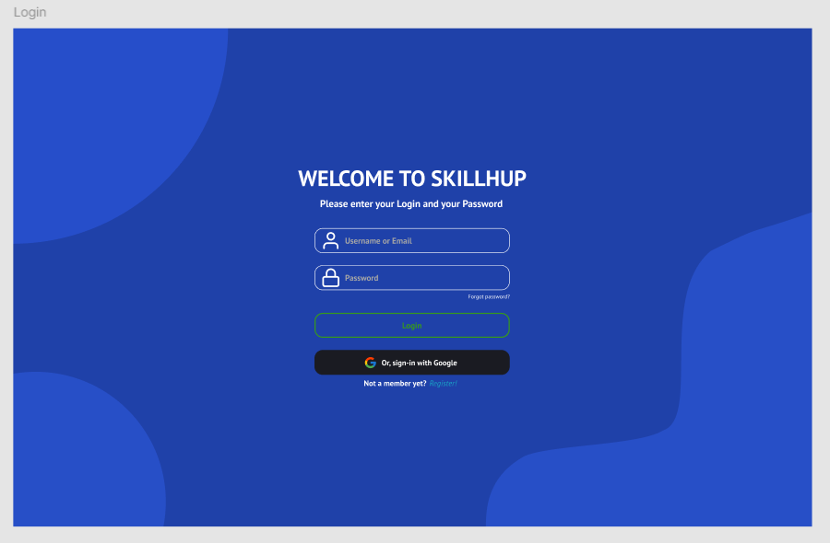

Login Page

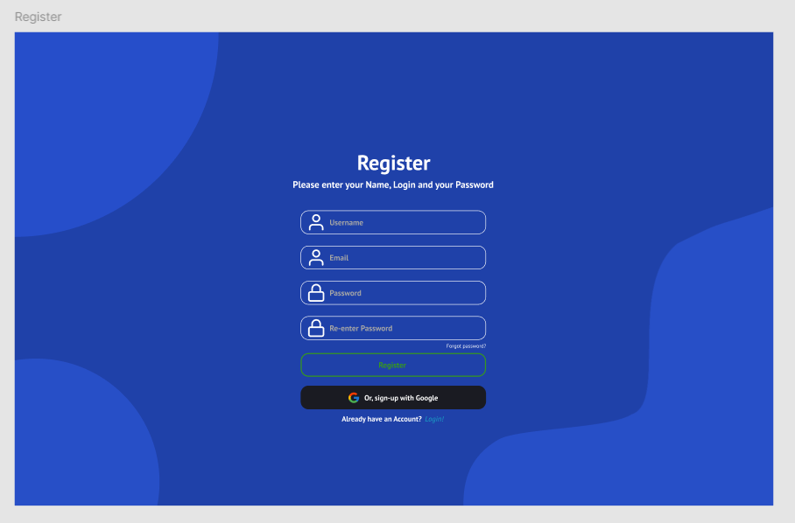SignUp Page

Figure 5: Main UI of Appointment system

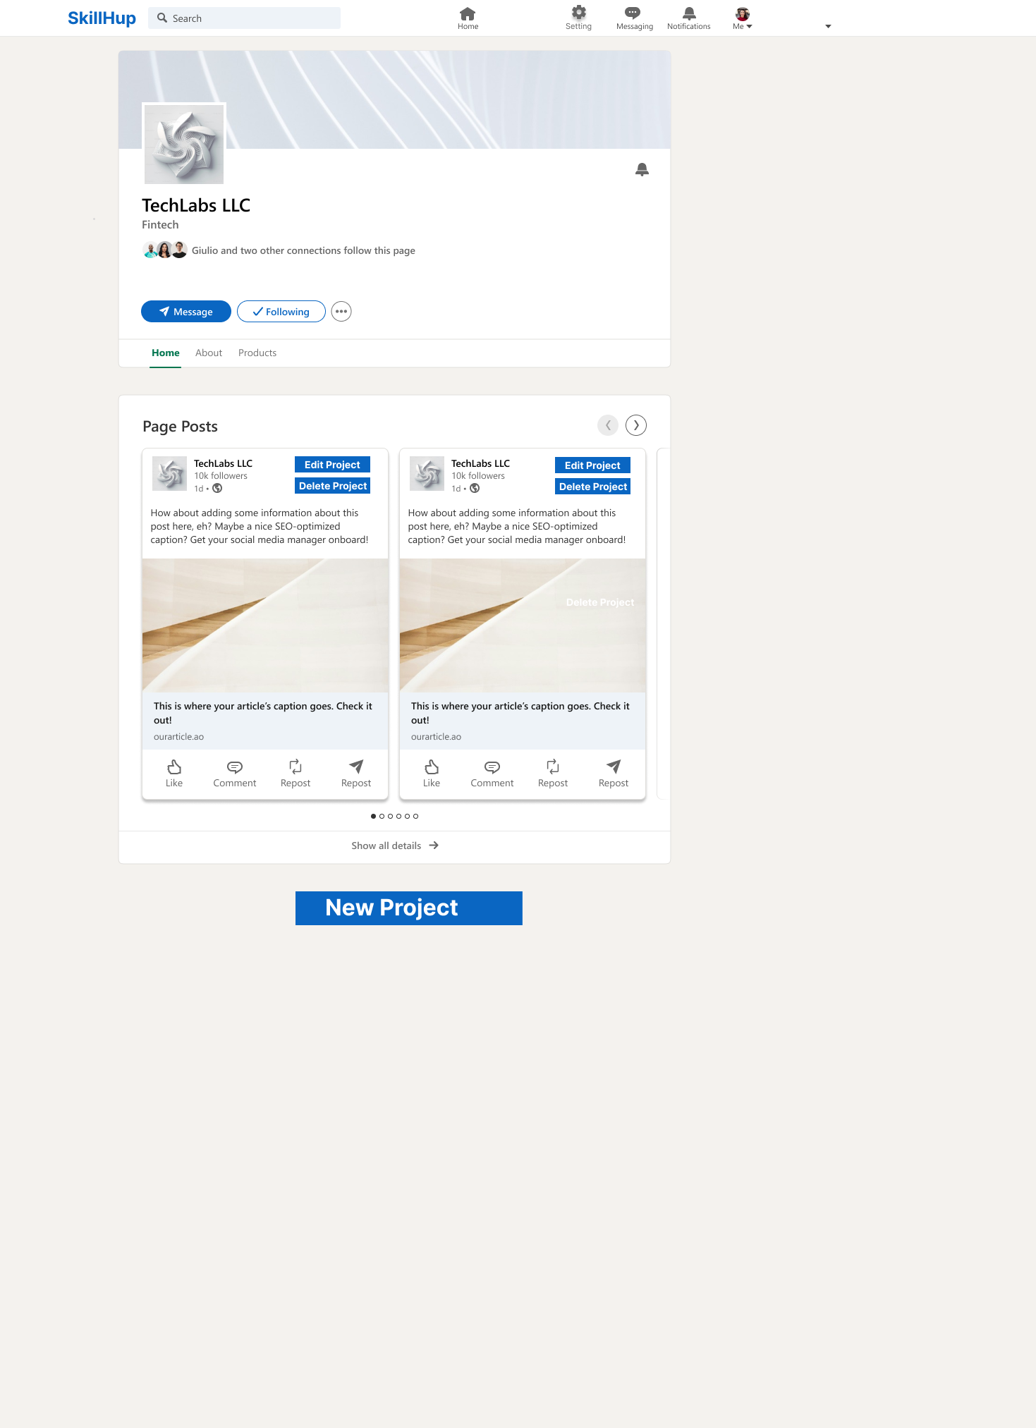

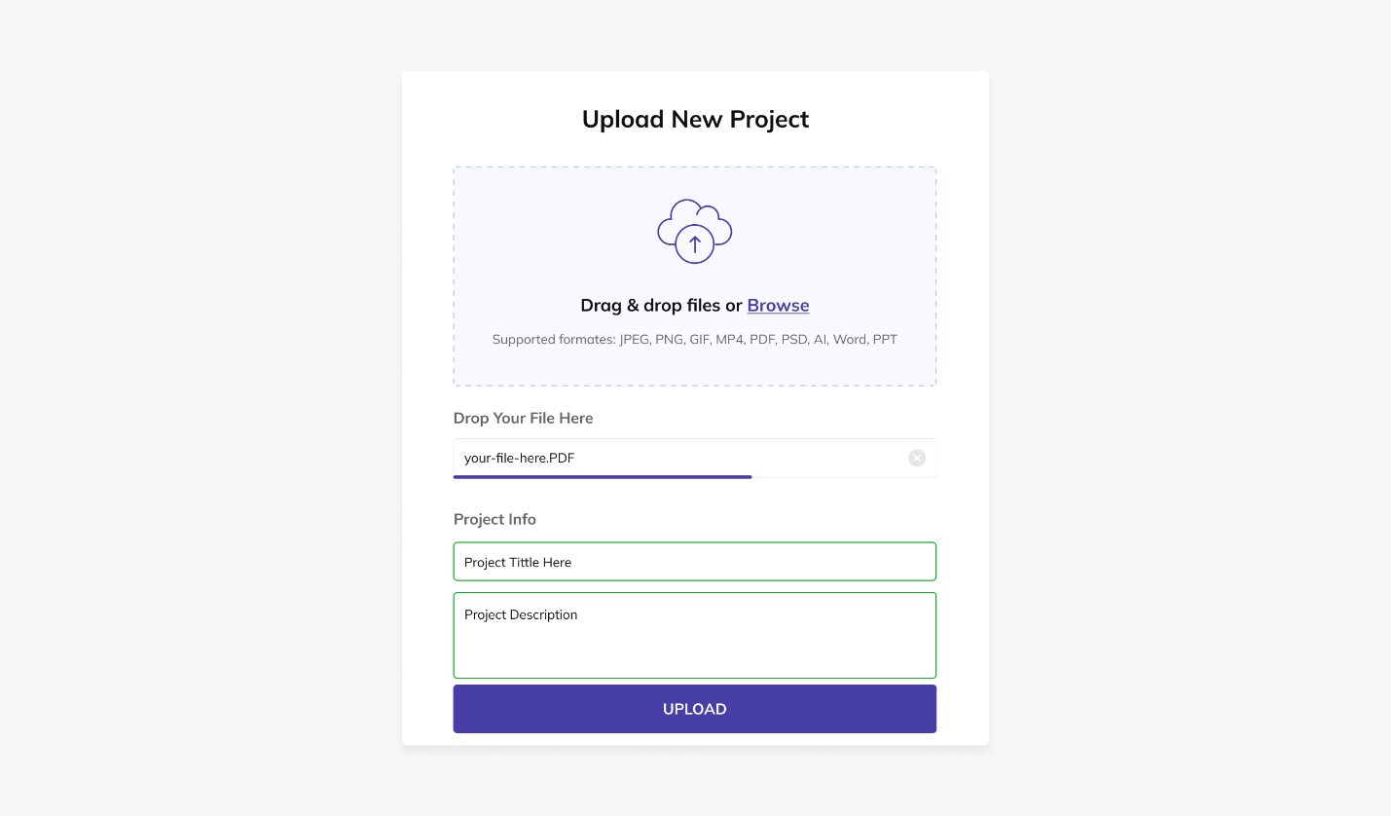

Figure 6: Show All UI of system