# احمد محمد فايز المحمود

ID: 202220296

## الصور

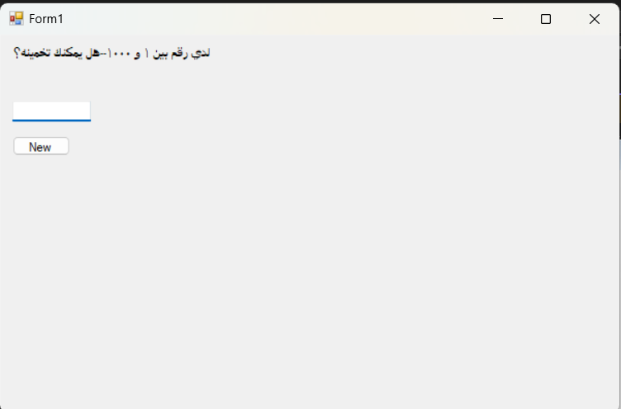

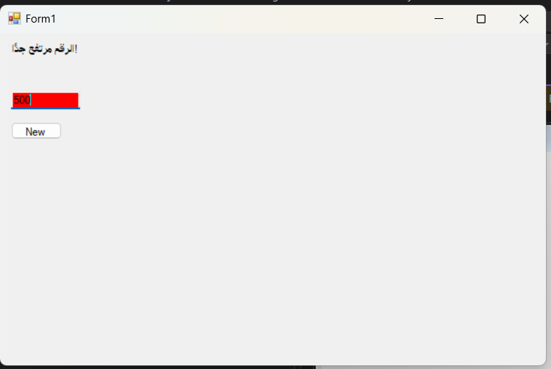

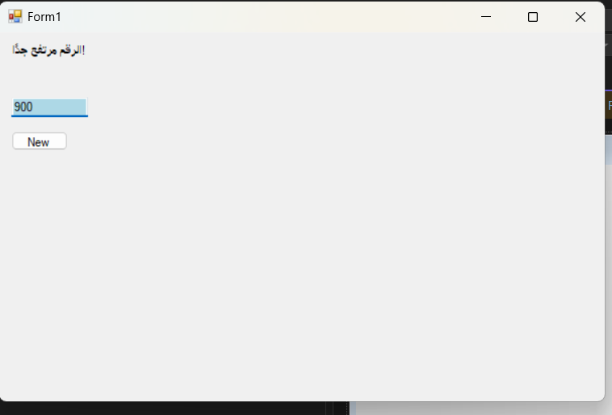

## الكود:

using System;  
using System.Collections.Generic;  
using System.ComponentModel;  
using System.Data;  
using System.Drawing;  
using System.Linq;  
using System.Text;  
using System.Threading.Tasks;  
using System.Windows.Forms;  
  
namespace WindowsFormsApp6  
{  
 public partial class Form1 : Form  
 {  
 private int randomNumber;  
 private int previousDifference = int.MaxValue;  
 private Random random = new Random();  
  
 public Form1()  
 {  
 InitializeComponent();  
 StartNewGame();  
 }  
  
 private void StartNewGame()  
 {  
 randomNumber = random.Next(1, 1001);  
 previousDifference = int.MaxValue;  
 lblFeedback.Text = "لدي رقم بين 1 و 1000--هل يمكنك تخمينه؟";  
 txtGuess.Text = "";  
 txtGuess.Enabled = true;  
 txtGuess.BackColor = Color.White;  
 this.BackColor = SystemColors.Control;  
 }  
  
 private void txtGuess_TextChanged(object sender, EventArgs e)  
 {  
 if (int.TryParse(txtGuess.Text, out int userGuess))  
 {  
 int currentDifference = Math.Abs(randomNumber - userGuess);  
  
 if (userGuess == randomNumber)  
 {  
 MessageBox.Show("صحيح!", "تهانينا", MessageBoxButtons.OK, MessageBoxIcon.Information);  
 this.BackColor = Color.Green;  
 txtGuess.Enabled = false;  
 }  
 else  
 {  
 txtGuess.BackColor = currentDifference < previousDifference ? Color.Red : Color.LightBlue;  
 lblFeedback.Text = userGuess < randomNumber ? "الرقم منخفض جدًا!" : "الرقم مرتفع جدًا!";  
 previousDifference = currentDifference;  
 }  
 }  
 else if (!string.IsNullOrEmpty(txtGuess.Text))  
 {  
 lblFeedback.Text = "الرجاء إدخال رقم صحيح!";  
 }  
 }  
  
 private void btnPlayAgain_Click(object sender, EventArgs e)  
 {  
 StartNewGame();  
 }  
  
 private void lblFeedback_Click(object sender, EventArgs e)  
 {  
 }  
 }  
}