

Functional Safety Concept Lane Assistance

**Document Version: [Version]**

**Template Version 1.0, Released on 2017-06-21**



# Document history

|  |  |  |  |
| --- | --- | --- | --- |
| Date | Version | Editor | Description |
| June 62, 2019 | 1.0 | Udacity, EB | Template version |
| April 22, 2019 | 1.1 | Ahmed Belal | Fill in the complete document |
|  |  |  |  |
|  |  |  |  |
|  |  |  |  |

# Table of Contents

Document history

Table of Contents

Purpose of the Functional Safety Concept

Inputs to the Functional Safety Analysis

Safety goals from the Hazard Analysis and Risk Assessment

Preliminary Architecture

Description of architecture elements

Functional Safety Concept

Functional Safety Analysis

Functional Safety Requirements

Refinement of the System Architecture

Allocation of Functional Safety Requirements to Architecture Elements

Warning and Degradation Concept

# Purpose of the Functional Safety Concept

The purpose of the functional safety concept (FSC) is the following:

* Derive functional safety requirement from the safety goals to refine the safety goals
* Allocating these safety requirements to the relevant parts of the system diagram which means defining which part of the system architecture will implement each requirement
* Refine the system architecture to handle the new requirements
* Assigning ASIL level to the system architecture blocks which will inherit the highest assigned requirement ASIL
* The fault tolerant time interval, which measures how quickly a system needs to react to a hazardous situation
* And the safe state, which discusses what a system looks like after it has avoided an accident

# Inputs to the Functional Safety Concept

## Safety goals from the Hazard Analysis and Risk Assessment

|  |  |
| --- | --- |
| **ID** | **Safety Goal** |
| Safety_Goal_01 | Lane Departure Warning (LDW) function shall apply a limited oscillating steering torque to provide the driver with haptic feedback |
| Safety_Goal_02 | The Lane Keeping Assistance (LKA) function shall be time limited and the additional steering torque shall end after a given time interval so that the driver cannot misuse the system for autonomous driving |
| Safety_Goal_03 | Lane Keeping Assistance (LKA) function shall apply a limited steering torque when active in order to stay in ego lane |
| Safety_Goal_04 | Lane Keeping Assistance (LKA) function shall apply the steering torque in the correct direction when active in order to stay in ego lane |

## Preliminary Architecture

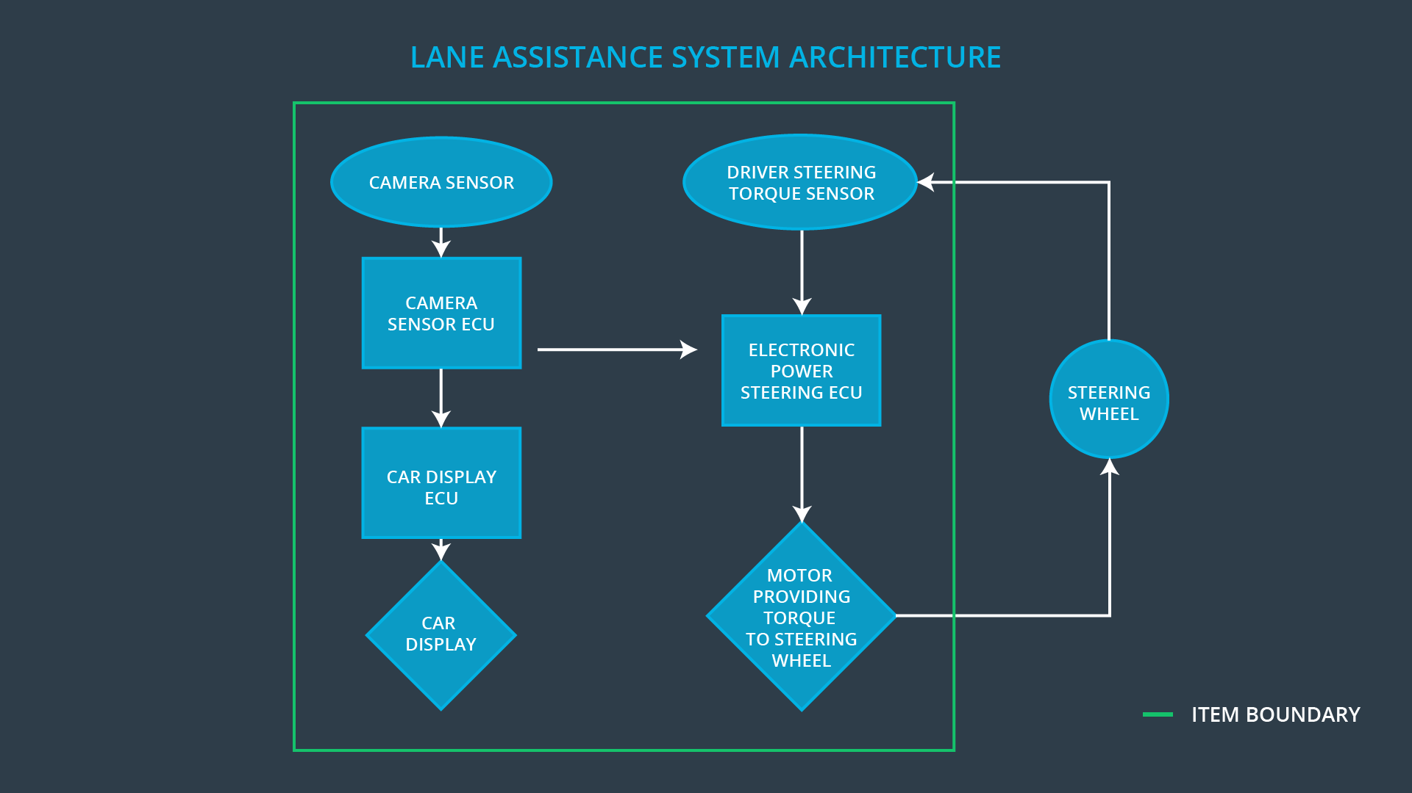

### Description of architecture elements

|  |  |
| --- | --- |
| **Element** | **Description** |
| Camera Sensor | Capture the road images |
| Camera Sensor ECU | Processing the images provided by the camera sensor for detecting the lane lines and determining when the vehicle leaves the lane by mistake |
| Car Display | Screen for showing the notification, warnings and vehicle status for the driver |
| Car Display ECU | Control the displayed data on the car display |
| Driver Steering Torque Sensor | Measure the steering torque applied on the steering wheels |
| Electronic Power Steering ECU | Control the steering wheels by sending the appropriate steering torque control signal to the steering motor driver |
| Motor | Apply the steering torque based on the received steering control signal from the Electronic power steering ECU (EPS) |

# Functional Safety Concept

The functional safety concept consists of:

* Functional safety analysis
* Functional safety requirements
* Functional safety architecture
* Warning and degradation concept

## Functional Safety Analysis

|  |  |  |  |
| --- | --- | --- | --- |
| **Malfunction ID** | **Main Function of the Item Related to Safety Goal Violations** | **Guidewords (NO, WRONG, EARLY, LATE, MORE, LESS)** | **Resulting Malfunction** |
| Malfunction_01 | Lane Departure Warning (LDW) function shall apply a limited oscillating steering torque to provide the driver with haptic feedback | MORE | The lane departure warning (LDW) function applies an oscillating torque with very high torque amplitude (above limit) |
| Malfunction_02 | Lane Departure Warning (LDW) function shall apply a limited oscillating steering torque to provide the driver with haptic feedback | MORE | The lane departure warning (LDW) function applies an oscillating torque with very high torque frequency (above limit) |
| Malfunction_03 | The Lane Keeping Assistance (LKA) function shall be time limited and the additional steering torque shall end after a given time interval so that the driver cannot misuse the system for autonomous driving | NO | The Lane Keeping Assistance (LKA) function is not limited in time duration which leads to misuse as an autonomous driving function. |
| Malfunction_04 | Lane Keeping Assistance (LKA) function shall apply a limited steering torque when active in order to stay in ego lane | MORE | Lane Keeping Assistance (LKA) function applies a steering torque with very high torque amplitude which affect the driver ability to steer the vehicle(above limit) |
| Malfunction_05 | Lane Keeping Assistance (LKA) function shall apply the steering torque in the correct direction when active in order to stay in ego lane | WRONG | Lane Keeping Assistance (LKA) function applies the steering torque in the wrong direction |

## Functional Safety Requirements

Lane Departure Warning (LDW) Requirements:

|  |  |  |  |  |
| --- | --- | --- | --- | --- |
| **ID** | **Functional Safety Requirement** | **ASIL** | **Fault Tolerant Time Interval** | **Safe State** |
| Functional  Safety  Requirement  01-01 | The lane keeping item shall ensure that the lane departure oscillating torque amplitude is below the MAX_TORQUE_AMPLITUDE | C | 50ms | Shut the system down by setting lane assistance output is set to zero |
| Functional  Safety  Requirement  01-02 | The lane keeping item shall ensure that the lane departure oscillating torque frequency is below the MAX_TORQUE_FREQUENCY | C | 50ms | Shut the system down by setting lane assistance output is set to zero |

Lane Departure Warning (LDW) Verification and Validation Acceptance Criteria:

|  |  |  |
| --- | --- | --- |
| **ID** | **Validation Acceptance**  **Criteria and Method** | **Verification Acceptance**  **Criteria and Method** |
| Functional  Safety  Requirement  01-01 | Validate the LDW MAX_TORQUE_AMPLITUDE of the oscillating steering torque | Verify that the LDW will shut down if the MAX_TORQUE_AMPLITUDE exceeded |
| Functional  Safety  Requirement  01-02 | Validate the LDW MAX_TORQUE_FREQUENCY of the oscillating steering torque | Verify that the LDW will shut down if the MAX_TORQUE_ FREQUENCY exceeded |

Lane Keeping Assistance (LKA) Requirements:

|  |  |  |  |  |
| --- | --- | --- | --- | --- |
| **ID** | **Functional Safety Requirement** | **ASIL** | **Fault Tolerant Time Interval** | **Safe State** |
| Functional  Safety  Requirement  02-01 | The electronic power steering ECU shall ensure that the lane keeping assistance (LKA) torque is applied for only MAX_DURATION | B | 50ms | Shut the system down by setting lane assistance output is set to zero |
| Functional  Safety  Requirement  03-01 | The electronic power steering ECU shall ensure that the lane keeping assistance (LKA) torque is below the MAX_TORQUE_AMPLITUDE when active in order to stay in ego lane | C | 50ms | Shut the system down by setting lane assistance output is set to zero |
| Functional  Safety  Requirement  04-01 | The electronic power steering ECU shall ensure that the lane keeping assistance (LKA) torque is applied in the correct direction when active in order to stay in ego lane | C | 50ms | Shut the system down by setting lane assistance output is set to zero |

Lane Keeping Assistance (LKA) Verification and Validation Acceptance Criteria:

|  |  |  |
| --- | --- | --- |
| **ID** | **Validation Acceptance**  **Criteria and Method** | **Verification Acceptance**  **Criteria and Method** |
| Functional  Safety  Requirement  02-01 | Validate the LKA MAX_DURATION of the steering torque | Verify that the LKA will shut down if the steering torque MAX_DURATION exceeded |
| Functional  Safety  Requirement  03-01 | Validate the LKA MAX_TORQUE_AMPLITUDE of the steering torque | Verify that the LKA will shut down if the MAX_TORQUE_AMPLITUDE exceeded |
| Functional  Safety  Requirement  04-01 | Validate the LKA correct steering torque direction | Verify that the LKA will shut down if the steering torque applied in the wrong direction |

## Refinement of the System Architecture

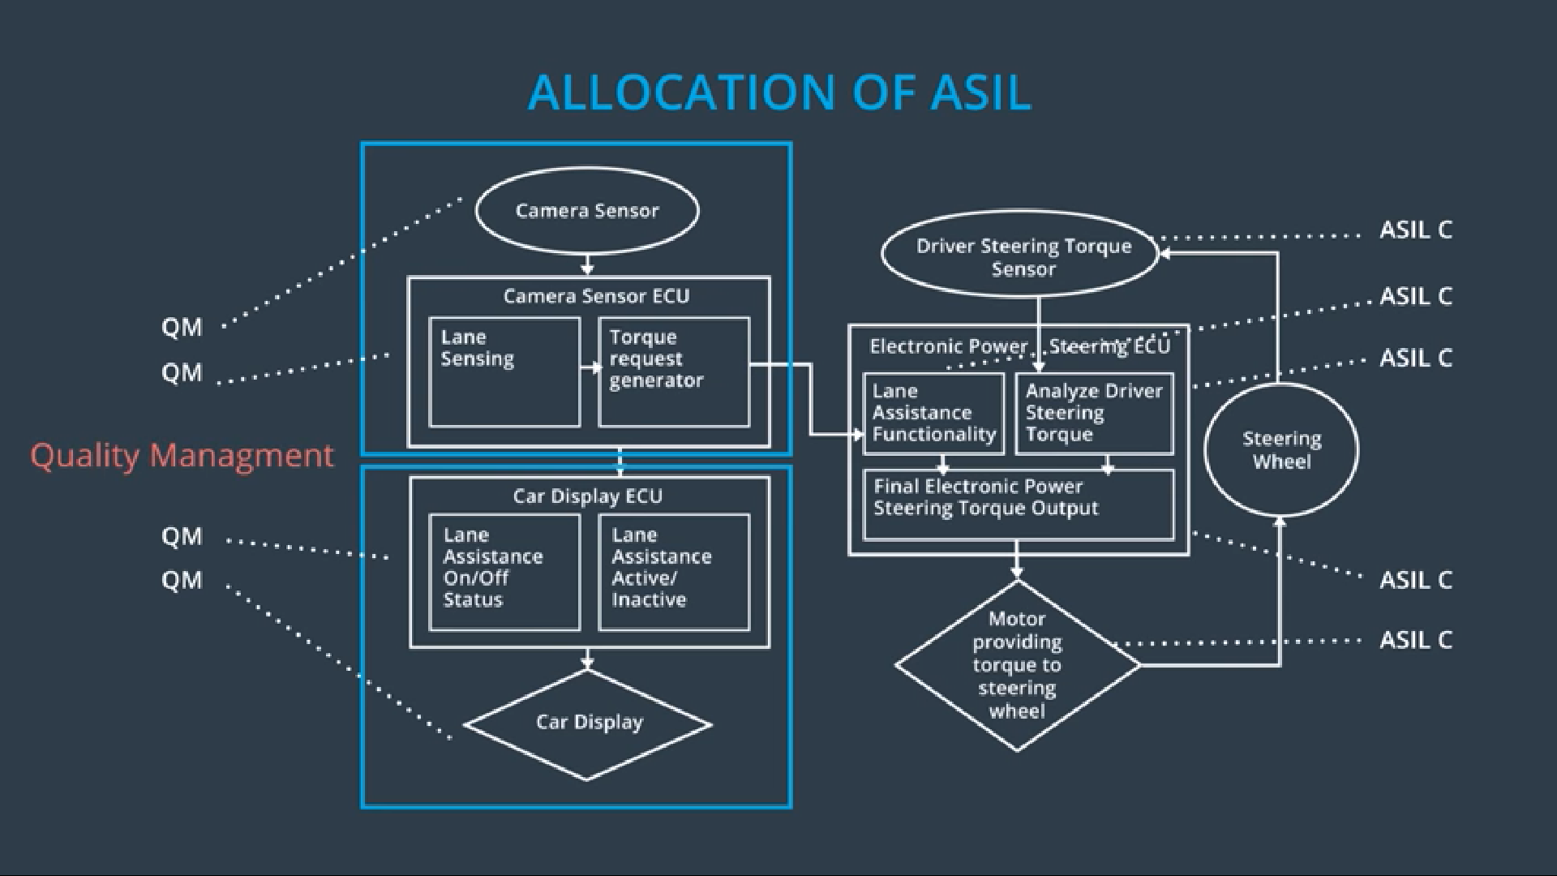

## Allocation of Functional Safety Requirements to Architecture Elements

|  |  |  |  |  |
| --- | --- | --- | --- | --- |
| **ID** | **Functional Safety Requirement** | **Electronic Power Steering ECU** | **Camera ECU** | **Car Display ECU** |
| Functional  Safety  Requirement  01-01 | The lane keeping item shall ensure that the lane departure oscillating torque amplitude is below the MAX_TORQUE_AMPLITUDE | ✔ |  |  |
| Functional  Safety  Requirement  01-02 | The lane keeping item shall ensure that the lane departure oscillating torque frequency is below the MAX_TORQUE_FREQUENCY | ✔ |  |  |
| Functional  Safety  Requirement  02-01 | The electronic power steering ECU shall ensure that the lane keeping assistance (LKA) torque is applied for only MAX_DURATION | ✔ |  |  |
| Functional  Safety  Requirement  03-01 | The electronic power steering ECU shall ensure that the lane keeping assistance (LKA) torque is below the MAX_TORQUE_AMPLITUDE when active in order to stay in ego lane | ✔ |  |  |
| Functional  Safety  Requirement  04-01 | The electronic power steering ECU shall ensure that the lane keeping assistance (LKA) torque is applied in the correct direction when active in order to stay in ego lane | ✔ |  |  |

## Warning and Degradation Concept

|  |  |  |  |  |
| --- | --- | --- | --- | --- |
| **ID** | **Degradation Mode** | **Trigger for Degradation Mode** | **Safe State invoked?** | **Driver Warning** |
| WDC-01 | Shut the system down by setting lane assistance output is set to zero | Malfunction_01  Malfunction_02 | Yes | Display LDW warning on driver dashboard |
| WDC-02 | Shut the system down by setting lane assistance output is set to zero | Malfunction_03  Malfunction_04  Malfunction_05 | Yes | Display LKA warning on driver dashboard |