First
Animation
Storyboard
Version of Adobe used

I used the 12.0.2.529 of the Adobe Flash Professional CS6 to create the animations.

Storyboard:
Fiesta Go!
Faculty of IT, Mathematics and Science

The plan was always to have the logo upfront and in the center of the animation but it would be too simple and wont be unique. This why I came up with the stickman cartoon that would lead into the main attraction with is the logo.
I had to setup many animations on the page itself such as the transition into it, the movement of the bottom title adding rotations and animation. This is storyboard was the main idea but when I used Adobe flash, I realized that there is so much more you can do with basic text and I added a lot of work into it.

HIGHLIGHTS OF EVENTS:

- Guest Lecturers
- Workshops
- CISCO DAY
- Logo and T-shirt design competition

This was the first page of the information panels. There was little information on these panels but I wanted to showcase a different animation style on each to demonstrate the use of adobe flash. Each topic has its own unique animation from rotation to tween to resizing. I also wanted to put up transitions between these pages but it seems that I couldn’t get them to look just as good as I wanted, so I simply used a Shape tween for the first page.

Thanksfor watching

This is the final message in theory, but in reality I had to make some adjustments to it inorder to make it more interactive and more fulfilling. It comes right after a nice shape animation and moves around the screen using the motion tween.

Screenshots:

Screenshot 1:

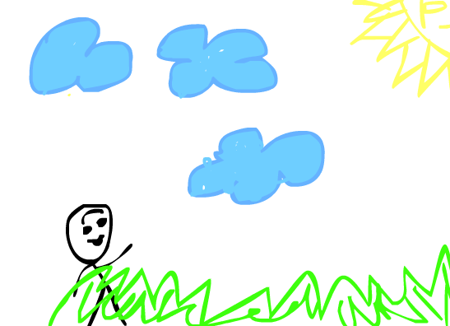

This is the opening frame of the animation. It begins with a little stickman named Sticky Stickman who is walking in the park. The sun is shining, grass is green and the clouds are clouds. Sticky Stickman is shown to be walking into the grass with various expressions, hand movements and animation all done using the onion skin effect and hand drawn graphics.
There is also nice music playing in the background that adds interest to story.

Screenshot 2:

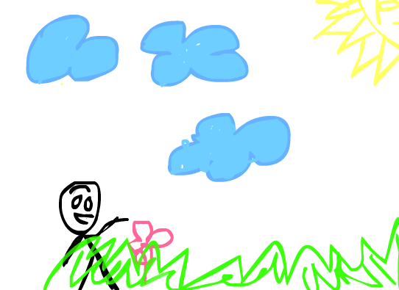

Then whilst walking he sees a pink flower, being the happy queer that he is, he attempts to pluck it out from the ground. The flower is animated using the onion skin as well. The flower disappears as soon as he tries to grab it.

Screenshot 3:

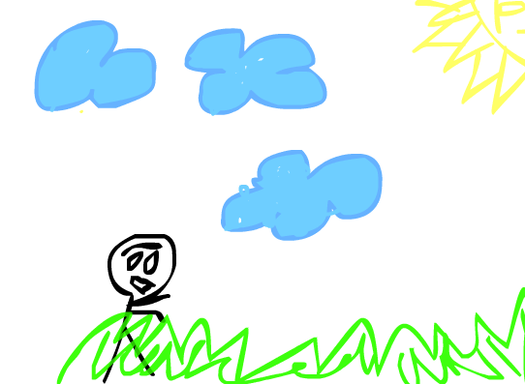

Now he’s visibly upset that the flower strangely vanished as he attempted to grab it. His movements are all active and animated. After a while of being in motion and being sad and agree that its disappeared he sees something strange in a distance and walks to it.

Screenshot 4:

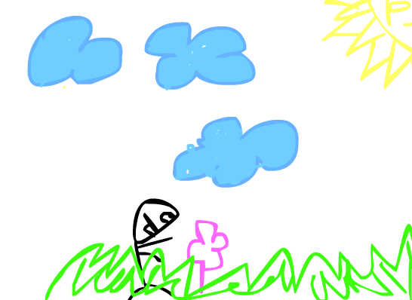

It is another flower that popped up (using onion skin) and he tries to grab it again but it seems that he has failed as its too fast for him and disappears.

Screenshot 5:

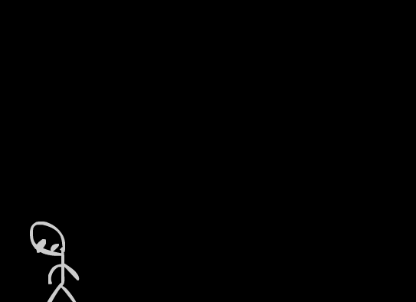

Now the clouds have moved away using the classic tween and the son has vanished and there is a darkness. This is done by using the shape tween to have a smooth transition towards darkness, from a small ball to complete dark. StickyStickMan is now very sad that his wonderful day was ruined as he tried to steal a flower and failed and was defeated by a plant. His body is shrinking using onion skin and his color is changing to a more grey tone. to reflect his sadness.
But then out of nowhere something appears.

Screenshot 6:

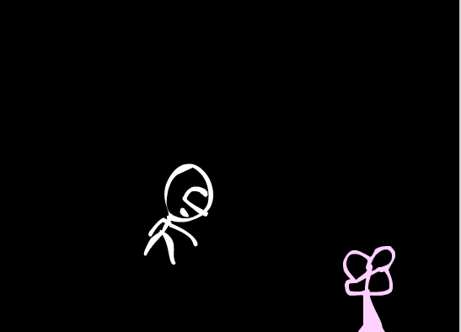

It’s the flower that has re appeared using making tool it is slowly revealed to our sticky friend but this time he turns around and jumps at it using the motion tween. He is shown leaping in the air and grabs the flower.

Screenshot 8:



The flower bursts into a large pink screen using the shape tween to enlarge it after our friend Sticky Stickman tried to grab it. The transition is smooth and stable.

Screenshot 9:



From the pink screen the FITMS logo is revealed using the masking effect. The animation is slow and the pink background turns into a dynamic yellow circle which expands in all directions and gradually covers over the pink and makes it all yellow. This is done using the shape tween again but it is done on multiple parts to give a nice transition. Please refer to CD as the transition doesn’t translate well into words. As the main logo appears, the bottom text starts appearing. First the first few words come on screen from the right side using motion tween. Then from the bottom and then finally the words “Mathematics & sciences” fly’s in from across the screen while rotating and moving around the scene. The words “Faculty of” pulse on and off to give a premium look and feel.

Screenshot 10:

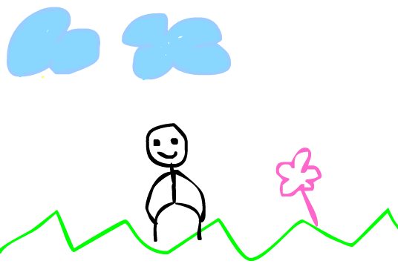
Now StickyStickMan is back and this time he is doing a little dance for us, moving his legs
and arms. Done using onion skin. The clouds are also in motion with classic tween. And there is the little flower that is slowly growing and becoming larger.

Screenshot 11:

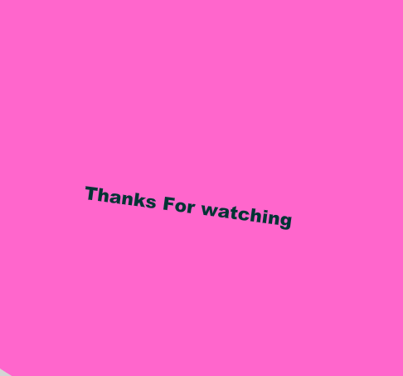

The flower becomes very large and then takes over the screen with the text “Thanks for watching” displayed. The text is in motion and is hitting thru edges of the screen and moving around, rotating. Done my motion tween. And shape tween.

Learning experience:

I believe that I had a lot to learn in this assignment. Animation isn’t exactly a difficult task but it is slow and tedious. It takes time and energy to get good at it. It made me appreciate all the work people put into cartoons and animations.

It is also very interesting to do as you can create objects and people and make them interact in fascinating ways. But animation clearly requires other hardware such as a pen tablet, as it is quite difficult to free hand with a mouse and a cursor.

Even so it is a very open field where you can create whatever you desire, all you need is patience and a drive to learn. Almost all the work was drawn and created by hand by me.

I think I learned a lot about the way the application (adobe flash) works, there were many instructions that I wasn’t familiar with and there were functions that I was confused about. Now it seems that I have a better understanding of how things work.

References:

Audio Lounge Music. 2015. Happy Marimba Royalty-Free . [ONLINE] Available at: https://www.youtube.com/watch?v=I1U6-Qogf14. [Accessed 10 October 2016].

